**Comment**

**Is biodiversity as intact as we think it is?**

Rhys E. Green1,2*, Philip A. Martin1, Piero Visconti3 and Andrew Balmford1

1Conservation Science Group, Department of Zoology, University of Cambridge, Downing Street, Cambridge CB2 3EJ, UK, 2RSPB Centre for Conservation Science, The Lodge, Sandy, Bedfordshire SG19 2DL, UK, 3Institute of Zoology, Zoological Society of London, Regent's Park, London, NW1 4RY, UK.

**Abstract**

The Biodiversity Intactness Index has been adopted as a key indicator by the Intergovernmental Platform on Biodiversity and Ecosystem services. However, there are signs that the indicator may be inaccurate, limiting its utility in tracking changes in biodiversity.

**Main text**

Robust indicators of the state of biodiversity provide essential guidance for tackling the extinction crisis. One increasingly prominent metric, the Biodiversity Intactness Index (BII), is intended to indicate the average abundance of wild species in a given geographical area, relative to that in pre-modern times [1] or in primary vegetation under current climatic conditions [2]. In principle the BII has several advantages over other biodiversity indicators – for example by reducing the risk of shifting baselines [3] leading to insufficiently ambitious conservation goals because the current state of biodiversity is simply compared with that in the recent past.

The BII has been endorsed by the Group on Earth Observations of the Biodiversity Observation Network and adopted by the Intergovernmental Platform on Biodiversity and Ecosystem Services (IPBES) as a "core" indicator of trends in biodiversity and ecosystem services for assessing progress towards the Convention on Biodiversity’s Aichi targets 12 and 14 (extinction risk and ecosystem resilience). It has also been adopted by the Biodiversity Indicators Partnership as an indicator to track progress towards Aichi target 5 (halving the rate of habitat loss by 2020).

**Problems with the Biodiversity Intactness Index**

Newbold et al [2] mapped the BII globally by modelling thousands of field-derived estimates of the abundance of a broad range of species as a function of human-induced pressures, and then extrapolating their model using remote-sensed data. The resulting surface represents an estimate of the current average abundance of those species that would occur in primary vegetation as a proportion of that expected in the absence of human activities.

However, many of the BII values presented on this map are surprising. For example, the BII exceeds 90% (and often 95%) in much of SE Asia, Indonesia, central America and eastern Madagascar – areas usually considered to be exposed to widespread habitat loss and with a high proportion of threatened species. On a finer-scale map [4] the BII within the UK exceeds 50% even within the cities of Birmingham and Manchester and peaks (at over 95%) in Kielder Forest, a large plantation dominated by non-native conifers. In light of these unusual patterns and given the growing policy significance of the BII, it seems prudent to test its credibility more systematically.

**Mismatch with other metrics**

The recent publication of a synthesis of estimates of current biomass stock relative to that without human activities, which we call biomass intactness (BMI) [5], provides an opportunity for a global quantitative check on the performance of the BII. Broadly speaking we might expect the two indices to be positively correlated across space. We would also anticipate that BII values should mostly be lower than BMI values (sometimes substantially so): where some of the current biomass is made up of non-native species, or where biodiversity faces other threats besides habitat loss; in contrast it is hard to conceive how it could be higher.

However, there is only a very weak correlation between the two indices (Fig. 1). In a relatively small but still substantial set of largely arid or semi-arid areas, the BII is considerably lower than the BMI (blue on Fig. 1A). However, in many areas where the BMI has been reduced dramatically – including much of Europe, China, India, and eastern Brazil - the BII is nevertheless estimated as being relatively high (red in Fig 1A). In these cases, a substantial fraction of primary vegetation has been removed, as indicated by low BMI, yet BII values suggest only a small proportion of biodiversity has been lost.

The BII and BMI concur (grey on Figure 1A) on much less than half of the Earth’s land surface, mostly in areas of boreal taiga and tundra and larger remnants of tropical rain forest. Both BII and BMI might be subject to errors, but comparison of the BII with the Human Footprint (HF [7]), a composite measure of the pressure on natural ecosystems from humans, confirms the impression of BII values being unusual: while BMI values correlate negatively with HF scores, as expected, BII is not negatively correlated with HF [Supplemental Information].

The mismatch between BII and BMI values is most striking in global biodiversity hotspots (defined as areas of exceptional endemism which have lost at least 70% of their primary vegetation [8]; red symbols in Fig. 1B). As expected, the BMI in these high priority areas for conservation is on average much lower than in other regions; however as measured by the BII, biodiversity intactness is apparently higher in hotspots than elsewhere. For example, in the Sundaland, Indo-Burma, Philippines and Madagascar hotspots, where the BMI confirms that a substantial fraction of primary vegetation has been removed, the BII suggests native species populations have on average declined by <10% [2]. Indeed, for the 32 biodiversity hotspots for which we have data on both BII and BMI, the mean BII of hotspots was significantly negatively correlated with mean BMI (Spearman correlation: *rS* = -0.595, *P*= 0.0003): hotspots with less remaining biomass have higher BII scores.

We do not understand these patterns, and are concerned that uncritical acceptance of the BII as a biodiversity metric will lead to unjustified complacency about the security of wild nature. According to the Newbold et al. analysis, on average the terrestrial BII stands at almost 85% [2] – in striking contrast to the suggestion that the land surface supports only half the biomass that it would in the absence of human land use [5]. We are sceptical that biodiversity is really as intact and secure as the BII suggests. We recommend rigorous further testing and, if necessary, the development of alternative methods.

**Supplementary information**

Figure S1.

**Author contributions**

All authors discussed the framework of the manuscript. P.M. performed the analyses and drew the Figure. P.V. identified relevance to policy and practice. R.E.G. and A.B. wrote the manuscript. All authors provided criticisms and revisions.

**References**

1. Scholes, R.J. and Biggs, R. (2005). A biodiversity intactness index. Nature 434, 45 – 49.
2. Newbold, T., Hudson, L.N., Arnell, A.P., Contu, S., De Palma, A., Ferrier, S., Hill, S.L.L., Hoskins A.J., Lysenko, I., Phillips, H.R.P., et al. (2016) Has land use pushed terrestrial biodiversity beyond the planetary boundary? A global assessment. Science 353,288–291.
3. Pauly, D. (1995). Anecdotes and the shifting baseline syndrome of fisheries. Trends in Ecology and Evolution 10, 430.
4. Purvis, A., De Palma, A. and Newbold, T. (2016) A UK-wide perspective on “biodiversity intactness”. In State of Nature 2016*,* Hayhow, D.B., Burns, F., Eaton, M.A., Al Fulaij, N., August, T.A., Babey, L., Bacon, L., Bingham, C., Boswell, J., Boughey, K.L., et al., (London: The State of Nature partnership), pp. 70-71.
5. Erb, K.-H., Kastner, T., Plutzar, C., Bais, A.L.S., Carvalhais, N., Fetzel, T., Gingrich, S., Haberl, H., Lauk, C., Neidertscheider, et al. (2018). Unexpectedly large impact of forest management and grazing on global vegetation biomass. Nature 553, 73-76.
6. Olson, D.M., Dinerstein, E., Wickramanayake, E.D, Burgess, N.D., Powell, G.V.N., Underwood, E.C., D’Amico, J.A., Itoua, I., Strand, H.E., Morrison, J.C., Loucks, C.J., Allnutt, T.F., Ricketts, T.H., Kura, Y., Lamoreux, J.F., Wettengel, W.W., Hedao, P., Kassem, K.R. (2001). Terrestrial Ecoregions of the world: a new map of life on Eath. Bioscience, 51 (22), 933-938 (GIS data downloaded from http://maps.tnc.org/gis_data.html)
7. Venter, O., Sanderson, E.W., Magrach, A., Allan, J.R., Beher, J., Jones, K.R., Possingham, H.P., Laurance, W.F., Wood, P., Fekete, B.M., Levy, M.A. and Watson, J.E.M. (2015). Sixteen years of change in the global terrestrial human footprint and implications for biodiversity conservation. Nature Communications 7, 12558.
8. Myers, N., Mittermeier, R.A., Mittermeier, C.G., da Fonseca, G.A.B. and Kent, J. (2000). Biodiversity hotspots for conservation priorities. Nature 403, 853-858. (GIS data downloaded from https://databasin.org/datasets/23fb5da1586141109fa6f8d45de0a260)

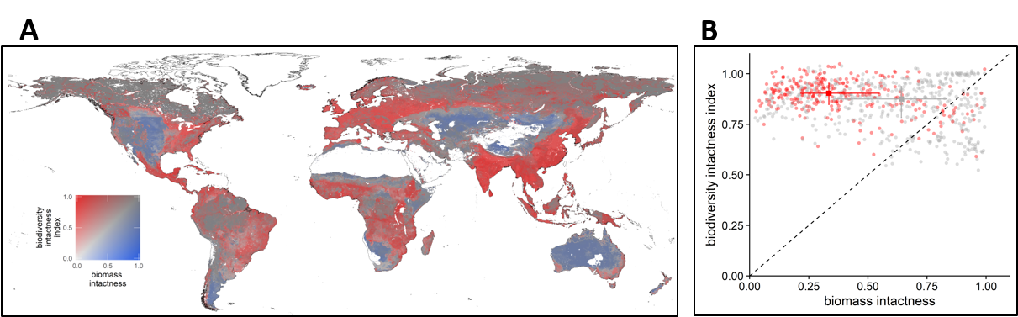

**Figure 1. Global comparison of the Biodiversity Intactness Index with the ratio of actual to potential biomass stock.**

(A) Bivariate map of BII and biomass intactness (BMI). Areas of land shown in white had no data available for one or both of the two indices. (B) Plot of BII against BMI. Each point represents the mean of the two indices for a terrestrial ecoregion [6]. Red circles represent ecoregions with more than half of their area inside a biodiversity hotspot and grey circles represent other ecoregions. The squares and associated lines show medians and interquartile ranges. The dashed diagonal line indicates equality of the two indices.

**SUPPLEMENTAL INFORMATION**

**Is biodiversity as intact as we think it is?**

Philip Martin, Andrew Balmford, Piero Visconti and Rhys E. Green

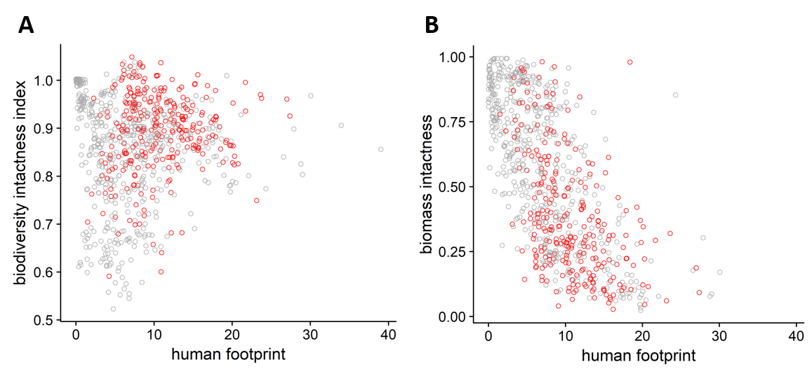

**Figure S1. Comparison of the Biodiversity Intactness Index (BII) and Biomass Intactness Index (BMI) with the Human Footprint measure of human pressure on ecosystems.**

(A) Plot of BII against Human Footprint index (from ref. 7 of the main text). Each point represents the mean of the two indices for a terrestrial ecoregion (from ref. 6 of the main text). Red circles represent ecoregions with more than half of their area inside a biodiversity hotspot and grey circles represent other ecoregions. (B) Plot of BMI against Human Footprint index. We expected that both BII and BMI would be negatively correlated with the Human Footprint measure of human pressure, but it is apparent that BII is not negatively correlated with Human Footprint, whereas BMI is negatively correlated with Human Footprint. We did not perform a statistical test of these correlations to avoid problems of spatial autocorrelation, which arise because many of the ecoregions are close to one another.