**Is biodiversity as intact as we think it is?**

**Philip A. Martin1*,Rhys E. Green1,3 and Andrew Balmford1**

1Conservation Science Group, Department of Zoology, University of Cambridge, Downing Street, Cambridge CB2 3EJ, UK,2 BioRISC St Catharine’s College, Cambridge CB2 1RL, UK 3RSPB Centre for Conservation Science, The Lodge, Sandy, Bedfordshire SG19 2DL, UK,

*Corresponding author- phil.martin.research@gmail.com

**The Biodiversity Intactness Index measures the average abundance of wild species relative to that in pre-modern times. Recently BII was mapped at a global scale by Newbold et al and consequently has gained traction in policy circles. However, we have some concerns about the accuracy of this map. For example, BII exceeds 90% in many areas that have suffered widespread habitat loss. We show here that BII shows little relationship with the intactness of vegetation biomass (BMI) and that BII is higher than BMI in most locations. In addition, Human Footprint is strongly correlated with BMI but not BII. These patterns are worrying, but we do not understand why they occur. We recommend rigorous further testing of the BII before it is used to inform policy.**

The Biodiversity Intactness Index (BII) is a high-profile metric of an area’s average abundance of wild species relative to that in pre-modern times1 or in primary vegetation under current climatic conditions2. It has been endorsed by the Group on Earth Observations of the Biodiversity Observation Network, adopted by the Intergovernmental Platform on Biodiversity and Ecosystem Services as a "core" indicator of progress towards the Convention on Biological Diversity’s Aichi targets 12 and 14, and accepted by the Biodiversity Indicators Partnership as an indicator for target 5. The growing policy significance of BII has drawn our attention to some unusual features of its outputs.

Newbold et al2 mapped the BII globally by modelling thousands of field-derived estimates of the abundance of individual species’ as a function of human-induced pressures, and then extrapolating their model using remote-sensed data. The resulting surface represents an estimate of the current average abundance of species that would occur in an area’s primary vegetation as a proportion of that expected in the absence of human activities. However, many mapped BII values seem surprising. For example, the BII exceeds 90% in much of SE Asia, Indonesia, central America and eastern Madagascar – where widespread habitat loss is linked with a high proportion of threatened species. In a finer-scale UK analysis3 the BII exceeds 50% even in the centres of large cities, and peaks (at >95%) in large plantation forests of non-native conifer trees.

A recently mapped synthesis of estimates of current biomass stock relative to that without human activities, which we call biomass intactness index (BMI)4, allows a more systematic check of the BII’s performance. Because habitat loss is the major driver of wild populations’ declines we expected the two indices to be positively correlated across space, but for BII values to generally be lower (sometimes substantially) than BMI values because current biomass typically includes non-native vegetation, and because biodiversity faces many threats besides habitat loss; in contrast it is hard to conceive how BII could exceed BMI.

However, the two indices exhibit very limited agreement. In many arid or semi-arid areas, the BII is considerably lower than the BMI (blue on Fig. 1a). In contrast in many areas with low BMI – much of Europe, China, India, and Brazil - reported BII values are high (red), suggesting that despite the removal of most primary vegetation only a small fraction of biodiversity has been lost. The BII and BMI concur (grey) on much less than half the global land surface, mostly in taiga and tundra, Amazonia and the Congo. Comparing the BII with the Human Footprint (HF5), a composite measure of anthropogenic pressure on natural ecosystems, confirms the impression of BII values being unusual: BMI values decline as expected as HF scores increase, but BII scores do not (Fig. 1b,c).

The mismatch between BII and BMI values is most striking in global biodiversity hotspots (priority areas of exceptional endemism which have lost ≥70% of their primary vegetation6; red in Fig. 1d). As expected, hotspots typically have low BMI scores. Bizarrely, though, the BII suggests their biodiversity is apparently more intact than elsewhere. For example, in the Sundaland, Indo-Burma, Philippines, and Madagascar hotspots, while the BMI confirms substantial loss of primary vegetation, the BII estimates native species populations have on average declined by <10%2. Indeed, across the 32 hotspots for which we have both BII and BMI data, mean BII and BMI scores were negatively correlated (*rS* = -0.595, *P*= 0.0003): hotspots with less biomass have higher BII scores.

We do not understand these patterns, and are concerned that uncritical acceptance of the BII will lead to unjustified complacency about the state of wild nature. According to Newbold et al., on average the terrestrial BII stands at almost 85%2 – in striking contrast to evidence that terrestrial biomass is only half what it would in the absence of human land use4. We are sceptical that biodiversity is really as secure as the BII suggests. We recommend rigorous further testing and, if necessary, the development of alternative methods before the BII is used to guide conservation policy.

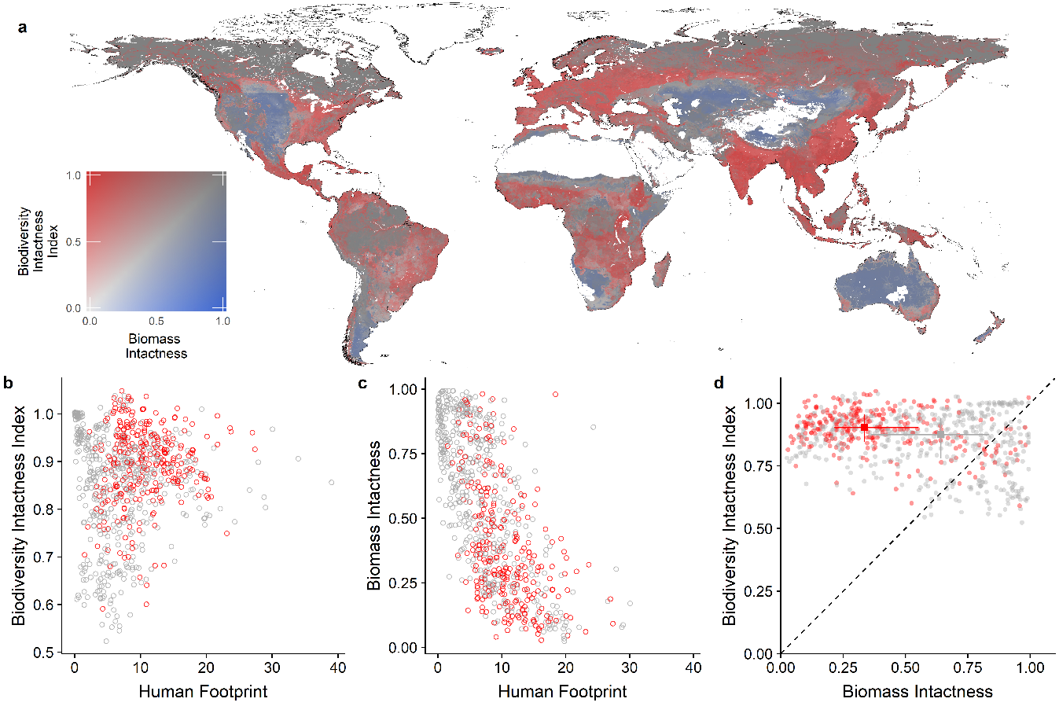

**Figure 1 │ Global comparison of the Biodiversity Intactness Index with biomass intactness and with the Human Footprint index. a,** Bivariate map of BII and biomass intactness (BMI). Land areas in white had no data available for one or both of the indices. **b, c,** Plots of BII and BMI against Human Footprint index5. **d,** Plot of BII against BMI. In **b**-**d** red circles represent mean scores for ecoregions7 with more than half their area inside a biodiversity hotspot6; grey circles represent mean scores for other ecoregions. In **d** the squares and associated lines show medians and interquartile ranges and the diagonal line indicates equality of the two indices.

**References**

1. Scholes, R.J. & Biggs, R. *Nature* **434,** 45 – 49 (2005).
2. Newbold, T. et al. *Science* **353,** 288–291 (2016).
3. Purvis, A., De Palma, A. & Newbold, T. in *State of Nature 2016* (eds Hayhow, D.B. et al.) 70-71 (The State of Nature Partnership, London, 2016).
4. Erb, K.-H. et al. *Nature* **553,** 73-76 (2018).
5. Venter, O. et al. *Nat. Comms* **7,** 12558 (2015).
6. Myers, N., Mittermeier, R.A., Mittermeier, C.G., da Fonseca, G.A.B. & Kent, J*. Natur****e* 403,** 853-858 (2000).
7. Olson, D.M. et al. *BioScience* **51,** 933-938 (2001).