**Is biodiversity as intact as we think it is?**

Philip A. Martin1,Rhys E. Green1,2* and Andrew Balmford1

1Conservation Science Group, Department of Zoology, University of Cambridge, Downing Street, Cambridge CB2 3EJ, UK, 2RSPB Centre for Conservation Science, The Lodge, Sandy, Bedfordshire SG19 2DL, UK,

The Biodiversity Intactness Index (BII) is a high-profile metric of an area’s average abundance of wild species relative to that in pre-modern times1 or in primary vegetation under current climatic conditions2. It has been endorsed by the Group on Earth Observations of the Biodiversity Observation Network, adopted by the Intergovernmental Platform on Biodiversity and Ecosystem Services as a "core" indicator of progress towards the Convention on Biological Diversity’s Aichi targets 12 and 14, and accepted by the Biodiversity Indicators Partnership as an indicator for target 5. We strongly support development of spatially-explicit indicators such as the BII, which can be used to prioritise areas for conservation interventions. However, it is important that the metric is as robust as possible, and we have noticed several unusual features of the BII that concern us.

Newbold et al2 mapped the BII globally by modelling thousands of field-derived estimates of the abundance of individual species’ as a function of human-induced pressures, and then extrapolating their model using remote-sensed land-use data. The resulting surface represents an estimate, for those species that would occur in an area’s primary vegetation, of their current average abundance as a proportion of that expected in the absence of human activities. However, in some regions BII values seem surprising. For example, the BII exceeds 90% in much of SE Asia, Indonesia, central America and eastern Madagascar – where widespread habitat loss is linked with a high proportion of threatened species. For example, in Madagascar, the populations of 34 (out of 98) lemur species have declined by at least 30% in in the last four decades alone3. In a finer-scale UK analysis4 the BII exceeds 50% even in the centres of large cities, and peaks (at >95%) in large plantation forests of non-native conifer trees.

A recently mapped synthesis of estimates of current biomass stock relative to that without human activities, which we call biomass intactness (BMI)5, allows a more systematic assessment of the BII’s performance. The global average of the BMI is estimated to be half of what it would be in the absence of human land use – in contrast to Newbold et al’s2 estimate that the average terrestrial BII stands at almost 85%2. Despite differences at a global scale, because habitat loss and degradation caused by anthropogenic land-use change is the major driver of wild populations’ declines we expected the two indices to be positively correlated across space However, biomass and abundance metrics measure different attributes of biodiversity. In some degraded forests it is possible that BII exceeds BMI6, but more generally we expected BII values to be lower (sometimes substantially) than BMI values because current biomass typically includes non-native vegetation, and because biodiversity faces many threats besides habitat loss.

However, the two indices exhibit very limited agreement. In many arid or semi-arid areas, the BII, as calculated by Newbold et al2, is considerably lower than the BMI (blue on Fig. 1a). But in many areas with low BMI – much of Europe, China, India, and Brazil - reported BII values are high (red), suggesting that despite the removal of most primary vegetation, population reductions have been far less severe. The BII and BMI concur (grey) across less than half the global land surface, mostly in taiga and tundra, Amazonia and the Congo. Comparing the BII with the Human Footprint (HF7), a composite measure of anthropogenic pressure on natural ecosystems, confirms the impression of BII values being unusual: BMI values decline as expected as HF scores increase, but, contrary to correlations between species extinction risk and HF8, BII scores do not (Fig. 1b,c). Of course, both the BMI and HF are also likely to have problems that may add noise to any correlations between the three metrics, but we would not expect this to remove any relationship between BII and the other two metrics, as we show here. The mismatch between BII and BMI values is most striking in global biodiversity hotspots (priority areas of exceptional endemism which have lost ≥70% of their primary vegetation9; red in Fig. 1d). As expected, hotspots typically have low BMI scores. However, the BII suggests their biodiversity is apparently more intact than elsewhere. For example, in the Sundaland, Indo-Burma, Philippines, and Madagascar hotspots, while the BMI confirms substantial loss of primary vegetation, the BII estimates native species populations have on average declined by <10%2. Indeed, across the 32 hotspots for which we have both BII and BMI data, mean BII and BMI scores were negatively correlated (*rS* = -0.595, *P*= 0.0003): hotspots with less intact plant biomass have higher BII scores.

We believe that measuring the relative intactness of species assemblages with metrics like the BII can be a useful indicator of the state of ecosystems. However, given our results, we urge caution in accepting that biodiversity is as secure as the current BII indicates. To be credible, we suggest that revised BII estimates should exhibit plausible co-variation with metrics such as BMI, HF and others; should generally be far lower in hotspots, cities and other foci of habitat conversion than elsewhere; should, when aggregated to global level, show reasonable alignment with global estimates of habitat, biomass and population change; and should be able to distinguish between ecosystems with similar structure but dissimilar biodiversity value, such as primary forests and plantations. It is unclear to us why the BII is unexpectedly high in many areas where HF is high and BMI is low. If this results from bias in BII, its causes should be identified. Last, revised BII values should be ground-truthed in a similar way to remote sensing data on other metrics such as land cover, by comparing modelled estimates with detailed new survey data of several taxa at a stratified random sample of sites. Without such rigorous validation and testing we believe it would be unwise to use the BII to guide conservation policy.

**References**

1. Scholes, R.J. & Biggs, R. *Nature* **434,** 45 – 49 (2005).
2. Newbold, T. et al. *Science* **353,** 288–291 (2016).
3. IUCN - The IUCN Red List of Threatened Species. Version 2018-2. http://www.iucnredlist.org. Downloaded on 19/02/2019 (2019).
4. Purvis, A., De Palma, A. & Newbold, T. in *State of Nature 2016* (eds Hayhow, D.B. et al.) 70-71 (The State of Nature Partnership, London, 2016).
5. Erb, K.-H. et al. *Nature* **553,** 73-76 (2018).
6. Lennox, G. D. *et al.* *Glob. Chang. Biol.* **24**, 5680–5694 (2018).
7. Venter, O. et al. *Nat. Comms* **7,** 12558 (2015).
8. Di Marco, M., Venter, O., Possingham, H. P. & Watson, J. E. M. *Nat. Commun.* **9**, 4621 (2018).
9. Myers, N., Mittermeier, R.A., Mittermeier, C.G., da Fonseca, G.A.B. & Kent, J*. Natur****e* 403,** 853-858 (2000).
10. Olson, D.M. et al. *BioScience* **51,** 933-938 (2001).

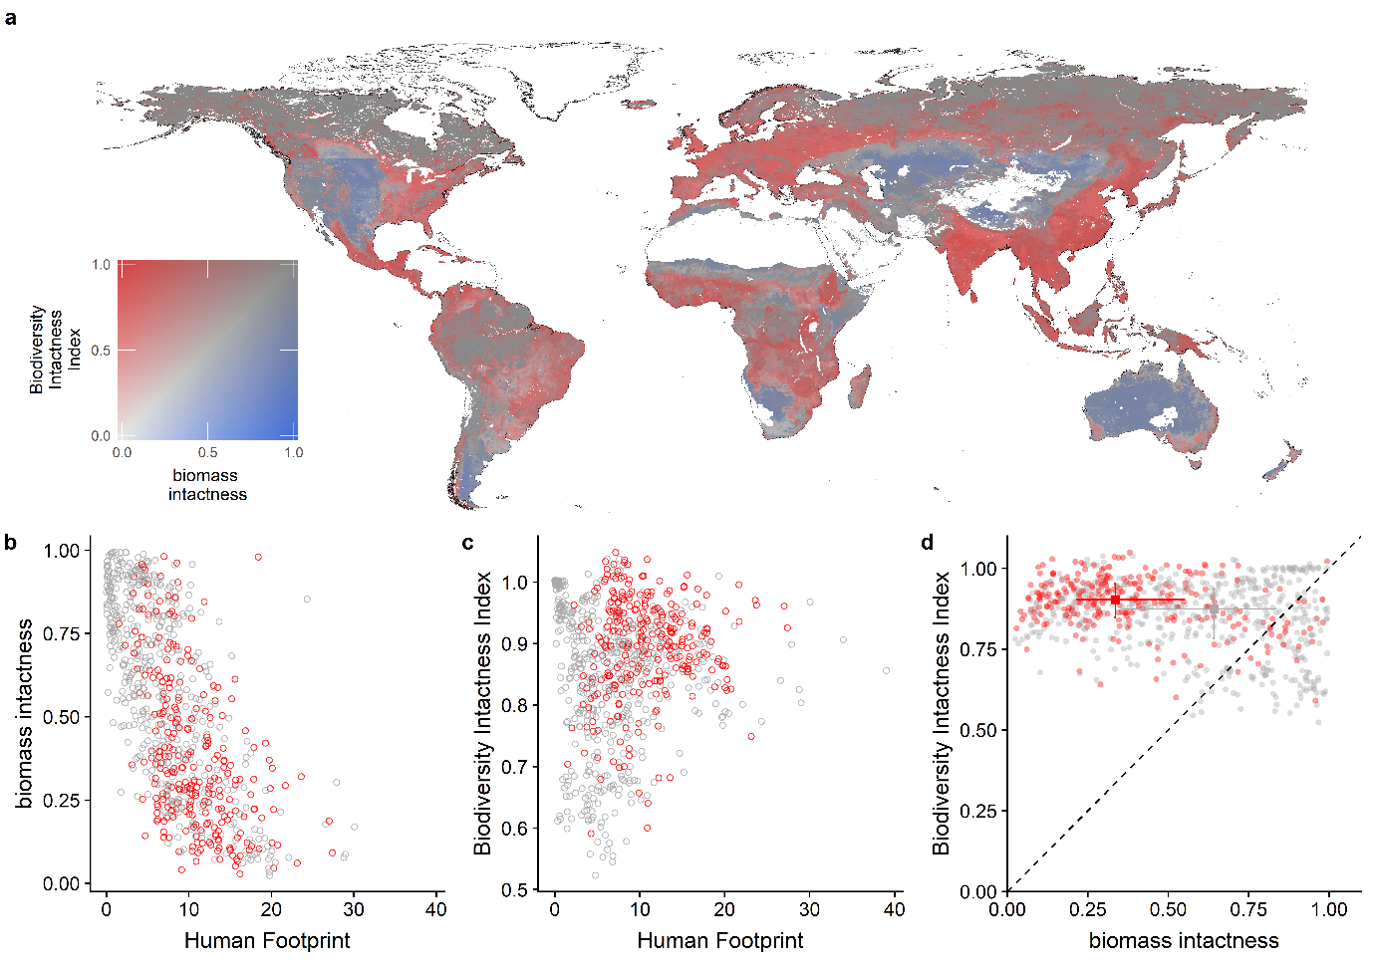

**Fig. 1 │ Global comparison of the Biodiversity Intactness Index with biomass intactness and with the Human Footprint index. a,** Bivariate map of BII and biomass intactness (BMI). Land areas in white had no data available for one or both of the indices. **b, c,** Plots of BMI and BII against Human Footprint index [5]. **d,** Plot of BII against BMI. In **b**-**d** red circles represent mean scores for ecoregions [from ref. 10] with more than half their area inside a biodiversity hotspot [6]; grey circles represent mean scores for other ecoregions. In **d** the squares and associated lines show medians and interquartile ranges and the diagonal line indicates equality of the two indices.