**Mortality and recruitment in a woodland undergoing collapse**

**Introduction**

* Mortality and recruitment are vital for understanding forest dynamics and recent studies have suggested alteration of both

An understanding of what influences tree mortality and recruitment is vital to understanding forest dynamics. As a result of changes in fire regimes, increases in water deficit and novel pests and pathogens numerous recent studies have shown increases in tree mortality and reductions in recruitment (van Mantgem *et al.* 2009; Peng *et al.* 2011; Mcintyre *et al.* 2014). In forests where individual species recruitment has not kept pace with mortality, such as in the Western USA, this can lead to alteration of forest composition (Mcintyre *et al.* 2014). Where mortality is particularly high, as seen in Eastern Amazonian forests where repeated fires have taken place, this can result in shifts to relatively treeless states (Barlow & Peres 2008; Brando *et al.* 2014). Any such transitions from forest to a non-forest ecosystem would inevitably result in large emissions of carbon as well as potentially negative impacts on other ecosystem services and conservation priorities.

* Identification of what drives tree recruitment and mortality could aid production of indicators of resilience

While numerous studies have details of increases in mortality over recent decades relatively few identify what factors determine the likelihood of tree death when a transition is occurring. Coomes *et al.* (2003) suggest that in the event of disturbance larger trees are likely to be more prone to death than small or intermediate trees and this appears to be true in many cases where transitions to non-forest states are occurring (Barlow *et al.* 2002; Mcintyre *et al.* 2014). Given that large trees produce large amounts of seeds (Greene & Johnson 1994) and play a vital role in maintaining the microclimatic conditions of forests by limiting the light reaching the forest floor their loss may have important consequences for recruitment. In addition to tree size it has been widely seen that slow growing trees tend to have increased risk of mortality. This observation may be particularly useful in the context of forests at risk of transitions to non-forest states since it may serve as an early warning indicator of low resilience (Camarero *et al.* 2015).

* In addition there is a potential in systems that positive feedbacks can drive system transitions

Positive feedbacks are important for maintaining ecosystems in their state. For example, in forests the presence of a canopy maintains relatively moist, dark conditions on the forest floor which results in relatively low ground flora biomass. However, unfavourable positive feedbacks ecosystems can cause transition from one state to another such as when forest canopies are disturbed leading to reduced seedling recruitment and invasion by grasses and shrubs in Mediterranean climates (Acácio *et al.* 2007). Positive feedback can also occur between different drivers such as when degradation and fragmentation increase fire risk in forest (Benchimol & Peres 2015). However, feedbacks such as these can occur at multiple different scales and thus can be difficult to identify (Reyer *et al.* 2015).

* Though there are numerous studies on forests in a state of transition to relatively treeless states few investigate the processes that affect individual trees to cause such changes.

**Statement of aims**

* To test the influence of tree size, growth rate, competition and proximity to dead trees on determining tree mortality.
* To test the factors that influenced seedling and sapling density to enable an understanding of recruitment
* Test the influence of tree size and competition on growth rate
* Use parameter estimates from these models along with estimates from the literature to produce an individual based model to look at the potential for regime shift in the system, in particular:
  + Hysteresis – does the system recover along the same trajectory it declined over

**Hypotheses**

* Recruitment did not keep pace with mortality for any species during any of the survey periods
* Mortality likelihood is u-shaped in relation to tree size
* Slow growing trees are more likely to die
* Proximity to trees that have died is more likely to result in tree death
* Under current conditions the woodland will show increased loss of tree cover. In situations where recruitment is maximized dramatic losses will be averted.

**Methods**

**Site history and characteristics**

The site used in this study, Denny Wood, is located in the New Forest National Park in Southern England (Lat: 50o 51.5’ N and 1o 32.5’ W). Detailed site descriptions are provided by Mountford *et al*. (1999), and are briefly summarized here. The site is situated on gentle slopes (1–3°), primarily on clay-rich brown earth soils (pH 4.5–5.0 at 10 cm depth) that are prone to winter waterlogging and summer drying, with localised areas of strongly acid (pH 3.5–4.5) podsols developed on sandier substrates. Woodland vegetation is dominated by old-growth beech (*Fagus sylvatica*)withfrequent pedunculate oak (*Quercus* robur) and birch (*Betula pendula, B. pubescens*), and an understory primarily of holly (*Ilex aquifolium*). In open areas the ground vegetation is mostly comprised of *Agrostis*-dominated grassland or stands of bracken (*Pteridium aquilinum*); *Rubus fruticosus* agg., *Juncus effusus* and *Molinia caerulea* are also locally abundant. There are large populations of deer, ponies and cattle int eh New Forest, resulting in high herbivore pressure. The portion of the site which we use for this study is likely to have experienced high browsing pressure since the 1960s (Mountford & Peterken 2003).

**Data collection**

Measurements were conducted in one 20 m-wide 1 km long transect, which was originally established in the 1950s. The transect was subdivided into contiguous 45 20 x 20 m (0.04 ha) subplot and surveyed in 1964, 1984, 1988, 1996 and 2014. Details of earlier measurements are presented by Mountford et al. (1999) and Mountford and Peterken (2003) and those for 2014 in Martin et al. (2015). In each survey, the location and species name of all woody stems >1.3 m in height were recorded, their diameter at breast height measured using diameter tapes, and their status assessed as either alive or dead. Each stem >1.3m height was given a unique ID number to allow changes in individual trees to be tracked.

In 2014 a number of variables were not recorded in previous surveys were also collected: seedling density, canopy openness, soil characteristics and, proxies of herbivore pressure. The density of tree seedlings of all species present in 10 x 10 m plots located in the centre of the 20 x 20 m plots was recorded. In addition the canopy openness of plots was assessed using a concave spherical densitometer in all four corners and the centre of 20 x 20 m plots and calculating the mean of these values. The soil types in each plot were assessed by collecting 3 soil samples from within each 20 x 20m plot using a 5 cm diameter soil corer. Only the fist 20 cm of the mineral layer was retained and subsequently soil samples were sent to the Forest Research laboratories where particle size distribution of the soil was determined by suspending 30 g of soil in water which was then passed through the flow cell of a laser diffraction particle size analyser (Beckman Coulter LS13320). To estimate the herbivore abundance a manual dung count was carried out in each sub-plot during which the amount and condition were recorded following the commonly used faecal standing crop method (Marques *et al.* 2001; Campbell, Swanson & Sales 2004). Following Jenkins & Manly (2008), the individual pellets/ bolus and their condition were recorded. The faecal matter of different animal species was recorded separately. The condition of each dung patch was classified as one of 4 groups:

1. surface smooth and shiny, interior firm;
2. dung surface pitted, interior friable (easily crumbled), < 10% of pellets/ bolus partially decomposed;
3. dung surface cracked, 10–50% of pellets/ bolus partially or completely decomposed;
4. > 50% of pellets/ bolus partially or completely decomposed.

**Statistical analysis**

**Individual tree mortality**

Statistical models of individual tree mortality were developed using logistic mixed effects models, which describe the probability that a tree dies in a given period of time. For this model we tested largely individual-level predictors of mortality. Models were developed in a four-step process similar to the workflow of Chao et al. (2008). In step 1 we prepared predictors classified into 3 groups: (i) tree size, (ii) tree growth, (iii) proximity to dead trees. Tree size represented diameter based measurements prior to death, specifically diameter at breast height, basal area and relative size. Tree growth was based on measurements of diameter at two separate time periods prior to death and represented both relative and absolute growth rates. Proximity to dead trees related to the prior to death distance of an individual tree to a dead tree or the abundance of dead trees in a 10m buffer.

In step 2 we selected we selected the best predictor for each group by choosing the univariate logistic mixed effect models which had the lowest AICc (Burnham & Anderson 2002; Chao *et al.* 2008). This step reduces intercorrelation of variables which can lead to difficulty in interpreting effects. In step 3 a full multivariate model was developed using these selected variables. In step 4 model averaging was used to produce parameter estimates using the most parsimonious models. Each of these steps is described in more detail below.

During data processing tree status (alive or dead) was coded at census time $t_{2}$. Only trees with diameter measurements at both $t_{0}$ and $t_{1}$ prior to time $t_{2}$ were included in analyses. Censuses on the transect were undertaken 5 times from 1964-2014 with a mean (± SD) census interval period of 12.5 ± 6.7 years (range 4-20 years). Since trees used in mortality models required censuses at both $t_{0}$ and $t_{1}$ prior to time $t_{2}$ we selected three non-overlapping census periods: 1984-1988, 1988-1996 and 1996-2014 (mean census period 10 ± 5.9 years). To correct for the variation in census interval we used a complementary log-log link with an offset equal to the census interval (Fortin *et al.* 2008). Plot ID was used as a random effect to account for repeated sampling of the same plots (Fortin *et al.* 2008).

Tree size metrics used were (i) DBH (cm): diameter at height of 1.3m of tree at time ; (ii) BA (m2): basal area of tree at time $t_{1}$; (iii) DBH (cm) and DBH2 (m2) – used to indicate possible u-shaped mortality curve (Holzwarth *et al.* 2013) and; (iv) The relative size of tree $i$ at time $t_{1}$ given with the equation:

$$RS=\frac{\sum{BA} of trees smaller than target tree i at time t_{1}}{\sum{BA} of all trees at time t_{1}}$$

For the biggest tree in the transect $RS$ is close to 1 for the smallest it is close to 0 (Monserud & Sterba 1999).

Tree growth rate metrics used were: (i) Annual diameter growth rate (mm year-1) calculated as:

$$GR=\frac{\left(\left({DBH}_{t1}-{DBH}_{t0}\right)×10\right)}{t1-t0}$$

where ${DBH}_{t1}$ and ${DBH}_{t0}$ are the *DBH* values for a tree at time $t1$ and $t0$ respectively; (ii) Basal area growth rate (cm2 year-1) calculated as:

$$BAGR=\frac{\left(\left({BA}_{t1}-{BA}_{t0}\right)×10 000\right)}{t1-t0}$$

where ${BA}_{t1}$ and ${BA}_{t0}$ are the *DBH* values for a tree at time $t1$ and $t0$ respectively; (iii) relative DBH growth rate (% DBH increase year-1) calculated as:

$$relGR=\frac{\left(\frac{GR}{10}\right)}{{DBH}_{t0}}$$

and; (iv) relative BA growth rate (% BA increase year-1) calculated as:

$$relBAGR=\frac{\left(\frac{BAGR}{10}\right)}{{BA}_{t0}}$$

Metrics of proximity to dead trees were: (i) *deadSD*=stem density of dead trees at time $t1$ within 10 metres of the target tree; (ii) *deadSD45*=stem density of dead trees ≥45cm DBH at time of death at time $t1$ within 10 metres of the target tree; (iii) *deadDist*=distance to nearest dead tree (m) at time $t1$; (iv) *deadDist45*=distance to nearest dead tree ≥45cm DBH at time of death (m) at time $t1$. Our rationale for focussing on dead trees ≥45cm DBH was that this represents the upper quartile of tree diameters in the woodland and we hypothesised that the death of larger trees plays a stronger role in altering local microclimate conditions.

As well as individual based variables that may affect tree mortality we assessed the importance of soil properties as well, given that finer soils may be prone to water logging in the winter, which impedes root growth and consequently reduces the ability of trees to take advantage of water deeper in the soil in dry summers.

* Poisson mixed models were used to assess how density of saplings and seedlings changed over time and with density of mature trees

**Recruitment**

To assess recruitment of trees we focussed on saplings and seedlings. To test the relationship between mature tree (>10 cm DBH) density and seedlings and saplings we produced generalised mixed models of seedling or sapling density and stem density of mature trees for the three major woody species present in Denny, beech, holly and oak. These models had poisson error structures since density data constitutes a type of count data.

In addition we tracked the fate of each sapling recorded to determine whether the widespread loss of smaller stems seen in a previous study was largely attributable to growth of individuals into other size classes or mortality. As part of this we also calculated the annual mortality rate, $m$, as defined by Sheil, Burslem & Alder (1995):

$$m=1-{\left(\frac{N_{0}}{N_{1}}\right)}^{1/t}$$

where $N_{0}$ and $N_{1}$ are the number of stems at the first and second surveys respectively and $t$ is the number of years between censuses.

**Individual based models of recruitment and mortality**

* An individual based model built in netlogo was parameterised using values from these analyses to investigate the potential changes in the woodland

**Results**

Figures

* Self-thinning relationships for all species



Figure ? – Relationship between subplot stem density and total subplot basal area. Points represent individual plots in 1964 (red circles), 1996 (green triangles) and 2014 (blue squares). The solid line represents the prediction from a mixed model of this relationship with the grey band representing the coefficient confidence intervals. Note that that both x and y axes are log transformed.

* Plots of the important variables for determining mortality of (i) beech, (ii) oak and (iii) holly

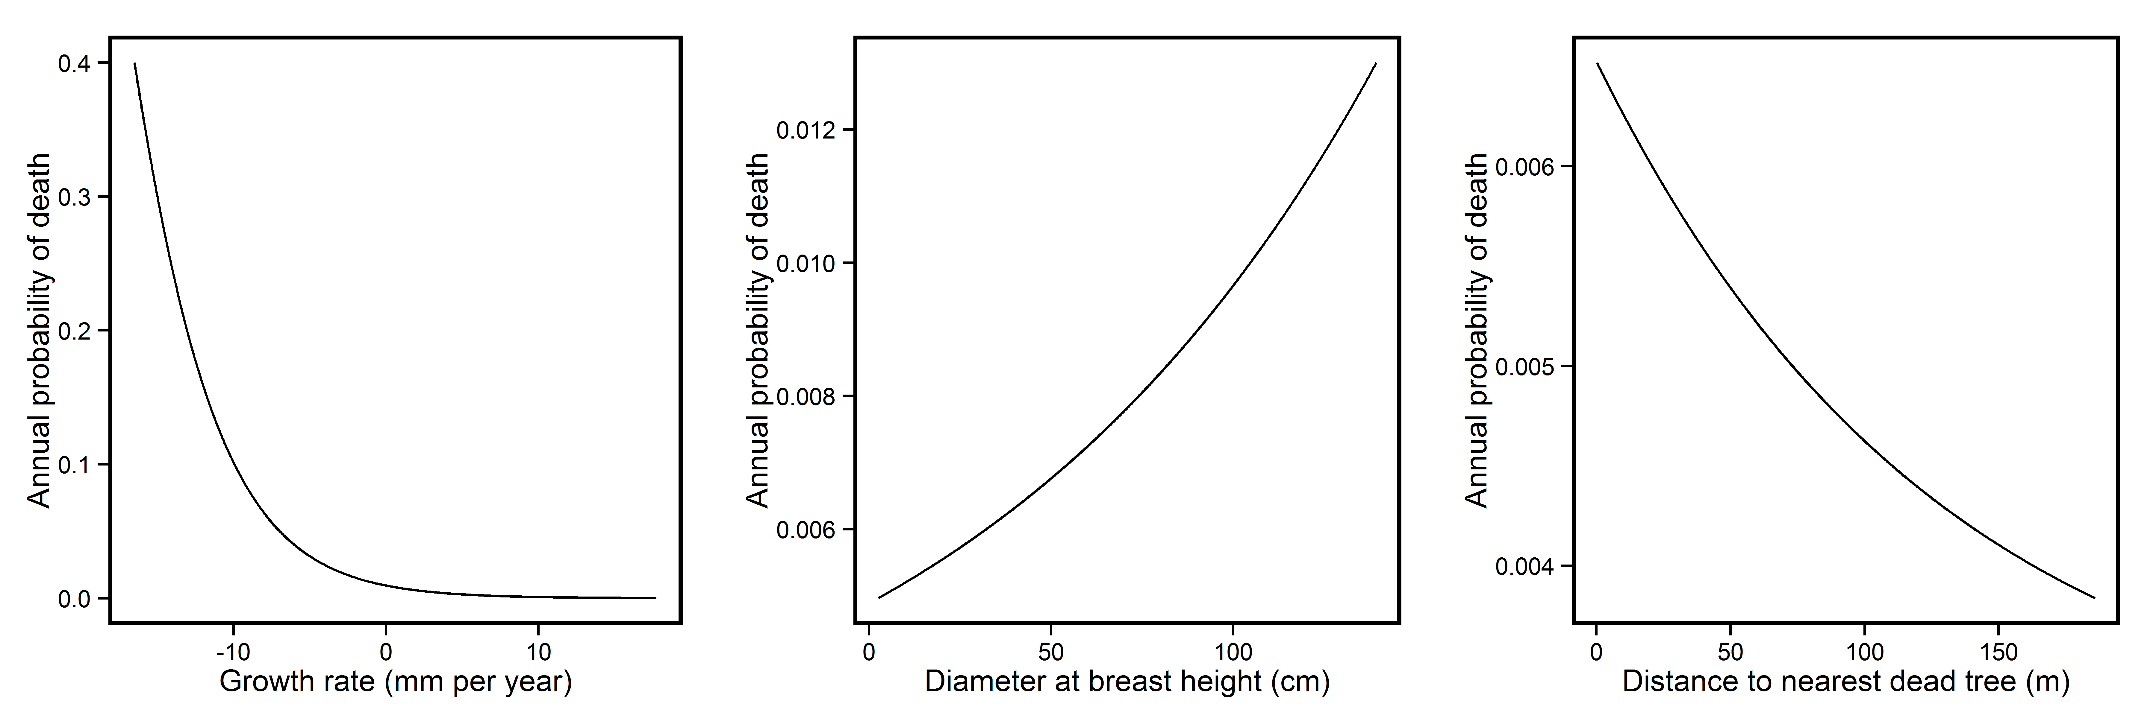

* Plots of the relationship between Beech sapling density and Beech mature tree density

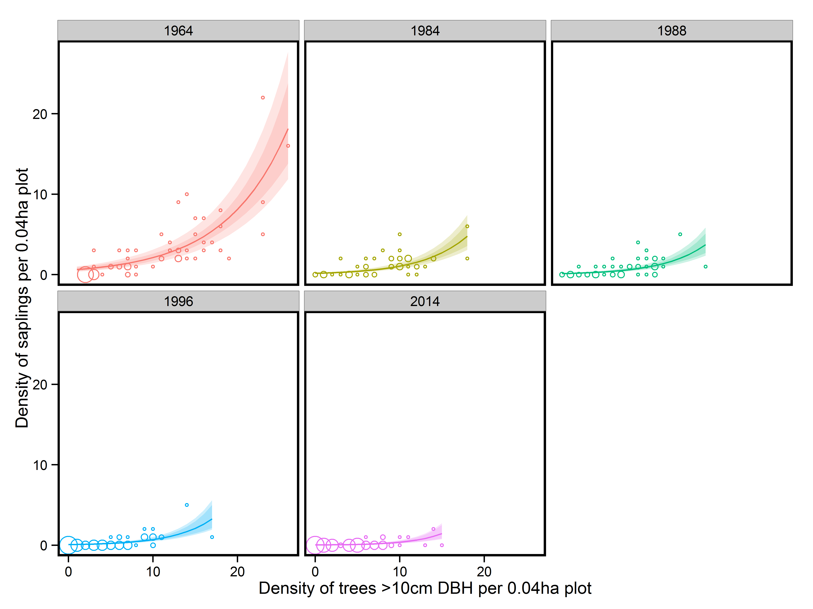

Figure ? – The change in the relationship between the density of beech trees >10 cm DBH and the density of beech saplings. While the relationship between the two is clear in 1964 by 2014 this relationship has disappeared. Solid lines represent predictions from a mixed model containing an interaction between year and density of trees >10 cm. Coloured bands represent confidence intervals of the coefficients. Points represent plots, with the size of the point indicating the number of plots with the same density values in order to ease interpretation.

* Table showing the fate of sapling for each species

|  |  |  |  |
| --- | --- | --- | --- |
| Census period | Proportion died | Proportion increased to >10 cm DBH | Annual mortality rate |
| 1964-1984 | 0.56 | 0.14 | 4.07% |
| 1984-1988 | 0.11 | 0.2 | 2.79% |
| 1988-1996 | 0.15 | 0.32 | 2.01% |
| 1996-2014 | 0.09 | 0.61 | 0.50% |

* Plots of the relationship between canopy openness and seedling density

**Discussion**

**References**

Acácio, V., Holmgren, M., Jansen, P.A. & Schrotter, O. (2007) Multiple Recruitment Limitation Causes Arrested Succession in Mediterranean Cork Oak Systems. *Ecosystems*, **10**, 1220–1230.

Barlow, J. & Peres, C. a. (2008) Fire-mediated dieback and compositional cascade in an Amazonian forest. *Philosophical transactions of the Royal Society of London. Series B, Biological sciences*, **363**, 1787–94.

Barlow, J., Peres, C., Lagan, B. & Haugaasen, T. (2002) Large tree mortality and the decline of forest biomass following Amazonian wildfires. *Ecology letters*, 6–8.

Benchimol, M. & Peres, C.A. (2015) Edge-mediated compositional and functional decay of tree assemblages in Amazonian forest islands after 26 years of isolation.

Brando, P.M., Balch, J.K., Nepstad, D.C., Morton, D.C., Putz, F.E., Coe, M.T., Silvério, D., Macedo, M.N., Davidson, E.A., Nóbrega, C.C., Alencar, A. & Soares-Filho, B.S. (2014) Abrupt increases in Amazonian tree mortality due to drought-fire interactions. *Proceedings of the National Academy of Sciences of the United States of America*, **111**, 6347–52.

Burnham, K.P. & Anderson, D.R. (2002) *Model Selection and Multimodel Inference: A Practical Information-Theoretic Approach*.

Camarero, J.J., Gazol, A., Sangüesa-Barreda, G., Oliva, J. & Vicente-Serrano, S.M. (2015) To die or not to die: early warnings of tree dieback in response to a severe drought (ed D Gibson). *Journal of Ecology*, **103**, 44–57.

Campbell, D., Swanson, G.M. & Sales, J. (2004) Methodological insights: Comparing the precision and cost-effectiveness of faecal pellet group count methods. *Journal of Applied Ecology*, **41**, 1185–1196.

Chao, K.J., Phillips, O.L., Gloor, E., Monteagudo, A., Torres-Lezama, A. & Martínez, R.V. (2008) Growth and wood density predict tree mortality in Amazon forests. *Journal of Ecology*, **96**, 281–292.

Coomes, D. a., Duncan, R.P., Allen, R.B. & Truscott, J. (2003) Disturbances prevent stem size-density distributions in natural forests from following scaling relationships. *Ecology Letters*, **6**, 980–989.

Fortin, M., Bedard, S., DeBlois, J. & Meunier, S. (2008) Predicting individual tree mortality in northern hardwood stands under uneven-aged management in southern Québec , Canada. *Annals of Forest Science*, **65**, 205.

Greene, D.F. & Johnson, E.A. (1994) Estimating the mean annual seed production of trees. *Ecology*, 642–647.

Holzwarth, F., Kahl, A., Bauhus, J. & Wirth, C. (2013) Many ways to die - partitioning tree mortality dynamics in a near-natural mixed deciduous forest (ed P Zuidema). *Journal of Ecology*, **101**, 220–230.

Jenkins, K.J. & Manly, B.F.J. (2008) A double-observer method for reducing bias in faecal pellet surveys of forest ungulates. *Journal of Applied Ecology*, **45**, 1339–1348.

Van Mantgem, P.J., Stephenson, N.L., Byrne, J.C., Daniels, L.D., Franklin, J.F., Fulé, P.Z., Harmon, M.E., Larson, A.J., Smith, J.M., Taylor, A.H. & Veblen, T.T. (2009) Widespread increase of tree mortality rates in the western United States. *Science (New York, N.Y.)*, **323**, 521–524.

Marques, F.F.C., Buckland, S.T., Goffin, D., Dixon, C.E., Borchers, D.L., Mayle, B.A. & Peace, A.J. (2001) Estimating deer abundance from line transect surveys of dung: sika deer in southern Scotland. *Journal of Applied Ecology*, **38**, 349–363.

Mcintyre, P.J., Thorne, J.H., Dolanc, C.R., Flint, A.L., Flint, L.E., Kelly, M. & Ackerly, D.D. (2014) Twentieth-century shifts in forest structure in California : Denser forests , smaller trees , and increased dominance of oaks. , 1–6.

Monserud, R. a. & Sterba, H. (1999) Modeling individual tree mortality for Austrian forest species. *Forest Ecology and Management*, **113**, 109–123.

Mountford, E.P. & Peterken, G.F. (2003) Long-term change and implications for the management of wood-pastures: experience over 40 years from Denny Wood, New Forest. *Forestry*, **76**, 19–43.

Peng, C., Ma, Z., Lei, X., Zhu, Q., Chen, H., Wang, W., Liu, S., Li, W., Fang, X. & Zhou, X. (2011) A drought-induced pervasive increase in tree mortality across Canada’s boreal forests. *Nature Climate Change*, **1**, 467–471.

Reyer, C.P.O., Brouwers, N., Rammig, A., Brook, B.W., Epila, J., Grant, R.F., Holmgren, M., Langerwisch, F., Leuzinger, S., Lucht, W., Medlyn, B., Pfeifer, M., Steinkamp, J., Vanderwel, M.C., Verbeeck, H. & Villela, D.M. (2015) Forest resilience and tipping points at different spatio-temporal scales: approaches and challenges (ed D Coomes). *Journal of Ecology*, **103**, 5–15.

Sheil, D., Burslem, D.F.R.P. & Alder, D. (1995) The Interpretation and misinterpretation of mortality rate measures. *Journal of Ecology*, **83**, 331–333.