**Mortality and recruitment in a woodland undergoing collapse**

**Introduction**

In recent decades many parts of the world have seen increases in tree mortality as a result of human-induced deforestation and degradation. For example, mortality rates in forests in the western USA have more than doubled over the past 30 years (van Mantgem *et al.* 2009) and have approximately tripled in boreal Canada since the 1960’s (Peng *et al.* 2011), probably as a result of contemporary climate change. Indeed increased tree mortality as a result of recent climate change has now been noted on all wooded continents (Allen *et al.* 2010; Steinkamp & Hickler 2015). At the same time as threats to forests from climate change have been increasing, so have the intensity and regularity of other disturbances. Large wildfires have quadrupled in frequency in the Western USA in the past 30 years and bark beetle damage in the same region has reached unprecedented levels. Similarly in Europe the negative effects of wildfire, windthrow and pathogen and pest species have all increased over the last two decades and are forecast to increase over the coming decade (Seidl *et al.* 2014).

In forests where recruitment has not kept pace with this increased mortality, such as in the Western USA, this has led to changes in dominant species from pine to oak (Mcintyre *et al.* 2014). In cases where tree mortality is particularly high this can result in shifts to relatively treeless savannah-like states (Barlow & Peres 2008; Brando *et al.* 2014). Indeed there are concerns that feedbacks between the land-cover changes and climate may result in transition of large areas of forest to shrub or grasslands (Staver, Archibald & Levin 2011; Scheffer *et al.* 2012). Any such transition would inevitably cause large losses of terrestrial carbon as well as potentially negative impacts on other ecosystem services and conservation priorities. However, though the consequences of transitions to non-forest states are potentially severe, relatively little is known about the mechanisms underlying such shifts. Improving this understanding would aid our ability to predict when transitions may occur and how to stop such transitions before they occur.

In order to understand forest dynamics it is vital to understand the basic processes of mortality and recruitment. Tree size is perhaps one of the variables most regularly used in models of tree mortality since it is thought to provide a proxy measure of the metabolic rate of an organism. Thus, given that trees differ in how they take up, assimilate and expend energy throughout their lifetime, disturbances are likely to increase the probability of mortality for particular sizes more than others. Coomes *et al.* (2003) suggest that where competition is the dominant driver of mortality smaller stems are most likely to die, whereas when there is evidence of exogenous disturbance larger trees are likely to be prone to death. Indeed in forests where there is dramatic change in structure as a result of human-induced disturbance it appears that larger trees tend to be at increased risk of death (Barlow *et al.* 2002; Mcintyre *et al.* 2014). Given that large trees produce large amounts of seeds (Greene & Johnson 1994) and play a vital role in maintaining the microclimatic conditions of forests by limiting light reaching the forest floor their loss may have important consequences for recruitment. In addition to tree size it has been widely seen that slow growing trees tend to have increased risk of mortality, since this measure provides a proxy of tree vigour. This observation may prove particularly useful in the context of forests at risk of transitions to non-forest states since it may serve as an early warning indicator of low resilience (Camarero *et al.* 2015).

The stability and resilience of ecosystems is thought to be governed in part by positive feedbacks. For example, in forests the presence of a canopy maintains relatively moist, dark conditions on the forest floor which results in relatively low ground flora biomass. However, unfavourable positive feedbacks ecosystems can cause transition from one state to another such as when forest canopies are disturbed leading to reduced seedling recruitment and invasion by grasses and shrubs in Mediterranean climates (Acácio *et al.* 2007). Positive feedbacks can also occur between different drivers such as when degradation and fragmentation increase fire risk in forests (Benchimol & Peres 2015). However, feedbacks such as these can occur at multiple different scales and thus can be difficult to identify (Reyer *et al.* 2015).

**Statement of aims**

* To test the influence of tree size, growth rate, competition and proximity to dead trees on determining tree mortality.
* To test the factors that influenced seedling and sapling density to enable an understanding of recruitment
* Test the influence of tree size and competition on growth rate
* Use parameter estimates from these models along with estimates from the literature to produce an individual based model to look at the potential for regime shift in the system, in particular:
  + Hysteresis – does the system recover along the same trajectory it declined over

**Hypotheses**

* Recruitment did not keep pace with mortality for any species during any of the survey periods
* Mortality likelihood is u-shaped in relation to tree size
* Slow growing trees are more likely to die
* Proximity to trees that have died is more likely to result in tree death
* Under current conditions the woodland will show increased loss of tree cover. In situations where recruitment is maximized dramatic losses will be averted.

**Methods**

**Site history and characteristics**

The site used in this study, Denny Wood, is located in the New Forest National Park in Southern England (Lat: 50o 51.5’ N and 1o 32.5’ W). Detailed site descriptions are provided by Mountford *et al*. (1999), and are briefly summarized here. The site is situated on gentle slopes (1–3°), primarily on clay-rich brown earth soils (pH 4.5–5.0 at 10 cm depth) that are prone to winter waterlogging and summer drying, with localised areas of strongly acid (pH 3.5–4.5) podsols developed on sandier substrates. Woodland vegetation is dominated by old-growth beech (*Fagus sylvatica*)withfrequent pedunculate oak (*Quercus* robur) and birch (*Betula pendula, B. pubescens*), and an understory primarily of holly (*Ilex aquifolium*). In open areas the ground vegetation is mostly comprised of *Agrostis*-dominated grassland or stands of bracken (*Pteridium aquilinum*); *Rubus fruticosus* agg., *Juncus effusus* and *Molinia caerulea* are also locally abundant. There are large populations of deer, ponies and cattle in the New Forest, resulting in high herbivore pressure. The portion of the site which we use for this study is likely to have experienced high browsing pressure since the 1960s (Mountford & Peterken 2003).

**Data collection**

Measurements were conducted in one 20 m-wide 1 km long transect, which was originally established in the 1950s. The transect was subdivided into contiguous 45 20 x 20 m (0.04 ha) subplot and surveyed in 1964, 1984, 1988, 1996 and 2014. Details of earlier measurements are presented by Mountford *et al.* (1999) and Mountford and Peterken (2003) and those for 2014 in Martin *et al.* (2015). In each survey, the location and species name of all woody stems >1.3 m in height were recorded, their diameter at breast height measured using diameter tapes, and their status assessed as either alive or dead. Each stem >1.3m height was given a unique ID number to allow changes in individual trees to be tracked. Stems <10 cm DBH were classified as saplings and those >10 cm DBH as mature.

In 2014 a number of variables were not recorded in previous surveys were also collected: seedling density, canopy openness, soil characteristics and, proxies of herbivore pressure. The density of tree seedlings of all species present in 10 x 10 m plots located in the centre of the 20 x 20 m plots was recorded. In addition the canopy openness of plots was assessed using a concave spherical densitometer in all four corners and the centre of 20 x 20 m plots and calculating the mean of these values. The soil types in each plot were assessed by collecting 3 soil samples from within each 20 x 20m plot using a 5 cm diameter soil corer. Only the first 20 cm of the mineral layer was retained and subsequently soil samples were sent to the Forest Research laboratories in Surrey where particle size distribution of the soil was determined by suspending 30 g of soil in water which was then passed through the flow cell of a laser diffraction particle size analyser (Beckman Coulter LS13320). To estimate the herbivore abundance a manual dung count was carried out in each sub-plot during which the amount and condition were recorded following the commonly used faecal standing crop method (Marques *et al.* 2001; Campbell, Swanson & Sales 2004). Following Jenkins & Manly (2008), the individual pellets/ bolus and their condition were recorded. The faecal matter of different animal species was recorded separately. The condition of each dung patch was classified as one of 4 groups:

1. surface smooth and shiny, interior firm;
2. dung surface pitted, interior friable (easily crumbled), < 10% of pellets/ bolus partially decomposed;
3. dung surface cracked, 10–50% of pellets/ bolus partially or completely decomposed;
4. > 50% of pellets/ bolus partially or completely decomposed.

**Statistical analysis**

**Individual tree mortality**

To determine whether some of the mortality observed in Denny wood could be explained by the self-thinning process we produced a statistical model of the relationship between log subplot stem density and log subplot basal area. To do this we used a linear mixed model with subplot number as a random effect to relate stem density to basal area. A negative slope suggests a gain in BA with a loss of stem density while a positive slope suggests a gain in BA with a gain in stem density.

Statistical models of individual tree mortality were developed using logistic mixed effects models, which describe the probability that a tree dies in a given period of time. For this model we tested largely individual-level predictors of mortality. Models were developed in a four-step process similar to the workflow of Chao et al. (2008). In step 1 we prepared predictors classified into 3 groups: (i) tree size, (ii) tree growth, (iii) proximity to dead trees and (iv) soil type. Tree size represented diameter based measurements prior to death, specifically diameter at breast height, basal area and relative size. Tree growth was based on measurements of diameter at two separate time periods prior to death and represented both relative and absolute growth rates. Proximity to dead trees related to the prior to death distance of an individual tree to a dead tree or the abundance of dead trees in a 10m buffer. Soil type was the percentage of each soil sample classified as sand during laboratory analyses. All model variables were standardised using the methods of Schielzeth (2010) by subtracting the mean of the variable and dividing by its standard deviation. This allows for more direct comparison between variables, reduces intercorrelation and improves model convergence (Schielzeth 2010).

In step 2 we selected we selected the best predictor for each group by choosing the univariate logistic mixed effect models which had the lowest AICc (Burnham & Anderson 2002; Chao *et al.* 2008). This step reduces intercorrelation of variables which can lead to difficulty in interpreting effects. In step 3 a full multivariate model was developed using these selected variables. In step 4 model averaging was used to produce parameter estimates using the most parsimonious models. Each of these steps is described in more detail below.

During data processing tree status (alive or dead) was coded at census time $t_{2}$. Only trees with diameter measurements at both $t_{0}$ and $t_{1}$ prior to time $t_{2}$ were included in analyses. Censuses on the transect were undertaken 5 times from 1964-2014 with a mean (± SD) census interval period of 12.5 ± 6.7 years (range 4-20 years). Since trees used in mortality models required censuses at both $t_{0}$ and $t_{1}$ prior to time $t_{2}$ we selected three non-overlapping census periods: 1984-1988, 1988-1996 and 1996-2014 (mean census period 10 ± 5.9 years). To correct for the variation in census interval we used a complementary log-log link with an offset equal to the census interval and plot ID was used as a random effect to account for repeated sampling of the same plots (Fortin *et al.* 2008).

Tree size metrics used were (i) DBH (cm): diameter at height of 1.3m of tree at time ; (ii) BA (m2): basal area of tree at time $t_{1}$; (iii) DBH (cm) and DBH2 (m2) – used to indicate possible u-shaped mortality curve (Holzwarth *et al.* 2013) and; (iv) The relative size of tree $i$ at time $t_{1}$ given with the equation:

$$RS=\frac{\sum{BA} of trees smaller than target tree i at time t_{1}}{\sum{BA} of all trees at time t_{1}}$$

For the biggest tree in the transect $RS$ is close to 1 for the smallest it is close to 0 (Monserud & Sterba 1999).

Tree growth rate metrics used were: (i) Annual diameter growth rate (mm year-1) calculated as:

$$GR=\frac{\left(\left({DBH}_{t1}-{DBH}_{t0}\right)×10\right)}{t1-t0}$$

where ${DBH}_{t1}$ and ${DBH}_{t0}$ are the *DBH* values for a tree at time $t1$ and $t0$ respectively; (ii) Basal area growth rate (cm2 year-1) calculated as:

$$BAGR=\frac{\left(\left({BA}_{t1}-{BA}_{t0}\right)×10 000\right)}{t1-t0}$$

where ${BA}_{t1}$ and ${BA}_{t0}$ are the *DBH* values for a tree at time $t1$ and $t0$ respectively; (iii) relative DBH growth rate (% DBH increase year-1) calculated as:

$$relGR=\frac{\left(\frac{GR}{10}\right)}{{DBH}_{t0}}$$

and; (iv) relative BA growth rate (% BA increase year-1) calculated as:

$$relBAGR=\frac{\left(\frac{BAGR}{10}\right)}{{BA}_{t0}}$$

Metrics of proximity to dead trees were: (i) *deadSD*=stem density of dead trees at time $t1$ within 10 metres of the target tree; (ii) *deadSD45*=stem density of dead trees ≥45cm DBH at time of death at time $t1$ within 10 metres of the target tree; (iii) *deadDist*=distance to nearest dead tree (m) at time $t1$; (iv) *deadDist45*=distance to nearest dead tree ≥45cm DBH at time of death (m) at time $t1$. Our rationale for focussing on dead trees ≥45cm DBH was that this represents the upper quartile of tree diameters in the woodland and we hypothesised that the death of larger trees plays a stronger role in altering local microclimate conditions.

As well as individual based variables that may affect tree mortality we assessed the importance of soil properties as well, given that finer soils may be prone to water logging in the winter, which impedes root growth and consequently reduces the ability of trees to take advantage of water deeper in the soil in dry summers. To do this we used data on the proportion of each soil sample that was classified as sand during laboratory analyses.

* Poisson mixed models were used to assess how density of saplings and seedlings changed over time and with density of mature trees

**Recruitment**

To assess recruitment of trees we focussed on saplings and seedlings. To test the relationship between mature tree (>10 cm DBH) density and seedlings and saplings we produced generalised mixed models of seedling or sapling density and stem density of mature trees for the three major woody species present in Denny, beech, holly and oak. These models had poisson error structures since density data constitutes a type of count data.

In addition we tracked the fate of each sapling recorded to determine whether the widespread loss of smaller stems seen in a previous study was largely attributable to growth of individuals into other size classes or mortality. As part of this we also calculated the annual mortality rate, $m$, as defined by Sheil, Burslem & Alder (1995):

$$m=1-{\left(\frac{N_{0}}{N_{1}}\right)}^{1/t}$$

where $N_{0}$ and $N_{1}$ are the number of stems at the first and second surveys respectively and $t$ is the number of years between censuses.

**Individual based models of recruitment and mortality**

* An individual based model built in netlogo was parameterised using values from these analyses to investigate the potential changes in the woodland

**Results**

**Tree mortality**

The slope of the relationship between log subplot stem density and log subplot basal area was positive (slope=0.41 ± 0.05, marginal R2=0.24 Figure ?). However, in general subplots lost both stem density and basal area between 1964 and 2014 (Figure ?). Given that self-thinning processes tend to be strongest when plots are increasing in biomass and losing stem density at the same time (Coomes & Allen 2007) such processes are unlikely to be responsible for the majority of tree death seen in Denny wood from 1964-2014.

When predicting the mortality of individual beech trees growth rate was considered the most important predictor, as it was included in all models with a ΔAICc≤7. Trees that grew slowly or shrunk were more likely to die than those that grew relatively quickly (slope=-0.59 ± 0.06, P value <0.001, Figure ?a). Next most important was tree DBH with an importance value of 0.8, and models suggested that tree size was positively correlated with probability of mortality (slope=0.21 ± 0.05m, P value<0.001, Figure ?b). Distance to nearest dead tree and soil type were of similar importance with importance values of 0.52 and 0.45 respectively, with models indicating that trees closer to dead trees were more likely to subsequently die (slope=-0.24 ± 0.06, P value<0.001, Figure ?c) and trees located in areas of the forest where soils had higher sand content were less likely to die (slope=-0.27 ± 0.01, P value<0.001, Figure ?d).

**Tree recruitment**

There was a positive relationship between mature beech density and sapling density (slope= 1.27 ± 0.14, P value<0.0001), and sapling density tended to be reduced over time (slope= -0.69 ± 0.10, P value<0.0001). The relationship between mature beech density and sapling density grew more positive over time (interaction term=0.38 ± 0.09, P value<0.001), though since the density of mature trees was also reduced over this time period this effect was relatively unimportant in determining sapling densities. As the number of beech saplings declined during the years 1964-2014, so did the mortality rates of these saplings (Table 2). Conversely the proportion of saplings that became mature trees (>10 cm DBH) showed an increase over this time period.

Mean beech seedling density (± SE) in 2014 was 115.22 ± 32.14 seedlings ha-1. Canopy openness was positively related to beech seedling density (slope=0.56 ± 0.09, P value <0.001), but no other variables were included in models which had ΔAICc≤7 and thus were considered to have poor support. No metrics of deer or pony density were related to seedling density in any way.

* Plots of the relationship between Beech sapling density and Beech mature tree density
* Table showing the fate of sapling for each species
* Plots of the relationship between canopy openness and seedling density

**Discussion**

**References**

Acácio, V., Holmgren, M., Jansen, P.A. & Schrotter, O. (2007) Multiple Recruitment Limitation Causes Arrested Succession in Mediterranean Cork Oak Systems. *Ecosystems*, **10**, 1220–1230.

Allen, C.D., Macalady, A.K., Chenchouni, H., Bachelet, D., McDowell, N., Vennetier, M., Kitzberger, T., Rigling, A., Breshears, D.D., Hogg, E.H. (Ted), Gonzalez, P., Fensham, R., Zhang, Z., Castro, J., Demidova, N., Lim, J.H., Allard, G., Running, S.W., Semerci, A. & Cobb, N. (2010) A global overview of drought and heat-induced tree mortality reveals emerging climate change risks for forests. *Forest Ecology and Management*, **259**, 660–684.

Barlow, J. & Peres, C. a. (2008) Fire-mediated dieback and compositional cascade in an Amazonian forest. *Philosophical transactions of the Royal Society of London. Series B, Biological sciences*, **363**, 1787–94.

Barlow, J., Peres, C., Lagan, B. & Haugaasen, T. (2002) Large tree mortality and the decline of forest biomass following Amazonian wildfires. *Ecology letters*, 6–8.

Benchimol, M. & Peres, C.A. (2015) Edge-mediated compositional and functional decay of tree assemblages in Amazonian forest islands after 26 years of isolation.

Brando, P.M., Balch, J.K., Nepstad, D.C., Morton, D.C., Putz, F.E., Coe, M.T., Silvério, D., Macedo, M.N., Davidson, E.A., Nóbrega, C.C., Alencar, A. & Soares-Filho, B.S. (2014) Abrupt increases in Amazonian tree mortality due to drought-fire interactions. *Proceedings of the National Academy of Sciences of the United States of America*, **111**, 6347–52.

Burnham, K.P. & Anderson, D.R. (2002) *Model Selection and Multimodel Inference: A Practical Information-Theoretic Approach*.

Camarero, J.J., Gazol, A., Sangüesa-Barreda, G., Oliva, J. & Vicente-Serrano, S.M. (2015) To die or not to die: early warnings of tree dieback in response to a severe drought (ed D Gibson). *Journal of Ecology*, **103**, 44–57.

Campbell, D., Swanson, G.M. & Sales, J. (2004) Methodological insights: Comparing the precision and cost-effectiveness of faecal pellet group count methods. *Journal of Applied Ecology*, **41**, 1185–1196.

Chao, K.J., Phillips, O.L., Gloor, E., Monteagudo, A., Torres-Lezama, A. & Martínez, R.V. (2008) Growth and wood density predict tree mortality in Amazon forests. *Journal of Ecology*, **96**, 281–292.

Coomes, D. a. & Allen, R.B. (2007) Mortality and tree-size distributions in natural mixed-age forests. *Journal of Ecology*, **95**, 27–40.

Coomes, D. a., Duncan, R.P., Allen, R.B. & Truscott, J. (2003) Disturbances prevent stem size-density distributions in natural forests from following scaling relationships. *Ecology Letters*, **6**, 980–989.

Fortin, M., Bedard, S., DeBlois, J. & Meunier, S. (2008) Predicting individual tree mortality in northern hardwood stands under uneven-aged management in southern Québec , Canada. *Annals of Forest Science*, **65**, 205.

Greene, D.F. & Johnson, E.A. (1994) Estimating the mean annual seed production of trees. *Ecology*, 642–647.

Holzwarth, F., Kahl, A., Bauhus, J. & Wirth, C. (2013) Many ways to die - partitioning tree mortality dynamics in a near-natural mixed deciduous forest (ed P Zuidema). *Journal of Ecology*, **101**, 220–230.

Jenkins, K.J. & Manly, B.F.J. (2008) A double-observer method for reducing bias in faecal pellet surveys of forest ungulates. *Journal of Applied Ecology*, **45**, 1339–1348.

Van Mantgem, P.J., Stephenson, N.L., Byrne, J.C., Daniels, L.D., Franklin, J.F., Fulé, P.Z., Harmon, M.E., Larson, A.J., Smith, J.M., Taylor, A.H. & Veblen, T.T. (2009) Widespread increase of tree mortality rates in the western United States. *Science (New York, N.Y.)*, **323**, 521–524.

Marques, F.F.C., Buckland, S.T., Goffin, D., Dixon, C.E., Borchers, D.L., Mayle, B.A. & Peace, A.J. (2001) Estimating deer abundance from line transect surveys of dung: sika deer in southern Scotland. *Journal of Applied Ecology*, **38**, 349–363.

Martin, P.A., Newton, A.C., Cantarello, E. & Evans, P. (2015) Stand dieback and collapse in a temperate forest and its impact on forest structure and biodiversity. *Forest Ecology and Management*.

Mcintyre, P.J., Thorne, J.H., Dolanc, C.R., Flint, A.L., Flint, L.E., Kelly, M. & Ackerly, D.D. (2014) Twentieth-century shifts in forest structure in California : Denser forests , smaller trees , and increased dominance of oaks. , 1–6.

Monserud, R. a. & Sterba, H. (1999) Modeling individual tree mortality for Austrian forest species. *Forest Ecology and Management*, **113**, 109–123.

Mountford, E.P. & Peterken, G.F. (2003) Long-term change and implications for the management of wood-pastures: experience over 40 years from Denny Wood, New Forest. *Forestry*, **76**, 19–43.

Mountford, E.P., Peterken, G.F., Edwards, P.J. & Manners, J.G. (1999) Long-term change in growth, mortality and regeneration of trees in Denny Wood, an old-growth wood-pasture in the New Forest (UK). *Perspectives in Plant Ecology, Evolution and Systematics*, **2**, 223–272.

Peng, C., Ma, Z., Lei, X., Zhu, Q., Chen, H., Wang, W., Liu, S., Li, W., Fang, X. & Zhou, X. (2011) A drought-induced pervasive increase in tree mortality across Canada’s boreal forests. *Nature Climate Change*, **1**, 467–471.

Reyer, C.P.O., Brouwers, N., Rammig, A., Brook, B.W., Epila, J., Grant, R.F., Holmgren, M., Langerwisch, F., Leuzinger, S., Lucht, W., Medlyn, B., Pfeifer, M., Steinkamp, J., Vanderwel, M.C., Verbeeck, H. & Villela, D.M. (2015) Forest resilience and tipping points at different spatio-temporal scales: approaches and challenges (ed D Coomes). *Journal of Ecology*, **103**, 5–15.

Scheffer, M., Hirota, M., Holmgren, M., Van Nes, E.H. & Chapin, F.S. (2012) Thresholds for boreal biome transitions. *Proceedings of the National Academy of Sciences of the United States of America*, **109**, 21384–9.

Schielzeth, H. (2010) Simple means to improve the interpretability of regression coefficients. *Methods in Ecology and Evolution*, **1**, 103–113.

Seidl, R., Schelhaas, M., Rammer, W. & Verkerk, P.J. (2014) Increasing forest disturbances in Europe and their impact on carbon storage. *Nature Climate Change*, 1–6.

Sheil, D., Burslem, D.F.R.P. & Alder, D. (1995) The Interpretation and misinterpretation of mortality rate measures. *Journal of Ecology*, **83**, 331–333.

Staver, a C., Archibald, S. & Levin, S. a. (2011) The global extent and determinants of savanna and forest as alternative biome states. *Science (New York, N.Y.)*, **334**, 230–2.

Steinkamp, J. & Hickler, T. (2015) Is drought-induced forest dieback globally increasing? (ed D Gibson). *Journal of Ecology*, **103**, 31–43.

Figures



Figure ? – Relationship between subplot stem density and total subplot basal area. Points represent individual plots in 1964 (red circles), 1996 (green triangles) and 2014 (blue squares). The solid line represents the prediction from a mixed model of this relationship with the grey band representing the coefficient confidence intervals. Note that that both x and y axes are log transformed.

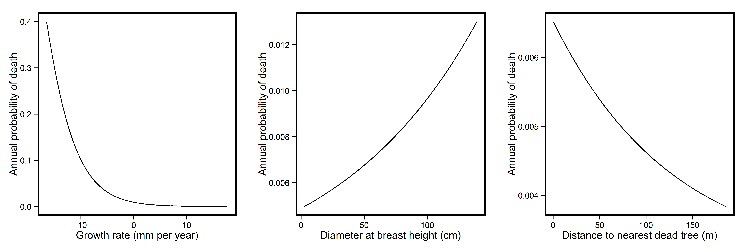

Figure ? – Relationship between annual probability of beech tree death (a) growth rate per year, (b) diameter at breast height, (c) distance to nearest dead tree and (d) sand content of soil. Lines represent predictions generated from model-averaged parameter estimates.

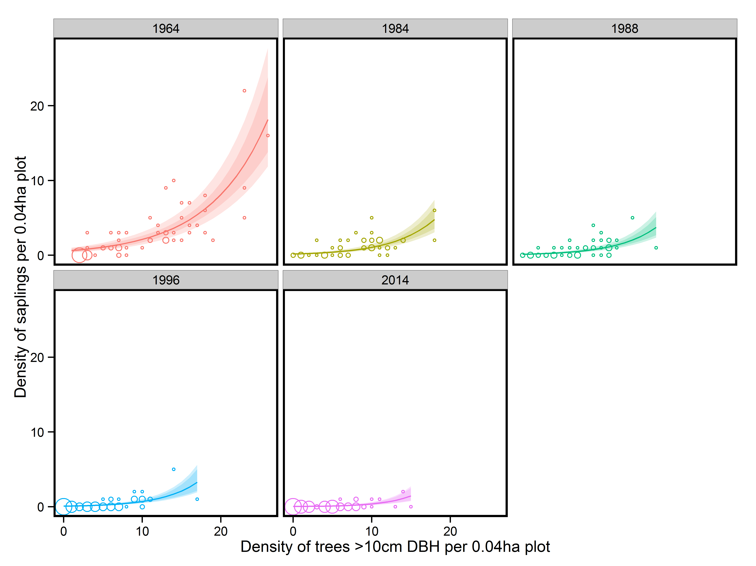

Figure ? – The change in the relationship between the density of beech trees >10 cm DBH and the density of beech saplings. While the relationship between the two is clear in 1964 by 2014 this relationship has disappeared. Solid lines represent predictions from a mixed model containing an interaction between year and density of trees >10 cm. Coloured bands represent confidence intervals of the coefficients. Points represent plots, with the size of the point indicating the number of plots with the same density values in order to ease interpretation.

Tables

Table 1

|  |  |  |  |  |  |  |  |  |
| --- | --- | --- | --- | --- | --- | --- | --- | --- |
| **Variable** | **Estimate** | **Std. Error** | **Adjusted SE** | **Lower CI** | **Upper CI** | **z value** | **p value** | **Importance value** |
| Intercept | -5.12 | 0.16 | 0.16 | -5.43 | -4.82 | 32.92 | <0.0001 | 1 |
| DBH | 0.21 | 0.05 | 0.05 | 0.11 | 0.31 | 4.11 | <0.0001 | 0.8 |
| Distance to dead tree | -0.24 | 0.06 | 0.06 | -0.36 | -0.12 | 3.79 | <0.0001 | 0.53 |
| Growth rate | -0.59 | 0.06 | 0.06 | -0.70 | -0.47 | 9.84 | <0.0001 | 1 |
| Sand content | -0.27 | 0.01 | 0.01 | -0.29 | -0.26 | 35.98 | <0.0001 | 0.45 |

Table 2

|  |  |  |  |
| --- | --- | --- | --- |
| Census period | Proportion died | Proportion increased to >10 cm DBH | Annual mortality rate |
| 1964-1984 | 0.56 | 0.14 | 4.07% |
| 1984-1988 | 0.11 | 0.2 | 2.79% |
| 1988-1996 | 0.15 | 0.32 | 2.01% |
| 1996-2014 | 0.09 | 0.61 | 0.50% |