**Secondary tropical forests retain avian functional diversity but not species richness: a meta-analysis**

C.A. Sayer1,2, J.M. Bullock2 and P.A. Martin2,3

1Imperial College London, Silwood Park, Buckhurst Road, Ascot, Berkshire, SL5 7QN, UK.

2NERC Centre for Ecology and Hydrology, Benson Lane, Wallingford, Oxfordshire, OX10 8BB, UK.

3Centre for Conservation Ecology and Environmental Science, School of Applied Sciences, Bournemouth University, Poole, BH12 5BB, UK.

Corresponding author email address: [catherinesayer28@gmail.com](mailto:catherinesayer28@gmail.com)

Corresponding author telephone number: +44(0)7963 417046

**Abstract**

Deforestation for agriculture in the tropics, followed by abandonment and subsequent regeneration, has resulted in large areas of secondary forest. Some authors have suggested that this secondary regrowth could help prevent mass extinction in the tropics by providing alternative habitat for forest species. However, current understanding of the biodiversity value of secondary forest is poor. To address this knowledge gap, we conducted a meta-analysis of avian responses to secondary forest succession, comparing data from 45 tropical secondary forest sites with nearby primary forest sites and investigating both species and functional diversity (dietary preference) based metrics. Species richness relative to primary forest increased with secondary forest age and reached primary forest values after approximately 50 years. The proportion of forest specialists relative to primary forest also increased with time since disturbance but did not reach equivalence with primary forest. Functional evenness was highest in young secondary forest and reached primary forest values after approximately 30 years. However, we found no difference between primary and secondary forest in terms of functional richness or functional divergence. Our results suggest that secondary tropical forests retain similar levels of avian dietary functional diversity to primary tropical forests and therefore, that levels of ecosystem functioning may be comparable in both forest types. Therefore, secondary tropical forest, particularly older regrowth, has high biodiversity value and can support important ecosystem functions. Secondary forest should be protected from further disturbance. However, preserving primary forest is vital to conserve forest specialists, which recover poorly in secondary forests.

**Key words:** forest recovery; birds; functional diversity; ecosystem functioning; avian biodiversity

**Acknowledgements**

Thank you to the authors of all of the studies used, in particular S.H. Borges, C. Banks-Leite, R.F. de Lima, D. Becker, R.K. Mulwa, E.L. Neuschulz, B. Maas and G. Ferraz, and to BirdLife International for providing data. P.A. Martin was funded by a NERC PhD studentship and by NERC via the Biodiversity & Ecosystem Service Sustainability (BESS) programme (Project ref. NE/K01322X/1).

**Introduction**

Agricultural expansion in the tropics has led to large-scale deforestation (Gibbs *et al.* 2010), causing loss of unique forest species. Traditionally, protected areas have been seen as the best way to protect ecosystems from conversion to human land use and limit the resulting loss of biodiversity. These protected areas generally consist of natural or near-natural ecosystems, such as primary forest (Dudley 2008). In the tropics such primary forests are generally considered to be irreplaceable for tropical biodiversity (Gibson *et al.* 2011), as well as providing numerous ecosystem services such as carbon storage and non-timber forest products to local communities. However, we cannot rely solely on protected areas to conserve tropical forest biodiversity. Biodiversity declines continue in many protected areas established in tropical forests (Curran *et al.* 2004; Laurance *et al.* 2012). In addition, it is not always feasible to designate sufficient land to represent adequately the range of communities found in specific biomes (Cox & Underwood 2011) or support viable populations of all species (Struhsaker, Struhsaker & Siex 2005). Possingham et al. (2015) showed through modelling that conservation actions should combine both protection and restoration to optimize benefits for biodiversity and ecosystem services

While degraded tropical forests may be of lower biodiversity value than primary forests, given that over half of all tropical forests are now considered to be degraded (ITTO 2002), they may provide a valuable opportunity for conservation. Forests that have been altered beyond the normal effects of natural processes, as a result of unsustainable use or natural disasters, are considered degraded; this includes secondary forests, which have undergone forest clearance (ITTO 2002). Wright and Muller-Landau (2006) suggest that expansion of secondary forests could play an important role in preventing extinctions by providing alternative habitat for forest species. Previous reviews suggest that secondary forests can be host to forest species, but also that these forests differ in their conservation value depending on connectivity, disturbance history and, in particular, site age (Gardner *et al.* 2007; Bowen *et al.* 2007; Chazdon *et al.* 2009). Despite these suggestions, the potential role of secondary forest in conserving tropical forest species is poorly understood. Past quantitative syntheses have investigated only a limited number of biodiversity metrics, have not considered heterogeneity amongst sites or have failed to account for non-independence in data (Dunn 2004a; Dent & Wright 2009). Thus, there is a need for quantitative, global syntheses of the biodiversity value of secondary tropical forest.

Measures of conservation value commonly use species-based metrics (Myers *et al.* 2000), with the value of an area measured by the community species richness or the presence of particular species of interest. A complementary approach to species-based metrics is to assess changes to ecosystems based on their functioning. Ecosystem functions are important in determining the persistence of interacting communities, and may also ultimately provide benefits to humans, including provision of food, which can be attributed an economic value (Gascon *et al.* 2015). Birds provide key functions, such as pollination, seed predation and dispersal, removal of carrion, and control of other animals, in tropical forests, and the roles of individual species are governed by their feeding behaviour (Sekercioglu, Daily & Ehrlich 2004). Ecosystem functioning in general tends to be correlated with both species richness and functional diversity, with indices based on traits (e.g. feeding behaviour) performing better than those based solely on species richness and abundance (Petchey & Gaston 2006; Griffin *et al.* 2009). Both the identity and distribution of functional traits have been shown to be important in predicting function (Gagic *et al.* 2015). Therefore, to assess ecosystem functioning we need to consider the abundance and distribution of relevant traits in the community. It has been shown that disturbance to tropical forests causes declines in fruit and insect-eating birds while causing increases in seed-eating birds (Gray *et al.* 2007; Newbold *et al.* 2013), which suggest changes in functioning, and so the functional diversity of secondary forests, should be an informative measure of ecosystem recovery.

***Aim and objectives***

The aim of this study is to compare the functional diversity, based on dietary preferences, of avian communities in secondary tropical forest with that of primary tropical forest, and to investigate how this changes, and possibly recovers, with secondary forest age. In addition, changes in avian species richness and the proportion of forest specialists are investigated as indicators of the recovery of biodiversity. To achieve these aims, we conducted a meta-analysis based on a systematic review. The analysis focused on birds as their distributions and ecological traits are well known and their populations are readily surveyed, with the result that they have been well studied across the tropics. Dietary preference was chosen as the functional trait for study to represent a particular and well-studied aspect of ecosystem functioning relating to trophic relationships, as dietary preference is directly linked to the processes of pollination, seed dispersal, carrion removal, and control of other animals.

**Methods**

***Data collation***

Using a standard methodology (Pullin & Stewart 2006), a systematic review of the literature was conducted in May 2013 by searching Thomson Reuters Web of Knowledge with the terms bird* AND (secondary or disturb*) AND forest AND tropic*. Additional studies were found in the reviews Barlow et al. (2007b), Bowen et al. (Barlow *et al.* 2007b), Gardner et al. (Gardner *et al.* 2007), Dent and Wright (Dent & Wright 2009) and Chazdon et al. (Chazdon *et al.* 2009).

Studies were selected if they included details of avian community composition in at least one secondary forest site and a reference undisturbed primary forest site. A primary forest was defined as a naturally forested area where there was no evidence of discontinuity in forest cover or modification by human activities. A secondary forest was defined as a naturally forested area where there had been discontinuity in forest cover over time (Corlett 1994). Forests that had previously been selectively logged were excluded as such sites recover differently to those converted for agriculture (Corlett 1994; Dunn 2004b). Studies from the tropics and sub-tropics between the latitudes of 40°N and 40°S were included.

Data on the abundances of bird species present in forest sites were extracted from the articles. Article authors were contacted to request these data when articles suggested that they had been collected but were not presented. Additionally, for each secondary forest site, the age, whether the site was continuous or discontinuous with primary forest, and whether the site’s disturbance history prior to secondary succession left remnants of the original forest vegetation (e.g. slash-and-burn agriculture, pasture) or not (e.g. arable agriculture, plantation) were noted. Where age and disturbance history were not presented, article authors were contacted to request the information. The median age of secondary forest was recorded when a range of possible values was given. Methodologies used to sample bird communities were consistent within studies, but differed among studies. Methodologies used were recorded for use in statistical analyses to control for the use of different methodologies.

Data on the traits of bird species were obtained from Wilman *et al.* (2014). For this study we selected traits linked to (i) foraging strata (ground, understory, mid-high levels in trees, canopy, or well above vegetation); (ii) diet (invertebrates, mammals/birds, reptiles/amphibians, fish, scavenger, fruit, nectar, seeds, or other plant material); (iii) body mass in grams. Where no match was found for the latin binomial name of a species in the trait database of Wilman *et al.* (2014) a web search was carried out to find synonymous names and the correct trait values assigned using these (10 species). We then calculated species richness and five functional diversity metrics: functional diversity (FD), functional richness (FRic), functional evenness (FEve), functional divergence (FDiv), and functional dispersion (FDis) for each of our secondary and primary forest sites.

Species richness was calculated by summing the number of species found in at each site. In all studies sampling effort was the same in secondary and primary sites. Using the R package fundiv we calculated FD (Petchey & Gaston 2002) a distance based metric of functional diversity that is not influenced by species abundances. FD is calculated by summing all the branch lengths of a functional dendrogram for all occurring species (Petchey & Gaston 2002). We calculated the remaining functional diversity metrics (FRic, FEve, FDiv and FDis) using the R package FD (Laliberte *et al.* 2010). These metrics are calculated in multidimentional trait space, with each axis representing a different trait, from which a convex hull containing all species is created (Villéger 2008). FRic represents the volume of the convex hull and thus the volume of trait space occupied by a community. High FRic indicates that many traits are present within a community, while low FRic indicates that some traits may be missing from the community. FEve represents the evenness of species abundances in multidimensional trait space. High FEve values suggest a relatively equal abundance of species in trait space, and in theory this means that resources within an ecosystem are being used in an efficient manner (Prescott *et al.* 2016). FDiv represents how species abundance is distributed along trait axes. FDiv is low when abundant species have trait values that are close to the centre of functional trait space, but high when abundant species have extreme trait values (Villéger 2008). This can be seen as a measure of the niche differentiation within a community, such that if FDiv is high, then there are high levels of niche differentiation (Prescott *et al.* 2016). FDis represents the distance from the centroid of trait space, weighted by species abundances (Laliberte *et al.* 2010). This metric is influenced by both the range of trait values in a community and the uniformity of species abundances within multidimensional trait space and it has thus been suggested that this metric can be used as a unified metric for functional diversity (Laliberte *et al.* 2010).

***Statistical analyses***

Prior to analysis the log response ratio (Hedges, Gurevitch & Curtis 1999) for species richness and all functional diversity metrics in secondary forest relative to primary forest was calculated for all paired sites. The log response ratio is similar to proportional difference, but conforms to statistical assumptions as it is centred at zero and can take any value (Hedges *et al.* 1999). Before analysis data exploration was carried out following the protocol of Zuur *et al.* (2010). As a result forest age was log transformed as data exploration indicated only 3 forests over 50 years old, which would otherwise exert a large influence over coefficient values. lme4(Bates *et al.* 2014)along with the package MuMIn (Barton 2014) to test the parsimonyof models including as well as null, intercept only modelsadjusted for small sample size cmost parsimonous(2013) Prior to model selection the impact of different methods on results was tested by fitting models with methods (point count, transect, mist-netting) including as random effects with the model with lowest AICc selected. On no occasion did a model including study methods outperform on which solely contained a random effect for each individual study (Table S1).

**Results**

A total of 28 studies that aimed to sample the entire avian community with data on 45 paired secondary and primary forest sites, were found in the systematic review. These studies documented 5065 observations of 1785 bird species. Details of studies used can be found in Table 1. Sites were widely distributed across the tropics but most were found in the Americas (46% of sites) or Asia (25%) (Table 1, Fig. 1). Secondary forest sites had regenerated for between 1 and 100 years but half of the sites had been disturbed within 10 years prior to the studies taking place (Table 1). Only five sites were older than 40 years since disturbance.

***Species richness***

The best model describing difference in species richness in secondary and primary forests contained only age as a predictor (Table 3). slope=0.08, SE=0.04, P=0.06, and was predicted to reach equivalence with primary forest approximately 50 years after disturbance (Fig. 2). However, the model showed relatively low explanatory power (*R*2GLMM=0.07, Table 3).

***Functional diversity metrics***

Of the functional diversity metrics we investigated FDiv was the only one for which the most parsimonious model included the time since last disturbance (Table 3). FDiv was negatively related to time since disturbance (slope=-0.015, SE=0.007), and tended to be higher in young secondary forests than in primary forests (Figure 2). However, this model showed low explanatory power (*R*2GLMM=0.06, Table 3). A null, intercept only model was the best supported for FD, FRic, FDis, and FEve (Table 3, Figure 3). FRic was approximately 65% lower in secondary forests (intercept=-1.04, SE=0.51, P=0.042), though confidence intervals for the estimate were very large (Figure 3). FD, FDis and FEve did not differ between secondary and primary tropical forests (Table 2, Figure 3).

**Discussion**

This study represents the largest meta-analysis of avian responses to secondary tropical forest succession to date. Our results indicate that young secondary forest retains high species richness but that primary forest is vital for forest-dependent species, hosting more forest specialists than recovering forests of any age. However, our study found little difference in measures of functional diversity related to dietary preference between primary forest and secondary forest of all ages, indicating potentially similar levels of ecosystem functioning in both forest types. Note that the mean values close to unity and the relatively small confidence intervals suggest this is a robust result. As the time since disturbance increases and species are added to the community, the new species are functionally similar to those already present. Niche space in secondary forest of over approximately 30 years in age is evenly exploited relative to primary forest, although may be underutilised when compared to young secondary forest.

***Changes in species richness and forest specialists***

Avian species richness increased with secondary forest age and reached primary forest levels in approximately 50 years, in line with tree species richness (Martin, Newton & Bullock 2013). In contrast, Dunn (Dunn 2004a) in reviewing the recovery of faunal communities during tropical forest regeneration, found avian species richness recovered over a shorter time period of 20 years. The wider range of site conditions and greater sample size of our study (45 compared to 22 secondary forest sites) mean it is likely to give a more robust representation of this relationship.

Changes in community composition with age were the result of species turnover and replacement of species from the early successional community, a pattern consistent with that of site-level studies of regenerating forest (Blankespoor 1991; Serong & Lill 2012). Changes in avian communities and accumulation of forest specialists probably reflect changes in vegetation structure, in terms of floristic composition and horizontal and vertical complexity, leading to increased habitat suitability for forest species (MacArthur & MacArthur 1961; Terborgh 1985; Sodhi *et al.* 2005). The greatest increase in the proportion of forest specialists relative to primary forest occurred in the first 30 years after disturbance, in line with the rates of increase in tree species richness and biomass demonstrated in a meta-analysis by Martin et al. (Martin *et al.* 2013). The predicted response beyond 40 years should be treated with caution due to the paucity of data, but suggests that the proportion of specialists did not reach equivalence with primary forest over the period of a century, which is in agreement with other reviews (Barlow *et al.* 2007a; Bowen *et al.* 2007). This suggests that preservation of primary forest is important for the conservation of forest specialists.

Previous qualitative reviews have suggested that land use history and landscape factors influence the recovery of faunal communities (Bowen *et al.* 2007; Chazdon *et al.* 2009), but our results did not support such relationships. The floristic and structural recovery of vegetation has been found to differ depending on land use history in terms of disturbance duration, intensity and type, which particularly impacts the state of the seed bank and soil fertility (Guariguata & Ostertag 2001; Kammesheidt 2002). For example, Borges and Stouffer (1999) found that a small change in disturbance regime resulted in distinct floral and avian communities. Details of disturbance history beyond broad classifications were largely absent from the publications we accessed, which could explain the disparity and highlights the need for improved metadata collection. Forest specialists refrain from travelling through open or intensively used areas (Laurance & Gomez 2005; Stouffer *et al.* 2006) to avoid risks posed by open and edge habitats where abiotic and biotic conditions differ (Laurance, Stouffer & Laurance 2004; Aben *et al.* 2012). However, the proportion of forest specialists in secondary forest relative to primary forest was not related to whether the secondary forest was continuous or discontinuous with primary forest. A better measure of isolation might have been the distance to primary forest as some bird species are vagile and can disperse over gaps (Lees & Peres 2009), but the relevant data were not available.

***Functional diversity***

Both SSR and FRic were comparable in primary forest and secondary forest of all ages. Together with our analyses of species richness, this suggests that although new species colonise secondary forest over time these species are functionally similar in terms of their dietary preferences to those already within the avian community. As a result, the identity of functional traits in the secondary forest community is not altered. Edwards et al. (Edwards *et al.* 2013a) also found that functional diversity of birds was similar for selectively logged and primary forests in Borneo. Taken together with our results, this suggests that functions provided by birds may be similar in recovering tropical forests and those that have not been degraded. However, this will likely depend on the landscape within which the secondary forest is found. If degradation increases over large areas, due to processes including deforestation and climate change, then avian communities may become depauperate over these large areas, resulting in decreased functioning (Mokany, Prasad & Westcott 2014). Additionally, given that tropical forest degradation may also alter the trophic level and breadth of bird species relative to primary forest (Edwards *et al.* 2013b), any conclusions based on existing studies that functioning may be similar should be treated with caution.

While FRic remained constant in secondary forests over time, FEve decreased with forest age and was predicted to reach equivalence with primary forest approximately 30 years post disturbance. A constant FRic suggests that bird species joining the community are functionally similar to those already present. If resource availability were to be even throughout the niche space, the change in FEve would suggest that as the age of secondary forest increases some parts of the occupied niche space become less utilised by the avian community. We might therefore expect younger forests to have increased functional redundancy, as species are regularly distributed amongst functional groups (Fonseca & Ganade 2001), and this can increase the resilience of a community to environmental change. However, this outcome may be the result of effects of other taxa in the overall forest community, which were not investigated in this study. For example, birds may make up a greater proportion of the early successional faunal community (Dent & Wright 2009), due to their vagile nature, whereas mammals may arrive later, leading to competition for food resources and redistribution of functional roles. This analysis did not consider mammalian communities because they have not been as well studied in the tropics as birds and data on their ecological traits, including dietary preferences, were not available.

Additionally, the relationship after 50 years of forest regeneration is based on a single data point only. At 50 years, FEve in secondary forest is 0.94 (95% confidence intervals: 1.45, 0.42) times that in primary forest, suggesting that in reality the relationship tends towards equivalence with primary forest. This relationship is in agreement with Audino et al. (Audino, Louzada & Comita 2014) and Katovai et al. (Katovai, Burley & Mayfield 2012) who found no difference in FEve in communities of dung beetles and understory plant species, respectively, between primary forest and secondary forest of close to 30 years of age or greater.

***Caveats***

Any meta-analysis is affected by the quality and consistency of approaches across the studies used (Martin *et al.* 2013). This issue can be addressed to some degree by careful selection of studies, but this should not be so rigorous that much important information is discarded. Therefore, a couple of caveats must be considered. It is a possibility that the species data extracted from studies were biased by edge effects and area effects. Based only on the species-area relationship, larger areas of forest would have greater predicted species richness than smaller areas (MacArthur & Wilson 2001), regardless of disturbance history, and small fragments of forest are also likely to be influenced by edge effects (Banks-Leite, Ewers & Metzger 2010). In all studies the sampling patch size was consistent across habitat types, but it was not possible to correct statistically for these effects based on data presented in source articles.

Primary forest sites varied in quality as statistical controls. As community similarity decreases with geographic distance (Steinitz *et al.* 2006), the relevance of primary forest controls will decrease with increasing distance between primary and secondary forest sites. Additionally, definitions of primary forest differed between studies and it was hard to determine the true history of sites, particularly in terms of small-scale disturbance such as historical timber extraction. Again, based on data presented in source articles, it was not possible to account for this variation.

***Implications for conservation***

The secondary forest sites investigated in this study are broadly representative of tropical secondary forest. Few sites were previously intensively farmed, but most regrowth is in hilly, upland areas that are unsuitable for large-scale agriculture (Asner *et al.* 2009). Approximately half of the sites were continuous and half were discontinuous with primary forest. The age distribution of forests available for this study was skewed with only 5 of 45 sites being older than 40 years. However, most secondary forest sites are young due to the types of disturbance that commonly lead to their creation. For example, regrowth after slash-and-burn agriculture is often left for only 20 years to recuperate soil productivity before being converted back to agriculture (Smith *et al.* 2003). Barlow et al. (Barlow *et al.* 2007a) found that birds show similar responses to land use change in terms of community structure as a diverse range of other taxa. Therefore, the results of our meta-analysis of avian responses to secondary tropical forest succession may be broadly applicable to secondary tropical forest communities in general.

Our results suggest that secondary tropical forests retain similar levels of functional diversity with regards to dietary preferences to primary tropical forests and therefore, that levels of ecosystem functioning are similar in both forest types. This supports the argument that secondary tropical forests have conservation value and can support provision of ecosystem services, including pollination and seed dispersal. However, secondary tropical forests are at high risk of conversion to other land uses. In South America, mid-age stands are often converted back to agriculture or regularly disturbed for bushmeat, timber or fruit extraction (Smith *et al.* 2003) and in Southeast Asia, degraded forests are likely to be converted to oil palm plantations (Koh & Wilcove 2008). For avian communities, functional diversity has been shown to be lower in both oil palm plantations and agroecosystems (Tscharntke *et al.* 2008; Edwards *et al.* 2013a). Young secondary forest retains high species richness, but regrowth cannot support as many forest specialists as primary forest. It is vital to preserve primary forest for protection of these species. Although species richness is high in new secondary forest, this increases with forest age and so the conservation value of secondary forest will never be maximised if regrowth is deforested or disturbed.

Therefore, to maximise the biodiversity value of tropical landscapes, secondary forest should be protected, particularly in landscapes where little pristine habitat remains. Protecting older secondary forest provides high conservation value now, whereas protecting young regrowth promises future returns. Restoration of young secondary forests could also play a role. Enrichment planting can be used to enhance biodiversity by adding tree species that are unlikely to colonise unassisted, for example late-successional species or those lacking dispersers (Lamb, Erskine & Parrotta 2005; Griscom & Ashton 2011). Assisting vegetative recovery to a late-successional species composition could improve habitat suitability for forest birds and hence, accelerate their recovery. Secondary forest has a role to play in the conservation of forest species and this should be recognised in tropical conservation strategies.

**Conflict of Interest:** The authors declare that they have no conflict of interest.

**References**

Aben J, Adriaensen F, Thijs KW, et al (2012) Effects of matrix composition and configuration on forest bird movements in a fragmented Afromontane biodiversity hot spot: Forest bird movements across an Afrotropical matrix. Anim Conserv 15:658–668. doi: 10.1111/j.1469-1795.2012.00562.x

Asner GP, Rudel TK, Aide TM, et al (2009) A Contemporary Assessment of Change in Humid Tropical Forests. Conserv Biol 23:1386–1395. doi: 10.1111/j.1523-1739.2009.01333.x

Audino LD, Louzada J, Comita L (2014) Dung beetles as indicators of tropical forest restoration success: Is it possible to recover species and functional diversity? Biol Conserv 169:248–257. doi: 10.1016/j.biocon.2013.11.023

Banks-Leite C, Ewers RM, Metzger J-P (2010) Edge effects as the principal cause of area effects on birds in fragmented secondary forest. Oikos 119:918–926. doi: 10.1111/j.1600-0706.2009.18061.x

Barlow J, Gardner TA, Araujo IS, et al (2007a) Quantifying the biodiversity value of tropical primary, secondary, and plantation forests. Proc Natl Acad Sci 104:18555–18560. doi: 10.1073/pnas.0703333104

Barlow J, Mestre LAM, Gardner TA, Peres CA (2007b) The value of primary, secondary and plantation forests for Amazonian birds. Biol Conserv 136:212 – 231. doi: http://dx.doi.org/10.1016/j.biocon.2006.11.021

Barton K (2015) MuMIn: Multi-Model Inference.

BirdLife International (2013) IUCN Red List for birds. http://www.birdlife.org. Accessed 1 Jun 2013

Blankespoor GW (1991) Slash-and-burn shifting agriculture and bird communities in Liberia, West Africa. Biol Conserv 57:41–71. doi: 10.1016/0006-3207(91)90107-K

Boehning-Gaese K, Oberrath R (1999) Phylogenetic effects on morphological, life-history, behavioural and ecological traits of birds. Evol Ecol Res 1:347–364.

Borges SH, Stouffer PC (1999) Bird Communities in Two Types of Anthropogenic Successional Vegetation in Central Amazonia. The Condor 101:529–536. doi: 10.2307/1370182

Bowen ME, McAlpine CA, House APN, Smith GC (2007) Regrowth forests on abandoned agricultural land: A review of their habitat values for recovering forest fauna. Biol Conserv 140:273 – 296. doi: http://dx.doi.org/10.1016/j.biocon.2007.08.012

Chazdon RL, Peres CA, Dent D, et al (2009) The potential for species conservation in tropical secondary forests. Conserv Biol J Soc Conserv Biol 23:1406–1417. doi: 10.1111/j.1523-1739.2009.01338.x

Corlett RT (1994) What is Secondary Forest? J Trop Ecol 10:445–447. doi: 10.2307/2560329

Cox RL, Underwood EC (2011) The Importance of Conserving Biodiversity Outside of Protected Areas in Mediterranean Ecosystems. PLoS ONE 6:e14508. doi: 10.1371/journal.pone.0014508

Curran LM, Trigg SN, McDonald AK, et al (2004) Lowland Forest Loss in Protected Areas of Indonesian Borneo. Science 303:1000–1003. doi: 10.1126/science.1091714

Del Hoyo J, Burn H, Collar N, Fuller E (eds) (2002) Handbook of the birds of the world. Volume 7: jacamars to Woodpeckers. Lynx Edicions, Barcelona

Del Hoyo J, Elliot A, Christie D (2005) Handbook of the birds of the world. Volume 10: cuckoo-shrikes to thrushes. Lynx Edicions, Barcelona

Del Hoyo J, Elliot A, Christie D (2010) Handbook of the birds of the world. Volume 15: weavers to New World warblers. Lynx Edicions, Barcelona

Del Hoyo J, Elliot A, Christie D (2011) Handbook of the birds of the world. Volume 16: tanagers to New World blackbirds. Lynx Edicions, Barcelona

Del Hoyo J, Elliot A, Christie D (eds) (2008) Handbook of the birds of the world. Volume 13: penduline-tits to Shrikes. Lynx Edicions, Barcelona

Del Hoyo J, Elliott A, Christie D (2003) Handbook of the birds of the world. Volume 8: broadbills to tapaculos. Lynx Edicions, Barcelona

Del Hoyo J, Elliott A, Christie D (2004) Handbook of the birds of the world. Volume 9: cotingas to pipits and wagtails. Lynx Edicions, Barcelona

Del Hoyo J, Elliott A, Christie D (2006) Handbook of the birds of the world. Volume 11: Old World flycatchers to Old World warblers. Lynx Edicions, Barcelona

Del Hoyo J, Elliott A, Christie D (2007) Handbook of the birds of the world. Volume 12. Picathartes to tits and chickadees. Lynx Edicions, Barcelona

Del Hoyo J, Elliott A, Christie D (2009) Handbook of the birds of the world. Volume 14: bush-shrikes to Old World sparrows. Lynx Edicions, Barcelona

Del Hoyo J, Elliott A, Sargatal J (1992) Handbook of the birds of the world. Volume 1: ostrich to ducks. Lynx Edicions, Barcelona

Del Hoyo J, Elliott A, Sargatal J (1994) Handbook of the birds of the world. Volume 2. New World vultures to guineafowl. Lynx Edicions, Barcelona

Del Hoyo J, Elliott A, Sargatal J (1996) Handbook of the birds of the world. Volume 3. Hoatzin to auks. Lynx Edicions, Barcelona

Del Hoyo J, Elliott A, Sargatal J (1997) Handbook of the birds of the world. Volume 4: sandgrouse to cuckoos. Lynx Edicions, Barcelona

Del Hoyo J, Elliott A, Sargatal J (1999) Handbook of the birds of the world. Volume 5: barn-owls to hummingbirds. Lynx Edicions, Barcelona

Del Hoyo J, Elliott A, Sargatal J (2001) Handbook of the birds of the world. Volume 6. Mousebirds to hornbills. Lynx Edicions, Barcelona

Dent DH, Wright SJ (2009) The future of tropical species in secondary forests: A quantitative review. Biol Conserv 142:2833 – 2843. doi: http://dx.doi.org/10.1016/j.biocon.2009.05.035

Dudley N (2008) Guidelines for Applying Protected Area Management Categories. IUCN, Gland, Switzerland

Dunn RR (2004a) Recovery of faunal communities during tropical forest regeneration. Conserv Biol 18:302–309. doi: 10.1111/j.1523-1739.2004.00151.x

Dunn RR (2004b) Managing the tropical landscape: a comparison of the effects of logging and forest conversion to agriculture on ants, birds, and lepidoptera. For Ecol Manag 191:215–224. doi: 10.1016/j.foreco.2003.12.008

Edwards DP, Woodcock P, Newton RJ, et al (2013a) Trophic Flexibility and the Persistence of Understory Birds in Intensively Logged Rainforest: Trophic Responses of Birds to Logging. Conserv Biol 27:1079–1086. doi: 10.1111/cobi.12059

Edwards FA, Edwards DP, Hamer KC, Davies RG (2013b) Impacts of logging and conversion of rainforest to oil palm on the functional diversity of birds in Sundaland. Ibis 155:313–326. doi: 10.1111/ibi.12027

Fonseca CR, Ganade G (2001) Species functional redundancy, random extinctions and the stability of ecosystems. J Ecol 89:118–125. doi: 10.1046/j.1365-2745.2001.00528.x

Gagic V, Bartomeus I, Jonsson T, et al (2015) Functional identity and diversity of animals predict ecosystem functioning better than species-based indices. Proc R Soc B Biol Sci 282:20142620–20142620. doi: 10.1098/rspb.2014.2620

Gardner TA, Barlow J, Parry LW, Peres CA (2007) Predicting the Uncertain Future of Tropical Forest Species in a Data Vacuum. Biotropica 39:25–30. doi: 10.1111/j.1744-7429.2006.00228.x

Gascon C, Brooks TM, Contreras-MacBeath T, et al (2015) The Importance and Benefits of Species. Curr Biol 25:R431–R438. doi: 10.1016/j.cub.2015.03.041

Gibbs HK, Ruesch AS, Achard F, et al (2010) Tropical forests were the primary sources of new agricultural land in the 1980s and 1990s. Proc Natl Acad Sci 107:16732–16737. doi: 10.1073/pnas.0910275107

Gibson L, Lee TM, Koh LP, et al (2011) Primary forests are irreplaceable for sustaining tropical biodiversity. Nature 478:378–381. doi: 10.1038/nature10425

Gray MA, Baldauf SL, Mayhew PJ, Hill JK (2007) The Response of Avian Feeding Guilds to Tropical Forest Disturbance. Conserv Biol 21:133–141. doi: 10.1111/j.1523-1739.2006.00557.x

Griffin JN, Méndez V, Johnson AF, et al (2009) Functional diversity predicts overyielding effect of species combination on primary productivity. Oikos 118:37–44. doi: 10.1111/j.1600-0706.2008.16960.x

Griscom HP, Ashton MS (2011) Restoration of dry tropical forests in Central America: A review of pattern and process. For Ecol Manag 261:1564–1579. doi: 10.1016/j.foreco.2010.08.027

Guariguata MR, Ostertag R (2001) Neotropical secondary forest succession: changes in structural and functional characteristics. For Ecol Manag 148:185–206.

Hill JK, Hamer KC (2004) Determining impacts of habitat modification on diversity of tropical forest fauna: the importance of spatial scale. J Appl Ecol 41:744–754. doi: 10.1111/j.0021-8901.2004.00926.x

ITTO (2002) ITTO guidelines for the restoration, management and rehabilitation of degraded and secondary tropical forests.

Kammesheidt L (2002) Perspectives on secondary forest management in tropical humid lowland America. AMBIO 31:243–250.

Katovai E, Burley AL, Mayfield MM (2012) Understory plant species and functional diversity in the degraded wet tropical forests of Kolombangara Island, Solomon Islands. Biol Conserv 145:214–224. doi: 10.1016/j.biocon.2011.11.008

Koh LP, Wilcove DS (2008) Is oil palm agriculture really destroying tropical biodiversity?: Oil palm agriculture and tropical biodiversity. Conserv Lett 1:60–64. doi: 10.1111/j.1755-263X.2008.00011.x

Laliberté E, Legendre P, Shipley B (2014) FD: measuring functional diversity from multiple traits, and other tools for functional ecology.

Lamb D, Erskine PD, Parrotta JA (2005) Restoration of Degraded Tropical Forest Landscapes. Science 310:1628–1632. doi: 10.1126/science.1111773

Laurance SGW, Gomez MS (2005) Clearing Width and Movements of Understory Rainforest Birds. Biotropica 37:149–152. doi: 10.1111/j.1744-7429.2005.04099.x

Laurance SGW, Stouffer PC, Laurance WF (2004) Effects of Road Clearings on Movement Patterns of Understory Rainforest Birds in Central Amazonia. Conserv Biol 18:1099–1109. doi: 10.1111/j.1523-1739.2004.00268.x

Laurance WF, Carolina Useche D, Rendeiro J, et al (2012) Averting biodiversity collapse in tropical forest protected areas. Nature 489:290–294. doi: 10.1038/nature11318

Lees AC, Peres CA (2009) Gap-crossing movements predict species occupancy in Amazonian forest fragments. Oikos 118:280–290. doi: 10.1111/j.1600-0706.2008.16842.x

MacArthur RH, MacArthur JW (1961) On Bird Species Diversity. Ecology 42:594–598. doi: 10.2307/1932254

MacArthur RH, Wilson EO (2001) The theory of island biogeography. Princeton University Press, Princeton

Martin PA, Newton AC, Bullock JM (2013) Carbon pools recover more quickly than plant biodiversity in tropical secondary forests. Proc R Soc B Biol Sci 280:20132236–20132236. doi: 10.1098/rspb.2013.2236

Mason NWH, Mouillot D, Lee WG, Wilson JB (2005) Functional richness, functional evenness and functional divergence: the primary components of functional diversity. Oikos 111:112–118. doi: 10.1111/j.0030-1299.2005.13886.x

Mokany K, Prasad S, Westcott DA (2014) Loss of frugivore seed dispersal services under climate change. Nat Commun. doi: 10.1038/ncomms4971

Myers N, Mittermeier RA, Mittermeier CG, et al (2000) Biodiversity hotspots for conservation priorities. Nature 403:853–858. doi: 10.1038/35002501

Nakagawa S, Schielzeth H (2013) A general and simple method for obtaining *R* 2 from generalized linear mixed-effects models. Methods Ecol Evol 4:133–142. doi: 10.1111/j.2041-210x.2012.00261.x

Newbold T, Scharlemann JPW, Butchart SHM, et al (2012) Ecological traits affect the response of tropical forest bird species to land-use intensity. Proc R Soc Lond B Biol Sci. doi: 10.1098/rspb.2012.2131

Petchey OL, Gaston KJ (2006) Functional diversity: back to basics and looking forward. Ecol Lett 9:741–758. doi: 10.1111/j.1461-0248.2006.00924.x

Pinheiro J, Bates D, DebRoy S, et al (2015) nlme: Linear and Nonlinear Mixed Effects Models.

Possingham HP, Bode M, Klein CJ (2015) Optimal Conservation Outcomes Require Both Restoration and Protection. PLOS Biol 13:e1002052. doi: 10.1371/journal.pbio.1002052

Pullin AS, Stewart GB (2006) Guidelines for Systematic Review in Conservation and Environmental Management. Conserv Biol 20:1647–1656. doi: 10.1111/j.1523-1739.2006.00485.x

R Core Team (2014) R: A Language and Environment for Statistical Computing. R Foundation for Statistical Computing, Vienna, Austria

Sekercioglu CH, Daily GC, Ehrlich PR (2004) Ecosystem consequences of bird declines. Proc Natl Acad Sci 101:18042–18047. doi: 10.1073/pnas.0408049101

Serong M, Lill A (2012) Changes in bird assemblages during succession following disturbance in secondary wet forests in south-eastern Australia. Emu 112:117. doi: 10.1071/MU11057

Smith J, Ferreira S, van de Kop P, et al (2003) The persistence of secondary forests on colonist farms in the Brazilian Amazon. Agrofor Syst 58:125–135. doi: 10.1023/A:1026049507421

Sodhi NS, Koh LP, Prawiradilaga DM, et al (2005) Land use and conservation value for forest birds in Central Sulawesi (Indonesia). Biol Conserv 122:547–558. doi: 10.1016/j.biocon.2004.07.023

Steinitz O, Heller J, Tsoar A, et al (2006) Environment, dispersal and patterns of species similarity. J Biogeogr 33:1044–1054. doi: 10.1111/j.1365-2699.2006.01473.x

Stouffer PC, Bierregaard RO, Strong C, Lovejoy TE (2006) Long-Term Landscape Change and Bird Abundance in Amazonian Rainforest Fragments: Birds in Amazonian Forest Fragments. Conserv Biol 20:1212–1223. doi: 10.1111/j.1523-1739.2006.00427.x

Struhsaker TT, Struhsaker PJ, Siex KS (2005) Conserving Africa’s rain forests: problems in protected areas and possible solutions. Biol Conserv 123:45 – 54. doi: http://dx.doi.org/10.1016/j.biocon.2004.10.007

Terborgh J (1985) Habitat selection in Amazonian birds. Academic Press, Inc., Orlando, Florida & London

Tscharntke T, Sekercioglu CH, Dietsch TV, et al (2008) Landscape constraints on functional diversity of birds and insects in tropical agroecosytems. Ecology 89:944–951. doi: 10.1890/07-0455.1

Wright SJ, Muller-Landau HC (2006) The Future of Tropical Forest Species. Biotropica 38:287–301. doi: 10.1111/j.1744-7429.2006.00154.x

**Figures**

**Fig. 1** Geographic distribution of the study sites used in this analysis

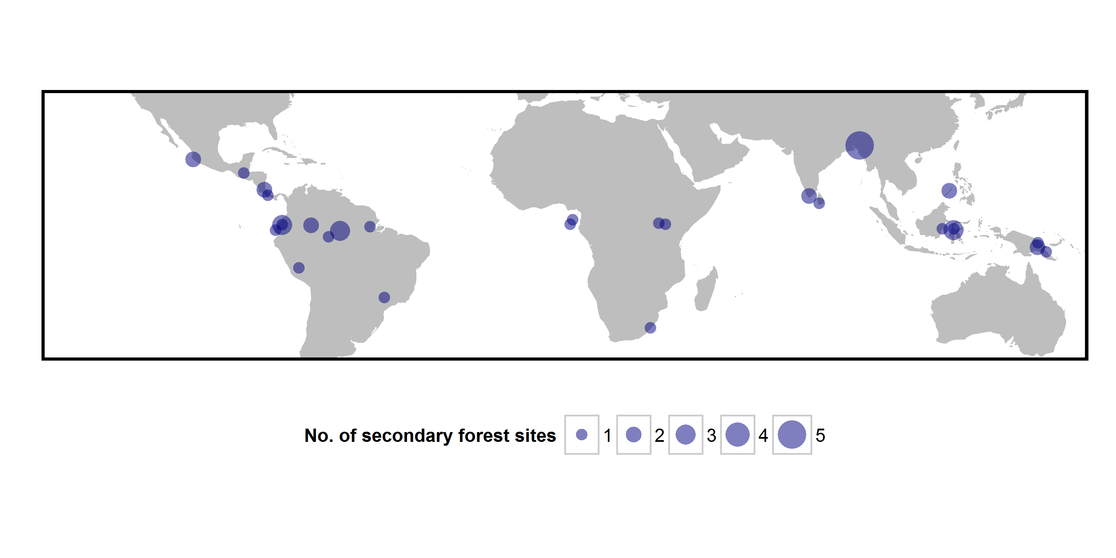

**Fig. 2** The relationship between secondary forest age and (a) functional divergence and (b) species richness in secondary forest relative to primary forest. The dotted black line represents the point at which metrics are equal in secondary and primary forest sites. Solid lines represent predictions from models with the lowest AICc and grey shaded areas represent the 95% confidence intervals for these predictions.

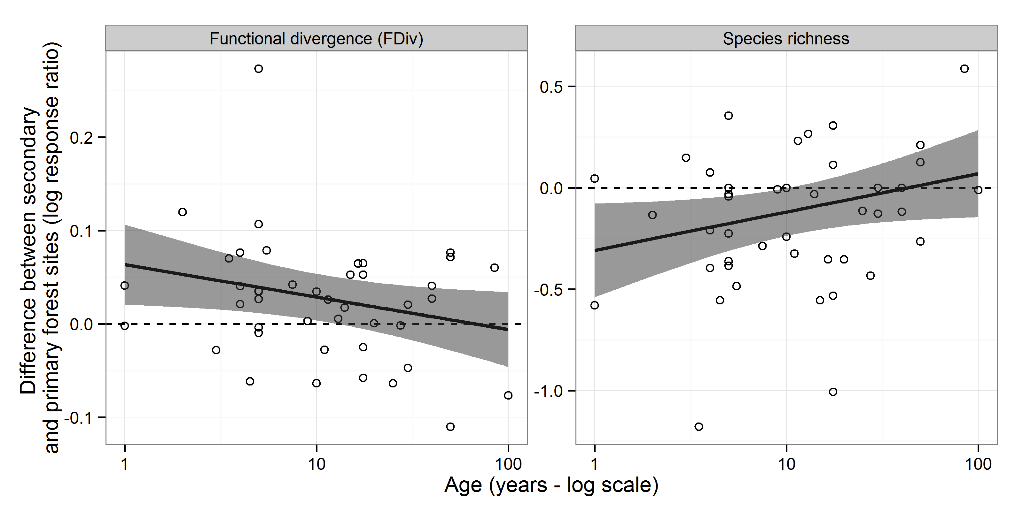

**Fig. 3** Difference between secondary and primary forest site diversity for variables where the null model was considered most parsimonious. Dots represent mean differences between secondary and primary sites and error bars represent 95% confidence intervals. Only functional richness (FRic) was significantly different (P<0.05).

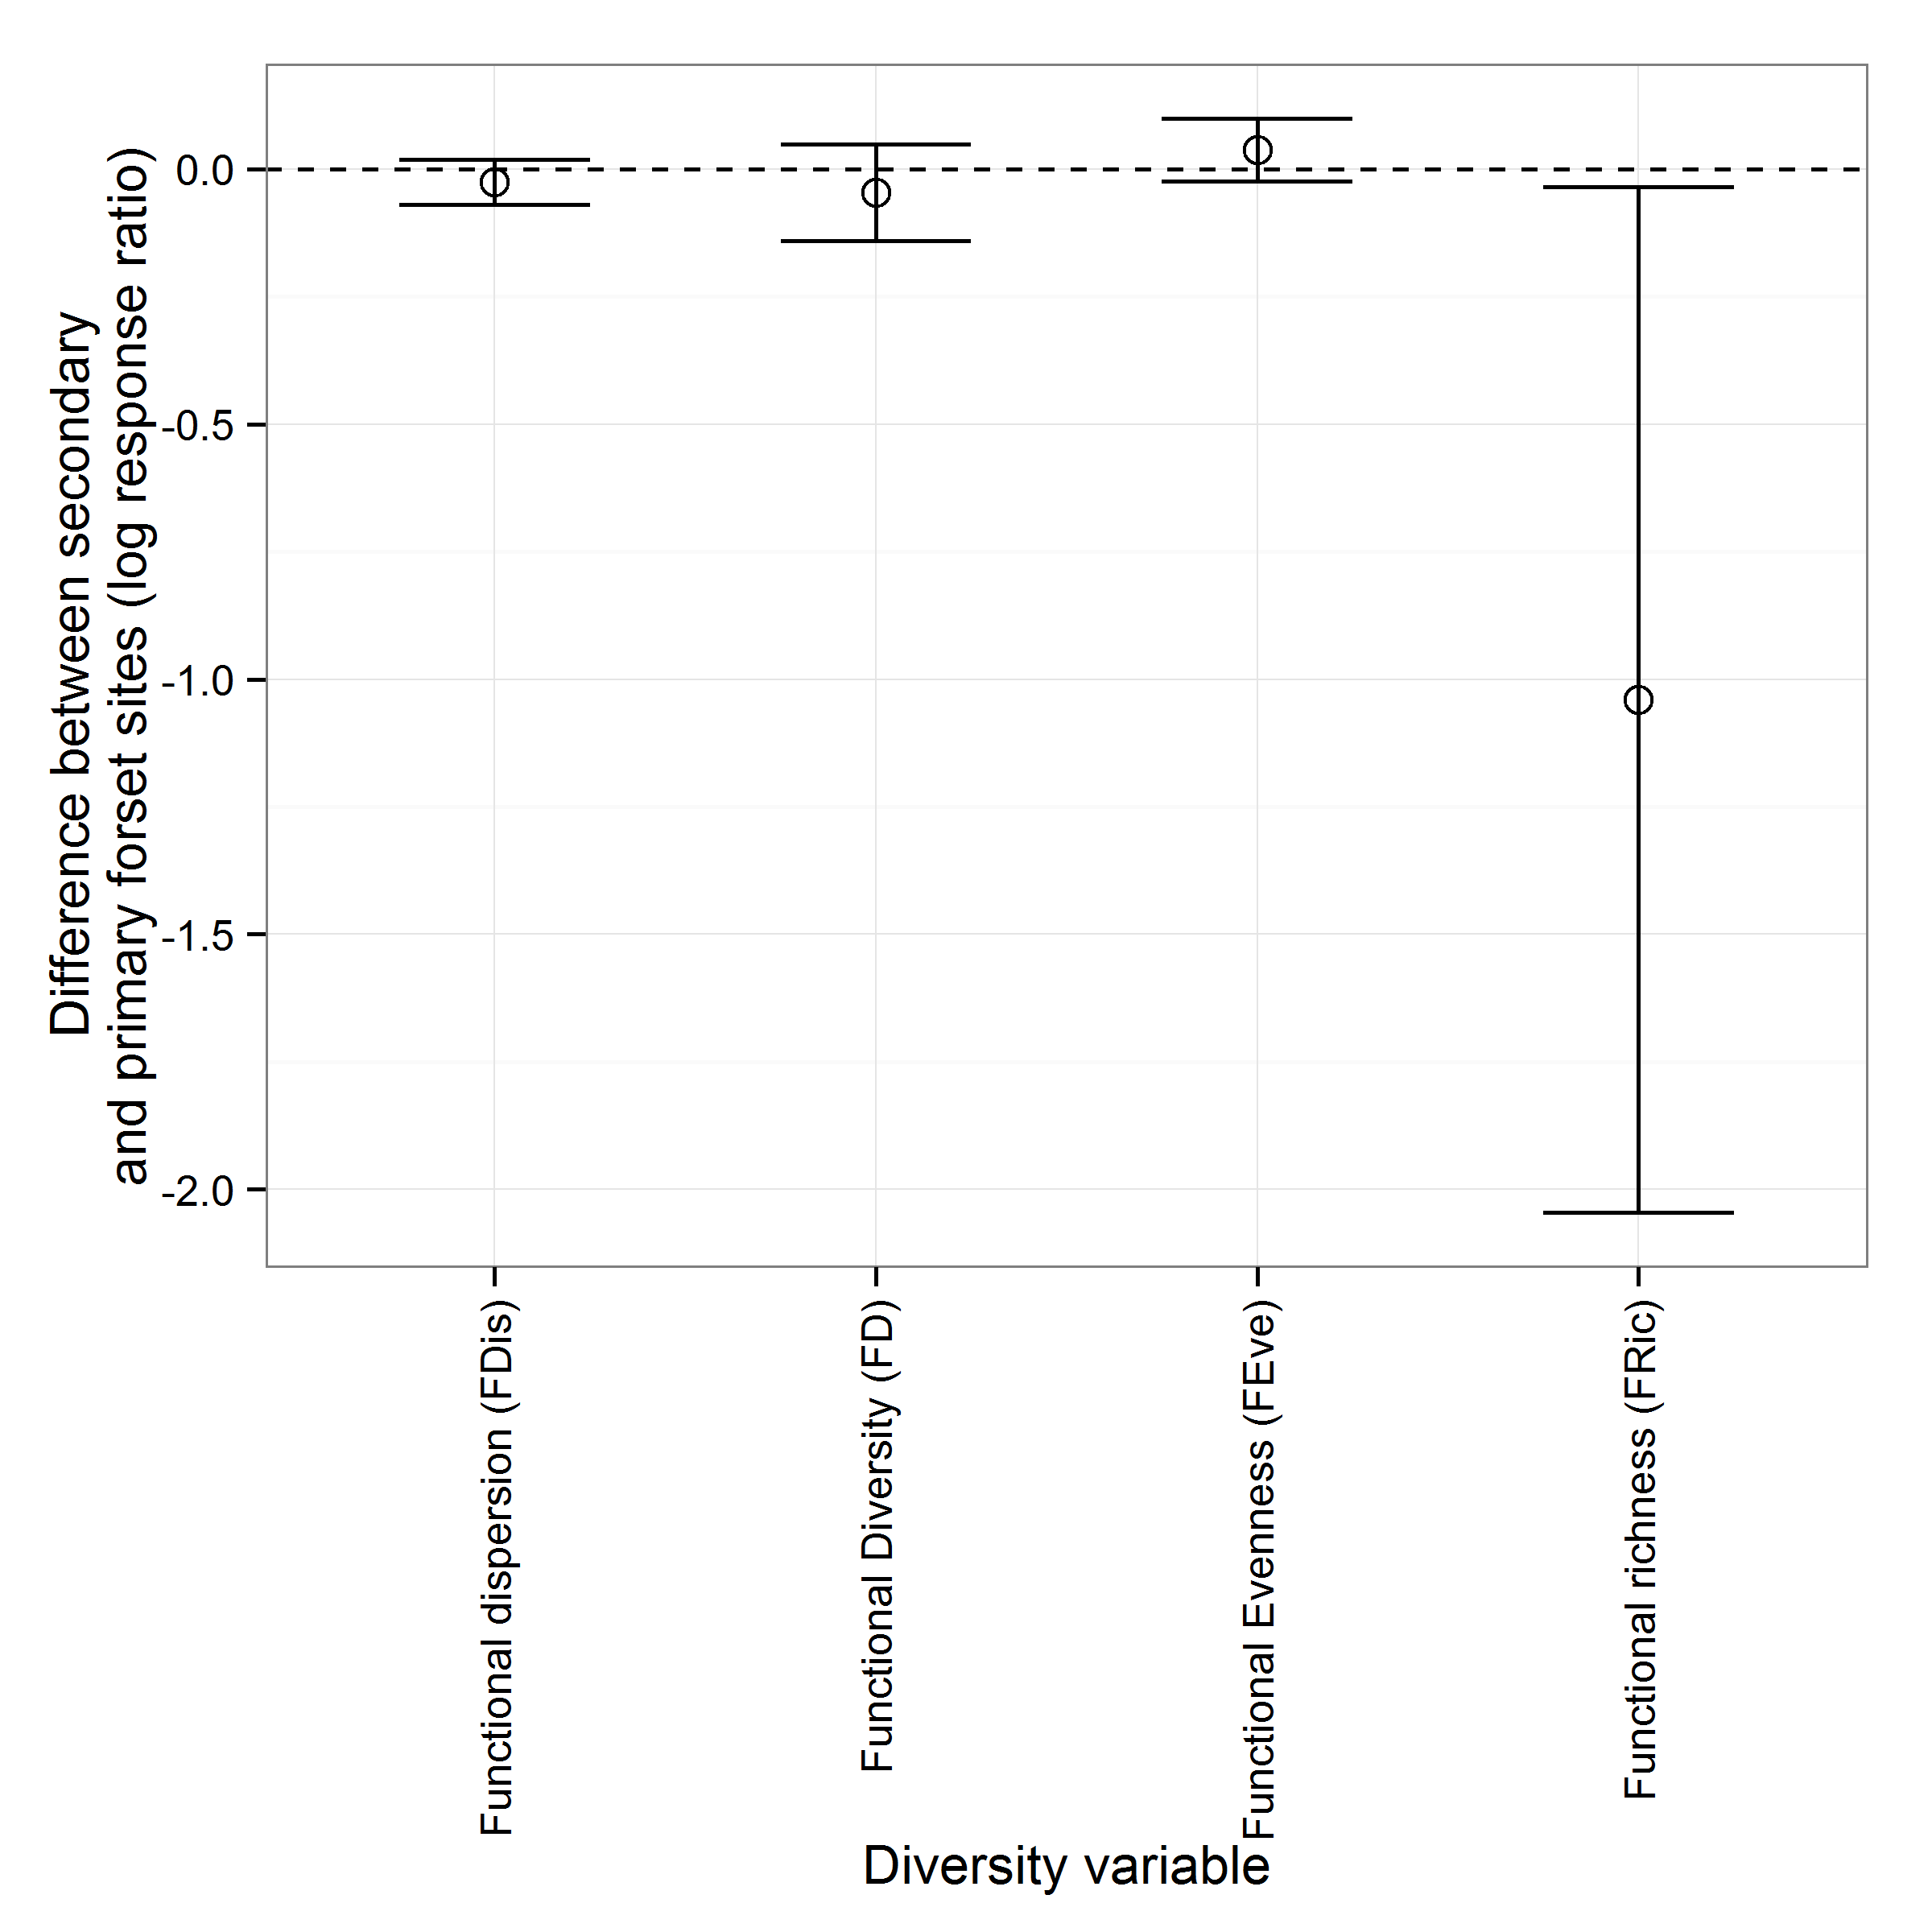

**Tables**

**Table 1** Studies from which avian community composition data were extracted, with location recorded at a country level and the age of secondary forest sites (measured as the number of years since disturbance) in each study

|  |  |  |
| --- | --- | --- |
| **Reference** | **Location of forest sites** | **Age of secondary forest site(s) / years** |
| Andrade GI, Rubio-Torgler H (1994) Sustainable Use of the Tropical Rain Forest: Evidence from the Avifauna in a Shifting-Cultivation Habitat Mosaic in the Colombian Amazon. Conserv Biol 8:545–554. doi: 10.1046/j.1523-1739.1994.08020545.x | Colombia | 3, 11.5 |
| Banks-Leite C, Ewers RM, Metzger JP (2012) Unraveling the drivers of community dissimilarity and species extinction in fragmented landscapes. Ecology 93:2560–2569. | Brazil | 50 |
| Barlow J, Mestre LAM, Gardner TA, Peres CA (2007) The value of primary, secondary and plantation forests for Amazonian birds. Biol Conserv 136:212 – 231. doi: http://dx.doi.org/10.1016/j.biocon.2006.11.021 | Brazil | 16.5 |
| Becker CD, Agreda A Bird community differences in mature and second growth Garua forest in Machalilla National Park, Ecuador. Ornitol Neotropical 16:297–319. | Ecuador | 17.5 |
| Becker CD, Loughin TM, Santander T (2008) Identifying forest-obligate birds in tropical moist cloud forest of Andean Ecuador. J Field Ornithol 79:229–244. doi: 10.1111/j.1557-9263.2008.00184.x | Ecuador | 17.5, 17.5, 40 |
| Blake JG, Loiselle BA (2001) Bird assemblages in second-growth and old-growth forests, Costa Rica: Perspectives from mist nets and point counts. The Auk 118:304–326. doi: 10.1642/0004-8038(2001)118[0304:BAISGA]2.0.CO;2 | Costa Rica | 5, 27.5 |
| Borges SH (2007) Bird assemblages in secondary forests developing after slash-and-burn agriculture in the Brazilian Amazon. J Trop Ecol 23:469–477. doi: 10.1017/S0266467407004105 | Brazil | 4.5, 11, 27.5 |
| Dallimer M, Parnell M, Bicknell JE, Melo M (2012) The importance of novel and agricultural habitats for the avifauna of an oceanic island. J Nat Conserv 20:191–199. doi: 10.1016/j.jnc.2012.04.001 | São Tomé and Príncipe | 5 |
| Dawson J, Turner C, Pileng O, et al Bird communities of the lower Waria Valley, Morobe Province, Papua New Guinea: a comparison between habitat types. Trop Conserv Sci 4:317–348. | Papua New Guinea | 20 |
| De Lima RF, Dallimer M, Atkinson PW, Barlow J (2013) Biodiversity and land-use change: understanding the complex responses of an endemic-rich bird assemblage. Divers Distrib 19:411–422. doi: 10.1111/ddi.12015 | São Tomé and Príncipe | 50 |
| Hutto RL (1989) The Effect of Habitat Alteration on Migratory Land Birds in a West Mexican Tropical Deciduous Forest: A Conservation Perspective. Conserv Biol 3:138–148. doi: 10.1111/j.1523-1739.1989.tb00066.x | Mexico | 2, 5 |
| Johns AD (1991) Responses of Amazonian rain forest birds to habitat modification. J Trop Ecol 7:417–437. doi: 10.1017/S0266467400005812 | Brazil | 1 |
| Maas B, Putra DD, Waltert M, et al (2009) Six years of habitat modification in a tropical rainforest margin of Indonesia do not affect bird diversity but endemic forest species. Biol Conserv 142:2665–2671. doi: 10.1016/j.biocon.2009.06.018 | Indonesia | 3.5, 4, 5.5 |
| Mallari NAD, Collar NJ, Lee DC, et al (2011) Population densities of understorey birds across a habitat gradient in Palawan, Philippines: implications for conservation. Oryx 45:234–242. doi: 10.1017/S0030605310001031 | Philippines | 10, 30 |
| Marsden SJ, Symes CT, Mack AL (2006) The response of a New Guinean avifauna to conversion of forest to small-scale agriculture. Ibis 148:629–640. doi: 10.1111/j.1474-919X.2006.00577.x | Papua New Guinea | 5, 14 |
| Mulwa RK, Böhning-Gaese K, Schleuning M (2012) High Bird Species Diversity in Structurally Heterogeneous Farmland in Western Kenya. Biotropica 44:801–809. doi: 10.1111/j.1744-7429.2012.00877.x | Kenya | 50 |
| Naidoo R (2004) Species richness and community composition of songbirds in a tropical forest-agricultural landscape. Anim Conserv 7:93–105. doi: 10.1017/S1367943003001185 | Uganda | 13 |
| Neuschulz EL, Botzat A, Farwig N (2011) Effects of forest modification on bird community composition and seed removal in a heterogeneous landscape in South Africa. Oikos 120:1371–1379. doi: 10.1111/j.1600-0706.2011.19097.x | South Africa | 85 |
| O’Dea N, Whittaker R (2007) How resilient are Andean montane forest bird communities to habitat degradation? Biodivers Conserv 16:1131–1159. doi: 10.1007/s10531-006-9095-9 | Ecuador | 17.5 |
| Raman TRS, Rawat GS, Johnsingh AJT (1998) Recovery of tropical rainforest avifauna in relation to vegetation succession following shifting cultivation in Mizoram, north-east India. J Appl Ecol 35:214–231. doi: 10.1046/j.1365-2664.1998.00297.x | India | 1, 5, 10, 25, 100 |
| Raman TRS, Sukumar R (2002) Responses of tropical rainforest birds to abandoned plantations, edges and logged forest in the Western Ghats, India. Anim Conserv 5:201–216. doi: 10.1017/S1367943002002251 | India | 5, 15 |
| Reid JL, Harris JBC, Zahawi RA (2012) Avian Habitat Preference in Tropical Forest Restoration in Southern Costa Rica. Biotropica 44:350–359. doi: 10.1111/j.1744-7429.2011.00814.x | Costa Rica | 9 |
| Renner S, Waltert M, Mühlenberg M (2006) Comparison of Bird Communities in Primary vs. Young Secondary Tropical Montane Cloud Forest in Guatemala. Biodivers Conserv 15:1545–1575. doi: 10.1007/s10531-005-2930-6 | Guatemala | 4 |
| Slik JWF, Van Balen S (2006) Bird Community Changes in Response to Single and Repeated Fires in a Lowland Tropical Rainforest of Eastern Borneo. Biodivers Conserv 15:4425–4451. doi: 10.1007/s10531-005-4385-1 | Indonesia | 4 |
| Sodhi NS, Koh LP, Prawiradilaga DM, et al (2005) Land use and conservation value for forest birds in Central Sulawesi (Indonesia). Biol Conserv 122:547–558. doi: 10.1016/j.biocon.2004.07.023 | Indonesia | 40 |
| Terborgh J, Weske JS (1969) Colonization of Secondary Habitats by Peruvian Birds. Ecology 50:765–782. doi: 10.2307/1933691 | Peru | 7.5 |
| Tvardikova K Bird abundances in primary and secondary growths in Papua New Guinea: a preliminary assessment. Trop Conserv Sci 3:373–388. | Papua New Guinea | 7 |
| Wijesinghe MR, Brooke M de L (2005) Impact of habitat disturbance on the distribution of endemic species of small mammals and birds in a tropical rain forest in Sri Lanka. J Trop Ecol 21:661–668. doi: 10.1017/S0266467405002695 | Sri Lanka | 5 |

**Table 2** Parameter estimates for fixed effects in all best models (selected based on AIC). Where data were transformed prior to analysis estimates are based on the transformed data used for model fitting

|  |  |  |  |  |  |
| --- | --- | --- | --- | --- | --- |
| Variable | Parameter | Estimate | SE | t-value | P value |
| Functional dispersal (FDis) | Intercept | -0.02556 | 0.022802 | -1.12099 | 0.262 |
| Functional evenness (FEven) | Intercept | 0.037418 | 0.031058 | 1.204752 | 0.228 |
| Functional Richness (FRic) | Intercept | -1.04061 | 0.512686 | -2.02971 | 0.042 |
| Functional Diversity (FD) | Intercept | -0.04689 | 0.048301 | -0.97083 | 0.332 |
| Functional divergence (FDiv) | Intercept | 0.063619 | 0.021463 | 2.964176 | 0.006 |
| log(Age) | -0.01512 | 0.00719 | -2.1033 | 0.051 |
| Species richness | Intercept | -0.30838 | 0.115256 | -2.67563 | 0.011 |
| log(Age)1 | 0.082037 | 0.041059 | 1.998044 | 0.060 |

Table 3 – Model selection table for all models considered in this study

|  |  |  |  |  |
| --- | --- | --- | --- | --- |
| **Variable** | **Model** | **AICc** | **ΔAICc** | **Conditional R2** |
| Species richness | Null model | 30.02455 | 1.514925 | 0 |
| log(Age) | 28.50963 | 0 | 0.07 |
| Functional Diversity (FD) | Null model | 6.584348 | 0 | 0 |
| log(Age) | 8.845862 | 2.261514 | <0.01 |
| Functional Richness (FRic) | Null model | 213.029 | 0 | 0 |
| log(Age) | 214.3756 | 1.346595 | 0.02 |
| Functional Evenness (FEve) | Null model | -57.9035 | 0 | 0 |
| log(Age) | -55.9112 | 1.992294 | <0.01 |
| Functional Divergence (FDiv) | Null model | -112.745 | 1.784054 | 0 |
| log(Age) | -114.529 | 0 | 0.06 |
| Functional Dispersion (FDis) | Null model | -56.2951 | 0 | 0 |
| log(Age) | -55.6519 | 0.643162 | 0.03 |

Supplementary materials

Table S1 – Model selection table showing test of different random effects structures for different variables investigated

|  |  |  |  |
| --- | --- | --- | --- |
| Variable | Random_effects | AICc | Model Rank |
| Species richness | Study | 36.93706 | 1 |
| Mist_nets+Transect+Study | 39.50605 | 2 |
| Mist_nets+Study | 39.50605 | 3 |
| Mist nets+ Transect+Vocal+Study | 42.19209 | 4 |
| Mist nets+Transect+Vocal+Study | 45.05876 | 5 |
| Point observation+Mist nets+Transect+Vocal+Study | 48.09405 | 6 |
| Functional Diversity (FD) | Study | 18.15588 | 1 |
| Mist_nets+Transect+Study | 20.72487 | 2 |
| Mist_nets+Study | 20.72487 | 3 |
| Mist nets+ Transect+Vocal+Study | 23.41996 | 4 |
| Mist nets+Transect+Vocal+Study | 26.28663 | 5 |
| Point obs+Mist nets+Transect+Vocal+Study | 29.32192 | 6 |
| Functional Richness (FRic) | Study | 214.1521 | 1 |
| Mist_nets+Transect+Study | 216.721 | 2 |
| Mist_nets+Study | 216.721 | 3 |
| Mist nets+ Transect+Vocal+Study | 219.4328 | 4 |
| Mist nets+Transect+Vocal+Study | 222.2994 | 5 |
| Point obs+Mist nets+Transect+Vocal+Study | 225.3347 | 6 |
| Functional Evenness (FEve) | Study | -43.5699 | 1 |
| Mist_nets+Study | -41.0009 | 2 |
| Mist_nets+Transect+Study | -41.0009 | 3 |
| Mist nets+ Transect+Vocal+Study | -38.2892 | 4 |
| Mist nets+Transect+Vocal+Study | -36.2568 | 5 |
| Point obs+Mist nets+Transect+Vocal+Study | -33.2215 | 6 |
| Functional Divergence (FDiv) | Study | -99.5184 | 1 |
| Mist_nets+Transect+Study | -96.9494 | 2 |
| Mist_nets+Study | -96.9494 | 3 |
| Mist nets+ Transect+Vocal+Study | -94.2384 | 4 |
| Mist nets+Transect+Vocal+Study | -91.3717 | 5 |
| Point obs+Mist nets+Transect+Vocal+Study | -88.3364 | 6 |
| Functional Dispersion (FDis) | Study | -43.32 | 1 |
| Mist_nets+Study | -40.9265 | 2 |
| Mist_nets+Transect+Study | -40.8142 | 3 |
| Mist nets+ Transect+Vocal+Study | -38.7318 | 4 |
| Mist nets+Transect+Vocal+Study | -35.8651 | 5 |
| Point obs+Mist nets+Transect+Vocal+Study | -32.8298 | 6 |