**PREPARATION**



◻◻ for white

◻ for black

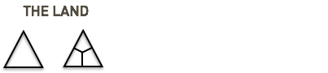

◻◻ for land

◻ for land with grid

◻◻ events from the grand jeu

**RULES**

* Wins who has more whites
* If the table has more than …… blacks all die
* If a player die all get ….. blacks
* To get into a cooperative you pay a fee of ……. whites

**EACH ROUND**



* Pay 1
* INVEST (after round 3 you can alternatively LEARN)
* Wheel of Fortune (EVENTS, INVEST, DESTROY, ENJOY)

**EVENTS**

|  |  |  |
| --- | --- | --- |
|  | **From Le Grand Jeu** | **From Neighborhood** |
| 1 | Internet blackout | Taxes |
| 2 | Pandemic | A gipsy camp settles on your land |
| 3 | Banks close down | cultural center in your land |
| 4 | General Strike | you get depression |
| 5 | Referendum | double your basic incomes |
| 6 | Killer Drones | but bees in your garden |
| 1 | War on prices | a new mall opens in your area |
| 2 | World Wide Festivity | the find out you gave your friends in |
| 3 | Xenophobia | cold winter halves your energy intake |
| 4 | Big Works | you don´t ear the alarm. Miss a round |
| 5 | Free Internet access and end of the net neutrality | you fall in love |
| 6 | Basic Income | goats destroy everything |
| 1 | The Communists take power | a flood destroys your garden |
| 2 | Terrorist attack | you learn o fly |
| 3 | New Water is found | new facilitations for wind plants |
| 4 | Robots work for you | Amy Winehouse lives again |
| 5 | Big Events |  |
| 6 | New Medicinal Plants |  |
| 1 | Global Warming |  |

Situation timeline

|  |  |  |  |  |  |
| --- | --- | --- | --- | --- | --- |
| Players /Rounds | **1** | **2** | **3** | **4** | **5** |
|  |  |  |  |  |  |
|  |  |  |  |  |  |
|  |  |  |  |  |  |
|  |  |  |  |  |  |
|  |  |  |  |  |  |

|  |  |  |  |  |  |
| --- | --- | --- | --- | --- | --- |
| Players /Rounds | **6** | **7** | **8** | **9** | **10** |
|  |  |  |  |  |  |
|  |  |  |  |  |  |
|  |  |  |  |  |  |
|  |  |  |  |  |  |
|  |  |  |  |  |  |

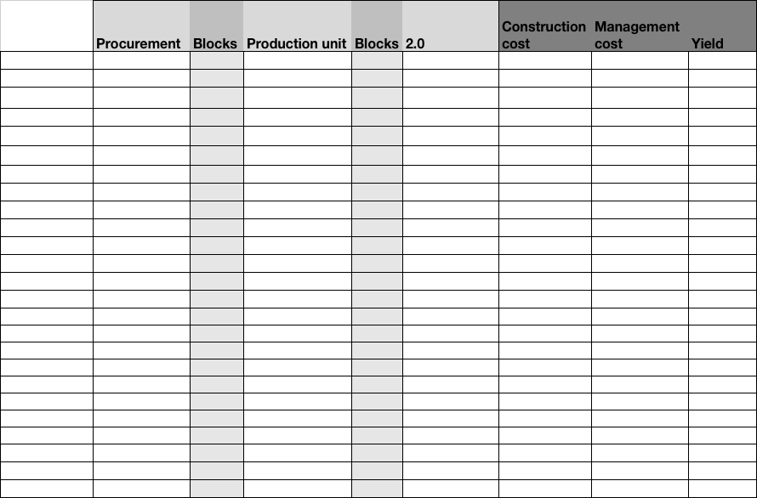



|  |  |  |
| --- | --- | --- |
| Date | Place | Language used to play |
| Number of players | Description of the situation | Name of the master |
| Iteration # 7 | Duration of game | Name of Winner |
| Description of the game | | Rules |
| Inventions | | |