horizontal line

**SOPR, INF5**

**Prof. Graf**

Sojaping

Group members:

Philipp Kessler, Jan Komposch, Irina Ungemach, Sophie Stein

# Technologies

* Java
* Java.net
* JavaFx, Gluon SceneBuilder
* SQLite
* JDBC
* Translation API

# Architecture

**Client Server** Architecture, Components: Server and multiple clients

**Model View Controller**, Components: GUI, Controller and Dataclasses

# 

# Domain Model(s)

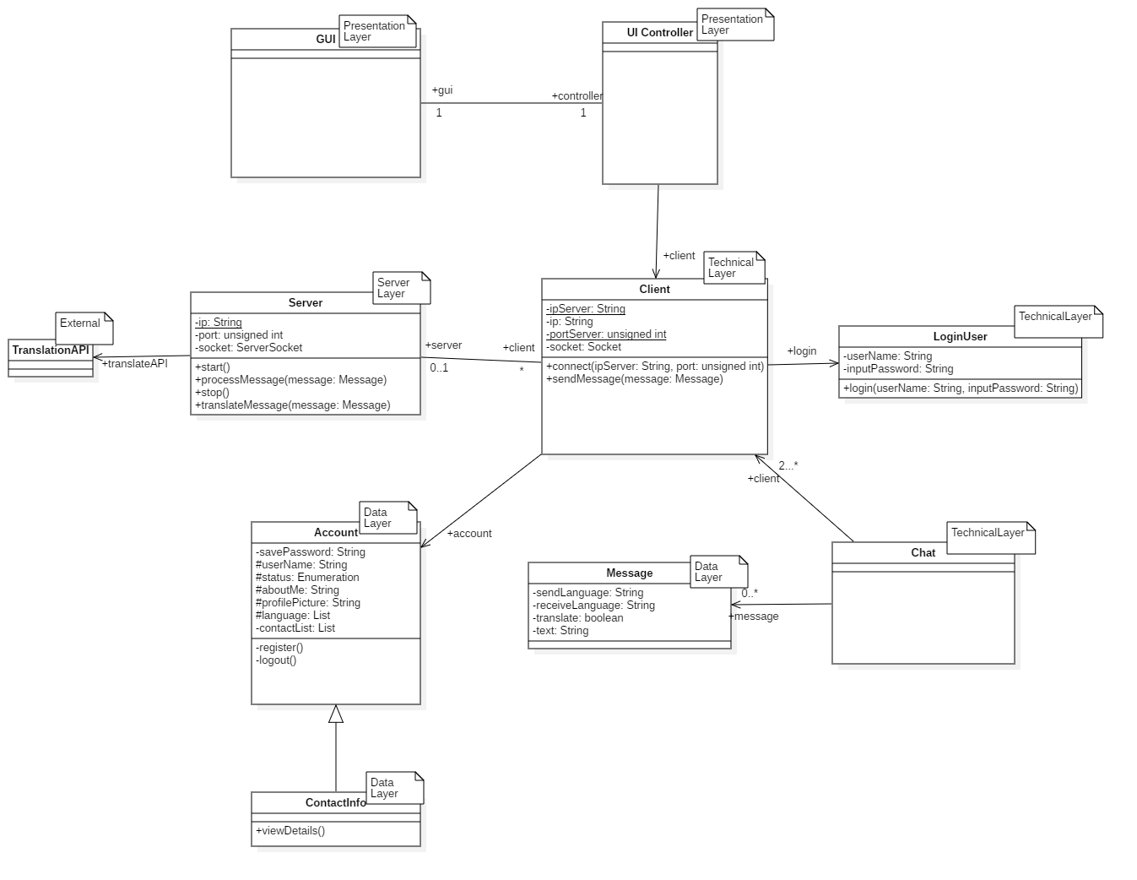

# 

# Software Architecture

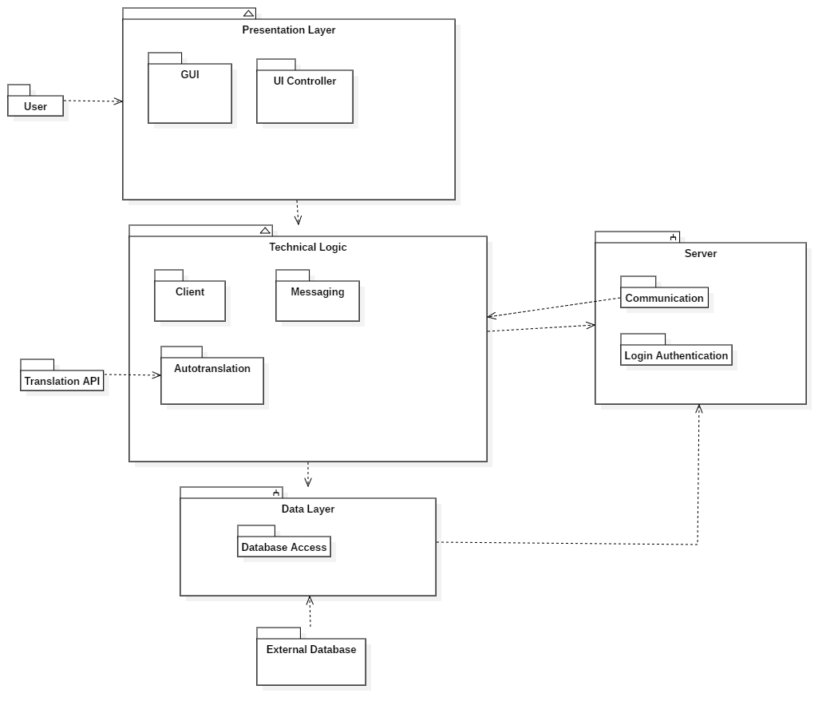

<https://de.wikibooks.org/wiki/Java_Standard:_Socket_und_ServerSocket_(java.net)>

<https://www.sqlitetutorial.net/sqlite-java/>