March 18, 2016

The Honorable Mayor  
Mayor of Munishipariti

ATTN: GIS Office/Planning Office/IT Department  
  
RE: LiDAR Data Access for the Municipality of Munishipariti

Dear Honorable Mayor,

The UP Training Center for Applied Geodesy and Photogrammetry (UP TCAGP) is currently undertaking a research program supported by the Department of Science and Technology (DOST) entitled “Hazard Mapping of the Philippines Using LIDAR (Phil-Lidar 1)”. The Data Archiving and Distribution (DAD) Component of Phil-LiDAR 1 is developing a LiDAR archiving and distribution system called LiPAD as part of the objectives of the project.

We are pleased to inform you that LiPAD is now available online via the URL [http://lipad.dream.upd.edu.ph](http://lipad.dream.upd.edu.ph/). DREAM/PHIL-LiDAR 1 final outputs, flood hazard maps, are readily available for public viewing and download through LiPAD. For other available LiDAR and LiDAR-derived datasets, an account will be needed for access.

Full launch of the system is scheduled for March 30, 2016. We invite your IT Department, GIS Office or Planning Department to register for an account online to be able to access DREAM/Phil-LiDAR 1 datasets for your municipality. Instructions for online registration are attached. For inquiries, please email lipad@dream.upd.edu.ph.

Very truly yours,



ENRICO C. PARINGIT, Dr.Eng

Program Leader

PHIL-LIDAR 1 PROGRAM  
 Attachments: LiPAD Overview and Account Registration Instructions

LiPAD Overview and Account Registration Instructions

# 1. Introduction

## 1.1 Scope and Purpose

The Phil-LiDAR 1 Program, an expansion of the Nationwide DREAM Program, aims to produce 3-D flood and hazard maps for the 2/3 of the Philippine river systems. Aside from addressing disaster risk reduction and climate change adaptation, the resource information to be generated by this project will also be useful in providing the information requirements of various sectors in the country.

The ongoing DOST-GIA Nationwide DREAM Program currently has covered only 1/3 of the total area of Philippine river systems, equivalent to 100,000 sq.km., or 18 major river basins. The Phil-LiDAR 1 program aims to cover the remaining 2/3 of river systems in the country by tapping state universities and colleges (SUCs) and private higher education institutions (HEIs) nationwide in the processing, validation, and modeling of the acquired LiDAR data.

The LiDAR Portal for Archiving and Distribution (LiPAD) is an online portal for archiving and distributing the LiDAR and LiDAR-derived datasets of the [DREAM Program](http://www.dream.upd.edu.ph/), [Phil-LiDAR 1](https://dream.upd.edu.ph/about-us/phil-lidar-1/) and [Phil-LiDAR 2](https://dream.upd.edu.ph/about-us/phil-lidar-2/) programs. Flood hazard maps, being the primary outputs of the DREAM and Phil-LiDAR 1 Program are available for public viewing and download through LiPAD. The rest of the datasets will be accessible to LiPAD users.

Table 1. List of available data types

|  |  |  |  |  |
| --- | --- | --- | --- | --- |
| Datasets | File format | Clipping dimension | Program | Access |
| Flood Hazard Maps | Vector | Municipal boundary | DREAM/Phil-LiDAR 1 | No registration needed |
| LiDAR Digital Terrain Models | Raster | 1 km tile | DREAM/Phil-LiDAR 1 | Registration required |
| LiDAR Digital Surface Models | Raster | 1 km tile | DREAM/Phil-LiDAR 1 | Registration required |
| Orthophotos | Raster | 1 km tile | DREAM/Phil-LiDAR 1 | Registration required |
| Classified LAZ | Point cloud | 1 km tile | DREAM/Phil-LiDAR 1 | Registration required |
| SAR Digital Elevation Models | Raster | Provincial boundary | DREAM | Registration required |
| Resource Layers | Raster and Vector | Municipal/Provincial boundaries,  River Basins, | Phil-LiDAR 2 | No registration needed |

## 1.2 Process Overview

Users who want to gain access to the site must submit a data request for LiDAR data to the Phil-LiDAR program. The system administrator will have the option to approve or deny a request based on the information given by the user. Upon approval, a LiPAD user account will be given to the user. Approved users will be able to log into the site using the given account and download resources based on the data provided during registration.

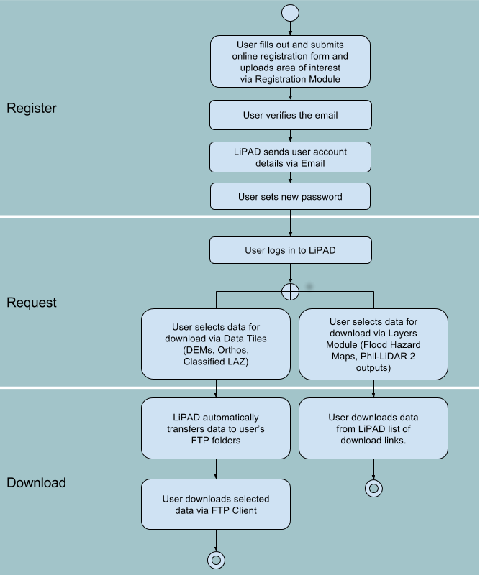

# 2. Data Request Registration Process

The information given during the registration will determine if your request will be approved by the administrators, so make sure that all the information you provided are valid.

Here are the steps for the registration process:

1. Go to the LiPAD website ([https://lipad.dream.upd.edu.ph](https://lipad.dream.upd.edu.ph/)).

2. Click the “**Register**” button on the top-right corner of the page. After clicking, you will be redirected to the first part of the data request registration.

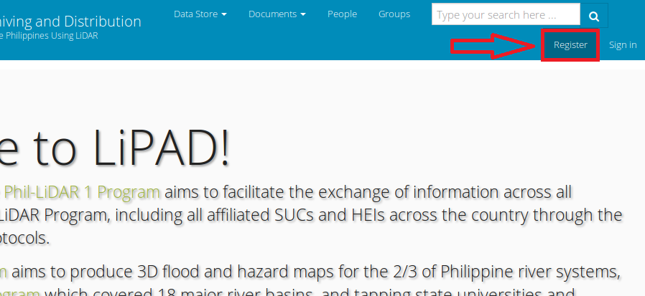

3. You need to fill out the whole form in order to proceed to the next step of the registration process.

4. After providing the required information, click the “**Continue**” button at the bottom-left part of the page.

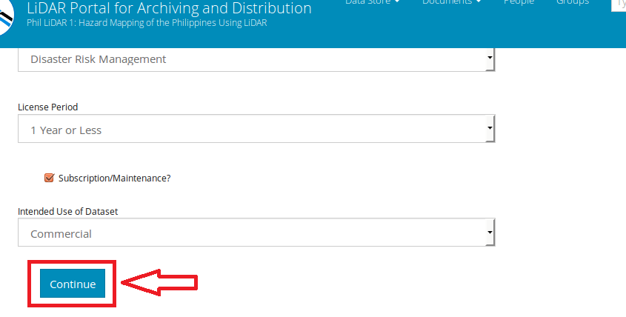

5. If you forgot to fill out some fields or provided invalid input, you will be redirected to the same page. Fields that need proper input will be marked red, and messages will be shown regarding the error.

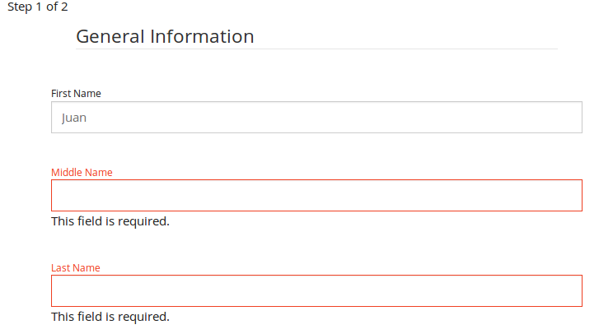

6. After providing the correct information, you will be redirected to the second step of the registration process. In this step, you will be required to provide a jurisdiction shapefile and answer the provided Captcha challenge.

The jurisdiction shapefile must be a valid one and must contain all the necessary parts. The administrator will check this file, and if your request is approved, you will be given access to resources based on the coverage of the shapefile you provided.

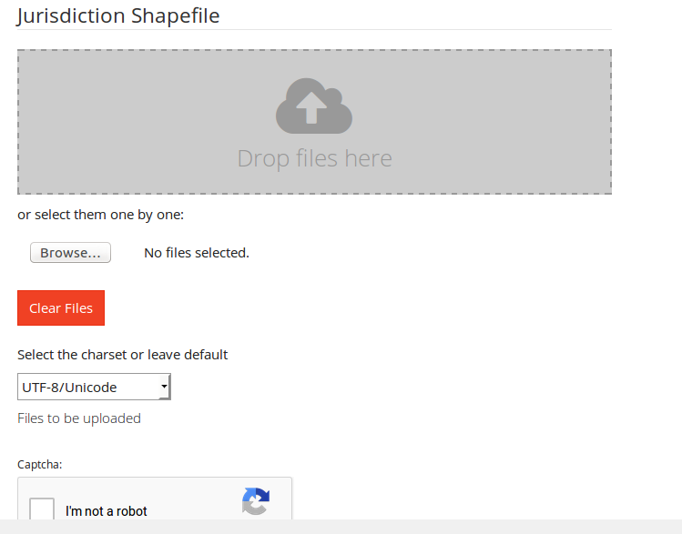

7. If you want to change some of the information you provided for the first step of the registration, you will be able to go back by clicking the “**Prev**” button on the bottom-left part of the page.

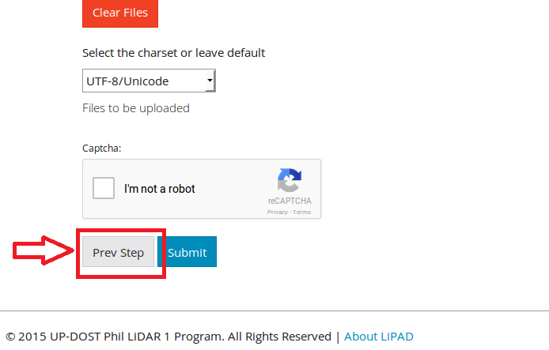

8. After providing a valid shapefile and answering the Captcha challenge, click the “**Submit**” button and wait for your registration data to be processed.

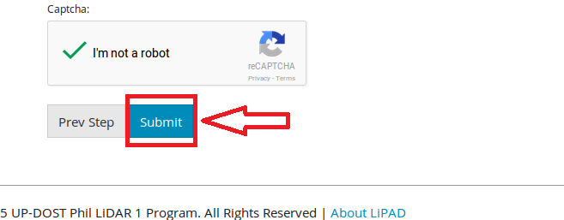

9. Once your registration data is processed, you will be redirected to the email confirmation page. An email will be sent to you for verification. You need to follow the steps provided in the email to complete the registration.

10. Once you verified your email, your registration is now complete. Your request will now be available to the administrator for approval. You will receive an email regarding the status of your registration once the administrator approve/reject your request. If your request if approved, the details of your new account for logging into the site will be included in the email.

# 3. Data Access

The following data types can be downloaded via LiPAD through the Data Store Section

1. Flood Hazard Maps (no account needed) - DREAM/Phil-LiDAR 1
2. Digital Terrain Models - DREAM/Phil-LiDAR 1
3. Digital Surface Models - DREAM/Phil-LiDAR 1
4. Orthophotos, selected - DREAM/Phil-LiDAR 1
5. Classified LAZ, selected - DREAM/Phil-LiDAR 1
6. sample datasets from Phil-LiDAR 2 (no account needed)

## 3.1 Downloading Flood Hazard Maps and other vector/layers via Data Store/Layers

1. View the desired layer on a map. See “Viewing a Layer”.  
   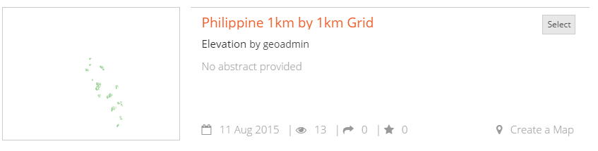
2. Click **Request Download** to request permission from the layer owner to download a layer.  
   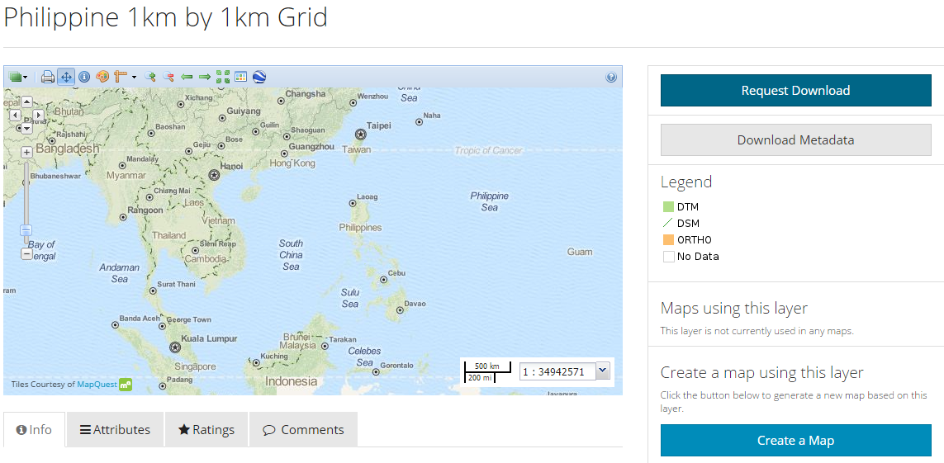
3. Wait for the approval of the owner of the uploaded layer.  
   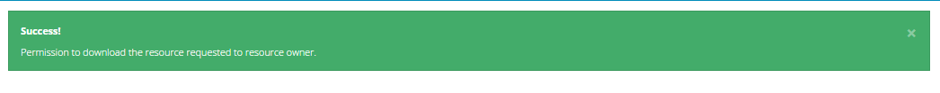
4. If approval is granted, view desired layer on map. Click on **Download Layer**.
5. End user license agreement (EULA) will be displayed. The user is required to click **I agree** to proceed with the download.  
   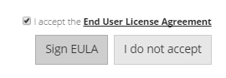
6. Click **Sign EULA**.
7. Choose desired format of layer to be downloaded. Some files have the option to view the layer in Google Earth.  
   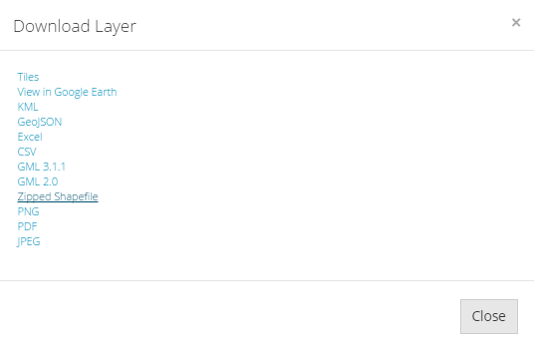
8. Save file and wait for download to finish.

## 3.2 Downloading other datasets via Data Store/Data Tiles

1. Login to LiPAD.
2. At the top of the page, click **Datastore** -> **Data Tiles** to display the tiled data map available for selection

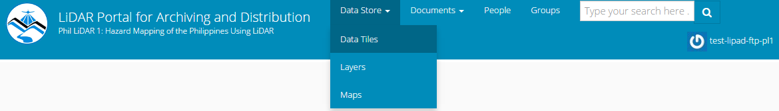

1. Navigate towards area of interest. 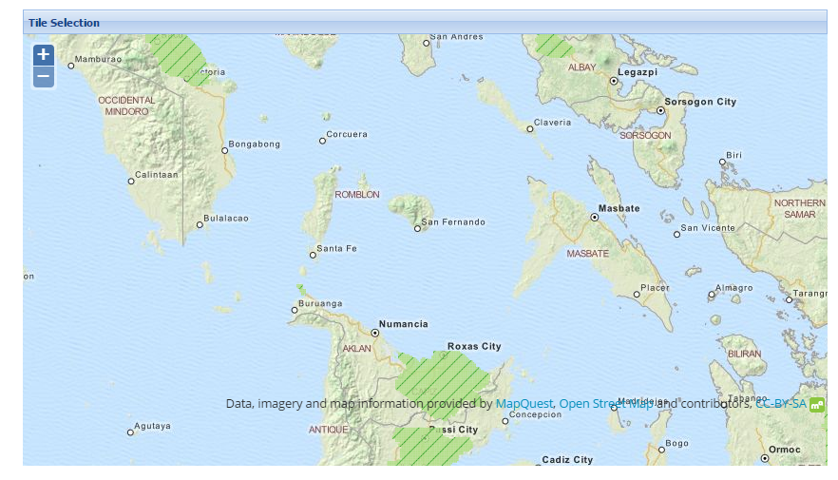

Zoom in by one level on specific area: scroll up using your mouse within the gridded map or click “+” on upper left side of map

1. Selecting tile/s:
   * + To select tiles one by one, simply **click on a map cell**.  
         
       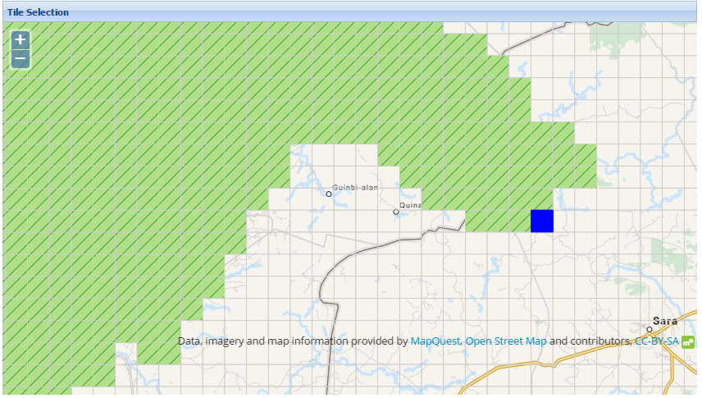
     + To select a group of tiles, **hold Shift while dragging the mouse to draw a rectangle**.  
       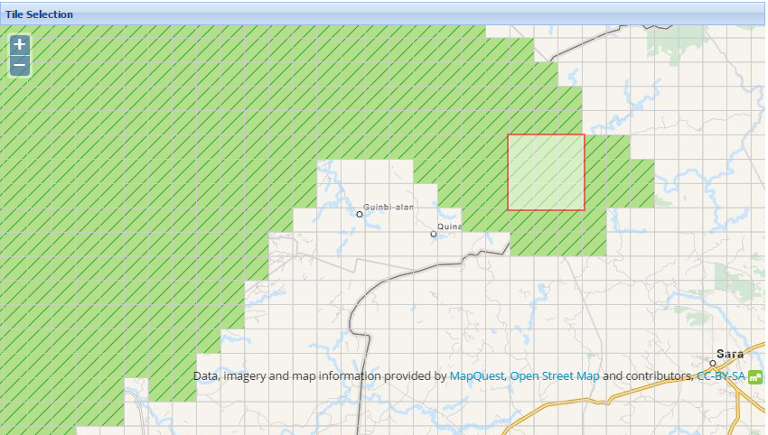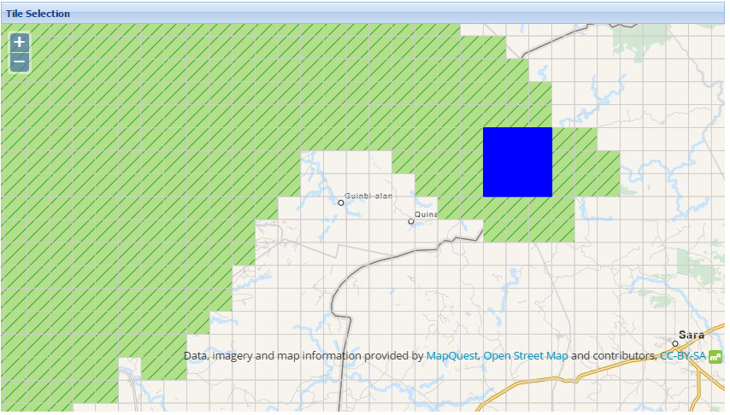  
       Selected tiles will be highlighted blue. The corresponding geo-reference of each tile is listed below the map.
2. Click **Submit** at the bottom of the geo-reference list.   
   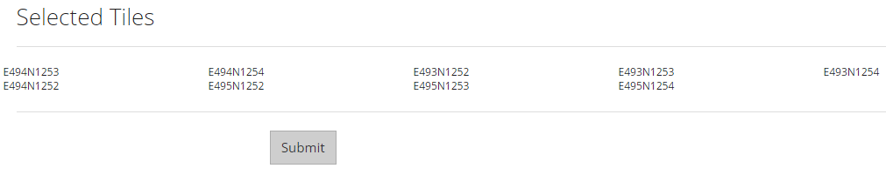
3. The Data Cart is displayed. This lists the associated files to the selected tiles.
   * + To erase the contents of the cart, click **Empty This Cart**.  
       
     + To proceed downloading the files, click **Create FTP Folder**. Requested files will be available for download via FTP.  
       
4. An email will be sent to the registered email address notifying the user of the creation of the FTP folder.
5. Run an FTP client:
   * + **Log in** to the DREAM Phil-LiDAR FTP server and navigate to the download folder. The file will be downloaded from the FTP client.