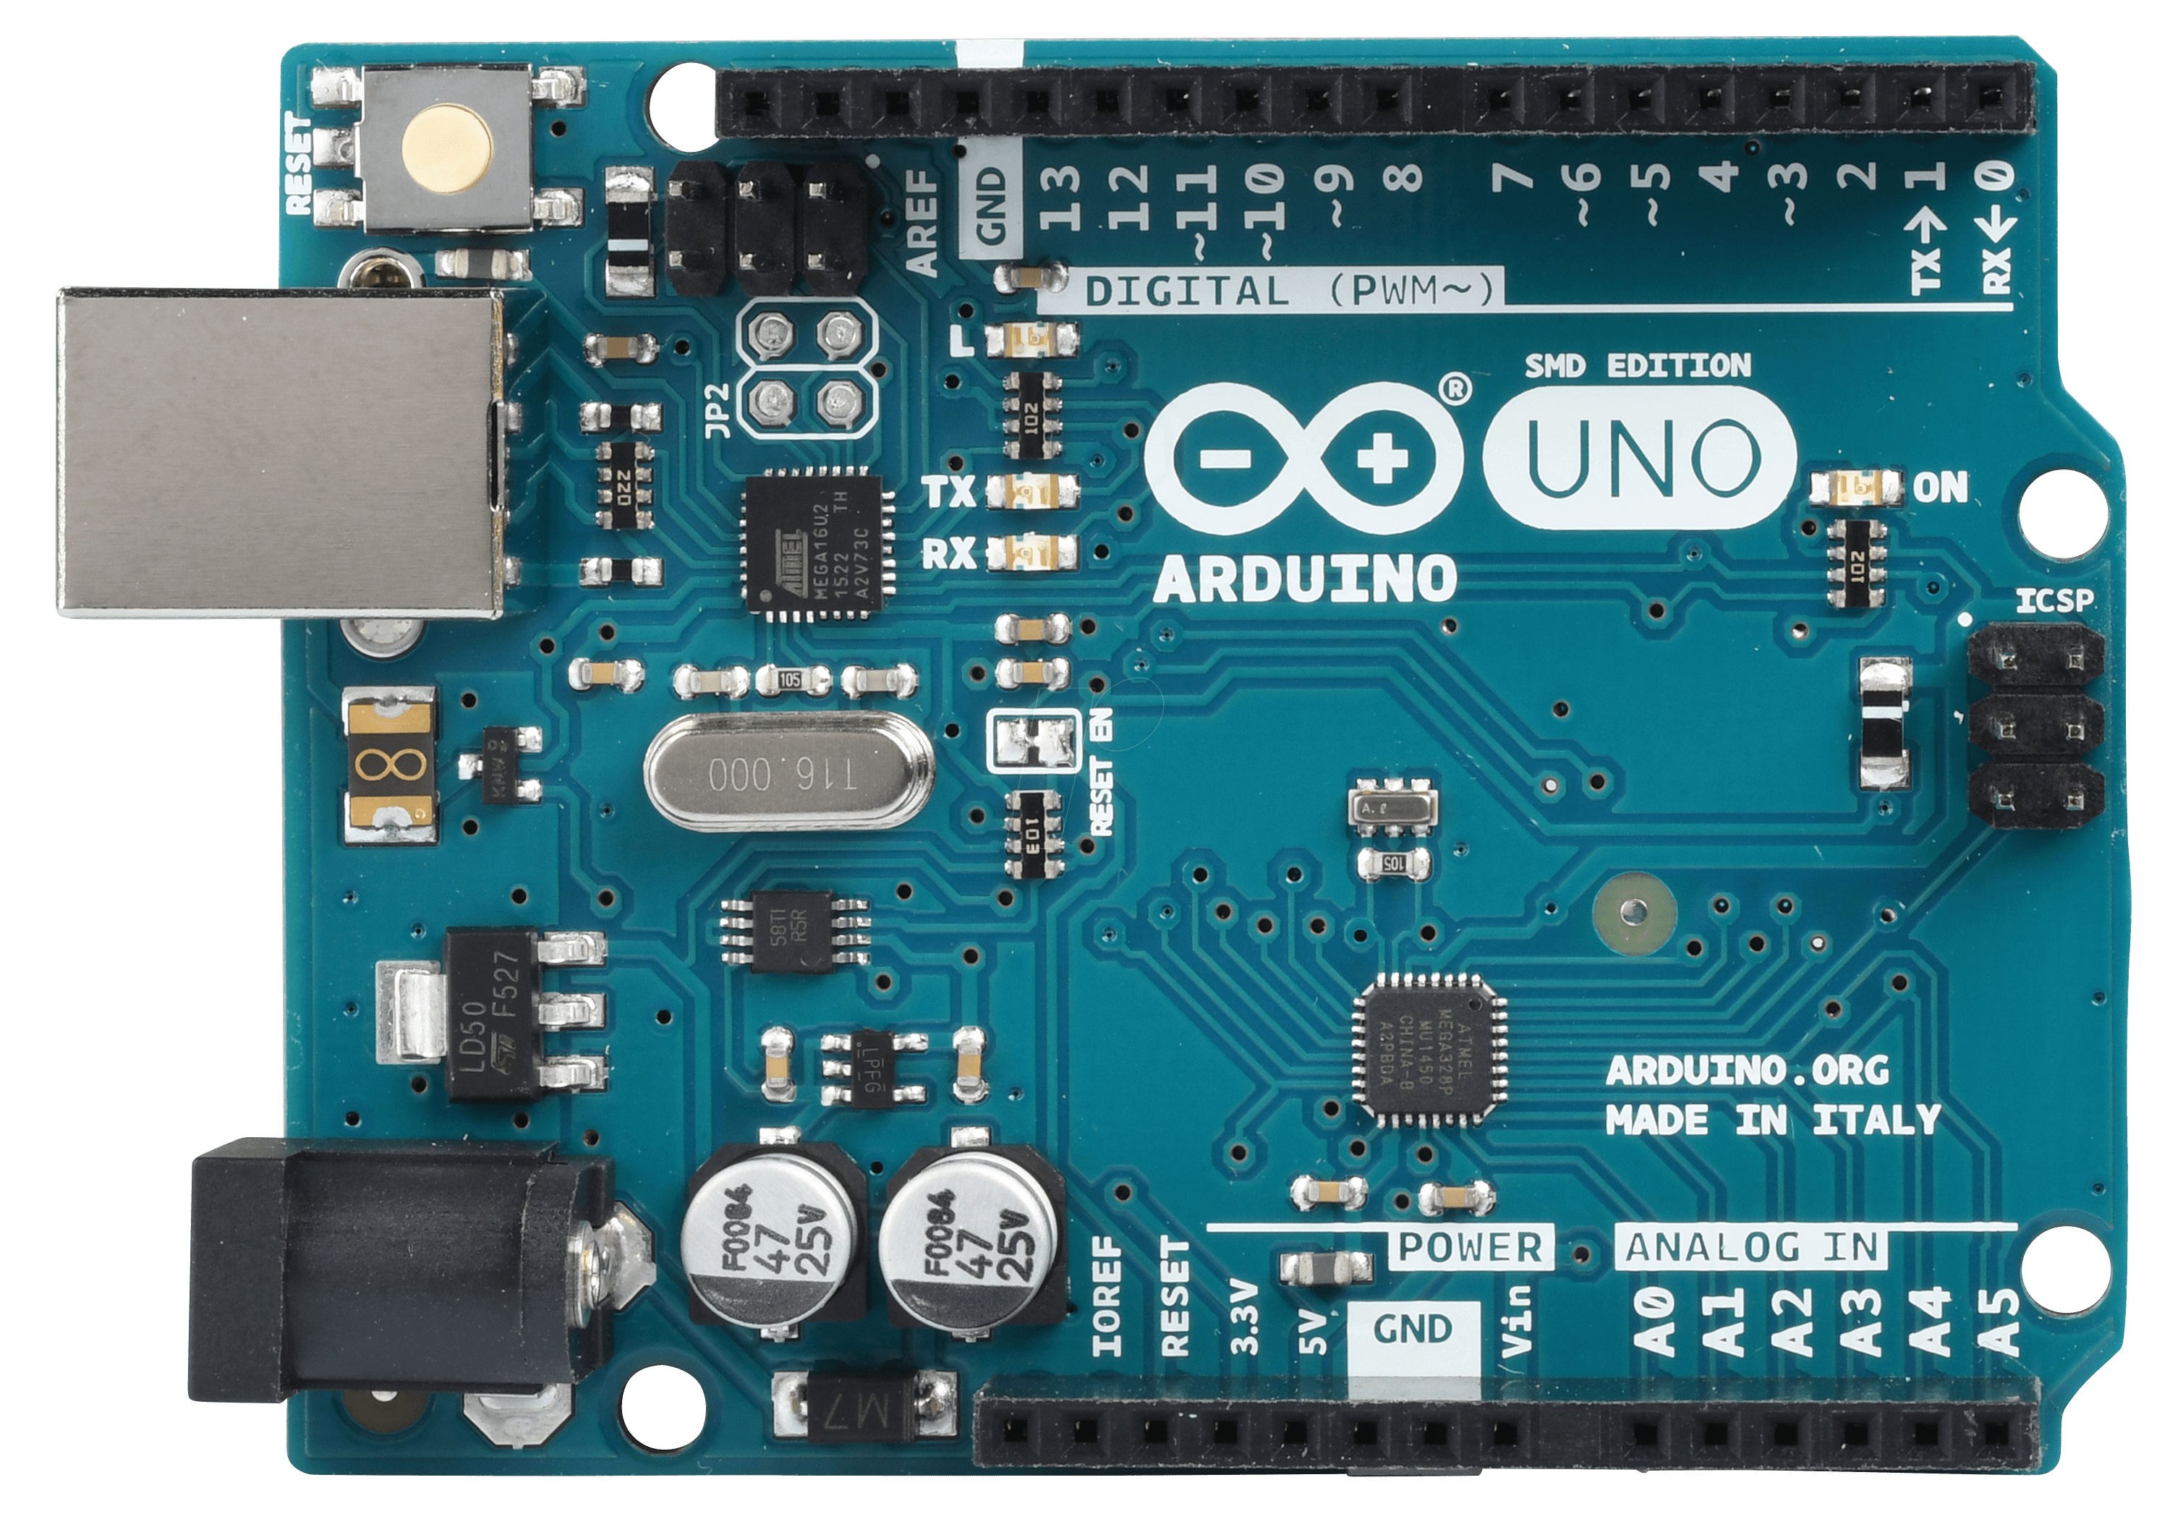

uBlox ZED-F9P-02B-00

SCL

U.FL

connector

SMA connectors



uBlox Antenna w/ grounding plate

SCL

SCL

SCL

SDA

SCL

3V3

SCL

GND

SCL

SDA

SCL

SCL

SCL

