Highlighter 2017-11-20 10:01 method

Open read01.html in browser (tested in Chrome). I have it on my hard drive.

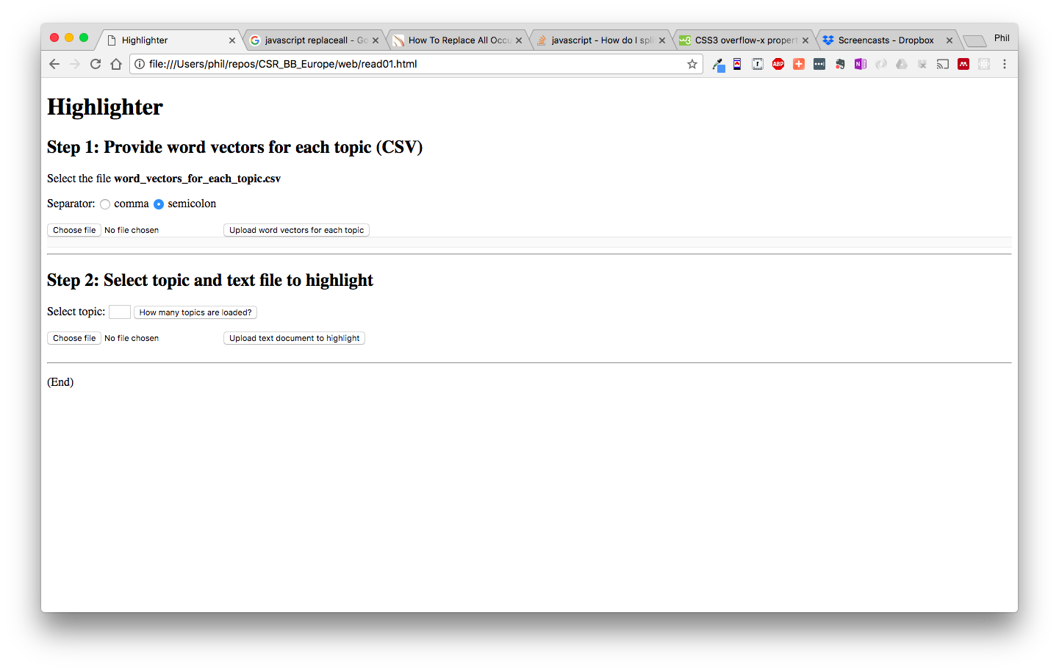

Step 1, ‘Choose file’, select SocialResponsibility/result/word_vectors_for_each_topic.csv

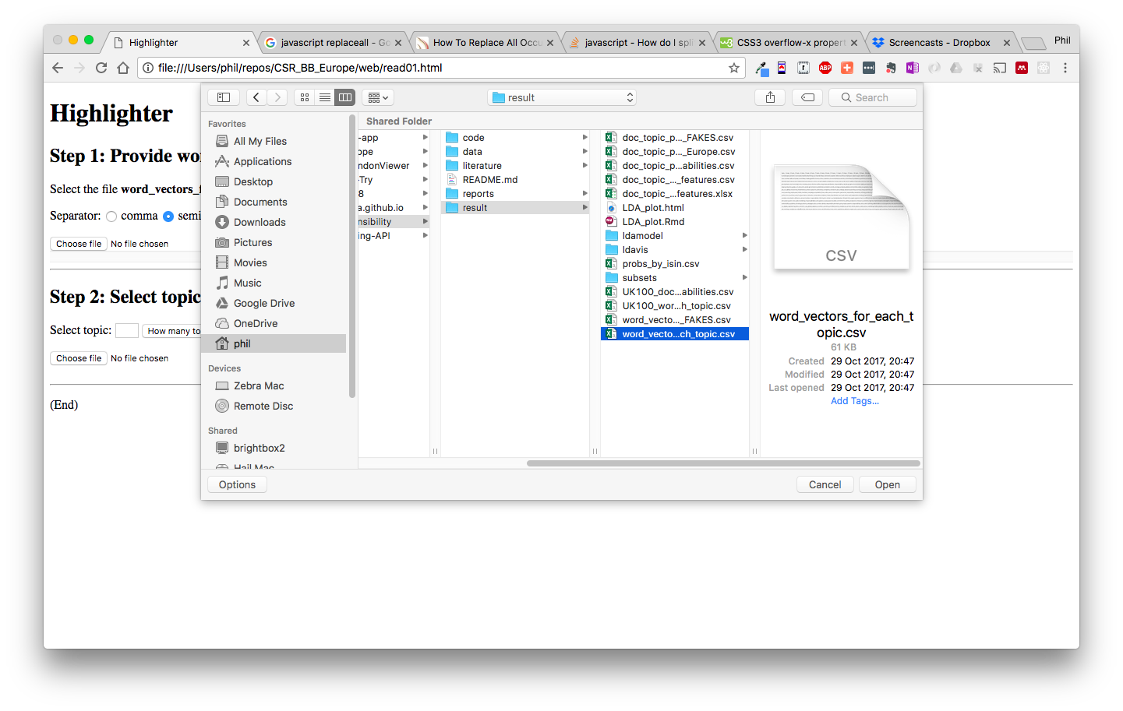

Click button ‘Upload word vectors for each topic’.

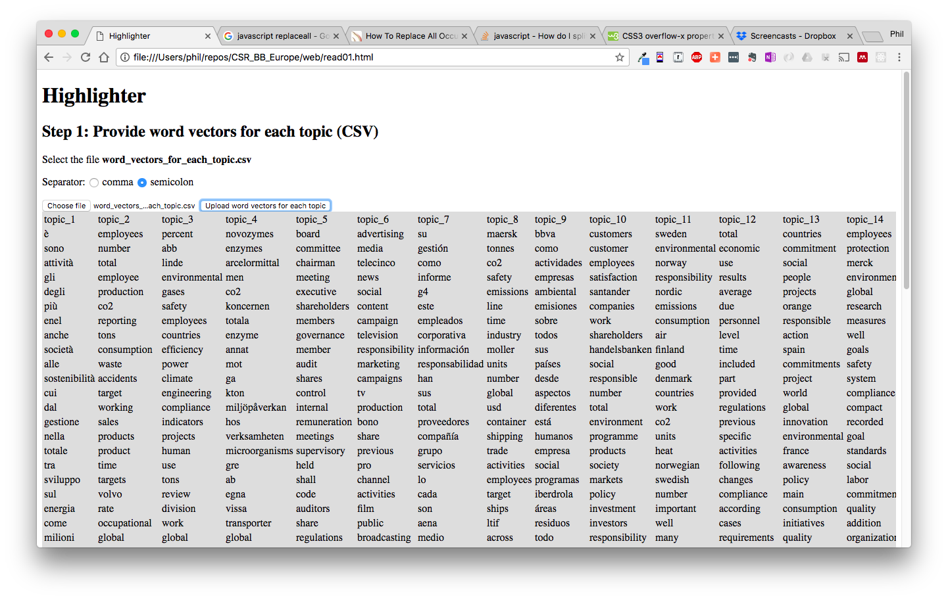

Table of word vectors for each topic appears (grey).

Scroll to Step 2.

Select topic number 1 to upper limit.

Use button ‘How many topics are loaded?’ to see upper limit (150).

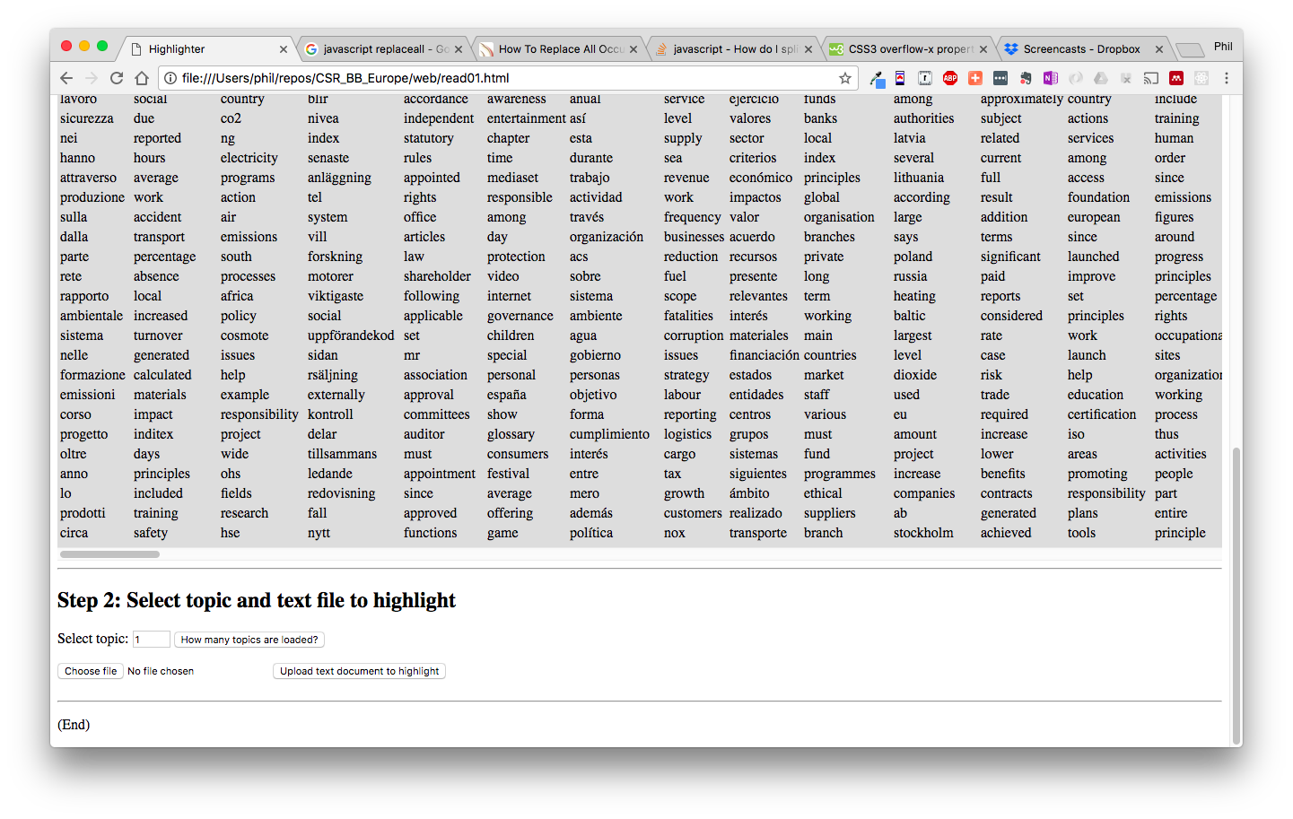

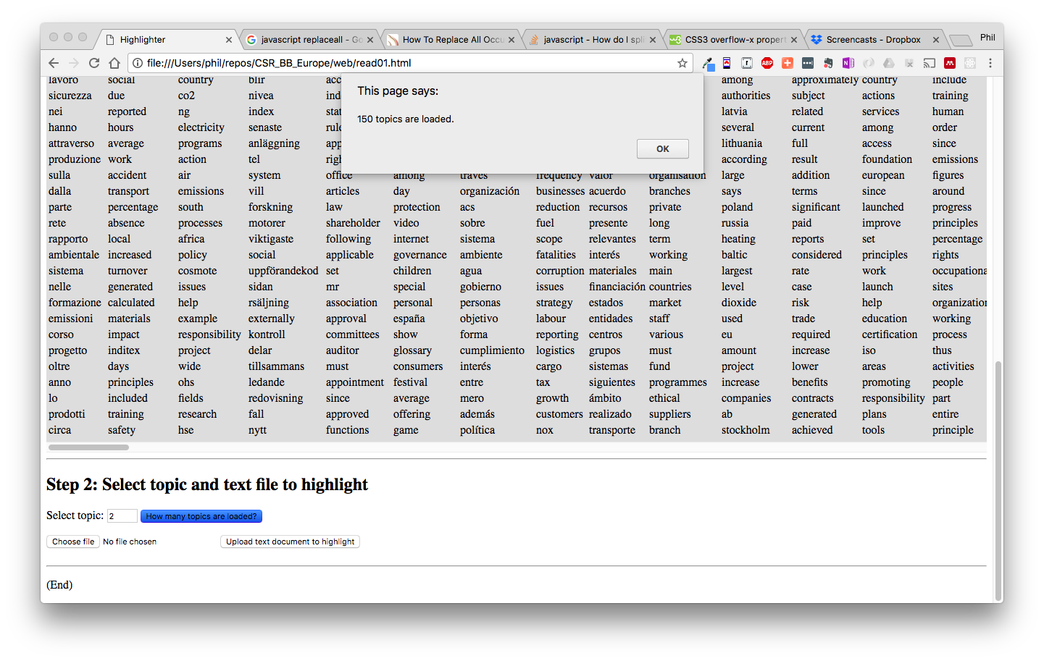

Choose file, the report text file you wish to study.

I tested with the same word vector csv because I know the words are in it.

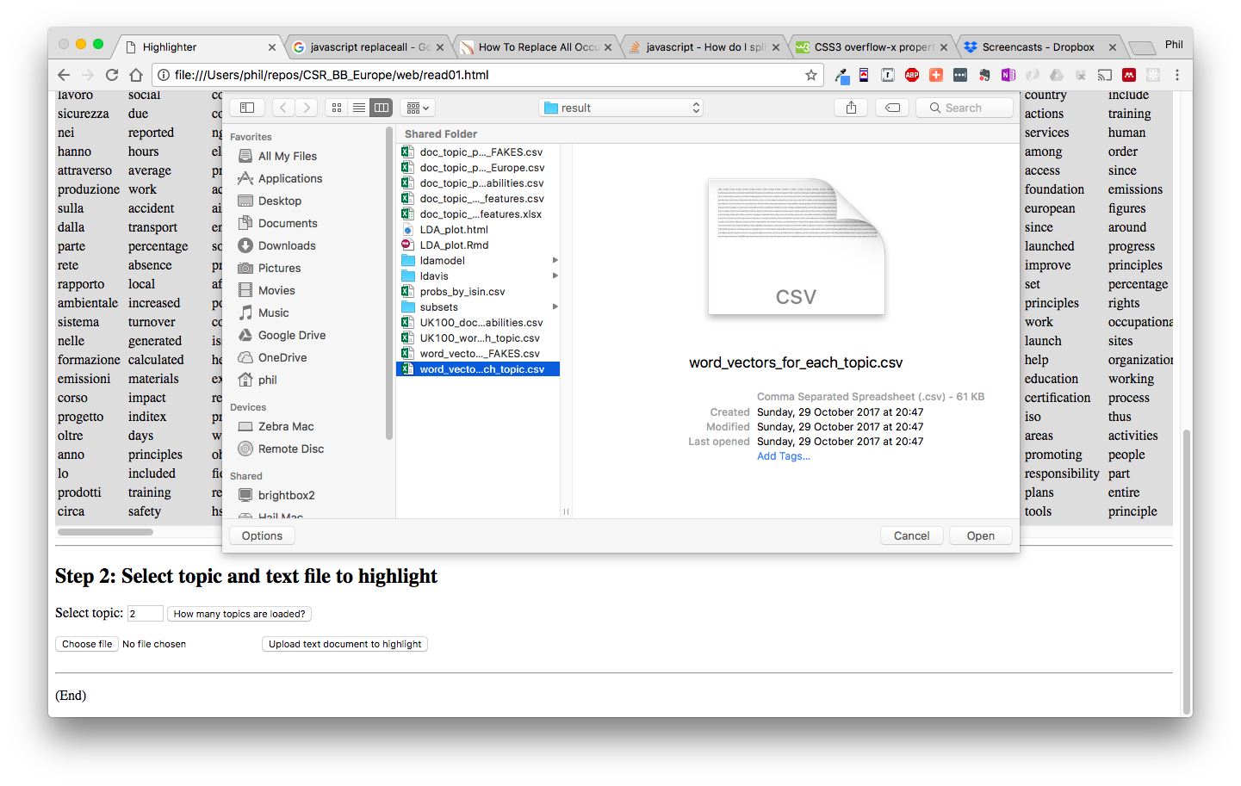

Scroll to see the report in grey background, all occurrences of topic words are bold and red.

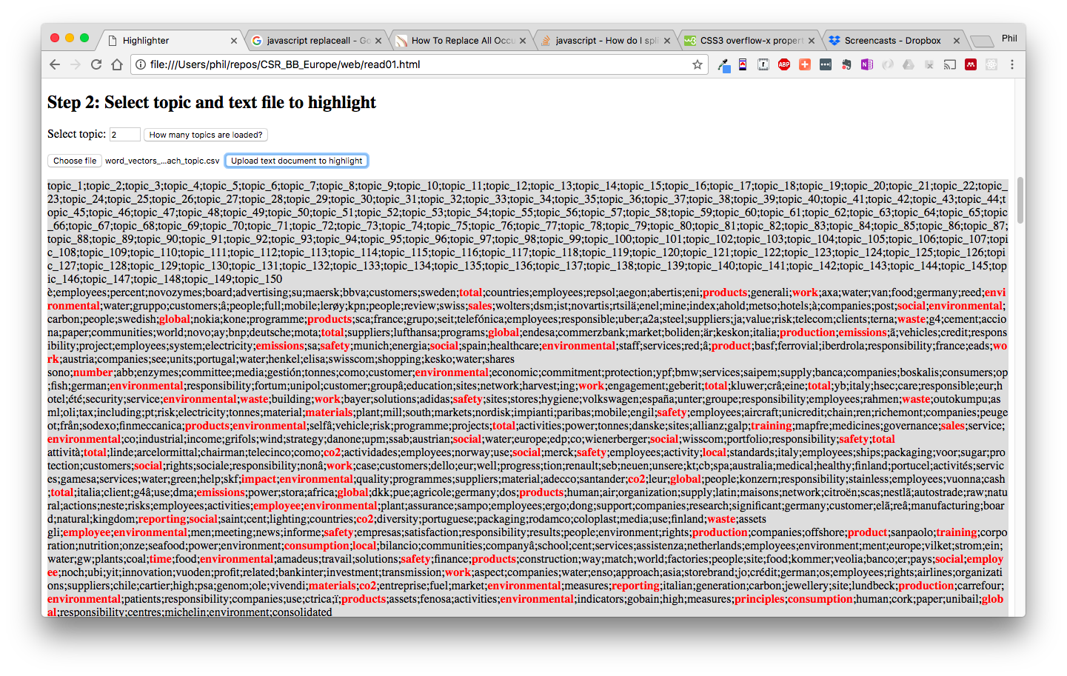

Repeat by selecting another topic number or file and press ‘Upload text document to highlight’ again.

Not yet tested

* topic words with hyphens
* real text reports