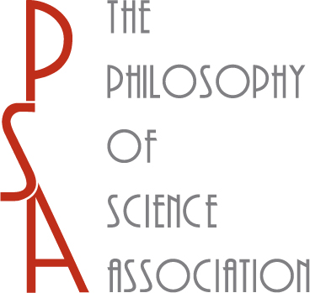 **2010 PSA ELECTION**

**PSA GOVERNING BOARD AND  
PSA PRESIDENCY**

**CALL FOR NOMINATIONS**

On December 31, 2010, four of the eight members of the current PSA Governing Board—Heather Douglas, Sandy Mitchell, John Norton, and P. Kyle Stanford—will end their second terms, and PSA President-Elect James Woodward will succeed Nancy Cartwright as PSA President. In its 2010 Election the PSA will elect four members of its Governing Board, each of whom will serve a four-year term beginning January 1, 2011, and a President-Elect, who will serve a two-year term as PSA President beginning January 1, 2013.

Per the By-Laws of the Philosophy of Science Association (Art. IV, §§6-7) nominations to run for the Governing Board and the Presidency of the PSA may be made by any fifteen full members of the PSA. Accordingly the PSA Nominating Committee (Margaret Morrison (chair), C. Kenneth Waters, and Alison Wylie) solicits nominations from the PSA membership for both the Governing Board and the Presidency of the PSA. Nominations should be submitted by e-mail to Margaret Morrison (mmorris at chass.utoronto.ca). Nominations for either office from any fifteen Full members of the PSA will appear on the ballot of the 2010 PSA Election provided they are received by **October 15, 2010**.

PSA members are reminded that only Full or retired Full (as opposed to Student or Associate) members of the PSA are eligible to run for PSA office, nominate candidates for PSA office, and vote in PSA elections. Full members of the PSA are PSA members with “a doctoral degree or its equivalent in any philosophical or scientific field, in the broadest sense of those terms; a professional position (assistant professorship or above, or the equivalent) in any of these fields; [or] a professional research position in any of these fields” (PSA By-Laws, Art. II, §2). In addition, PSA members are reminded that past Presidents of the PSA may not serve a second term as PSA President and that Governing Board members may not serve two consecutive terms.