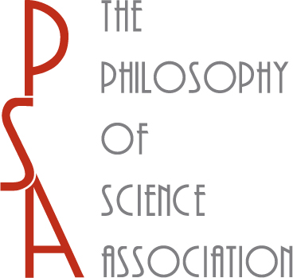 **2013 PSA ELECTION**

**PSA GOVERNING BOARD AND  
PSA NOMINATING COMMITTEE**

**CALL FOR NOMINATIONS**

On December 31, 2013, the terms of two of the eight members of the current PSA Governing Board—Roberta Millstein and Stephan Hartmann—will come to an end, as will the terms of the three members of the PSA Nominating Committee: Hanne Andersen, Kathleen Okruhlik, and P. Kyle Stanford. In its 2013 Election, the PSA will elect two members of its Governing Board, each to serve a four-year term through December 31, 2017, and three members of its Nominating Committee, each to serve a two-year term ending December 31, 2015.

Per the By-Laws of the Philosophy of Science Association (Art. IV, §§5, 7), nominations to run for the PSA Governing Board or the PSA Nominating Committee may be made jointly by any fifteen or more full members of the PSA. Accordingly, the PSA Nominating Committee solicits nominations from the PSA membership for the PSA Governing Board. Nominations for PSA Governing Board should be submitted by e-mail to P. Kyle Stanford ([stanford@uci.edu](mailto:stanford@uci.edu)). In addition, the PSA Governing Board solicits nominations from the PSA membership for the PSA Nominating Committee. Nominations for the PSA Nominating Committee should be submitted by email to Jessica Pfeifer ([psa@umbc.edu](mailto:psa@umbc.edu)).

Nominations for either position from any fifteen Full members of the PSA will appear, along with the candidates nominated through the standard committee process, on the ballot of the 2013 PSA Election.  In order to assure that the PSA election is conducted in a timely fashion, complete ballot information for candidates so nominated must be provided by **November 1, 2013.**Members intending to organize such a nomination are requested to inform the Executive Secretary and Treasurer at [psa@umbc.edu](mailto:psa@umbc.edu) by **October 1**, so that we can clear time to incorporate the nominations (along with candidate information) into the ballot.

PSA members are reminded that only Full or Retired Full (as opposed to Student) members of the PSA are eligible to run for PSA office, nominate candidates for PSA office, and vote in PSA elections. Full members of the PSA are PSA members with “a doctoral degree or its equivalent in any philosophical or scientific field, in the broadest sense of those terms; a professional position (assistant professorship or above, or the equivalent) in any of these fields; [or] a professional research position in any of these fields” (PSA By-Laws, Art. II, §2). In addition, PSA members are reminded that PSA Governing Board members may not serve two consecutive terms.