Software for the Global Market II

Phase 2

# Group Number:

Group 13

# Group Members:

1. C17425952 Declan Throne
2. C16475956 Conor Monahan
3. C17337523 Arkadiusz Rybicki
4. C17319656 Harry Bebbington
5. C17433026 Philip Toolan

# Concept and scope (Extended/corrected from phase 1)

The concept of our app is a website of surfing locations across Ireland, which people can view, to see if they want to visit. The site will focus on highlighting the optimum locations in the country for the ultimate surfing experience.

The site is aimed at Students who are looking for cheap places to visit while still maximising the experience.

The basic site architecture consists of a header, nav bar or drop-down menu depending on the user, space for content and a footer.

Each member developed a page focusing on one surfing location in Ireland:

Philip – Bundoran – Donegal

Conor – Bellmullet – Mayo

Arek – Strandhill – Sligo

Harry – Lahinch – Clare

Declan – Ballybunnion – Kerry

Different aspects of the site are also spread across our group members. Harry has implemented our basic site structure and the design for a German user, Declan has implemented the design for our Korean user, Arek and Conor have implemented the design for our polish user, Philip and Conor have implemented our language codes and ensured that our site can vary across our numerous users.

# Internationalization, Localization and Culturalization (Extended/corrected from phase 1)

The languages we are addressing other than English are Polish, German and Korean. Each group member is doing a separate page, ensuring that the translations are correct for their page.

We are using language codes and if statements to control the locale/language change within the application. We have to ensure that for each change the site adapts to fit the new format while still staying consistent across all versions.

The different styles of css are named according to their locale as to avoid confusion. The images for the different styles of pages are contained within separate folders that each are named after their particular locale.

We have offered a drop-down list with languages which allows the user to change the language/locale on demand.

The cultural dimensions we are tackling range from uncertainty avoidance and individualism and collectivism.

All group members are addressing the cultural dimensions for their own pages.

# Personas (Extended/corrected from phase 1)

Our persona template consists of goals, frustrations, personality, motivation, traits and a bio. The goals and frustrations go hand in hand as they allow us to develop scenarios for what kind of user needs our site and will use our site. Personality, motivation, traits and bio allow us to further develop the persona into a realistic user of our site. They allow us to build a full picture of the potential users and they ensure that we follow our design guidelines.

## Declan-

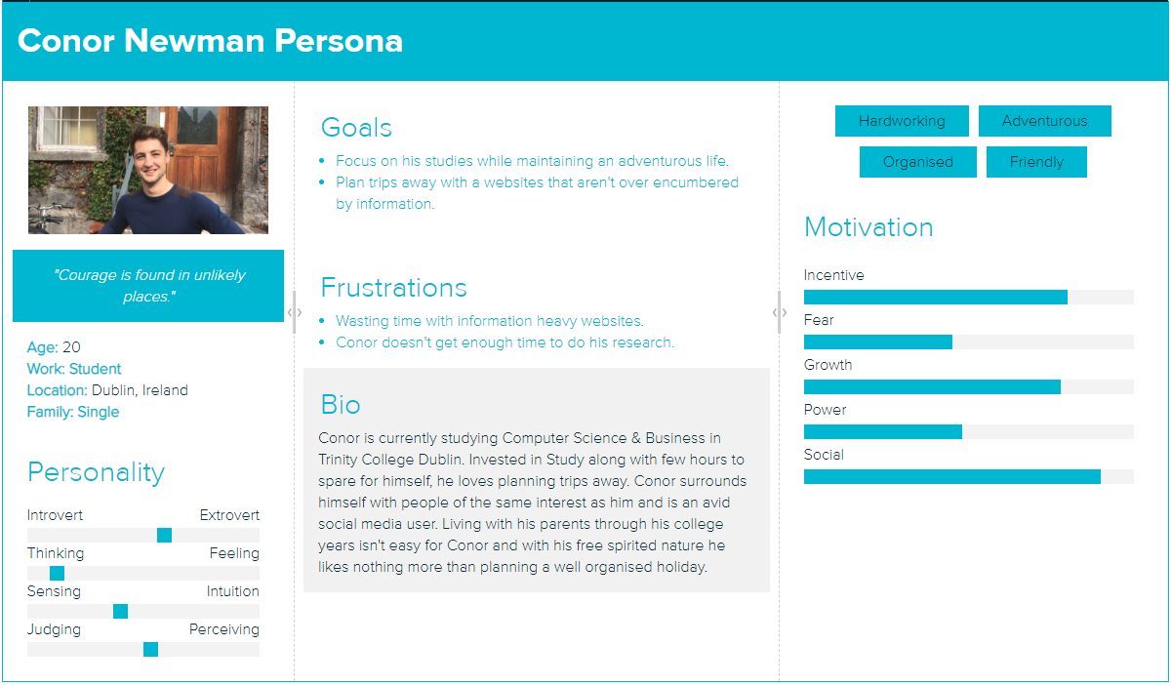

## 

## Philip-

## Conor-

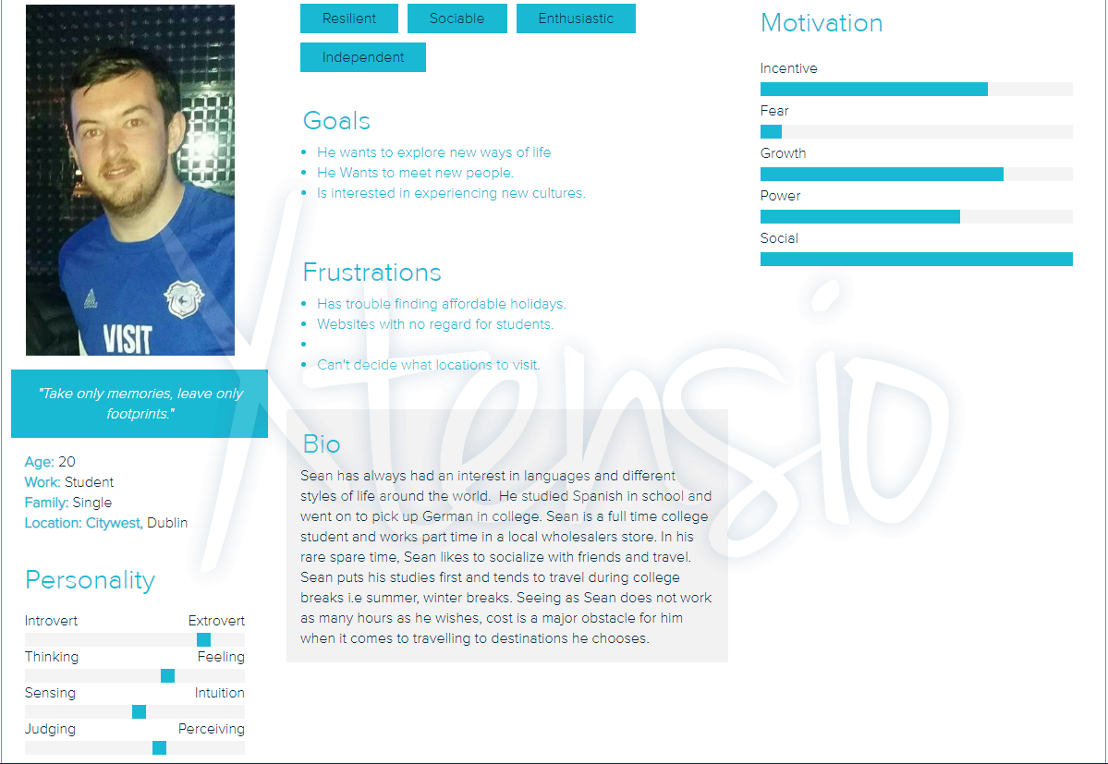

## 

## Arek-

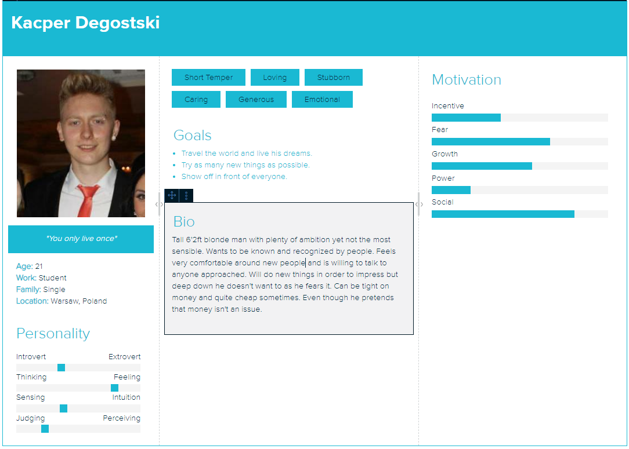

## Harry-

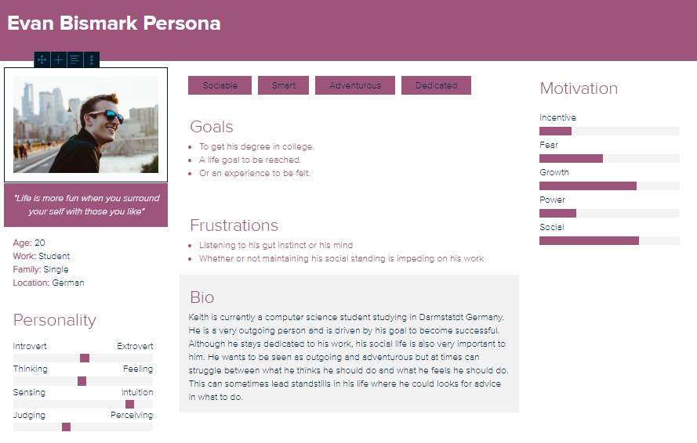

# Design Guidelines (Extended/corrected from phase 1)

The website has a simplistic design with clear indicators to specific content. Navigating through the website should be easy with plenty of eye catching and appealing images to capture the attention of the user. The layout will have a top down design, with drop down menus, point & click navigation and clear information decorating each page.

Cultural Dimensions:

Uncertainty Avoidance – Ireland and Germany have a low uncertainty avoidance, Poland and China have a high uncertainty avoidance.

The site for Germany and Ireland will be similar, it will allow for exploration by the user. Navigation will be done using a drop-down menu and all aspects of the page have a very minimalist approach.

The site for Poland and Korea follows a different approach. They have most elements explicitly pointed out to the user across the page. This allows them to get where they need to go across the site quickly.

Individualism and Collectivism – Korea has low individualism, our other 3 locales all have high individualism.

The design for the Korean site will include a lot more aspects of family and groups. Images will be focused on the experience with friends and family. Information on the page will be more focused on group activities and phrasing is changed to reflect this also.

The design for Ireland, Germany and Poland is more focused on the individual. Images will be of lone surfers and will show the kind of wild experience someone would be able to get. Information is more about the adventure rather than family activities.

# Wireframes (Extended/corrected from phase 1)

# Harry-WireFrame

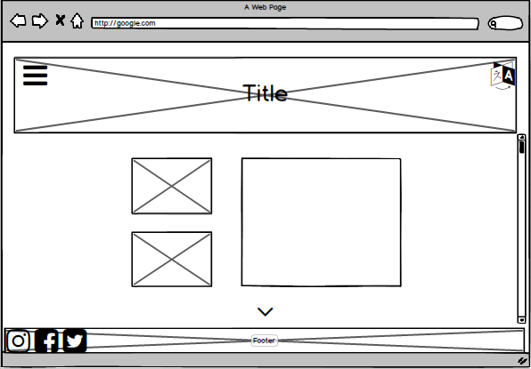

This frame is the basic design for the site used by an Irish Person and a German person.

Ideal for a linear active personality commonly found in German people and is also suited to our cultural dimensions for both of these users. Irish and German users both have low uncertainty avoidance and have both got high individualism. This design allows the user to explore at their own pace and doesn’t bombard them with all possible information at once.

This wireframe is suited for the following user personas we have developed: Evan Bismark, Conor Newman and Sean.

# Arek-WireFrame

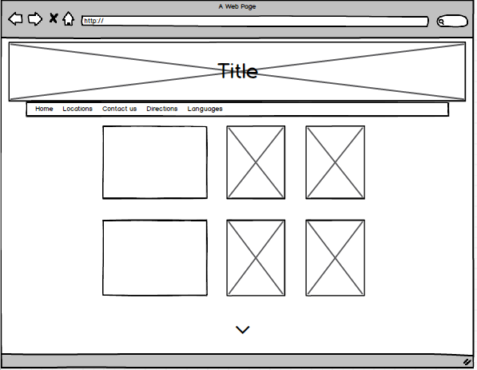

This design is suited to a user that is factual and linear-active and multi-active, like those found in Poland. This design also fits our cultural dimensions as the information is clearly displayed for the Polish user who has a high uncertainty avoidance. The design consists of images and text simply displayed and also shows all pages the user can travel to.

This wireframe suits our user persona from Poland Kacper Degostski.

# Philip-WireFrame

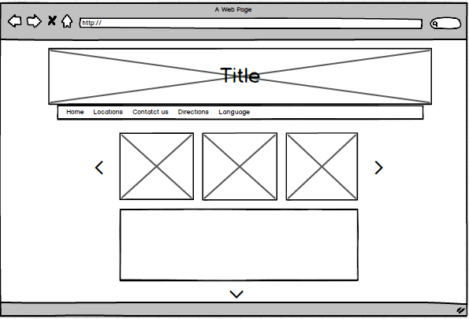

This design is ideal for the Korean market. It still follows our design guidelines of having a minimalistic design. It is ideal for a reactive society like Korea. The design fits our cultural dimensions as it provides the Korean user with all the information they need at once. The design allows for multiple images which will include family and group activities as the Korean user has low individualism.

# Implementation

Every page can be launched in the side menu of the home page. Each page (Bundoran - Philip, Lahinch - Harry, Ballybunnion - Declan, Bellmullet - Conor and Strandhill - Arek) must be able to adjust to all of our cultural dimensions and languages. Each of us developed those pages with the wireframes we had completed in mind. When a language is changed, it changes the layout, content and images of the page based on the particular user persona who would use that language.

The layout is controlled by if statements in the html files. The css, images and javascript for the pages are held in the static folder in the g13app folder. Different images and css are called based on the language code that is desired.

We start on the homepage in English, this is for our Irish persona. The design is very minimalist and it allows the user to explore the site. When you press on the side bar it pops out giving you the options of changing to a different page or changing the language.

If we change to German, you can see that the page is much the same bar for some differences in content (Images and language). This is because Germany has similar values for individualism and uncertainty avoidance as Ireland does.

When we switch to Polish (again in the sidebar), we can see the first big change which is navigation. Our Polish user has a higher uncertainty avoidance than our Irish and German users. The navigation is held in a bar at the top of the page rather than in the side menu. The actual content of the page is slightly altered again like the German page as they have similar values for individualism.

We can then select the korean option in the navigation bar. This is the biggest change for the site, we have a lot more images and a lot more hand holding. The Korean user has high uncertainty avoidance and low individualism so the pictures are focused more on groups than individuals and navigation is kept simple. These rules are kept the same across all pages on the site.