BeSecured
P12 – Personal Cybersecurity Risk Scanner
WEEK 3 DESIGN REPORT

Project Manager: Mohammedreda El Aroui
Version 1.0 | April 2026 | Sprint: Week 3 of 10
Phase | Status
System Design | In Progress
Duration | Owner
10-week project | Devs / PO

1. Project Overview
BeSecured is a 10-week academic project building a lightweight cybersecurity risk scanner for individuals and small organizations with little to no technical background. The tool scans users' environments for common vulnerabilities, computes a risk score (0–100), and presents clear, actionable recommendations through an intuitive dashboard.

This Week 3 report consolidates all System Design sprint outputs:

- System architecture diagram
- Module breakdown: Scanner, Risk Engine, Dashboard, AI module (optional)
- UI wireframes for all 5 core screens
- Full product backlog and risk register

2. Sprint Schedule — Week 3 in Context
Week | Phase | Key Tasks | Owner | Deliverable
W1 | Kick-off | Finalize charter, repo setup, DoD, tooling | PO / SM | Project Charter
W2 | Planning | Backlog, story mapping, risk register, tech stack | PO / SM | Project Plan + Backlog
W3 ▶ | System Design | Architecture, modules, data-flow, UI wireframes | Devs / PO | Design Docs & Wireframes
W4 | Env. Setup | CI/CD, skeleton codebase, test framework | Devs | Working Dev Env + CI
W5 | Scanner | Open ports, passwords, firewall, software checks | Devs | Scanner Module
W6 | Risk Engine | Scoring algorithm, severity weights, false-positive layer | Devs | Risk Score Engine
W7 | Dashboard | UI, issue list, remediation steps, export | Devs / PO | Dashboard + Export
W8 | AI (opt.) | LLM plain-language explanations (if time allows) | Devs | AI Module
W9 | Testing | Unit/integration/UAT, bug fixes, privacy audit | All | Test Report
W10 | Delivery | Final demo, docs, code freeze, handoff | All | Final Presentation

3. System Architecture
BeSecured follows a clean three-module pipeline. All processing occurs locally — no data is ever stored or transmitted outside the user's device. The architecture below was produced during the Week 3 sprint and represents the agreed system design before development begins.

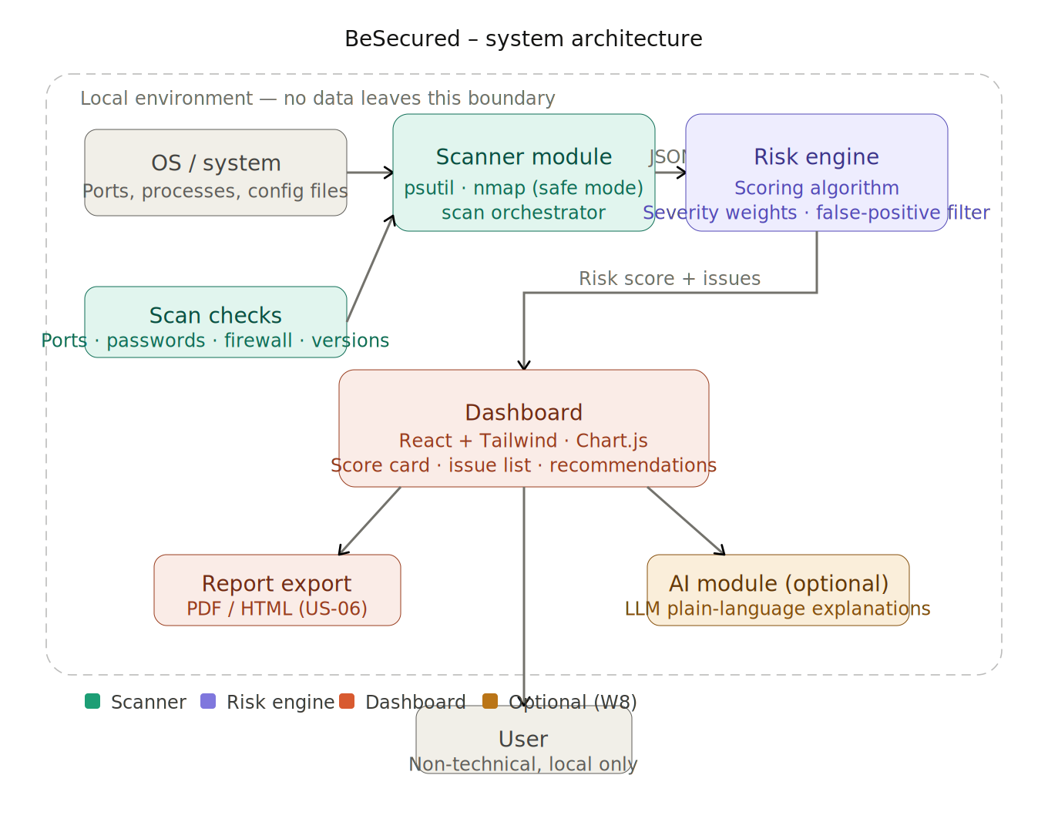
Figure 1 — BeSecured system architecture: Scanner → Risk Engine → Dashboard (all local)

4. Module Breakdown
The four modules below define the full scope of BeSecured. Each has a defined owner, sprint target, purpose, inputs, and outputs. The AI module is optional and will be descoped if Week 8 is at risk.

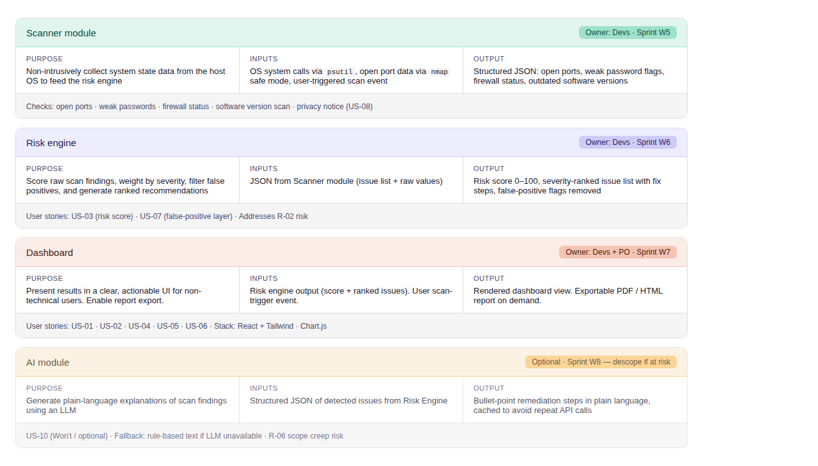
Figure 2 — Module breakdown: Scanner (W5), Risk Engine (W6), Dashboard (W7), AI optional (W8)

5. UI Wireframes
Five screens have been wireframed to guide the Dashboard sprint (W7). Each screen maps to one or more user stories and is designed for non-technical users — plain language, large visual cues, one primary action per screen.

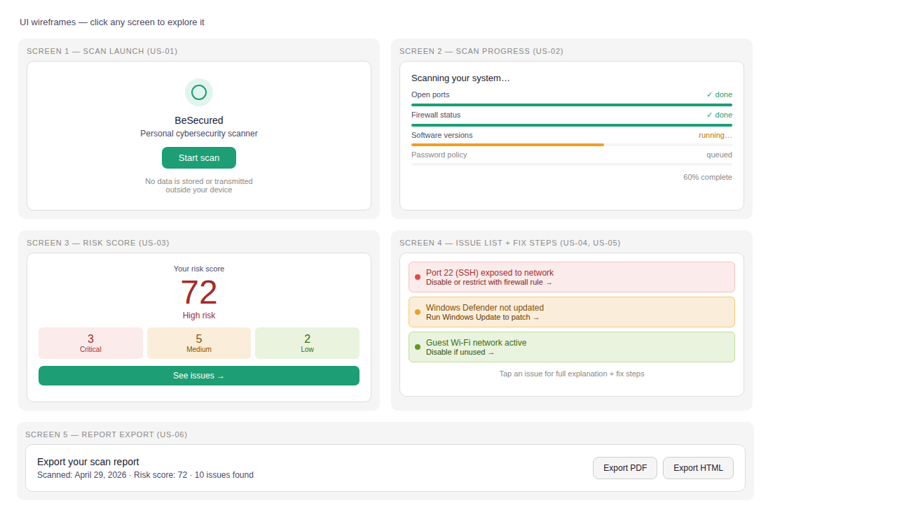
Figure 3 — UI wireframes: Scan Launch · Progress · Risk Score · Issue List · Report Export

Screen | Name | Key Elements | User Stories
1 | Scan Launch | App logo, 'Start Scan' CTA, privacy notice | US-01 · US-08
2 | Scan Progress | Real-time progress bars per check category | US-02
3 | Risk Score Dashboard | Large score, colour-coded severity breakdown | US-03
4 | Issue List + Fix Steps | Colour-coded issue cards with one-line fix hints | US-04 · US-05
5 | Report Export | Scan metadata, Export PDF and Export HTML buttons | US-06

6. Product Backlog (User Stories)
Prioritized using MoSCoW. Story points on a Fibonacci scale. Total: 63 pts (Must 37 · Should 8 · Could 5 · Won't/opt. 13).

ID | User Story | Pts | Priority | Sprint
US-01 | As a user, I can launch the scanner with one click | 5 | Must | W5
US-02 | As a user, I see a real-time progress bar during the scan | 3 | Should | W5
US-03 | As a user, I receive a risk score (0–100) after each scan | 8 | Must | W6
US-04 | As a user, I can view detected issues sorted by severity | 5 | Must | W7
US-05 | As a user, each issue has a plain-language explanation + fix steps | 8 | Must | W7
US-06 | As a user, I can export my scan report as PDF or HTML | 5 | Should | W7
US-07 | As a user, a false-positive layer cross-checks results before display | 8 | Must | W6
US-08 | As a user, I am informed no personal data is stored/transmitted | 3 | Must | W5
US-09 | As a user, I can re-run a scan and compare results over time | 5 | Could | W8
US-10 | As a user, I can get AI-generated risk explanations (optional) | 13 | Won't (opt.) | W8

7. Risk Register & Mitigation
Severity scale: 5 = Critical · 4 = High · 3 = Medium. Each risk includes a designated owner and concrete mitigation.

ID | Risk | Sev. | Level | Mitigation | Owner
R-01 | Difficulty accessing system data (OS restrictions) | 4 | High | Fallback to limited checks; notify user of reduced accuracy | Devs
R-02 | False positives mislead users | 3 | Med | Add validation layer to cross-check results before display | Devs
R-03 | Performance degradation during scan | 3 | Med | Apply optimization techniques; cap scan scope if needed | Devs
R-04 | Data privacy concerns / legal restrictions | 5 | Critical | No sensitive data stored or transmitted; clear privacy notice in-app | SM / PO
R-05 | Team lacks cybersecurity expertise | 3 | Med | Instructor feedback loops; dedicated research time each sprint | All
R-06 | Schedule slippage (AI scope creep) | 4 | High | Treat AI as optional; descope if W8 is at risk | PO / SM

8. Success Criteria
ID | Criterion | Measurable Target
SC-01 | Application stability | ≥ 95% of test runs execute without critical errors
SC-02 | Risk score generation | 100% of valid scans produce a cybersecurity risk score
SC-03 | Vulnerability detection | ≥ 80% of known test-case vulnerabilities correctly detected
SC-04 | User comprehension | ≥ 80% of test users rate recommendations as clear and useful
SC-05 | Usability | A new user completes a full scan in under 5 minutes without help
SC-06 | Schedule | All 10 deliverables delivered within the defined weekly schedule
SC-07 | Team velocity | ≥ 90% task completion rate per sprint
SC-08 | Privacy compliance | Zero sensitive data stored or transmitted outside user's device

9. Next Steps — Week 4
- Set up dev environments for all team members (Python venv + Node/React)
- Configure GitHub: branch protection, PR review rules, GitHub Actions CI/CD pipeline
- Create skeleton codebase: Scanner stub, Risk Engine stub, React project scaffold
- Pre-commit hooks (Husky + eslint / flake8) for code quality enforcement
- Establish unit test framework: pytest (backend) + Jest + React Testing Library (frontend)
- Review architecture and module interfaces with instructor
- Present Week 3 artefacts at Friday sprint review for sponsor feedback

All Week 3 design artefacts are complete and ready for review.

Prepared by: Mohammedreda El Aroui | Project Manager, BeSecured P12 | April 2026

