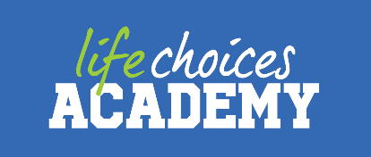

**Overview:**

Full Name: Philani Sthembiso Ndhlela

Date of Birth: 1998-01-02

Gender: Male

Location (suburb): Parow

Nationality (or legal status in this country): South African

Willing to relocate (Yes/No – Then where Johannesburg, Pretoria or Durban): Yes

Where: Johannesburg,Pretoria or Durban

Do you have support in the above region: If yes please describe and who will you be staying with? Please note guys that support will take priority here so if you have family that can support you then good.

JHB and Pretoria- I have a family that would be willing to host me for as long as I am in need.

KZN- I have a friend who lives in his flat.

Any type of criminal record: Yes/No (please be as honest as possible – companies check this): No

Are you blacklisted or do you have any credit issues? Yes/No: No

**Student Bio:**

**Please supply us with a bio of yourself**

I am a problem solver who always stays focused until I achieve what I have set my mind to. I believe that failure is a stepping stone to everything I do and always puts others first. I am a man of action and will stay true to my word. I aspire to be a full stack developer one day.

**Please provide us with an idea as to where your passion for the tech space came from.**

In my early high school years, I would go to the community centre after school to do research on the computers into film production (one of my passions). While at the centre, I would help the staff to type up documents. Eventually, I got curious about how computers operate and how they are able to do what they do and that is how I fell in love with coding.

**Passion Board:**

* Acting
* Debate
* Soccer
* Reading
* Singing (choir)

**Education:**

**Matric (year and school):** Amadlelo Aluhlaza Secondary School, 2016

**Any other education (even if you have no completed it please give details):**

University name: University Of Johannesburg

Course name: Bsc in Informatics in Computer Science

Period: 2017 only

Completed: no

**Any other education (even if you have no completed it please give details):**

University name: Cape Peninsula University of Technology

Course name: ND: Electrical (control systems) Engineering

Period: 2018-2019

Completed: no

**Working Experience:**

Company: Wimpy Restaurant

Period: 2014-2019 (part-time)

Role: Waiter

Duties:

* working at the till.
* Taking and making orders for customers.
* Drawing kids.
* Counting the stock and helping the supervisor.

Contact me

Email: philanisithembiso@gmail.com

LinkedIn: <https://www.linkedin.com/in/philani-sithembiso>

GitHub: <https://github.com/Philan-igmt>