Model Performance Report — Baseline Logistic Regression
Accuracy
The model achieved an accuracy of 36%, meaning it correctly classified market direction slightly above random guessing (which would be 33% for three classes).
As a baseline model, this level of performance is expected, but it shows considerable room for improvement.
Confusion Matrix Analysis
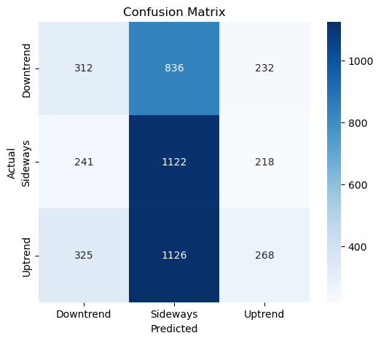
Rows = true labels
Columns = predicted labels
True Downtrend (1380)
- Correctly predicted: 312
- Predicted as Sideways: 836
- Predicted as Uptrend: 232
Majority of downtrend days are misclassified as Sideways.
True Sideways (1581)
- Correctly predicted: 1122
- Misclassified as Downtrend: 241
- Misclassified as Uptrend: 218
The model strongly favors Sideways predictions.

True Uptrend (1719)
- Correctly predicted: 268
- Misclassified as Sideways: 1126
- Misclassified as Downtrend: 325
Most uptrend days (65%) are incorrectly predicted as Sideways.
Summary of Key Insights
Strengths
- Good at detecting Sideways movement (high recall).
- Provides a realistic baseline for comparison with advanced models.
Weaknesses
- Downtrend and Uptrend are poorly detected.
- Strong bias toward predicting Sideways, leading to imbalance in predictions.

Random Forest Model Performance Summary
The initial Random Forest model achieved an accuracy of 34.7%, which is only slightly above random chance (33% for three classes). This indicates that the model struggles to reliably predict daily stock movement.
Confusion Matrix Interpretation
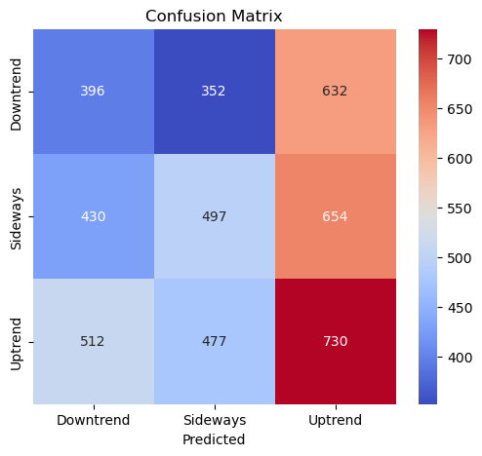
Key Insights
- Downtrend (Row 1):
Only 396 out of 1,380 downtrend days were correctly predicted.
A large number were misclassified as Sideways (352) or Uptrend (632).
- Sideways (Row 2):
The model correctly captured 497 sideways days out of 1,581.
Misclassification was high, with many predictions falling into Downtrend (430) and Uptrend (654).
- Uptrend (Row 3):
Uptrend had the highest correct predictions (730 out of 1,719),
but still suffered heavy confusion with Downtrend (512) and Sideways (477).
Overall Interpretation
- The model does not show strong predictive power for any of the classes.
- All classes experience heavy misclassification, which limits the model’s usefulness.
- Accuracy is similar to the logistic regression baseline, suggesting that features may not contain enough signal, or the market is too noisy for this modeling approach.
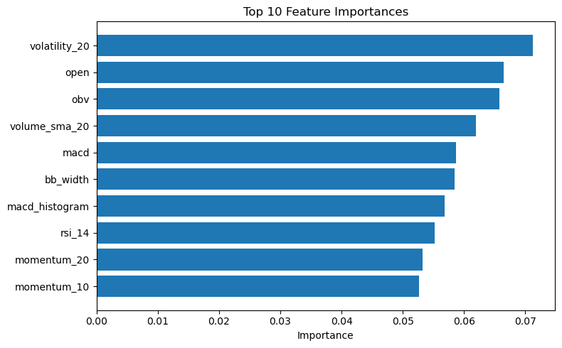
The above features in the bar plot are the top 10 importance features random forest selected and the following insights explain why these features are important.
1. Trend direction indicators
- MACD
- MACD histogram
- Momentum_20
- RSI_14
- Return_lag_1
These help the model understand where price is moving.
2. Volatility indicators
- volatility_20
- bb_width
The model uses these to understand trend strength and breakout potential.
3. Volume indicators
- OBV
- volume_sma_20
The model checks whether volume supports the trend.

SHAP Summary Plot
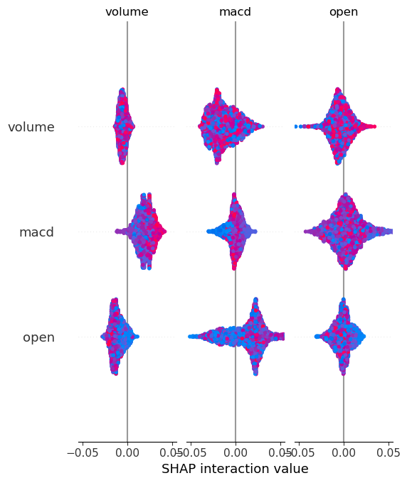
The SHAP interaction plot shows that MACD has the strongest interaction effects among the selected features. MACD combined with high volume or higher open prices tends to increase the predicted probability of an uptrend, while low MACD values combined with low volume contribute to downtrend predictions. In contrast, volume and open price do not exhibit strong interactions with each other, indicating that they mainly influence the model independently. Overall, MACD is not only important individually but also influences predictions through interactions with other features.

Market Factors That Contribute to Low Model Performance
1. Stock prices are largely unpredictable (Market Efficiency)
Financial markets—especially daily movements—tend to follow the Efficient Market Hypothesis (EMH), meaning:
- New information is absorbed instantly
- Price changes behave like random noise
- Predictable patterns quickly disappear
This makes it extremely difficult for simple ML models to reliably classify day-to-day direction.

2. High volatility and noise
Daily prices are affected by:
- News announcements
- Unexpected economic events
- Global shocks
- Market sentiment
- Intraday volatility
These events create rapid, unpredictable price movements that make Uptrend and Downtrend hard to model.
This is exactly reflected in our model low recall for these classes.

3. Class imbalance in true market behavior
Real financial markets spend more time sideways than trending.
This creates natural imbalance:
- Fewer consistent uptrends
- Fewer consistent downtrends
- Many small oscillations that look sideways
The baseline model reflects this:
High recall for Sideways
Very low recall for Uptrend and Downtrend
The market itself makes trends rare and harder to predict.

4. Overlapping patterns between classes
A sideways movement can look like:
- a weak uptrend
- a weak downtrend
- price consolidation
- noise with no clear direction
This makes the classes hard to separate.
The confusion matrix shows this clearly:
Most Uptrend and Downtrend cases were misclassified as Sideways → because the boundaries are fuzzy.

5. Technical indicators often lag behind price
Indicators like:
- RSI
- MACD
- Moving averages
- Volatility
- Momentum
are backward-looking, meaning they reflect past prices.
But the market’s next movement is driven by future news, not past behavior.
This limits how much predictive power indicators can offer.

6. Short-term random fluctuations
Daily stock movements contain a large amount of white noise:
- small price jumps
- micro-movements
- unpredictable reactions
These make short time horizons (daily direction prediction) extremely hard to model using standard techniques.

7. Lack of external market information
This baseline model likely uses only price and volume-based indicators.
But real market direction depends on many external factors:
- interest rate changes
- macroeconomic announcements
- company earnings
- geopolitical events
- investor sentiment and risk appetite
- sector rotation
Without these, the model sees only the chart—but not the forces behind it.

Summary: Why the model performs poorly
This baseline model struggles because:
- The market is mostly random and noisy at the daily level
- Trends are rare and difficult to distinguish
- Sideways movement dominates
- Indicators lag behind real market action
- External economic drivers are missing
- Daily data is too short-term to show strong signals

