**Arab Academy for Science and Technology**

Faculty of Engineering



**Project Modi-SIC Report**

**(November 2022)**

Submitted by: Philimon Elkess Dawoud

Department: Computer Engineering

Registration Number: 19102648

Submitted to: Dr. Noha Seddik

Submitted on: 21/11/2022

Table of contents Page number

1.0 About Project............................ ……………......……………………………………………..1

2.0 Sample Input...................................................... ………………….........……………..............2

3.0 Intermediate.txt …....……………………………………….....................................…...…….3

4.0 Out_Pass1.txt ………………………...………………….……………...........................….…4

4.0 Symbol_Table.txt ………………………...………………….……...................………..….…5

4.0 Out_Pass2.txt ………………………...…………….........................…….……………..….…6

4.0 HTE.txt ……………………...................................…...………………….……………..….…7

1. About Project

The project was generated by only one student using Python programming language for its flexibility and wide variety of functions, what makes it the best choice to work on such project.

The Modi-SIC project supports instructions of format one and format three either immediate or not. It helps the user recognize errors in the time of compilation specifying the type and the location of error and how to correct it.

Cases handled:

1. Any syntax errors by validating the program name length, the right syntax of START the size of the program.
2. Any syntax errors near end like its address not matching with START’s.
3. The right syntax of BYTE and its values as well as WORD and its maximum and minimum size, also RESW and RESB.
4. Checking on used label’s whether they are defined or not and checking for their repetition.
5. The program does not execute unless it is error free.
6. It ignores any operand given to a format-one instruction.
7. It gets rid of all unnecessary elements in the program text such as comments and line numbers.
8. Not only that but it may be more effective to try it to know other options.
9. Sample Input:

1 PROG1 START 2000

2 FLOAT

3 LDA GAMMA

4 STA INDEX

5 SIO

6 TIO

7 LOOP LDX INDEX

8 LDA GAMMA

9 STA ALPHA,X

10 LDA INDEX

11 ADD #3

12 STA INDEX

13 COMP K100

14 TIX TWENTY

15 JLT LOOP

16 FIX

17 INDEX RESB 1

18 ALPHA RESW 100

19 GAMMA BYTE X'0502'

20 K100 WORD 100

21 TWENTY WORD 20

22 END 2000

1. Intermediate.txt:

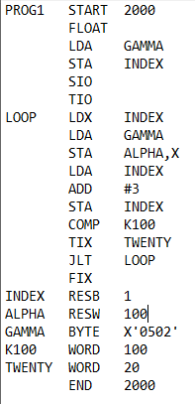

1. Out_Pass1.txt:

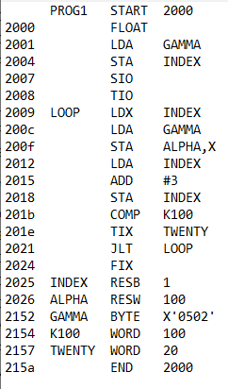

1. Symbol_Table.txt:

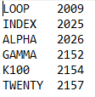

1. Out_Pass2.txt:

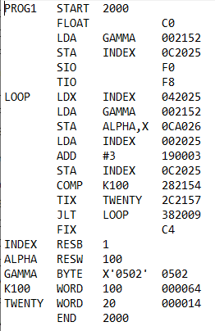

1. HTE.txt:

