[https://www.hpmagicwords.com.br/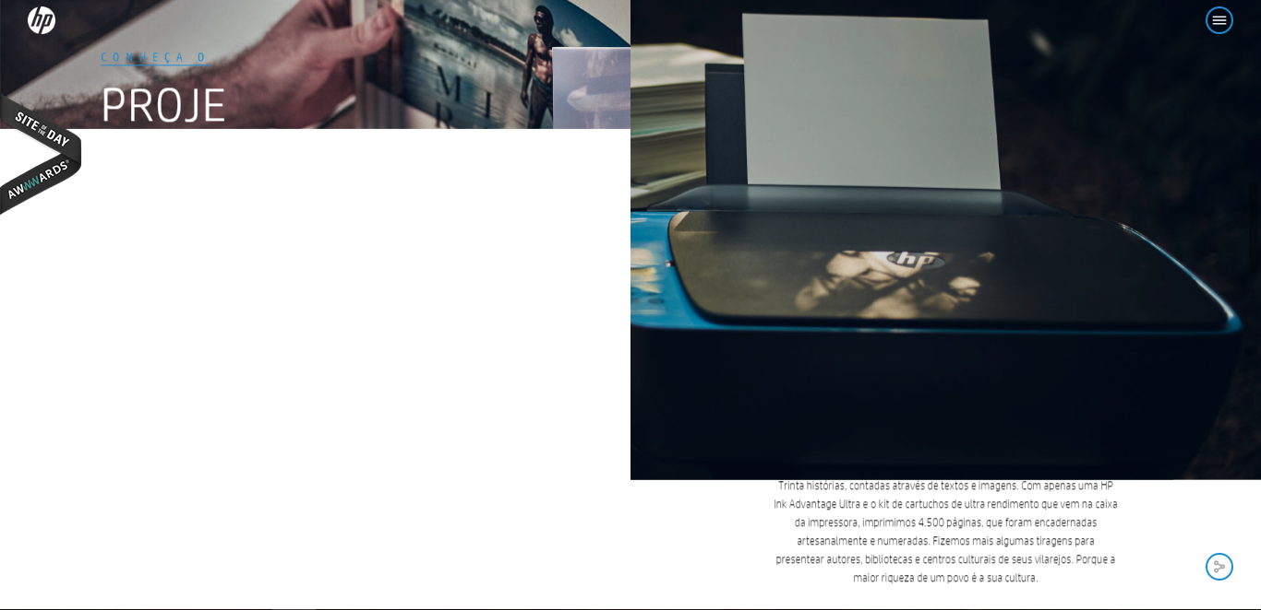](https://www.hpmagicwords.com.br/#)

[**http://falter.madebywild.com/#en**](http://falter.madebywild.com/#en)

[**http://data2.unhcr.org/en/situations#_ga=1.256076107.1389613120.1477820826**](http://data2.unhcr.org/en/situations#_ga=1.256076107.1389613120.1477820826)

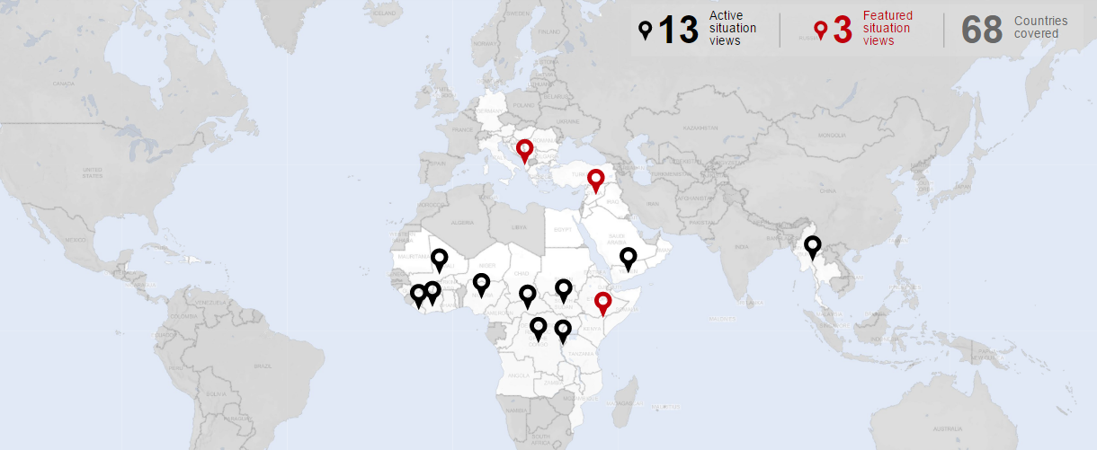 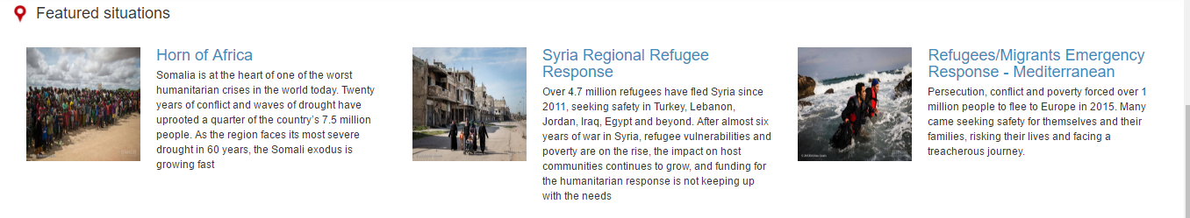

<http://masonry.desandro.com/>

Story

gallery image hover

[**https://miketricking.github.io/dist/**](https://miketricking.github.io/dist/)

[**http://www.unhcr.org/news/stories/2015/6/56ec1e9f8/the-death-boats-a-survivors-tale.html**](http://www.unhcr.org/news/stories/2015/6/56ec1e9f8/the-death-boats-a-survivors-tale.html)

[**http://www.unhcr.org/news/stories/2016/6/57714a234/aya-doesnt-die-feisty-four-year-old-syria-survives-exile.html**](http://www.unhcr.org/news/stories/2016/6/57714a234/aya-doesnt-die-feisty-four-year-old-syria-survives-exile.html)

[**http://www.unhcr.org/news/stories/2014/9/56ec1e6112/syrias-oldest-refugees.html**](http://www.unhcr.org/news/stories/2014/9/56ec1e6112/syrias-oldest-refugees.html)

[**http://www.unhcr.org/news/stories/2016/3/57441470e6/refugees-at-border-bottleneck.html**](http://www.unhcr.org/news/stories/2016/3/57441470e6/refugees-at-border-bottleneck.html)

[**http://www.unhcr.org/news/stories/2016/6/577383ed4/blind-salvadoran-couple-play-dead-flee-gang-threat.html**](http://www.unhcr.org/news/stories/2016/6/577383ed4/blind-salvadoran-couple-play-dead-flee-gang-threat.html)

[**http://www.unhcr.org/news/stories/2016/12/583d50594/young-abandoned-and-on-the-run.html**](http://www.unhcr.org/news/stories/2016/12/583d50594/young-abandoned-and-on-the-run.html)

[**http://www.unhcr.org/news/stories/2015/4/56ec1e891e/fleeing-bullets-and-then-mosquitoes.html**](http://www.unhcr.org/news/stories/2015/4/56ec1e891e/fleeing-bullets-and-then-mosquitoes.html)

[**http://www.unhcr.org/news/latest/2016/4/57178bcf6/massive-loss-life-reported-latest-mediterranean-tragedy.html**](http://www.unhcr.org/news/latest/2016/4/57178bcf6/massive-loss-life-reported-latest-mediterranean-tragedy.html)

[**http://www.unhcr.org/news/stories/2014/12/56ec1e739/rescue-from-the-boats-of-death.html**](http://www.unhcr.org/news/stories/2014/12/56ec1e739/rescue-from-the-boats-of-death.html)