Game Viewer
Web Development
Philip Griffin

Contents

Game Viewer 1
Introduction: 3
Screenshots: 3
Home Page: 3
Login: 3
Login Functionality: 4
Registration: 5
Registration Functionality: 5
Post Content: 6
Content Functionality: 6
Search: 7
Search Functionality: 8
Postman: 9
Screenshots: 9
Issues with development: 14

Introduction:
This social media site is made to post and share users’ ideas and thoughts about video games. The site allows for users to register an account along with following different users and posting their own content. Along with this the user can search for other user accounts and search for key terms within all content stored on the site. The site stores all content and user data via MongoDB.

Screenshots:

Home Page:

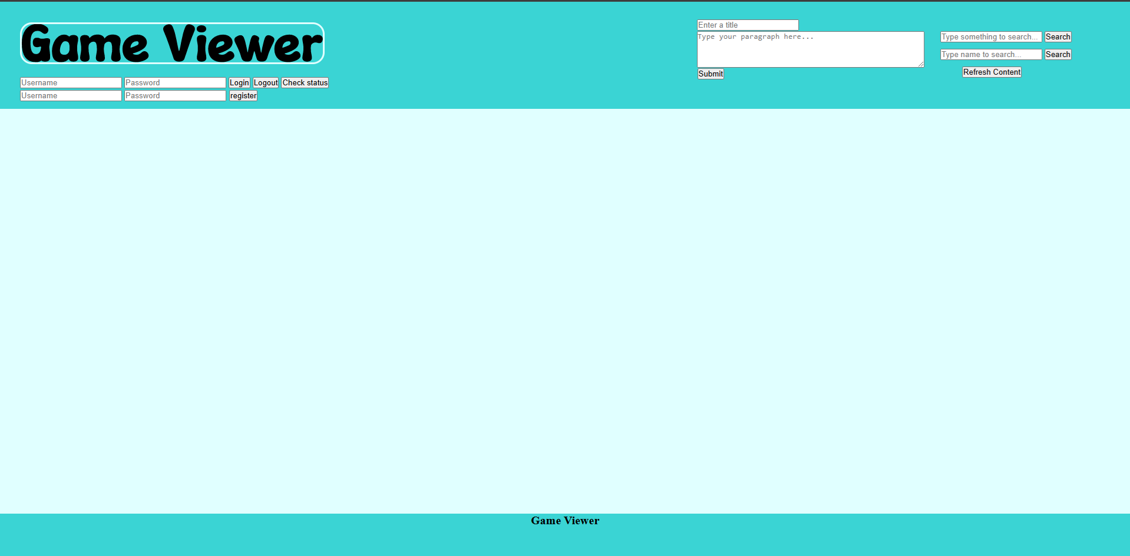

Login:
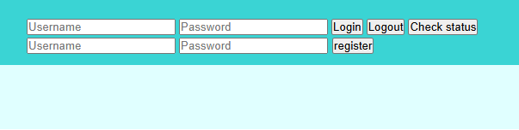

Login failure:
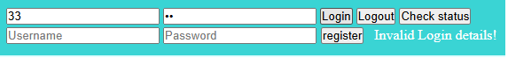

Login with no details: 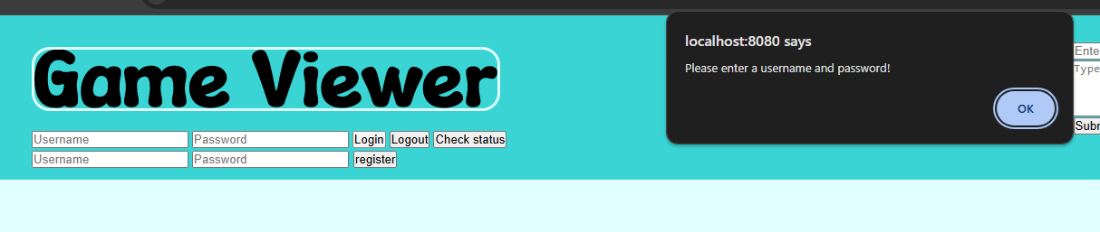

Successful login:
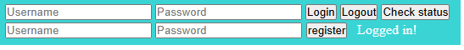

Logging out:
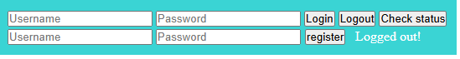

Status Check: logged in:
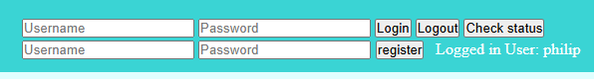
Logged out:
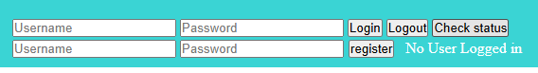

Login Functionality:
The login system allows the user to enter a username and password that is then checked against the stored usernames and passwords within the MongoDB database. If found the user is logged into the site and the session user is assigned the username entered by user. A check is made to ensure the user doesn’t leave either username or password field empty. The login button handles taking the user’s inputted data and the logout button will remove the user from the session. Along with this is a check status button to check the currently logged in user.

Registration:


Registration with no details:
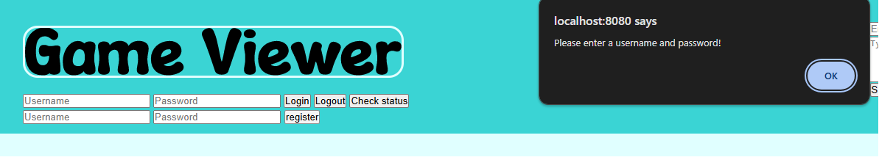

Registration with password too short:
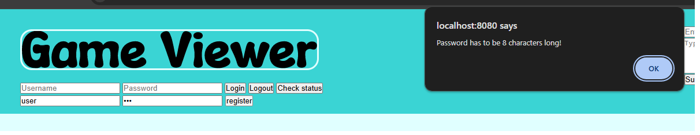

Successful Registration:
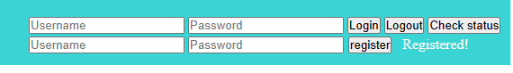

Registration Functionality:
The registration system allows the user to register a new account into the system, there is a check to make sure either field is left empty, or the password is below 8 characters. The register button will handle the data inputted by user, if checks are made and passed then details entered by user is added to the MongoDB collection.

Post Content:
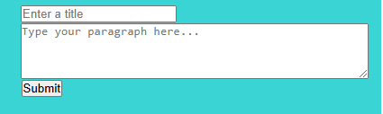

Logged out trying to post content:


Trying to post with no paragraph entered:
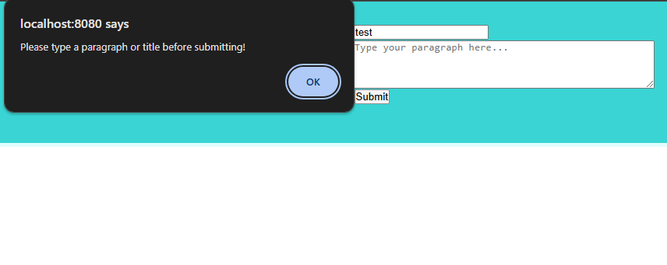

Successful content post:


Content Functionality:
This allows the user to post content in the form of a Title and Paragraph. A check is made to ensure the user is logged in when they click the submit button. Once its pressed and the paragraph field is not empty then the session username along with the title and paragraph are added to the MongoDB collection.

Search:
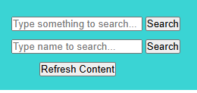

Successful game name search:
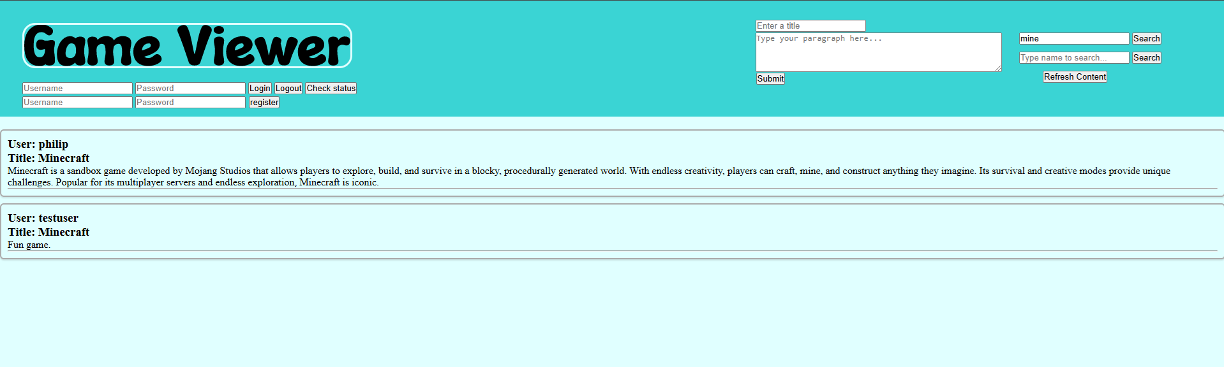

No reults found from search:
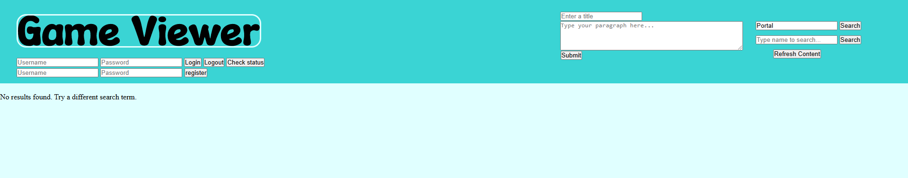

Successful user name search:
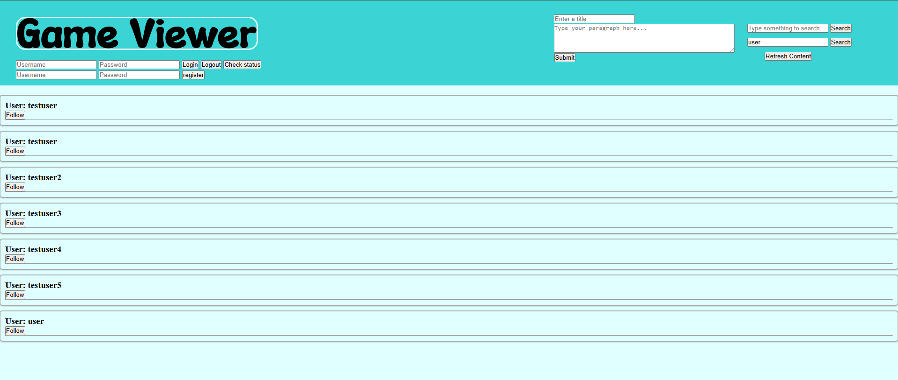

No results found from search:
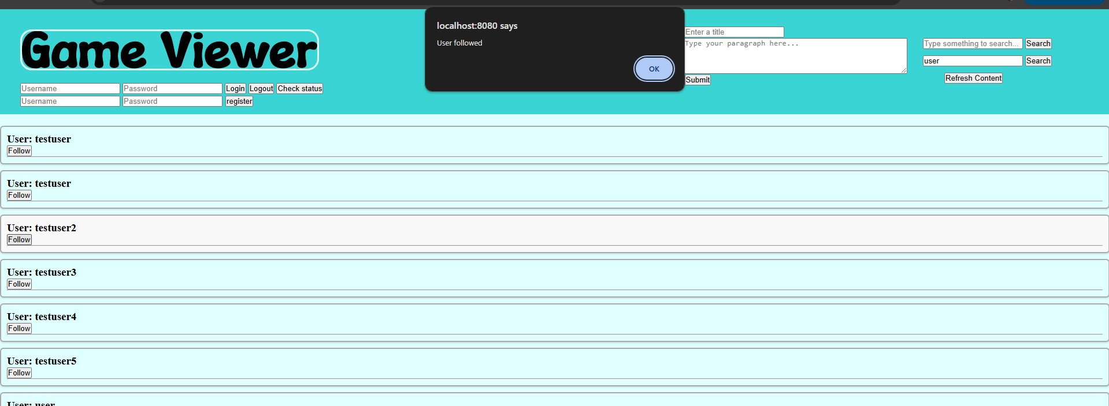

Search Functionality:
This allows the user to search either for content directly or for users. For content, the query entered by the user is to be checked against the username, title and paragraph of each item in collection, if found then the whole item is added to a list. This list is used to then display the items in order of being added, for each item in list the site displays the username, title and paragraph. For the user search, the search looks into a different collection on MongoDB which only holds the usernames and passwords ensuring only users are retrieved once. All users found by the search will have their name displayed along with a follow button allowing the user to follow the selected user.

Postman:

Screenshots:
Logout:
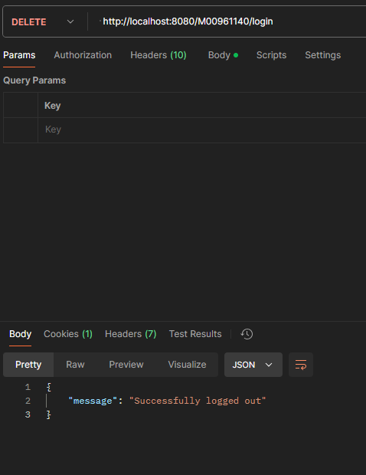

Check if login status:
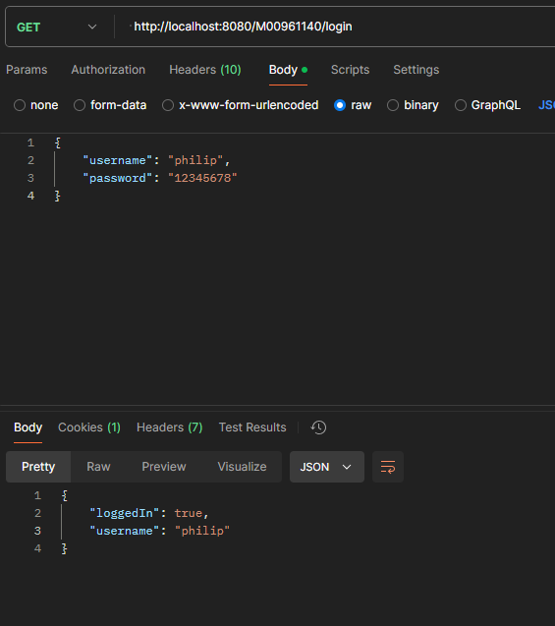

Get Content by Search:
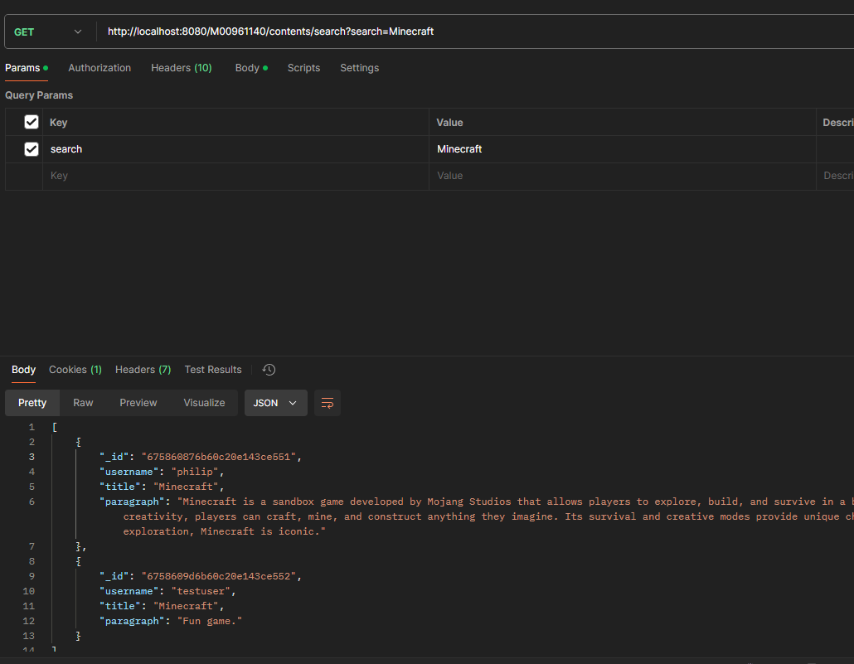

Get Users by search:
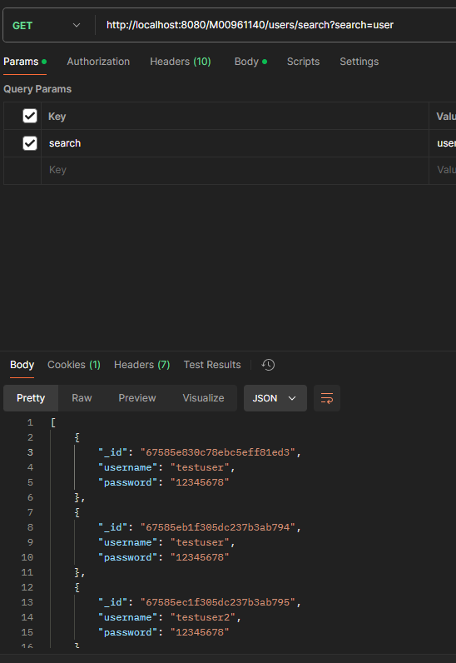

Post content:
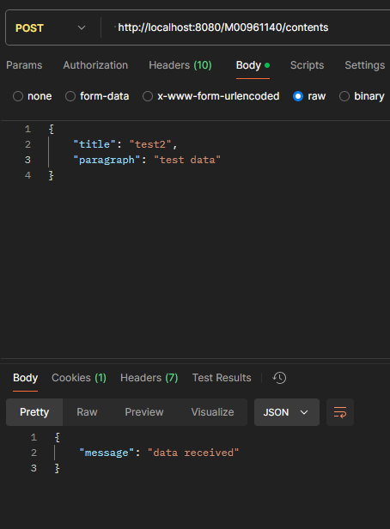

Post login:
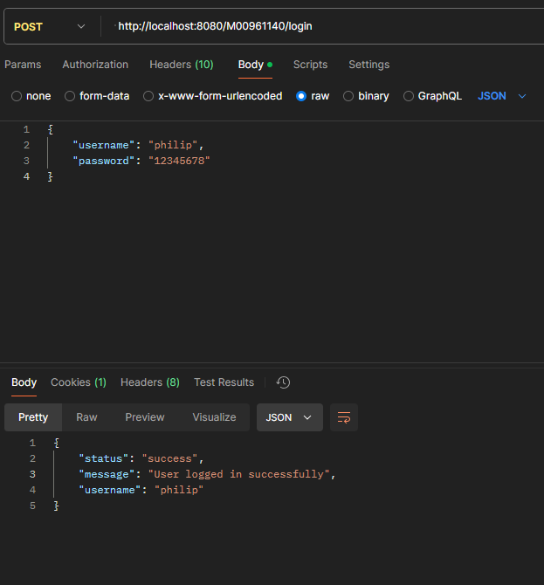

Issues with development:
Throughout the course of development of this site there have been some issues. Mainly the learning curve to web service implementation along with connection of backend and frontend via AJAX. This made development more difficult as simple additions to the site may mean a lot of complex code along with the implementation of a database that has to be properly formatted.

