Stephensi Multiplexing Analysis

P Leftwich

## Quarto

Quarto enables you to weave together content and executable code into a finished document. To learn more about Quarto see <https://quarto.org>.

## Effects of Mosaicism

# Homing Rates

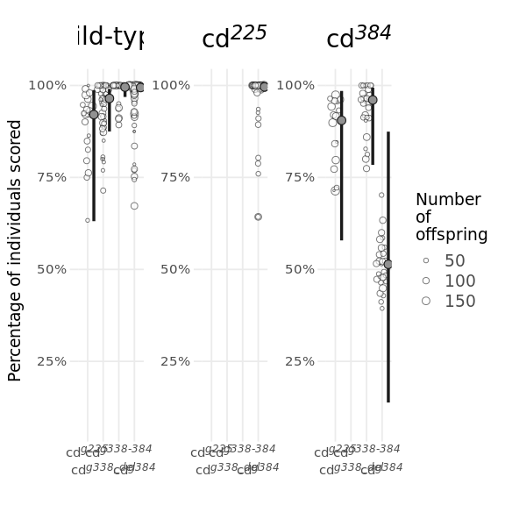

| Transgenic | wild-type | cd225 | cd384 |
| --- | --- | --- | --- |
| cdg225 | 0.92(0.63-0.99) | - | 0.91(0.58-0.99) |
| cdg338_del | 0.96(0.87-0.99) | - | - |
| cdg338-384 | 1(0.97-1) | - | 0.96(0.78-0.99) |
| cdg384 | 0.99(0.98-1) | 1(0.98-1) | 0.51(0.14-0.87) |

| contrast | odds.ratio | SE | df | null | z.ratio | p.value |
| --- | --- | --- | --- | --- | --- | --- |
| (cd<sup><i>g225</i></sup> wild-type) / (cd<sup><i>g338_del</i></sup> wild-type) | 0.42440743 | 0.50922740 | Inf | 1 | -0.71430408 | 9.966129e-01 |
| (cd<sup><i>g225</i></sup> wild-type) / (cd<sup><i>g338-384</i></sup> wild-type) | 0.05276458 | 0.07378049 | Inf | 1 | -2.10392910 | 4.122173e-01 |
| (cd<sup><i>g225</i></sup> wild-type) / (cd<sup><i>g384</i></sup> wild-type) | 0.06657149 | 0.07390452 | Inf | 1 | -2.44063618 | 2.217021e-01 |
| (cd<sup><i>g225</i></sup> wild-type) / (cd<sup><i>g384</i></sup> cd<sup><i>225</i></sup>) | 0.04769040 | 0.05817040 | Inf | 1 | -2.49479279 | 1.974525e-01 |
| (cd<sup><i>g225</i></sup> wild-type) / (cd<sup><i>g225</i></sup> cd<sup><i>384</i></sup>) | 1.22007365 | 1.69567414 | Inf | 1 | 0.14312086 | 9.999999e-01 |
| (cd<sup><i>g225</i></sup> wild-type) / (cd<sup><i>g338-384</i></sup> cd<sup><i>384</i></sup>) | 0.47621049 | 0.65620386 | Inf | 1 | -0.53839722 | 9.994526e-01 |
| (cd<sup><i>g225</i></sup> wild-type) / (cd<sup><i>g384</i></sup> cd<sup><i>384</i></sup>) | 11.00117029 | 15.09053715 | Inf | 1 | 1.74817002 | 6.553403e-01 |
| (cd<sup><i>g338_del</i></sup> wild-type) / (cd<sup><i>g338-384</i></sup> wild-type) | 0.12432530 | 0.15107897 | Inf | 1 | -1.71565947 | 6.770435e-01 |
| (cd<sup><i>g338_del</i></sup> wild-type) / (cd<sup><i>g384</i></sup> wild-type) | 0.15685751 | 0.13652129 | Inf | 1 | -2.12835365 | 3.964122e-01 |
| (cd<sup><i>g338_del</i></sup> wild-type) / (cd<sup><i>g384</i></sup> cd<sup><i>225</i></sup>) | 0.11236938 | 0.11299524 | Inf | 1 | -2.17385624 | 3.676517e-01 |
| (cd<sup><i>g338_del</i></sup> wild-type) / (cd<sup><i>g225</i></sup> cd<sup><i>384</i></sup>) | 2.87476978 | 3.47435327 | Inf | 1 | 0.87373905 | 9.883724e-01 |
| (cd<sup><i>g338_del</i></sup> wild-type) / (cd<sup><i>g338-384</i></sup> cd<sup><i>384</i></sup>) | 1.12205975 | 1.33997595 | Inf | 1 | 0.09643695 | 1.000000e+00 |
| (cd<sup><i>g338_del</i></sup> wild-type) / (cd<sup><i>g384</i></sup> cd<sup><i>384</i></sup>) | 25.92124819 | 30.79119942 | Inf | 1 | 2.74024066 | 1.106890e-01 |
| (cd<sup><i>g338-384</i></sup> wild-type) / (cd<sup><i>g384</i></sup> wild-type) | 1.26167010 | 1.41756170 | Inf | 1 | 0.20687491 | 9.999992e-01 |
| (cd<sup><i>g338-384</i></sup> wild-type) / (cd<sup><i>g384</i></sup> cd<sup><i>225</i></sup>) | 0.90383358 | 1.11103215 | Inf | 1 | -0.08225382 | 1.000000e+00 |
| (cd<sup><i>g338-384</i></sup> wild-type) / (cd<sup><i>g225</i></sup> cd<sup><i>384</i></sup>) | 23.12296662 | 32.51433489 | Inf | 1 | 2.23363704 | 3.313882e-01 |
| (cd<sup><i>g338-384</i></sup> wild-type) / (cd<sup><i>g338-384</i></sup> cd<sup><i>384</i></sup>) | 9.02519228 | 12.56316159 | Inf | 1 | 1.58046218 | 7.622595e-01 |
| (cd<sup><i>g338-384</i></sup> wild-type) / (cd<sup><i>g384</i></sup> cd<sup><i>384</i></sup>) | 208.49535857 | 289.55834696 | Inf | 1 | 3.84498625 | 3.036691e-03 |
| (cd<sup><i>g384</i></sup> wild-type) / (cd<sup><i>g384</i></sup> cd<sup><i>225</i></sup>) | 0.71637869 | 0.63841655 | Inf | 1 | -0.37427836 | 9.999522e-01 |
| (cd<sup><i>g384</i></sup> wild-type) / (cd<sup><i>g225</i></sup> cd<sup><i>384</i></sup>) | 18.32726846 | 20.52134433 | Inf | 1 | 2.59743436 | 1.566593e-01 |
| (cd<sup><i>g384</i></sup> wild-type) / (cd<sup><i>g338-384</i></sup> cd<sup><i>384</i></sup>) | 7.15336940 | 7.89339136 | Inf | 1 | 1.78311842 | 6.316480e-01 |
| (cd<sup><i>g384</i></sup> wild-type) / (cd<sup><i>g384</i></sup> cd<sup><i>384</i></sup>) | 165.25346731 | 181.36815204 | Inf | 1 | 4.65367732 | 8.859459e-05 |
| (cd<sup><i>g384</i></sup> cd<sup><i>225</i></sup>) / (cd<sup><i>g225</i></sup> cd<sup><i>384</i></sup>) | 25.58321268 | 31.43137759 | Inf | 1 | 2.63873728 | 1.421121e-01 |
| (cd<sup><i>g384</i></sup> cd<sup><i>225</i></sup>) / (cd<sup><i>g338-384</i></sup> cd<sup><i>384</i></sup>) | 9.98545807 | 12.11372343 | Inf | 1 | 1.89684333 | 5.530523e-01 |
| (cd<sup><i>g384</i></sup> cd<sup><i>225</i></sup>) / (cd<sup><i>g384</i></sup> cd<sup><i>384</i></sup>) | 230.67892576 | 278.78391872 | Inf | 1 | 4.50216148 | 1.812041e-04 |
| (cd<sup><i>g225</i></sup> cd<sup><i>384</i></sup>) / (cd<sup><i>g338-384</i></sup> cd<sup><i>384</i></sup>) | 0.39031291 | 0.54079043 | Inf | 1 | -0.67902262 | 9.975401e-01 |
| (cd<sup><i>g225</i></sup> cd<sup><i>384</i></sup>) / (cd<sup><i>g384</i></sup> cd<sup><i>384</i></sup>) | 9.01680835 | 12.43571041 | Inf | 1 | 1.59450295 | 7.538710e-01 |
| (cd<sup><i>g338-384</i></sup> cd<sup><i>384</i></sup>) / (cd<sup><i>g384</i></sup> cd<sup><i>384</i></sup>) | 23.10148660 | 31.59089814 | Inf | 1 | 2.29611350 | 2.955568e-01 |



# Meiotic Drive data

| 1 | prob | SE | df | asymp.LCL | asymp.UCL |
| --- | --- | --- | --- | --- | --- |
| overall | 0.4877789 | 0.01378523 | Inf | 0.4608223 | 0.5148069 |

| 1 | prob | SE | df | asymp.LCL | asymp.UCL |
| --- | --- | --- | --- | --- | --- |
| overall | 0.446007 | 0.01114005 | Inf | 0.4242907 | 0.4679315 |

# Indel formation

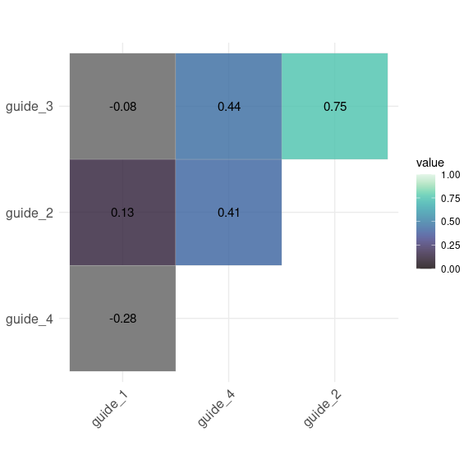

|  |  |  |  |
| --- | --- | --- | --- |
|  | cbind(`#Reads`, (10529 - `#Reads`)) | | |
| Predictors | Odds Ratios | CI | p |
| (Intercept) | 0.00 | 0.00 – 0.00 | **<0.001** |
| guide 11 | 262.37 | 184.58 – 390.24 | **<0.001** |
| guide 21 | 1.75 | 1.11 – 2.83 | **0.018** |
| guide 31 | 15.43 | 10.72 – 23.16 | **<0.001** |
| guide 41 | 33.06 | 23.14 – 49.37 | **<0.001** |
| guide 11 × as guide 21 | 0.03 | 0.02 – 0.04 | **<0.001** |
| guide 11 × as guide 31 | 0.00 | 0.00 – 0.00 | **<0.001** |
| guide 21 × as guide 31 | 0.15 | 0.09 – 0.24 | **<0.001** |
| guide 11 × as guide 41 | 0.00 | 0.00 – 0.00 | **<0.001** |
| guide 21 × as guide 41 | 0.01 | 0.01 – 0.02 | **<0.001** |
| guide 31 × as guide 41 | 0.01 | 0.01 – 0.02 | **<0.001** |
| guide 11 × as guide 21 × as factor(guide 3)1 | 990.50 | 573.94 – 1737.01 | **<0.001** |
| guide 11 × as guide 21 × as factor(guide 4)1 | 80.59 | 35.87 – 181.41 | **<0.001** |
| guide 11 × as guide 31 × as factor(guide 4)1 | 1256.30 | 776.88 – 2085.85 | **<0.001** |
| guide 21 × as guide 31 × as factor(guide 4)1 | 568.13 | 285.72 – 1169.43 | **<0.001** |
| guide 11 × as guide 21 × as factor(guide 3)1 × as factor(guide 4)1 | 0.01 | 0.00 – 0.02 | **<0.001** |
| Observations | 16 | | |