Table of Contents
Introduction 2
Task 1 3
Flowchart 3
Task 1 - Sample runs 4
Task 2 7
Pseudocode 7
Task 2 of sample runs 8
Task3 13
Flowchart 13
Task 3 sample runs 14
References 16
Appendix A - Pseudocode 17
Appendix B – Task 1 Python Code 18
Appendix C – Task 2 & 3 Python Code 19
Appendix D - Addition Screenshots 26

Introduction
This report will outline the development process for the creation of a new software system for a small shop that loans fishing and camping equipment. Each task utilized the program development cycle where a design was created in the form of flowcharts and pseudocode, where after code was written in accordance with the design using appropriate syntax. Once all syntax errors were corrected and program was in an executable state, extensive testing was done to verify if the logic worked as intended. In the cases where results showed logic errors the process was repeated until no error was found (Gaddis, 2024).

Task 1

Flowchart
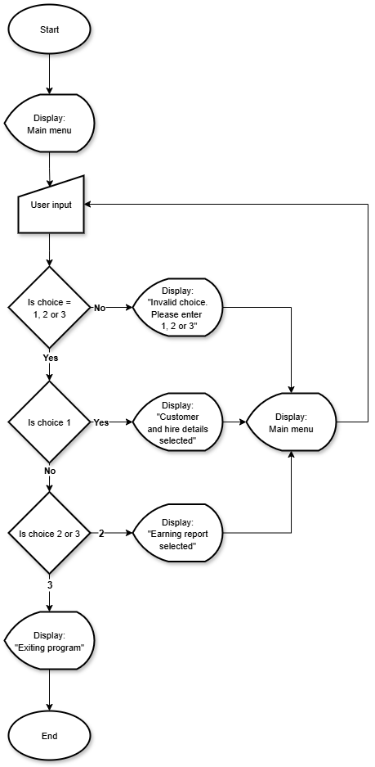
Figure 1 - Task 1 Flowchart
The flowchart as seen in figure 1 represents the algorithm used for the main menu. When program starts, the users is presented with three options (Customer and hire details, Earnings report, and Exit).
The program first checks whether the input is valid. If the input is invalid, the message “Invalid choice. Please enter 1, 2 or 3” is displayed and the user is redirected back to the menu. If the input is valid, the program displays a message based on the option chosen.
Option 1 displays “Customer & hire details selected” and returns to the menu.
Option 2 displays “Earnings report selected” and returns to the menu.
Option 3 displays “Exiting program” and ends the program.

Task 1 - Sample runs
The following screenshots shows that the program manages both valid and invalid inputs correctly.
The return to main menu has not been shown in these examples, however additional screenshots in Appendix D, Figure 26 shows that the program returns to the menu after each option.

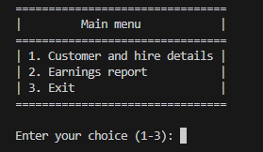
Figure 2 - Main menu
In Figure 2 the program starts by displaying the main menu. The user is prompted to enter a choice between 1 – 3.

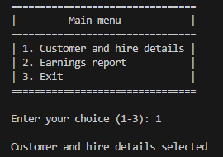
Figure 3 - Option 1
In Figure 3, the user selects option 1. The program outputs “Customer and hire details selected” confirming this option functions correctly.
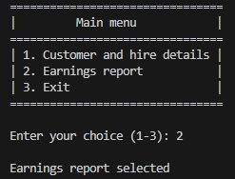
Figure 4 - Option 2
In Figure 4, the user selects option 2. The program outputs “Earnings report selected” confirming that this option functions correctly.

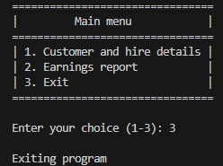
Figure 5 - Option 3
In Figure 5, the user selects option 3. The program outputs “Exiting program” and ends the program, confirming that this option functions correctly.

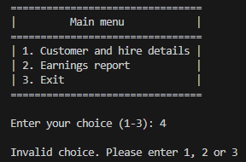
Figure 6 - Invalid input: 4
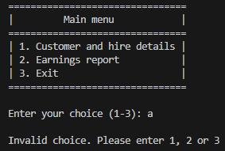
Figure 7 - Invalid input: a
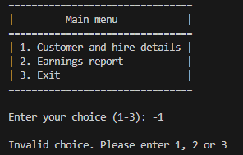
Figure 8 - Invalid input: -1
The figures above demonstrate how the program manages invalid inputs.
- In Figure 6, the user inputs “4”.
- In Figure 7, the user inputs “a”
- In Figure 8, the user inputs “-1”
In each case the program rejects the inputs and displays “Invalid choice. Please enter 1, 2 or 3” confirming that only options 1, 2 and 3 are accepted as valid inputs.

Task 2

Pseudocode
The full pseudocode text can be found in Appendix A
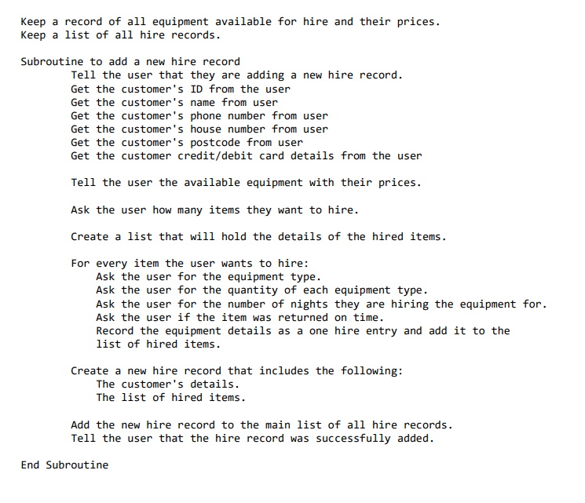
Figure 9 - Pseudocode
The pseudocode in Figure 9 starts by recording the available equipment and prices along with an empty list to store hire records. A subroutine is then created for adding a new hire record.
The subroutine starts by collecting customer details (ID, name, phone number, house number, postcode and payment details). The available equipment and their prices are displayed, and the user is asked how many items they would like to hire. For every item the user wants to hire, the program collects the equipment type, quantity, number of nights and if it was returned on time.
These details are stored as a hire entry and added to the list of hired items. A new hire record is created that contains both the customer’s details and the list of hired items. This record is added to the main list of all hire records and the user is displayed a message that the record was successfully added.

Task 2 of sample runs
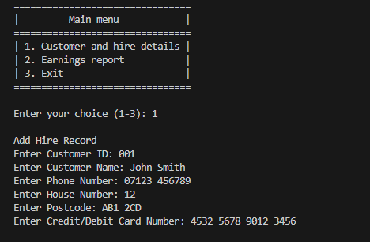
Figure 10 - Customer detail input
In Figure 10, the user selects option 1 from the menu. Instead of displaying the original message from Task 1, the program now calls the add hire record function. The program prompts the user for the customer’s details, including ID, name, phone number, house number, postcode and debit/credit card number. All the details are entered successfully, confirming the program correctly collects customer details before proceeding to next step.

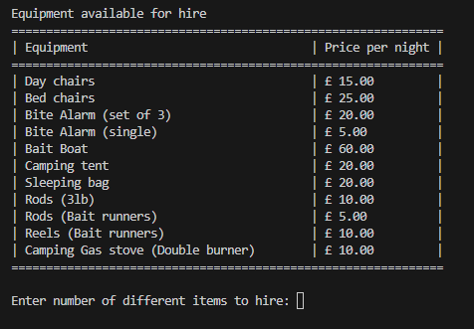
Figure 11 - Output available equipment
In Figure 11, once the customer’s details have been entered, the program displays a table of all available equipment with their prices. The user is then prompted to enter the number of different items they want to hire. This ensures the user has all the necessary information to make a decision.
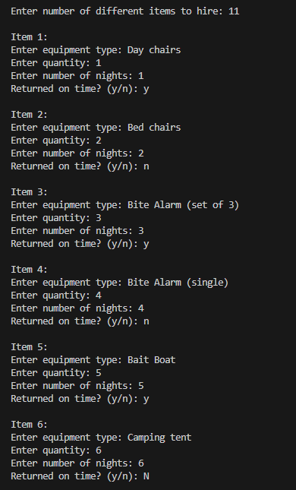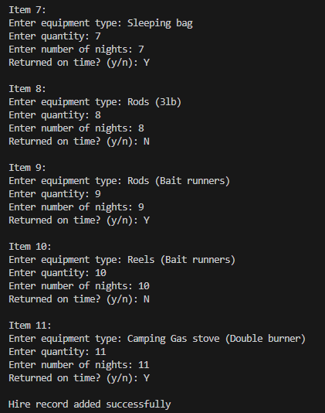
Figure 12 - Valid input for items 1-6 Figure 13 - Valid input for item 7-11
In Figure 12 and 13, the user enters the details for 11 different items, covering every type of equipment available. The quantity and number of nights increases by one for each item while the return status switches between y, n, Y, N to show input flexibility. Once all the details have been entered, the program displays “Hire record added successfully”, confirming that the hire record was successfully created and stored.

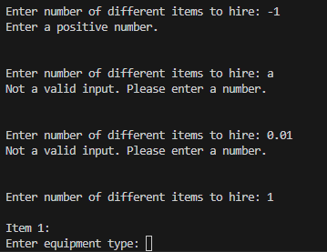
Figure 14 - Invalid inputs: Items for hire
In Figure 14, the user enters invalid values for the number of different items to hire, including -1, a and 0.01. Each invalid attempt results in an error message. When the input is not a number, the program displays “Not a valid input. Please enter a number.”. For numerical but negative values, the program displays “Enter a positive number.”. Only after a valid positive number is entered does the program proceed to the next step, confirming that the input validation works as intended.

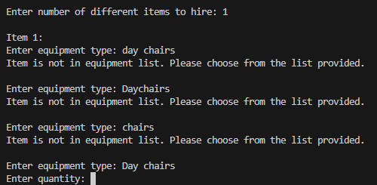
Figure 15- Invalid inputs: Equipment type
In Figure 15, the user enters incorrect equipment names such as day chairs, Daychairs and chairs. Each invalid attempt results in the error message “Item is not in equipment list. Please choose from the list provided.”. Only “Day chairs” is accepted confirming that the program validates equipment names accurately.
A potential improvement would be to make the equipment input more user friendly. Currently the program only accepts exact, case sensitive inputs, which increase the chance of typing errors. Providing each equipment with a related number would reduce input mistakes and make it more efficient.
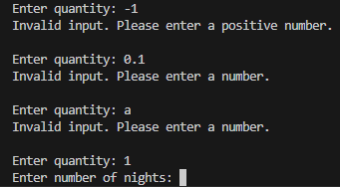
Figure 16- Invalid inputs: Quantity
In Figure 16, the user enters invalid quantities such as -1, 0.1 and a. Each invalid attempt results in an error message. When the input is not a number, the program displays “Not a valid input. Please enter a number.”. For numerical but negative values, the program displays “Enter a positive number.”. Only after a valid positive number is entered does the program proceed to the next step, confirming that the input validation works as intended.

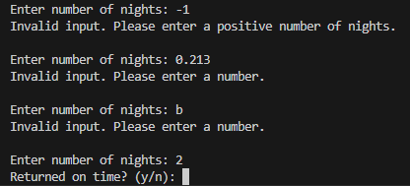
Figure 17- Invalid inputs: Number of nights
In Figure 17, the user enters invalid values for number of nights including -1, 0.213 and b. Each invalid attempt results in an error message, consistent with the input validation shown in Figures 14 and 16. Only when a positive number is entered, the program proceeds to next step.

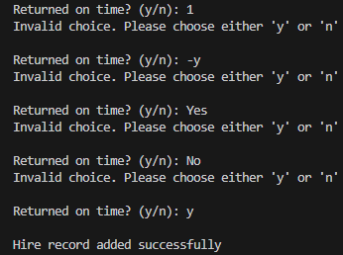
Figure 18 - Invalid inputs: Returned on time (y)
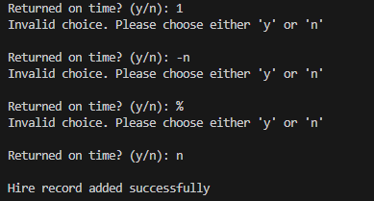
Figure 19 – Invalid inputs: Returned on time (n)
In Figures 18 and 19, the user enters invalid values for the returned on time input field, including 1, -y, -n, Yes, No and %. The program rejects these inputs and displays the error message “Invalid choice. Please choose either ‘y’ or ‘n’ ”Only after a valid input is provided, (y) or (n), does the program accept the input and complete the process by displaying “Hire record added successfully”

Task3

Flowchart
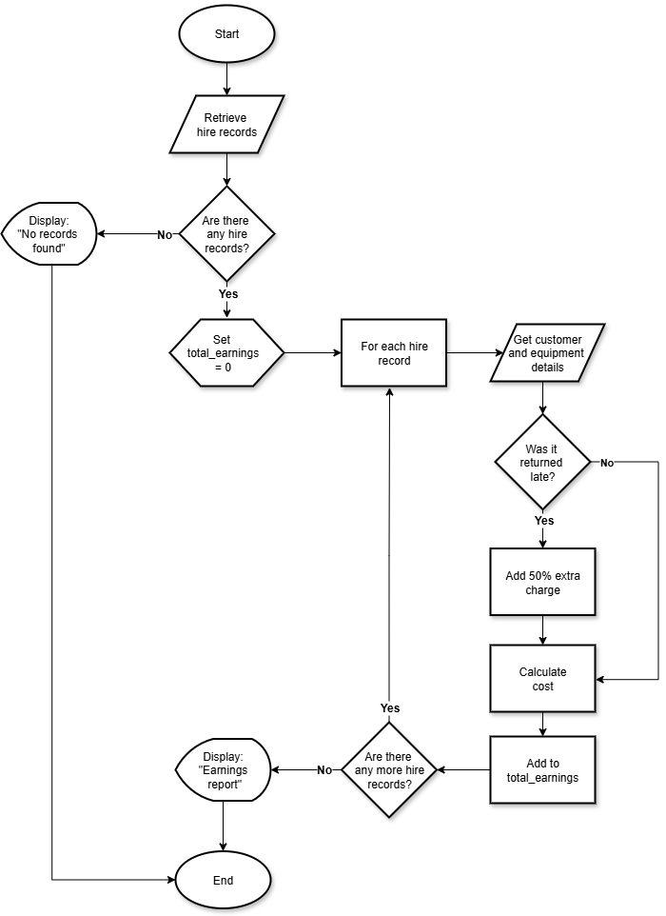
Figure 20 - Task 3 flowchart
The flowchart in Figure 20 represents the algorithm for generating the earnings report. The program starts by retrieving the hire records. If no record is found, the program displays the message “No records found” and ends.
If a record is found, the program sets the total earnings to zero and processes each hire record in turn. For every record, it retrieves the customer and equipment details then checks if the item was returned late. If items were returned late a 50% late fee is added before calculating the total cost. The cost is then added to the total earnings.
Then the program continues looping until all records have been processed. Once there are no more records to process, it displays the final earnings report and ends.

Task 3 sample runs
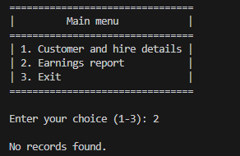
Figure 21 - No records found
In Figure 21, the user selects option 2 from the menu to view the earnings report. Since no hire records have been created at this point, the program displays the message “ No records found”. This confirms that the program correctly handles the case where no data has been entered, instead of displaying an empty report, the user is provided with a clear message.

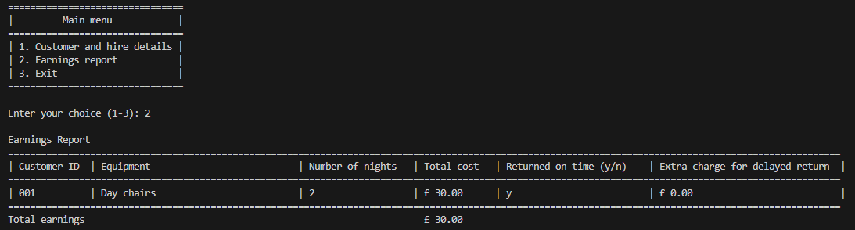
Figure 22 – Earnings report (1 Hire record)
In Figure 22, the user selects option 2 from the menu after one hire record has been created. The program retrieves the record and displays the earnings report, including the customer’s ID, equipment type, number of nights, total cost, if it was returned on time and extra charge for delayed returns. This confirms that the program generates, retrieves and displays a report when a single hire record is available.

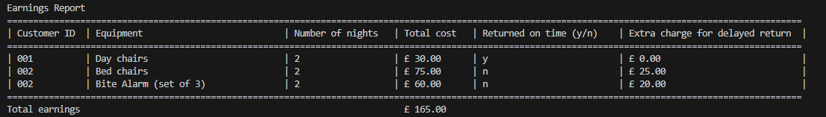
Figure 23 - Earnings report (2 Hire records)
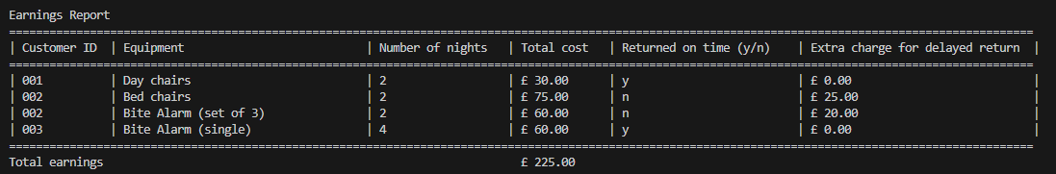
Figure 24 – Earnings report (3 Hire records)
Figure 23 and 24 shows the earnings report after multiple hire records have been created. The program retrieves and displays these entries, including different equipment types hired by the same customer. This shows that the program can accurately calculate late fees for individual items, as customers can hire multiple items and return some on time while other are returned late. This confirms that the program can consistently retrieves and displays multiple records.
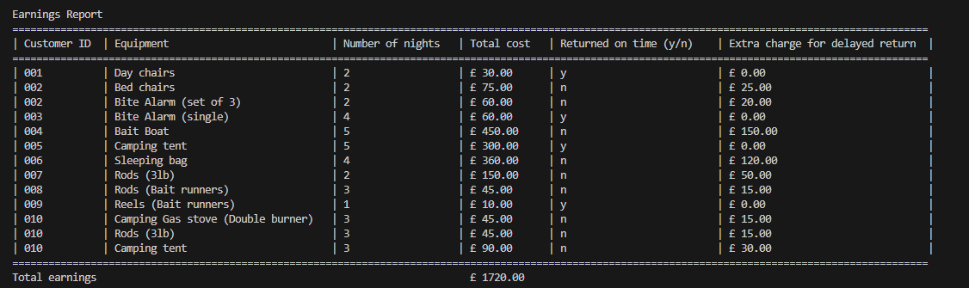
Figure 25 – Earnings report (10 Hire records)
In Figure 25, the earnings report displays ten hire records, including multiple customers, each with one or more pieces of equipment hired for multiple nights. Some items were returned late, while others were returned on time, this shows the program’s ability to calculate late fees accurately.
This confirms that the program can handle large sets of data while keeping the report format consistent. It allows multiple entries to be stored and displayed without losing previous records and only clears the data when option 3 is selected from the main menu to end the program.

References
Balti, H. and Weiss, K. A., (2021). Job Ready Python [online]. Wiley.
Gaddis, T., (2024). Starting Out with Python, Global Edition [online]. Harlow: Pearson.
Horstmann, C. S., & Necaise, R. D., (2019). Python For Everyone [online]. Wiley.
Ståle, H. and Egil , J., (1998). Python Tutorial. Available from W3Schools: https://www.w3schools.com/python/ [Accessed 2025].
Yu, A., (n.d.). 100 Days of Code: The Complete Python Pro Bootcamp. Available from Udemy: https://www.udemy.com/course/100-days-of-code/ [Accessed 2025].

Appendix A - Pseudocode
Keep a record of all equipment available for hire and their prices.
Keep a list of all hire records.
Subroutine to add a new hire record
Tell the user that they are adding a new hire record.
Get the customer's ID from the user
Get the customer's name from user
Get the customer's phone number from user
Get the customer's house number from user
Get the customer's postcode from user
Get the customer credit/debit card details from the user
Tell the user the available equipment with their prices.
Ask the user how many items they want to hire.
Create a list that will hold the details of the hired items.
For every item the user wants to hire:
Ask the user for the equipment type.
Ask the user for the quantity of each equipment type.
Ask the user for the number of nights they are hiring the equipment for.
Ask the user if the item was returned on time.
Record the equipment details as a one hire entry and add it to the list
of hired items.
Create a new hire record that includes the following:
The customer's details.
The list of hired items.
Add the new hire record to the main list of all hire records.
Tell the user that the hire record was successfully added.
End Subroutine

Appendix B – Task 1 Python Code
# Task 1: Main menu
# Student number: 24120579

# Program displays a menu and processes user's input.
# Loops until option 3 (Exit) is selected.
while True:
# Displays main menu.
print("================================")
print("| Main menu |")
print("================================")
print("| 1. Customer and hire details |")
print("| 2. Earnings report |")
print("| 3. Exit |")
print("================================")

# Get user input.
choice = input("\nEnter your choice (1-3): ")

# Validates user input.
if choice not in ["1", "2", "3"]:
print("\nInvalid choice. Please enter 1, 2 or 3")
continue

# Process valid input.
if choice == "1":
print("\nCustomer and hire details selected")
elif choice == "2":
print("\nEarnings report selected")
elif choice == "3":
print("\nExiting program")
break # Exits loop and ends the program.

Appendix C – Task 2 & 3 Python Code
# Task 2 and 3: Hiring equipment and Earnings report
# Student number: 24120579

# Dictionary containing available equipment and their prices.
equipment_inventory = {
"Day chairs": {"price": 15.00},
"Bed chairs": {"price": 25.00},
"Bite Alarm (set of 3)": {"price": 20.00},
"Bite Alarm (single)": {"price": 5.00},
"Bait Boat": {"price": 60.00},
"Camping tent": {"price": 20.00},
"Sleeping bag": {"price": 20.00},
"Rods (3lb)": {"price": 10.00},
"Rods (Bait runners)": {"price": 5.00},
"Reels (Bait runners)": {"price": 10.00},
"Camping Gas stove (Double burner)": {"price": 10.00},
}

# List to store all hire records.
hires = []

# Subroutine to add a new hire record
def add_hire_record():
print("\nAdd Hire Record")

# Collects customer details.
customer_id = input("Enter Customer ID: ")
customer_name = input("Enter Customer Name: ")
phone_number = input("Enter Phone Number: ")
house_number = input("Enter House Number: ")
postcode = input("Enter Postcode: ")
credit_or_debit_card = input("Enter Credit/Debit Card Number: ")

# Displays available equipment and price.
print("\nEquipment available for hire")
# Creates table structure
print("="*62)
print(f"| {'Equipment':<40} | {'Price per night':<12} |")
print("="*62)

for equipment, details in equipment_inventory.items():
print(f"| {equipment:<40} | £ {details['price']:<13.2f} |")

print("="*62)

# Collects and validates the number of items to hire.
while True:
try:
items_for_hire = int(input("\nEnter number of different items to hire: "))
if items_for_hire > 0:
break
else:
print("Enter a positive number.\n")
except ValueError:
print("Not a valid input. Please enter a number.\n")

# Collects hire item details.
hired_items = []

for item_number in range(1, items_for_hire + 1):
print(f"\nItem {item_number}: ")

# Collects and validates equipment type.
while True:
equipment_type = input("Enter equipment type: ")
if equipment_type in equipment_inventory:
break
else:
print("Item is not in equipment list. Please choose from the list provided.\n")

# Collects and validates quantity.
while True:
try:
quantity = int(input("Enter quantity: "))
if quantity > 0:
break
else:
print("Invalid input. Please enter a positive number.\n")
except ValueError:
print("Invalid input. Please enter a number.\n")

# Collects and validates number of nights.
while True:
try:
number_of_nights = int(input("Enter number of nights: "))
if number_of_nights > 0:
break
else:
print("Invalid input. Please enter a positive number of nights.\n")
except ValueError:
print("Invalid input. Please enter a number.\n")

# Collects and validates return status.
while True:
returned_on_time = input("Returned on time? (y/n): ").lower()
if returned_on_time not in ["y", "n"]:
print("Invalid choice. Please choose either 'y' or 'n'\n")
else:
break

# Add item details to list.
hired_items.append({
"equipment_type": equipment_type,
"quantity": quantity,
"number_of_nights": number_of_nights,
"returned_on_time": returned_on_time,
})

# Create hire record from user entered details.
hire_record = {
"customer_id": customer_id,
"customer_name": customer_name,
"phone_number": phone_number,
"house_number": house_number,
"postcode": postcode,
"credit_or_debit_card": credit_or_debit_card,
"hired_items": hired_items,
}

# Store hire record in hires list.
hires.append(hire_record)
print("\nHire record added successfully")

# Subroutine to generate the earnings report.
def earnings_report():
# Checks if hire list is empty.
if not hires:
print("\nNo records found.")
return

total_earnings = 0

# Creates earning report structure.
print("\nEarnings Report")
print("="*152)
print(f"| {'Customer ID':<12} | {'Equipment':<35} | {'Number of nights':<18} | {'Total cost':<12} | {'Returned on time (y/n)':<25} | {'Extra charge for delayed return':<32} |")
print("="*152)

# Loops through every hire record.
for record in hires:

# Loops through every hired item in this record.
for item in record["hired_items"]:
equipment_type = item["equipment_type"]
quantity = item["quantity"]
number_of_nights = item["number_of_nights"]
returned_on_time = item["returned_on_time"]

# Calculates initial cost.
price_per_night = equipment_inventory.get(equipment_type, {}).get("price", 0)
cost = price_per_night * quantity * number_of_nights
late_fee = 0

# Calculate and apply late fee if items were returned late.
if returned_on_time.lower() == "n":
late_fee = cost*0.5
cost += late_fee

print(f"| {record['customer_id']:<12} | {equipment_type:<35} | {number_of_nights:<18} | £{cost:< 11.2f} | {returned_on_time:<25} | £{late_fee:< 31.2f} |")

# Add item cost to total earnings.
total_earnings += cost

print("=" * 152)
# Displays final totals.
print(f"{'Total earnings':<12} {'':<60} £{total_earnings: .2f}")

# Program displays a menu and processes user's input.
# Loops until option 3 (Exit) is selected.
while True:
# Displays main menu.
print("================================")
print("| Main menu |")
print("================================")
print("| 1. Customer and hire details |")
print("| 2. Earnings report |")
print("| 3. Exit |")
print("================================")

# Get user input.
choice = input("\nEnter your choice (1-3): ")

# Validates user input.
if choice not in ["1", "2", "3"]:
print("\nInvalid choice. Please enter 1, 2 or 3")
continue

# Process valid input.
if choice == "1":
add_hire_record()
elif choice == "2":
earnings_report()
elif choice == "3":
print("\nExiting program")
break # Exits loop and ends the program.

Appendix D - Addition Screenshots
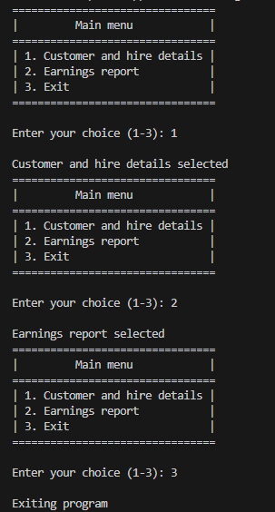
Figure 26 - Return to main menu

