Website Specification Document – Explore Cape Town

Website objectives/Goals:
The objective of this website is to promote tourism in Cape Town, South Africa. Inspiring visitors to experience its culture, traditional foods and historical landmarks while simultaneously providing the user with an accessible and engaging experience when navigating the website.

Key Audience(s):
The website is tailored to both adventure seekers, looking for an exciting experience with either hiking, surfing, shark cage diving or just appreciating the view from the cable cars while offering a more sophisticated experience for luxury travellers, such as those interested in Cape Town’s wine tasting tours.

Provisional site structure:
Home Page:
Contains an eye-catching image with a brief introduction to Cape Town and some activities the user might enjoy.
Booking Page:
A simple form that has input and output fields gathering personal and travel information from the users.
Plan a trip Page:
Provides a table with activities, helping users determine the best time of year for their chosen activity.
Culture Page:
Page is divided into three sections, religious, historical and a food section. It provides important information, helping users become familiar with Cape Town’s rich heritage
Attractions Page:
Showcases multiple activities through images.
About Us Page:
On opening the webpage, a welcoming image appears with a description of the site’s goals and intent.
Navigations bar:
All pages are connected through a responsive navigation bar and a footer with contact links and sources.

Site Map:

Functional specifications:
General Features:
- All images have alt text for accessibility.
- Has a return to top button on each page.
- Use of media queries to adapt to different devices.
- Keyboard navigation friendly.
Navigation and Footer:
- A responsive navigation bar is present on each page.
- Bar scrolls seamlessly with page.
- Text on navigation bar acts as links to different pages.
- Footer is present on all pages and contains links to company email and assets page.
Home page:
- Displays a full-width background image and text that is arrange responsively for different screen sizes.
Booking Page:
- Interactive and responsive form with:
- Input fields for entering personal details.
- Text boxes for comments/additional information.
- Drop-down options to select tours.
- Radio buttons to choose a preferred contact method.
- Date selector for travel.
- Input to select number of travellers, starting at 1.
- Required fields that must be completed.
- Submit and Cancel buttons to either submit or clear form.
Plan a Trip Page:
- Contains a table that fits on different screens, displaying optimal times for visit based on activity.
Culture Page:
- Responsive text and image are displayed in three separate boxes.
Attraction Page:
- Contains 8 images arranged in a grid layout.
- Attraction name appears when hovering over image.
About Page:
- Images and text are responsive on different screens.

Wireframe Diagrams:

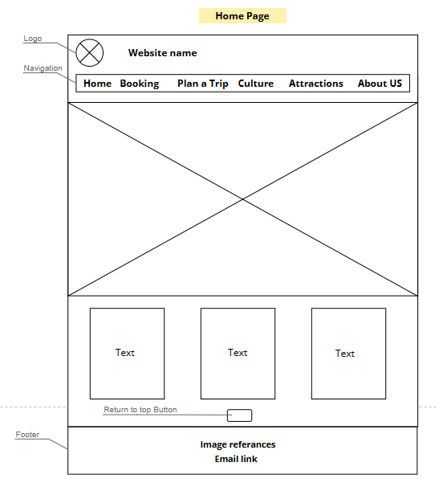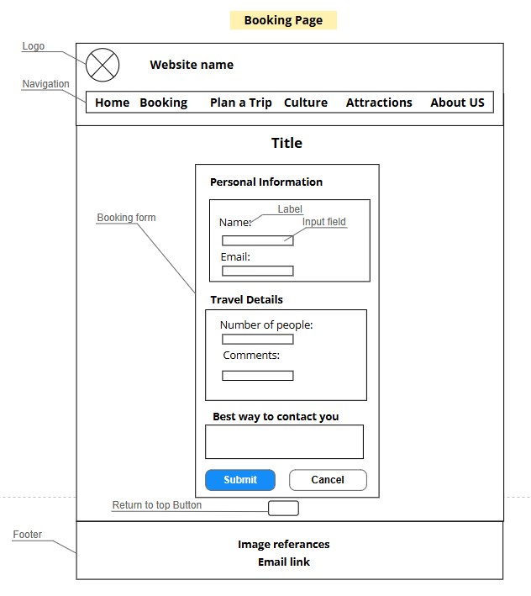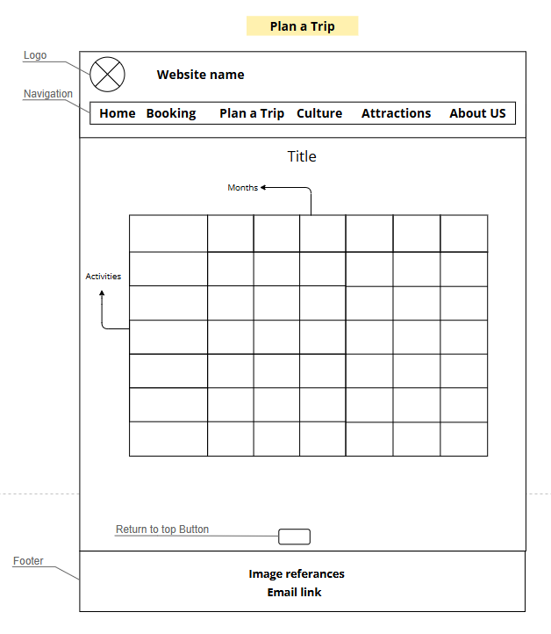

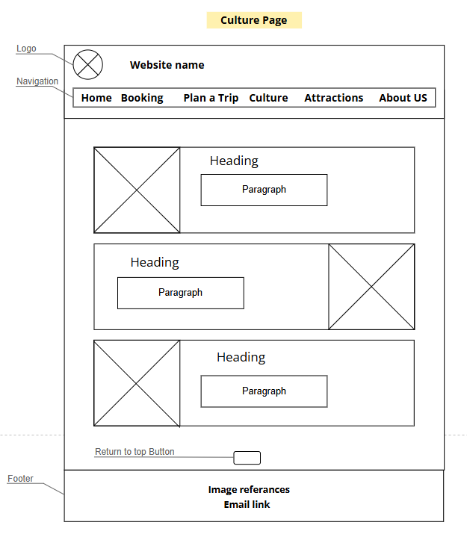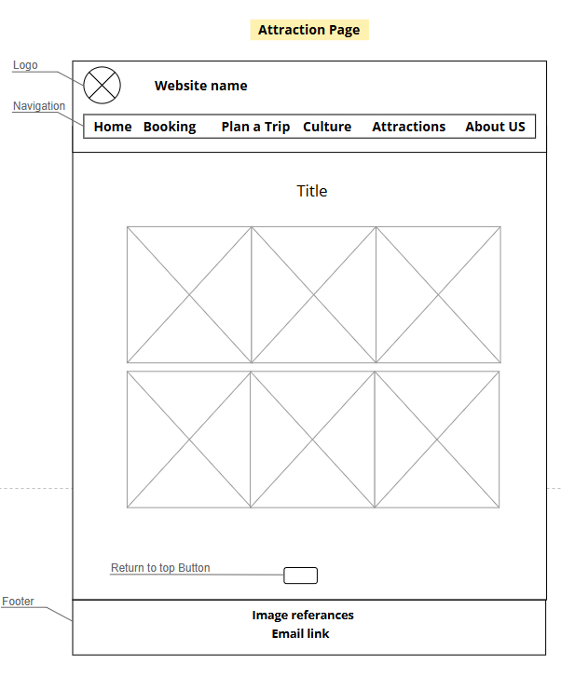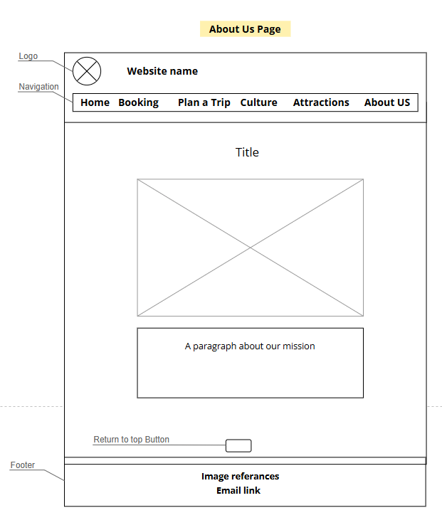

Website comparison:
Website | URL | Design | Usability | Accessibility
Cape Town Tourism | https://www.capetown.travel/ | - Has strong call to action buttons.  - Makes use of many images. | - Responsive and mobile friendly.  - Easy to navigate to desired page. | - Not all images have alternative text.  - Text is readable over background colour
Lonely Planet | https://www.lonelyplanet.com/ | - Follows a minimalist design approach.  - Use white spaces to make content stand out. | - Has a working search bar with good results.  - Pages load slower compared to other websites. | - Easy to navigate with keyboard.
Titan Travel | https://www.titantravel.co.uk/ | - Uses a dark purple colour scheme with text heavy content. | - Pages load fast and is responsive.  - The excessive use of text makes navigation slow. | - Provides special assistance and mobility support.  - Not suitable for keyboard only navigation.

