Raspberry Pi with RA-02 (LoRa Module)
Raspberry Pi (Pin) | GPIO Number | RA-02 (LoRa Module)
Pin 6 | GND | GND
Pin 1 | 3.3V | VCC
Pin 19 | GPIO10 | MOSI
Pin 21 | GPIO9 | MISO
Pin 23 | GPIO11 | SCK
Pin 24 | GPIO8 | NSS
Pin 22 | GPIO25 | RESET
Pin 15 | GPIO22 | DIO0

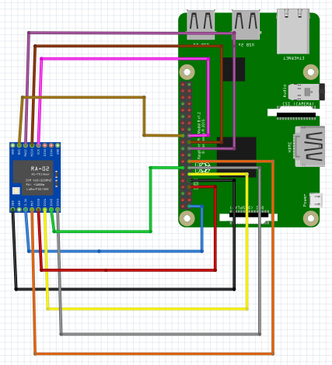

Arduino Uno with RA-02 and DHT22

Arduino Uno with RA-02
Arduino Uno Pin | RA-02 Pin | Λειτουργία
GND | GND | Γείωση
3.3V | VCC | Τροφοδοσία
D11 (MOSI) | MOSI | Master Out Slave In
D12 (MISO) | MISO | Master In Slave Out
D13 (SCK) | SCK | Serial Clock
D10 | NSS | Chip Select
D9 | RESET | Επαναφορά
D2 | DIO0 | Ψηφιακή Έξοδος 0

Arduino Uno with DHT22
Arduino Uno Pin | DHT22 Pin | Λειτουργία
GND | GND | Γείωση
5V | VCC | Τροφοδοσία
D3 | DATA | Μεταφορά Δεδομένων

