**Software Engineering**

**Requirement Specification**



**TEAM 4**

|  |  |  |  |
| --- | --- | --- | --- |
| **제출일** | **2018. 04. 15.** | **전공** | **소프트웨어학과** |
| **과목** | **Software Engineering** | **이름** | **문지환 201333186**  **윤지은 201533658**  **장해웅 201635846** |

**[ INDEX ]**

**1. Introduction**

1.1 Document Purpose

1.2 Scope of Development Project

**2. Overall Descriptions**

2.1 Product Perspective **(Use case Diagram)**

2.2 User requirement

2.3 Assumptions and Dependencies

2.4 Requirement

**3. SPECIFIC REQUIREMENTS**

3.1 Functional Requirements **(Class Diagram)**

3.2 Design Constraints

3.3 Non-Functional Requirements

3.3.1 Performance Requirements

3.3.2 Organizational requirement

3.3.3 External requirement

**4. Other Requirements(Expandability)**

4.1 Web Contents

4.2 Stop-Motion Video Function

(END)

**1. Introduction**

**1.1 Document Purpose**

The main objective of this document is to illustrate the requirements of the project CHALNA android camera application system. The document gives the detailed description of the both functional and non-functional requirements. The purpose of this project is to provide tool to easily create frame art. This project describes the software interface using UML.

**1.2 Scope of Development Project**

The proposed software product is Android-based camera application. This project is especially specialized in making frame art. Frame art is the art field in which several photographs are woven into animated picture. This project makes it easier to take pictures using previous frame. For this purpose, both the transparency and edge guided methods are used. These two are optional by the user. It also provides schedule management functions so that frame art can be created periodically.

**2. Overall Descriptions**

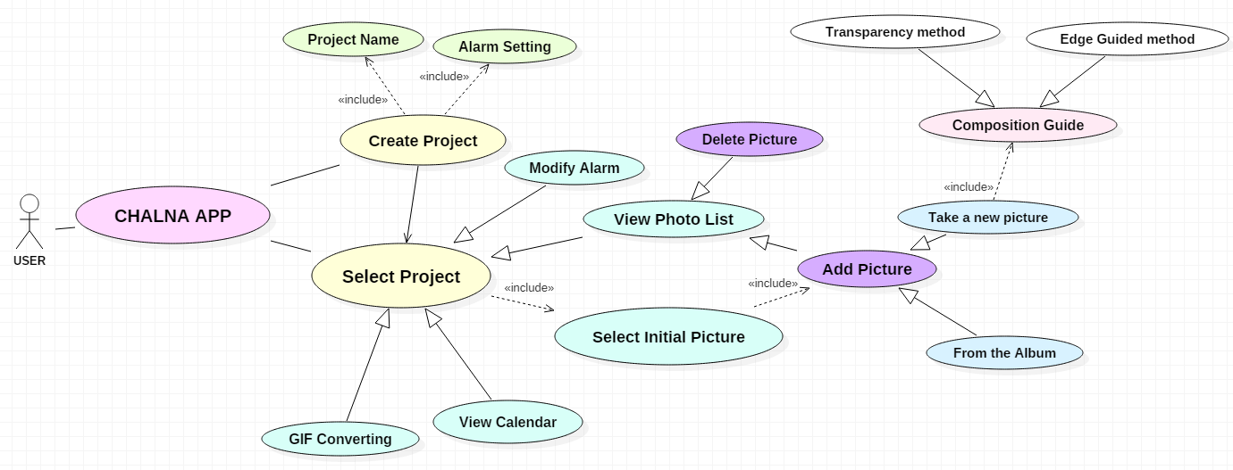**2.1 Product Perspective (Use case Diagram)**

This is Use Case Diagram of our application.

When a user uses our application, the user first creates a project or select an existing project.

First, if the user created a new project, he has to set the name and alarm cycle. After you select a created project or an existing project, you must select an initial photo that will guide you through the composition. How to choose a photo can be taken new or taken from an album. In addition, you can modify alarm and view calendars, photo lists, and delete or add photos. And you can convert picture as gif format.

**2.2 User requirement**

The application provides the ability to take and manage pictures in the same composition. You can also convert these pictures to gif and save them.

- Can create own picture project.

- Can add photo to the project.

- Can periodically manage the project through the alarm function.

- When photographing a user, the user can guide the composition through two methods.

- Composition Guide method 1 : Transparency method.

- Composition Guide method 2 : Edge guided method.

- Can convert pictures of the project into GIF.

**2.3 Assumptions and Dependencies**

*The assumption are :*

- The coding should be error free.

- The system should be user-friendly, so that it is easy to use for the users.

- The system should provide search facility and support quick transactions.

*The dependencies are :*

- The specific hardware and software due to which the product will be run

- On the basis of listing requirements and specification the project will be developed and run

-The system should have the general report stored

**2.4 Requirement**

This software package is developed using java as front end. Operating System is android.

Language: Java Runtime Environment / C++ / Dalvic Virtual machine

Android Min Version Requirement: AP 15: Android 4.0.3 (IceCreamSandwich)

Library: Java OpenCV, NDK

**3. SPECIFIC REQUIREMENTS**

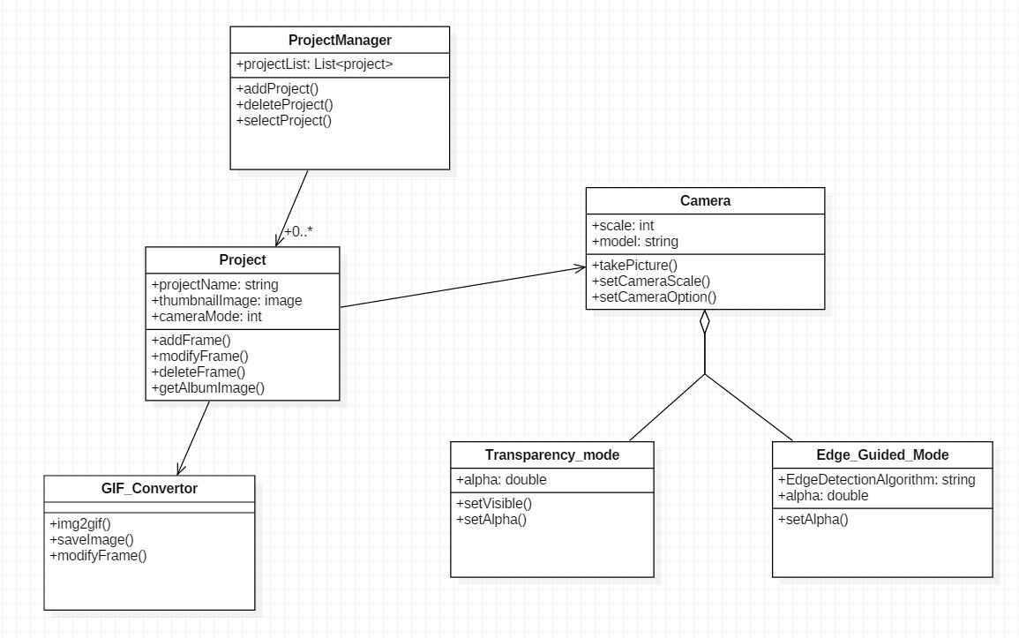**3.1 Functional Requirements (Class Diagram)**

*1) Camera*

The Autofocus function shall be provided.

When rotating, the photograph shall rotate as well

It shall be stored separately in separate directory for each project.

The selected photo shall be available as a specific composition.

*2) Project Management*

It shall be notified at a set interval.

The frame shall free to be replaced.

It shall be able to distinguish between completed projects and ongoing projects.

And it shall be able to complete or remove the ongoing projects at will.

*3) GIF Convertor*

It shall be able to convert the finished project to GIF.

It shall use its own GIF convertor technics. (Don’t use explicit intent)

The frame of the GIF shall be adjustable.

The converted photos shall be stored in the normal album directory.

**3.2 Design Constraints**

This is the list of wire-frame of app **‘CHALNA'.**



This is splash image that pops up when application starts.

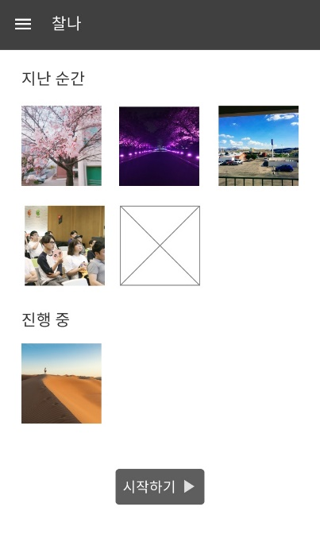

This is main page of application that you can see first. In the upper part of screen, you can see projects that you've done in the past, project that you are on process, and in lower part, there's a start button that you can start new project.

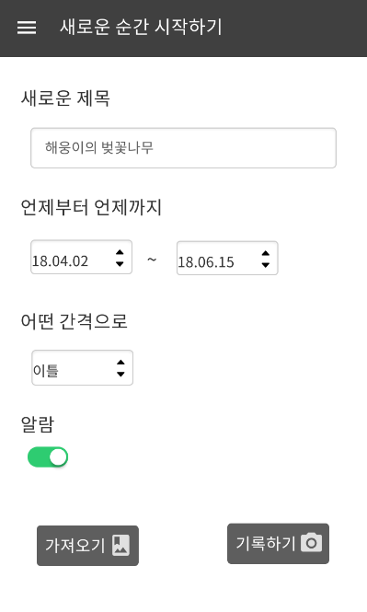

This page shows up when user press start button. User can set title, date of start, the end of project, and gap between alarm and turn on/off the alarm.

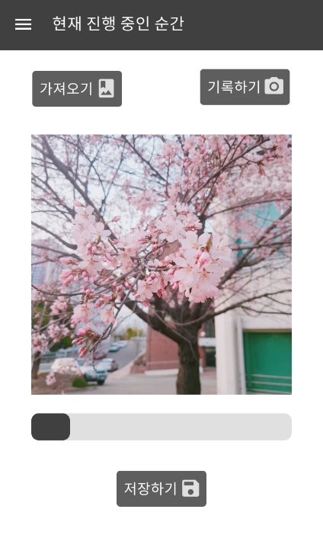

This is for managing projects. User can import picture from gallery or take a picture and start project. Slider in the lower part can move to each picture easily. And if user press save button, app will convert to gif file.

**3.3 Non-Functional Requirements**

**3.3.1 Performance Requirements**

There shall be no delays in taking pictures. The response time of the edge guided function shall not exceed 2 seconds. UI/UX for project management shall be intuitive. A tutorial shall be ready to help you understand frame art.

**3.3.2 Organizational requirement**

The user shall use the Android Play Store.

**3.3.3 External requirement**

It shall work without a network environment. The user shall use it where the light is sufficient.

**4. Other Requirements(Expandability)**

This item will be developed when we have time to spare extra function. We thought 2 things to improve, web and stop motion. The following is the list of other requirements.

**4.1 Web Contents**

Our application is basically camera application and it's optimized on mobile platform. But for the convenience of users, we concerned to extend to web platform. Similarly, instagram is a good example of using web platform but is camera application. Instagram is an app that upload pictures on own's timeline after correcting you have taken or uploaded, and you can see them on web too. So we thought of web platform that offer function that can view user's own projects on web platform. It's not appropriate to take picture with PC, but more convenient to see pictures.

**4.2 Stop-Motion Video Function**

This function is to make stop motion from video. How it works, it captures each frame of video and make it as stop motion style video. And app will convert to gif automatically.