**Chapter 22 : Project Management**

**22.1**



**Software cannot be inspected like shipbuilding or a civil engineering project in which it is visible which parts of the structure is unfinished. Software is intangible. That means, it cannot be seen or touched.**

**Some of the important goals of software management are delivering the software in the proposed time, budget and to meet all the requirements of the customer. But the software being intangible, it is difficult for the software project managers to tell exactly what the status of the development is. They cannot see the progress by simply looking at the artifact that is being constructed. Rather they rely on others to produce evidence that they can use to review the progress of the work.**

**22.2**



**Project managers are responsible for various activities like project planning, reporting, risk management, people management, proposal writing etc. They have to manage a group of people. They should be aware of the potential problems of people management and should try to develop people management skills. So, they need the skills to interact with people, assign the tasks and supervise them. They have to be able to communicate at a range of levels, from detailed technical information to management summaries.**

**But a programmer simply needs the technical skills. He may not have good presentation and communication skills. Software engineers often have strong technical skills but may lack the softer skills that enable them to motivate and lead a project development team. Hence a best programmer, who may be best at his technical skills do not always make the best soft manager.**

**22.4**



**Other possible risks that could arise in software projects:**

**1. Technology risks: Risks that derive from the software or hardware technologies that are used to develop the system.**

**2. People risks: Risks those are associated with the people in the development team.**

**3. Organizational risks: Risks that derive from the organizational environment where the software is being developed.**

**4. Tools risks: Risks that derive form the software tools and other support software used to develop the system.**

**5. Requirements risks: Risks that derive form changes to the customer requirements and the process of managing the requirements change.**

**6. Estimation risks: Risks that derive from the management estimates of the resources required to build the system.**

**22.5**



**Probability of risk**

**Any undefined or uncertain activity which may arise during the development of any project is known as risk. The project has different types of risks like, business risk, product risk, or project risk etc. associated with it.**

**The probability and cost or consequences of any risk changes as the development of project is occurred with respect to time.**

**• It is possible that any business competitor has launched the same project with low cost or earlier than you. In this case; the probability and cost or consequences of business risk will change.**

**• When, the product is facing any legal issue, then, the probability and consequences of risk will change.**

**So, probability and cost of any risk is changed as per the development of project.**

**22.6**

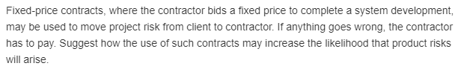

**Fixed priced contracts can increase the likelihood of product risks because the financial control will be under contractor. To make the product available with in the fixed price, the contractor may compromise with the quality of the product. Even, the contractor may not put afford much amount on testing. He may neglect some risks identified and may resolve them temporarily which may lead to product risks later. The contractor will want to spend less time on the more high costing jobs of the project to keeps costs low. Contractor is prone to avoid late delivery and give bug-ridden software to the client.**

**22.7**



**The most effective way of promoting cohesion is to be inclusive. This means that you should treat group members as responsible and trustworthy, and make information freely available. If all the members of a group are informed about the progress, it reduces the disparities among the members of the team. If the information is hidden, there is a possibility of mistrust. Simple information exchange is an effective way of making people feel valued and that they are part of the group.**

**22.8**



**The problems that may arise by devolving management decisions to the team members are:**

**1. Members of a software development team will be technically good and may not have much skill in taking managerial decisions. So the decisions may be influenced by the technical considerations rather than from business perspective.**

**2. As they focus much on rapid iteration, the management decisions will be short tern. The long term decisions and issues will be focused much.**

**22.9**

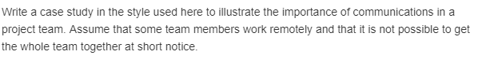

**Case study: Group communication**

**As a software project manager, Alice usually work to tight deadlines and consequently use communication channels, as she is aware of the importance of communications. Group cohesiveness is very important as it contributes to the group members, abilities to complete the task as expected. Good communications helps strengthen group cohesiveness. arranges meetings of the group member’s as it helps to know the status of project and understand the motivations, strength and weakness of other members in the group. Stakeholders should be informed of the issues and changes to the system and delivery plans through good communications.**

**But effective communication is achieved when communications are two way, and the people involved can discuss issues and information and establish a common understanding of proposals and problems. is aware that few of the members work remotely other than the organization workplace, which makes meetings difficult. To counter such issues Alice uses all kind of communication channels like e-mail messages, wikis, blogs and remote technologies like team viewer which allow project member’s and stakeholders to exchange information, irrespective of their location. Sometimes instant messaging and teleconferences can also be arranged.**

**22.10**

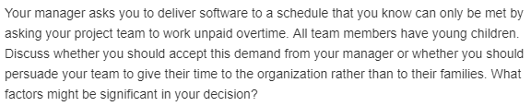

**To make a decision whether to accept the demand of manager or not, various issues are to be considered from both the team and management perspectives. Various factors to be considered are the financial state of the company, attitude and personal circumstances of team members, flexibility of present conditions of team and project, availability of alternative employees etc.**

**Some of the team members may have flexibility of making some adjustments to work for extra hours. If not, they should not be compelled to give their time to the organization rather than to their families. Some other alternatives like hiring employees from other teams or to suggest the team members to work from home have to be planned.**