**Chapter 7 : Design and Implementation**

**7.2**



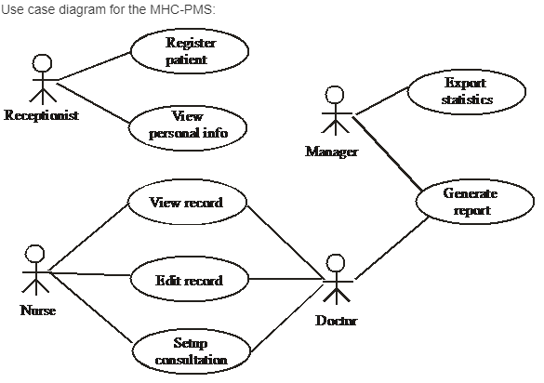

***•The Medical Receptionist is able to register new patients***

***•The Medical Receptionist is able to view patients' personal information***

***•The Manager is able to view patients' personal information***

***•The Manager is able to export system statistics***

***•The Manager is able to generate patient reports***

***•The Nurse is able to view patient records***

***•The Nurse is able to edit patient records***

***•The Doctor is able to view patient records***

***•The Doctor is able to edit patient records***

***•The Doctor is able to set up patient consultations***

***•The Doctor is able to generate patient reports***

**7.3**

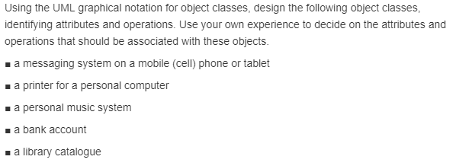

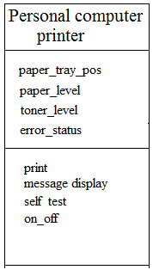



**7.5**

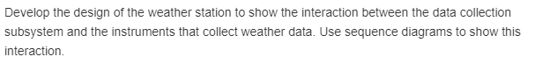

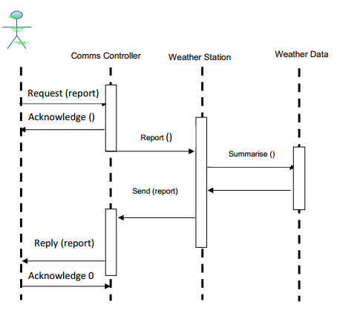

**7.6**

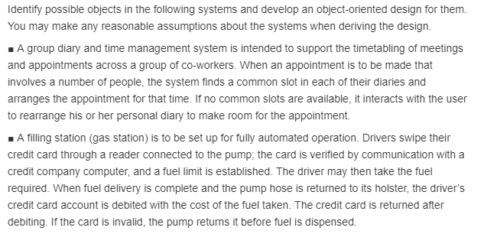

1. **2)**

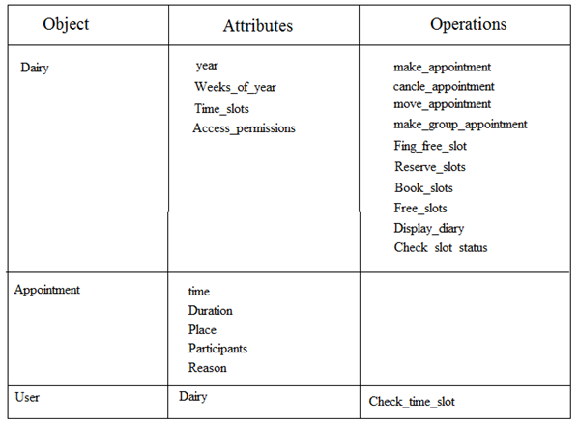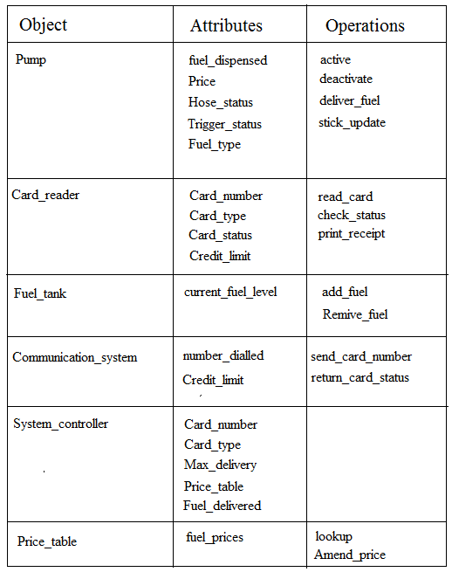

**7.7**



**A group diary system is intended to support the scheduling of meetings and appointments across a group of co-workers.**

**The sequence diagram for group diary system, when a group of people are arranging a meeting:**

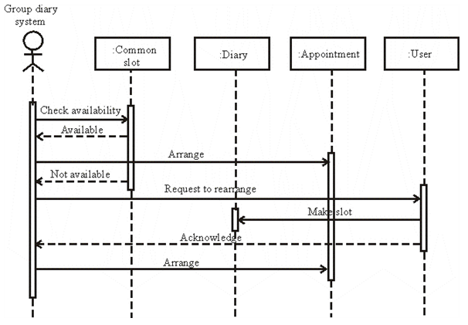

**1. The group diary system checks for an availability of common slot.**

**2. If available, it arranges an appointment.**

**3. If a common slot is not available, it requests to arrange the appointments of the members.**

**4. When the users make a slot and intimates, the system arranges an appointment.**

**7.8**



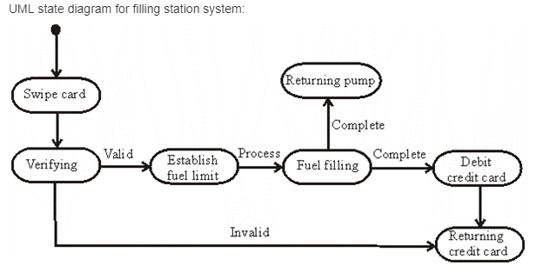

**The filling station system performs the actions in various states as shown:**

**1. When the swipe card state is completed, the card details are verified in the verifications state.**

**2. If the credentials are valid then the fuel limit is established and the fuel filling state is processed.**

**3. After the fuel filling state, the returning pump state occurs and the card is debited.**

**4. When the card is debited or if the credentials are not matched, the card returning state occurs.**

**7.9**



**Configuration management is essential when a team of people are cooperating to develop software. Because it is the process of managing changes to evolving software system, Main aim of configuration management is to support the system integration process so that all developers can access the project code and documents in a controlled way, find out what changes have been made, and compile and link components to create a system. It follows some of activities like Version management, System integration and Problem tracking.**

**EX:**

**When something goes wrong with a new version of a system, it may be able to go back to a working version of the system or component.**

**Explanation:**

**If a new version of software is created, there is a significant change in functionality, technology, or the hardware is runs on, etc. On the other hand a new revision of software refers to minor bug fix in that software.**

**Here, one version of a mathematical computation package might run on Unix-based machines, another on Microsoft Windows and so on. As software is released and used by the customer, errors are discovered that need correction. Enhancements to the functionalities of the software is an improves system intended to replace an old one.**

**7.10**

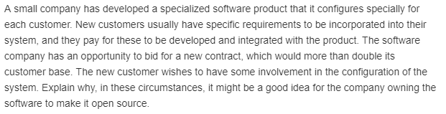

**It might be a good idea for the company to make the software open source because it reduces the development costs and effort. Developing a product especially for each customer is a very tough task. It increases development costs and also requires more effort and time. Adding requirements to each product and developing is a difficult task.**

**When it is made open source, then the source code will be available to the customers and are permitted to make changes. It helps them in making their own changes as per their requirements. As customers can have a better idea of their requirements, they can make the product even better for fewer prices. It also helps the company in reducing their effort and also in attracting the customers by allowing them for more involvement in configuring the system. It is the best way to satisfy all the requirements of the individual customers and also to make them involved.**