COMP3438 System Programming

Assignment 1

Installation guide

**Running Environment:**

Ubuntu linux or department csdoor apollo server

**Compile and execute the program**

Use *cc shell.c –o shell* to compile program

Use *./shell* to execute the program

To terminate the program: use **ctrl+c**

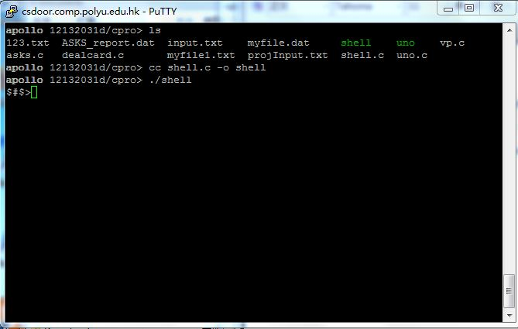

**Execute different commands**

(This program use execvp() so it may support all functions defined in $PATH)

1. **Single command**

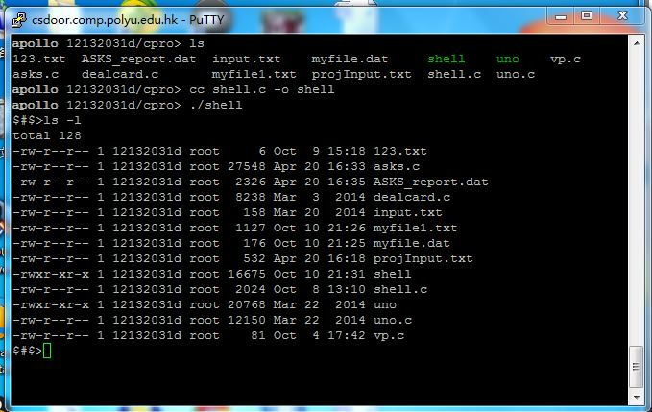

1. **Commands with pipe**

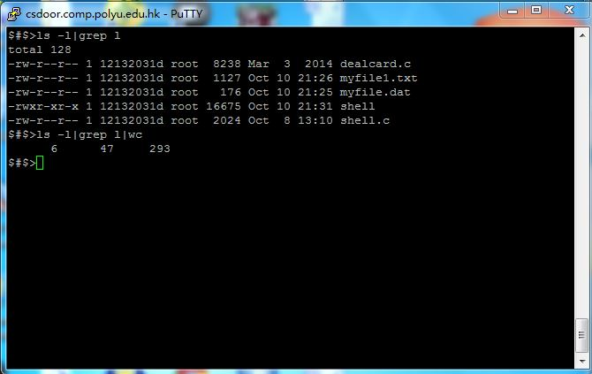

1. **Commands with redirection**

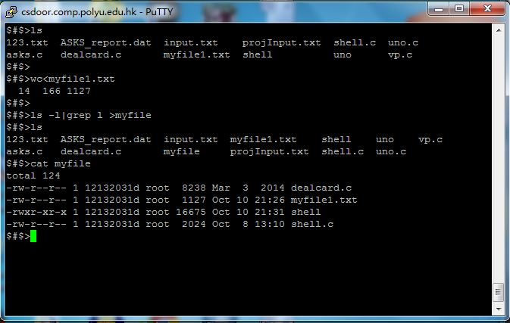

1. **Run in background**

