|  |
| --- |
| GOLDEN PIXIE GAMING |
| Forest Ambush TD |
| **Game Design Document** |
| Version #1.0.1  All work Copyright © 2021 by Golden Pixie Gaming.  All rights reserved. |
| **[Philip Henderson]** |
|  |



|  |
| --- |
| October 2th 2022 |

**Table of Contents**

[Your Table of Contents should go here. Make sure that your document’s sections are hyperlinked to their corresponding pages.]

Contents

Version History 3

Game Overview 4

Game Play Mechanics 4

Camera 4

Controls 4

Saving and Loading 5

Interface Sketch 5

Menu and Screen Descriptions 5

Game World 5

Levels 6

Game Progression 6

Characters 6

Non-player Characters 6

Enemies 7

Weapons 7

Abilities 7

Script 8

Scoring 8

Sound Index 8

Story Index 8

Art / Multimedia Index 8

Design Notes 9

Future Features 9

# Version History

[This is where you keep track of the detailed changes made to your document throughout the course of development.]

Version 1.0.1 – Initial Document Design

## Game Overview

* *You, Wizard Golden Wand, are tasked to protect the Pixie kingdom from the dastardly Orcs who are intent on the Destruction of the forest.*
* *Stop the Enemies from traversing the forest and reaching the pixie kingdom.*
* *Use different types of pixie towers to convert the enemies to woodland creatures or fairy Dust*

## Game Play Mechanics

*Environment:*

* *Spawning at a Orc Camp or Orc Boats on a shoreline,*
* *Enemies travel along a path, attempting to reach the Pixie Kingdom, reducing the kingdoms and thus the players overall health.*
* *The player must build towers along the sides of the path to prevent the orcs from reaching the Pixie Kingdom.*
* *Different levels will have different orc starting areas, indicating the increasing difficulty*

*Game:*

* *This Game will be a Rogue Like style game*
* *You will receive gems to purchase in game skins*
* *The higher your score in the third level, the higher number of gems you will receive*
* *You will not receive any gems for the first 2 levels as they are more like tutorial levels and help you gain supplies for final level set up.*
* *If the Kingdoms Health drops to zero, then the game Is over.*
* *The number of enemies that will spawn will increase incrementally as the levels progress.*
* *Tower types will range from Fire, Water and Ice*
* *The Last/Third Level is endless, survive longer to receive a higher score, if you can!*

## Camera

* 2D Birds Eye View

## Controls

* Touch Controls in Unity

## Saving and Loading

* *No Saving*
  + *Rogue Like*
* *Loading*
  + *At app start, show company logo*
  + *Before game starts, show an in-game tip, wait for screen touch to start*
  + *After game over screen, show an in-game tip for 1 second before displaying the main menu*

## Interface Sketch

*Sketches:*

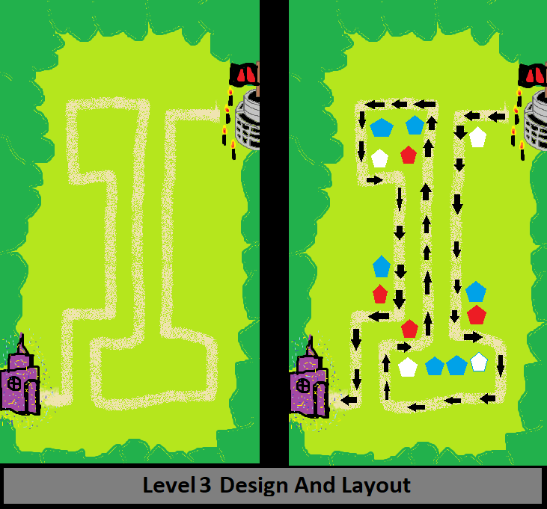

*Screen Shots:*

* TBI(To Be Included)

## Menu and Screen Descriptions

*(Include additional screen shots and accompanying descriptions for any menus and additional screen)*

* TBI(To Be Included)

## Game World

*(Describe Your Game Environment)*

* *This game is designed to be cute and cuddly. Not killing the enemies, but converting to small, nice creatures or Pixie Dust*
* *Mystical forest area with a few woodland animals, mushrooms and plants.*
* *Game area is walled in by forest with only two openings in the forest walls, in which the attackers path starts and finishes with the orc camp and the pixie kingdom*
* *With a big open field area in the middle that the attackers path whines through*

## Levels

*(Describe Each of your game levels)*

*Each Level will have the same basic template with different paths.*

*Level 1 – Enemies will Spawn for 30 secs*

* *Has a basic S Pattern for a path with the enemy starting location at the top right and the kingdom at the bottom right.*
* *The orc spawn will be a small camp*
* *Difficulty multiplier: 1.0x*

*Level 2 – Enemies will Spawn for 1 min*

* *Has a Vertical Pattern, enemies will travel up and down on the path to reach the kingdom.*
* *The orc spawn will be a shoreline with an orc boat*
* *Difficulty Multiplier: 1.5x*

*Level3 – Endless/ Enemies will Spawn endlessly till player dies*

* *Has a Double boot Shaped Pattern, allowing 1 tower to be placed within the boot shaped path*
* *The orcs spawn will be an orc castle*
* *Difficulty Multiplier: 2.0x (Increases by .5 every 1 min)*

## Game Progression

* Progress Levels by surviving the time limits.
* Last level is attempting a to get high score

## Characters

*(Describe Your game avatar if applicable)*

* *Wizard Gold Wand – (Sort of) Player Character*

## Non-player Characters

(Describe Any Computer controlled Allies and how they work)

* *Twilla - Pixie High Queen – Head of the Pixie Kingdom*
* *Astro – Head Advisor – To the Queen*
* *Towns Fork – Complain about the Orc invasions getting worse*

## Enemies

*(Describe computer-generated enemies and boss monsters)*

* *Grumpton Smelly-Weather – Orc Commander – Leader of the Orc army*
* *Orc Army – Rage and grunt and cause problems for the Pixie Kingdom*

## Weapons

*(Describe any weapons available to the user)*

*Towers:*

* *Ice: Low Damage (AOE)*
  + *Attack Speed: Fast*
  + *Slows Down Enemies*
  + *Turns Enemies to White Pixie Dust*
  + *Turns Enemies into small creature (small chance (Rabbit))*
* *Fire: Medium Damage (Single Target)*
  + *Attack Speed: Medium*
  + *Additional Damage every second for 3 seconds*
  + *Turns Enemies to Red Pixie Dust*
  + *Turns Enemies into small creature (small chance (Fox))*
* *Wind: Very High Damage (Single Target)*
  + *Attack Speed: Very Slow*
  + *Turns Enemies to Blue Pixie Dust*
  + *Turns Enemies into small creature (small chance (Bird))*

## Abilities

* *Powers:*
  + *Earthquake:*
    - *Inflicting damage to enemies walking in area while causing the ground to shake*
    - *Slows enemies in area*
    - *Small earth-shattering animation*
  + *Water Blast:*
    - *Inflicts damage while causing the enemies to be temporarily pushed backwards on the path.*
    - *Plays a Blue water blast animation*
  + *Magic Wall:*
    - *Creates a magic barrier to temporarily stop all enemies from moving forward past the wall*

## Script

TBI(To Be Included)

## Scoring

*Small Enemies – 1 point*

*Medium Enemies – 10 points*

*Large Enemies – 20 points*

*Super Enemies – 50 Points*

*Boss – 100 points*

*Level 1 – Seconds* ***left*** *\* Points from Enemies*

*Level 2 – Seconds* ***left*** *\* Points from Enemies*

*Level 3- Seconds * Points from Enemies*

## Sound Index

TBI(To Be Included)

## Story Index

*(Outline your game story here)*

*You, Wizard Golden Wand, are tasked to protect the Pixie kingdom from the dastardly Orcs who are intent on the Destruction of the forest. The Pixie High Queen Twilla who is deeply connected to the forest and its inhabitants, is crippled by its destruction. Help to Defend and replenish the forests nature splendor to what it once was.*

*Stop the Enemies from traversing the forest and reaching the pixie kingdom.*

## Art / Multimedia Index

TBI(To Be Included)

## Design Notes

TBI(To Be Included)

## Future Features

*Player Gets an army to push back the orcs*