Theme – Travel Destinations

1. Florida
2. Bahamas
3. Fiji
4. Africa
5. London
6. Thailand
7. New Zealand
8. Sonoma
9. Greece
10. Italy

//user makes a letter choice

//capture the letter choice

//letter compared to current word, and letters already selected

//display the result in the appropriate field

//randomly select new word when user wins or runs out of chances

Game Pseudo code

1. Select any keyboard letter [keystroke Event] . Might need to use the onkeyup function. Need the letters selected to get stored in 2a or 2b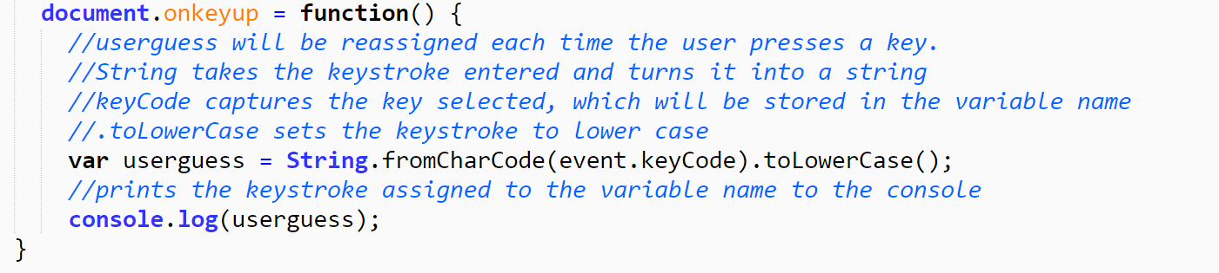
2. Letters are checked against the letters in the word [so we’ll have an Array of the different destinations, and have a loop that runs through the destinations, possibly at random, and then have a conditional that checks for the users entry against the letters of the current word with charAt. Might have to use .indexof here to see if a letter selected matches one of the letters in the current word. See arrays-activity from Tuesday class]
   1. If not in the word: Keyboard letters already guessed (incorrectly) are stored on the bottom of the screen (create a variable to capture these letters. To display the letters on the page I’ll need to create html inside the function)
   2. If in the word: If any of the letters selected match a letter in the word, they populate in the appropriate space (may need to create a separate variable to capture these letters. To display the letters on the page I’ll need to create html inside the function)
3. A counter counts down from 12 with the number of chances (letters) that can be selected (LOOP, or do we just create a variable within a function for the counter and set it to 12, then use – to reduce by one each time a letter is selected).
   1. If the counter gets to 0, game over. (Conditional“If # of guesses remaining > 0, keep guessing”)
   2. If you try to select the same letter more than once, it only causes the counter to reduce the first time selected, not every time
4. If you complete all of the letters in the word: (add html in function for this step)
   1. it causes a picture related to the word to appear on the screen.
   2. Text changes at the top of the screen.
   3. Appropriate music starts playing.
   4. another counter increases your win count by 1. (create variable to capture win total. The win total should be increased with ++ within the function after each win)
5. If you win, (need to have a new word randomly selected)
   1. the game starts back at the beginning with the message to select any key to begin
   2. the Current Word changes [all of the words are in their own Array and are randomly selected] and all blank underscores appear again [the letters in the array update with the letters of the new word]

Games starts

Hit a key

Select a letter

If letter’s good it goes in the appropriate space. If not , it goes to bottom of screen

My chances reduce by one

I keep selecting letters until I get all of the letters for the name or I run out of chances

If I run out of chances, Game Over, the word to solve changes, and hit any key to begin again.

If I get all of the letters, I win, the picture and text changes, music plays, and hit any key to begin again

Select letter and reduce the number of chances by 1

Is letter part of the word? Yes/No

If yes – enter it into the blank space . If all spaces have been filled, user wins

If no, put the letter in the letters guessed area. If no more chances, game over. If more chances remain, continue game and repeat