Fragmentation, Consolidation, and the Coalition Effect
A Quantitative Analysis of Malawi's Electoral History, 1994-2020
Malawi Elections Analytics Project - Findings Report (Second Edition)
July 2026

Contents
Contents 2
Executive Summary 3
1. Introduction and Political Context 4
1.1 Why Malawi, and why these years 4
1.2 A note on what came after 4
2. Data and Methods 5
2.1 Source material and the problem of shape 5
2.2 Party reconciliation and district canonicalization 6
2.3 The treatment of independents 6
3. Behavioural Findings: Seven Metrics and a Map 7
3.1 Metric 1 - Effective number of competitors (Laakso-Taagepera) 7
3.2 Metric 2 - Margin of victory and seat competitiveness 8
3.3 Metric 2 extended - The 2019 → 2020 presidential swing map 9
3.4 Metric 3 - Pedersen volatility 10
3.5 Metric 4 - Regional concentration (nationalization) 10
3.6 Metric 5 - Split-ticket divergence 12
3.7 Metric 6 - Wasted-vote share 12
3.8 Metric 7 - Incumbent re-election, and a lesson in join fragility 13
4. Descriptive Findings: Who Won Where, and By How Much 15
4.1 National vote share by party 15
4.2 The district winner maps 16
4.3 Parliamentary seats won by party 17
4.4 Regional vote shares and dominance 18
4.5 Turnout - handled honestly 19
4.6 Two further analyses: disproportionality and bellwethers 20
5. Data Quality and Limitations 23
6. Conclusions and Next Steps 23
7. Sources and Further Reading 24

Executive Summary
This report presents a full-cycle data analytics study of Malawi's electoral history from the founding multiparty elections of 1994 through the court-ordered presidential re-run of 2020. Twelve heterogeneous official results files - spanning presidential and parliamentary races, and ranging from hand-aggregated district summaries to modern polling-station returns - were harmonized into a single tidy dataset of 189,419 candidate-level result rows. From this foundation, two layers of analysis were built: a behavioural layer of seven established political-science metrics (effective number of competitors, margin of victory and seat competitiveness, Pedersen volatility, regional vote concentration, split-ticket divergence, wasted-vote share, and incumbent re-election), and a descriptive layer answering the questions every findings report is asked first - who won each district and region, by how much, and how many seats each party took.
The headline finding is a precise quantification of what Malawian commentators call the coalition effect. Between the annulled 2019 presidential election and the fresh 2020 poll, the effective number of presidential competitors collapsed from 3.15 to 1.95 - a 38 percent contraction of the competitive field achieved not by any change in the electorate but by the fusion of opposition forces into the Tonse Alliance under the country's new 50-percent-plus-one majority rule. The district winner maps make the mechanism visible at a glance: the UTM's purple North of 2019 turns MCP green in 2020, district for district, while the DPP's thirteen Southern districts hold. MCP's national vote share jumped from 35.4 to 59.3 percent between the two polls, and its mean winning margin in districts it carried widened to roughly 65 points.
Beyond the 2020 story, the longer arc is equally consequential. Parliamentary safe seats fell from 88 percent of constituencies in 1994 to under 38 percent by 2019; the mean wasted-vote share in parliamentary contests more than doubled, from 25 percent to 56 percent; and the Gallagher index of seat-vote disproportionality spiked to 16.3 in 2009 and settled at four times its 1994 level - three faces of the same arithmetic by which first-past-the-post ceased to deliver majoritarian legitimacy, the argument that culminated in the Constitutional Court's 2020 reinterpretation of the presidential majority requirement.
The report also documents the data engineering that makes these numbers defensible - grain harmonization, denominator deduplication, party-label reconciliation, and a district-name canonicalization that collapses 33 raw spellings to Malawi's 28 official districts - and is candid about the limitations, including a missing 2004 presidential file, absent 2019 and corrupted 2020 voter-registration figures, and a name-matching artifact that renders two incumbency transitions unreliable.

1. Introduction and Political Context

1.1 Why Malawi, and why these years
Malawi's democratic era opened in 1994, when the country's first multiparty elections ended three decades of one-party rule under Hastings Kamuzu Banda's Malawi Congress Party (MCP). The elections that followed - 1999, 2004, 2009, 2014, and the tumultuous 2019-2020 sequence - trace one of the most instructive democratic trajectories in Southern Africa: a party system that fragmented steadily for two decades, a persistent pattern of regional bloc voting across the Northern, Central, and Southern regions, and then, in 2020, an abrupt consolidation that made Malawi a continental reference point for opposition coalition politics.
The 2019-2020 episode deserves particular emphasis because it frames the central analytical question of this study. In May 2019, incumbent President Peter Mutharika of the Democratic Progressive Party (DPP) was declared re-elected with roughly 38.6 percent of the vote, ahead of Lazarus Chakwera of the MCP (35.4 percent) and Saulos Chilima of the United Transformation Movement (UTM, 20.2 percent). The result was immediately contested. Court proceedings revealed widespread irregularities in the tallying process - most notoriously the alteration of result sheets with correction fluid, which earned the contest its enduring nickname, the "Tipp-Ex election." On 3 February 2020, Malawi's Constitutional Court annulled the presidential result, citing widespread, systematic, and grave irregularities, and ordered a fresh election within 150 days. Malawi thereby became only the second African country, after Kenya in 2017, to annul a presidential election - and the first in which the opposition went on to win the re-run.
The Court's ruling did something else of profound structural importance: it reinterpreted the constitutional requirement that a president be elected by a "majority" to mean an absolute majority of 50 percent plus one, replacing the first-past-the-post plurality rule under which every previous president had been elected. As analysts at Chatham House observed at the time, this change directly encouraged Malawi's regionally anchored opposition parties to set rivalry aside and contest as a bloc. The result was the Tonse Alliance - a nine-party coalition headlined by Chakwera as presidential candidate and Chilima as running mate - which won the 23 June 2020 fresh election with 58.57 percent of the vote against Mutharika's roughly 40 percent, in a poll international observers judged free and fair.
This report treats that political narrative as a set of testable quantitative propositions. If the Tonse Alliance truly fused a fragmented field, the effective number of presidential competitors must fall sharply between 2019 and 2020. If the coalition operated as a transfer of Chilima's vote to Chakwera, the geography of MCP's gains must map onto UTM's 2019 strongholds. If first-past-the-post was producing progressively weaker mandates, the wasted-vote share must climb across the parliamentary series. Each proposition is confirmed in the data, and each is developed in Sections 3 and 4.

1.2 A note on what came after
Although the dataset ends with the 2020 fresh election, the subsequent trajectory sharpens the interpretation of these findings rather than dating them. The Tonse Alliance did not survive the pressures of incumbency: UTM left the coalition in 2024, and in the September 2025 general election - the first conducted after this dataset closes - Peter Mutharika returned to the presidency with 56.8 percent of the vote against Chakwera's roughly 33 percent, a defeat widely attributed by Malawian analysts to economic crisis, inflation, and unmet campaign promises. The 2020 consolidation documented here was therefore an event, not an equilibrium: the coalition effect this report quantifies proved as reversible as it was decisive. Extending the pipeline to the 2025 station-level results is the project's most valuable next step, because it would let every metric in this report tell a complete rise-and-fall arc.

2. Data and Methods

2.1 Source material and the problem of shape
The raw material comprises twelve Excel workbooks released by or derived from the Malawi Electoral Commission (MEC), covering six parliamentary elections (1994-2019) and six presidential contests (1994, 1999, 2009, 2014, 2019, 2020; no 2004 presidential file was available). The files fall into two structural families that reflect two eras of election administration. The presidential summaries for 1994-2014 are wide-format district tables - one row per district, one column per candidate - the shape of a hand-compiled national summary. The parliamentary files and the 2019-2020 presidential files are long-format, one row per candidate per place, and from 2019 onward they descend to the individual polling station, reflecting the MEC's modernized results-transmission systems.
The harmonization pipeline (harmonize.py) resolves this heterogeneity declaratively: each file is described once in a configuration block that names its sheet, its column mappings, and its granularity, and two generic loaders - one that renames long files into a standard schema, one that melts wide files into long form and parses candidate name and party out of the column header - produce identically shaped frames. The target shape is the tidy-data canon: one row equals one candidate's result in one place in one election. Stacked, the twelve files yield 189,419 rows across seventeen standard columns, persisted as both CSV and Parquet with a full data dictionary.
Two engineering decisions deserve explanation because the metrics depend on them. First, granularity is carried as an explicit column rather than hidden in the row count, because 97 percent of all rows come from the station-level 2019-2020 files; any analysis that ignored this would silently drown the earlier elections. Every metric in Section 3 therefore begins by rolling the data up to a stated, consistent grain - constituency for seat-level metrics, district for cross-era party trends, since district is the only grain all twelve files share. Second, denominator columns such as valid votes, null-and-void ballots, and registered voters describe the place, not the candidate, and so repeat identically on every candidate row for that place. Summing them naively would inflate turnout figures several-fold; the pipeline instead splits the table into a candidate-votes frame (summed normally) and a deduplicated one-row-per-place denominators frame (taking the first value per unit), a split validated by confirming that candidate votes sum exactly to reported valid votes and that valid plus null-and-void equals total voted.

2.2 Party reconciliation and district canonicalization
Party labels arrive in 54 raw spellings across the twelve files. These were collapsed to 44 canonical codes through an externalized mapping table (party_map.csv), so that every reconciliation decision is transparent, reviewable, and editable without touching code. Patterned variants such as the numbered independent labels (IND 1 through IND 7) are handled by regular-expression rules rather than enumerated entries, which future-proofs the mapping against new variants. One abbreviation required special treatment: the code UP denotes two entirely different parties depending on the era, so the lookup is year-aware rather than a flat dictionary. The reconciliation step is guarded by an invariant assertion that the national total of 51.6 million candidate-votes is bit-identical before and after mapping - a cheap check that has repeatedly caught silent join errors in development.
A parallel problem surfaced when the descriptive layer was built: district names, too, carry spelling splits across eras - Chikwawa versus Chikhwawa, Nkhata Bay versus Nkhatabay, Nkhotakota versus Nkhota Kota, Mzimba versus its formal title M'Mbelwa (Mzimba) - plus Mzuzu, a city reported separately in some files despite lying within Mzimba district. Simple upper-casing does not merge these, so any per-district tally would silently double-count. A canonical district mapping was therefore added, collapsing 33 raw spellings to Malawi's 28 official districts; all district-level results in this report use the canonical key.

2.3 The treatment of independents
Roughly 43,000 rows carry the canonical party code IND. Treating all independents as a single party would fabricate a large phantom bloc and distort every fragmentation statistic. The convention adopted here is that seat-level metrics (effective number of competitors, margins, wasted votes) operate over candidates within a constituency, where each independent is naturally a distinct competitor, while cross-election party-trend metrics (volatility, regional concentration) aggregate by party and treat independents as a residual category - the standard compromise in the comparative-politics literature. Seat counts in Section 4, by contrast, deliberately keep independents visible as a bloc, because their scale in Malawi's National Assembly is itself a finding.

3. Behavioural Findings: Seven Metrics and a Map

3.1 Metric 1 - Effective number of competitors (Laakso-Taagepera)
The effective number of parties (ENP), introduced by Laakso and Taagepera in 1979, is the standard index of party-system fragmentation: the reciprocal of the sum of squared vote shares. Two evenly matched parties yield exactly 2.0; a dominant party with fringe rivals yields a value near 1.0. Its virtue is that it counts competitors weighted by their actual electoral weight, making "consolidation" a measurable quantity rather than a rhetorical claim. ENP was computed per parliamentary seat (summarized as the yearly median) and for the national presidential field.
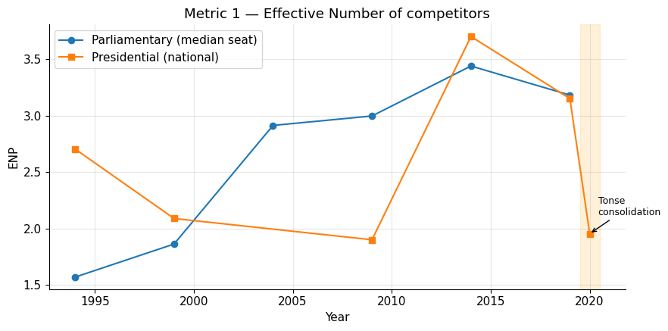
Figure 1. Effective number of competitors, 1994-2020. The shaded band marks the 2019-2020 re-run interval; the presidential series collapses from 3.15 to 1.95.
Year | Parliamentary median seat ENP | Presidential national ENP
1994 | 1.57 | 2.70
1999 | 1.86 | 2.09
2004 | 2.91 | - (no presidential file)
2009 | 3.00 | 1.90
2014 | 3.44 | 3.70
2019 | 3.18 | 3.15
2020 | - | 1.95
Table 1. Effective number of competitors by year.
The parliamentary series tells a twenty-five-year story of steady pluralization: the median constituency went from a near two-party contest in 1994 (ENP 1.57) to a genuinely multiparty one by 2014 (3.44). The presidential series is more dramatic. It peaks at 3.70 in 2014 - the most fragmented presidential field in Malawian history, with twelve candidates - and stands at 3.15 in the annulled 2019 election, reflecting the three-way Mutharika-Chakwera-Chilima split. In the 2020 fresh election, with the same electorate voting thirteen months later, ENP collapses to 1.95: effectively a two-candidate race. That single drop is the coalition effect, quantified. It did not happen because voters changed their minds en masse; it happened because the 50-percent-plus-one rule imposed by the Constitutional Court made a divided opposition arithmetically unviable, and the Tonse Alliance responded by removing the division.

3.2 Metric 2 - Margin of victory and seat competitiveness
For every seat, competitors were ranked by vote share and the margin computed as winner minus runner-up. Margins were then binned into three declared tiers: tossup (under 10 points), lean (10-20 points), and safe (20 points or more). The thresholds are a convention, stated openly rather than hidden - the analytical value lies in the trend, which is robust to reasonable threshold choices.
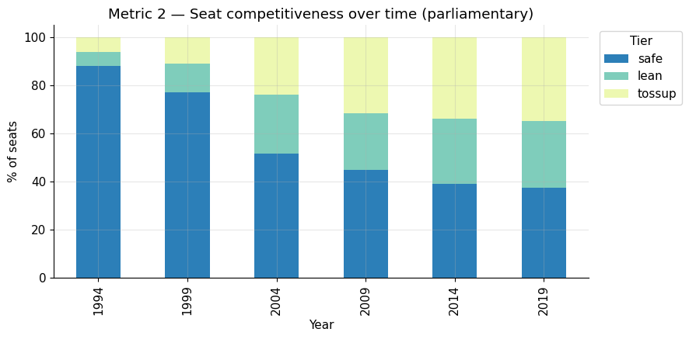
Figure 2. Parliamentary seats by competitiveness tier, 1994-2019.
Year | Safe (%) | Lean (%) | Tossup (%)
1994 | 88.1 | 5.6 | 6.2
1999 | 77.1 | 12.0 | 10.9
2004 | 51.6 | 24.5 | 23.9
2009 | 44.8 | 23.4 | 31.8
2014 | 39.1 | 27.1 | 33.9
2019 | 37.5 | 27.6 | 34.9
Table 2. Share of parliamentary seats by competitiveness tier.
In 1994 Malawi's parliamentary map was overwhelmingly settled: 88 percent of seats were safe, a signature of regional bloc voting in which the North voted AFORD, the Centre MCP, and the South UDF almost monolithically. By 2019 the safe share had fallen to 37.5 percent and more than a third of all seats were decided by fewer than ten points. In business-intelligence terms, the number of genuine "swing markets" quintupled over the period - a structural transformation of where campaign resources matter. At the presidential level the same machinery yields a subtler 2019-2020 finding: the mean district-level margin of victory widened from 0.47 in 2019 to 0.69 in 2020. Consolidation did not merely change the national winner; it converted close local three-way contests into decisive two-way outcomes district by district.

3.3 Metric 2 extended - The 2019 → 2020 presidential swing map
ENP established that the vote consolidated; a district swing map establishes where. For each district, MCP's presidential vote share in 2020 minus its share in 2019 was mapped onto Natural Earth admin-2 boundary polygons (with one documented geometry correction: the source file mislabels Karonga as a second Chitipa polygon, resolved by centroid position). The companion dumbbell chart shows each district's 2019 and 2020 MCP share as paired points, colored by region.
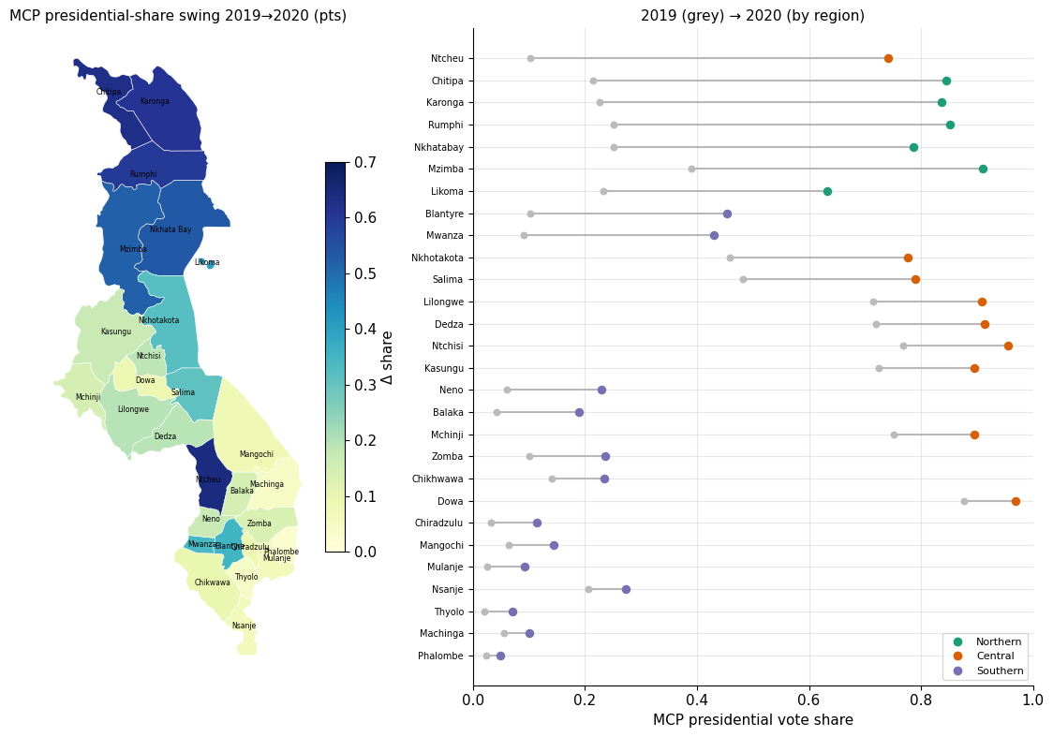
Figure 3. Left: MCP presidential-share swing by district, 2019→2020. Right: district-by-district movement from 2019 (grey) to 2020 (colored by region).
The pattern is unambiguous. MCP gained share in every single district, but the gains cluster overwhelmingly in the Northern Region - Chitipa (+63 points), Karonga (+61), Rumphi (+60), Nkhata Bay (+54), Mzimba (+52) - plus Ntcheu in the Central Region (+64), the home district of Saulos Chilima. These are precisely the districts where Chilima's UTM ran strongest in 2019. The DPP's Southern heartland of Thyolo, Mulanje, Phalombe, and Machinga barely moved. The re-run was therefore not a uniform national mood swing against the incumbent; it was a geographically targeted coalition transfer, in which UTM's regional base moved almost wholesale behind the joint Tonse ticket - consistent with contemporaneous reporting that the alliance's principal electoral logic was the pooling of MCP's Central Region base with UTM's Northern and urban support.

3.4 Metric 3 - Pedersen volatility
The Pedersen index measures the net share of the electorate that switched parties between two consecutive elections of the same type: half the sum of absolute changes in party vote shares. It is the standard gauge of party-system instability, and values above roughly 20 percent are considered high by comparative standards.
Transition | Parliamentary volatility (%) | Presidential volatility (%)
1994 → 1999 | 8.8 | 18.9
1999 → 2004 / 2009* | 38.9 | 68.8*
2004 → 2009 | 47.4 | -
2009 → 2014 | 24.9 | 35.5
2014 → 2019 | 23.5 | 30.9
2019 → 2020 | - | 25.6
Table 3. Pedersen volatility between consecutive elections. *The presidential 1999→2009 step spans a decade because no 2004 presidential file exists; its extreme value is an interval artifact and should not be read as single-election churn.
Parliamentary volatility peaks at 47.4 percent across 2004-2009, capturing the largest realignment of the democratic era: President Bingu wa Mutharika's 2005 break from the UDF that had elected him, and the meteoric rise of his new Democratic Progressive Party, which by 2009 had absorbed much of the old UDF base. The system then settles into volatility in the low twenties - still high by international standards, indicating that Malawian party attachments remain fluid outside each party's regional core. The most analytically interesting entry is the last one: the 2019 and 2020 presidential elections are often described as a re-run of the same contest, yet they register 25.6 percent volatility - a quarter of the national vote changed party labels between two polls thirteen months apart. Superficially similar elections concealed a massive reshuffle underneath: the UTM-into-MCP flow that the swing map localizes geographically, the Pedersen index totals nationally.

3.5 Metric 4 - Regional concentration (nationalization)
Regional bloc voting is the oldest stylized fact of Malawian electoral politics. To test it quantitatively, each party-year's presidential vote was split across the three regions and a Herfindahl index computed over the regional shares. A value of 1.0 means every vote came from one region; a value near one-third means perfectly even national support. Parties with under 20,000 votes in a year were excluded to suppress noise.
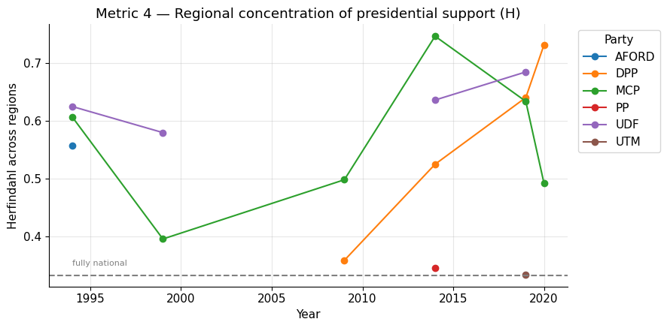
Figure 4. Herfindahl index of presidential vote concentration across Malawi's three regions (dashed line = fully national).
Year | AFORD | MCP | UDF | DPP | PP | UTM
1994 | 0.56 | 0.61 | 0.62 | - | - | -
1999 | - | 0.40 | 0.58 | - | - | -
2009 | - | 0.50 | - | 0.36 | - | -
2014 | - | 0.75 | 0.64 | 0.52 | 0.35 | -
2019 | - | 0.63 | 0.68 | 0.64 | - | 0.33
2020 | - | 0.49 | - | 0.73 | - | -
Table 4. Herfindahl index of presidential vote concentration (1.0 = purely regional; 0.33 = fully national).
Three findings stand out. First, the founding 1994 parties were all heavily regional (H between 0.56 and 0.62), the numerical face of the North-AFORD, Centre-MCP, South-UDF triptych described in every account of that election. Second, the extremes of the chart bracket the modern era: MCP in 2014 is the most regional major actor ever measured here (H = 0.75, locked into the Central Region), while UTM in 2019 is the most national (H = 0.33 - Chilima drew almost perfectly evenly across all three regions, a genuinely unusual profile for a Malawian party). Third, and central to the coalition story: MCP's concentration falls from 0.63 in 2019 to 0.49 in 2020. The Tonse Alliance did not simply add votes to MCP's pile; it broadened the party's geographic base, importing UTM's national profile - a measurable nationalization event. DPP moved in the opposite direction, retreating to its Southern core (H rising from 0.64 to 0.73) as its support elsewhere evaporated.

3.6 Metric 5 - Split-ticket divergence
In the five years with simultaneous presidential and parliamentary races (1994, 1999, 2009, 2014, 2019), each party's presidential vote share was compared with its parliamentary vote share at district grain. The divergence - presidential minus parliamentary share - measures whether a party's presidential candidate ran ahead of its local candidates, the classic signature of a personal or coattail vote at the top of the ticket.
Year | Party | Mean divergence (share points) | Districts
1994 | MCP | +0.006 | 22
1994 | UDF | +0.018 | 22
1999 | MCP | +0.140 | 24
2009 | DPP | +0.307 | 27
2009 | MCP | +0.161 | 26
2014 | DPP | +0.177 | 24
2019 | DPP | +0.142 | 28
2019 | MCP | +0.090 | 28
Table 5. Selected split-ticket divergences (presidential share minus parliamentary share, district mean).
The standout is DPP in 2009: Bingu wa Mutharika's presidential vote ran 31 points ahead of his party's parliamentary vote in the average district. The explanation is historical: the DPP had existed for only four years, had thin local candidate networks, but was headed by an incumbent president enjoying enormous personal popularity after a first term marked by the farm-input subsidy program and strong economic growth - his 2009 landslide is generally regarded as the high-water mark of personal incumbent appeal in Malawi. Voters backed Mutharika for president while frequently voting for someone else, often an independent, for MP. The near-zero divergences of 1994, by contrast, show a founding election in which party and candidate were indistinguishable - people voted the regional party ticket straight down the ballot.

3.7 Metric 6 - Wasted-vote share
Under plurality rule, every vote not cast for the seat's winner elects nobody. A simple per-seat proxy - one minus the winner's share of valid votes - aggregates this into the mean wasted-vote share, the structural cost of first-past-the-post in a fragmenting system.
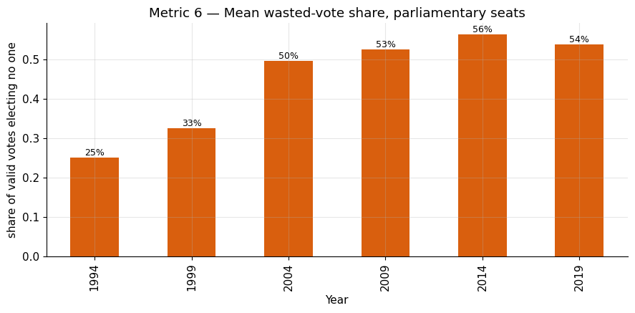
Figure 5. Mean share of valid votes cast for losing parliamentary candidates, by year.
The trend is the report's single most policy-relevant number. In 1994, three-quarters of voters in the average constituency were represented by the MP they helped elect; by 2014 the average winning MP was opposed by 56 percent of their own constituency's voters. Fragmentation (Metric 1) and wasted votes are two faces of the same arithmetic: as fields crowd, winners win with ever-smaller pluralities. This is precisely the legitimacy problem that Malawi's Constitutional Court confronted at the presidential level in 2020, when it held that election by a "majority" under section 80(2) of the Constitution requires 50 percent plus one rather than a bare plurality - a ruling that transformed coalition-building from a tactical option into a mathematical necessity. The parliamentary tier, it should be noted, remains first-past-the-post, and these wasted-vote figures constitute the standing empirical case invoked in Malawian debates over parliamentary electoral reform.

3.8 Metric 7 - Incumbent re-election, and a lesson in join fragility
The final behavioural metric attempts to track whether sitting MPs re-ran and re-won, by matching each seat's winner at election t to the candidate field in the same constituency at election t+1 using surname and constituency name as the join key.
Transition | Seats matched | Re-ran (%) | Re-won (%)
1994 → 1999 | 139 | 45.3 | 29.5
1999 → 2004 | 120 | 59.2 | 30.0
2004 → 2009 | 122 | 2.5* | 0.0*
2009 → 2014 | 191 | 3.1* | 1.0*
2014 → 2019 | 167 | 80.2 | 26.9
Table 6. Incumbent re-run and re-election rates. *Values for 2004→2009 and 2009→2014 are join artifacts, not political facts - see text.
Read this table skeptically, because it is deliberately presented with its failure intact. The 2004→2009 and 2009→2014 rows imply that almost no MP in Malawi ever stood for re-election in those cycles - which is plainly false. The cause is mechanical: those pairs of source files format constituency names and candidate names differently (ordering, initials, honorifics), so the surname-plus-constituency key silently fails to match. The believable transitions tell a coherent story - roughly half to four-fifths of winners re-run, but only 27 to 30 percent of matched seats return the same member, an incumbent survival rate low by international standards and consistent with the well-documented churn of Malawi's National Assembly. The metric is retained in this form because it doubles as the project's clearest data-quality lesson: a metric is only as trustworthy as the join beneath it.

4. Descriptive Findings: Who Won Where, and By How Much
The behavioural metrics compress voter behaviour into single defensible numbers. This section presents the descriptive layer beneath them - vote shares, winners, seat counts, and margins by district and region - the views a findings report is asked for first, and the direct feed for the planned interactive dashboard. All district-level figures here use the canonical 28-district key described in Section 2.2.

4.1 National vote share by party
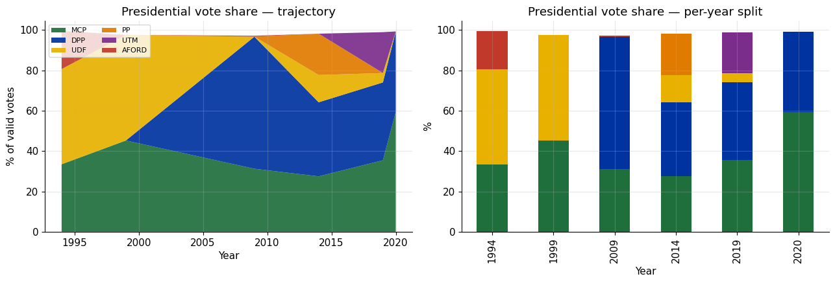
Figure 6. Presidential national vote share by party - trajectory (left) and per-year split (right).
Year | MCP | DPP | UDF | PP | UTM | AFORD
1994 | 33.4 | - | 47.1 | - | - | 18.9
1999 | 45.2 | - | 52.3 | - | - | -
2009 | 31.2 | 65.4 | - | - | - | 0.5
2014 | 27.4 | 36.7 | 13.5 | 20.5 | - | -
2019 | 35.4 | 38.6 | 4.7 | - | 20.2 | -
2020 | 59.3 | 39.9 | - | - | - | -
Table 7. Presidential national vote share (%) by party and year, six largest parties.
The table reads as a compressed political history of the Third Republic. UDF's founding dominance (47.1 percent in 1994, 52.3 in 1999) gives way after Bingu wa Mutharika's defection to the DPP era, whose 65.4 percent in 2009 remains the largest presidential vote share ever recorded in multiparty Malawi. The 2014 field splinters four ways - the fragmentation peak Metric 1 registered as ENP 3.70 - and 2019 splits three ways almost evenly enough to guarantee litigation. The final column pair is the coalition effect in raw shares: MCP jumps from 35.4 to 59.3 percent between the annulled election and the re-run, a 24-point single-cycle gain with no precedent in the series, while DPP gains barely a point. The arithmetic is stark: Chakwera's 2020 share is almost exactly his 2019 share plus Chilima's.

4.2 The district winner maps
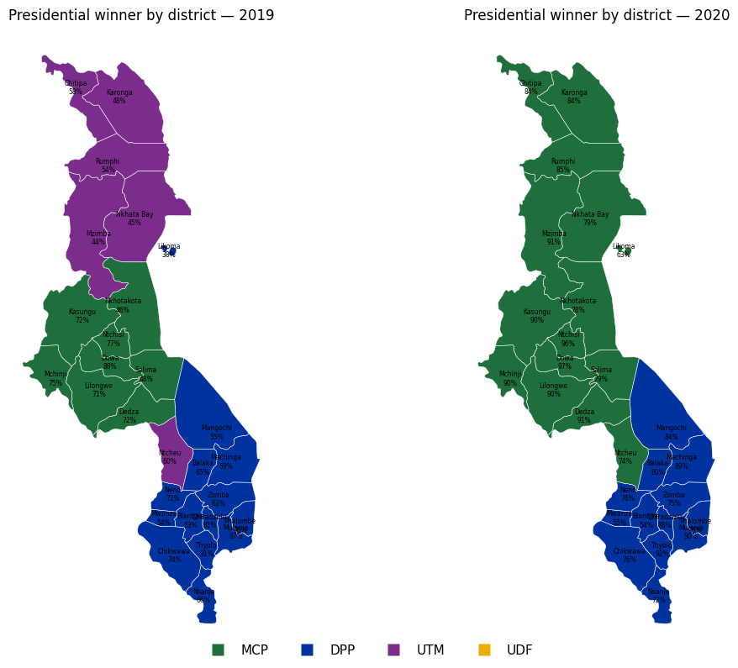
Figure 7. Presidential winner by district, 2019 (left) and 2020 (right), labeled with the winner's percentage of the district vote.
These two maps are the report's most legible artifact, and arguably its entire argument in one image. In 2019 the country is tri-colored: UTM purple across the North (Chitipa, Karonga, Rumphi, Nkhata Bay, Mzimba) plus Ntcheu; MCP green across the Central Region; DPP blue across all thirteen Southern districts. In 2020 the purple is gone - every UTM district turns MCP green, the Centre deepens, and the DPP South holds but shrinks to exactly its 2019 footprint. Not a single district changed hands between MCP and DPP directly; the entire realignment ran through the dissolved UTM bloc. The maps also show the win percentages hardening: MCP's Central districts move from the seventies into the nineties (Ntchisi 96 percent, Dowa 97 percent), while the DPP's Southern strongholds stay in the eighties and nineties on both maps - polarization deepening on both sides of a stable frontier.
Region | 2019: DPP | 2019: MCP | 2019: UTM | 2020: DPP | 2020: MCP
Northern | 1 | 0 | 5 | 0 | 6
Central | 0 | 8 | 1 | 0 | 9
Southern | 13 | 0 | 0 | 13 | 0
Table 8. Presidential districts won, by region and party, 2019 versus 2020.

4.3 Parliamentary seats won by party
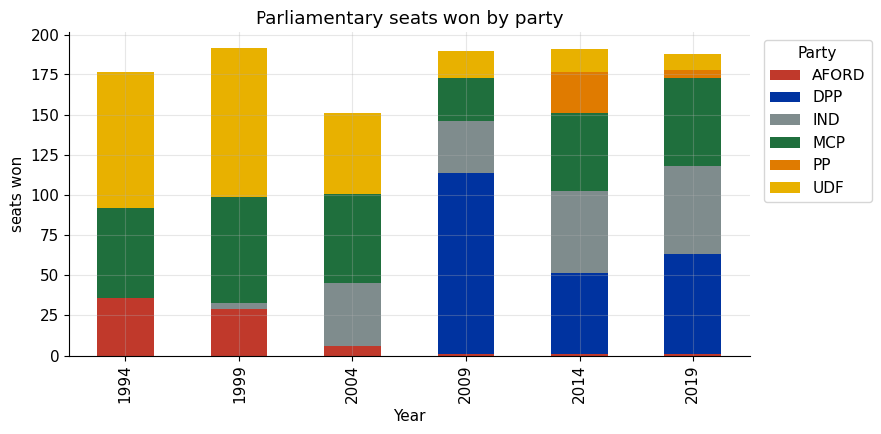
Figure 8. Parliamentary seats won by party, 1994-2019 (six largest parties; independents shown as a bloc).
Year | AFORD | DPP | IND | MCP | PP | UDF
1994 | 36 | - | - | 56 | - | 85
1999 | 29 | - | 4 | 66 | - | 93
2004 | 6 | - | 39 | 56 | - | 50
2009 | 1 | 113 | 32 | 27 | - | 17
2014 | 1 | 50 | 52 | 48 | 26 | 14
2019 | 1 | 62 | 55 | 55 | 5 | 10
Table 9. Parliamentary seats won by party and year (constituencies in the dataset).
Two structural stories live in this table. The first is the rise and fall of parliamentary majorities: UDF's 93 seats in 1999 and DPP's 113 in 2009 are the only approaches to single-party dominance, and both evaporated within one cycle. The second, less told internationally, is the independents: from 4 seats in 1999 to 39 in 2004 to a 52-55 seat bloc in 2014 and 2019 - by 2014 independents were the second-largest "party" in the National Assembly. In Malawi, losing a party primary and re-running as an independent is a mainstream career move, and many independents rejoin parties after winning; this is why Malawian legislative politics cannot be read through a party-seat lens alone, and why the seat totals never resolve into a clean two-party story even as the presidential race did in 2020.

4.4 Regional vote shares and dominance
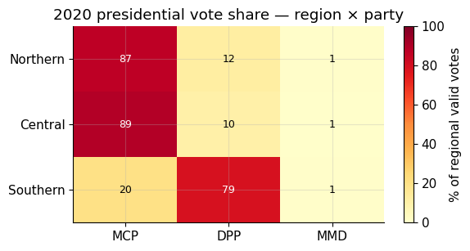
Figure 9. 2020 presidential vote share by region and party.
The heatmap restores what win-counts hide: magnitude. In 2020 MCP took 87 percent of the Northern vote and 89 percent of the Central vote, while DPP held 79 percent of the Southern vote - a near mirror-image country split along one internal frontier. This is why the Tonse coalition worked arithmetically: the North and Centre together simply out-populate the South, so a bloc that pools them wins any two-way race. It is also why the arrangement was fragile: subtract the Northern component (as UTM's 2024 exit did) and the arithmetic reverses, which is essentially what the 2025 result went on to demonstrate.
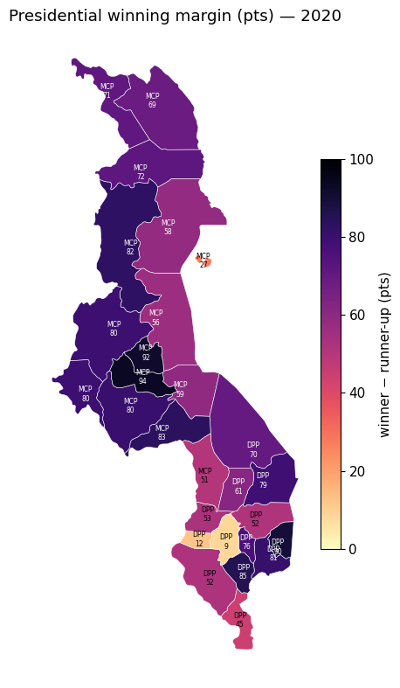
Figure 10. Presidential winning margin by district, 2020 (winner minus runner-up, percentage points).
The margin map shows how little contested ground remained after consolidation. Almost the entire map is dark - the mean district margin was roughly 65 points, and Central Region districts like Ntchisi and Dowa were won by more than 90. The pale exceptions are instructive: Balaka (12 points) and Neno (9 points) on the Southern fringe are the only districts where the two blocs genuinely fought, marking the narrow seam between MCP's expanded coalition and the DPP heartland. Likoma, the small island district, stands out as the North's only competitive spot (27 points). For campaign-resource purposes, the 2020 map contains fewer than a handful of true battlegrounds.

4.5 Turnout - handled honestly
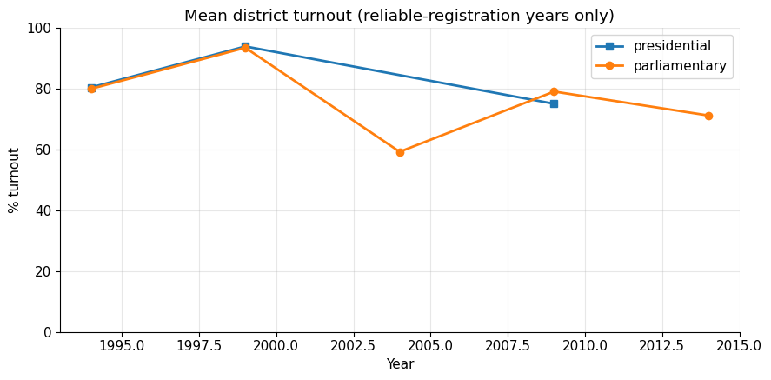
Figure 11. Mean district turnout for years with reliable registration data. 2019 (registration missing) and 2020 (registration corrupted) are excluded.
Year | Presidential turnout (%) | Parliamentary turnout (%)
1994 | 80.5 | 80.0
1999 | 94.0 | 93.6
2004 | - | 59.3
2009 | 75.1 | 79.1
2014 | - | 71.2
Table 10. Mean district turnout, reliable-registration years only.
Turnout required a data-integrity decision worth reporting in its own right. The 2019 files carry no registered-voter counts at all (a known gap), and inspection revealed that the 2020 file's registration column is corrupted: it sums to roughly 18.2 million registered voters against 4.4 million ballots cast, implying a 24 percent national turnout when the true 2020 figure was approximately 65 percent. Rather than publish a poisoned number, both years are excluded and the exclusion is stated. The believable series peaks at Malawi's famously high 1999 turnout (around 94 percent) and drifts downward thereafter - a common trajectory as founding-election enthusiasm fades - with the 2004 parliamentary figure (59.3 percent) marking the trough of the disillusioned mid-2000s. Sourcing clean MEC registration figures for 2019 and 2020 remains the single highest-value data acquisition on the roadmap, because it would unlock the turnout-elasticity question the 2019-2020 comparison otherwise leaves open.

4.6 Two further analyses: disproportionality and bellwethers
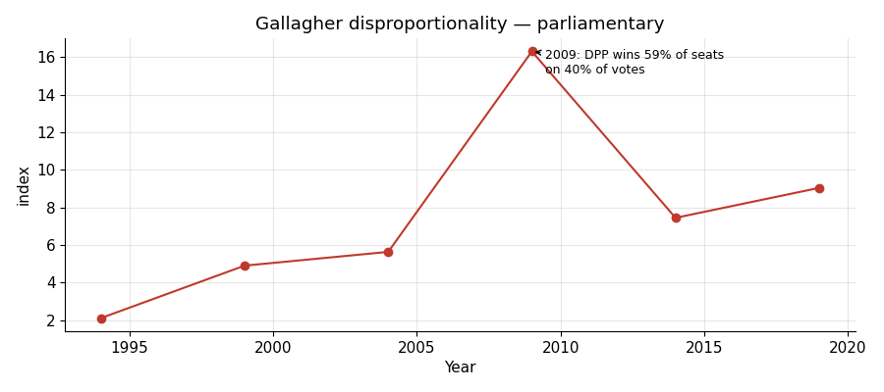
Figure 12. Gallagher index of seat-vote disproportionality, parliamentary elections (candidate-level seat winners; corrected series).
The Gallagher least-squares index measures how far parliamentary seat shares diverge from vote shares - the seat-level companion to the wasted-vote metric. Malawi's index rises from 2.1 in 1994 (near-proportional, because regionally concentrated parties win their own regions' seats efficiently) and spikes to 16.3 in 2009, when the DPP converted 40 percent of the parliamentary vote into 59 percent of the seats - the textbook first-past-the-post winner's bonus, delivered at the height of Bingu wa Mutharika's personal popularity. It then settles at 7.5-9.0, still roughly four times the 1994 level. A methodological note that belongs in the open: an earlier draft of this index determined seat winners from party-aggregated constituency votes, which silently merged co-running independents into one bloc, awarded them 17-29 phantom seats per election from 2004 onward, and produced a smoother series peaking at 10.6 in 2014. A seat is won by a candidate, not a party aggregate; computing winners at candidate level - consistent with the seat counts in Table 9 - yields the corrected series shown here. It is the same lesson the incumbency metric teaches: the metric is only as trustworthy as the join beneath it.
Most reliable bellwethers | Match rate | Strongest partisan anchors | Match rate
Likoma | 100% (4 elections) | Lilongwe | 17%
Blantyre | 83% | Dedza | 17%
Mulanje | 83% | Mzimba | 33%
Thyolo | 83% | Chitipa | 33%
Mwanza | 83% | Karonga | 33%
Ntcheu | 83% | Mchinji | 33%
Table 11. Bellwether analysis: how often each district's presidential winner matched the national winner, 1994-2020.
The bellwether table inverts the stronghold story. Tiny Likoma island has voted with the national presidential winner in all four elections it appears in, and a band of Southern districts (Blantyre, Mulanje, Thyolo, Mwanza) plus frontier Ntcheu matched five of six - these are the districts a dashboard should watch on election night. At the other pole sit the great partisan anchors: Lilongwe and Dedza matched the national winner only once in six elections, because they vote MCP regardless of who wins nationally, just as the Northern districts' low rates reflect their AFORD-then-UTM loyalty. In a country this regionally polarized, the informative districts are not the biggest but the ones that sit on the seam.

5. Data Quality and Limitations
Five limitations bound the conclusions above, and stating them is part of what makes the rest defensible. First, granularity is mixed by construction: presidential results for 1994-2014 exist only at district level and parliamentary results for 1994-2014 only at constituency level, while 2019-2020 descend to roughly 5,000 polling stations. All cross-era comparisons are made at the coarsest common grain (district), and no metric mixes grains within a single computation; but any question requiring sub-district detail before 2019 is simply unanswerable from this data.
Second, no 2004 presidential results file was available. The presidential volatility series therefore contains a decade-long 1999→2009 step whose extreme value (68.8 percent) is an artifact of the interval, not evidence of a single-election earthquake; it is flagged as such wherever it appears. Third, registered-voter counts are absent from both 2019 files and - a finding of this edition - corrupted in the 2020 file, whose registration column implies a physically implausible 24 percent turnout against a true figure near 65 percent. Turnout is therefore reported only for 1994-2014, and the turnout-elasticity comparison between the annulled election and the re-run remains open pending clean MEC registration data. Fourth, district names carried spelling splits across eras that would silently double-count districts; these are resolved by the canonical 28-district mapping described in Section 2.2, but the fix is itself a mapping decision that should be reviewed alongside party_map.csv. Fifth, the incumbency metric's name-matching artifact, documented in Section 3.8, invalidates two of its five transitions pending fuzzy-matching work.
Against these limitations stand the pipeline's affirmative guarantees: candidate votes reconcile exactly to reported valid-vote totals within every unit; total-voted equals valid plus null-and-void wherever both are reported; the 51.6-million-vote national total is invariant across the party-reconciliation step; and every row carries its source file, so any figure in this report can be traced back to a specific cell range in a specific MEC workbook.

6. Conclusions and Next Steps
Three conclusions carry the weight of this study. First, Malawi's party system pluralized steadily and measurably for a quarter-century: median seat-level fragmentation more than doubled, safe seats fell from nine in ten to fewer than four in ten, the wasted-vote share climbed until winning MPs were routinely minority representatives of their own constituencies, and seat-vote disproportionality ran at roughly four times its 1994 level, peaking with the 2009 winner's bonus. Second, the 2020 fresh presidential election was a consolidation event of rare scale and precision - a 38 percent collapse in the effective number of competitors, a 24-point single-cycle gain in MCP's national share, a 25.6 percent Pedersen reshuffle between two elections thirteen months apart, and a district map on which every UTM district, and only the UTM districts, changed color. The data supports the strong reading of the coalition effect: institutional change (the 50-percent-plus-one rule) altered party strategy, and party strategy, not a diffuse change in public mood, produced the result. Third, regionalism bent but did not break: even in 2020, MCP's nationalization coexisted with a DPP holding 79 percent of the Southern vote across an unmoved thirteen-district bloc, and the post-dataset events of 2024-2025 - the Tonse Alliance's dissolution and Mutharika's landslide return - confirm that Malawi's regional architecture remains the substrate on which coalitions are temporarily built.
The project's roadmap follows directly. Ingesting the 2025 station-level results would convert the 2020 consolidation from an endpoint into the middle of a rise-and-fall arc, which is a stronger analytical narrative and a sterner test of every metric. Sourcing clean 2019 and 2020 registration figures would unlock the turnout-elasticity question. Fuzzy name-matching would rehabilitate the incumbency metric. And the cleaned dataset, its persisted metric tables (seven behavioural, eight descriptive), and the district geometry are the exact inputs required for the planned interactive dashboard - the point at which this analysis stops being a report and becomes a tool.

7. Sources and Further Reading
Primary data: Malawi Electoral Commission results workbooks, 1994-2020 (twelve files, presidential and parliamentary), harmonized as described in Section 2; Natural Earth admin-2 boundaries (public domain / CC-BY) for district geometry. All figures in this report were produced from the project's analysis notebook (Malawi_Elections_Analysis.ipynb) and are reproducible from the persisted output tables.
External context consulted for this report includes: the Constitutional Court judgment in Chilima and Chakwera v. Mutharika and the Electoral Commission (Constitutional Reference No. 1 of 2019) and commentary on it in the Journal of African Elections (EISA, 2021); Chatham House, "Malawi's Re-Run Election is Lesson for African Opposition" (July 2020); Freedom House, "Malawi: Voters Uphold Electoral Integrity and Democracy in Presidential Rerun" (June 2020); LSE Africa blog commentary on the February 2020 ruling; Al Jazeera and other press reporting on the annulment and the "Tipp-Ex" tallying irregularities; and regional press analysis of the September 2025 election (Nation Media Group). Methodological references: Laakso and Taagepera (1979) on the effective number of parties; Pedersen (1979) on electoral volatility; Gallagher (1991) on the least-squares index of disproportionality.

