🌍 MALAWI · TRADE INTELLIGENCE REPORT
Export Trade Analysis
1986 – 2024

A data-driven investigation into Malawi's export structure, trading partner dynamics, commodity concentration, and five-year market outlook - powered by KNIME Analytics Platform.

67%  Tobacco Export Share  of total export value | #1 Belgium  Top Trading Partner  23.7% of export value

38 Years  Dataset Span  FAOSTAT: 1986–2024 | 2029  Forecast Horizon  Linear regression projection

Contents
Contents 2
Project Overview 3
Analytical Objectives 3
Tools & Technology 3
Analytical Methodology 4
Pipeline Architecture 4
Data Preprocessing Notes 4
Export Concentration Metrics 5
Top Commodity Finding 5
Top Partner Finding 5
Concentration Metrics - Data Tables 6
Partner & Commodity Cluster Analysis 7
Methodology 7
Cluster Interpretation 7
Year-Over-Year Growth Analysis 8
Key Observation: The 1997–1998 Spike 8
Rolling Volatility - Belgium (3-Year Window) 10
Findings 10
5-Year Market Forecast - Tobacco Exports 11
Model Findings 11
Model Limitations 12
Key Takeaways & Strategic Implications 13
Data Source & Citation 14
Acknowledgements 14

01 PROJECT OVERVIEW

Project Overview

Malawi is a landlocked sub-Saharan nation whose export economy is heavily shaped by a small number of agricultural commodities and a concentrated set of trading relationships. This project applies a multi-technique data analytics pipeline - built entirely in KNIME Analytics Platform - to 38 years of FAOSTAT trade data (1986–2024), covering all recorded export transactions between Malawi and its global trading partners.
The goal is to move beyond surface-level descriptive statistics and generate actionable intelligence across five analytical dimensions: trade concentration, partner and commodity clustering, year-over-year growth dynamics, rolling volatility, and forward-looking market prediction.

Analytical Objectives
- Identify structural concentration - quantify how much of Malawi's export value is carried by a single commodity and a single partner.
- Reveal natural groupings - use k-Means clustering and PCA to segment both trading partners and commodities into behaviorally similar groups.
- Track growth trends - compute year-over-year growth rates across the full dataset to identify inflection points and sustained trends.
- Measure trade risk - apply a 3-year rolling standard deviation to quantify export volatility with the top partner (Belgium).
- Forecast future performance - train a linear regression model on tobacco export history and project values through 2029.

Tools & Technology
Tool | Role in Project
KNIME Analytics Platform | End-to-end data pipeline: preprocessing, analysis, visualization
k-Means Clustering | Unsupervised grouping of partners and commodities
PCA (Principal Component Analysis) | Dimensionality reduction for cluster visualization
Linear Regression (Learner/Predictor) | 5-year export value forecasting
Moving Aggregator Node | Rolling 3-year standard deviation for volatility analysis
FAOSTAT (fao.org/faostat) | Primary data source - international agricultural trade data

02 METHODOLOGY

Analytical Methodology

The project was structured as a modular KNIME workflow, with each analytical section receiving a preprocessed data feed from a shared Data Preprocessing branch. This design ensures consistency across all analyses and allows each module to be updated independently.

Pipeline Architecture
Stage | Nodes Used | Output
Data Preprocessing | CSV Reader → Row/Column Filter → Unpivot → Renamer → String to Date → Auto Type Cast → Math Formula | Cleaned, typed, long-format trade table
Concentration Metrics | GroupBy → Sorter → Row Filter → Column Appender → Renamer → Math Formula → Pie Chart | Top 10 partners & commodities by export share
Clustering | Pivot → Missing Value → Normalizer → k-Means → Color Manager → PCA → Scatter Plot | Cluster assignments + PCA scatter plots
YoY Growth | GroupBy → Lag Column → Math Formula → Line Plot | Annual growth % time series
Rolling Volatility | Row Filter → Moving Aggregator → Line Plot | 3-year rolling std. dev. for Belgium
5-Year Forecast | GroupBy → Table Partitioner → LR Learner → Regression Predictor → Concatenate → Line Plot | Tobacco export forecast through 2029

Data Preprocessing Notes
- Raw FAOSTAT data was imported in wide format (one column per year) and unpivoted to long format to enable time-series operations.
- String date columns were cast to KNIME Date&Time format, and numeric columns were auto-typed for compatibility with downstream math nodes.
- Row and column filters were applied to isolate Malawi as the reporting country and remove non-export trade flow types.
- A Math Formula node computed derived fields including export value aggregations and growth rate percentages.

03 CONCENTRATION METRICS

Export Concentration Metrics

The concentration analysis reveals two critical structural features of Malawi's export economy: extreme commodity dependence and a narrow partner base. Both represent significant risk factors for long-term trade stability.

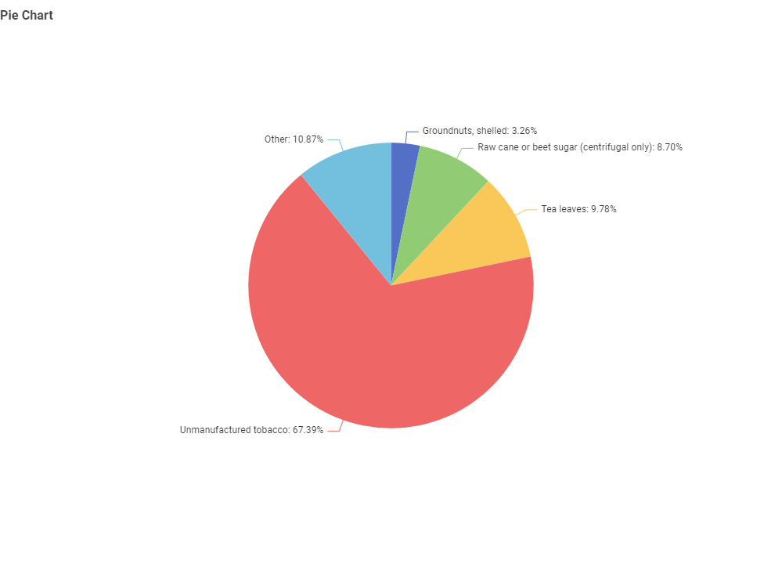 | 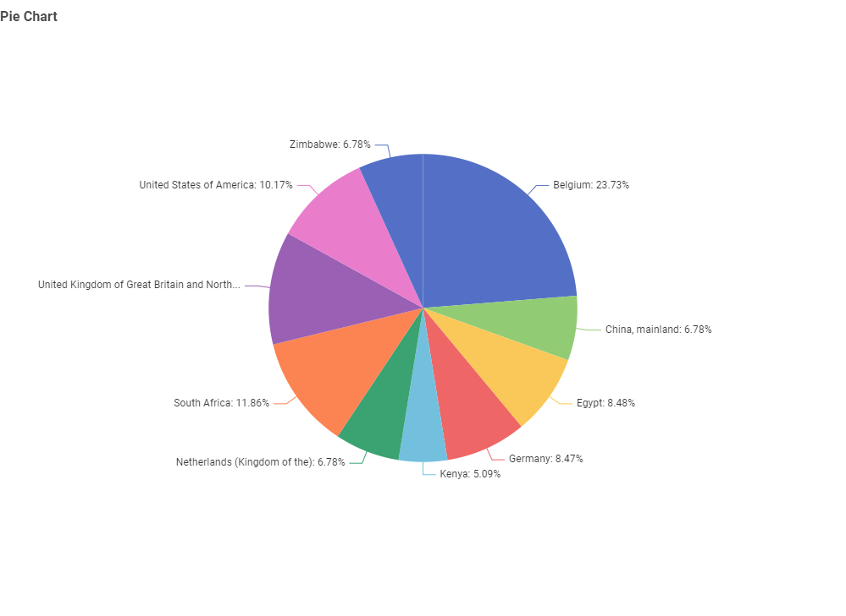
Figure 1: Top 10 Export Commodities by Share | Figure 2: Top 10 Trading Partners by Export Value

Top Commodity Finding
Unmanufactured tobacco accounts for 67.39% of Malawi's recorded export value across the entire 1986–2024 dataset - a strikingly dominant share. The remaining export portfolio is composed of tea leaves (9.78%), raw cane or beet sugar (8.70%), groundnuts shelled (3.26%), and a combined 'other' category (10.87%). This level of monoculture dependency is characteristic of economies where a single cash crop has historically defined the trade identity of the nation.

Top Partner Finding
Belgium holds a commanding 23.73% share of Malawi's export value, nearly double that of the second-ranked partner, South Africa (11.86%). The United States (10.17%), Germany (8.47%), and Egypt (8.48%) round out the top five. European nations collectively account for a majority of the top-tier partner weight, while African regional partners - South Africa, Zimbabwe, Kenya - represent a meaningful but secondary share.

Concentration Risk: Malawi's top commodity (tobacco) and top partner (Belgium) together represent a structural vulnerability. Any disruption in global tobacco demand or Belgium-based trade flows would have outsized consequences on total export revenue.

Concentration Metrics - Data Tables
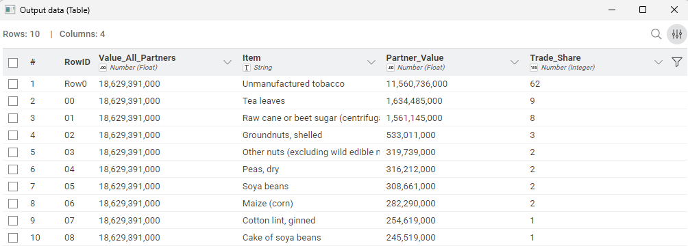 | 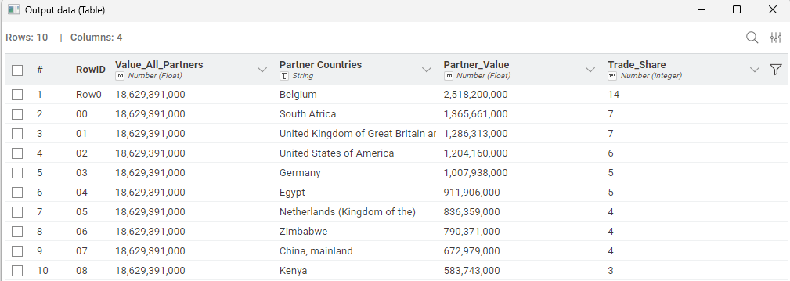
Table 1: Top 10 Products - Export Value | Table 2: Top 10 Partners - Export Value

04 CLUSTER ANALYSIS

Partner & Commodity Cluster Analysis

K-Means clustering was applied to both the trading partner dataset and the commodity dataset, after normalizing export value features across all available years. PCA was then used to reduce dimensionality and produce two-dimensional scatter plots for visual cluster inspection.

Methodology
- Input features: Pivoted annual export values (one column per year) for each partner/commodity.
- Preprocessing: Missing values imputed, data normalized using KNIME's Normalizer node (z-score standardization).
- Clustering: k-Means algorithm applied; clusters labeled cluster_0, cluster_1, etc.
- Visualization: PCA reduced the feature space to two principal components for scatter plot rendering.

Cluster Interpretation
Cluster | Entity Type | Characteristics | Representative Members
cluster_0 | Commodity | Low-volume, sporadic exports across most years - minimal market presence | Almonds, Anise, Animal fats
cluster_1 | Partner | Low-to-moderate engagement; presence in specific years only; smaller trade flows | Afghanistan, Albania, Algeria
High-value | Partner/Commodity | Consistent, high-volume exports across the full time horizon | Belgium, South Africa, Tobacco

The clustering results confirm the concentration narrative: a small cluster of high-value entities (Belgium, South Africa, tobacco) dominates the trade landscape, while the majority of partners and commodities occupy low-activity clusters. This pattern is analytically consistent with Pareto dynamics - a small proportion of the trade network generates the vast majority of value.

05 YEAR-OVER-YEAR GROWTH

Year-Over-Year Growth Analysis

Year-over-year (YoY) growth rates were computed for total export value across the full 1986–2024 span, using a lag-column approach in KNIME to compare each year's value against the prior year. The resulting time series reveals a highly significant structural event in the mid-to-late 1990s.

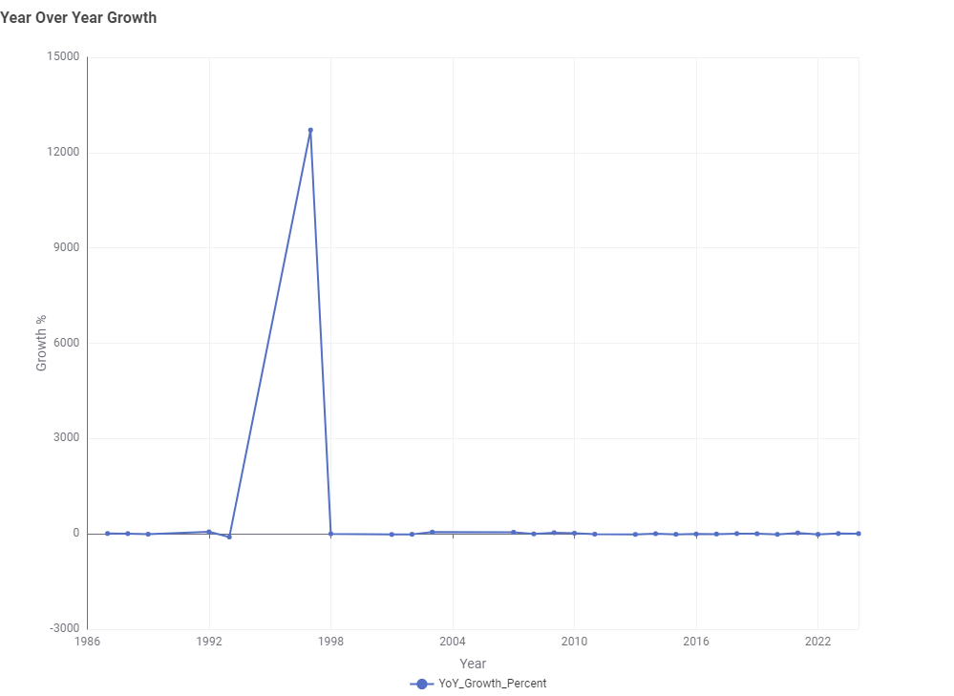
Figure 3: Year-Over-Year Export Growth (%), 1986–2024

Key Observation: The 1997–1998 Spike
The chart shows a dramatic spike in YoY growth approaching +12,500% around 1997–1998, followed by an immediate return to near-zero growth in subsequent years. This is analytically significant for two reasons:
- Data continuity event: A near-zero baseline in earlier years (possibly due to data gaps or unreported trade flows in FAOSTAT prior to 1992) can generate artificially extreme percentage changes when values begin to populate - a known artifact in long-horizon trade datasets.
- Economic inflection point: The period 1994–2000 coincides with Malawi's post-democratization economic transitions and shifts in international tobacco trade dynamics, which may have generated genuine structural growth.

Post-2000, YoY growth stabilizes in a low single-digit range, consistent with a maturing export market rather than a high-growth trajectory.

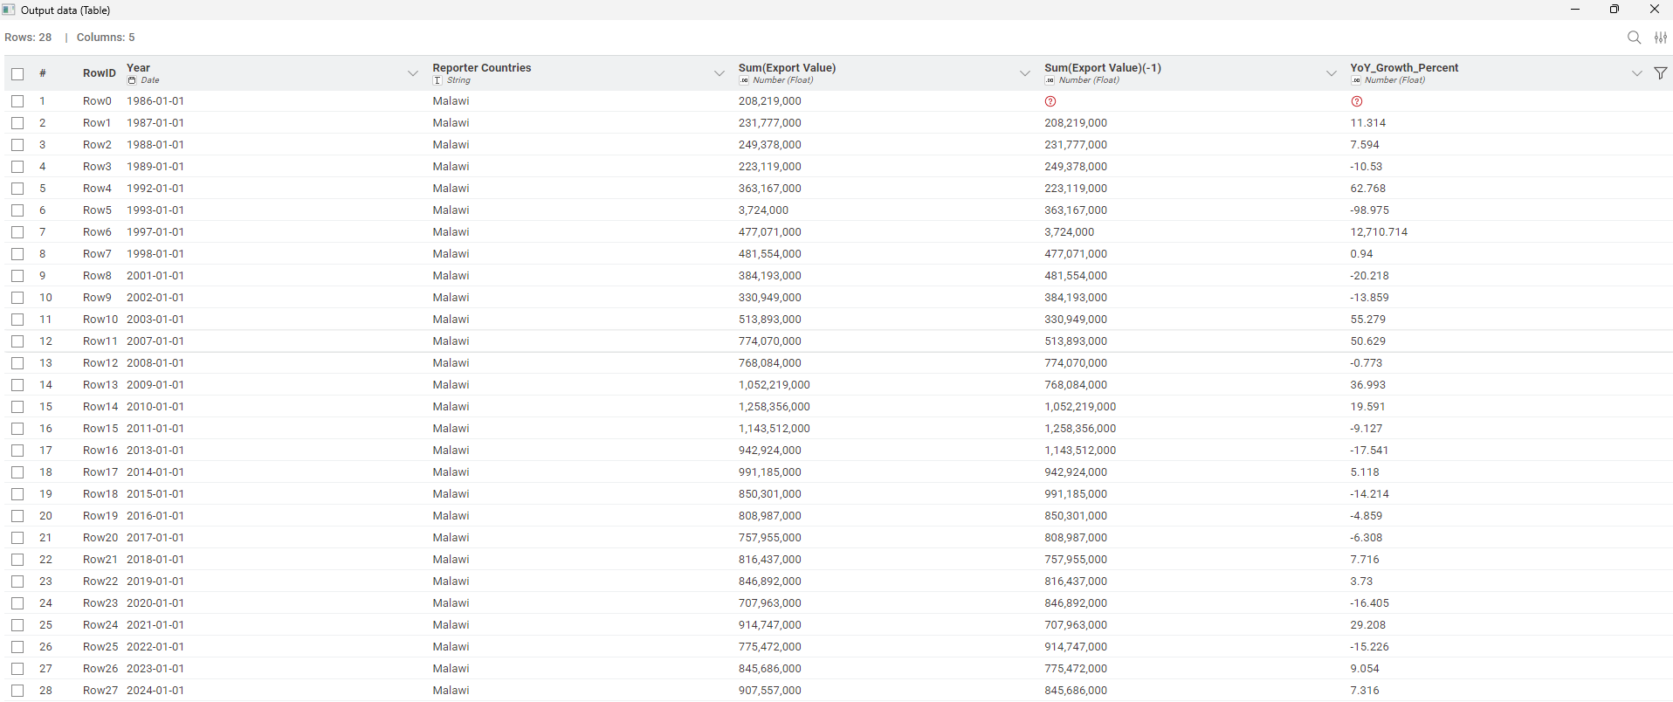
Table 3: Year-Over-Year Growth Data (KNIME output)

06 ROLLING VOLATILITY

Rolling Volatility - Belgium (3-Year Window)

To assess trade risk with Malawi's dominant partner, a 3-year rolling standard deviation was computed on annual export values to Belgium. This metric quantifies how erratically trade volumes have fluctuated over time - with higher values indicating less predictable trade relationships and higher operational risk.

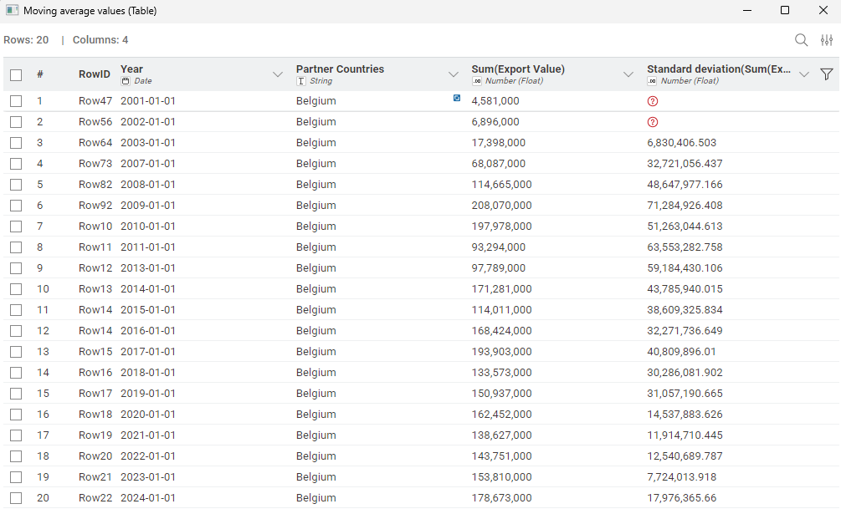
Table 4: 3-Year Rolling Volatility - Belgium Export Values (2001–2024)

Findings
- Peak volatility (2009): The 3-year standard deviation reached approximately $71.3M in 2009, coinciding with global commodity price turbulence during and after the 2008 financial crisis.
- Declining volatility trend: From 2009 onward, rolling volatility with Belgium shows a sustained downward trajectory - falling to approximately $7.7M by 2023 and $17.9M in 2024.
- Stabilizing relationship: The convergence of volatility toward lower values in recent years suggests a maturing, more predictable trade relationship - a positive signal for trade planning and forecasting.
- Early years missing: Standard deviation values are absent for 2001–2002 due to insufficient data points within the 3-year rolling window - an expected behavior in moving aggregation.

07 5-YEAR MARKET FORECAST

5-Year Market Forecast - Tobacco Exports

A linear regression model was trained on historical tobacco export value data and used to project annual export values through 2029. Given tobacco's dominant 67% share of Malawi's export portfolio, this forecast functions as a proxy for total export trajectory.

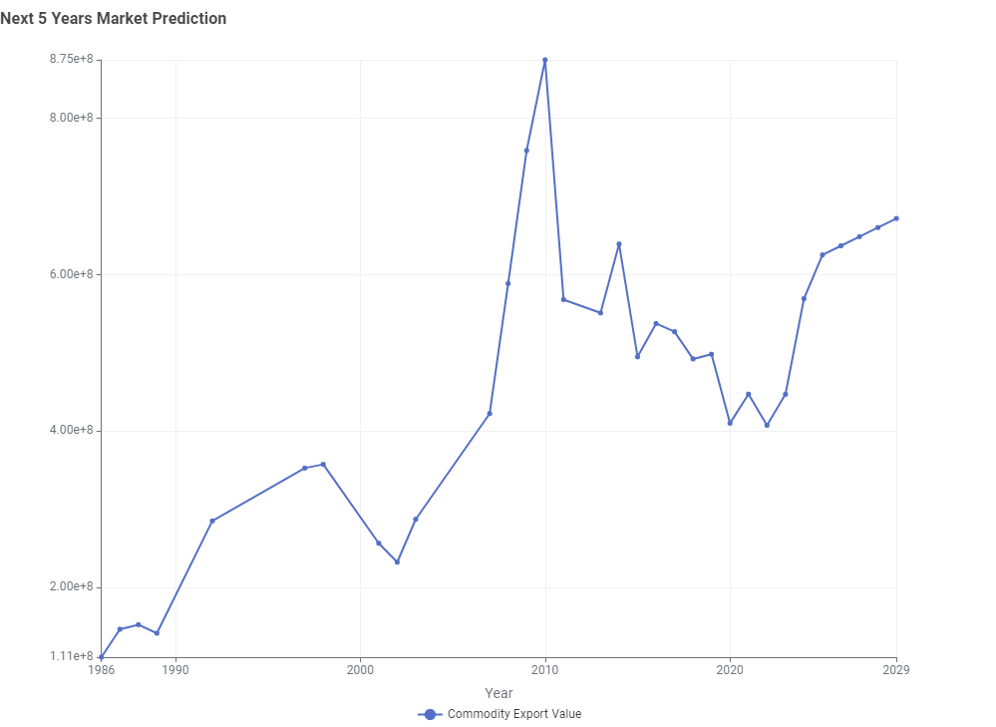
Figure 4: Tobacco Export Value - Historical (1986–2024) + Forecast (2025–2029)

Model Findings
- Historical peak (2010): Tobacco export values reached approximately $875M, representing the highest recorded annual value in the dataset.
- Post-2010 decline: Values dropped sharply through 2013–2014 and continued oscillating at a lower plateau (~$400–550M) through 2022.
- Recovery trend (2022–2024): Export values show renewed upward movement, reaching approximately $640–670M by 2024.
- Forecast to 2029: The linear regression model projects continued recovery toward $670–700M by 2029, consistent with the recent growth trajectory.

Model Limitations
Linear regression assumes a constant directional trend and does not capture cyclical patterns, policy shocks, or non-linear dynamics. The 2010 peak and subsequent volatility demonstrate that tobacco export values are subject to disruption. This forecast should be interpreted as a baseline trend indicator rather than a precise prediction.

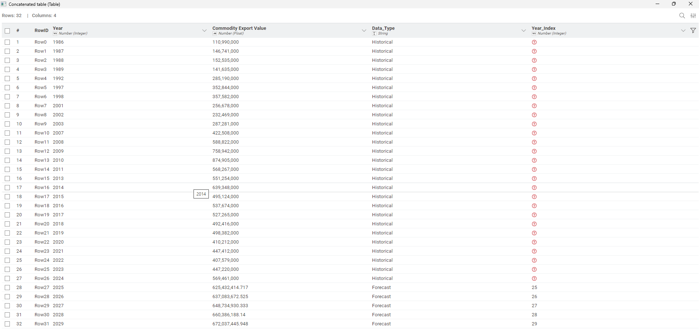
Table 5: Linear Regression Output - Predicted Export Values

08 KEY TAKEAWAYS

Key Takeaways & Strategic Implications

Extreme Commodity Concentration
Unmanufactured tobacco at 67.39% creates a single point of failure in Malawi's export economy. Diversification into tea, sugar, and emerging commodities is strategically critical for resilience.

Partner Dependency on Belgium
Belgium's 23.73% share - driven by its role as a tobacco trading hub - means any shifts in European tobacco procurement or regulation could disproportionately impact Malawi's export revenue.

Stabilizing Trade Relationship
Declining rolling volatility with Belgium (from $71M in 2009 to $7.7M in 2023) signals a maturing, more predictable partnership - a foundation for longer-term trade planning.

Cautious Optimism in the Forecast
The linear regression model projects a modest recovery in tobacco export values through 2029. However, global tobacco demand faces long-term headwinds from regulatory pressures and shifting consumption patterns, making diversification even more urgent.

Data Infrastructure Opportunity
The 1997-1998 YoY anomaly highlights gaps in FAOSTAT data continuity for early years, suggesting an opportunity for improved trade data infrastructure to support more reliable long-horizon analyses for Malawian policymakers.

09 DATA SOURCE

Data Source & Citation

All trade data used in this analysis was sourced from the Food and Agriculture Organization of the United Nations (FAO) Statistical Database - FAOSTAT.

Field | Details
Source | FAOSTAT - Food and Agriculture Organization of the United Nations
URL | https://www.fao.org/faostat
Dataset | Trade: Crops and Livestock Products (Detailed Trade Matrix)
Reporting Country | Malawi
Trade Flow | Export
Time Range | 1986 – 2024 (38 years)
Unit of Measure | USD (1000 US$)
Access Date | 2025

Acknowledgements
This project was completed independently as part of a professional data analytics portfolio. The analytical pipeline was designed and executed in KNIME Analytics Platform (open-source). All findings and interpretations are those of the author.

Philip Katema · Data Analytics Portfolio · 2025

