How to earn your badge:
- Identify a number of common electronic components that are shown to you.
  - Explain, in simple terms, the functions they perform in electronic circuits.
- Describe the systems used for marking components with their values
  - Demonstrate by identifying the values of resistors and capacitors by their markings. Explain the importance of the rating of a component.
- Show that you know the symbols used to represent common components in circuit diagrams.
  - Show how to identify the polarity of a diode and a specific PIN on an integrated circuit.
- Show that you’re aware of the safe working practices to be followed when handling electronic components, circuit boards and when soldering.
- Use a multimeter to measure voltage, current and resistance in a simple circuit.
  - Explain the relationship between these values.
- Talk about the main differences in the operation of digital and analogue circuits.
- Construct three simple circuits.
  - One of these should be based mainly on digital electronics. They can be from a book or magazine, or you can design the circuits yourself. If possible, at least one of the circuits should be soldered using either stripboard or a custom-made printed circuit board.
- Explain the principles behind the operation of each circuit and the typical values of voltage and current found in each.
- Explain the possible uses of the three circuits you built.
- Talk about the uses and benefits of electronics in everyday life.
  - Explain how electronics can be used to improve lives.

History and Introduction
Electronics is the science that controls the behavior of electrons so that some type of useful function is performed. (Electrons will be explained more fully later in this book.) Today, electronics is a fast-changing and exciting field. The rapid growth of electronics started in the early 20th century when vacuum tubes were introduced and used to manipulate electronic signals. This was something that could not be done with the telegraph and telephone circuits or the high-voltage transmitters of those days. Vacuum tubes allowed weak radio and powerful signals to be amplified, or to be made louder or stronger, and be sent on powerful waves.
Electronics changed even more dramatically in 1948 when the transistor, a small, low-powered, solid-state electronic device, was invented. Transistors are smaller than vacuum tubes, require less power to function, and are more reliable. The development of the integrated circuit, or IC, advanced this technology further. ICs can contain tens of thousands of tiny transistors built onto a small piece of conducting material. This allows for the construction and production of complex electronic circuits, which are more efficient than tubes in processing electronic signals. ICs are used in many products today, including computers, audio equipment, cell phones, appliances, and automobiles.

How to Earn the Electronics Merit Badge
The first step in earning your Electronics merit badge is to discuss the requirements with your merit badge counsellor.
To fulfil requirement 1, learn about the precautions you should take when using, building, altering, or repairing electronic devices. Many electronic components (parts) could be damaged if mishandled. Here are some basic safety precautions; there are more safety suggestions later in this pamphlet. As you read this pamphlet and work on the requirements, pay attention to safety and see whether you can add to this list.
For requirement 2, study the chapter called “Schematic Diagrams.” You may choose a schematic diagram from this pamphlet, then copy it carefully with a pencil. Your drawing must show resistors, capacitors, and transistors or integrated circuits. Use the correct symbols for these components, label all parts, and be prepared to tell the purpose of each component. Show your drawing to your counsellor and tell what you have learned.
For requirement 3, learn how to solder and then practice soldering and desoldering wires. When you think you are ready, show your soldering skills to your counsellor. Be prepared to discuss soldering precautions, printed circuit boards, and possible heat damage to components when using a soldering iron.
Requirement 4 is demanding but fun because you will actually build a working electronics circuit. Choose your project carefully. Make sure that all the required parts are available at an electronics parts store, from a catalogue, or over the internet (only with your parent or guardian’s permission). Also consider what tools you will need. You can choose a project other than those in this pamphlet, but check with your counselor first to make sure that the project is suitable. After you are done with the project, show it to your counselor and explain how it works.
For requirement 4 you will also learn the basic principles of digital techniques, how you can use electronics for control purposes, and about audio applications. Learn the binary system so that you know how to change decimal numbers into binary numbers and binary into decimal.
For requirement 5, you will need to solve a simple problem using Ohm’s law. You also should be able to discuss test equipment, the different types, and what they’re used for.
For the final requirement, study three career opportunities in electronics that interest you. Discuss with your counsellor the education and training needed for each.

Tools for Electronics Work
The basic tools you will need for most of your electronics work are shown here. You can probably find some around your home and get others at an electronics parts store.
Some Basic Tools
Phillips screwdriver
Nut driver
Slotted (flat-bladed) screwdriver
Cutting pliers, which cut either flush or diagonally, cut wires and trim soldered leads.
Long-nosed pliers are used to bend leads on components and hold parts while you solder.
Tweezers, straight or curved, are used for handling small components.

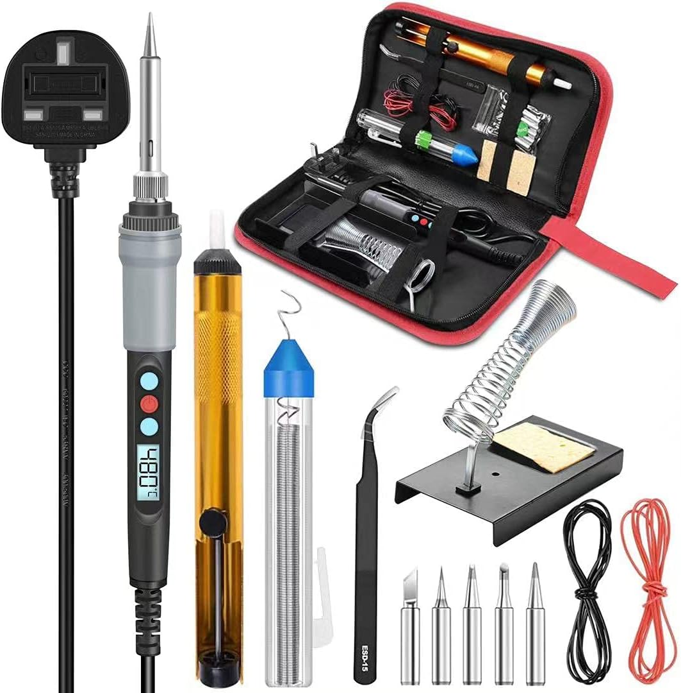
https://amzn.to/4a0yyuT

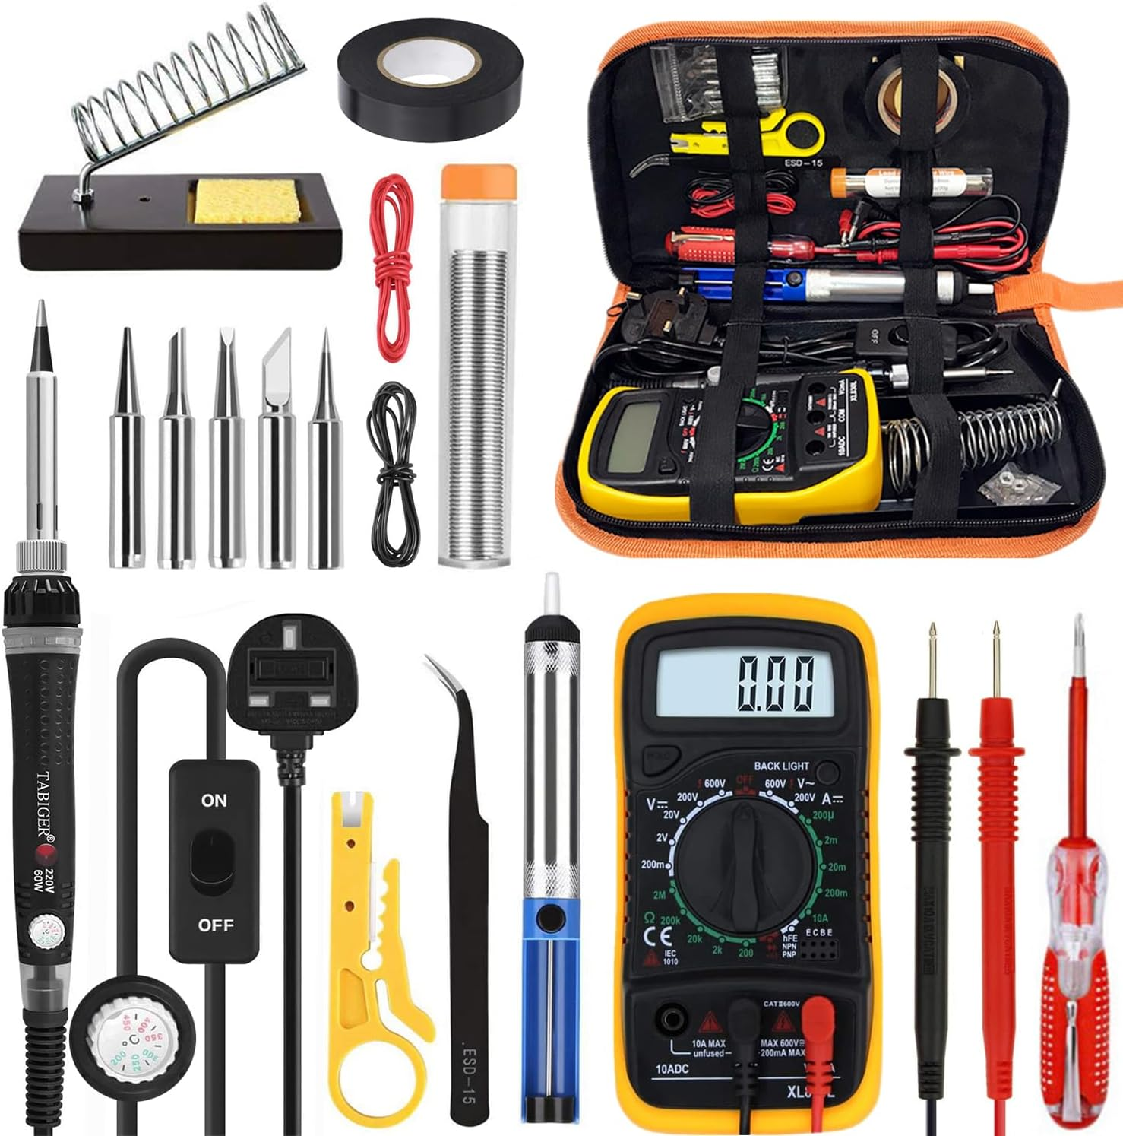
https://amzn.to/3LD7jic

For most projects, you can use any small-diameter solid or stranded hookup wire. Some projects might also require very small wire. A magnifier or magnifying work lamp is recommended for examining the circuit board to check solder connections. Most electronics parts stores have a selection of perforated circuit boards made specially for wiring electronics projects. Many come with small clips for mounting parts. These boards are ideal for building simple circuits. You also will need an electric soldering iron, which you
can buy at a hobby, electronics parts, or hardware store.

The soldering iron in a beginner’s tool kit should be a 15- to 40-watt iron with a fine chisel tip. Use 60/40 rosin-core solder (60 percent tin, 40 percent lead) that is marked for “electronic use.” Never use acid core solder. Most of the solder you will need will have a diameter of 0.03 inch.

You also should have a solder wick for desoldering a connection if you make a mistake or want to remove a component.

Use a workbench for your project if you have one. If not, you can use a kitchen table, desk, or sturdy card table. You will need to have good light and ventilation and access to power outlets. You also will need a few small boxes, trays, or jars to hold parts.

Buying Parts
Most electronics parts stores will have the components you will need for your project. If you do a project from scratch, you will have to buy the parts separately. While you also can buy a complete project as a kit, many electronics kits found in retail stores are not soldering kits, and building a project from scratch is challenging and rewarding. Scratch projects can be inexpensive if you can scrounge for most of the parts.

However, a kit has a number of advantages. All the necessary assembly instructions and parts are supplied, including wire and solder. Special parts, such as printed circuit boards, come with the kit. In addition, fewer tools are required because all necessary holes are prepunched. Since the kit has been carefully tested, you know that the finished product will work. A complete kit generally costs less than buying the parts separately.
Investigate doing a project both ways before you invest your money.

Basic Electronics Theory

Before you learn about electronic components, let’s look at the theory behind electronics. Controlling electrons is the science of electronics. So, our study of electronics theory begins with the electron.

Atoms and Electrons

To understand electrons, we must learn about the makeup of matter. All matter is composed of atoms, and an atom is composed of three elementary particles: electrons, protons, and neutrons. Negatively charged electrons revolve around the core (the nucleus) of the atom, which is composed of positively charged protons and neutral (not charged) neutrons.

Generally, a negatively charged electron is matched by a positively charged proton. For example, copper has 29 electrons revolving around a nucleus containing 29 protons. A basic law of nature controls electrical charges. This law simply stated is that unlike charges attract and like charges repel. This means a negative charge is drawn to a positive charge but pushes away from another negative charge. This is called electrostatic force. Normally, the positively charged protons hold the negatively charged electrons in place. However, an electron sometimes breaks away from an atom because of an outside force, such as heat, light, magnetic fields, or chemical reactions.

Once freed, electrons can “float” among atoms. These free electrons are what is important in electronics. Devices such as resistors, capacitors, inductors, and transistors are used to control the behavior of these free electrons.

Conductors and Insulators

Conductors act as a pathway for free electrons. Most metals are good conductors of electrons, so they can be used to “transport” electrons from one place to another. Insulators act as walls or barriers, preventing electrons from flowing where we do not want them to flow. Insulators, for example, are used on most electrical wires to protect us from electrical shock. Copper, silver, and gold are popular conductors because they have a large number of free electrons. As an example of how to make the electrons flow, picture a length of copper wire with one end connected to the positive terminal of a battery and the other end connected to the negative terminal. The positive terminal attracts the negatively charged free electrons of the wire (remember: unlike charges attract) while at the same time the negative terminal repels the electrons. The result is a flow of electrons through the wire from the negative to the positive terminal. This flow is called an electric current. An insulator works just the opposite. In some materials, such as plastics and glass, atoms hold their electrons tightly. These materials have very few free electrons. Therefore, if a length of insulator is connected to a battery the same way the copper wire was attached, no measurable current would flow.

Current, Voltage, and Resistance

Here are some basic definitions of terms used in electronics.

- Current is the orderly movement of electrons through a conductor. Current is measured in amperes, or amps, or the rate at which electrons move past a given point. One ampere is the movement of about 6 billion billion electrons past that point in one second.
- Voltage is an electrical pressure that can cause current to flow. Voltage forces current to flow through a wire in much the same way that water pressure forces water to flow through a pipe. This electrical pressure can be caused with magnetism, chemicals, friction, light, or heat. The unit of voltage is the volt.
- The opposition to current flow is resistance. The resistance of a material is mainly determined by how many free electrons it has. If the material doesn’t have many, it will have little or no current flow. The unit of resistance is the ohm. One ohm is the amount of resistance that will allow 1 ampere of current to flow when the applied voltage is 1 volt.

Frequency

Frequency, or cycles per second, uses the term hertz as its unit of measure. The electricity from electrical utilities is 60 Hertz AC and the voltage changes in a sine wave pattern.

Ohm’s Law

Ohm’s law describes the basic relationships between current, voltage, and resistance. The formula for Ohm’s law is:
Voltage (volts) = Current (amperes) × Resistance (ohms)

To determine current, the formula would be:

Current (amperes) = Voltage (volts) ÷ Resistance (ohms)

If you know current and resistance, you can find out the voltage. For example, how much voltage is needed to force 2 amperes of current to flow through 10 ohms of resistance?
Ohm’s law tells us that we need to multiply our 2 amperes. (current) by the 10 ohms (resistance) to arrive at the answer: 20 volts.

If you know voltage and resistance, you can figure out current (Voltage ÷ Resistance). Therefore, how much current will flow in a circuit having 5 ohms of resistance when 15
volts are applied?
15 volts ÷ 5 ohms = 3 amperes

With these formulas, you can solve simple problems involving current, voltage, and resistance.

Power

Another electrical quantity is power. Power is the rate at which work is done. The unit of electrical power is the watt and can be compared to the unit of mechanical power, called horsepower. One horsepower is equal to 746 watts. The formula for power is

Power (watts) = Voltage (volts) × Current (amperes)

When this formula is applied, you can determine the amount of power used by a circuit if you know the voltage and current.

For example, how much power is used by a 120-volt toaster that draws 5 amperes?

120 volts × 5 amperes = 600 watts

The power used by the toaster is 600 watts. This power is used, or dissipated, in the form of heat to toast the bread.

Current Delivery

Electrical signals are classified as either direct current (DC) or alternating current (AC). Direct current signals are at a constant voltage or at a constant polarity where AC signals typically follow a sine wave or other pattern and alternate between positive and negative voltages. If the AC signal follows a specific pattern, the number of times the pattern repeats within one second is the signal’s frequency. The electricity from electrical utilities is 60 Hertz AC and the voltage changes in a
sine wave pattern.

Resistance and Resistors

You have learned that when you apply a voltage to the ends of a conductor, it creates a current. Its strength depends on the applied voltage and the resistance of the conductor. The resistance of a conducting material depends on three factors:
- The kind of material
- The length of the material
- The diameter or thickness of the material

Temperature also is a factor in resistance. In most materials, resistance is increased when the temperature rises and decreased if the temperature is colder. In most simple circuits, however, temperature is not critical and is often ignored. The kind of material is probably the most important factor in resistance. Copper, for example, is a good conductor, while iron of a similar size has a higher resistance. Carbon has even a higher resistance than iron.
The longer the conductor, the higher the resistance will be. For instance, if the length of a copper wire is doubled, the resistance will be doubled. As an example, a 60-foot length of
copper wire might have a resistance of 1 ohm. A same-sized copper wire that is 120 feet long would have a resistance of 2 ohms.

Size is important, too. A thick conductor will carry more current and offer less resistance than a thin one. Think again of water pipes. A large water pipe will allow more water to flow than a small one. When a current flows through a resistor, a component that limits or opposes the flow of a current, work is being done to move the electrons. This work produces heat and warms the resistor. Heat produced by an electric current is the basis for the operation of many electrical devices and appliances such as heaters, toasters, stoves, and soldering irons. In a lightbulb, an electrical current causes a wire filament to become so hot that it glows to produce light. Only a fraction of the power that comes from the filament produces light.

The rest generates heat, which is why incandescent bulbs are so inefficient. A resistor is designed to have a specific value of resistance, and resistors are available in a wide range of values. Standard power sizes are 1/4 watt, 1/2 watt, 1 watt, and 2 watts. These values indicate the maximum recommended power that the resistor can dissipate. The higher the power rating, the larger the resistor.

Capacitors and Capacitance

A capacitor is a device for storing electrons, or an electrical charge, that can be released at a later time. Imagine two sheets of aluminum foil (conducting plates) that are separated by a sheet of waxed paper (an insulator). If you connect a battery to the two aluminum sheets, electrons will flow from the sheet that is connected to the positive terminal of the battery. Simultaneously, the same number of electrons will flow from the negative terminal of the battery to the other aluminum sheet. The number of electrons that are transferred makes the voltage between the aluminum sheets exactly that of the connected battery. If the battery is removed, the aluminum sheets will remain in their charged state. If there is no leakage through the waxed paper, the sheets will remain charged indefinitely.

Any two conducting plates separated by an insulator make up a capacitor. A capacitor can consist of many conducting plates with insulating separators. Alternate plates would be connected to form interleaved stacks. The higher the voltage, the greater will be the amount of charge that is transferred from one plate to the other. The ratio of charge to voltage is defined as the capacitance of the capacitor. Or you could also say that the “electrical size” of a capacitor is its capacitance, which is the amount of electric charge it can hold. The unit of capacitance is the farad.

However, this unit is too large for most practical capacitors, so capacitors are manufactured to measure millionths of a farad (microfarads) and trillionths of a farad (picofarads, which are micro-microfarads). The insulators that separate conducting plates in a capacitor can be made of several materials, including ceramic materials, mica, certain types of paper, air, and oxide (a compound containing oxygen). A popular capacitor has been the electrolytic capacitor. In this capacitor, the insulator is an extremely thin oxide layer. The leads of electrolytic capacitors are marked positive and negative. These indicate how the capacitor must be connected for proper operation.

Electron Tubes

The electron tube made the science of electronics possible. Although it largely has been replaced by transistors, it still has special uses. Tubes for high power are still used today in lasers, radars, strobe lights, and special-use vacuum tubes. Many high-end stereo collectors still prefer the sound of a tube amplifier over that of a transistor amplifier.

Semiconductors
The word semiconductor is used to name a wide variety of electronic devices. Made of solid or liquid material, semi-conductors generally are able to conduct electricity more easily than an insulator, but not as easily as a metal. The semiconductor diode performs the same basic function as the electron-tube diode. It allows current to flow in one direction, but not the other. This diode consists of two different types of silicon crystals. An impurity (some type of substance) can be added to one area of the silicon to control the silicon’s conductivity. The silicon is said to have been “doped” when it has been treated with atoms from an impurity. These atoms combine with the silicon atoms in such a way that electrons float around freely inside the silicon. This type of silicon is called N-type (or negative-type). The N-type silicon is the cathode of the diode.

The other area of silicon also has an added impurity. But the atoms of this impurity combine with the silicon atoms in such a way that there is a shortage of one electron in the bonding. The absence of an electron is called a “hole,” and this hole can grab an electron from a neighboring atom. Thus, a hole can “float” from atom to atom the same way an electron might. The silicon with the holes is called P-type (positive).

For current to flow through the diode, the negative terminal of the battery must connect to the N-type silicon (the cathode) and the positive terminal to the P-type silicon (the anode). The negative terminal repels the free electrons of the N-type material. The electrons are forced toward the junction where they fill the waiting holes. However, as the electrons leave the anode, new holes form. This results in a constant flow of current from cathode to anode. Current cannot flow in the opposite direction (see the illustration for the semiconductor diode). If the battery’s connection is turned around, it attracts the electrons and the holes away from the junction. Because there are no free electrons at the junction, no current can flow.

The transistor is perhaps the most important invention in the history of electronics so far. A transistor uses the P-type and N-type silicon in much the same way as a diode. However, the transistor has three electrodes, called the emitter, the base, and the collector. The collector is connected to the positive terminal of the battery, and the emitter is connected to the negative terminal. Electrons will try to flow from the emitter to the collector. However, a thin layer (the base) separates these two elements. If the base is negative, it repels the free electrons in the emitter. In this case, no current can flow from the emitter to the collector.

If the base is positive, electrons can flow into the base from the emitter. Some of the electrons will flow into the positive base lead. But because the base is very thin, most of the electrons travel through the base to the collector. Thus, if the base is made more positive, more electrons will flow. Conversely, making the base less positive will reduce the current flow. You can see then that a small voltage on the base will control the amount of current through the transistor. For this reason, the transistor can be used as an amplifier in much the same way as a vacuum tube.

Notice the symbol in the illustration used to represent the NPN transistor. Another type of transistor is called the PNP transistor. Its structure and schematic symbol are shown in the following illustration. This transistor requires opposite polarity voltages for proper operation.

NPN and PNP transistors are called bipolar transistors, and they are the most popular types used.

Field Effect Transistor

The field effect transistor uses a single N-channel or P-channel with an insulated metal plate used to control current flow. Current enters the channel at the source lead and flows toward the drain lead at the other end of the channel. The voltage applied to the insulated plate, known as the gate, limits the current flow through the channel from source to drain. The most used FET is the metal-oxide semiconductor FET or MOSFET. An N-channel MOSFET will not conduct current if there is no voltage difference source to gate and allow current flow when a higher voltage is applied to the gate (voltage difference with respect to the source pin). A P-channel MOSFET will conduct current if there is no voltage difference source to gate and allow current flow when a lower voltage is applied to the gate (voltage difference with respect to the source pin).

Complementary MOS or CMOS technologies use one P-channel MOSFET and one N-channel MOSFET connected such that the P-channel source pin connects to the circuit higher voltage (typically power supply) and connects the N-channel source to the lower voltage supply (typically 0-volt or ground). The drain of the two MOSFETs are connected and is the circuit output. The gates are tied together. When the gates are connected to a low voltage (ground), the source to gate voltage of the N-channel is 0 volts so the channel transistor is “off” while the gate to source voltage of the P-channel FET is the “hi” voltage, so that transistor is “on” meaning the output voltage is connected to the power supply or high (for a low input). Conversely, if the two gates are tied to the higher voltage, the N-channel gate to source is now high, so it is “on” while the P-channel transistor gate to source
is voltage is low, so it is “off.”

Integrated Circuits
An integrated circuit (IC) is a complete circuit in a single package. Transistors, resistors, diodes, and capacitors can be formed in a single chip of silicon, a semiconductor. One chip can contain thousands or even millions of electronic components. Integrated circuits have revolutionized many
fields, including communications, information handling, and computing. They have reduced the size of devices, while providing faster speeds and increased reliability. The individual components of ICs are extremely small and are assembled to a pattern that has been planned in advance. A chip might look flat, but it has several layers for circuits. Switches control the electrical current through the chip. The switches manipulate the binary code (discussed below) with “on” and “off” switches. The binary code is at the core of how a computer operates.

Chips come in many different sizes, with millions of transistors being able to fit on chips the size of a postage stamp. Two basic types of IC are called linear and digital. Linear circuits include amplifiers, oscillators, regulators, and other circuits used in TV sets, audio amplifiers, radios, and hearing aids. Digital circuits include memories and arithmetic circuits and counters in watches, calculators, computers, and video games.

Microprocessors
The microprocessor is a type of ultra-large IC. By 1971,
the technique of making ICs had progressed to the point
where enough computing power could be put on a single
IC to form a tiny, primitive computer, or calculator. The
first microprocessor was born. Today, microprocessors can
incorporate more than a billion transistors, plus components
such as resistors, capacitors, diodes, and wires.
The microprocessor accepts input data, modifies that
data in some way, and produces an appropriate output. The
earliest application of the microprocessor was the calculator.
A calculator accepts numbers that the user enters on a key-
board, performs a mathematical operation on those numbers
that the user desires, and then sends the result to a display.
Today’s microprocessors function as the central processing unit
(CPU) of computers. They also are used in many electronics
systems such as cameras, printers, planes, and automobiles.
The microprocessor in an automobile, for instance, exam-
ines inputs from several sensors, makes decisions based on
those inputs, and adjusts such things as the mixture of air
and fuel and the timing of ignition firing. The microproces-
sor’s most important aspect is that it can be programmed to
perform an almost limitless number of applications.

Printed Circuit Boards
A printed circuit board (PCB) consists of a sheet of
some type of insulator, a composite material classified as
FR-4 made of woven fiberglass cloth with an epoxy resin
binder. The FR-4 material is an insulator with copper traces
printed or etched onto the FR-4 surface. The copper traces are
implementations of the wire lines of the schematic drawing.
Parts of traces may need to be routed from one side (layer)
to the other side (layer). To connect the traces, feed-through
holes are added to the circuit board.
Feed-through holes are drilled through the printed circuit
board then filled with solder. The solder connects the copper
of the top, bottom, and optional intermediate layers. Feed-
through hole’s solder is done during the fabrication of the
circuit board.
Optionally, feed-through holes can be used to hold
component leads. The feed through has a hole drilled
through the solder for the component lead. The drilled
hole is done during fabrication of the printed circuit
board. The completed printed circuit board is now
ready for insertion of the components drawn in the
schematic.
A feed-through hole used for a component lead
must be larger to allow room for the component
lead diameter plus some insertion clearance of the
lead into the hole. If no component lead is being
inserted in the hole, the diameter of the feed-
through hole can be much smaller and require
less printed circuit board space.
Later, during the assembly process, a component lead is
inserted into the hole and the hole and lead must be soldered
together to make solid electrical contact.
Several layers of traces, separated by FR-4 sheets may
be sandwiched together for more complex electronic designs
with feed-through holes connecting the traces as needed.

Through-Hole Technology
The technology used for placing component leads in holes
drilled through the printed circuit board reached a practical
limit when integrated circuits got over about 40 pins. A
feed-through hole with space for the lead and the insertion
tolerance meant that, based on PCB fabrication technologies
at the time, integrated circuit leads needed to be about 0.100"
apart. Various techniques were tried with larger IC packages
including longer packages, the IC pins in a grid pattern and
others. There was not a viable solution to reach what would
eventually be today’s package pin counts.

Surface-Mount Technology
By removing the component pin from going through the feed-
through hole, the feed-through could be much smaller and
moved away from the component. The component pins could
be replaced with a square pad on the component and the
printed circuit board would have a matching pad on the “out-
side” copper layer. Without the constraint of the feed-through
hole with drilled lead space, component pins could be placed
much closer together or more pins could be placed around
the former through hole package sizes. This change led to the
very high pin count packages required for today’s integrated
circuits, such as the processor of your home computer.

Schematic Diagrams
The illustrations in the previous section didn’t show you a
picture of a real diode or transistor. Instead, they showed
you a kind of illustrated outline, called a schematic diagram.
These diagrams are a simple way of showing how electronic
components are connected. In a schematic, symbols stand for
the different electronic components. The schematic diagram
illustrated here is for a code-practice oscillator, used to
practice Morse code. The corresponding pictorial representation
shows how the components actually look. In the schematic,
a different type of symbol represents each type of component:
long and short lines represent the battery; a zigzag line stands
for a resistor. In this section, you will learn these symbols so
that you can understand schematic diagrams.

To start, compare the schematic diagram with the pictorial
and match each symbol in the schematic with its equivalent
component in the pictorial. Also match each line in the sche-
matic with the appropriate wire in the pictorial. Notice where
two lines cross in the schematic. If the wires are to be connect-
ed, a dot shows at the crossing on the schematic. If there is no
dot, the two wires bypass each other and are not connected.
When you draw your schematic for requirement 2, you
will need a sharp pencil, paper, and a ruler or straight edge
for drawing straight lines. A compass might be helpful for
drawing circles. If you have a computer with a drawing pro-
gram, you might use that to draw a schematic. There are also
several freely available schematic capture tools.

Component Types
Before we look at the most common types of electronics
components, as well as the schematic symbol and a pictorial
of each one, let’s define and review some basic terms (also
see the Basic Electronics Theory section):
•
Electricity is a property that electrons have that causes
them to behave in certain predictable ways.
•
Electrical charge is a quantity of electricity.
•
The electron is a tiny particle that has a negative
electrical charge.
•
Current is defined as the flow of electrons.
•
Voltage is the pressure that causes current to flow.
•
Resistance is the opposition to current flow.
•
Direct current (DC) is current that always flows in
the same direction.
•
Alternating current (AC) is a current that reverses
its direction of flow many times each second.
•
Frequency is the number of times that a repeats its pattern in
one second.

Passive Components
Fixed Resistor: Each resistor has a specific amount of
resistance. A resistor is like a nozzle on a water hose. For a
given water pressure, the nozzle controls the amount of water
that is allowed out of the hose. Similarly, for a given voltage, a
resistor controls the flow of electrical current.

Most resistors are made of a carbon compound. Resistors
used for high currents often are made from special wire that is
wound on an insulating form. The type of compound or wire
used determines how much electrical current can flow for a
given voltage.
The value of a resistor is given in ohms. The symbol for the
ohm is the Greek capital letter omega (Ω). Thus, 1Ω designates
the resistance of 1 ohm. A 1kΩ resistor has a resistance of
1 kilohm, or 1,000 ohms. A 1MΩ resistor has a resistance of
1 megohm, or 1 million ohms.
The illustration below shows a variety of fixed resistors
and a cross-section of a fixed resistor. The values of fixed resis-
tors cannot be changed.

Older types of fixed resistors have bands of color that
allow you to determine their resistance value. (See “The Color
Code of Resistors” section on page 40.) The cross-section of
this fixed resistor shows the inside, which is made of carbon.
Note the schematic symbol for a fixed resistor.
Variable Resistor: The resistance of variable resistors can
be adjusted. Rheostats are two-leaded devices that vary in
resistance from 0 to the rated resistance value. Three leaded
variable resistors, known as potentiometers (pots), have a fixed
resistance between leads 1 and 3, and have a resistance on lead
2 proportional to the amount of rotation on the adjustment
arm. These variable resistors can be used in appliances that
need their currents adjusted or when the resistance needs to be
varied, such as with lights that can be dimmed.

Capacitor: A capacitor is a storage element for electrical
charge, similar to a bottle that stores a liquid. The basic unit
of capacitance is the farad (F). Practical capacitors have
capacitance values in microfarads (µF). The physical size of
a capacitor depends on its voltage rating and its capacitance
value. The higher the voltage rating and the larger the
capacitance value, the larger the capacitor must be.
Inductor: An inductor is a coil of wire usually wrapped
around some type of metal or hollow core material and is used
to smooth out variations in the current flow. When current is
applied to the coil, a magnetic field is established around the
core. When the current flow stops, the magnetic field begins
to collapse and in doing so induces current back into the wire
until the field has collapsed. The magnetic field tends to col-
lapse at a rate that maintains the original current in the wire.
Single coil configurations are generally called a choke whereas
two or more coils can be configured either as a choke to filter
current changes or as a transformer for changing voltage and
current values.

Transformer: A transformer consists of two or more coils
each with multiple turns of wire around the magnetic core.
The primary coil is the coil where power is applied to the
transformer and the other coils are referred to as secondary
coil(s). The transformer uses the magnetic field established
by current flow in the primary coil to induce a current in the
secondary coil(s). The ratio of turns from the primary to a
secondary coil determines how much the incoming voltage is
multiplied on the secondary side and how much the secondary
current is divided by the primary current in the secondary.
Because transformers operate on changing magnetic fields
caused by changing current, transformers do not operate on
direct current (DC) currents.
Semiconductor Devices
Semiconductor devices are typically made of silicon-based
material. Diodes and transistors are two common semiconduc-
tor component types. Semiconductors come in various package
sizes based on the amount of power they must dissipate in
rated operation.
Diodes: Diodes operate as check valves, passing current in one
direction but not the other. A diode’s most common applica-
tion is in power supplies. It changes alternating current (AC)
into direct current (DC).

Transistors: Transistors are solid-state devices used for con-
trolling current. A very small input current controls a much
larger output current. For example, the small current from a
microphone can control a much larger current that drives a
loudspeaker. This is the idea behind the audio amplifiers used
in public address systems.

Integrated Circuits (ICs)
Complex circuits are available in integrated circuit (IC) form
at inexpensive prices. The IC, which typically consumes little
power, is reliable, cheap, and small. Because devices using ICs
can be improved and made cheaper, the IC has replaced tradi-
tional components in many applications. As shown here, ICs
come in several types of packages. The dual in-line package
(DIP) is the most popular style for most hobby applications.
Schematic symbols for ICs are typically very function-specific.

Electromechanical Components
Microphone: A microphone changes sounds into electrical
impulses. Either a thin, flexible disk (a diaphragm) or a crystal
in the mike vibrates whenever sound strikes it. The vibrations
are changed into small electrical signals. These signals typically
need to be amplified before they are usable.

Speaker: A speaker then converts the electrical impulses back
into sounds. An electromagnet moves a speaker cone based
on the incoming audio signal. The speaker cone moves the air
around and it which causes the audio sound to spread across
the space and recreating the original sound.

Switches: are an important part of almost all electronic equip-
ment. They come in a wide variety of shapes, sizes, and func-
tions. Switches are categorized by the number of circuits they
switch (single, double, triple, etc.) and then by the number of
switch position contacts. A switch may have an output contact
for each position of the switch. The switch will typically have
a default position. A circuit that makes contact in that position
is called a Normally Closed (NC) contact or in drawing below
from terminal A to C. If the switch is moved out of default
position, and makes contact with an electrical terminal, that
position is called Normally Open (NO) and is shown as con-
nections A to B in drawings below).

The simplest is the single-pole, single-throw type. When
closed, this switch completes a circuit, allowing an electric
current to flow. When it is open, the circuit is broken, and the
current does not flow. The on-off switches on most electronic
devices are of this type (above left).
A single-pole, double-throw switch has a contact arm that
can be set in either of two positions. In the example shown
here, terminal A can be connected to either terminal B or
terminal C. The dashed line between the switches shows the
mechanical connection (above center).
A double-pole, double-throw switch can simultaneously
switch two wires from one circuit to another. It can be thought
of as two single-pole, double-throw switches that operate
together (above right).
A rotary or selector switch has one or more arms (poles)
that can be set to various positions. A single pole 10-position
switch is shown below. Notice that the terminal at the very
bottom connects the signal to the rotatable arm.

Relays: A relay is a magnetically operated switch. It has a
wire coil wrapped around an iron core forming an electro-
magnet. When current flows through the coil, a magnetic
field develops. The magnetic field attracts a movable part
called an armature, which moves all relay switch poles from
normally Closed (magnet off) to Normally Open (magnet
energized).
A relatively small current can cause the switch contacts
to close, but the contacts can handle a much heavier current.
The relay allows a small current to switch higher current(s)
on or off. By using several contact sets (single, double, triple
or more poles and single or double throw). A multi-pole relay
allows a single control (coil) current to control several different
currents simultaneously.
Chemical Components
Batteries: Batteries are made from several types of materials
for different uses. Alkaline, lithium, and mercury batteries are
used when long life is desired. Nickel-cadmium batteries give
shorter service but can be recharged. The nickel–metal hydride
battery is replacing the nickel-cadmium battery because it
doesn’t suffer the memory effect (that is, not allowing a par-
tially charged battery to fully recharge before use). Lithium-Ion
type batteries have replaced many of the older battery types.
Zinc-carbon also is used in many inexpensive dry-cell batteries.
Most electronic circuits and products operate at low sup-
ply voltages and have low power requirements. These devices
are often driven from small batteries or DC voltage sources.
Depending on the type of product, a coin battery, one, two or
four flashlight batteries are often adequate for relatively long
service.
Ordinary flashlight dry cells produce approximately 1.5
volts. Four 1.5-volt cells connected in a series can provide 6
volts. Single 9-volt batteries also are used.

Photocells: A photoelectrical cell changes one or more of its
characteristics when exposed to light. It is popularly called the
electric eye, which controls operations such as traffic lights,
door openers, and devices that activate lights at dusk and
turn them off at dawn. One type of photoelectric cell is called
a photoconductive cell. Another name for this type of cell is
the light-dependent resistor (LDR). This special resistor has a
small window so that light can strike the resistance material.
Generally, such a cell has a high resistance when in darkness.
Another type is called a photovoltaic cell. This is the familiar
“solar cell” that is used to power electronic equipment on
spacecraft. It produces a low voltage across its terminals when
exposed to light, especially sunlight, thus converting light
energy into electrical energy.
Other Component Types: There are many other types of com-
ponents used in electronics but these are the more common
components that a hobbyist is likely to use.

The Colour Code of Resistors

The value of a resistor is specified in ohms and is indicated by colored bands around one end of the resistor. The electronics industry devised this system because small printed numbers would be too hard to read or might be concealed by the position of the resistor.

Most resistors have four bands, with the first three (counting from the end of the resistor) indicating the value in ohms. The fourth, which is either silver or gold, indicates the tolerance (discussed below). Colors used for the bands are used in place of numbers. To determine the resistance value in ohms, examine the color bands starting with the one closest to the end of the resistor.

Suppose a resistor has a brown, a black, and then a brown band. The code chart shown here tells you that brown represents the number 1. The second black band represents the number 0. The third band tells you how many zeroes to add to the first two numbers. In the example, the band is brown, so you add one zero. Therefore, the value of this resistor is 1-0-0, or 100 ohms.

Now try the example for the resistor shown here, which has a red band first, then a yellow band, and then an orange band. The red band means that the first number is 2. The yellow band corresponds to the number 4. The orange band tells us to add three zeroes. Thus, the value is 2-4-000, which translates to 24,000 ohms, or 24 kilohms (kΩ).

Most surface mount components are too small for color bands, so the color bands are converted back to digits and printed onto the top of the resistor as 243 for 24,000 ohms, or 24 kilohms (kΩ).

Soldering

Before you begin working with a circuit, read and study this chapter on soldering. Anyone working in electronics must know how to solder well, and safely. It takes practice, but once you learn, you will be able to properly assemble an electronics project. In all electronics work, the wiring connections must be absolutely secure. A loose connection in a radio, for example, could result in noise, scratching sounds, or no sounds at all. Poor connections in a TV could disrupt the sound and picture. And beyond just a radio and a TV in someone’s home, the safe operation of airplanes and the lives of astronauts in flight depend on secure electronics connections.

Soldering is not just
gluing metals together like
you glue together pieces of
wood. Done correctly,
soldering unites the metals
so that electrically they
act as one piece of metal.
You do this with a mixture
of lead and tin solder and
a soldering iron.

The Soldering Iron
An inexpensive pencil-type soldering iron of no more than
40-watt capacity (15 to 25 watts are also suitable) is the best for
electronics work. The tip should be 1 to 2 millimeters (mm);
the solder should be 1 mm. It is helpful to get an iron with
interchangeable tips of different diameters or shapes to be used
on different kinds of work. The iron should be well-balanced
and have a handle that will remain cool while you work.
Tinning your iron means coating the tip of the solder
iron with a thin coat of solder. If your iron is new, read the
instructions about preparing it for use. Most new irons are
already tinned, so you might not have to tin it. If the tips are
silvery, you can use them as they are.
If instructions aren’t included with your iron and the tip
is not silvery, first use a fine file to file the tip until it is shiny.
Then heat the iron and coat the tip with rosin-core solder. Be
sure to coat all sides of the tip.
If you have an older iron that has been used and the point
is already silvery, just wipe it clean with a cloth and you are
ready for work. If it is dull or looks coppery, file and tin it.
You also should have a heat-resistant bench-type iron
holder so that the hot iron can safely be set down between
uses. Look for one that has a holder for tip-cleaning sponges.
How to Solder
A well-soldered joint, one that will be reliable in use, will be
nice and shiny looking. To achieve a well-soldered joint, make
sure you do the following:
1. Solder with a clean, well-tinned tip. Wipe the tip on
a damp sponge before soldering and between soldering.
2. Make sure all wires, parts, and the circuit board to be
soldered are clean.
3. Make a good mechanical joint before soldering.
4. Allow the joint to get hot enough before applying solder,
then apply an adequate amount of solder to the joint. Only
heat the joint with the solder iron, not the solder itself.
When you touch the solder to the joint, the solder will flow
onto the joint
5. Allow the solder to set before handling or moving
soldered parts.

Remember that in preparing work for soldering, dirt is
the enemy of soldering. A solder will not take if parts are dirty,
so be sure to completely clean all wires and surfaces before
applying solder. Use fine sandpaper or emery paper to clean flat
surfaces or wire. If you do have dirty parts or a dirty surface,
you might try to use too much heat to force a connection.
When preparing wires, remove the insulation with wire
strippers or a hobby knife. If using a knife, hold the knife at an
angle as if you were sharpening a pencil. Do not cut straight
into the insulation because you could nick the wire and weaken
it. For enameled wire, use the back of the knife blade to scrape
the wire until it is clean and bright.
Next, tin the clean end of the wire. Hold the heated tip
of the soldering iron against the undersurface of the wire, and
place the end of the rosin-core solder against the upper surface.
As the solder melts, it will flow on to the clean end of the
wire. Hold the hot tip of the iron against the under surface of
the tinned wire and remove the excess solder by letting it flow
down the tip. When properly tinned, the exposed surface of
the wire should be covered with a thin, even coating of solder.

Unless you are creating a temporary joint, the
next step is to make a good mechanical connection
between the parts to be soldered. For instance, wrap
the wire carefully and tightly around a soldering
terminal or soldering lug. (Bend wire and make con-
nections using long-nosed pliers.) When connecting
two wires, make a tight splice before soldering. Once
you have made a good mechanical contact, you are
ready to solder.
When you are working with an ordinary circuit
board, you will bend the wires of a component through
the board. For those parts, such as some resistors, that
become hot when in operation, raise them slightly
above the board to allow some air circulation.
The next step is to apply the soldering iron and
solder to the connection. The temperature of all the
parts that are being soldered should be raised to about
the same degree before applying the solder. If solder-
ing a spliced wire, hold the iron below the splice and
apply solder to the top of the splice. If the tip of the
iron has a bit of melted solder on the side held against
the splice, heat is transferred more readily to the splice,
and the soldering can be done more easily. Don’t
try to solder by applying solder to the joint and then
pressing down on it with the iron.
It usually takes two to three seconds to solder on
a printed circuit board. Remember: Too much solder
on a joint might cause short circuits with adjacent
joints. However, if you don’t apply enough solder, you
might not form a secure and fully working joint.
When soldering the wires of a component, you
might snip the extra wire leads off before soldering.
However, with some components, such as semi-
conductors, it might be best to snip the surplus
wire after you have made the joint.
Don’t disturb the soldered joint until the solder
has set. This might take several seconds, depending
on the amount of solder used to make the joint Then
take a good look at the joint. It should have a shiny,
smooth appearance. It should not be pitted or grainy.
If it is, then reheat the joint, scrape off the solder,
clean the connection, and start over.

After the solder is well set, pull slightly on the wire to see
whether it is a good, tight connection.

How to Desolder
In case you accidentally make a wrong connection or have to
move a component that has been placed incorrectly, you should
learn how to desolder connections. Take care when desoldering
to avoid breaking or destroying good parts. The leads on
components such as resistors or transistors and the lugs on
other parts might sometimes break off when desoldering a good,
tight joint. To avoid heat damage, use as much care in
desoldering delicate parts as you do in soldering them.
There are two ways to desolder. The first and usually
easiest way is to use a metal wick or braid on a small dispenser
reel to remove the melted solder. This braid is available at most
electronics parts stores. Place the braid against the joint that you
want to desolder. Use your heated soldering iron to gently press
the braid against the joint. As the solder melts, it is pulled into
the braid. Don’t let the joint cool while the
braid is resting against the joint. By repeating
this process, you can remove virtually all the
solder from the joint. Then reheat the joint
and lift off the component leads.
The second method involves using a
desoldering pump, or a vacuum device, to
suck up the molten solder. Most electronics
parts stores have these devices. Follow the
manufacturer’s instructions for the pump you
are using, but here are some general guide-
lines. Use your soldering iron to heat the joint
you want to desolder until the solder melts.

Then push down on the top of the pump to remove the air
inside. Next, quickly place the tip of the pump on the melted
solder you want to remove and press the button on the side.
This will cause the pump’s plunger to rise rapidly and create a
vacuum inside. The rush of air at the tip of the pump will pull
the melted solder in. Repeat until you have removed most of the
molten solder. Then reheat the joint and gently pry off the wires.
Experiment with and practice your soldering techniques to
fulfill requirement 3 before you begin working on your circuit.
Use pieces of wire or some old components and wire. Practice
until you can solder joints that are smooth, shiny, and tight.
Then practice desoldering some of the connections until you
are satisfied that you can do them quickly and without
breaking wires or lugs.

Soldering Printed Circuit Boards

Most electronic devices use one or more printed circuit (PC) boards. A PC board is made of a nonconducting material, such as a thin sheet of fiberglass or phenolic resin (plastic) that has a pattern of foil conductors “printed” on it and has predrilled holes designed to hold components. You insert component leads into the holes and solder
the leads to the foil pattern. This method of
assembly is widely used, and you probably
will use it if you choose to work with an
electronics kit.
Printed circuit boards make assembly
easier. First, insert component leads through
the correct holes in the board. Mount the
parts tightly against the circuit board unless
otherwise directed. Insert a lead and then
bend it slightly outward to hold the part in
place. Then follow these steps.
Step 1—Touch the tip of your soldering iron
to both the component lead and the foil
until they are uniformly hot enough to melt
the solder.
Step 2—Apply a small amount of solder to
both the tip and the connection.
Step 3—Remove the iron and let the solder
set before moving the wire or the board. The
finished connection, as you have learned,
should be smooth and shiny.

Step 4—Finally, clip off the excess
wire length.
Occasionally a solder “bridge” will form
when solder connects between two adjacent
foil conductors. You must remove such bridges
or a short circuit will exist between the two
conductors and the circuit won’t function
properly. Remove the bridge by heating it
with your soldering iron and quickly wiping
away the melted solder with a soft cloth.

Woggle
This is derived from the Scouts Queensland eWoggle, and follows the design principles laid out in the document “Circuit design principles for Scout electronics projects for JOTA/JOTI“ by Michael Gross of Cobargo Venturers (https://cobargoscouts.org.au/jota-joti-electronics.html), I have also combined the functionality of the eWoggle with the Franzininho DIY (https://docs.franzininho.com.br/docs/franzininho-diy/sobre) Arduino like capabilities allowing the scouts to upload new firmware after they have assembled their woggles.

