DEIL
DIGITAL EVIDENCE & INTELLIGENCE LAB

DIGITAL FORENSIC EXAMINATION REPORT
OPERATION ROTOR TRACE
Aircraft Accident Digital Evidence Examination (Bell 412, Registration XAL-412)

Case Name: Operation Rotor Trace
Evidence Reference Number: HIVE-AV-2026-018
Case Number: HIVE-AV-2026-018
Report Type: Digital Forensic Examination Report
Investigating Organization: Hive Consult
Examining Analyst: Philip Oppong Adanse
Date of Report: 14 September 2026
Classification: Confidential - For Authorized Recipients Only
Forensic Platform: Autopsy 4.22.1

TABLE OF CONTENTS
1. EXECUTIVE SUMMARY 3
2. CASE BACKGROUND 4
3. EXAMINER INFORMATION 5
4. EVIDENCE SUMMARY 6
5. CHAIN OF CUSTODY 7
6. HASH VERIFICATION 8
7. METHODOLOGY 9
8. TOOLS USED 10
9. EXAMINATION AND ANALYSIS 11
10. TIMELINE ANALYSIS 17
11. CORRELATION AND VALIDATION 19
12. FINDINGS 20
13. LIMITATIONS 21
14. CONCLUSION 22
15. RECOMMENDATIONS 23
16. EXAMINER'S OPINION 24
17. APPENDICES 25

1. EXECUTIVE SUMMARY
This report documents a digital forensic examination conducted on behalf of Hive Consult in connection with the accident involving a Bell 412 helicopter, registration XAL-412, operated by Xavier Air Logistics, which crashed on 18 August 2026 approximately 38 minutes after departing Accra on a scheduled flight to Tarkwa.
The examination was undertaken to reconstruct the sequence of events surrounding the accident, determine whether maintenance records associated with the aircraft were altered prior to the flight, establish what the flight crew and maintenance personnel knew before and during the flight, and assess whether the available digital evidence supports maintenance negligence, record falsification, component irregularities, mechanical failure, or another causal explanation.
Evidence reviewed during this examination included a forensic disk image of a maintenance laptop, a recovered USB storage device (Kingston DataTraveler 3.0, volume XAL_MAINT_16GB), maintenance audit logs, component certification and procurement records, mobile phone communications, and flight-related datasets including the Flight Data Recorder (FDR), Cockpit Voice Recorder (CVR), Health and Usage Monitoring System (HUMS) data, flight telemetry, GPS/route data, Air Traffic Control (ATC) communications, and weather records.
The examination identified: (1) a maintenance release status for aircraft XAL-412 that was changed from “AIRCRAFT NOT SERVICEABLE” to “CLEARED FOR FLIGHT” on 17 August 2026, attributable to the user account kwame.adu, (2) a serial number discrepancy between the installed gearbox oil-pressure sensor assembly and its supporting certificate and supplier invoice, (3) browser search activity on the maintenance laptop, performed shortly after the status change, consistent with attempts to remove or conceal system and file activity, (4) recovered deleted files indicating that an earlier, unfavorable maintenance record and supporting diagnostic material existed prior to the status change, (5) pre-flight communications among maintenance and operations personnel indicating that a recurring gearbox warning and the serial number discrepancy were known before the aircraft was released, and (6) flight data (FDR, HUMS, telemetry, CVR) showing a progressive in-flight gearbox failure beginning with a rise in gearbox temperature, followed by increasing vibration and a critical loss of oil pressure consistent with the mechanical symptoms discussed by maintenance personnel before departure.
The route deviation flown by the crew was examined separately and, based on ATC communications and weather data, is assessed as an authorized, weather-related deviation that does not appear to have contributed to the mechanical failure.
The findings in this report are limited to the digital evidence supplied for examination. No physical inspection of the aircraft, gearbox components, or crash site was performed as part of this examination. All conclusions are stated in proportion to the supporting evidence, and any matter that could not be determined from the available evidence is identified as such in the relevant section.

2. CASE BACKGROUND

2.1 Nature of the Investigation
On 18 August 2026, a Bell 412 helicopter operated by Xavier Air Logistics departed Accra on a scheduled flight to Tarkwa. Approximately 38 minutes after take-off, the helicopter ceased transmitting to air-traffic monitoring and crashed in a remote forested area along the flight route.
Prior to the loss of the aircraft, the pilot in command, Captain Daniel Mensah, reported intermittent navigation indications but did not declare an emergency. Cockpit Voice Recorder (CVR) data captured the crew discussing rising gearbox temperature, decreasing oil pressure, and increasing vibration in the minutes preceding the loss of the aircraft. Witnesses near the crash site reported hearing an abnormal mechanical sound before observing the helicopter descend rapidly.
Preliminary review established that the aircraft had undergone maintenance three days before the accident, during which a replacement gearbox oil-pressure sensor assembly was installed. A discrepancy was later identified between the serial number marked on the installed component and the serial number recorded on its supporting certificate and supplier invoice. Two versions of the associated maintenance report were also identified, an original version recording the aircraft as “AIRCRAFT NOT SERVICEABLE” and a later version recording the aircraft as “CLEARED FOR FLIGHT.”

2.2 Scope and Objectives of the Examination
This examination was scoped to address ten investigative questions concerning the original maintenance status of the aircraft and evidence of its alteration, attribution of that alteration to a specific user and device, verification of the installed component's serial number against supporting documentation, browser activity on the maintenance laptop suggestive of evidence concealment, the content and connection history of a recovered USB device, reconstruction of the in-flight mechanical failure sequence using FDR, HUMS, and telemetry data, correlation of CVR crew conversation with flight system data, pre-flight communications among maintenance and operations personnel, the significance of the aircraft's in-flight route deviation, and a final consolidated timeline and forensic assessment of contributing factors.
This report and the underlying analysis concern a fictional case scenario developed for digital forensics training purposes. The evidentiary items, personnel, and organization referenced throughout (including Xavier Air Logistics and the named individuals) are components of the exercise dataset and are treated in this report as such.

3. EXAMINER INFORMATION
Field | Detail
Examining Analyst | Philip Oppong Adanse
Role | Digital Forensic Examiner
Organization | Hive Consult
Responsibilities | Evidence identification, preservation, acquisition verification, examination, analysis, and reporting
Forensic Suite Used | Autopsy 4.22.1

4. EVIDENCE SUMMARY
The following items constitute the digital evidence base for this examination, as identified from the supplied disk image, case exhibits, and case narrative.
Item | Description | Source
Forensic disk image | "The Crashed Helicopter.img" - image of the maintenance laptop used by engineer Kwame Adu | Maintenance office
USB storage device | Kingston DataTraveler 3.0, volume label XAL_MAINT_16GB, serial 60A44C421A21F8F10 | Recovered from maintenance office
Maintenance audit log | Maintenance_Component_and_Release_Audit.xlsx | User profile: kwame.adu
Maintenance status reports | B412_Maintenance_Status_15Aug2026_ORIGINAL.docx and _FINAL.docx | User profile: kwame.adu / recovered USB
Component documentation | Component_Certificate_XAL-412-7781.pdf; Supplier_Invoice_XAL-412-7781.pdf; installed component photographs | Maintenance records
Browser history | Chrome browsing history, maintenance laptop | User profile: kwame.adu
Deleted file artifacts | Recovered from C:\Users\kwame.adu\Documents\Temporary_Review | Maintenance laptop (unallocated/recovered)
Mobile phone communications | Messages among Capt. Daniel Mensah, Kwame Adu, Isaac Tetteh, Emmanuel Quartey, Linda Agyeman | Pilot and personnel phones
Flight Data Recorder (FDR) | B412_FDR_Parsed_18AUG2026.csv | Aircraft recovery
Cockpit Voice Recorder (CVR) | CVR transcript, 18 August 2026 | Aircraft recovery
HUMS data | HUMS_18AUG2026.csv | Aircraft recovery
Flight telemetry | B412_Flight_Telemetry_18AUG2026.csv | Aircraft recovery
GPS / planned route | Planned route (GPX) data | Operator flight planning records
ATC communications | ATC_Event_Timeline.csv | Air traffic control
Weather records | Weather_Route_18AUG2026.csv; WEATHER_BRIEFING_18AUG2026.pdf | Meteorological services

Acquisition detail: hash verification of the disk image was performed via Windows PowerShell prior to analysis (see Section 6). The image was subsequently ingested into Autopsy 4.22.1 for examination. Full chain-of-custody detail is provided in Section 5.

5. CHAIN OF CUSTODY
The chain of custody documentation supplied with this case records the following handling history for the primary evidence image:
Step | Action | Detail
1 | Hash verification | Integrity hashes (MD5 and SHA-256) were generated for the evidence image via Windows PowerShell prior to examination.
2 | Case creation | Autopsy 4.22.1 was opened and a new case, “OPERATION ROTOR TRACE,” was created to host the examination.
3 | Ingestion and analysis | The evidence image was ingested and loaded into the case, examination and analysis were then commenced.

Information regarding evidence custodians, transfer dates and times, and physical handling signatures beyond the steps above could not be determined from the available evidence.

6. HASH VERIFICATION
Hash verification is used to confirm that a forensic image is a bit-for-bit duplicate of its source and that the image has not been altered between acquisition and examination. A cryptographic hash (a fixed-length digital fingerprint) is calculated for the evidence at the time of acquisition and recalculated at the time of examination, matching values confirm data integrity, while a mismatch would indicate that the underlying data had changed.

6.1 Methodology
Hash verification for the evidence image was performed using the Windows PowerShell Get-FileHash cmdlet, applying both the SHA-256 and MD5 algorithms, and comparing the computed values against the previously recorded reference hashes using an equality check.

6.2 Recorded Hash Values
Algorithm | Hash Value
SHA-256 | 3E98EB9913EAFB6157E4B37D1BC411788C73A183028CFC30B0EDDFE847A84E14
MD5 | 00FF1DFF294CF10B769136BEBBEACF82

6.3 Verification Outcome
As shown in Exhibit A, both the SHA-256 and MD5 hash comparisons returned a result of “True,” confirming that the computed hash values for the evidence matched the reference values. This confirms the integrity of the evidence image at the point of examination.
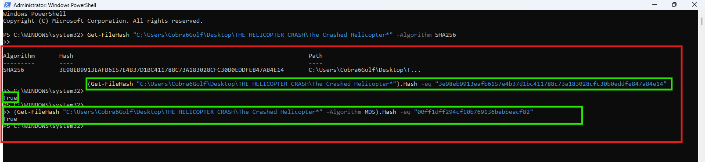
Exhibit A - PowerShell Get-FileHash verification of the evidence image (SHA-256 and MD5), both returning “True.”

7. METHODOLOGY
The examination followed a standard digital forensic workflow, applied consistently with the evidence and workflow reflected in the supplied case materials:

7.1 Identification
Potential sources of digital evidence were identified from the case materials, including the maintenance laptop image, the recovered USB device, mobile phone communications, and flight recorder datasets (FDR, CVR, HUMS, telemetry, GPS).

7.2 Preservation
The evidence image was hash-verified prior to examination to establish a documented integrity baseline (Section 6). Analysis was performed against the ingested image within Autopsy rather than against source media directly.

7.3 Acquisition
The evidence image (“The Crashed Helicopter.img”) was received in forensic image format together with supporting exhibits (USB content, communications records, and flight datasets) for ingestion.

7.4 Examination
The image was ingested into Autopsy 4.22.1 and examined using the platform's file listing, deleted file recovery, file metadata, text/keyword search, and OS account modules to identify relevant maintenance documents, audit log entries, browser history, USB connection artifacts, and deleted file remnants.

7.5 Analysis
Artifacts recovered from the image were correlated against the supplied flight datasets (FDR, HUMS, telemetry, CVR, ATC, and weather records) and communications records to reconstruct the sequence of events and test the consistency of the available evidence.

7.6 Documentation and Reporting
Findings were documented against each investigative question, supported by exhibits drawn from the examined evidence, and consolidated into the findings, timeline, and conclusion sections of this report.

8. TOOLS USED
Tool | Purpose | Use in This Examination
Autopsy 4.22.1 | Digital forensic examination platform | Case creation, image ingestion, file system navigation, deleted file recovery, keyword/text search, and OS account analysis
Windows PowerShell (Get-FileHash) | Cryptographic hash generation and verification | Generation and verification of SHA-256 and MD5 hash values for the evidence image (Section 6)
gmapstogpx | GPS/route data conversion utility | Conversion of route/GPS data for comparison against the planned flight corridor

9. EXAMINATION AND ANALYSIS
This section addresses each investigative question in turn. Findings are supported by the artifacts identified during examination, exhibits are referenced where a supporting screenshot or extracted record is available.

9.1 Original Maintenance Status and Evidence of Alteration
Examination of the recovered maintenance documentation identified two versions of the aircraft's maintenance status report. The original document, B412_Maintenance_Status_15Aug2026_ORIGINAL.docx, recorded the release status of aircraft XAL-412 as “AIRCRAFT NOT SERVICEABLE,” citing an intermittent gearbox oil-pressure indication observed during a ground run and an elevated gearbox-temperature trend identified in HUMS review. The engineering assessment recorded in this document specified that the aircraft was not to be released until the oil-pressure indication, sensor installation, and component certification were verified (Exhibit D).
A second file, B412_Maintenance_Status_15Aug2026_FINAL.docx, together with an entry in the maintenance audit log (Maintenance_Component_and_Release_Audit.xlsx) recorded a change of the release status field for record XAL-412 from “AIRCRAFT NOT SERVICEABLE” to “CLEARED FOR FLIGHT” at 2026-08-17 21:43:49 UTC, flagged in the audit log with a review priority of “HIGH” (Exhibit F).
Finding: The original maintenance status of the Bell 412 was “AIRCRAFT NOT SERVICEABLE.” This status was changed to “CLEARED FOR FLIGHT” on 17 August 2026 at 21:43:49 UTC. The alteration is evidenced by the coexistence of the ORIGINAL and FINAL status documents and the corresponding EDIT entry in the maintenance audit log.

9.2 Attribution of the Maintenance Report Modification
The maintenance audit log entry recording the release-status change identifies the acting user as kwame.adu. This attribution is corroborated by multiple independent artifacts recovered from the maintenance laptop:
- The edited file, Maintenance_Component_and_Release_Audit.xlsx, resides within the user profile directory C:\Users\kwame.adu\Documents\, associating the document with the kwame.adu profile.
- OS account records (User_Accounts.csv) identify kwame.adu with account SID S-1-5-21-20260818-1001, account type “Local Administrator,” and a last logon of 2026-08-18T07:32:41Z, indicating the account was active on the system (Exhibit G).
- A subsequent SAVE_AS action in the same audit log, timestamped 2026-08-17 21:44:26 UTC, records the file B412_Maintenance_Status_15Aug2026_ORIGINAL.docx being saved as B412_Maintenance_Status_15Aug2026_FINAL.docx under the same user account, immediately following the status-field edit.
Finding: The maintenance report was modified by the user account kwame.adu on 17 August 2026 at 21:43:49 UTC. Attribution rests primarily on the maintenance audit log, which records the specific field change, responsible account, and timestamp, and is corroborated by user-profile file location and OS account activity records. Attribution using these artifacts associates the action with the kwame.adu account, it does not independently confirm the individual who was physically operating the device at that time.
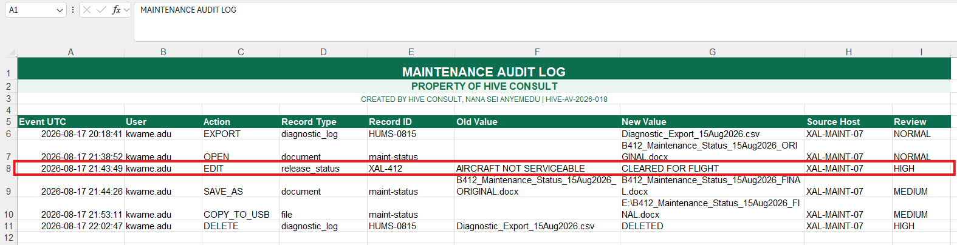
Exhibit F - Maintenance audit log (Maintenance_Component_and_Release_Audit.xlsx) showing the EDIT of record XAL-412 from “AIRCRAFT NOT SERVICEABLE” to “CLEARED FOR FLIGHT” at 21:43:49 UTC, and the subsequent SAVE_AS, COPY_TO_USB, and diagnostic-log DELETE actions.

9.3 Replacement Component Serial Number Verification
Comparison of the installed component photograph, maintenance record, component certificate, and supplier invoice identified a serial number discrepancy for the replacement Gearbox Oil-Pressure Sensor Assembly installed on XAL-412:
Source | Serial Number
Installed Component Photograph (visible serial) | B412-OPS-883419
Maintenance Record (installed serial) | B412-OPS-883419
Component Certificate (certificate serial) | B412-OPS-883941
Supplier Invoice (serial shipped) | B412-OPS-883941

The maintenance register independently flagged this discrepancy with a status of “SERIAL MISMATCH.”
Finding: The serial number physically present on the installed component (B412-OPS-883419) does not match the serial number recorded on its supporting certificate and supplier invoice (B412-OPS-883941), indicating that the component installed on XAL-412 was not the same unit documented in its certification and procurement paperwork.

9.4 Browser Activity Indicative of Evidence Concealment
Chrome browser history recovered from the maintenance laptop identified a series of searches relating to the removal of digital traces and system activity records, several of which preceded the maintenance status modification and several of which followed it closely:
Search Term | Timestamp (UTC)
Bell 412 gearbox warning code | 2026-08-15 18:42:11
oil pressure sensor Bell 412 | 2026-08-15 18:44:09
aircraft HUMS log storage location | 2026-08-17 20:18:33
how to clear aircraft maintenance software history | 2026-08-17 20:22:17
delete diagnostic logs windows | 2026-08-17 20:24:58
remove metadata from word document | 2026-08-17 20:29:44
USB connection history windows | 2026-08-17 20:31:12
remove recent files windows 11 | 2026-08-17 21:58:07
clear browser history permanently | 2026-08-17 22:01:41

Correlated against the maintenance audit log, the searches for “remove recent files windows 11” (21:58:07 UTC) and “clear browser history permanently” (22:01:41 UTC) occurred approximately 14 and 18 minutes, respectively, after the status change recorded at 21:43:49 UTC.
Event | Time (UTC)
Maintenance status changed from AIRCRAFT NOT SERVICEABLE to CLEARED FOR FLIGHT | 21:43:49
Search: “remove recent files windows 11” | 21:58:07
Search: “clear browser history permanently” | 22:01:41

Finding: The timing of the post-modification searches is consistent with an attempt to conceal system and file activity following the maintenance-status change. The earlier searches (20:18–20:31 UTC), which specifically reference clearing maintenance software history, deleting diagnostic logs, and removing document metadata, indicate that this concern predated the status change itself.

9.5 USB Evidence and Connection History
The recovered USB device (Kingston DataTraveler 3.0, volume XAL_MAINT_16GB) contained copies of the maintenance report, component certificate, supplier invoice, and installed-component photographs relating to XAL-412, including a copy of the original maintenance report, B412_Maintenance_Status_15Aug2026_FINAL.docx, present on the device.
Deleted files recovered from C:\Users\kwame.adu\Documents\Temporary_Review on the maintenance laptop included:
- B412_NOT_SERVICEABLE.pdf
- Component_Certificate_Original.pdf
- Diagnostic_Export_15Aug2026.csv
- Gearbox_Inspection_Notes.txt
- Maintenance_History_Backup.db
- Supplier_Component_Query.eml
These recovered items indicate that earlier maintenance records, diagnostic exports, inspection notes, and supporting documentation existed on the system and were subsequently deleted.
USB Device Attribute | Value
Volume Label | XAL_MAINT_16GB
Vendor / Product | Kingston / DataTraveler 3.0
Serial | 60A44C421A21F8F10
Associated User | kwame.adu
First Connected (UTC) | 2026-08-15 18:14:08
Last Connected (UTC) | 2026-08-17 22:03:12
Drive Letter | K:

Finding: The USB device was first connected on 15 August 2026 (the date of the original maintenance work) and last connected on 17 August 2026 at 22:03:12 UTC, by the kwame.adu account approximately 19 minutes after the maintenance status change and shortly after the browser searches associated with evidence removal. This timing corroborates a link between the USB activity, the status modification, and the associated concealment-related browser activity. This is further corroborated by the audit log's own COPY_TO_USB entry at 21:53:11 UTC, recording the FINAL status document being copied to drive E:.
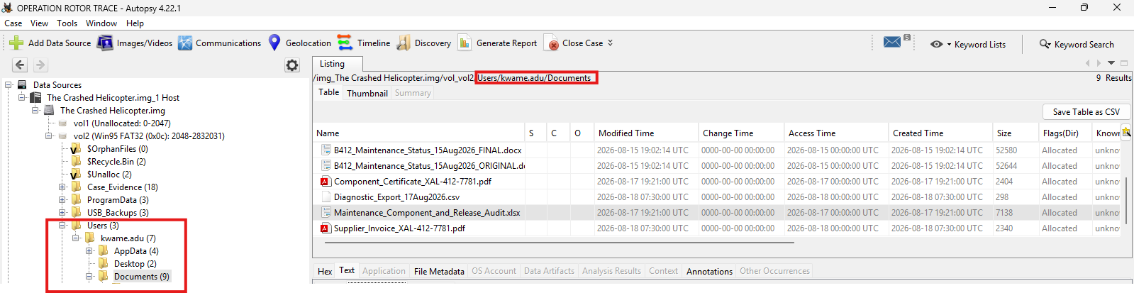
Exhibit H - Recovered component certification and maintenance documentation associated with the XAL-412 replacement component.

9.6 Reconstruction of the In-Flight Mechanical Failure Sequence
Correlation of the FDR, flight telemetry, and HUMS datasets establishes the following sequence of abnormal readings during the final stage of the flight:
Order | Event | Time (UTC) | Source Artifact
1 | Gearbox temperature exceeded 100°C | 08:31:59 | FDR & Flight Telemetry
2 | Rotor vibration exceeded 1.0 g | 08:34:09 | FDR & Flight Telemetry
3 | Oil pressure dropped below 30 psi | 08:34:34 | HUMS, FDR & Flight Telemetry

The FDR (B412_FDR_Parsed_18AUG2026.csv) and flight telemetry (B412_Flight_Telemetry_18AUG2026.csv) independently recorded gearbox temperature exceeding 100°C at 08:31:59 UTC (100.10°C and 100.08°C respectively). HUMS, sampling at ten-second intervals, recorded the same condition within seconds of this event. Approximately two minutes and ten seconds later, at 08:34:09 UTC, rotor vibration exceeded 1.0 g across both FDR and telemetry sources (1.003 g and 1.007 g respectively). At 08:34:34 UTC, oil pressure fell below the 30 psi threshold across all three datasets (FDR: 29.84 psi; telemetry: 29.82 psi; HUMS: 29.82 psi).
Finding: The first abnormal condition was a rise in gearbox temperature above 100°C at 08:31:59 UTC. This was followed by abnormal rotor vibration at 08:34:09 UTC and a critical loss of oil pressure at 08:34:34 UTC. This sequence overheating, followed by increasing vibration and lubrication loss is consistent with progressive gearbox mechanical degradation.

9.7 Cockpit Voice Recorder Correlation
The Cockpit Voice Recorder documents the crew's progressive identification of the developing gearbox malfunction, beginning with a report of rising gearbox temperature and continuing through to loss of the recording:
Time (UTC) | CVR Event | Correlated Artifact / Interpretation
08:34:07 | Crew: “Gearbox temperature is climbing.” | Matches FDR/telemetry temperature rise recorded at 08:31:59 - 08:34:09 UTC.
08:35:32 | Crew: “Oil pressure is moving down.” | Matches early oil-pressure decline in HUMS/FDR/telemetry.
08:36:12–08:36:16 | Caution tone, Capt. Mensah: “Gearbox oil pressure caution.” | Corresponds with oil pressure approaching caution limits.
08:37:41–08:37:44 | Crew: “Vibration.” / Capt. Mensah: “I feel it.” | Matches FDR/HUMS vibration increase recorded from 08:34:09 UTC.
08:38:18 | Crew: “Oil pressure dropping fast.” | Matches rapid oil pressure decline in HUMS/FDR/telemetry.
08:38:54–08:39:01 | Warning tone, Capt. Mensah: “We've got a serious vibration now.” | Matches vibration reaching peak recorded values.
08:39:18–08:40:08 | Loud mechanical sound; “RPM!”, high-level warning tone, rapid change in rotor/engine sound | Consistent with advanced mechanical distress preceding loss of the aircraft.
08:40:22 | End of CVR recording | Final recorded event.

Finding: The crew's verbal observations closely track the technical data, confirming that the flight crew directly perceived and responded to the same overheating, vibration, and oil-pressure-loss sequence independently recorded by the FDR, HUMS, and telemetry systems.

9.8 Pre-Flight Communications
Review of mobile phone communications among Captain Daniel Mensah, Kwame Adu, Isaac Tetteh, Emmanuel Quartey, and Linda Agyeman identified the following exchanges prior to the flight:
Timestamp (UTC) | From → To | Message
2026-08-17 19:14:22 | Kwame Adu - Linda Agyeman | “The serial on the unit does not match the certificate. Stores are checking it.”
2026-08-17 19:18:40 | Linda Agyeman - Kwame Adu | “I see B412-OPS-883419 on the photo. Certificate says B412-OPS-883941. I am asking the supplier.”
2026-08-17 20:42:08 | Kwame Adu - Isaac Tetteh | “Ops needs the aircraft tomorrow. I will update the system after we confirm.”
2026-08-17 20:55:31 | Emmanuel Quartey - Kwame Adu | “Do not ignore the HUMS trend. The warning returned during the last ground run.”
2026-08-18 07:20:11 | Emmanuel Quartey - Capt. Daniel Mensah | “The gearbox warning returned during the ground run. Engineering is looking at it. Monitor the temperature indication closely.”
2026-08-18 07:41:04 | Isaac Tetteh - Capt. Daniel Mensah | “Paperwork is cleared. Aircraft released for flight.”
2026-08-18 07:45:17 | Capt. Daniel Mensah - Emmanuel Quartey | “Copy. I will monitor the indications.”

Correlation: The 19:14 - 19:18 UTC exchange between Kwame Adu and Linda Agyeman aligns with the documented serial number mismatch (Section 9.3). The 20:55 UTC message from Emmanuel Quartey aligns with the HUMS, FDR, and telemetry data showing an eventual gearbox abnormality in flight. The 20:42 UTC message, in which Kwame Adu indicates he will “update the system after we confirm,” precedes the 21:43:49 UTC status change by approximately one hour. The 07:20 and 07:41 UTC messages on 18 August establish that Captain Mensah was informed of the recurring gearbox warning before departure and separately informed that the aircraft's paperwork had been cleared for release.
Finding: The most significant communications are those documenting
- the identification and confirmation of the serial number mismatch
- the warning that the HUMS gearbox trend had returned during the final ground run
- the release of the aircraft for flight despite these unresolved items
These communications establish that both the component documentation discrepancy and the recurring gearbox warning were known to maintenance and operations personnel before the aircraft was released, and that the pilot was informed of the gearbox warning though not, on the evidence reviewed, of the unresolved serial number discrepancy prior to departure.

9.9 Assessment of the Route Deviation
The helicopter deviated from its planned route during the flight. This deviation was examined against ATC communications and weather data to determine whether it was operationally justified or potentially indicative of concealment or an unauthorized maneuver.
Time (UTC) | Artifact | Event
08:26:14 | Weather_Route_18AUG2026.csv | Planned corridor experiencing heavy rainfall (22.0 mm/hr) and reduced visibility (4.7 km).
08:27:20 | ATC_Event_Timeline.csv | XAL-412: “Accra Control, Xavier Four-One-Two, deviating left for weather.”
08:27:28 | ATC_Event_Timeline.csv | ATC: “Xavier Four-One-Two, deviation approved. Report established.”
08:30:14 | Weather_Route_18AUG2026.csv | Revised corridor: improved visibility (10.1 km), lower rainfall (3.2 mm/hr).
08:32:56 | ATC_Event_Timeline.csv | Pilot reported intermittent navigation indications; position stable.
08:37:04 | ATC_Event_Timeline.csv | Pilot reported intermittent indications; requested lower level.
08:39:47 | ATC_Event_Timeline.csv | Final incomplete transmission from XAL-412.

The weather briefing document (WEATHER_BRIEFING_18AUG2026.pdf) independently states that localized heavy rainfall and reduced visibility were observed along the originally planned corridor west of Accra, and that the revised corridor offered materially better visibility and lower rainfall. This is consistent with the Weather_Route dataset and with the pilot's stated reason for the deviation.
Finding: The pilot reported the deviation to ATC and received approval eight seconds later, indicating that the maneuver was authorized and not concealed. Weather data recorded materially worse conditions along the originally planned corridor than the revised route at the time of the deviation. The available evidence indicates that the route deviation was an operationally reasonable response to adverse weather rather than an indicator of wrongdoing, and that it does not account for the subsequent gearbox temperature rise, oil pressure decline, or vibration trend, which developed independently later in the flight.

9.10 Final Timeline and Forensic Assessment
Section 10 (Timeline Analysis) below consolidates the chronology from the maintenance work performed three days before the accident through the final recorded flight event. Section 12 (Findings) and Section 14 (Conclusion) set out the corresponding forensic assessment of contributing factors.

10. TIMELINE ANALYSIS

10.1 Maintenance Phase – 15 - 17 August 2026
Date/Time (UTC) | Event | Artifact
2026-08-15 | Gearbox oil-pressure sensor replacement performed on XAL-412; original maintenance status recorded as AIRCRAFT NOT SERVICEABLE. | Maintenance Records / B412_Maintenance_Status_15Aug2026_ORIGINAL.docx
2026-08-15 | Replacement component installed; serial number B412-OPS-883419 recorded in maintenance documentation. | Maintenance Records
2026-08-15 18:14:08 | USB device XAL_MAINT_16GB first connected to the maintenance laptop. | USB Connection Records
2026-08-17 19:14:22 | Kwame Adu flags serial number mismatch to Linda Agyeman. | Phone Messages
2026-08-17 19:18:40 | Linda Agyeman confirms certificate/installed serial discrepancy (883419 vs. 883941). | Phone Messages
2026-08-17 20:42:08 | Kwame Adu advises Isaac Tetteh that operations needs the aircraft; will “update the system after we confirm.” | Phone Messages
2026-08-17 20:55:31 | Emmanuel Quartey warns Kwame Adu not to ignore the HUMS trend; warning returned on last ground run. | Phone Messages
2026-08-17 20:18:33 – 20:31:12 | Browser searches relating to clearing maintenance history, deleting diagnostic logs, and removing metadata. | Chrome Browser History
2026-08-17 21:43:49 | Maintenance status changed from AIRCRAFT NOT SERVICEABLE to CLEARED FOR FLIGHT by kwame.adu. | Maintenance Audit Log
2026-08-17 21:44:26 | Original status document saved as the FINAL status document under the kwame.adu account. | Maintenance Audit Log
2026-08-17 21:53:11 | FINAL status document copied to USB drive (E:). | Maintenance Audit Log
2026-08-17 21:58:07 – 22:01:41 | Browser searches for “remove recent files windows 11” and “clear browser history permanently.” | Chrome Browser History
2026-08-17 22:02:47 | Diagnostic log entry (HUMS-0815) deleted. | Maintenance Audit Log
2026-08-17 22:03:12 | USB device XAL_MAINT_16GB last connected to the maintenance laptop. | USB Connection Records

10.2 Pre-Departure Phase - 18 August 2026
Time (UTC) | Event | Artifact
07:20:11 | Emmanuel Quartey advises Capt. Mensah that the gearbox warning returned during the ground run and to monitor temperature. | Phone Messages
07:41:04 | Isaac Tetteh informs Capt. Mensah that paperwork is cleared and the aircraft is released for flight. | Phone Messages
07:45:17 | Capt. Mensah acknowledges and states he will monitor indications. | Phone Messages

10.3 Flight Phase - 18 August 2026
Time (UTC) | Event | Artifact
08:26:14 | Planned corridor showing heavy rainfall / reduced visibility. | Weather-Route Data
08:27:20 – 08:27:28 | Pilot reports and ATC approves weather-related route deviation. | ATC Communications
08:31:59 | Gearbox temperature exceeds 100°C — first abnormal condition. | FDR / Flight Telemetry
08:34:07 | Crew reports gearbox temperature climbing. | CVR
08:34:09 | Rotor vibration exceeds 1.0 g. | FDR / Flight Telemetry
08:34:34 | Oil pressure drops below 30 psi. | HUMS / FDR / Flight Telemetry
08:35:32 | Crew reports oil pressure moving down. | CVR
08:36:12–08:36:16 | Caution tone; crew reports gearbox oil pressure caution. | CVR / Warning System
08:37:41–08:37:44 | Crew reports and confirms vibration. | CVR
08:38:18 | Crew reports oil pressure dropping fast. | CVR
08:38:54–08:39:01 | Warning tone; crew reports serious vibration. | CVR / Warning System
08:39:18–08:40:08 | Loud mechanical sound; high-level warning tone; rapid rotor/engine sound change. | CVR / FDR
08:39:47 | Final incomplete ATC transmission from XAL-412. | ATC Communications
08:40:22 | End of CVR recording — final recorded event. | CVR

11. CORRELATION AND VALIDATION
Where independent artifact sources support the same finding, this section summarizes the corroboration observed during the examination.

11.1 Maintenance Status Alteration
The maintenance audit log, the coexistence of ORIGINAL and FINAL status documents, and the file's user-profile location together corroborate that the status of XAL-412 was changed by the kwame.adu account at 21:43:49 UTC on 17 August 2026.

11.2 Serial Number Discrepancy
The installed component photograph, maintenance record, component certificate, supplier invoice, and phone communications between Kwame Adu and Linda Agyeman independently and consistently identify the same two serial numbers (B412-OPS-883419 installed vs. B412-OPS-883941 certified), corroborating the existence and awareness of the discrepancy before the flight.

11.3 Evidence-Concealment Activity
The timing of the browser search activity, when placed against the maintenance audit log's EDIT, SAVE_AS, COPY_TO_USB, and DELETE entries, and against the USB device's last-connection timestamp, forms a consistent and mutually corroborating sequence of concealment-related activity following the status change.

11.4 In-Flight Mechanical Failure
The FDR, flight telemetry, and HUMS datasets independently recorded the same three-stage sequence (temperature rise, vibration increase, oil pressure loss) within seconds of one another, and this sequence is further corroborated by the crew's contemporaneous CVR observations, which describe the same symptoms in the same order.

11.5 Pre-Flight Awareness of Risk
The phone communications, the original (pre-alteration) maintenance status document, and the recurring HUMS warning referenced in those communications corroborate that maintenance and operations personnel, and subsequently the pilot, were aware of unresolved mechanical concerns before the aircraft was released for flight.

12. FINDINGS
Finding 1: The original maintenance status of aircraft XAL-412 was “AIRCRAFT NOT SERVICEABLE.” This was changed to “CLEARED FOR FLIGHT” on 17 August 2026 at 21:43:49 UTC, an action attributable to the kwame.adu user account based on the maintenance audit log and corroborating user-profile and account artifacts.
Finding 2: A serial number discrepancy existed between the installed gearbox oil-pressure sensor assembly (B412-OPS-883419) and its supporting certificate and supplier invoice (B412-OPS-883941). This discrepancy was identified and discussed by maintenance and stores personnel before the flight.
Finding 3: Browser search activity on the maintenance laptop both before and, more pointedly, in the 14 -18 minutes following the status change is consistent with an attempt to remove or conceal system and file activity associated with the modification.
Finding 4: Deleted files recovered from the maintenance laptop, together with content recovered from the USB device, confirm that the original (unfavorable) maintenance status document and supporting diagnostic material existed prior to the status change and were subsequently deleted from the laptop, though a copy remained recoverable.
Finding 5: Personnel identified a recurring HUMS gearbox warning before the flight, and this concern was communicated to Captain Mensah prior to departure. He acknowledged the instruction to monitor the temperature indication.
Finding 6: The aircraft was released for flight approximately one hour after operational pressure to make the aircraft available was communicated internally, and despite unresolved communications concerning both the serial number discrepancy and the recurring gearbox warning.
Finding 7: The in-flight failure sequence began with a rise in gearbox temperature above 100°C at 08:31:59 UTC, followed by abnormal rotor vibration at 08:34:09 UTC and a critical loss of oil pressure at 08:34:34 UTC. This sequence is independently corroborated across the FDR, HUMS, flight telemetry, and CVR.
Finding 8: The route deviation flown by the crew was reported to and approved by ATC and is supported by contemporaneous weather data showing worse conditions on the originally planned corridor. No evidence was identified indicating the deviation was unauthorized, concealed, or connected to the subsequent mechanical failure.

13. LIMITATIONS
- This examination was conducted using the digital artifacts supplied as part of the case materials. No physical examination of the Bell 412 helicopter, its gearbox components, or the crash site was performed.
- Findings are based on the maintenance records, communications, audit logs, browser history, USB artifacts, HUMS data, FDR data, telemetry records, ATC communications, weather records, and CVR transcript made available for this examination. Additional evidence outside this dataset may provide further context and could alter or refine the findings above.
- User attribution in this report was performed using account information, audit logs, timestamps, and system artifacts. These artifacts associate actions with a specific account; they do not, on their own, conclusively establish which individual was physically operating the device at the time of the action.
- The serial number discrepancy identified during this examination was assessed using the supplied documentation and communications. Independent verification of component authenticity with the manufacturer or supplier was outside the scope of the available evidence.
- Examiner identity, physical evidence-transfer records, and additional custodial signatures beyond the three chain-of-custody steps supplied (Section 5) could not be determined from the available evidence.
- This report and its underlying case materials concern a fictional scenario developed for digital forensics training purposes; conclusions are limited to, and should be interpreted within, the context of that exercise.

14. CONCLUSION
Based on the digital evidence examined, the accident involving aircraft XAL-412 was preceded by two unresolved maintenance concerns, a recurring HUMS gearbox warning and a documented serial number discrepancy affecting the replacement gearbox oil-pressure sensor assembly. Communications among maintenance and operations personnel establish that both issues were known before the aircraft's release status was changed from “AIRCRAFT NOT SERVICEABLE” to “CLEARED FOR FLIGHT” on 17 August 2026.
Following that status change, activity on the maintenance laptop including browser searches associated with the removal of system and file traces, a USB copy of the amended status document, and deletion of a related diagnostic-log entry is consistent with an attempt to conceal the circumstances of the modification.
During the flight on 18 August 2026, the aircraft experienced a progressive gearbox failure, evidenced consistently across the FDR, HUMS, and flight telemetry datasets and corroborated by the crew's own observations recorded on the CVR, rising gearbox temperature, followed by increasing vibration and a critical loss of oil pressure, preceding loss of the aircraft. The in-flight route deviation flown by the crew is separately assessed as an authorized, weather-related maneuver and is NOT indicated by the evidence to be a contributing factor.
Taken together, the available digital evidence supports a conclusion in which known, unresolved maintenance concerns, a component documentation discrepancy and a recurring gearbox warning, preceded a decision to release the aircraft for flight, and in which the subsequent in-flight gearbox failure is consistent in nature and timing with those pre-existing concerns. The evidence further indicates conduct on the maintenance laptop, following the release decision, consistent with an effort to obscure the record of that decision.

15. RECOMMENDATIONS
- Require dual authorization before any change of an aircraft's release status from “AIRCRAFT NOT SERVICEABLE” to “CLEARED FOR FLIGHT.”
- Ensure all recurring HUMS warnings are fully investigated and resolved before an aircraft is released for operational use.
- Independently verify component serial numbers against certificates, invoices, and maintenance records before installation and release approval.
- Protect maintenance audit logs with tamper-resistant logging and continuous monitoring to improve accountability.
- Implement review procedures for unusual user activity, including searches related to deleting logs, removing metadata, or clearing system history following maintenance actions.
- Provide flight crews with complete documentation of unresolved maintenance concerns before they accept an aircraft for operation.
- Conduct regular audits of maintenance documentation and release procedures to identify discrepancies before they affect flight operations.

16. EXAMINER'S OPINION
Based on the available digital evidence, the most significant contributing factors identified in this fictional incident were the known gearbox warning condition, the component documentation discrepancy, and the decision to release the aircraft for flight despite these unresolved concerns. The HUMS, FDR, telemetry, CVR, communications, and maintenance artifacts collectively indicate that warning signs existed before departure and were subsequently reflected in the progressive gearbox failure observed during the final stages of the flight. This opinion is confined to the digital evidence reviewed and is offered within the scope of this examination, it does not constitute a determination of legal responsibility.

17. APPENDICES

Appendix A - Exhibit Index
Exhibit | Description
Exhibit A | PowerShell hash verification (SHA-256 and MD5) of the evidence image
Exhibit B | Autopsy 4.22.1 new-case creation (“OPERATION ROTOR TRACE”)
Exhibit C | Autopsy case interface following evidence ingestion
Exhibit D | Original maintenance status document content (“AIRCRAFT NOT SERVICEABLE”) and file system metadata
Exhibit E | Maintenance-related file listing, including audit log and component documentation
Exhibit F | Maintenance audit log detail (status EDIT, SAVE_AS, COPY_TO_USB, DELETE entries)
Exhibit G | OS account records (User_Accounts.csv) identifying the kwame.adu account
Exhibit H | Recovered component certification and maintenance documentation

Appendix B - Supporting Screenshots
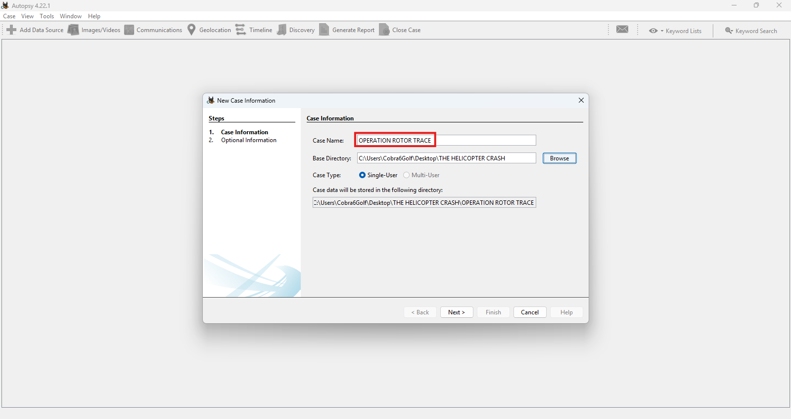
Exhibit B - Autopsy 4.22.1 new case creation for “OPERATION ROTOR TRACE.”
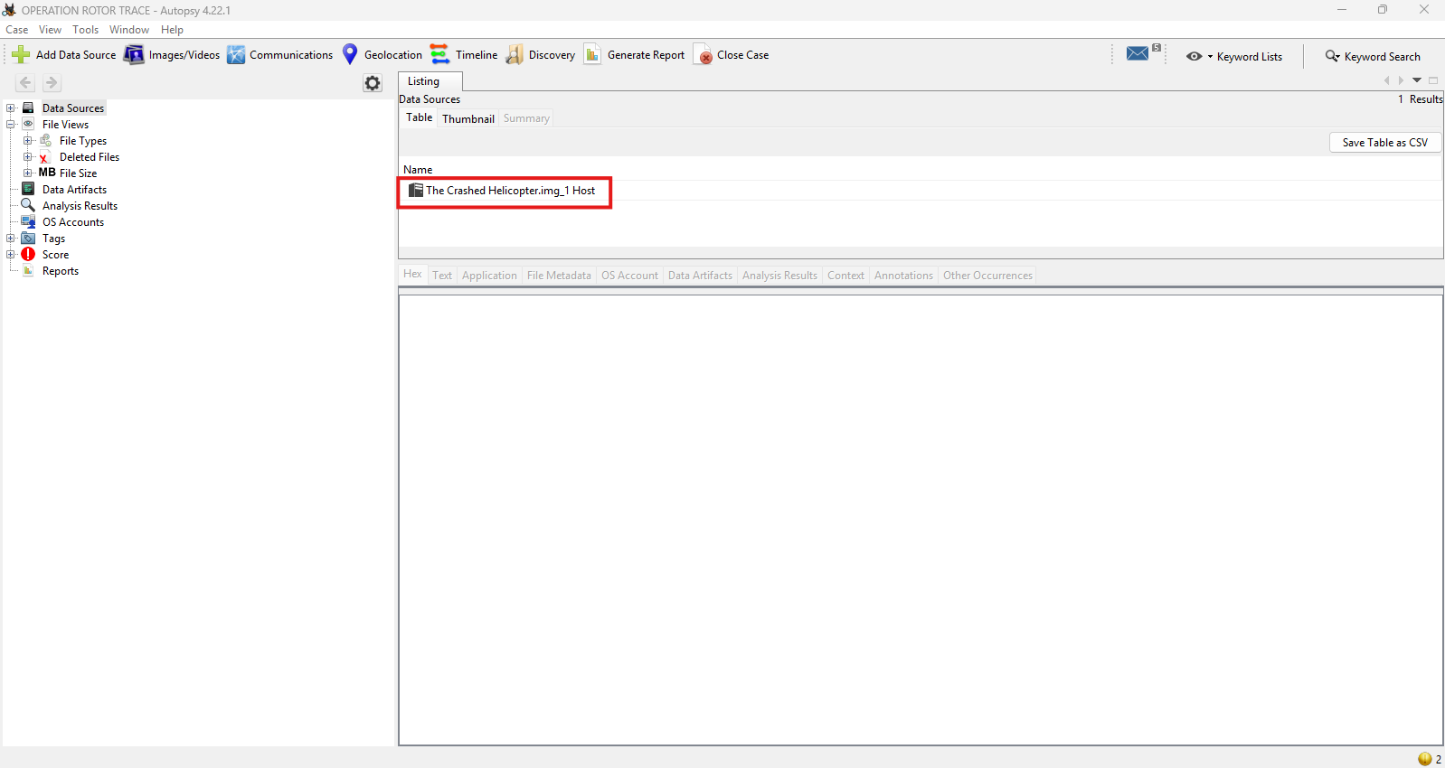
Exhibit C - Autopsy case interface following ingestion of the evidence image.

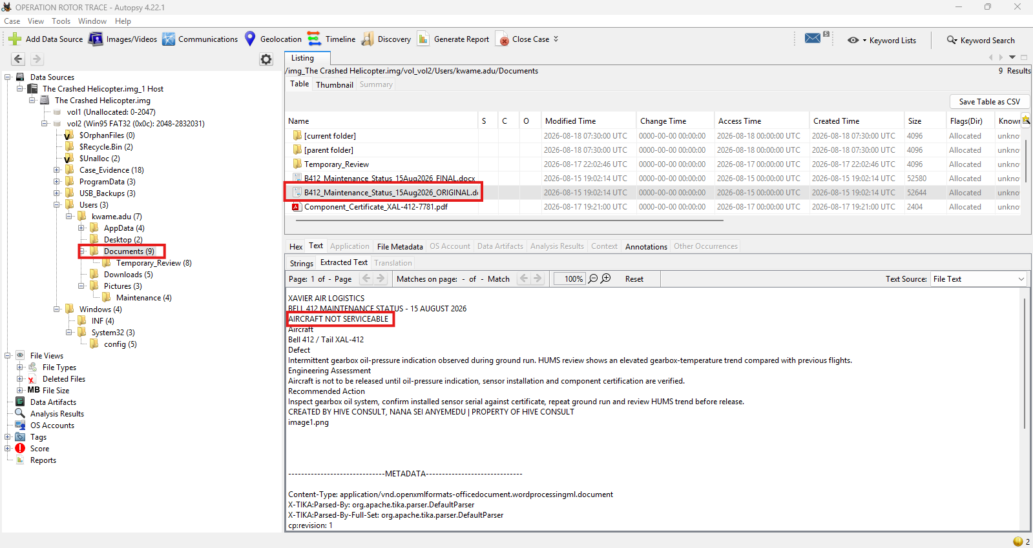
Exhibit D - File listing and extracted text of the ORIGINAL maintenance status document, recording “AIRCRAFT NOT SERVICEABLE.”
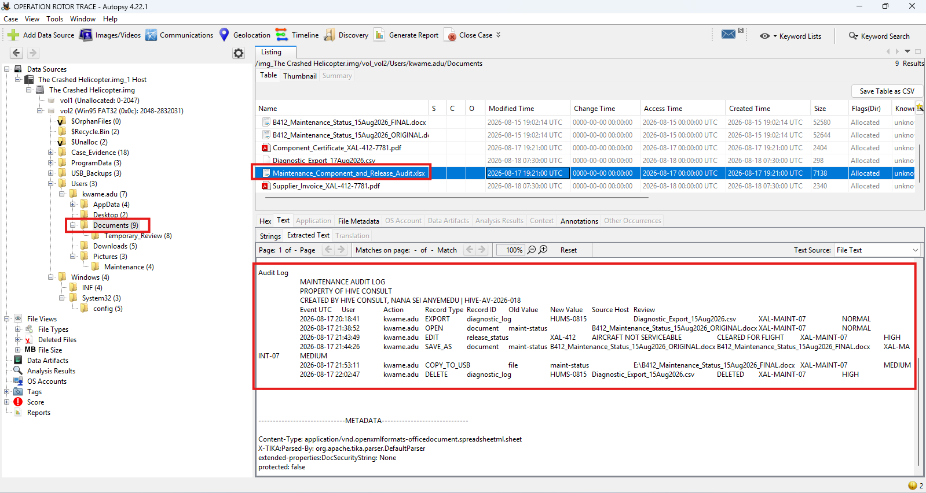
Exhibit E - Maintenance document file listing, including the audit log spreadsheet and component certification records.

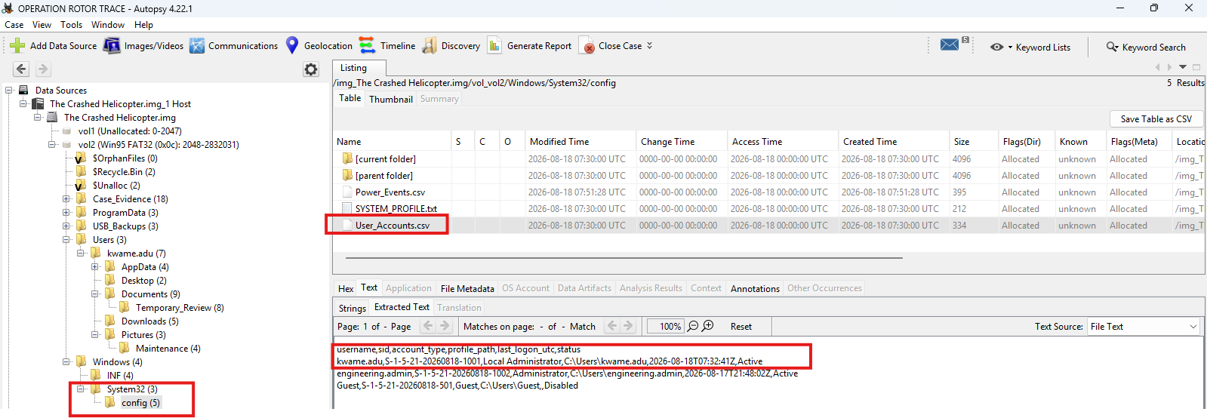
Exhibit G - OS account records (User_Accounts.csv) confirming the kwame.adu Local Administrator account and last-logon timestamp.

Appendix C - Chain of Custody Record
1. Hash verification via PowerShell.
2. Opened Autopsy V4.22.1 to create a case.
3. Image was ingested and loaded; examination and analysis begun.

