First name Last name (Matr.-Nr.), First name Last name (Matr.-Nr.), ...

My Topic – Title Should Not Exceed
More Than Two Lines and Use Capitalization
Optionally, there is the possibility of preceding the article with an abstract. This is a concise summary that provides the most essential information without needing to read the full text. The abstract is characterized by objectivity, brevity, clarity, completeness, and accuracy.

Guidelines for Writing an Academic Paper

Formal criteria

Structure
The overall content structure should provide the reader with a clear thread that addresses the research question of the academic paper. The outline helps the reader understand the structure of the text.
A brief introduction outlines the problem area and highlights its relevance. Finally, the article's further approach (tasks and structure) is discussed. The main part analyzes the central question or thesis, including relevant methods, concepts (approaches, models), and their implementation (tools, optimizations, etc.). The conclusion summarizes the key findings. The summary serves as a content framework that refers back to the initial research question presented in the introduction.

Writing style
In academic writing in English, it is perfectly fine to use a personal style. Using pronouns like „I” or „we” makes the text more engaging and direct. For example, instead of saying, „The developed solution is highly complex,” you can simply say, „We found the solution to be highly complex.” Note that this rule is quite different in German, where academic writing should maintain an impersonal style. Additionally, abbreviations can make the text more concise, so using „e.g.” instead of „for example” is completely acceptable. However, do not use abbreviations excessively with less known terms.

Working with sources – proper citation
The academic quality of a research paper is determined by the precise and appropriate use of external sources. It is crucial to accurately reproduce the original content while clearly differentiating it from the author's own arguments. An exception is made only for universally accepted statements. The following types of citations are distinguished:

Direct quotations
According to CARD et al., information visualization is defined as „The use of computer-supported, interactive, visual representations of data to amplify cognition“ (CARD et al. 1999).

Indirect quotations
One way to formalize multitouch gestures is the GeForMT language (KAMMER et al. 2010), which will be examined below for its completeness and adaptability for spatial gestures.

Paraphrasing (one sentence)
Thus, the brain uses various depth cues to extrapolate spatial arrangements (cf. GOLDSTEIN 2002).

Paraphrasing (multiple sentences)
In particular, spatial perception is based on a complex mechanism. The brain uses various depth cues to extrapolate spatial arrangements (cf. GOLDSTEIN 2002).

Using this Template
The text always runs in a single column within the fixed text area. In the entire document, the spacing between text units is controlled by the paragraph formatting properties. Only use „soft breaks” for manual line breaks! Optionally, there is the possibility to include a brief summary at the beginning. The „Title” template is used to highlight the title and should only appear once throughout the document! Heading 1 divides the main sections of the text (Introduction – Related Works – ...), and it should not be longer than one line. Heading 2 can follow directly after Heading 1, but it is not mandatory. Heading 2 may span multiple lines. Caution: Line breaks should be inserted meaningfully. Heading 3 can only be used if the text being structured has already been titled with Heading 2 or 3. Quotes and terms are highlighted in italics.

For further subdivisions in the text. Use the style as in this paragraph for additional structure. Format the headings with „Open Sans Medium” followed by a period. Only in this case, separate the paragraphs with exactly one blank line.

Graphics/Images
Include appropriate graphics and refer to them. They always have a running figure number and a caption (see Figure 01). Images are also subject to proper citation, and even the caption should already provide information about their origin. For example, if the image comes from a book, the source includes: author, year, and page number. If the self-created image is based on an external image idea (e.g., reproduction in case of poor source quality), the source should be preceded by according to.
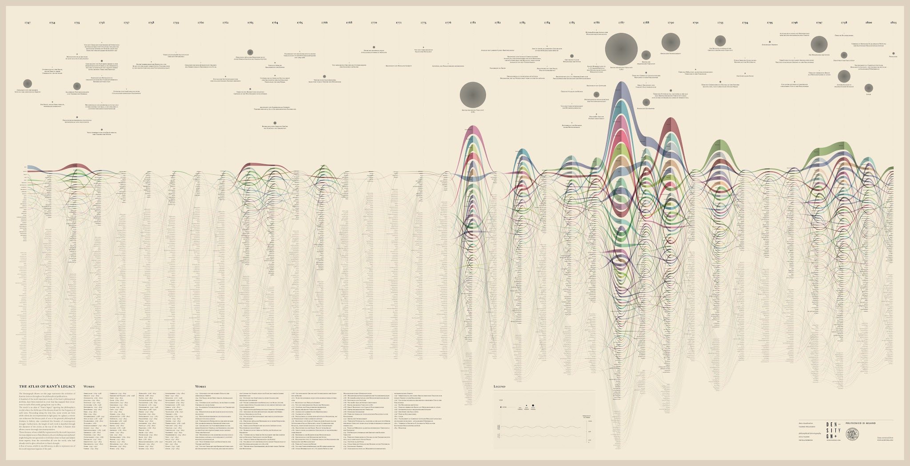

Figure 01 Information Visualization by Valerio Pellegrini.

Image and Text
The spacing between the image and the body text or text frame is regulated by Heading 4. Caution: Image numbering must unfortunately be done manually in Google Docs, and the font style of the description text should be set to Open Sans Light. An „en space” should be inserted between the image number and the description – this can be found under Insert > Special characters > Search for „en space.” Images should ideally appear at the top of a page. If an image appears between simple paragraphs, it should be manually separated from the paragraph above by exactly one blank line.

Source Code
Code examples are placed in a table with a single cell and manually highlighted with syntax highlighting if needed (Roboto Mono Medium). For the code, Inconsolata Light with font size 8 should be used. Line numbers can be added if necessary. Indentation should be done with at least 2 spaces. You may also use external plugins for Google Docs such as Code Blocks: https://workspace.google.com/marketplace/app/code_blocks/100740430168.

1: if(roll < -70 && xPos1 >370 && xPos1 <420) {
2: println("GESTURE: PLAY " + roll);
3: spotify.play();
4: try {
5: Thread.sleep(1000);
6: } catch (Exception e) { }
7: }

Code 01 Recognition of a swipe gesture.
Code blocks are also labeled with a caption, just like images, and referenced in the same way. The caption is preceded by the word „Code” and a consecutive number.

Enumerations
Bullet points should be separated from the text by a blank line before and after. The standard circle should be used:

- This is
- a bullet point
- with exactly
- four items

Separated from the rest of the text.

References
List your references in a consistent and complete style. For URLs please supply the date of your last access. For the reference format you can use the APA style: https://apastyle.apa.org/style-grammar-guidelines/references/examples.

LAST NAME, FIRST NAME (2001): Where to find it? – A good source work, In: Publisher
.
.
.
.

