|  |
| --- |
| WolfAir Flight Application |
| Instruction Manual |
|  |
|  |



Contents

Introduction 2

Passwords 2

Logging In 3

Booking Flights 4

Confirming Flights 6

Administration 7

Add/remove Airports 7

View Bookings 8

## Introduction

Thank you for choosing the Wolf Inc. flight booking system. This document will help get you started.

## Passwords

To allow you to test the application, we have provided you with a number of users accounts.

|  |  |  |
| --- | --- | --- |
| Username | Password | Administrator |
| pwoulfe | password | No |
| admin | admin | Yes |
| jvaljean | 24601 | No |
| Jmith | 12345 | No |

Figure 1 Password Table

## Logging In

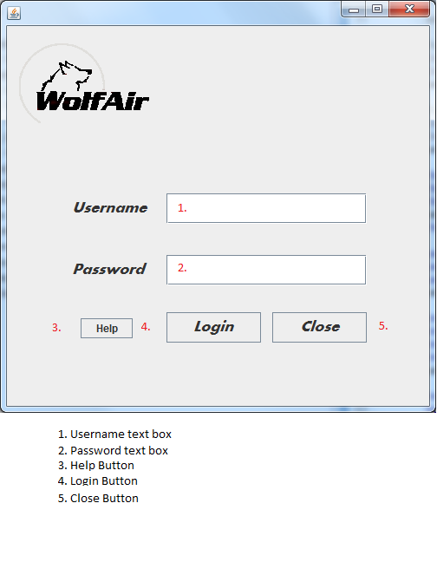

Figure 2 Login Screen

Using this screen, you can login to the application. Enter a username into the username text box and a matching password from the password table.

Clicking help will open the help document.

If you use an administrator password, it will bring you to the administration screen. If you use a non-administrator password, it will take you to the booking flights screen.

Clicking close will exit the application.

## Booking Flights

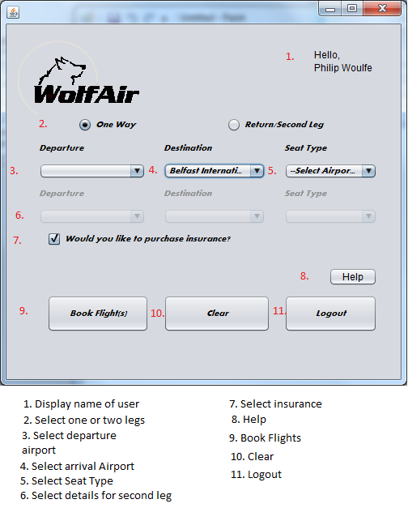

Figure 3 Booking Screen

Using this screen, you can select the details of the required flight(s). Your name will be displayed in the name box. Selecting the number of legs will (de)activate the second leg options. Selecting an airport from 3 will remove it from 4.

If a second leg is selected, selecting an airport in 4 will populate it in 6 and selecting an airport in 6 will populate it in 6b.

You may select a seat type in 5.

You may select if insurance is required in 7.

8. Displays the help document.

9. Opens the booking screen with the selected details.

10. Resets all fields to defaults.

11. Returns to the login screen.

## Confirming Flights

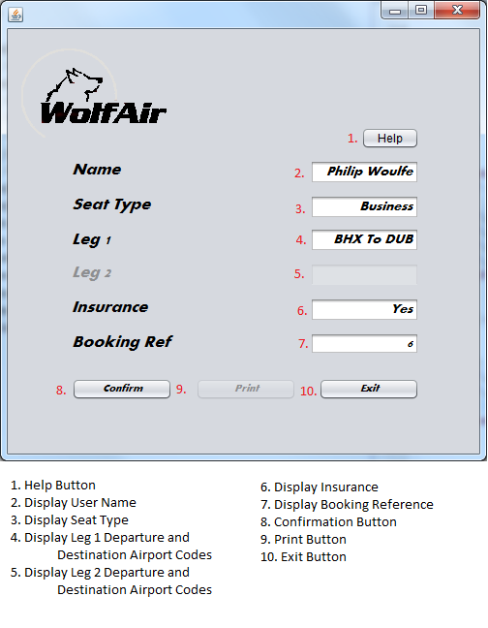

Figure 4 Confirmation Screen

1. Click to open help
2. Displays the name of the current user
3. Displays the seat type
4. Displays the departure and destination airport codes for the first leg
5. Displays the departure and destination codes for the second leg (Disabled if only one leg selected)
6. Displays whether insurance was required
7. Displays booking reference
8. Click button to confirm flight (Disabled on confirmation)
9. Click button to print details of flight (Prints to the default printer – will not print if no default printer is set)
10. Click to return to customer screen

This screen will display the details of the flight before confirmation. Clicking confirm will disable the confirm button to prevent confirming the same flight twice.

## Administration

This screen can be used to add airports to the application, remove airports from the application and view the details of every flight booked.

### Add/remove Airports

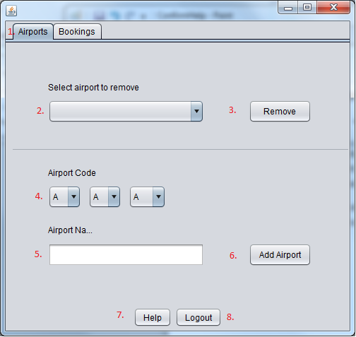

Figure 5 Airport Maintenance Screen

1. Airport tab
2. Airport dropdown – populates with all current airports
3. Removes currently selected airport from list
4. Select three letter code for new airport
5. Enter name of new airport
6. Add airport – 5 must contain unique three letter code
7. Opens help
8. Returns to login screen

### View Bookings

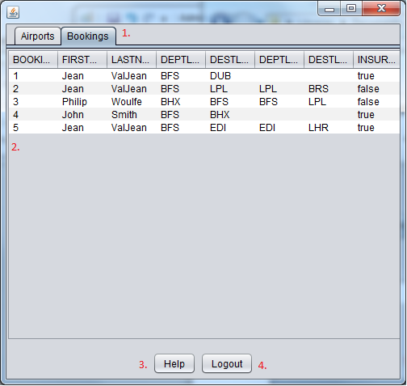

Figure 6 Booking Maintenance Screen

1. Booking tab
2. Table of all booked flights
3. Help button
4. Returns to login screen