Laboratory Exercise 004

Yau, Philip Excequel | “I can do this!”

June 29, 2024

**Procedure:**

1. Make sure you have a running version of the “Hello World” application shown in Module 004. If not, review the steps to setup your Work Environment.
2. There will be a series of problems you are required to code. For each, you need to provide C++ codes for the actual solution.
3. Keep the project files for record as they may be requested by the instructor.

**Questions:**

1. Write a program that accepts user’s section, and display them back with the format “*** Section: *user’s section* ***”.

C++

string section;

cout << "Enter your section: ";

cin >> section;

cout << "*** Section: " << section << " ***" << std::endl;

cout << "Press any key to continue...";

getchar(); // pause the program and wait for user input

Flow Chart

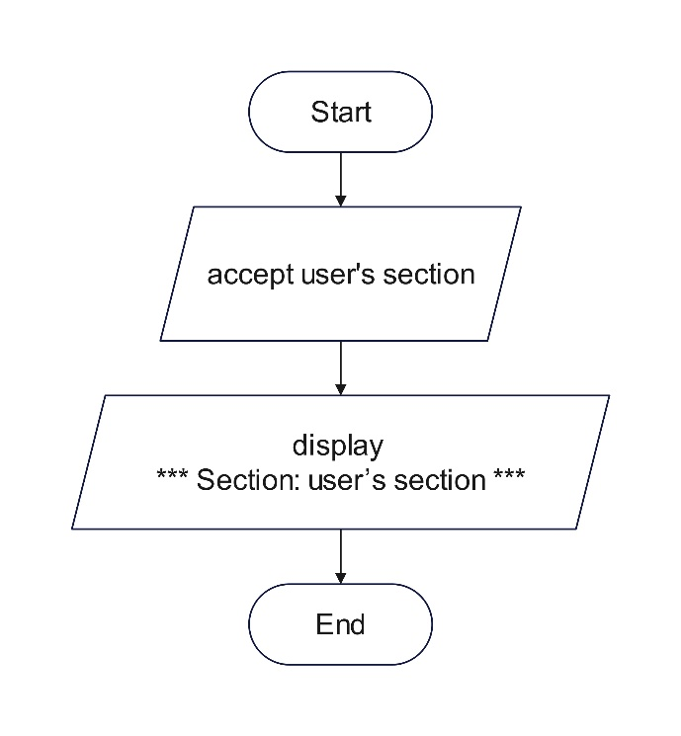

Pseudocode

DECLARE section AS STRING

PROMPT "Enter your section: "

INPUT section

OUTPUT "*** Section: " + section + " ***"

1. Write a program that accepts user’s daily budget and display the product of the daily budget and itself.

C++

cout << "Enter daily budget: ";

cin >> dailybudget;

product = dailybudget * dailybudget;

cout << "" << product << std::endl;

cout << "Press enter to exit...";

cin.get(); // wait for enter key press

Flowchart

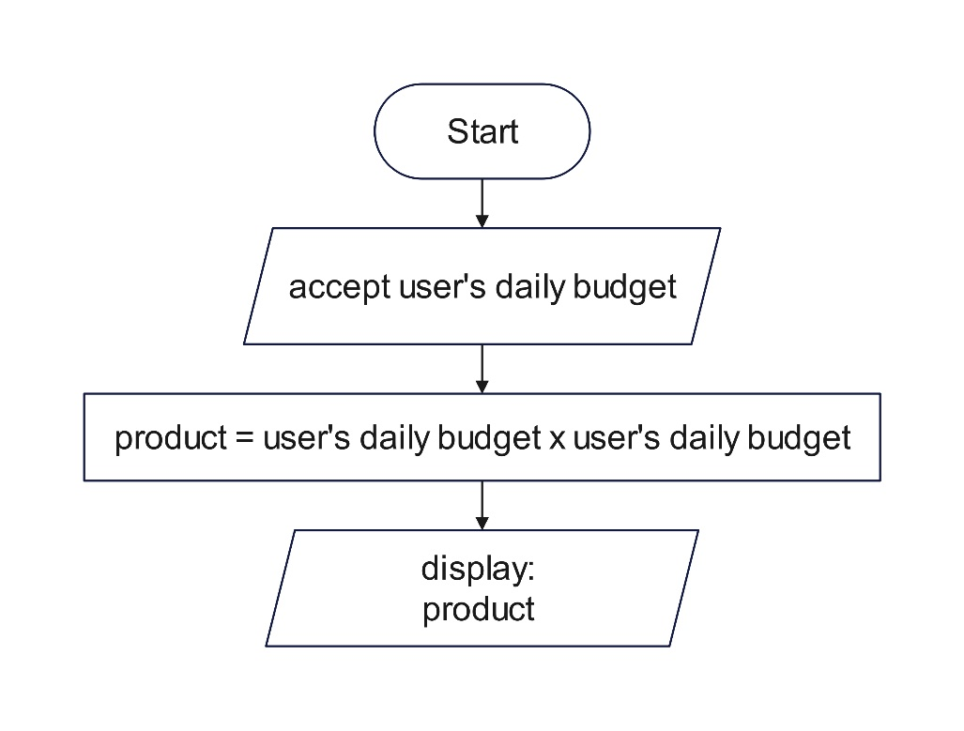

Pseudocode

DECLARE dailybudget

DECLARE product

INPUT dailybudget

SET product TO dailybudget x dailybudget

OUTPUT “”,product

1. Write a program that accepts user’s name, password and address and display them back using the format “Hi, I am *user’s name*. I live at *user’s address*.”.

Restrictions:

* + - Use only three variables.
    - Make sure you support spaces.

C++

string username;

string password;

string address;

cout << "Enter your username: ";

cin >> username;

cout << "Enter your password: ";

cin >> password;

cout << "Enter your address: ";

cin >> address;

cout << "Hi, I am " << username << ". I live at " << address << "." << endl;

cout << "Press any key to continue...";

cin.get();

Flowchart

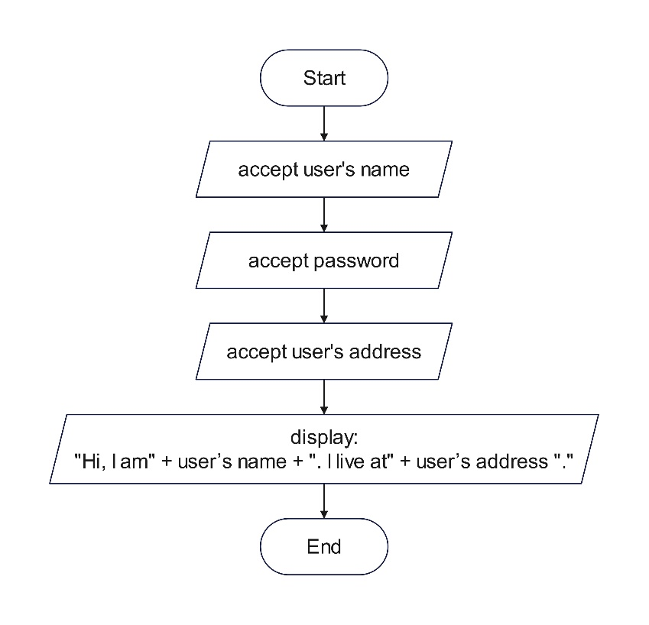

Pseudocode

DECLARE username

DECLARE password

DECLARE address

INPUT username

INPUT password

INPUT address

OUTPUT “Hi, I am” + username + “. I live at” + address.

1. What can you conclude from this activity?

I conclude from this activity is I learn basic C++ programming, variables, string, integer, character. How to analyze the question, how to solve the problem.

Github/gitfront.io link

https://gitfront.io/r/philipyau/8RYgSjL67iRN/YauPhilipExcequel-LaboratoryExercise004/s