

NAME: PHILIP ANTWI
ID: PUIT/24120002
LEVEL: 400
COURSE: AI AND EXPERT SYSTEMS
TITLE: IRIS CLASSICATION REPORT
PROGRAM: BSC INFORMATION TECHNOLOGY
LECTURER: MR, HARRY ATIEKU-BOATENG

CONTENTS
ABSTRACT 3
1. INTRODUCTION 3
2. LITERATURE REVIEW 4
3. DATASET DESCRIPTION 4
Table 1: Iris Dataset Feature Ranges. 4
4. DATA PREPROCESSING AND PREPARATION 4
Table 2: Train-Test Split Distribution. 5
5. LOGISTIC REGRESSION ALGORITHM 5
6. MODEL TRAINING AND EVALUATION 5
6.1 Confusion Matrix 5
6.2 Classification Report 6
Table 3: Classification Report Iris Test Set. 6
7. SYSTEM DESIGN AND IMPLEMENTATION 7
Table 4: Project Files and Descriptions. 7
7.1 Frontend HTML / CSS / JavaScript 7
7.2 Backend Python Prediction API 7
7.3 Deployment on Vercel 7
8. PERSONAL REFLECTION AND CHALLENGES 9
9. CONCLUSION AND RECOMMENDATIONS 11
REFERENCES 12
APPENDIX PROJECT SOURCE CODE: 13

ABSTRACT
This report documents the design, development, and deployment of an Iris Flower Species Classification system built with Logistic Regression and Python. Using the Scikit-learn Iris dataset 150 balanced observations of three species (Setosa, Versicolor, Virginica) described by four morphological measurements the trained model achieved 96.67% test accuracy. The system was deployed as a live web application on Vercel, connecting an HTML/CSS/JavaScript frontend to a Python prediction API. This report covers the full project lifecycle: data preparation, model training, evaluation, system design, deployment, and a personal reflection on the learning journey.
Keywords: Machine Learning, Logistic Regression, Iris Classification, Scikit-learn, Python API, Vercel.

1. INTRODUCTION
Machine learning enables computers to learn patterns from data and make predictions without being explicitly programmed for every scenario [1]. Classification assigning a label to an unseen input is one of its most fundamental applications. The Iris dataset, introduced by Fisher in 1936 [2], is the most widely used benchmark for evaluating classification algorithms. It contains 150 labelled flower samples across three species: Iris Setosa, Iris Versicolor, and Iris Virginica.
This project trains a Logistic Regression classifier on the Iris dataset, evaluates it rigorously, and deploys it as a publicly accessible web application. The aim is to demonstrate the complete machine learning lifecycle from raw data to a live, user-facing prediction system while reinforcing the academic and practical skills acquired during the BSc Information Technology programme at Pentecost University.
The specific objectives are:
1. Explore and describe the Iris dataset.
2. Train and evaluate a Logistic Regression model using Scikit-learn [3].
3. Build an interactive web application for real-time species prediction.
4. Deploy the system publicly on the Vercel cloud platform.
5. Document the project in a professional academic report.

2. LITERATURE REVIEW
Supervised machine learning involves training a model on labelled data so it can generalise to new, unseen examples [1]. Logistic Regression, despite its name, is a classification algorithm that estimates class probabilities using the sigmoid function [4]. James et al. [4] confirm that it is especially effective when decision boundaries between classes are approximately linear a property that holds for the Iris dataset.
Scikit-learn [3] is the dominant Python library for machine learning, providing implementations of Logistic Regression, evaluation metrics, and dataset utilities in a consistent API. Géron [5] recommends Joblib for model serialisation because it handles NumPy arrays more efficiently than Python's built-in Pickle. For deployment, Vercel's serverless functions allow lightweight Python APIs to be served globally without managing servers [6], making it an appropriate choice for academic projects.

3. DATASET DESCRIPTION
The Iris dataset (sklearn. datasets. load_iris) contains 150 observations, 50 per class, with no missing values. Each sample has four continuous features measured in centimetres and a categorical target label (0 = Setosa, 1 = Versicolor, 2 = Virginica).

Table 1: Iris Dataset Feature Ranges.
Feature | Min (cm) | Max (cm) | Mean (cm)
Sepal Length | 4.3 | 7.9 | 5.84
Sepal Width | 2.0 | 4.4 | 3.05
Petal Length | 1.0 | 6.9 | 3.76
Petal Width | 0.1 | 2.5 | 1.20
Source: Scikit-learn Iris dataset documentation [3].

4. DATA PREPROCESSING AND PREPARATION
The dataset required minimal preprocessing. No missing values or duplicates were found. The data was split into training (80%) and test (20%) sets using stratified random sampling (random state=42) to maintain class proportions in both subsets [3].

Table 2: Train-Test Split Distribution.
Subset | Total Samples | Per Class
Training Set | 120 | 40 per class
Test Set | 30 | 10 per class
Total | 150 | 50 per class
Feature scaling was not applied, as all features share comparable centimetre ranges and the L-BFGS solver used by Scikit-learn is robust under these conditions [3].

5. LOGISTIC REGRESSION ALGORITHM
Logistic Regression estimates class membership probabilities using the logistic (sigmoid) function. For a binary problem, the probability is:
P (y = 1 | x) = 1 / (1 + e⁻⁺ʷᵀx + b⁻)
where w is the weight vector and b is the bias term. For the three-class Iris problem, Scikit-learn uses the One-vs-Rest (OvR) strategy: a separate binary classifier is trained for each species versus all others, and the class with the highest probability is selected [4]. The model was instantiated with max_iter=200 to ensure convergence and trained on the 120-sample training set.
Logistic Regression was chosen for its interpretability, computational efficiency on small datasets, native probability output (enabling the confidence display in the web application), and proven accuracy on linearly separable problems [4][5].

6. MODEL TRAINING AND EVALUATION
The model was trained using model.fit (X_train, y_train) and serialised to iris_model.pkl using Joblib for reuse by the prediction API without retraining [5]. Predictions on the 30-sample test set were generated with model. predict(X_test), and class probabilities with model. predict_proba(X_test). The model achieved a test accuracy of 96.67% (29 out of 30 samples correctly classified).

6.1 Confusion Matrix
The confusion matrix below visualises prediction performance at the class level. Rows represent actual species; columns represent predicted species. Diagonal entries indicate correct classifications.
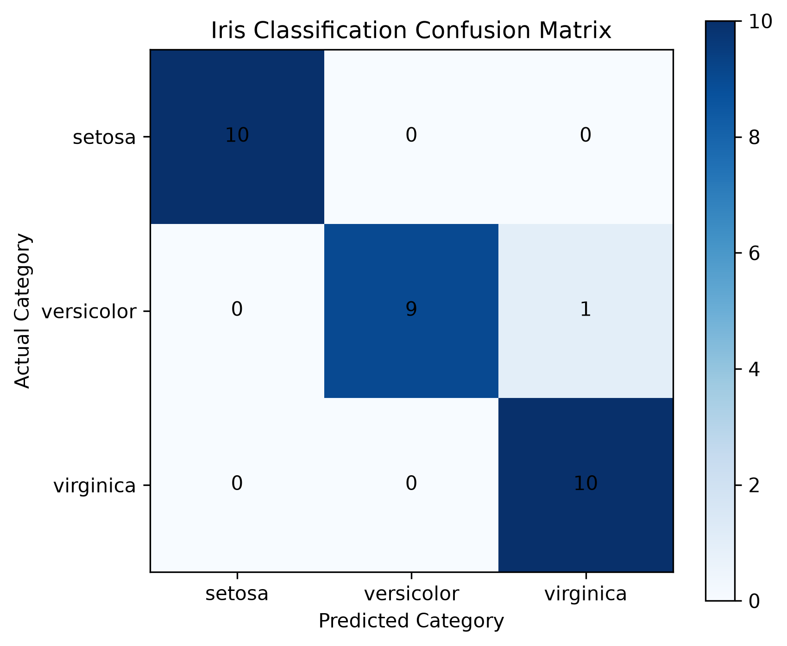
Figure 1: Iris Classification Confusion Matrix (generated by Matplotlib [3]).
Results: Iris Setosa 10/10 (100% recall, perfectly linearly separable). Iris Versicolor 9/10 (one sample misclassified as Virginica, the sole error). Iris Virginica 10/10 (100% recall). The single misclassification reflects the known overlap between Versicolor and Virginica in the petal dimension feature space.

6.2 Classification Report
Table 3 presents precision, recall, and F1-score for each class.

Table 3: Classification Report Iris Test Set.
Class | Precision | Recall | F1-Score | Support
Iris Setosa | 1.00 | 1.00 | 1.00 | 10
Iris Versicolor | 1.00 | 0.90 | 0.95 | 10
Iris Virginica | 0.91 | 1.00 | 0.95 | 10
Accuracy |  |  | 0.97 | 30
Macro Average | 0.97 | 0.97 | 0.97 | 30
Weighted Average | 0.97 | 0.97 | 0.97 | 30
Source: sklearn. metrics. classification_report output.

7. SYSTEM DESIGN AND IMPLEMENTATION
The system follows a three-tier architecture: a static HTML/CSS/JavaScript frontend, a Python serverless API backend, and the serialised machine learning model. Table 4 summarises the project files.

Table 4: Project Files and Descriptions.
File | Description
iris_classification.py | Model training, evaluation, and confusion matrix generation.
iris_model.pkl | Serialised trained model (Joblib).
index.html | Production frontend HTML structure, CSS styles, JavaScript logic.
api/predict.py | Python serverless prediction API (Vercel handler).
vercel. json | Vercel deployment configuration (framework: null).

7.1 Frontend HTML / CSS / JavaScript
The production frontend (index.html) is a fully responsive single-page application. Three species information cards at the top introduce Setosa, Versicolor, and Virginica. A two-column form collects the four measurements, and a Predict button sends an asynchronous HTTP POST request (Fetch API) to /api/predict. The JSON response updates the DOM to display the predicted species name, confidence percentage, and per-class probability bars all without a page reload.

7.2 Backend Python Prediction API
The API (api/predict.py) extends Python's BaseHTTPRequestHandler to handle POST requests in Vercel's serverless format. On each call it: (1) reads the JSON body and extracts the four measurement values; (2) constructs a NumPy array of shape (1, 4); (3) calls model. predict () and model. predict_proba (); (4) returns the predicted species, confidence score, and full probability dictionary as JSON. A CORS header (Access-Control-Allow-Origin: *) permits browser requests from any origin, and all exceptions return a 400-error response.

7.3 Deployment on Vercel
Vercel was selected for its native Python serverless support via the api/ directory convention, seamless GitHub integration enabling continuous deployment on every commit, and a free tier suitable for academic projects [6]. The vercel.json file sets "framework": null, instructing Vercel to serve index.html as a static asset and expose api/predict.py as the serverless function at /api/predict.
🌐 Live Application: https://iris-classification-project-rk73.vercel.app/
🐙 GitHub Repository: https://github.com/Philipntwi-bot/Iris_Classification_Project

8. PERSONAL REFLECTION AND CHALLENGES
Looking back on this project, I am genuinely proud of what I was able to accomplish. When I first began, the idea of training a machine learning model and deploying it as a live web application felt overwhelming. I had studied the theory of algorithms in class, but translating that knowledge into working, deployable code was a very different challenge altogether.
One of the most significant technical hurdles I encountered was the transition from the Streamlit prototype to a production web application. Streamlit made it easy to build an interface quickly, but I realised it was tightly coupled to Python and not suitable for a professional deployment. Learning how to write a Python serverless API using Python's built-in BaseHTTPRequestHandler, and connecting it to an HTML/CSS/JavaScript frontend using the Fetch API, required me to step outside my comfort zone and learn concepts I had not formally studied REST API design, asynchronous JavaScript, and cloud deployment configuration.
Deploying to Vercel also presented unexpected challenges. I initially struggled to understand why the model file (iris_model.pkl) could not be located by the API at runtime. After careful investigation, I discovered that the file path needed to be resolved relative to the API script using Python's pathlib. Path, rather than relying on a relative path string. This was a small but important lesson in the difference between local development environments and cloud serverless environments.
On the machine learning side, I found the evaluation phase particularly insightful. While the 96.67% accuracy was satisfying, analysing the confusion matrix revealed something more nuanced: the model's single error misclassifying one Versicolor sample as Virginica was not random. It reflected a known biological overlap between the two species, which no linear model can fully resolve without additional features. This taught me that accuracy alone does not tell the full story of a model's behaviour.
If I were to redo this project, I would implement feature scaling from the beginning, compare multiple algorithms (such as SVM and Random Forest), and add logging to the API so that prediction requests could be monitored over time. I would also explore adding a feedback form to the web application, allowing users to report incorrect predictions a simple but powerful mechanism for continuous model improvement.
Overall, this project was one of the most rewarding experiences of my academic journey. It gave me the confidence to work across the full machine learning pipeline from raw data to a live, publicly accessible application and demonstrated to me that the skills I have developed during my BSc programme are genuinely applicable to real-world problems.

9. CONCLUSION AND RECOMMENDATIONS
This project successfully demonstrated the design, implementation, and deployment of a machine learning classification system for Iris flower species. A Logistic Regression model trained on the Scikit-learn Iris dataset achieved 96.67% test accuracy, with strong per-class precision, recall, and F1-scores confirmed by the confusion matrix and classification report. The system was deployed as a fully functional, publicly accessible web application on Vercel, connecting a responsive HTML/CSS/JavaScript frontend to a Python prediction API that serves real-time results.
The project confirms that Logistic Regression is a reliable, interpretable baseline for multi-class botanical classification problems. The end-to-end workflow from Streamlit prototype through API development to cloud deployment illustrates a practically relevant software engineering process aligned with industry standards.
Recommendations for future work include:
• Comparative evaluation against SVM, Random Forest, and k-NN classifiers.
• Implementation of k-fold cross-validation for more robust accuracy estimates.
• Addition of feature scaling (StandardScaler) for generalisation to other datasets.
• Prediction logging and monitoring in the deployed API.
• Extending the system to classify a broader range of plant species.

REFERENCES

[1] T. M. Mitchell, Machine Learning. New York, NY: McGraw-Hill, 1997.
[2] R. A. Fisher, "The use of multiple measurements in taxonomic problems," Annals of Eugenics, vol. 7, no. 2, pp. 179–188, 1936, doi: 10.1111/j.1469-1809. 1936.tb02137. x.
[3] F. Pedregosa et al., "Scikit-learn: Machine learning in Python," Journal of Machine Learning Research, vol. 12, pp. 2825–2830, 2011. [Online]. Available: https://jmlr.org/papers/v12/pedregosa11a.html
[4] G. James, D. Witten, T. Hastie, and R. Tibshirani, An Introduction to Statistical Learning with Applications in R, 2nd ed. New York, NY: Springer, 2021. [Online]. Available: https://www.statlearning.com/
[5] A. Géron, Hands-On Machine Learning with Scikit-Learn, Keras, and TensorFlow, 3rd ed. Sebastopol, CA: O'Reilly Media, 2022.
[6] Vercel Inc., "Serverless Functions Documentation," 2024. [Online]. Available: https://vercel.com/docs/functions
[7] G. Varoquaux et al., "Joblib: Running Python functions as pipeline jobs," 2020. [Online]. Available: https://joblib.readthedocs.io/
[8] Streamlit Inc., "Streamlit A faster way to build and share data apps," 2024. [Online]. Available: https://streamlit.io/

APPENDIX PROJECT SOURCE CODE:
A.1 Model Training Script (iris_classification.py)
from sklearn. Datasets import load_iris
from sklearn.model_selection import train_test_split
from sklearn.linear_model import LogisticRegression
from sklearn.metrics import accuracy_score, confusion_matrix, classification_report
import matplotlib.pyplot as plt
import joblib
iris = load_iris()
X, y = iris.data, iris.target
X_train, X_test, y_train, y_test = train_test_split(
X, y, test_size=0.2, random_state=42, stratify=y)
model = LogisticRegression(max_iter=200)
model.fit(X_train, y_train)
joblib.dump(model, "iris_model.pkl")
y_pred = model.predict(X_test)
print("Accuracy:", accuracy_score(y_test, y_pred) * 100, "%")
print("Confusion Matrix:\n", confusion_matrix(y_test, y_pred))
print("\nClassification Report:\n",
classification_report(y_test, y_pred, target_names=iris.target_names))
A.2 Python Prediction API (api/predict.py)
import json, joblib, numpy as np
from pathlib import Path
from http.server import BaseHTTPRequestHandler
from sklearn.datasets import load_iris
MODEL_PATH = Path(__file__).resolve().parent.parent / "iris_model.pkl"
model = joblib.load(MODEL_PATH)
iris = load_iris()
flower_names = iris.target_names
class handler(BaseHTTPRequestHandler):
def do_POST(self):
try:
n = int(self.headers.get("Content-Length", 0))
data = json.loads(self.rfile.read(n))
x = np.array([[float(data["sepal_length"]), float(data["sepal_width"]),
float(data["petal_length"]), float(data["petal_width"])]])
pred = model.predict(x)[0]
proba = model.predict_proba(x)[0]
response = {
"predicted_species": flower_names[int(pred)],
"confidence": round(float(proba[int(pred)] * 100), 2),
"probabilities": {
flower_names[i]: round(float(proba[i]*100), 2)
for i in range(len(flower_names))}}
self.send_response(200)
self.send_header("Content-Type", "application/json")
self.send_header("Access-Control-Allow-Origin", "*")
self.end_headers()
self.wfile.write(json.dumps(response).encode())
except Exception as e:
self.send_response(400)
self.end_headers()
self.wfile.write(json.dumps({"error": str(e)}).encode())

