Ein Bild, das Text, Menschliches Gesicht, Kleidung, Mann enthält.

Table of Contents

Startup 3

Registration process 4

Login 7

Main Page 8

Matches 9

Shop 10

Filter 11

User Manual:

# Startup

When you start the app for the first time, the first screen you will be introduced to Dapper with a slideshow that displays what the app is made for:

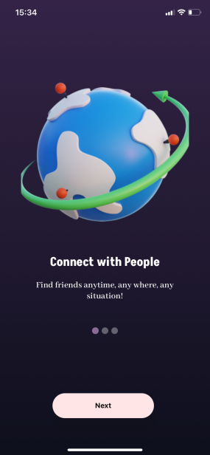 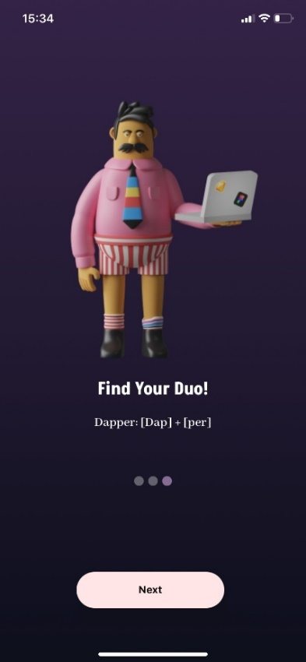 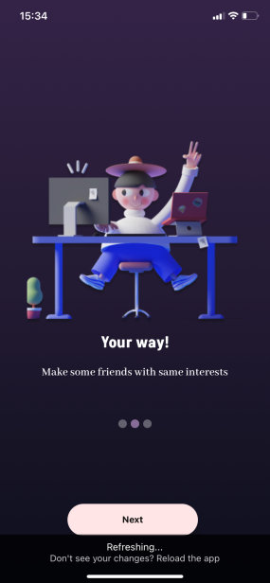

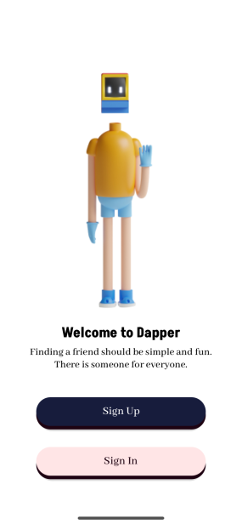

Clicking the “Next”-Button on the bottom of the Screen will   
  
lead you to the next page where you get to choose between  
  
2 options:

1. Logging in:

Choose this if you already have a Dapper account and you want to use it.

1. Registering:

Choose this if you haven’t used Dapper before and want to get started.

# Ein Bild, das Text, Screenshot, Schrift, Zahl enthält. Automatisch generierte BeschreibungRegistration process

If you want to create a new dapper account, you first need to input you email address together with a password of your choice, which you have to provide twice to confirm it. Furthermore, you need to agree to our terms and conditions. You can view those by clicking the blue link next to the checkbox. If you want to save time, you can also choose to sign up with your Facebook, Snapchat, or Google account. If you provided wrong inputs, you will be asked to change them so you can continue.

As soon as you are done with that and proceed to click the “Sign Up”-Button you will be asked to tell us some things about yourself so we can find the perfect matches just for you.

The first thing we need to know about you is your date of birth, to input that, you first have to click the “Show Date Picker”-Button and then choose the correct date using the given date-picker:

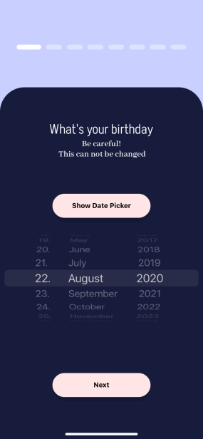Clicking the “Next”-Button will lead you to the next page, where you have to choose a unique username that nobody else, but you can use combined with a nickname. Multiple users can use the same nickname to make it possible that people can see your real name when matching with you.

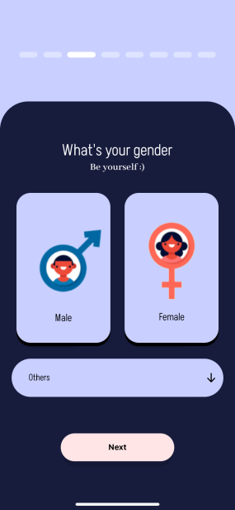Ein Bild, das Text, Screenshot, Schrift, Design enthält.
After clicking “Next” again you will be asked to provide your gender, if you identify with a non-binary gender, you can use the dropdown menu to find what you are looking for.

Clicking the “Next” button once more will lead you to a page, that collects information about your sexual orientation(s).

Ein Bild, das Text, Screenshot, Schrift, Design enthält.

After clicking “Next” again, you will be asked about what you are looking for. The options you can choose from here range from relationship to casual friendship. The “Pick some interests”-button navigates you to another page, where you then can choose from lots of interests which are organized in different categories. The “Back”-button leads back to the page you were on before.

Ein Bild, das Text, Screenshot, Design enthält.
Ein Bild, das Text, Screenshot, Schrift, Handy enthält.

Ein Bild, das Text, Screenshot, Schrift, Design enthält.
Clicking “Next”, leads you to the next page, where you need to provide information about where you are from. This will help the app find matches in your proximity.

Ein Bild, das Text, Screenshot, Schrift, Design enthält.
Clicking the “Next”-button leads to the second to last step of the registration process. Here you are asked for your social media handles.

Since others obviously want to know what you look like, the last step of the registration process needs you to upload your first picture.

Ein Bild, das Text, Screenshot, Anzug, Mann enthält.

# Login

If you already possess a Dapper account, you can easily sign in by choosing the “Sign In”-Option. You just need to input the email and the password you signed up with. You can also sign in with Facebook, Snapchat, or Google if you signed up using one of these options.

Ein Bild, das Text, Screenshot, Menschliches Gesicht, Betriebssystem enthält.

# Main Page

As soon as you’re logged in or signed up successfully, you will be navigated to the main page of the Dapper application.  
Here is how it looks:

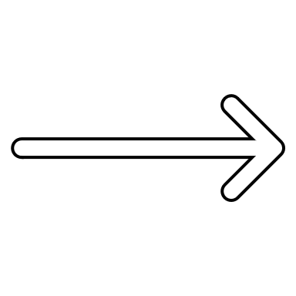Ein Bild, das Text, Screenshot, Betriebssystem, Design enthält.



COMING SOON

COMING SOON

This button leads to the shop, where you can purchase the premium subscription and more.

This button leads to the filters. Filters define which people will be displayed for you to match with.

This button is used to dislike the person that is currently displayed on the card in the centre.

This button is used to like the person that is currently displayed on the card in the centre.

Here you can see the number of “Hearts” you have left. You need these to be able to keep swiping.

The card in the middle displays the pictures, age, and a brief description of the people you can match with.

This button leads to a page where you can view all your matches.

COMING SOON

# Matches

On this page you can view all your matches. You match with a person if you both liked each other. The information displayed consists of the genders, the names, and the ages of the people you matched with.

Ein Bild, das Text, Screenshot, Schrift, Design enthält.

# Shop

This page gives you the possibility to purchase different plans of the premium version of the app. You can buy it for 1 month only, but you can also choose to take 3 months which is a little bit cheaper in comparison. Furthermore, it is also possible to recommend Dapper to your friends and rate the application in the app store. This way you can gain more “Hearts”, with which you can then like more people.

Ein Bild, das Text, Screenshot, Schrift, Betriebssystem enthält.

# Filter

On this page, you can filter the people, who will be displayed to you on the main page. You can filter by gender, age, and by country. The gender can be selected with the 3 radio buttons on the top of the screen, the age can be filtered using the slider underneath and the country can be selected with the dropdown on the bottom. If no country is selected, then people from all over the world get suggested to you. Clicking the “Filter”-Button, applies the settings and navigates you back to the main page.

Ein Bild, das Text, Screenshot, Design enthält.
