**degree number and percentage for all authors in NKOS workshops**

authors with degree more than 16 in the community of NKOS workshops

**Authors with betweenness more than 0.001 in the community of NKOS workshops**

**Authors with betweenness more than 0.14 in the community of NKOS workshops**

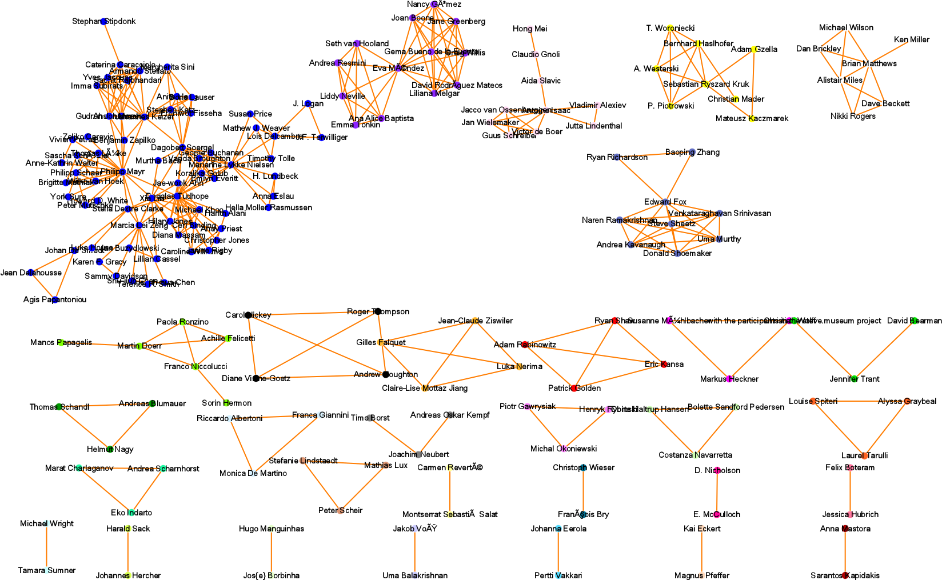

Figure 1 The whole network of authors in community of NKOS workshops

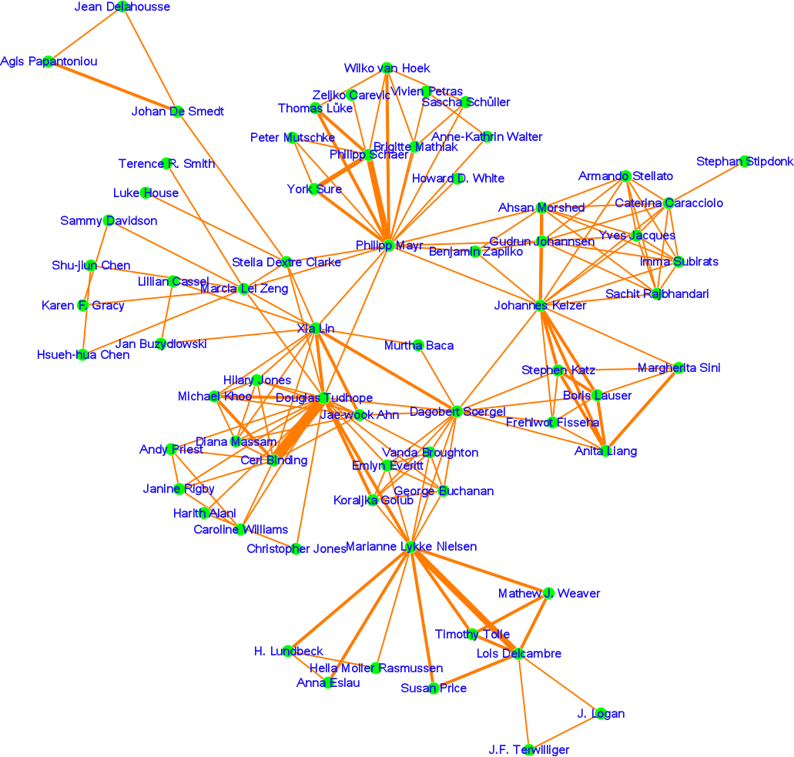

Figure 2 largest component in the NKOS authorship-network

