[tokenResults, trialInfo] = ASF_eyeParseAscii('exampleCentralEL.asc', {'MSG', 'EFIX', 'ESACC', 'EBLINK'})

tokenResults =

1x4 struct array with fields:

token

nFound

lines

trialInfo =

1x80 struct array with fields:

sacEvents

blinkEvents

fixEvents

trialStart

pagVec

pageOnset

trialEnd

samples

pupilArea

>> trialNo = 3; trialInfo(trialNo)

ans =

sacEvents: [1x4 struct]

blinkEvents: []

fixEvents: [1x4 struct]

trialStart: 6691938

pagVec: [2 3 2 6 2]

pageOnset: [6691953 6692166 6692180 6692206 6692286]

trialEnd: 6693483

samples: [1546x3 double]

pupilArea: [1546x1 double]

# Visual Inspection of a trial

%VISUAL INSPECTION

trialNo = 3;

%WE RETRIEVE TIMING INFO FROM THE SAMPLES' TIMESTAMPS

t0 = trialInfo(n).samples(1, 1);

t = trialInfo(n).samples(:, 1) - t0;

%ASSIGN THE SAMPLES TO A VARIABLE xy

xy = trialInfo(n).samples(:, 2:3);

%PLOT TRIAL

plot(t, xy, 'LineWidth', 2);

legend('x', 'y')

box off

xlabel('Time from trial-onset [ms]')

ylabel('Gaze Position [pixels]')

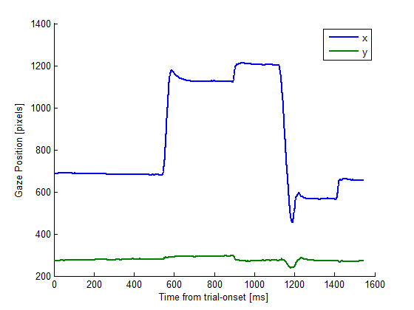

|  |  |
| --- | --- |
| A gaze traces with mask onset as reference | B marking of prime (red) and mask (green) onsets |
| C marking of saccade onsets | D identifying the first saccade after the mask to determine reaction time |

%VISUAL INSPECTION

trialNo = 3;

thisTrial = trialInfo(trialNo);

%WE RETRIEVE TIMING INFO FROM THE SAMPLES' TIMESTAMPS

t0 = thisTrial.samples(1, 1);

t = thisTrial.samples(:, 1) - t0;

%ASSIGN THE SAMPLES TO A VARIABLE xy

xy = thisTrial.samples(:, 2:3);

%PLOT TRIAL (FIGURE 1, and FIGURE 2 PANEL A)

figure

subplot(2, 2, 1)

plot(t, xy, 'LineWidth', 2);

legend('x', 'y')

box off

xlabel('Time from trial-onset [ms]')

ylabel('Gaze Position [pixels]')

%MARKING EXPERIMENTAL EVENTS, AND WE MAKE THE ONSET OF THE MASK t0

pagePrime = 2;

pageMask = 4;

t0 = thisTrial.pageOnset(pageMask);

tMask = thisTrial.pageOnset(pageMask) - t0; %SHOULD BE 0

tPrime = thisTrial.pageOnset(pagePrime) - t0;

t = thisTrial.samples(:, 1) - t0;

%PLOT TRIAL

subplot(2, 2, 2)

plot(t, xy, 'LineWidth', 2);

legend('x', 'y')

box off

xlabel('Time from mask-onset [ms]')

ylabel('Gaze Position [pixels]')

yLim = get(gca, 'ylim');

hold on

%MARK PRIME AND MASK

plot([tPrime, tPrime], yLim, ':r')

plot([tMask, tMask], yLim, ':g')

hold off

%IDENTIFY SACCADIC ONSETS

%PLOT TRIAL

subplot(2, 2, 3)

plot(t, xy, 'LineWidth', 2);

legend('x', 'y')

box off

xlabel('Time from mask-onset [ms]')

ylabel('Gaze Position [pixels]')

yLim = get(gca, 'ylim');

hold on

nSaccades = length(thisTrial.sacEvents);

sacStart = zeros(1, nSaccades);

hold on

for i = 1:nSaccades

sacStart(i) = thisTrial.sacEvents(i).sacStart - t0;

plot([sacStart(i), sacStart(i)], yLim, 'color', [.5, .5, .5]);

end

hold off

%SACCADIC REACTION TIME IS THE TIME BETWEEN ONSET OF THE MASK AND ONSET OF

%THE FIRST SUBSEQUENT SACCADE

idxFirstValidSaccade = find(sacStart > 0, 1 );

srt = sacStart(idxFirstValidSaccade);

subplot(2, 2, 4)

plot(t, xy, 'LineWidth', 2);

legend('x', 'y')

box off

xlabel('Time from mask-onset [ms]')

ylabel('Gaze Position [pixels]')

yLim = get(gca, 'ylim');

arrow([srt, yLim(2)], [srt, yLim(1)])