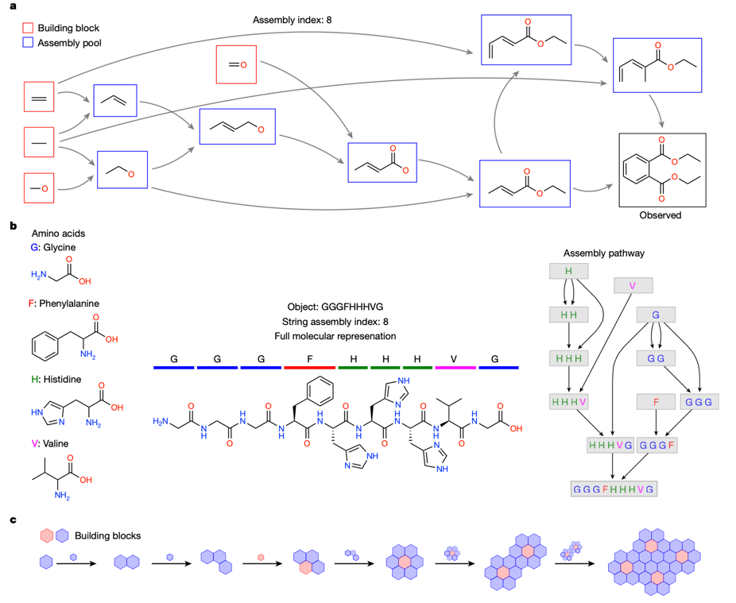

**S1. The principle of Assembly Theory.**

In **a**, the building blocks are shown in red and are different functional groups, and the assembly pools in blue. The assembly index is 8 because there are 8 assembly pools. **b.** represents different amino acids as letters and shows how they are arranged in the molecule. The assembly index is also 8 in this case. **c.** shows how the building blocks are assembled like a puzzle. (Sharma et al., 2023)

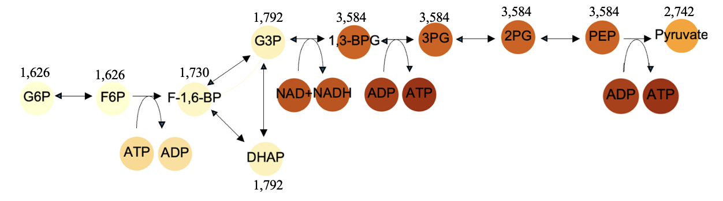

**S2.** ***S*chematic representation of glycolysis with the SE of metabolic intermediates calculated considering the stoichiometric ratios of each intermediate.** The SE values are shown above each intermediate. The red intensity represents the SE of each intermediate*.*

The above figure shows a similar trend to Figure *3*, with the SE entropy increasing from G6P to 1,3-BPG, and remaining approximately constant up to PEP. Similarly, there is a drop in SE from PEP to pyruvate. In both Figure 3 and Figure 4, G3P and dihydroxyacetone phosphate (DHAP) have higher SE values than D-fructose-1,6-bisphosphate (F-1,6-BP), and its preceding metabolites. However, both G3P and DHAP are branched, straight-chain molecules, whereas G6P, D-fructose-6-phosphate (F6P) and F-1,6-BP have cyclic structures. Cyclic structures should have a higher SE than straight-chain structures because they are more complex (Bonchev, 1995).