AssignmentPart1

ucesday

27 October 2018

# Assignment Part 1

## Libraries

library(knitr)  
library(colorspace)  
library(ggplot2)  
library(png)

## ArcMap Map

img1_path <- "C:/Users/pippa/OneDrive/Documents/GitHub/CASA-GIS-T1/Arc_MTW_IOW1.png"  
  
include_graphics(img1_path)

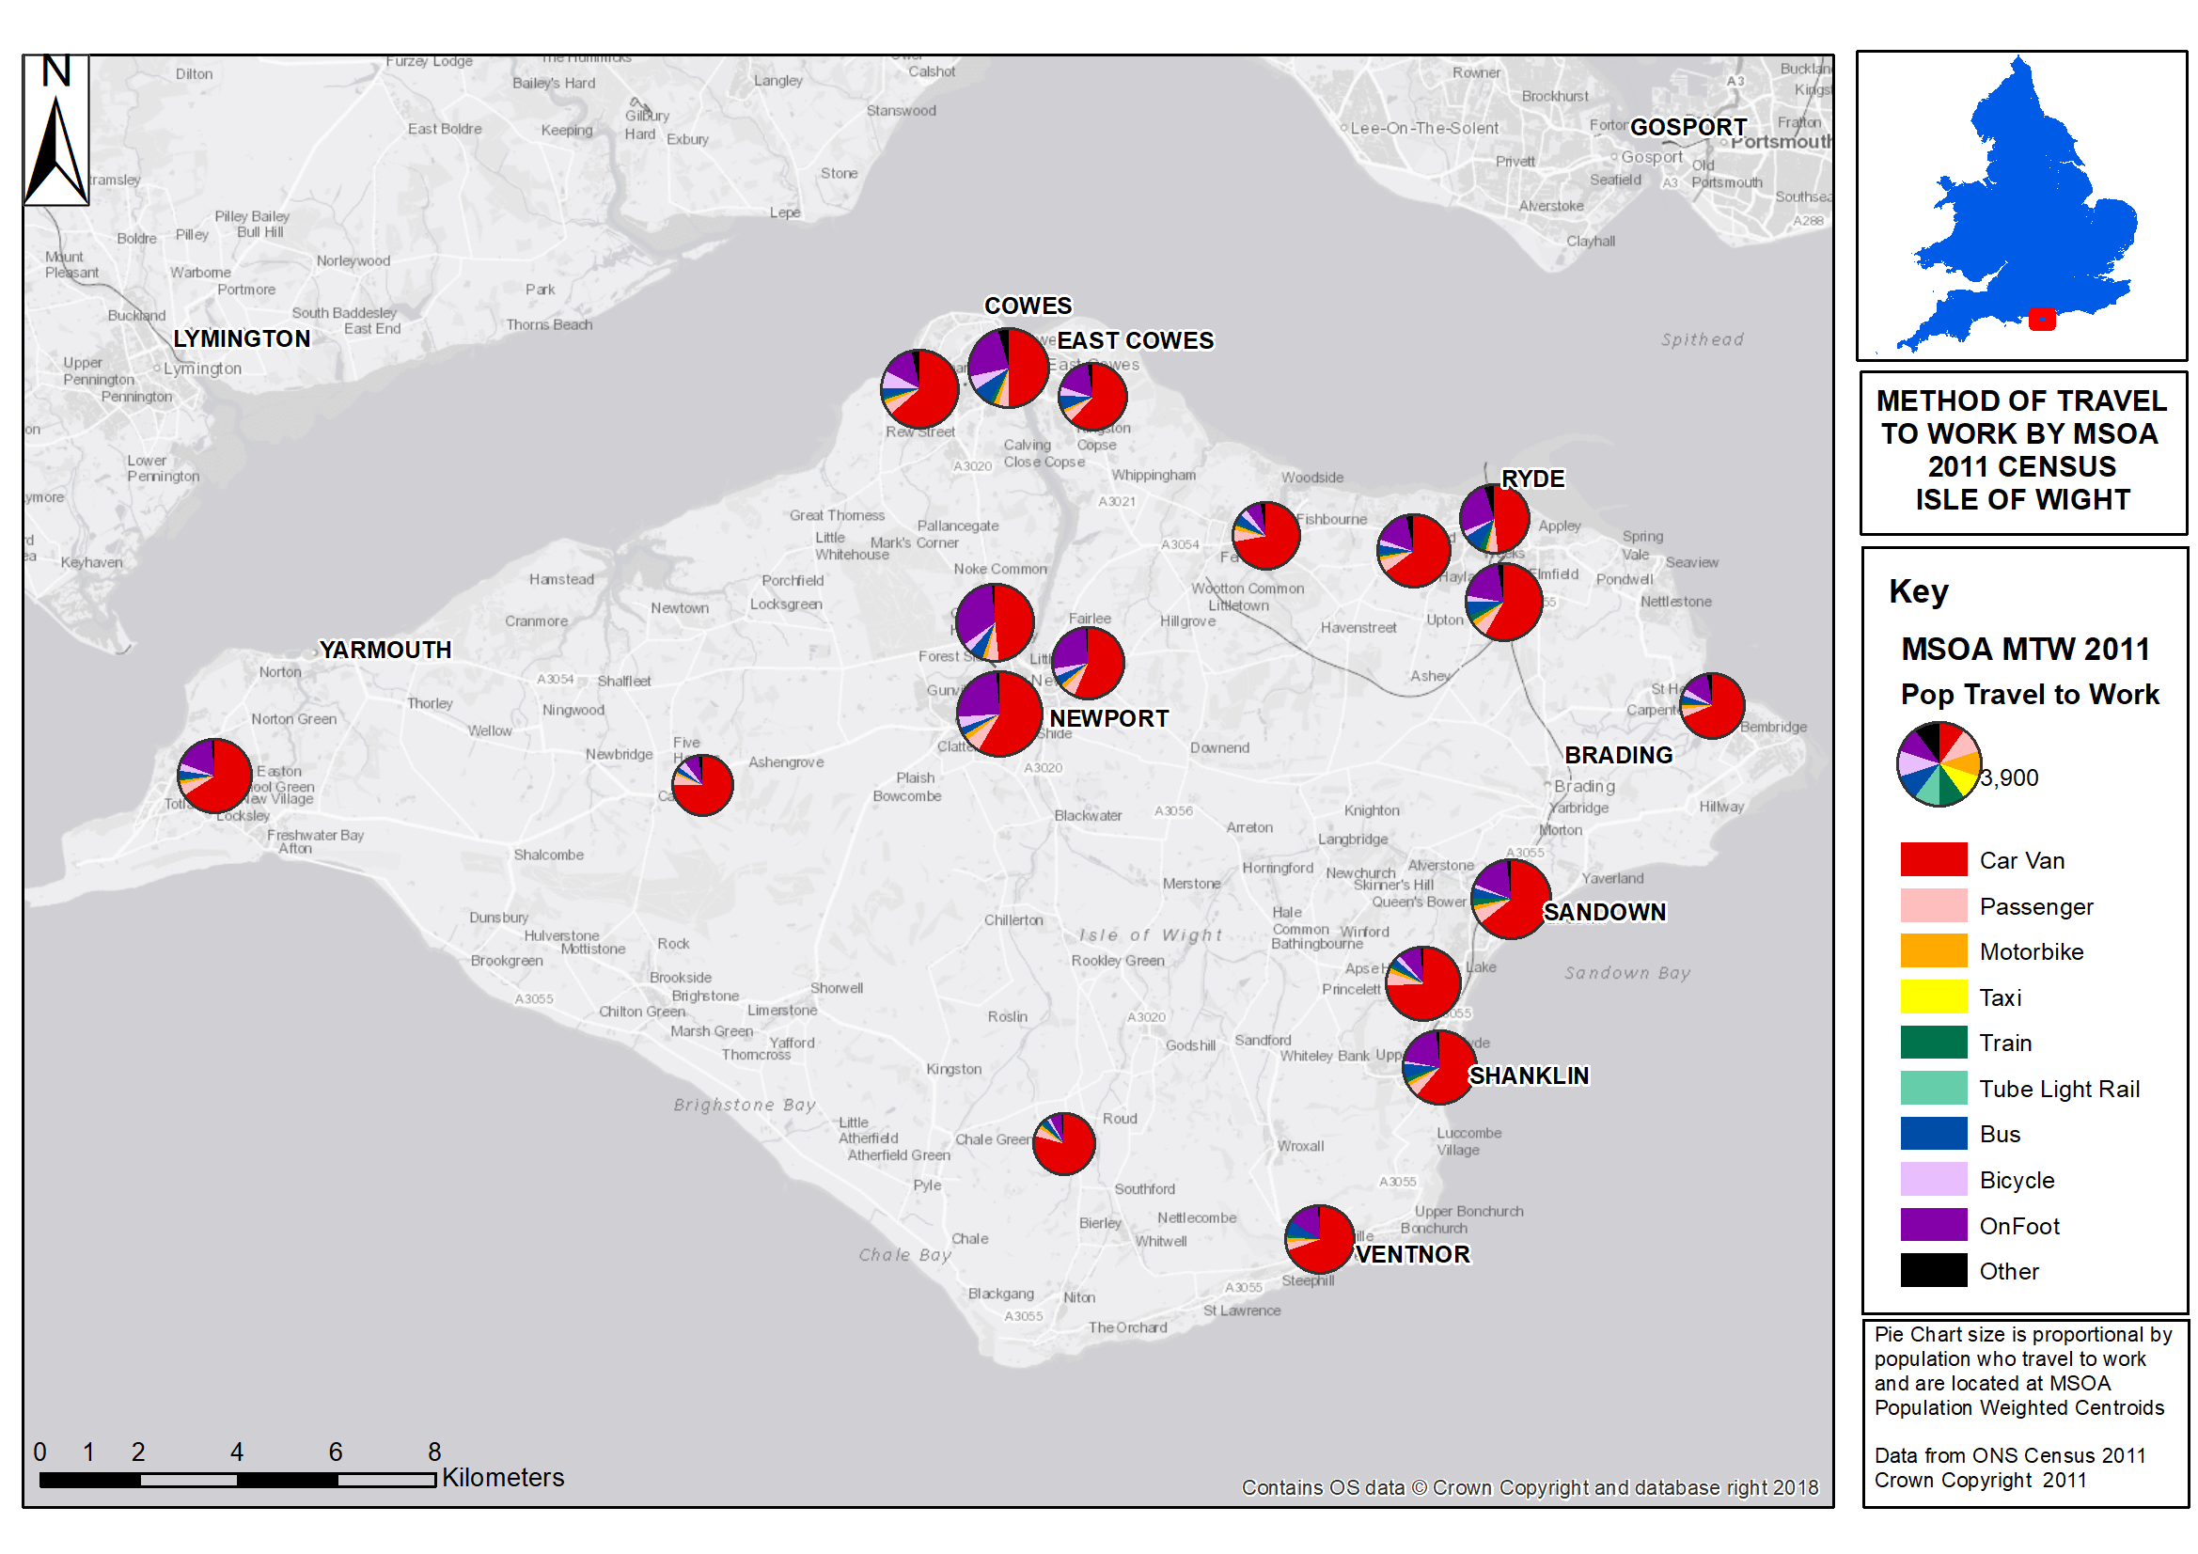

##{r, fig.width=2}out.width = "25%"  
## https://www.zevross.com/blog/2017/06/19/tips-and-tricks-for-working-with-images-and-figures-in-r-markdown-documents/

This is a map using ArcGIS.

Data from: <>,<>,<>. Insert hyperlinks… how to have an alt text appear to hyperlink?

When you click the **Knit** button a document will be generated that includes both content as well as the output of any embedded R code chunks within the document. You can embed an R code chunk like this:

summary(cars)

## speed dist   
## Min. : 4.0 Min. : 2.00   
## 1st Qu.:12.0 1st Qu.: 26.00   
## Median :15.0 Median : 36.00   
## Mean :15.4 Mean : 42.98   
## 3rd Qu.:19.0 3rd Qu.: 56.00   
## Max. :25.0 Max. :120.00

## Including Plots

You can also embed plots, for example:



Note that the echo = FALSE parameter was added to the code chunk to prevent printing of the R code that generated the plot.