Reference Guide

RAIL / ROAD INTERFACE

**V 1.2 (July 2023)**

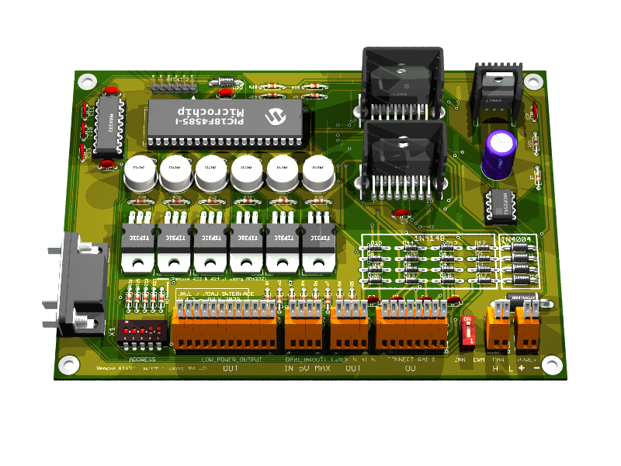

Written by: Philippe Cavenel

17 July 2023 Last update January, 5 2024

Documentation Version 1.6

Content

Content 1

Illustrations 3

1 Preamble 4

1.1 History 4

1.2 Abbreviations 4

1.3 Typographic convention 4

2 Disclaimer 5

3 Introduction 6

3.1 Document purpose 6

Why this document? 6

Document content 6

Warning 6

3.2 Technical References 7

Eagle 6.6.0 7

POV-Ray 3.7 7

MPLAB 8.92 8

PICKIT 2 8

4 Electronic design 10

4.1 Global architecture 10

4.2 Data transfer between boards 11

4.3 Data transfer between master board and PC 12

4.4 Schematic 13

4.5 Pin assignment 18

4.6 Place and route 19

Top view 19

Bottom view 19

Components view 20

3D view 21

4.7 BOM 22

L7805 or DollaTek 5V 1A 22

4.8 Generate the manufacturing files 23

First step: ERC on Eagle 23

Step two: DRC and silkscreen on Eagle 23

Step three: CAM processor on Eagle 23

Fourth stage: Final rendering 23

How to add a 3d model 24

Fifth stage: BOM 25

Sixth step: send files for manufacturing 25

5 Firmware design 26

5.1 Set PIC18F frequency to 32MHz 26

5.2 CAN bus control library 26

Introduction 26

Module Features 26

List of Component Modules 26

Functions 27

CAN Initialization 27

CAN Reception 27

5.3 PWM management in analog mode, DCC management in NMRA digital mode and TM1637 device management 30

5.4 Flash storage of programming information 36

5.5 Automation management 40

5.6 Software design 41

5.7 Protocol on serial link 41

5.8 BNF Grammar 41

5.9 Protocol on CAN bus 42

5.10 Output display and knob controls 44

5.11 Command 45

Programming DCC mode on a board 45

Programming ANA mode on a board 46

Initialize a GPIO as output on a board 47

Initialize a GPIO as input on a board 48

Program an automatic action on a GPIO driven by a timer 49

Program an automatic action on a LPO driven by a timer 50

Program an automatic action on a track driven by a timer 51

Program on a timer driven by a timer 52

Turn On or Off an automation driven by a timer 53

Program an automatic action on a GPIO driven by a change of level on a GPIO 54

Program an automatic action on a LPO driven by a change of level on a GPIO 55

Program an automatic action on a track driven by a level change on a GPIO 56

Program an automatic action on a loco (DCC) driven by a level change on a GPIO 57

Program on a timer driven by a level change on a GPIO 58

Turn on or off an automation by a level change on a GPIO 59

Program an automatic action on a GPIO driven by a change of vehicle presence on a track 60

Program an automatic action on a LPO driven by a change of vehicle presence on a track 61

Program an automatic action on a track driven by a change of vehicle presence on a track 62

Program an automatic action on a loco (DCC) by a change of vehicle presence on a track 63

Program on a timer driven by a change of vehicle presence on a track 64

Turn on or off an automation by a change of vehicle presence on a track 65

Delete an automation on a board 66

Force the value on a GPIO on a board 67

Create a timer on a board 68

Force the value on a LPO on a board 69

Turn on an automation on a board 70

Turn off an automation on a board 71

Force speed and direction on a track 72

Send a DCC command to a board 73

Request the status of all the GPIOs on a board 74

Request the status of all the LPOs on a board 75

Request track status on a board 76

Request board status 77

Request the list of actions programmed on a board 78

Request a dump of memory on a board 79

5.12 Global command 80

Stop all 80

Run all 80

Run a specific board 80

Reset all automation of a specific board 80

Inconsistent programming 81

Illustrations

Figure 1 PICkit 2 Programmer Connector pinout 9

Figure 2 PWM Mode 10

Figure 3 DCC NMRA mode 10

Figure 4 Master/slave board operating diagram 11

Figure 5 CAN bus wiring diagram 12

Figure 6 Transceiver MCP2551 wiring diagram 12

Figure 7 (Proposed by Kyle Thomson Revised 8/18/2009) 12

Figure 8 5V power supply with standard 7805 13

Figure 9 CAN and RS232 interface 13

Figure 10 Master or Slave board 14

Figure 11Power boost 14

Figure 12 vehicle presence detection 15

Figure 13 Top, Pads, Vias 19

Figure 14 Bottom, Pads, Vias 19

Figure 15 Pads, Vias, tPlace, tValues 20

Figure 16 Top View (800 x 600) 21

Figure 17 Bottom View (800 x 600) 21

# Preamble

## History

|  |  |  |
| --- | --- | --- |
| **History** | **Change** | **Date** |
| Version 1.0 | Creation | 18/May/2021 |
| Version 1.1 | New PCB design | 18/May/2023 |
| Version 1.2 | Replace H-bridge transistors with L298s | 22/July/2023 |

## Abbreviations

**DCC**: Digital Command Control (defined by a NMRA standard)

**NMRA**: National Model Railroad Association

**AMS**: Auto Motor Sport (Faller)

**HO**: Half-O (model railway scale corresponding to 1:87)

**DIY**: Do It Yourself

**PC**: Personal Computer

**USB**: Universal Serial Bus

**FTDI**: Future Technology Devices International

**CAN** (bus): Controller Area Network

**TTL**: Transistor-Transistor logic

**GPI** : Global Purpose Input-Output

**LED**: Light-Emitting Diode

**PWM**: Pulse Width Modulation

**EMC**: ElectroMagnetic Compatibility

**STL:** STereo-Lithography

**STEP**: STandard for the Exchange of Product model data

**DRC**: Design Rule Check

**ERC**: Electrical Rule Check

## Typographic convention

The file names are in Courier New format, for example RailDriverCamJob.cam file

The online order examples or file contents are in bold **Courier New** on a grey background, for example

**stl2pov.exe myModel.stl > myModel.inc.**

**Warning is in bold red inside a frame**

Binary names are in bolt like for example **stl2pov.exe**

# Disclaimer



The information contained in this document has been obtained from sources believed to be reliable. However, it may contain technical inaccuracies or typographical errors.

The author reserves the right to correct such errors as soon as they are brought to his attention. We strongly recommend that you check the accuracy and relevance of the information provided in this document.

The information contained in this document is subject to change at any time, and may have been updated. In particular, it may have been updated between the time it was downloaded and the time the user takes cognizance of it.

Use of the information contained in this document is at the user's sole risk, and the user assumes full responsibility for any consequences arising therefrom, without any liability or recourse against the author.

**In no event shall the author be liable for any damages whatsoever resulting from the interpretation or use of the information contained herein.**

# Introduction

## Document purpose

### Why this document?

Faller AMS car networks do not have a DCC-type control mode (NMRA standard). This makes it difficult to have several vehicles on the same network. Using diodes, it is possible to operate a maximum of 2 vehicles per track, which is not very many. By creating track sections and vehicle detections per track section, you can have many more vehicles on the track. On the other hand, the realism of these networks is not respected with operating speeds that are too high, and by using PWM-type pulsed current mechanism, a much more realistic effect can be achieved.

As soon as this type of board is developed, it seems interesting to have a universal programmable interface that can also be used to drive a railway network, and thus support DCC mode (NMRA).

### Document content

This document describes the development of a DIY Faller AMS network board for HO rail and road models and the various associated software (Firmware for PIC18F4585 and PC software) developed since 2021.

The board is designed to communicate with a PC via an RS232 serial link (or via a USB connection using an FTDI cable connected to the RS232 connector, available at Amazon: DSD TECH SH-RS232G USB to DB9 Female serial cable Integrated FTDI FT232RL chip) and with each other via a CAN bus.

Each board can drive up to 4 sections in analog or digital DCC mode (NMRA standard) with electric vehicle presence detection, and 6 low-power controls for lighting or small mechanisms (such as turnout controls). Finally, 8 TTL inputs/outputs (GPIOs) 4 are dedicated to vehicle presence detection, and 4 enable the addition of detectors, control LEDs, or the linking of boards to generate automatic control mechanisms (blocking).

Boards cannot individually mix DCC and analog modes, but it is possible to run one board in DCC mode and another in analog mode.

Each board has a 5-bit address (so 31 can be used, i.e. 128 slots for the whole network). The PC interface board called the “master” is set to address 31 by default. Each other boards should have at least the bit 0 or 1 or 2 set to 0.

### Warning

The current 2023 version at the time of writing is V1.2, and this document describes this version.

This board was developed for personal usage and on an old but readily available and quickly mastered environment that can simply be replaced by a tool like KiCad EDA or Altium on more recent computers.

**All technical indications (such as layer numbers in the Eagle tool) therefore refer to these tools (see Technical References below). To simplify use of this documentation, a zip file containing all developments is available for download.**

Finally, the development of a professional version would require the use of SMD components, a minimum EMC and countries compliance study, integration into a great casing, cost analysis, user manual, and targeting of customers for a possible market launch. This is not the purpose of this documentation. This development should be considered as a simple prototype for personal usage.

## Technical References

In order to reduce development costs and simplify board assembly, the entire board is mounted using radial components, and the design was conceived on an available professional version 6.6.0 of Eagle, MPLAB 8.92 and POV-Ray 3.7 running Mac OS High Sierra on a MacBook Pro in early 2011, 2.7 GHz Intel Core I7 with 16 GB DDR3 1333 MHz memory. This computer runs Mac OS and Windows on Parallel desktop V16.5.1. Development environment needs tools on both operating system Mac OS and Windows. Pending the development of a bootloader for the master and slave boards, the firmware is updated using a PICkit™ 2 programmer/debugger (PG164120).

### Eagle 6.6.0

EAGLE contains a schematic editor, for designing circuit diagrams. Schematics are stored in files with .SCH extension, parts are defined in device libraries with .LBR extension. Parts can be placed on many sheets and connected together through ports.

The PCB layout editor stores board files with the extension .BRD. It allows back-annotation to the schematic and auto-routing to automatically connect traces based on the connections defined in the schematic.

EAGLE saves Gerber and PostScript layout files as well as Excellon and Sieb & Meyer drill files. These are standard file formats accepted by PCB fabrication companies, but given EAGLE's typical user base of small design firms and hobbyists, many PCB fabricators and assembly shops also accept EAGLE board files (with extension .BRD) directly to export optimized production files and pick-and-place data themselves.

EAGLE provides a multi-window graphical user interface and menu system for editing, project management and to customize the interface and design parameters. The system can be controlled via mouse, keyboard hotkeys or by entering specific commands at an embedded command line. Keyboard hotkeys can be user defined. Multiple repeating commands can be combined into script files (with file extension .SCR). It is also possible to explore design files utilizing an EAGLE-specific object-oriented programming language (with extension .ULP).

*(source Wikipedia)*

### POV-Ray 3.7

POV-Ray (Persistence of Vision Raytracer), or POV, is a free raytracing software available on a wide variety of platforms (Windows, Mac OS, GNU/Linux, etc.). It was originally based on DKBTrace sources, and to a lesser extent on Polyray.

POV-Ray does not have an integrated graphical interface (3D modeler) like most current synthesis software, but uses scene description scripts, in which all objects, lights, etc. must be described.

Modelers dedicated solely to POV-Ray exist (KPovModeler, Moray, Yet another POV-Ray modeller...), while many others export to the POV-Ray file format. Its file format is ASCII, and the default file extension is ".pov".

This provides basic shapes (spheres, boxes, toroids, etc.) on which Boolean operations can be performed using CSG. It also makes it possible to create volumes or surfaces based on mathematical functions, such as isosurfaces.

Example: function {x*x - F/y*y + z*z} draws a kind of gravity well, with F representing its force.

It is also possible to import objects from other software (such as 3D Studio Max, Poser, etc.), which will be rendered in POV-Ray as an assembly of triangles, as many software programs are compatible, but it is very difficult to export POV-Ray objects to other formats.

POV-Ray can also be used to create animations.

*(source Wikipedia)*

### MPLAB 8.92

MPLAB is a proprietary freeware integrated development environment for the development of embedded applications on PIC microcontrollers, and is developed by Microchip Technology.

MPLAB X is the latest edition of MPLAB, and is developed on the NetBeans platform. MPLAB and MPLAB X support project management, code editing, debugging and programming of Microchip 8-bit PIC and AVR (including ATMEGA) microcontrollers, 16-bit PIC24 microcontrollers, as well as 32-bit SAM (ARM) and PIC32 (MIPS) microcontrollers.

MPLAB is designed to work with MPLAB-certified devices such as the MPLAB ICD 3 and MPLAB REAL ICE, for programming and debugging PIC microcontrollers using a personal computer. PICKit programmers are also supported by MPLAB.

MPLAB X supports automatic code generation with the MPLAB Code Configurator and the MPLAB Harmony Configurator plugins.

*(source Wikipedia)*

### PICKIT 2

The PICkit™ 2 programmer/debugger (PG164120) is a low-cost development tool with a comprehensive interface for programming and debugging microchips or microcontrollers.

Its comprehensive Windows® programming interface supports basic families (PIC10F, PIC12F5xx, PIC16F5xx), mid-range families (PIC12F6xx, PIC16F), controller families **PIC18F**, PIC24, dsPIC30, dsPIC33, and PIC32, 8-bit, 16-bit and 32-bit, and a large number of EEPROM-type serial microchips.

With the powerful Integrated Development Environment (IDE), PICkit™ 2 lets you debug on-circuit directly, on most PIC® microcontrollers. On-circuit debugging runs, pauses, and executes the program step by step, while the microcontroller is integrated into the application. When paused on a breakpoint, file registers can be examined and modified.

*(source* [*https://pickit2.software.informer.com*](https://pickit2.software.informer.com) *)*

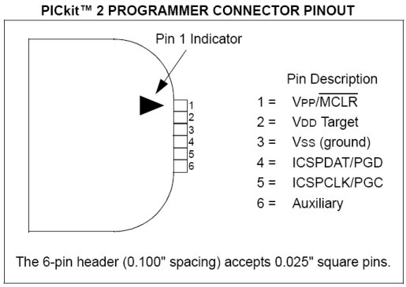

Figure 1 PICkit 2 Programmer Connector pinout

# Electronic design

## Global architecture

The complete system consists of a PC running a rail or road network control application. This may be a fully developed application, or an existing one with a programmable interface driver. The interface between this PC and the control boards is via a 115200 Baud serial bus connected to a board with an RS232 serial interface. Only one of these boards, known as the “Master” board, has this interface.

The master board communicates with the other boards, known as slaves, via a 500K Baud CAN bus. The master board contains an RS232 transmitter (MAX232). By default, this board has address 31 (the address selector on this board must be removed, as well as resistors R23 and R24, giving it the value 31 by hardware setting). Address 31 is therefore forbidden on other boards, as it indicates to the PIC18F the presence of an RS232 transmitter.

If the user inadvertently sets address 31 on a board that does not contain an RS232 transmitter module, the PIC18F will begin by testing the presence on the TX line (RC6/TX/CK, pin 25) of either level 0 (switch bit 4 to 0) or level 1 (switch bit 4 to 1). If either of these levels is detected, address 31 has been selected by mistake, and the PIC18F goes into standby mode until the address is changed.

If two cards have the same address, the overall behavior of the system may be inconsistent, without compromising network security.

Each board is supplied with a power supply between 12 and 24V DC. The optimum supply voltage depends on the type of equipment operating on the network. The maximum theoretical voltage supported is 32V, but such a voltage could destroy the equipment connected to the board. In practice, we advise you not to exceed a supply voltage of 20V especially if you use DCC environment.

Each board can drive 4 PWM or DCC blocks and 6 low-power modules. The boards also feature 8 TTL-level inputs/outputs (not to be used for direct control of a power module).

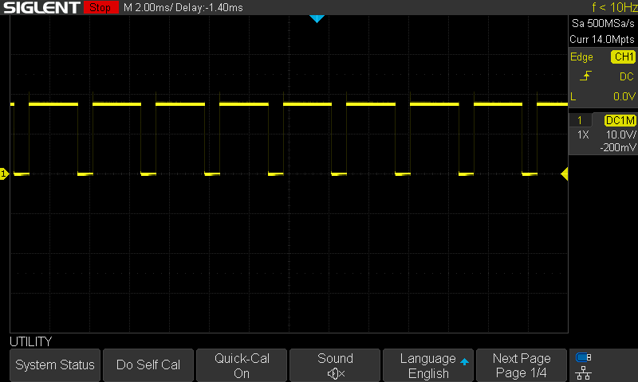

Figure 2 PWM Mode

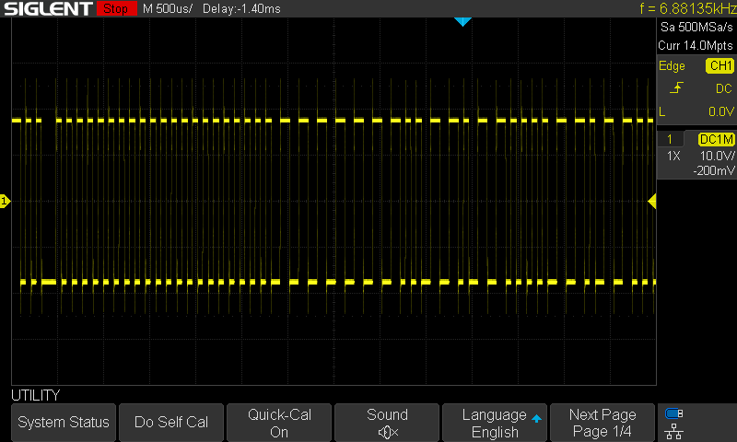

Figure 3 DCC NMRA mode

The system is controlled using a command language sent to the master board via the RS232 serial link. This language has two modes: a programming mode and a control mode.

* In programming mode, it is possible to specify the direction of each board's GPIOS, and to trigger automatic actions on events, e.g. "on detection of a vehicle on block 3 of board 8, feed block 6 of board 5 in the forward direction at speed 10" (speeds are between 0 and 15).
* In control mode, commands can be given, e.g. "feed block 3 of board 2 in the reverse direction at speed 2".

Each event (detection or loss of presence of a vehicle or change of status on a GPIO or TIMER triggered) generates an event which is sent to the other boards on CAN bus.

The commands and language are described in the following chapters.

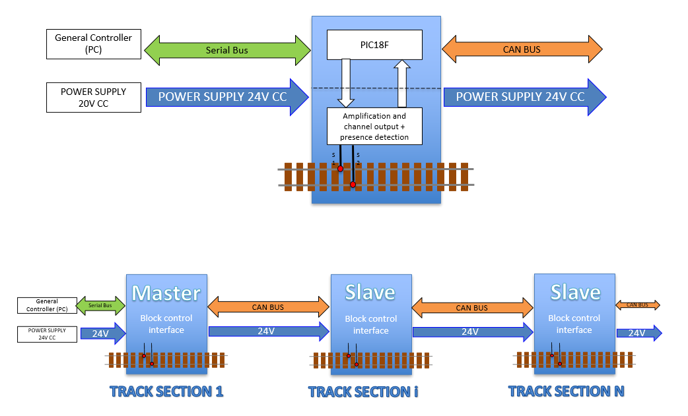

Figure 4 Master/slave board operating diagram

## Data transfer between boards

Data transfer between boards is via a 500 KBaud CAN bus. The boards are connected to the CAN bus.

|  |  |
| --- | --- |
|  | The first and last boards in this network have a switch for connecting a terminating resistor. |

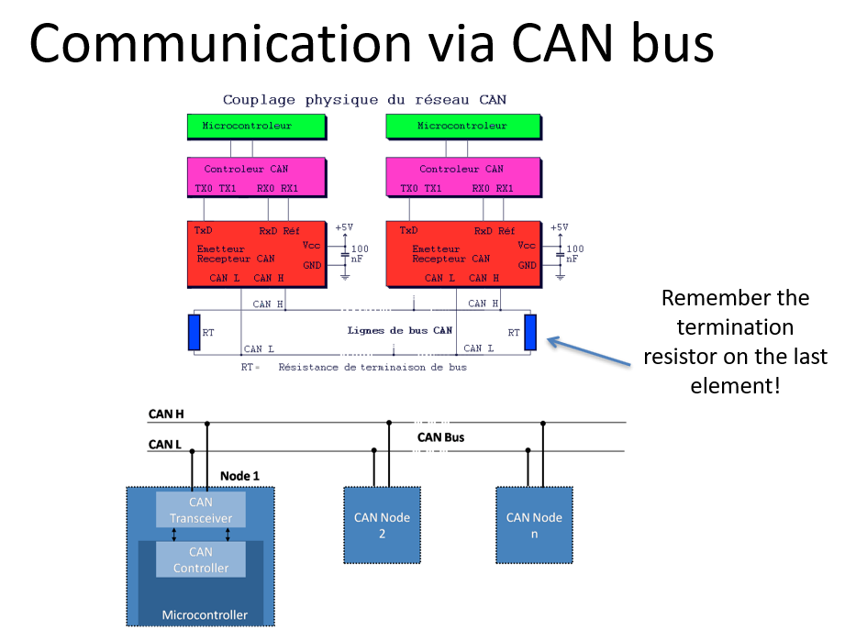

Figure 5 CAN bus wiring diagram

A transceiver MCP2551 is used to link the PIC18F to the CAN bus.

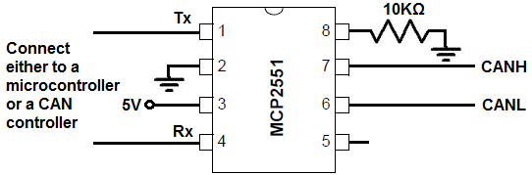

Figure 6 Transceiver MCP2551 wiring diagram

## Data transfer between master board and PC

Data transfer between the master board and the PC is via an RS232 serial bus at 115200 baud. The link to the PC and the PIC18F is done via a MAX232 transmitter, which can be connected to an FTDI RS232/USB cable if the user so wishes.

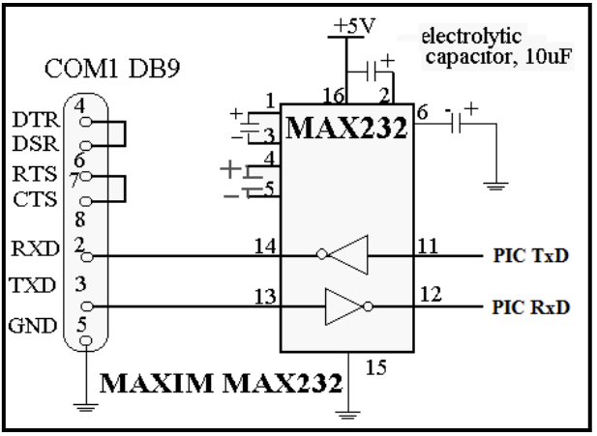

Figure 7 (Proposed by Kyle Thomson Revised 8/18/2009)

## Schematic

The schematic consists of two parts:

* The first contains the 5V power supply (Note the STTH5L06RL inversion protection diode on this power supply). The L7805 could be replaced by a DollaTek 5V 1A regulated board, more robust.(https://www.amazon.fr/DollaTek-r%C3%A9gulateur-bornes-lentr%C3%A9e-LM7805/dp/B081JMJZG6)

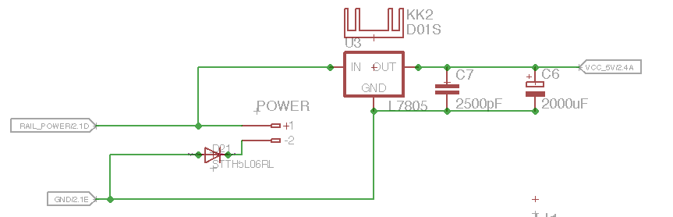

Figure 8 5V power supply with standard 7805

* The RS232 and CAN bus transmitters and transceivers, the programming connector for the PIC18F and the board address selector.

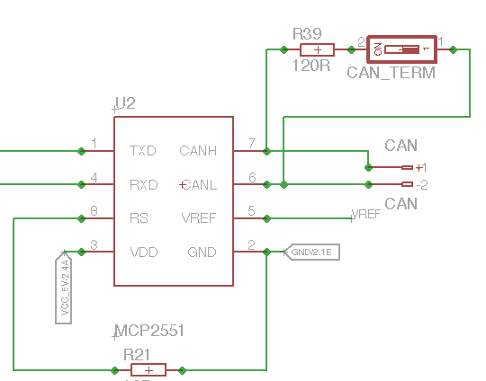 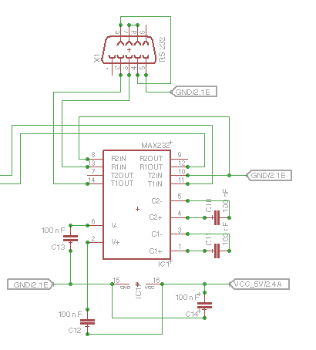

Figure 9 CAN and RS232 interface

* This assembly enables the master and slave boards to be wired on the same design. For the master board, solder the RS232 DB9 connector, the MAX232 transmitter and remove resistors R23 and R24 as well as the address selector. For the slave board, do not solder the RS232 DB9 connector, nor the MAX232 transmitter.

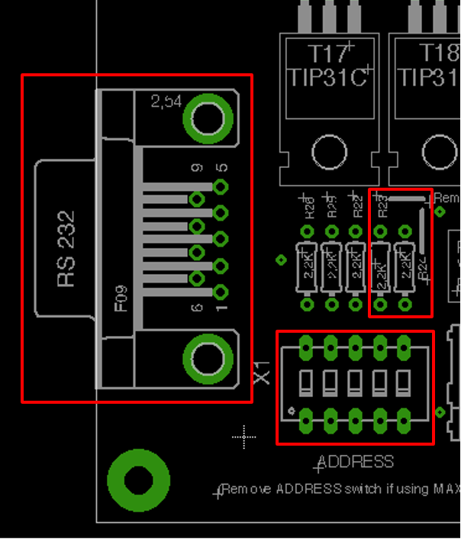 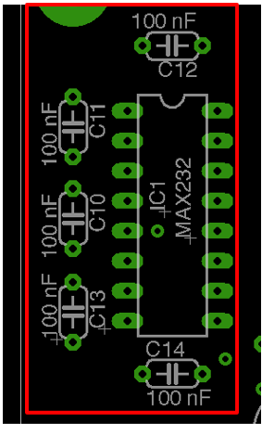

Figure 10 Master or Slave board

* The second contains the L298 power drivers and the 6 TIP31C transistors in Darlington circuit controlled by the PIC18F, as well as the power outputs to the rail or road network.

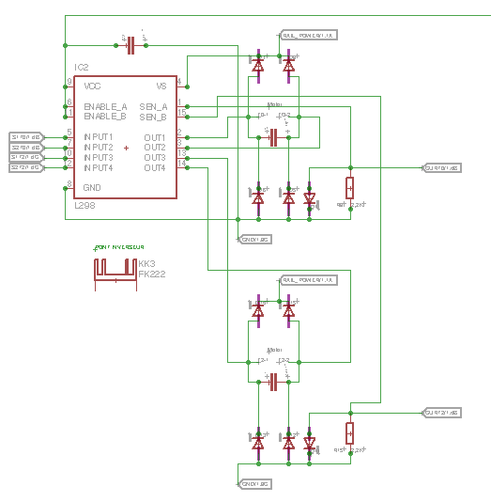 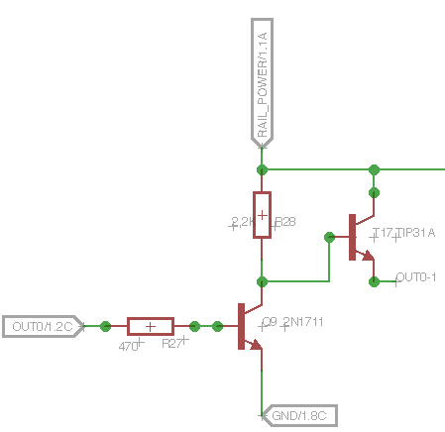

Figure 11Power boost

* Note that it is essential to place decoupling capacitors as close as possible to the components on the 5V supply, otherwise there is a risk of catastrophic loss of control due to PIC18F shutdown. These decoupling capacitors are 100nF on the 5V supply and 2500pF on the power outputs of the tracks to be supplied.
* Vehicle presence is detected by measuring the voltage across a diode at the output of the L298. When no load is present, a voltage close to 0V is measured at the terminal of a 2K2 resistor connected to ground, whereas when a load is present, the connection to ground is made via the 1N4004 diode, whose 0.7V bias voltage is then detected by the PIC18F.

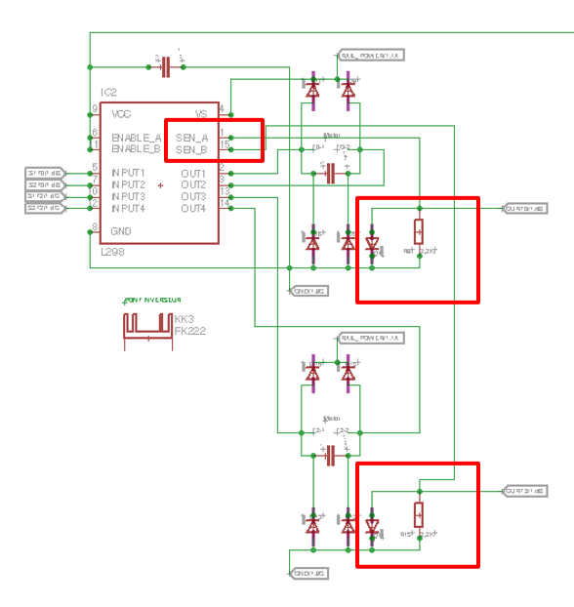

Figure 12 vehicle presence detection

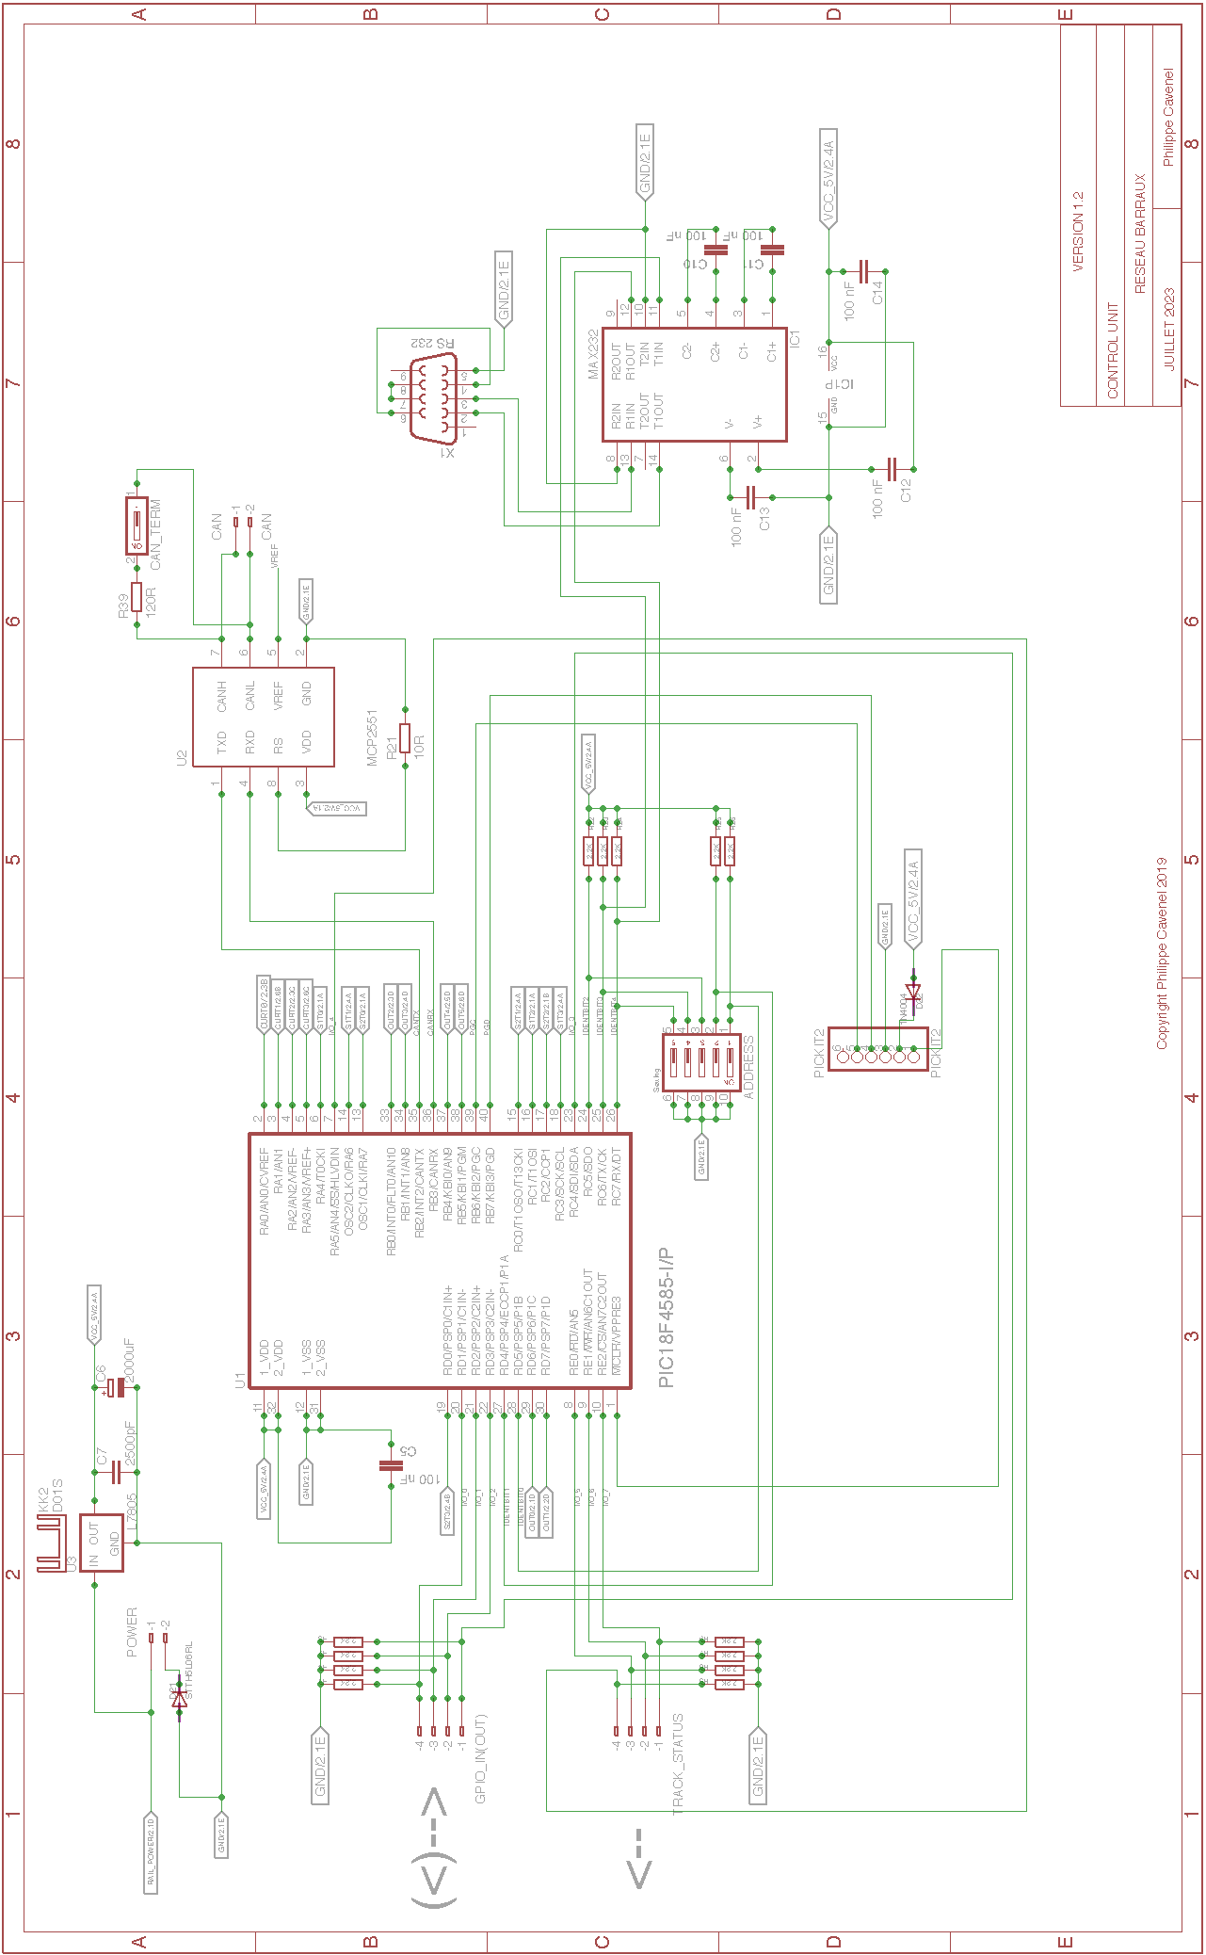

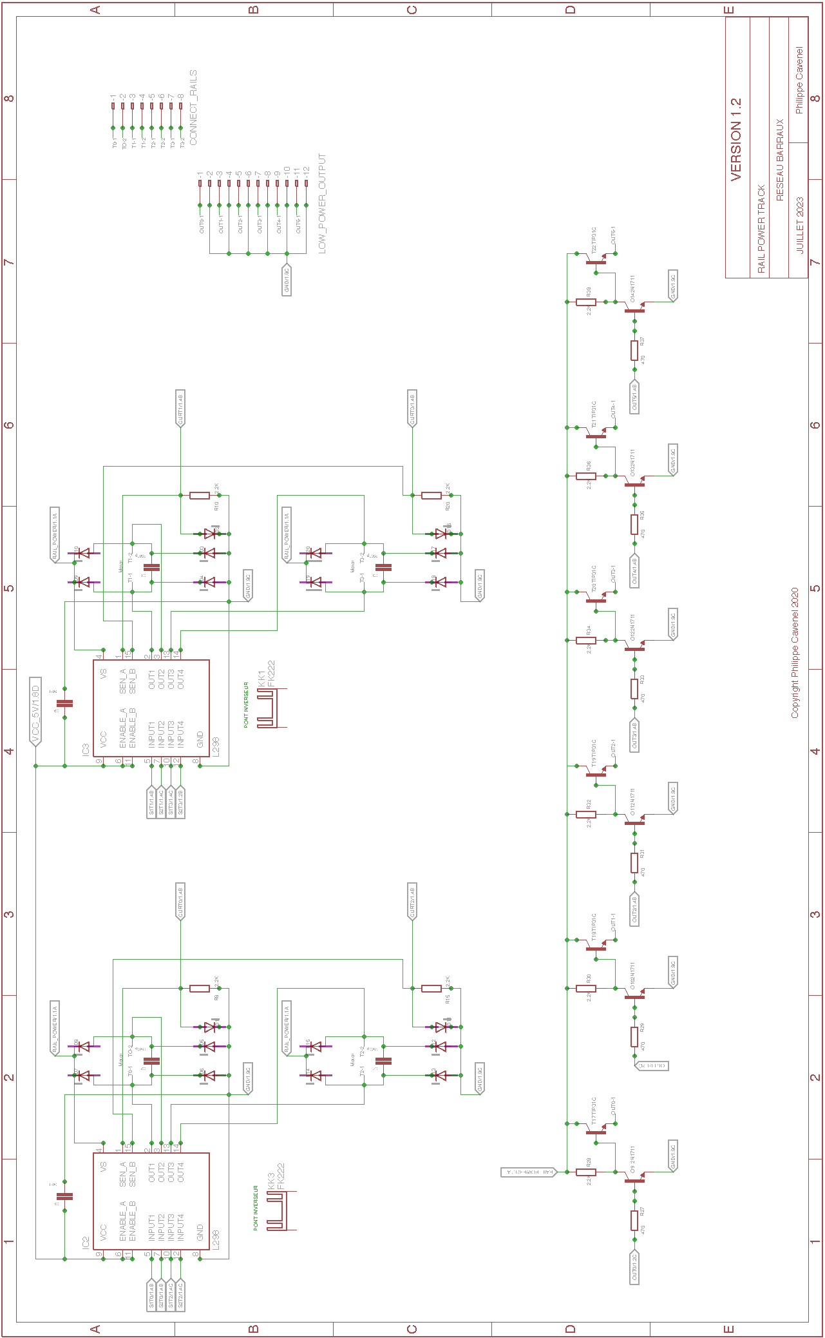

## Pin assignment

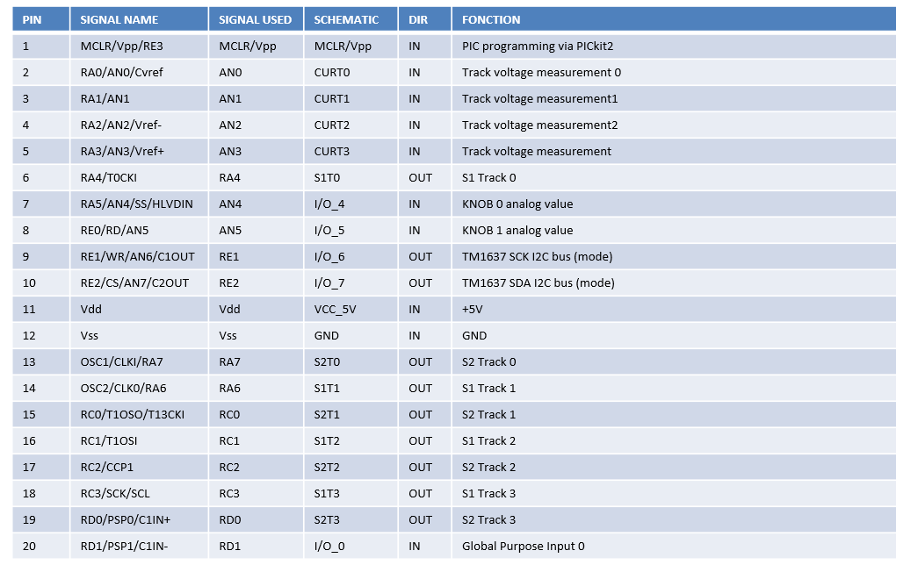

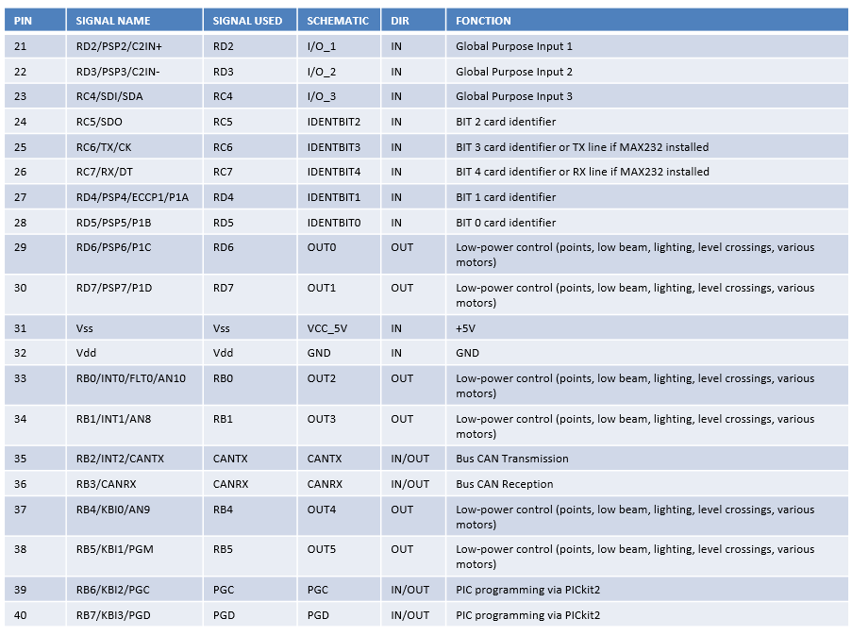

## Place and route

Components are placed as close as possible to each other to limit the distance between related components, especially for decoupling capabilities. Routing is performed automatically.

### Top view

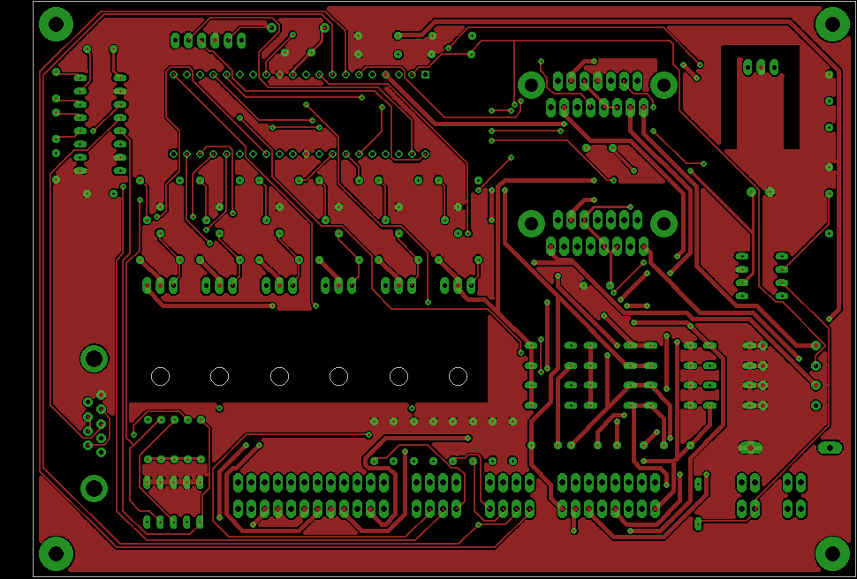

Figure 13 Top, Pads, Vias

### Bottom view

Figure 14 Bottom, Pads, Vias

### Components view

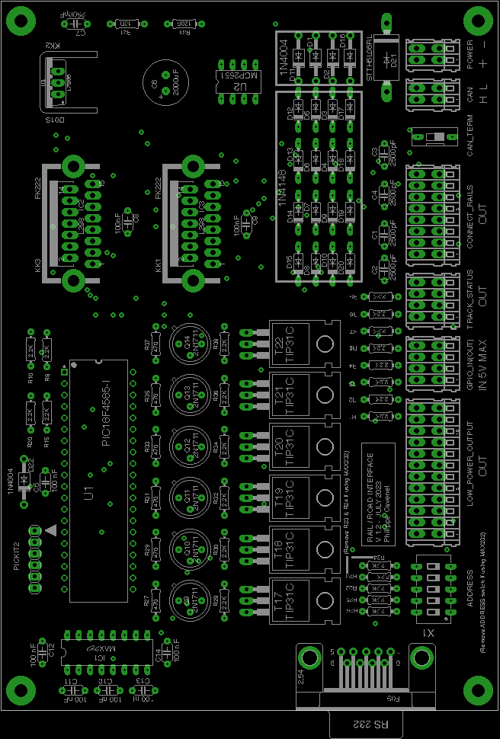

Figure 15 Pads, Vias, tPlace, tValues

### 3D view



Figure 16 Top View (800 x 600)

Figure 17 Bottom View (800 x 600)

## BOM

|  |  |  |  |
| --- | --- | --- | --- |
| **Qty** | **VALUE** | **DESCRIPTION** | **Farnell** |
| 1 | Connecteurs D-Sub standards AMPL PLUG HD20, R/A 9P, B/L,4-40 INS | X1 | 2857982 |
| 8 | 100nF | C5, C8, C9, C10, C11, C12, C13, C14 | 2309064 |
| 1 | MAX 232N | IC1 | 3121260 |
| 1 | 2000uF | C6 | 2766923 |
| 1 | 10R | R21 | 2329993 |
| 1 | 120R | R39 | 2329862 |
| 16 | 1N4148 | D3, D4, D5, D6, D7, D8, D9, D10, D12, D13, D14, D15, D17, D18, D19, D20 | 9843680 |
| 5 | 1N4004 | D22, D1, D11, D2, D16 | 1843708 |
| 1 | STTH5L06RL | D21 | 2353682 |
| 23 | 2,2K | R1, R2, R3, R4, R5, R6, R7, R8, R9, R10, R15, R20, R22, R23, R24, R25, R26, R28, R30, R32, R34, R36, R38 | 9341536 |
| 5 | 2500pF | C1, C2, C3, C4, C7 | 2860175 |
| 6 | 2N1711 | Q9, Q10, Q11, Q12, Q13, Q14 | 1611558 |
| 6 | 470 | R27, R29, R31, R33, R35, R37 | 3496822 |
| 1 | Commutateur DIP / SIP, 5 Circuit(s), Glissière, Traversant, SPST, 24 VDC, 100 mA | ADDRESS | 3397711 |
| 1 | Bornier x2 | CAN | 1777096 |
| 1 | Bornier x2 | POWER | 1777096 |
| 1 | Commutateur DIP / SIP, 1 Circuit | CAN TERMINATOR | 1960919 |
| 1 | Bornier x12 | LOW_POWER_OUTPUT | 1777102 |
| 1 | Bornier x8 | CONNECT_RAILS | 1777101 |
| 2 | Bornier x4 | TRACK_STATUS, GPIO_IN(OUT) | 1777098 |
| 1 | L7805 or DollaTek 5V 1A | U3 | 1467758 |
| 1 | MCP2551P | U2 | 1439745 |
| 1 | PIC18F4585-I | U1 | 1439547 |
| 1 | PICKIT2 | PICKIT2 | 1187827 |
| 6 | TIP31C | T17, T18, T19, T20, T21, T22 | 9804145 |
| 2 | L298N | IC2, IC3 | 403295 |
| 2 | FK222 | KK1, KK3 | 4621281 |
| 1 | 274-1AB | KK2 | 1611445 |

## Generate the manufacturing files

### First step: ERC on Eagle

* Generate schematic and validate circuit with ERC
* Pay particular attention to net class, especially for the power section (larger surface area required)

### Step two: DRC and silkscreen on Eagle

* Component placement and automatic routing.
* To fill the top and bottom polygons, draw a polygon around the map, selecting the right layer (Top or Bottom) in the top left-hand corner after routing (otherwise automatic routing won't work), then restart routing.
* Validate with a DRC, selecting only the Top, Bottom, Via and Pad layers.
* Finalize silkscreen (layer 21) by placing all indications correctly, then generate drill legend on layer 144 by launching the ULP icon in the layout screen of Eagle on drillegend-stack.ulp

### Step three: CAM processor on Eagle

* Generate the files for CAM Processor production by clicking on the CAM_JOB/RailDriverCamJob.cam file.
* In the top-left File menu, select the .brd file for the corresponding design.
* The directories and file names must be correct in the various tabs (check and correct if necessary).
* All that's left to do is run PROCESS JOB to produce the files.

### Fourth stage: Final rendering

* To modify the selection of unknown boxes, modify the 3D_RENDERING/eagle3d/ulp/3dusrpac.dat file.
* Update the configuration files directory in 3dconf.dat
* Generate a 3D rendering of the design by launching the ULP icon in the layout screen of Eagle on 3D_RENDERING/eagle3d/ulp/3d50.ulp
* Specify the .brd file, which will generate a .pov file that can be processed by POV-Ray to obtain the 3D rendering.
* Select "User-defined model" in the General tab
* Add layer 25 in Miscellaneous Case Design
* Modify Writing on plate to display layers 21 and 25 only.
* Add layers 25 and 27 in Case Reference
* Click on Create POVRay file and Exit.
* Copy the generated EAGLE_FILES/RailDriver/RailDriver.pov file into 3D_RENDERING/eagle3d/povray
* Repeat the same operation, moving the camera to shoot from below (using Y) and/or from the other sides (using X and Z).
* Click on the 3D_RENDERING/eagle3d/povray/RailDriver.pov file to start building the 3D view with POV-Ray (automatic launch on Windows). Use 800 x 600 AA 0.3 for a reasonable image creation time, or 1600 x 1200 A 0.3 for a better resolution, but the image creation time will take several tens of minutes (On old PC).
* In Eagle, make a screen copy of the various layers built during the construction of the manufacturing files. Place all views in a PNGVIEW directory

### How to add a 3d model

* Retrieve the model in STL format from the net (snapeda for example on <https://www.snapeda.com/> ). If the model is in STEP format, it must first be converted to STL, you can do that for example at on https://polyd.com/fr/convertir-step-en-stl-en-ligne
* Use the **stl2pov.exe** utility (launch a Windows shell)

**stl2pov.exe myModel.stl > myModel.inc.**

* Copy it to 3D_RENDERING/eagle3d/povray. For example:

**stl2pov.exe "TO220HeatSink\TO220_Heatsink.stp">"TO220HeatSink\TO220HeatSink.inc"**

* Modify the myModel.inc file so that it is understood by POV-Ray, taking as an example fk_222_sa.inc
* Add the following include to the 3D_RENDERING/eagle3d/povray/e3d_user.inc file:

**#include "myModel.inc".**

* Add the following information to the 3D_RENDERING/eagle3d/ulp/3dusrpac.dat file:

**MYMODEL:0:1:0:0:0:0:0:0:0:0:0:0:0:0:0:0:0:0:0:0:0:0:0:0:0:0:0:0:0:0: MYMODEL (:MYMODEL_GRND**

|  |  |
| --- | --- |
| [00] Eagle component package name  [01] Output name  [02] Output value  [03] Define color bands  [04] SMD offset (parts will be moved pcb_cuhight up/down)  [05] LED options (LED options dialog box will be displayed)  [06] Ready for sockets (see explanation)  [07] Quartz height request  [08] A part of a macro (e.g. SMD jumpers)  [09] SMD resistor, generates a combination of numbers  [10] Socket macro  [11] Socket height in 1/10mm  [12] Comments on socket  [13] Internal for administration (not currently used) | [14] Y-axis rotation correction  [15] Correction offset x  [16] Offset correction y  [17] Correction offset z  [18] Use Prefix from Part?  [19] Shunt on pin header (a dialog box will be displayed)  [20] Logo selection dialog box is displayed  [21] Reserved  [29] Minimum encircling box  [30] Maximum bounding box  [31] POV-Ray macro (Name of pov macro and left parenthesis)  [32] Package comments (German)  [33] Package comments (English) |

### Fifth stage: BOM

* Update the BOM to purchase components on Farnell or Mouser or other dealers on the net.

### Sixth step: send files for manufacturing

* Compress CAM_JOB and PNGVIEW directories to start manufacturing on a PCB manufacturing site such as AllPcb: <https://www.allpcb.com/> or other manufacturer on the net.

# Firmware design

## Set PIC18F frequency to 32MHz

**OSCCON = 0x70; //** **no pre-divider => 8MHz // comment to set 8MHz**

**OSCTUNE = 0x40; //activate PLL *4 => 32MHz // comment to set 8MHz**

## CAN bus control library

### Introduction

This document describes programming interface to ECAN (Enhanced Controller Area Network) module. At the time of writing this document, only PIC18F8680/6680 family of microcontroller contained ECAN module. This module provides access to ECAN module in polling fashion. This module is completely written in ‘C’ language. It provides many customization options that may result in significant code reduction. To utilize this module, one must understand all options offered by ECAN module. This module is also available in Microchip Application Note AN878.

*(source ECANPoll.ReadMe file)*

### Module Features

* Out-of-box support for Microchip C18 and HI-TECH PICC-18TM C compilers
* Offers simple abstract interface to ECAN module for most applications
* Additional functions/macros are available for advanced applications
* Supports all three functional modes
* Provides access to all ECAN features in Polling mode
* Easily modifiable to Interrupt-driven mode
* Operates in two main modes:
* Run-time Library Mode and Fixed Library Mode
* Various compile-time options to customization routines to a specific application
* Also available as Microchip Application Note AN878

*(source ECANPoll.ReadMe file)*

### List of Component Modules

|  |  |
| --- | --- |
| ECAN.ex.txt | This is main test file developed to demonstrate use of the library functions. |
| ECANPoll.c | This is ECAN code implementation file. One needs to include this file in their project. |
| ECANPoll.h | This file contains prototypes of functions and macros. One needs to include this file in every source file where ECAN functions will be called. |
| ECANPoll.def | This file contains all compile-time options for ECAN module. If you are using Maestro, this file will be created as per your option selections. This file is automatically included by ECANPoll.h file. |

### Functions

Refer to the ECANPoll.ReadMe file

### CAN Initialization

In order to improve performance, data reception is interrupted.

**// ECAN**

**TRISBbits.TRISB3 = 1; // CANRX input setting**

**gl_InputBufferPointer=0;**

**gl_getDataCANPointer=0;**

**gl_canMode=CAN_UNKNOWN;**

**ECANInitialize(); // init ECAN**

**PIE3bits.RXB0IE=1; // enable interrupt for CAN**

**PIE3bits.RXB1IE=1; // enable interrupt for CAN**

### CAN Reception

Can reception is shared with RS232 reception:

**/****************************************************************************/**

**/* high_isr */**

**/****************************************************************************/**

**#pragma interrupt high_isr**

**void high_isr(void){**

**BYTE dataLen; // Number of bytes transmitted in the message**

**ECAN_RX_MSG_FLAGS flags; // Flags**

**unsigned long id; // Id of sender**

**if(PIR3bits.RXB0IF ||PIR3bits.RXB1IF) {**

**while(ECANReceiveMessage(&id, &gl_inputBuffer[gl_InputBufferPointer], &dataLen, &flags)) {**

**gl_InputBufferPointer+=dataLen;**

**if(gl_InputBufferPointer>=MAXTRAMESIZE)gl_InputBufferPointer-=MAXTRAMESIZE;**

**}**

**gl_synchroSend=(gl_boardNumber+1)*SYNCHROSENDDELAY;**

**}**

**if (gl_master==FALSE)return;**

**// Check if interrupt originates from USART reception**

**if (PIR1bits.RCIF)**

**{**

**// Read received data**

**gl_receivedUSARTData[gl_receivedUSARTPointer++] = RCREG;**

**if (gl_receivedUSARTPointer>=USARTBUFFERSIZE)gl_receivedUSARTPointer=0;**

**}**

**}**

**#pragma code**

Can transmission is performed either by the user_putc() function when an ASCII message is to be sent to the master, or by a specific CAN routine to send compressed data.

**/*****************************************************************************/**

**/* CANsendDelay*/**

**/*****************************************************************************/**

**void CANsendDelay() {**

**unsigned short delay;**

**for(delay=0;delay<WAITDELAYTRAMECAN;delay++);**

**}**

**/*****************************************************************************/**

**/* _user_putc*/**

**/*****************************************************************************/**

**int _user_putc (char c) {**

**unsigned long id; // Id of sender**

**unsigned char dataOut[8]; // DATA to CAN**

**unsigned char dataCounter;**

**unsigned char dataOutCounter;**

**unsigned char trameComplete;**

**BYTE dataLen; // Number of bytes transmitted in the gl_message**

**ECAN_RX_MSG_FLAGS flags; // Flags**

**// On master board send to UART via standart putc()**

**if (gl_master==TRUE){**

**if (gl_inputCounter==0)sendUSART(c);**

**}**

**else {**

**if (gl_outputBufferCounter<MAXMESSAGESIZE)gl_outputBuffer[gl_outputBufferCounter++]=c;**

**// Send on CAN bus**

**if (gl_outputBufferCounter==MAXMESSAGESIZE || c==ENDOFPRINTFTRAME) {**

**dataLen=8;**

**flags=ECAN_TX_STD_FRAME;**

**id=gl_boardNumber;**

**// header trame**

**for(dataOutCounter=0;dataOutCounter<8;dataOutCounter++) dataOut[dataOutCounter]=TRAMEPRINTHEADER;**

**// Synchro send**

**while(gl_synchroSend >0);**

**while(!ECANSendMessage(id,dataOut,dataLen,flags));**

**CANsendDelay();**

**// trame**

**trameComplete=FALSE;**

**dataCounter=0;**

**while(dataCounter<MAXMESSAGESIZE) {**

**for(dataOutCounter=0;dataOutCounter<8;dataOutCounter++) {**

**if (dataCounter<gl_outputBufferCounter) {**

**dataOut[dataOutCounter]=gl_outputBuffer[dataCounter++];**

**if (dataOut[dataOutCounter]==ENDOFPRINTFTRAME) trameComplete=TRUE;**

**}**

**else {**

**dataOut[dataOutCounter]=ENDOFPRINTFTRAME;**

**if (dataCounter<MAXMESSAGESIZE)dataCounter++;**

**trameComplete=TRUE;**

**}**

**}**

**while(!ECANSendMessage(id,dataOut,dataLen,flags));**

**CANsendDelay();**

**if (trameComplete==TRUE) break;**

**}**

**gl_outputBufferCounter=0;**

**// footer trame**

**for(dataOutCounter=0;dataOutCounter<8;dataOutCounter++) dataOut[dataOutCounter]=TRAMEPRINTFOOTER;**

**while(!ECANSendMessage(id,dataOut,dataLen,flags));**

**CANsendDelay();**

**}**

**}**

**return(c);**

**}**

**/*****************************************************************************/**

**/* sendRequestToCAN() */**

**/*****************************************************************************/**

**void sendRequestToCAN(unsigned char* request) {**

**unsigned long id; // Id of sender**

**unsigned char dataOut[8]; // DATA to CAN**

**unsigned char dataCounter;**

**unsigned char dataOutCounter;**

**BYTE dataLen; // Number of bytes transmitted in the gl_message**

**ECAN_RX_MSG_FLAGS flags; // Flags**

**unsigned char trameSize;**

**// Convert request to dataOut using gl_dataStructure**

**trameSize=compressData(request);**

**dataLen=8;**

**flags=ECAN_TX_STD_FRAME;**

**dataCounter=0;**

**id=gl_boardNumber;**

**// header trame**

**for(dataOutCounter=0;dataOutCounter<8;dataOutCounter++) {**

**dataOut[dataOutCounter]=TRAMEREQUESTHEADER;**

**}**

**// Synchro send**

**while(gl_synchroSend >0);**

**CANsendDelay(); // Delay to avoid sending to fast after receiving a trame**

**while(!ECANSendMessage(id,dataOut,dataLen,flags));**

**CANsendDelay();**

**// trame**

**while(dataCounter<trameSize) {**

**for(dataOutCounter=0;dataOutCounter<8;dataOutCounter++) {**

**if (dataCounter<trameSize) {**

**dataOut[dataOutCounter]=request[dataCounter++];**

**if(dataCounter>=MAXTRAMESIZE) return; // Something wrong happened**

**}**

**else {**

**dataOut[dataOutCounter]=0;**

**}**

**}**

**while(!ECANSendMessage(id,dataOut,dataLen,flags));**

**CANsendDelay();**

**}**

**// footer trame**

**for(dataOutCounter=0;dataOutCounter<8;dataOutCounter++) {**

**dataOut[dataOutCounter]=TRAMEREQUESTFOOTER;**

**}**

**while(!ECANSendMessage(id,dataOut,dataLen,flags));**

**uncompressData(request); // get back to initial data for other action in manageRequest()**

**}**

**/*****************************************************************************/**

**/* getInputRequestFromCAN() */**

**/*****************************************************************************/**

**unsigned char getInputRequestFromCAN(unsigned char* request) {**

**unsigned char requestHeaderTrameDetected=0;**

**unsigned char printHeaderTrameDetected=0;**

**unsigned char requestFooterTrameDetected=0;**

**unsigned char printFooterTrameDetected=0;**

**char requestTrameEnd;**

**char printTrameEnd;**

**unsigned char dataInCounter;**

**unsigned char dataStructureCounter;**

**sprintf(gl_message,"");**

**while (gl_getDataCANPointer!=gl_InputBufferPointer) {**

**if (gl_inputBuffer[gl_getDataCANPointer]==TRAMEREQUESTHEADER) requestHeaderTrameDetected++; else requestHeaderTrameDetected=0;**

**if (gl_inputBuffer[gl_getDataCANPointer]==TRAMEREQUESTFOOTER) requestFooterTrameDetected++; else requestFooterTrameDetected=0;**

**if (gl_inputBuffer[gl_getDataCANPointer]==TRAMEPRINTHEADER) printHeaderTrameDetected++; else printHeaderTrameDetected=0;**

**if (gl_inputBuffer[gl_getDataCANPointer]==TRAMEPRINTFOOTER) printFooterTrameDetected++; else printFooterTrameDetected=0;**

**// REQUEST HEADER**

**if (requestHeaderTrameDetected==8) {**

**gl_canMode=CAN_REQUEST;**

**requestHeaderTrameDetected=0;**

**gl_requestTrameStart=gl_getDataCANPointer+1;**

**if (gl_requestTrameStart>=MAXTRAMESIZE)gl_requestTrameStart=0;**

**}**

**// PRINT HEADER**

**else if (printHeaderTrameDetected==8) {**

**gl_canMode=CAN_PRINT;**

**printHeaderTrameDetected=0;**

**gl_printTrameStart=gl_getDataCANPointer+1;**

**if (gl_printTrameStart>=MAXTRAMESIZE)gl_printTrameStart=0;**

**}**

**// REQUEST FOOTER**

**else if (requestFooterTrameDetected==8 && gl_canMode==CAN_REQUEST) {**

**requestTrameEnd=gl_getDataCANPointer-7;**

**if (requestTrameEnd<0)requestTrameEnd+=MAXTRAMESIZE;**

**dataInCounter=gl_requestTrameStart;**

**dataStructureCounter=0;**

**while(dataInCounter!=requestTrameEnd) {**

**request[dataStructureCounter++]=gl_inputBuffer[dataInCounter++];**

**if (dataInCounter>=MAXTRAMESIZE)dataInCounter=0;**

**}**

**gl_canMode=CAN_UNKNOWN; // If more data arrive.... we delete this trame**

**gl_getDataCANPointer++;**

**if (gl_getDataCANPointer>=MAXTRAMESIZE)gl_getDataCANPointer=0;**

**uncompressData(request);**

**return(TRUE); // Mean request available to proceed**

**}**

**// PRINT FOOTER**

**else if (printFooterTrameDetected==8 && gl_canMode==CAN_PRINT) {**

**printTrameEnd=gl_getDataCANPointer-7;**

**if (printTrameEnd<0)printTrameEnd+=MAXTRAMESIZE;**

**dataInCounter=gl_printTrameStart;**

**while(dataInCounter!=printTrameEnd) {**

**if (gl_master==TRUE)printf("%c",gl_inputBuffer[dataInCounter]);**

**dataInCounter++;**

**if (dataInCounter>=MAXTRAMESIZE)dataInCounter=0;**

**}**

**if (gl_master==TRUE) prompt(gl_message);**

**gl_canMode=CAN_UNKNOWN; // If more data arrive.... we continue to get data**

**gl_getDataCANPointer++;**

**if (gl_getDataCANPointer>=MAXTRAMESIZE)gl_getDataCANPointer=0;**

**return(FALSE); // Mean no more data to print**

**}**

**// read new data**

**gl_getDataCANPointer++;**

**if (gl_getDataCANPointer>=MAXTRAMESIZE)gl_getDataCANPointer=0;**

**}**

**return(FALSE); // Nothing to do**

**}**

## PWM management in analog mode, DCC management in NMRA digital mode and TM1637 device management

PWM or DCC signal management is performed under interrupt, including TM1637 7 segment display management

**//////////////////////////////////////////////////////////////////////////////**

**// INTERRUPT AND SIGNAL MANAGEMENT**

**//////////////////////////////////////////////////////////////////////////////**

**//////////////////////////////////////////////////////////////////////////////**

**// function set7segmentPort**

**//////////////////////////////////////////////////////////////////////////////**

**void set7segmentPort(unsigned char CLK, unsigned char DIO) {**

**unsigned char myPortE; // used to better synchronised output updates**

**unsigned char delay;**

**myPortE= (CLK<<1) + (DIO<<2);**

**LATE=myPortE;**

**}**

**/////////////////////////////////////////////////////////////////////////////**

**// function twoWire_init()**

**/////////////////////////////////////////////////////////////////////////////**

**void twoWire_init() {**

**set7segmentPort(0,0);**

**}**

**/////////////////////////////////////////////////////////////////////////////**

**// function twoWire_start()**

**/////////////////////////////////////////////////////////////////////////////**

**void twoWire_start(){**

**set7segmentPort(1,1);**

**set7segmentPort(1,0);**

**}**

**/////////////////////////////////////////////////////////////////////////////**

**// function twoWire_stop()**

**/////////////////////////////////////////////////////////////////////////////**

**void twoWire_stop(){**

**set7segmentPort(0,0);**

**set7segmentPort(1,0);**

**set7segmentPort(1,1);**

**}**

**/////////////////////////////////////////////////////////////////////////////**

**// function twoWire_ack()**

**/////////////////////////////////////////////////////////////////////////////**

**void twoWire_ack(){**

**set7segmentPort(0,0);**

**set7segmentPort(1,0);**

**}**

**/////////////////////////////////////////////////////////////////////////////**

**// function twoWire_write(char data)**

**/////////////////////////////////////////////////////////////////////////////**

**char twoWire_write(char data){**

**unsigned char tx;**

**unsigned char DIO;**

**for(tx = 0 ; tx < 8 ; tx++) {**

**DIO = ((data >> tx) & 0x01) ? 1 : 0 ; //LSB first (Real 12c sends MSB first)**

**set7segmentPort(0,DIO);**

**set7segmentPort(1,DIO);**

**set7segmentPort(0,DIO);**

**}**

**}**

**/////////////////////////////////////////////////////////////////////////////**

**// function**

**/////////////////////////////////////////////////////////////////////////////**

**void TM1637_init(void){**

**twoWire_init();**

**}**

**/////////////////////////////////////////////////////////////////////////////**

**// function TM1637_write(unsigned char number1, unsigned char number2)**

**/////////////////////////////////////////////////////////////////////////////**

**void TM1637_write(short number1,short number2){**

**char str1Num[4];**

**char str2Num[4];**

**char strNum[8];**

**char size;**

**sprintf(str1Num,"%3d",number1);**

**sprintf(str2Num,"%3d",number2); // 3 characters**

**sprintf(strNum,"%s%s",str2Num,str1Num);**

**for(size=5;size>=0;size--) {**

**if (strNum[size]==' ')twoWire_write(digits[11]);**

**else if (strNum[size]=='-')twoWire_write(digits[10]);**

**else {**

**unsigned char i = strNum[size] - '0'; //Get index 0 - 9**

**twoWire_write(digits[i]);**

**}**

**twoWire_ack();**

**}**

**}**

**/////////////////////////////////////////////////////////////////////////////**

**// main function for display TM1637_display(unsigned char number1, unsigned char number2)**

**/////////////////////////////////////////////////////////////////////////////**

**void TM1637_display(short number1,short number2){**

**twoWire_start();**

**twoWire_write(0x40);**

**twoWire_ack();**

**twoWire_stop();**

**twoWire_start();**

**twoWire_write(0xC0);**

**twoWire_ack();**

**TM1637_write(number1,number2);**

**twoWire_stop();**

**}**

**/////////////////////////////////////////////////////////////////////////////**

**// Valid brightness values: 0 - 8.**

**// 0 = display off.**

**// main function for display TM1637_setBrightness(char level)**

**/////////////////////////////////////////////////////////////////////////////**

**void TM1637_setBrightness(char level){**

**gl_mutex=1;**

**twoWire_start();**

**twoWire_write(0x87 + level);**

**twoWire_ack();**

**twoWire_stop();**

**gl_mutex=0;**

**}**

**//////////////////////////////////////////////////////////////////////////////**

**// function SetPort**

**//////////////////////////////////////////////////////////////////////////////**

**void setPort(){**

**unsigned char OUTCounter;**

**unsigned char myPortA; // used to better synchronised output updates**

**unsigned char myPortB; // used to better synchronised output updates**

**unsigned char myPortC; // used to better synchronised output updates**

**unsigned char myPortD; // used to better synchronised output updates**

**if (gl_stopAll==TRUE) {**

**gl_S1T0char=0; gl_S2T0char=0;**

**gl_S1T1char=0; gl_S2T1char=0;**

**gl_S1T2char=0; gl_S2T2char=0;**

**gl_S1T3char=0; gl_S2T3char=0;**

**for(OUTCounter=0;OUTCounter<6;OUTCounter++) gl_OUTchar[OUTCounter]=1;**

**}**

**myPortA=(gl_S1T0char<<4) + (gl_S1T1char<<6) + (gl_S2T0char<<7);**

**myPortB=(gl_OUTchar[2]) + (gl_OUTchar[3]<<1) + (gl_OUTchar[4]<<4) + (gl_OUTchar[5]<<5);**

**myPortC=(gl_S2T1char) + (gl_S1T2char<<1) + (gl_S2T2char<<2) + (gl_S1T3char<<3) +(TRISCbits.RC4==0 ? gl_GPIOchar[3] <<4 : 0);**

**myPortD=(gl_S2T3char) + (TRISDbits.RD1==0 ? gl_GPIOchar[0] <<1 :0) + (TRISDbits.RD2==0 ? gl_GPIOchar[1] <<2:0) +(TRISDbits.RD3==0 ? gl_GPIOchar[2] <<3:0) + (gl_OUTchar[0]<<6) + (gl_OUTchar[1]<<7);**

**LATA=myPortA;**

**LATB=myPortB;**

**LATC=myPortC;**

**LATD=myPortD;**

**}**

**/*****************************************************************************/**

**/* interrupt_at_high_vector */**

**/*****************************************************************************/**

**#pragma code high_vector=0x08**

**void interrupt_at_high_vector(void){**

**_asm goto high_isr _endasm**

**}**

**#pragma code**

**/****************************************************************************/**

**/* high_isr */**

**/****************************************************************************/**

**#pragma interrupt high_isr**

**void high_isr(void){**

**BYTE dataLen; // Number of bytes transmitted in the message**

**ECAN_RX_MSG_FLAGS flags; // Flags**

**unsigned long id; // Id of sender**

**if(PIR3bits.RXB0IF ||PIR3bits.RXB1IF) {**

**while(ECANReceiveMessage(&id, &gl_inputBuffer[gl_InputBufferPointer], &dataLen, &flags)) {**

**gl_InputBufferPointer+=dataLen;**

**if(gl_InputBufferPointer>=MAXTRAMESIZE)gl_InputBufferPointer-=MAXTRAMESIZE;**

**}**

**gl_synchroSend=(gl_boardNumber+1)*SYNCHROSENDDELAY;**

**}**

**if (gl_master==FALSE)return;**

**// Check if interrupt originates from USART reception**

**if (PIR1bits.RCIF)**

**{**

**// Read received data**

**gl_receivedUSARTData[gl_receivedUSARTPointer++] = RCREG;**

**if (gl_receivedUSARTPointer>=USARTBUFFERSIZE)gl_receivedUSARTPointer=0;**

**}**

**}**

**#pragma code**

**/*****************************************************************************/**

**/* low_interrupt */**

**/*****************************************************************************/**

**#pragma code low_vector=0x18**

**void low_interrupt (){**

**_asm goto low_isr _endasm**

**}**

**#pragma code**

**/*****************************************************************************/**

**/* low_isr */**

**/*****************************************************************************/**

**#pragma interruptlow low_isr**

**void low_isr(void){**

**unsigned char bitStateCounter;**

**unsigned char delay;**

**unsigned char selectBitDelay;**

**unsigned char bitNumber;**

**unsigned char bitValue;**

**short ADC;**

**// Synchro send**

**if(gl_synchroSend>0)gl_synchroSend--;**

**if (!gl_mutex) {**

**// KNOB VALUE**

**ADCON0=INKNOB0;**

**ADCON0bits.GO = 1; // ADCON0.GODONE = 1**

**while(ADCON0bits.GO == 1); // wait till GODONE bit is zero**

**ADC = ADRESH; //Read converted result**

**ADC = (ADC<<8) + ADRESL;**

**gl_adcKnobValue0=((9*gl_adcKnobValue0)+ADC)/10;**

**gl_knobValue0=(9*gl_knobValue0+(gl_adcKnobValue0/20)-25)/10;**

**if (gl_knobValue0<-15)gl_knobValue0=-15;**

**if (gl_knobValue0>15)gl_knobValue0=15;**

**ADCON0=INKNOB1;**

**ADCON0bits.GO = 1; // ADCON0.GODONE = 1**

**while(ADCON0bits.GO == 1); // wait till GODONE bit is zero**

**ADC = ADRESH; //Read converted result**

**ADC = (ADC<<8) + ADRESL;**

**gl_adcKnobValue1=((9*gl_adcKnobValue1)+ADC)/10;**

**gl_knobValue1=(9*gl_knobValue1+(gl_adcKnobValue1/9))/10;**

**if (gl_knobValue1<0)gl_knobValue1=0;**

**if (gl_knobValue1>MAXINERTIAVALUE)gl_knobValue1=MAXINERTIAVALUE;**

**// GPIO IN Detection**

**if(TRISDbits.RD1==1 && PORTDbits.RD1!=gl_GPIOchar[0]){**

**gl_GPIOstabilized[0]++;**

**if (gl_GPIOstabilized[0]>GPIOTHRESHOLD) {**

**gl_GPIOchar[0]=PORTDbits.RD1;**

**if (gl_GPIOchar[0]==1)gl_GPIOcounter[0]++;**

**gl_GPIONotification[0]=TRUE;**

**gl_GPIOstabilized[0]=0;**

**}**

**}**

**else gl_GPIOstabilized[0]=0;**

**if(TRISDbits.RD2==1 &&PORTDbits.RD2!=gl_GPIOchar[1]){**

**gl_GPIOstabilized[1]++;**

**if (gl_GPIOstabilized[1]>GPIOTHRESHOLD) {**

**gl_GPIOchar[1]=PORTDbits.RD2;**

**if (gl_GPIOchar[1]==1)gl_GPIOcounter[1]++;**

**gl_GPIONotification[1]=TRUE;**

**gl_GPIOstabilized[1]=0;**

**}**

**}**

**else gl_GPIOstabilized[1]=0;**

**if(TRISDbits.RD3==1 & PORTDbits.RD3!=gl_GPIOchar[2]){**

**gl_GPIOstabilized[2]++;**

**if (gl_GPIOstabilized[2]>GPIOTHRESHOLD) {**

**gl_GPIOchar[2]=PORTDbits.RD3;**

**if (gl_GPIOchar[2]==1)gl_GPIOcounter[2]++;**

**gl_GPIONotification[2]=TRUE;**

**gl_GPIOstabilized[2]=0;**

**}**

**}**

**else gl_GPIOstabilized[2]=0;**

**if(TRISCbits.RC4==1 & PORTCbits.RC4!=gl_GPIOchar[3]){**

**gl_GPIOstabilized[3]++;**

**if (gl_GPIOstabilized[3]>GPIOTHRESHOLD) {**

**gl_GPIOchar[3]=PORTCbits.RC4;**

**if (gl_GPIOchar[3]==1)gl_GPIOcounter[3]++;**

**gl_GPIONotification[3]=TRUE;**

**gl_GPIOstabilized[3]=0;**

**}**

**}**

**else gl_GPIOstabilized[3]=0;**

**if (gl_stopAll==FALSE) {**

**// TIMER**

**gl_timer--;**

**if (gl_timer==0) {**

**gl_timer=INITTIMERVALUE;**

**if (gl_TIMERValue[gl_timerNumber]>0){**

**gl_TIMERValue[gl_timerNumber]--;**

**if (gl_TIMERValue[gl_timerNumber]==0)gl_TIMERNotification[gl_timerNumber]=TRUE;**

**}**

**gl_timerNumber++;**

**if(gl_timerNumber>MAXTIMER)gl_timerNumber=0;**

**}**

**gl_trackNumber=gl_trackNumber+1;**

**if (gl_trackNumber>3)gl_trackNumber=0;**

**//////////// MODE ANALOG ////////////////**

**if(gl_boardMode==ANAValue) {**

**gl_speedCounter++;**

**if (gl_speedCounter>MAX_INERTIA_COUNTER) {**

**gl_speedCounter=1;**

**}**

**if (gl_curSpeed[gl_trackNumber]!=gl_setPoint[gl_trackNumber]) {**

**if (gl_curSpeed[gl_trackNumber]>gl_setPoint[gl_trackNumber]){**

**gl_curSpeed[gl_trackNumber]-=(MAXINERTIAVALUE-gl_setStep[gl_trackNumber]+1)/5;**

**if(gl_curSpeed[gl_trackNumber]<gl_setPoint[gl_trackNumber])gl_curSpeed[gl_trackNumber]=gl_setPoint[gl_trackNumber];**

**}**

**else {**

**gl_curSpeed[gl_trackNumber]+=(MAXINERTIAVALUE-gl_setStep[gl_trackNumber]+1)/5;**

**if(gl_curSpeed[gl_trackNumber]>gl_setPoint[gl_trackNumber])gl_curSpeed[gl_trackNumber]=gl_setPoint[gl_trackNumber];**

**}**

**if (gl_curSpeed[gl_trackNumber]>0) {**

**gl_speed[gl_trackNumber]=gl_curSpeed[gl_trackNumber]/(MAXINTERNALSPEED);**

**gl_direction[gl_trackNumber]=TRACK_BACKWARD;**

**}**

**else if (gl_curSpeed[gl_trackNumber]<0) {**

**gl_speed[gl_trackNumber]=-gl_curSpeed[gl_trackNumber]/(MAXINTERNALSPEED);**

**gl_direction[gl_trackNumber]=TRACK_FORWARD;**

**}**

**else {**

**gl_direction[gl_trackNumber]==TRACK_STOP;**

**gl_speed[gl_trackNumber]=0;**

**}**

**}**

**if (gl_speed[gl_trackNumber]>=gl_speedCounter) {**

**if (gl_direction[gl_trackNumber]==TRACK_FORWARD) {**

**switch (gl_trackNumber) {**

**case 0:gl_S1T0char=1; gl_S2T0char=0;break;**

**case 1:gl_S1T1char=1; gl_S2T1char=0;break;**

**case 2:gl_S1T2char=1; gl_S2T2char=0;break;**

**case 3:gl_S1T3char=1; gl_S2T3char=0;break;**

**}**

**}**

**if (gl_direction[gl_trackNumber]==TRACK_BACKWARD) {**

**switch (gl_trackNumber) {**

**case 0:gl_S1T0char=0; gl_S2T0char=1;break;**

**case 1:gl_S1T1char=0; gl_S2T1char=1;break;**

**case 2:gl_S1T2char=0; gl_S2T2char=1;break;**

**case 3:gl_S1T3char=0; gl_S2T3char=1;break;**

**}**

**}**

**if (gl_direction[gl_trackNumber]==TRACK_STOP) {**

**switch (gl_trackNumber) {**

**case 0:gl_S1T0char=0; gl_S2T0char=0;break;**

**case 1:gl_S1T1char=0; gl_S2T1char=0;break;**

**case 2:gl_S1T2char=0; gl_S2T2char=0;break;**

**case 3:gl_S1T3char=0; gl_S2T3char=0;break;**

**}**

**}**

**}**

**else {**

**switch (gl_trackNumber) {**

**case 0:gl_S1T0char=0; gl_S2T0char=0;break;**

**case 1:gl_S1T1char=0; gl_S2T1char=0;break;**

**case 2:gl_S1T2char=0; gl_S2T2char=0;break;**

**case 3:gl_S1T3char=0; gl_S2T3char=0;break;**

**}**

**}**

**setPort();**

**}**

**//////////// MODE DIGITAL ////////////////**

**if(gl_boardMode==DCCValue && gl_dcc_ready==0) {**

**for (bitStateCounter=0;bitStateCounter<FRAME_SIZE;bitStateCounter++) {**

**if (gl_dcc[bitStateCounter]==0) selectBitDelay=DCC_0;**

**else selectBitDelay=DCC_1;**

**gl_S1T0char=0;gl_S1T1char=0;**

**gl_S1T2char=0;gl_S1T3char=0;**

**gl_S2T0char=1;gl_S2T1char=1;**

**gl_S2T2char=1;gl_S2T3char=1;**

**setPort();**

**for (delay=0;delay<selectBitDelay;delay++);**

**gl_S2T0char=0;gl_S2T1char=0;**

**gl_S2T2char=0;gl_S2T3char=0;**

**gl_S1T0char=1;gl_S1T1char=1;**

**gl_S1T2char=1;gl_S1T3char=1;**

**setPort();**

**for (delay=0;delay<selectBitDelay;delay++);**

**}**

**gl_S1T0char=0; gl_S2T0char=1;**

**gl_S1T1char=0; gl_S2T1char=1;**

**gl_S1T2char=0; gl_S2T2char=1;**

**gl_S1T3char=0; gl_S2T3char=1;**

**setPort();**

**for (delay=0;delay<selectBitDelay;delay++);**

**for (bitStateCounter=0;bitStateCounter<FRAME_SIZE;bitStateCounter++)gl_dcc[bitStateCounter]=1;**

**}**

**gl_dcc_ready--;**

**if (gl_dcc_ready<0) gl_dcc_ready=INITWAITDCCCOUNTER;**

**setPort();**

**// TRACK DETECTION**

**switch(gl_trackNumber) {**

**case 0 : ADCON0=CURT0;break;**

**case 1 : ADCON0=CURT1;break;**

**case 2 : ADCON0=CURT2;break;**

**case 3 : ADCON0=CURT3;break;**

**}**

**// NEED TO GET LOW VOLTAGE VALUE WHEN TRACK IS OFF FOR CALIBRATION AT POWER ON**

**if (gl_calibration==TRUE) {**

**ADCON0bits.GO = 1; // ADCON0.GODONE = 1**

**while(ADCON0bits.GO == 1); // wait till GODONE bit is zero**

**ADC = 0;**

**ADC = ADRESH; //Read converted result**

**ADC = (ADC<<8) + ADRESL;**

**gl_average[gl_trackNumber]=(SAMPLEFORCALIBRATION*gl_average[gl_trackNumber]+ADC)/(SAMPLEFORCALIBRATION+1);**

**if (gl_noVehicule[gl_trackNumber]>gl_average[gl_trackNumber])gl_noVehicule[gl_trackNumber]=gl_average[gl_trackNumber];**

**}**

**if((gl_speed[gl_trackNumber]==gl_speedCounter && gl_boardMode==ANAValue) || (gl_dcc_ready==INITWAITDCCCOUNTER && gl_boardMode==DCCValue)) { // ONLY WHEN POWER ON**

**ADCON0bits.GO = 1; // ADCON0.GODONE = 1**

**while(ADCON0bits.GO == 1); // wait till GODONE bit is zero**

**ADC = 0;**

**ADC = ADRESH; //Read converted result**

**ADC = (ADC<<8) + ADRESL;**

**if (gl_average[gl_trackNumber]<ADC) gl_average[gl_trackNumber]=ADC; // TRAP THE EVENT**

**else gl_average[gl_trackNumber]=(SAMPLEFORAVERAGE*gl_average[gl_trackNumber]+ADC)/(SAMPLEFORAVERAGE+1);**

**if ((10*gl_average[gl_trackNumber]>(10+HYSTERERISHIGH)*gl_noVehicule[gl_trackNumber]) && (gl_OUTSTATchar[gl_trackNumber]==0) && (gl_trackNotification[gl_trackNumber]==FALSE)) {**

**gl_OUTSTATchar[gl_trackNumber]=1;**

**gl_trackNotification[gl_trackNumber]=TRUE;**

**}**

**else if ((10*gl_average[gl_trackNumber]<(10+HYSTERERISLOW)*gl_noVehicule[gl_trackNumber]) && (gl_OUTSTATchar[gl_trackNumber]==1) && (gl_trackNotification[gl_trackNumber]==FALSE)) {**

**gl_OUTSTATchar[gl_trackNumber]=0;**

**gl_trackNotification[gl_trackNumber]=TRUE;**

**}**

**}**

**}**

**else setPort();**

**}**

**// INTERRUPT RESET**

**if(INTCONbits.TMR0IF==1){**

**INTCONbits.TMR0IF = 0;**

**T0CONbits.PSA = 0; // Timer0 prescaler is assigned**

**T0CONbits.T0PS0 = 0; // Prescale value**

**T0CONbits.T0PS1 = 0; // Prescale value**

**T0CONbits.T0PS2 = 0; // Prescale value**

**}**

**}**

**#pragma code**

The DCC frame in standard NMRA format is generated by the setDcc() function and sent by low_isr(void)shown above . Please note that the timings have been adjusted by the following define values:

**// DELAY FOR DCC SIGNAL**

**#define DCC_0 48**

**#define DCC_1 18**

Any modification to the code, such as the use of int instead of char for example, may modify the timing and cause the DCC signal to become invalid. In this case, it is necessary to check the correct timing values of the DCC signal with an oscilloscope (58us for a 1 and 100us for a 0).

**/////////////////////////////////////////////////////////////////////////////**

**// setDcc**

**/////////////////////////////////////////////////////////////////////////////**

**void setDcc(unsigned char address, unsigned char command) {**

**unsigned char i;**

**unsigned char bitNumber;**

**unsigned char control;**

**control=address ^ command; // Control**

**bitNumber=0;**

**// PREAMBULE**

**for(i=0;i<PREAMBLE_SIZE;i++) {**

**gl_dcc[bitNumber++]=1;**

**}**

**// 0**

**gl_dcc[bitNumber++]=0;**

**// ADDRESS**

**for(i=0;i<8;i++) {**

**gl_dcc[bitNumber++]=address >> (7-i) & 1;**

**}**

**// 0**

**gl_dcc[bitNumber++]=0;**

**// COMMAND**

**for(i=0;i<8;i++) {**

**gl_dcc[bitNumber++]=command >> (7-i) & 1;**

**}**

**// 0**

**gl_dcc[bitNumber++]=0;**

**// CONTROL**

**for(i=0;i<8;i++) {**

**gl_dcc[bitNumber++]=control >> (7-i) & 1;**

**}**

**// 1**

**gl_dcc[bitNumber++]=1;**

**gl_dcc[bitNumber++]=1; // Only one is enough, but in case of....**

**}**

## Flash storage of programming information

EEPROM data storage is managed by a set of flash read/write functions. In order to get more space, automations are compressed inside EEPROM.

**//////////////////////////////////////////////////////////////////////////////**

**// EEPROM READ / WRITE FUNCTION**

**//////////////////////////////////////////////////////////////////////////////**

**/\*\*\*\*\*\*\*\*\*\*\*\*\*\*\*\*\*\*\*\*\*\*\*\*\*\*\*\*\*\*\*\*\*\*\*\*\*\*\*\*\*\*\*\*\*\*\*\*\*\*\*\*\*\*\*\*\*\***

**This function reads a byte at given addresse in EEPROM.**

**IN: address**

**OUT: data**

**Return Value: ERROR, SUCCESS**

**\*\*\*\*\*\*\*\*\*\*\*\*\*\*\*\*\*\*\*\*\*\*\*\*\*\*\*\*\*\*\*\*\*\*\*\*\*\*\*\*\*\*\*\*\*\*\*\*\*\*\*\*\*\*\*\*\*\*/**

**unsigned char ReadEEPROM(unsigned int adr, unsigned char *data){**

**if(adr > 0x3FF){**

**return(ERROR);**

**}**

**else{**

**EEADR = adr&0xFF;**

**EEADRH = (adr>>8) & 0x3;**

**EECON1bits.EEPGD = 0; // Point to data memory**

**EECON1bits.CFGS = 0; // Access EEPROM**

**EECON1bits.RD = 1; // Read data**

**\*data = EEDATA; // Load data**

**return(SUCCESS);**

**}**

**} // end of ReadEEPROM()**

**/\*\*\*\*\*\*\*\*\*\*\*\*\*\*\*\*\*\*\*\*\*\*\*\*\*\*\*\*\*\*\*\*\*\*\*\*\*\*\*\*\*\*\*\*\*\*\*\*\*\*\*\*\*\*\*\*\*\*\*\*\*\*\*\*\*\*\*\*\*\*\*\*\*\*\*\***

**\***

**\* Function ResetEEPROM**

**\***

**\*\*\*\*\*\*\*\*\*\*\*\*\*\*\*\*\*\*\*\*\*\*\*\*\*\*\*\*\*\*\*\*\*\*\*\*\*\*\*\*\*\*\*\*\*\*\*\*\*\*\*\*\*\*\*\*\*\*\*\*\*\*\*\*\*\*\*\*\*\*\*\*\*\*\*\*/**

**void ResetEEPROM(){**

**unsigned char value;**

**unsigned short adr;**

**unsigned char checkMagicNumberCounter;**

**// Init EEPROM after flashing the board**

**adr=(unsigned short)MAGICNUMBER_ADDRESS;**

**for (checkMagicNumberCounter=0;checkMagicNumberCounter<MAGICNUMBERSIZE;checkMagicNumberCounter++) {**

**WriteEEPROM(adr++,checkMagicNumberCounter);**

**}**

**// Set ANA mode**

**adr=(unsigned short)MODE_ADDRESS;**

**value=ANAValue;**

**WriteEEPROM(adr,value);**

**// No automation**

**adr=(unsigned short)NEXTTAUTOMATION_ADDRESS;**

**value=0;**

**WriteEEPROM(adr,value);**

**gl_mutex=1;gl_mode = ANAValue;gl_nexAvailableAutomation=0;gl_mutex=0;**

**// GPIO IN**

**for(adr=(unsigned short)GPIO0DIR_ADDRESS;adr<=(unsigned short)GPIO0DIR_ADDRESS+3;adr++)WriteEEPROM(adr,1);**

**// Init**

**initSignal();**

**// Calibration**

**calibration();**

**}**

**/\*\*\*\*\*\*\*\*\*\*\*\*\*\*\*\*\*\*\*\*\*\*\*\*\*\*\*\*\*\*\*\*\*\*\*\*\*\*\*\*\*\*\*\*\*\*\*\*\*\*\*\*\*\*\*\*\*\*\*\*\*\*\*\*\*\*\*\*\*\*\*\*\*\*\*\***

**\***

**\* Function ReadEEPROMConfig**

**\***

**\*\*\*\*\*\*\*\*\*\*\*\*\*\*\*\*\*\*\*\*\*\*\*\*\*\*\*\*\*\*\*\*\*\*\*\*\*\*\*\*\*\*\*\*\*\*\*\*\*\*\*\*\*\*\*\*\*\*\*\*\*\*\*\*\*\*\*\*\*\*\*\*\*\*\*\*/**

**void ReadEEPROMConfig(void) {**

**unsigned char value;**

**unsigned short adr;**

**unsigned char automationCounter;**

**unsigned char automationDataCounter;**

**unsigned char checkMagicNumberCounter;**

**// Read MAGIC NUMBER**

**adr=(unsigned char)MAGICNUMBER_ADDRESS;**

**for (checkMagicNumberCounter=0;checkMagicNumberCounter<MAGICNUMBERSIZE;checkMagicNumberCounter++) {**

**ReadEEPROM(adr++,&value);**

**if (value!=checkMagicNumberCounter) {**

**ResetEEPROM();**

**return;**

**}**

**}**

**// Read in EEPROM MODE**

**adr=(unsigned short)MODE_ADDRESS;**

**ReadEEPROM(adr,&value);**

**gl_mutex=1;gl_mode=value;gl_mutex=0;**

**// Read in GPIO dir**

**adr=(unsigned short)GPIO0DIR_ADDRESS;**

**ReadEEPROM(adr++,&value);**

**TRISDbits.RD1=value;**

**ReadEEPROM(adr++,&value);**

**TRISDbits.RD2=value;**

**ReadEEPROM(adr++,&value);**

**TRISDbits.RD3=value;**

**ReadEEPROM(adr,&value);**

**TRISCbits.RC4=value;**

**// Read in EEPROM last automation**

**uncompressAutomation();**

**}**

**/\*\*\*\*\*\*\*\*\*\*\*\*\*\*\*\*\*\*\*\*\*\*\*\*\*\*\*\*\*\*\*\*\*\*\*\*\*\*\*\*\*\*\*\*\*\*\*\*\*\*\*\*\*\*\*\*\*\***

**This function informs on if write to EEPROM is completed.**

**IN: None**

**OUT: None**

**Return Value: IN_PROGRESS, SUCCESS**

**\*\*\*\*\*\*\*\*\*\*\*\*\*\*\*\*\*\*\*\*\*\*\*\*\*\*\*\*\*\*\*\*\*\*\*\*\*\*\*\*\*\*\*\*\*\*\*\*\*\*\*\*\*\*\*\*\*\*/**

**unsigned char WriteCompletedEEPROM(void) {**

**if(PIR2bits.EEIF){**

**PIR2bits.EEIF=0; // Clear write complete flag**

**EECON1bits.WREN = 0; // Disable write**

**return(SUCCESS); // Write to EEPROM completed**

**}**

**else {**

**return(ERROR); // Write to EEPROM not completed**

**}**

**}**

**/\*\*\*\*\*\*\*\*\*\*\*\*\*\*\*\*\*\*\*\*\*\*\*\*\*\*\*\*\*\*\*\*\*\*\*\*\*\*\*\*\*\*\*\*\*\*\*\*\*\*\*\*\*\*\*\*\*\***

**This function informs on if it is possible to write in EEPROM.**

**IN: None**

**OUT: None**

**Return Value: ERROR, SUCCESS**

**\*\*\*\*\*\*\*\*\*\*\*\*\*\*\*\*\*\*\*\*\*\*\*\*\*\*\*\*\*\*\*\*\*\*\*\*\*\*\*\*\*\*\*\*\*\*\*\*\*\*\*\*\*\*\*\*\*\*/**

**unsigned char WriteRdyEEPROM(void){**

**if(!EECON1bits.WR) {**

**return(SUCCESS); // New Write Enabled**

**}**

**else {**

**return(ERROR); // new Write Disabled**

**}**

**}**

**/\*\*\*\*\*\*\*\*\*\*\*\*\*\*\*\*\*\*\*\*\*\*\*\*\*\*\*\*\*\*\*\*\*\*\*\*\*\*\*\*\*\*\*\*\*\*\*\*\*\*\*\*\*\*\*\*\*\***

**This function writes a byte at given addresse in EEPROM.**

**IN: addresse, data**

**Return Value: ERROR, SUCCESS**

**\*\*\*\*\*\*\*\*\*\*\*\*\*\*\*\*\*\*\*\*\*\*\*\*\*\*\*\*\*\*\*\*\*\*\*\*\*\*\*\*\*\*\*\*\*\*\*\*\*\*\*\*\*\*\*\*\*\*/**

**unsigned char WriteEEPROM(unsigned short adr, unsigned char data){**

**if(adr > 0x3FF){**

**return(ERROR);**

**}**

**else{**

**// Wait eeprom ready to be written**

**while (WriteRdyEEPROM()==(unsigned char) ERROR);**

**EEADR = adr&0xFF; // Address of the data in EEPROM**

**EEADRH = (adr>>8) & 0x3; // Address of the data in EEPROM**

**EEDATA = data; // Data to write in EEPROM**

**EECON1bits.EEPGD = 0; // Point to data memory**

**EECON1bits.CFGS = 0; // Access EEPROM**

**EECON1bits.WREN = 1; // Enable write**

**INTCONbits.GIE = 0; // Disable Interrupt**

**EECON2 = 0x55;**

**EECON2 = 0x0AA;**

**EECON1bits.WR = 1; // Begin write**

**// Wait data written**

**while (WriteCompletedEEPROM()==(unsigned char) IN_PROGRESS);**

**while (WriteRdyEEPROM()==(unsigned char) ERROR);**

**INTCONbits.GIE = 1; // Enable Interrupt**

**return(SUCCESS);**

**}**

**} // end of WriteEEPROM()**

**/////////////////////////////////////////////////////////////////////////////**

**// memAvailable**

**/////////////////////////////////////////////////////////////////////////////**

**void memAvailable() {**

**sprintf(gl_message,"Memory available %d %",uncompressAutomation());**

**prompt(gl_message);**

**if (gl_nexAvailableAutomation>0) {**

**if (gl_nexAvailableAutomation==1)sprintf(gl_message,"%d automation",gl_nexAvailableAutomation);**

**else sprintf(gl_message,"%d automations",gl_nexAvailableAutomation);**

**prompt(gl_message);**

**}**

**sprintf(gl_message,"");**

**prompt(gl_message);**

**}**

**/////////////////////////////////////////////////////////////////////////////**

**// uncompressAutomation**

**/////////////////////////////////////////////////////////////////////////////**

**unsigned char uncompressAutomation() {**

**unsigned short quantityValue;**

**unsigned char automationCounter;**

**unsigned char automationDataCounter;**

**unsigned char value;**

**unsigned short adr;**

**long percentage;**

**// Get next automation address**

**adr=(unsigned short)NEXTTAUTOMATION_ADDRESS;**

**ReadEEPROM(adr,&value);**

**gl_nexAvailableAutomation=value;**

**if (gl_nexAvailableAutomation==0) return((double)100); // nothing to do**

**// Read and uncompress automation from EEPROM**

**adr=(unsigned short)AUTOMATION_ADDRESS;**

**ReadEEPROM(adr++,&value);**

**quantityValue=value;**

**ReadEEPROM(adr++,&value);**

**for(automationCounter=0;automationCounter<gl_nexAvailableAutomation;automationCounter++) {**

**for(automationDataCounter=0;automationDataCounter<AUTOMATIONSIZE;automationDataCounter++) {**

**gl_automation[automationCounter][automationDataCounter]=value;**

**if (quantityValue>0)quantityValue--;**

**if (quantityValue==0) {**

**ReadEEPROM(adr++,&value);**

**quantityValue=value;**

**ReadEEPROM(adr++,&value);**

**}**

**if (quantityValue==0 || adr>=1024) {**

**percentage=100*(1024-(long)adr)/(1024-(long)AUTOMATION_ADDRESS);**

**return((unsigned char)percentage);**

**}**

**}**

**}**

**percentage=100*(1024-(long)adr)/(1024-(long)AUTOMATION_ADDRESS);**

**return((unsigned char)percentage);**

**}**

**/////////////////////////////////////////////////////////////////////////////**

**// compressAutomation**

**/////////////////////////////////////////////////////////////////////////////**

**unsigned char compressAutomation() {**

**unsigned char automationCounter;**

**unsigned char automationDataCounter;**

**unsigned short dataCounter;**

**unsigned short dataEeprom;**

**unsigned short quantityValue;**

**unsigned char curValue;**

**unsigned short adr;**

**unsigned char value;**

**unsigned char checkValue;**

**// Codage is simply a list of (X,Y) where X is the number of Y.**

**dataCounter=0;**

**curValue=gl_automation[0][0];**

**quantityValue=0;**

**// Check size**

**for(automationCounter=0;automationCounter<gl_nexAvailableAutomation;automationCounter++) {**

**for(automationDataCounter=0;automationDataCounter<AUTOMATIONSIZE;automationDataCounter++) {**

**if (gl_automation[automationCounter][automationDataCounter]==curValue) {**

**quantityValue++;**

**if (quantityValue>=256) {**

**gl_parserErrorCode=AUTOMATIONSIZELIMIT;**

**return(FALSE);**

**}**

**}**

**else {**

**if (dataCounter<=(unsigned short)(1021-AUTOMATION_ADDRESS)) {**

**dataCounter+=2;**

**}**

**else {**

**gl_parserErrorCode=AUTOMATIONSIZELIMIT;**

**return(FALSE);**

**}**

**quantityValue=1;**

**curValue=gl_automation[automationCounter][automationDataCounter];**

**}**

**}**

**}**

**// Write to eeprom**

**curValue=gl_automation[0][0];**

**quantityValue=0;**

**adr=(unsigned short)AUTOMATION_ADDRESS;**

**for(automationCounter=0;automationCounter<gl_nexAvailableAutomation;automationCounter++) {**

**for(automationDataCounter=0;automationDataCounter<AUTOMATIONSIZE;automationDataCounter++) {**

**if (gl_automation[automationCounter][automationDataCounter]==curValue) {**

**quantityValue++;**

**}**

**else {**

**value=quantityValue;**

**ReadEEPROM(adr,&checkValue);**

**if (checkValue!=value)WriteEEPROM(adr++,value);else adr++;**

**value=curValue;**

**ReadEEPROM(adr,&checkValue);**

**if (checkValue!=value)WriteEEPROM(adr++,value);else adr++;**

**quantityValue=1;**

**curValue=gl_automation[automationCounter][automationDataCounter];**

**}**

**}**

**}**

**// Write end of automation list (no more data)**

**if (adr<=1021) {**

**value=quantityValue;**

**ReadEEPROM(adr,&checkValue);**

**if (checkValue!=value)WriteEEPROM(adr++,value);else adr++;**

**value=curValue;**

**ReadEEPROM(adr,&checkValue);**

**if (checkValue!=value)WriteEEPROM(adr++,value);else adr++;**

**value=0;**

**ReadEEPROM(adr,&checkValue);**

**if (checkValue!=value)WriteEEPROM(adr++,value);else adr++;**

**}**

**// update in EEPROM next automation value**

**adr=(unsigned short)NEXTTAUTOMATION_ADDRESS;**

**value=gl_nexAvailableAutomation;**

**ReadEEPROM(adr,&checkValue);**

**if (checkValue!=value)WriteEEPROM(adr++,value);**

**return(TRUE);**

**}**

## Automation management

The system is automated using a language that allows commands to be given or actions to be programmed on receipt of events. Syntax is parsed using a parser() function, and semantics and automation management are handled by a function for managing the system's various requests (from the RS232 link or the CAN bus).

A main loop in the main() function analyzes data from the RS232 link, CAN bus, internal timers, GPIOs or vehicle presence detection on the tracks.

## Software design

## Protocol on serial link

The protocol describes all the data exchanged between a PC and a master board. All data exchanged on the serial bus are in ASCII format, so the value 25 is transmitted with the letter “2” followed by the letter “5”. This allows the board to be controlled directly from a terminal. Each transmission could be followed by one or more return messages.

* If message sent to the master needs a specific response
  + a status of a board (DCC or ANA)
  + a list of automation (value and name)
  + a status of a track
  + a status of GPIO
  + a status of a board
* Error: the board number with an error message

## BNF Grammar

Sending a command on the serial bus uses the following BNF grammar:

**Command ::= <Mode> <Board Number> <Control> |**

**<Global Command>**

**Mode ::= PROG | COM**

**Board Number ::= <between 0 and 31>**

**Control ::= <Program> | <Command>**

**Global Command ::= STOP | RUNALL | RUN <Board Number> |RESET <Board Number>**

For Programing Mode (P)

**Program ::= <Board Mode> |**

**<GPIO Setting> |**

**<Automation> |**

**<Del Automation>**

**Board Mode ::= DCC | ANA**

**GPIO Setting ::= GPIO <GPIO Number> <GPIO Dir>**

**GPIO number ::= 0 | 1 | 2 | 3**

**GPIO Dir ::= IN | OUT**

**Automation ::= AUT <Identifier> <Manual Status> <Event> ACT <Action>**

**Manual Status ::= AUTOFF | AUTON**

**Identifier ::= <List of 2 characters max between 2 spaces>**

**Event ::= BOARD < Board Number> TIMER <Timer Number>**

**BOARD < Board Number> GPIO < Board Number> <GPIO Level>|**

**BOARD < Board Number> TRACK < Track Number> STA <vehicle status>**

**Board Number ::= <between 0 and 31>**

**Timer number ::= <A value between 0 and 15>**

**GPIO Level ::= <0 or 1 for output, a value between 0 and 255 and input, counter mode>**

**vehicle status ::= ONTRACK | OFFTRACK**

**Action ::= TIMER <Timer Number> <Timer Delay>**

**GPIO <GPIO Number> <GPIO Level> |**

**LPO <LPO Number> <LPO Level> |**

**TRACK <Track Number> SPEED <Track Speed> <Track Dir> ACCEL <Acceleration>|**

**DCC <DCC NMRA>|**

**MANUAL | AUTOMATIC |**

**AUTOFF <identifier> | AUTON <identifier>**

**Timer delay ::= <A value between 0 and 255>**

**LPO Number ::= 0 | 1 | 2 | 3 | 4 | 5**

**LPO Level ::= 0 | 1**

**Track Number ::= 0 | 1 | 2 | 3 | 4**

**Track Speed ::= <A value between 0 and 99> | KNOB0 | KNOB1**

**Track Dir ::= FORW | BACK**

**Acceleration ::= <A value between 0 and 99> | KNOB0 | KNOB1**

**Del Automation ::= DEL <Automation Number>**

For Command Mode (C)

**Command ::= < Action > |**

**<GPIO Status> |**

**<LPO Status> |**

**<Track Status> |**

**<Board Status> |**

**<Automation List> |**

**<Dump Memory>**

**Action ::= TIMER<Timer Number> <Timer delay>**

**GPIO <GPIO Number> <GPIO Level> |**

**LPO <LPO Number> <LPO Level> |**

**TRACK <Track Number> SPEED <Track Speed> <Track Dir> ACCEL <Acceleration>|**

**DCC <DCC NMRA> |**

**MANUAL | AUTOMATIC**

**AUTOFF <identifier> | AUTON <identifier>**

**Timer number ::= <A value between 0 and 15>**

**Timer delay ::= <A value between 0 and 255>**

**GPIO Number ::= 0 | 1 | 2 | 3**

**GPIO Level ::= <0 or 1 for output, a value between 0 and 255 and input, counter mode>**

**LPO Number ::= 0 | 1 | 2 | 3 | 4 | 5**

**LPO Level ::= 0 | 1**

**Track Number ::= 0 | 1 | 2 | 3 | 4**

**Track Speed ::= <A value between 0 and 99> | KNOB0 | KNOB1**

**Acceleration ::= <A value between 0 and 99> | KNOB0 | KNOB1**

**DCC NMRA ::= <See NMRA standard specification>**

**GPIO Status ::= GSTAT**

**LPO Status ::= LSTAT**

**Track Status ::= TSTAT**

**Board Status ::= BSTAT**

**Automation List::= AUTLIST**

**Dump Memory ::= DUMP**

Any other syntax in command or programing mode should produce an error.

Response from the master

**Response ::= <Acknowledge> |**

**Board <Board Number> : GPIO <GPIO Number> VAL <GPIO Level> <GPIO Dir> |**

**Board <Board Number> : LPO <LPO Number> VAL <LPO Level> |**

**Board <Board Number> : KNOB0 VAL <knob 0 value> |**

**Board <Board Number> : KNOB1 VAL <knob 1 value> |**

**Board <Board Number> : TRACK <Track Number> SPEED <Track Speed> <Track Dir><vehicle status>**

**Board <Board Number> : DCC |**

**Board <Board Number> : ANA |**

**Board <Board Number> : AUT <Number> <Identifier> ON | AUT <Number> <Identifier> OFF |**

**Board <Board Number> : <Memory content>**

**Memory content ::= (<Automation number>,<Data index>,<Data>)<Memory Content>| <empty>**

**vehicle status ::= ONTRACK | OFFTRACK**

**Acknowledge ::= Board <Board Number> : <Error Message>**

## Protocol on CAN bus

Each data exchange on the CAN bus is made up of a frame containing the sender identifier (address value defined with the switch) and a set of data grouped on 8 bytes (Data Field); the other frame information is of no importance here. These fields are described below:

**SOF (START OF FRAME) : 1 BIT.**

**Frame start field always equal to 0.**

**IDENTIFIER : 11 BITS.**

**Identifies the message sender.**

**RTR (REMOTE TRANSMISSION REQUEST) : 1 BIT.**

**Usually 0 except in the case of a request frame.**

**COMMAND : 6 BITS.**

**Contains the DLC (Data Length Code), the length of data transmitted in of bytes. For example, if 4 bytes of data: DLC = 001000.**

**DATA : FROM 0 TO 8 BYTES.**

**CRC (CYCLIC REDUNDANCY CHECK) : 16 BITS.**

**A calculation algorithm is used to check for transmission errors.**

**ACK (ACKNOWLEDGE) : 2 BITS.**

**Acknowledges whether the frame has been read by a node.**

**EOF (END OF FRAME) : 7 BITS.**

**Indicates the end of message transmission, 7 bits to 1: 1111111.**

The data exchanged on the CAN bus is either text between two 8-byte frames (header 0xCC and footer 0xDD) or compressed data between two 8-byte frames (header 0xEE and footer 0xFF).

## Output display and knob controls

We can connect 2 knobs and an output display of 6 7-segments LEDS compliant with TM1637 protocol on track status GPIO

* GPIO 4 is used for KNOB0 where a value between 0 and 5V must be read.
* GPIO 3 is used for KNOB1 where a value between 0 and 5V must be read.
* GPIO 2 is used for CLK (or SCK) line.
* GPIO 1 is used for DIO (or SDA) line.

On the SPEED and ACCEL command or program, the numerical value can be replaced by KNOB0 or KNOB1, in which case the value read when the command is executed on GPIO 4 or 3 is used.

KNOB0 has a value between -15 and 15, where -15 is 0V and 15 is 5V

KNOB1 has a value between 0 and 100, where 0 is 0V and 100 is 5V

Negative value used on SPEED reverses the running direction. The highest acceleration value corresponds to the shortest time needed to change speed.

Warning: A FORW command with a negative value will result in a BACK side and a BACK command with a negative value will result in a FORW command

The corresponding values are sent to the 7-segments LEDS display

The left side shows the value of KNOB0 and the right side of KNOB1

In MANUAL mode, speed and acceleration have an immediate action on all the tracks.

## Command

### Programming DCC mode on a board

|  |  |
| --- | --- |
| Description | This command allows you to configure a board to operate at the NMRA DCC standard. This action remains memorized when the power is off |
| Syntax | PROG <Board Number> DCC |
| Response | No response |
| Example | To configure board number 5 in DCC mode:  **PROG 5 DCC** |

### Programming ANA mode on a board

|  |  |
| --- | --- |
| Description | This command allows you to configure a board to operate in analogic mode using PWM on track for speed setting. This action remains memorized when the power is off |
| Syntax | PROG <Board Number> ANA |
| Response | No response |
| Example | To configure board number 5 in ANA mode:  **PROG 5 ANA** |

### Initialize a GPIO as output on a board

|  |  |
| --- | --- |
| Description | This command allows you to configure a GPIO in output mode. This action remains memorized when the power is off (By default, the 4 GPIO are in input mode). Default value in output mode is 1. |
| Syntax | PROG <Board Number> GPIO <GPIO Number> OUT |
| Response | No response |
| Example | To configure GPIO 3 on board 5 in output mode  **PROG 5 GPIO 3 OUT** |

### Initialize a GPIO as input on a board

|  |  |
| --- | --- |
| Description | This command allows you to configure a GPIO in input mode (default mode). This action remains memorized when the power is off  In input mode, the GPIO counts level changes from 0 to 255. To reset this counter to 0, simply initialize the GPIO to 0 as if it were an output GPIO, and the counter will be reset to zero. |
| Syntax | PROG <Board Number> GPIO <GPIO Number> IN |
| Response | No response |
| Example | To configure GPIO 3 on board 5 in input mode  **PROG 5 GPIO 3 IN** |

### Program an automatic action on a GPIO driven by a timer

|  |  |
| --- | --- |
| Description | This command allows you to program an automatic change on GPIO output level when a timer is triggered. This action remains memorized when the power is off |
| Syntax | PROG <Board Number> AUT <Identifier> <Manual Status> BOARD <Board Number> TIMER <Timer Number> ACT GPIO <GPIO Number> <GPIO Level> |
| Response | No response |
| Example | To automatically switch the level of GPIO 3 of board 5 to level 1 when the TIMER 2 of board 2 is triggered  **PROG 5 AUT Test AUTOFF BOARD 2 TIMER 2 ACT GPIO 3 1** |
| Detail | **PROG 5** => programming board number 5  **AUT Test AUTOFF BOARD 2 TIMER 2** => when TIMER 2 of board 2 is triggered. This action is not active in manual mode  **ACT GPIO 3 1** => GPIO 3 of board 5 is set to 1 |

### Program an automatic action on a LPO driven by a timer

|  |  |
| --- | --- |
| Description | This command allows you to program an automatic change on LPO output level when a timer is triggered. This action remains memorized when the power is off |
| Syntax | PROG <Board Number> AUT <Identifier> <Manual Status> BOARD <Board Number> TIMER <Timer Number> ACT LPO <LPO Number > <LPO Level> |
| Response | No response |
| Example | To automatically switch the level of GPIO 3 of board 5 to level 1 when the TIMER 2 of board 2 is triggered  **PROG 5 AUT Test AUTON BOARD 2 TIMER 2 ACT LPO 3 1** |
| Detail | **PROG 5** => programming board number 5  **AUT Test AUTON BOARD 2 TIMER 2** => when TIMER 2 of board 2 is triggered. This action is active in manual mode  **ACT LPO 3 1** => LPO 3 of board 5 is set to 1 |

### Program an automatic action on a track driven by a timer

|  |  |
| --- | --- |
| Description | This command allows you to program an automatic change of track speed and direction when a timer is triggered. This action remains memorized when the power is off |
| Syntax | PROG <Board Number> AUT <Identifier> <Manual Status> BOARD <Board Number> TIMER <TIMER Number> ACT TRACK <Track Number> SPEED <Track Speed> <Track Dir> ACCEL <Acceleration> |
| Response | No response |
| Example | To slowly change speed and direction of track 2 of board 5 to speed 10 and travel forward when the TIMER 2 of board 2 is triggered  **PROG 5 AUT Test1 AUTOFF BOARD 2 TIMER 2 ACT TRACK 2 SPEED 10 FORW ACCEL 15** |
| Detail | **PROG 5** => programming board number 5  **AUT Test1 AUTOFF BOARD 2 TIMER 2** => when TIMER 2 of board 2 is triggered. This action is not active in manual mode  **ACT TRACK 2 SPEED 10 FORW** **ACCEL 15** => set track 2 for board 5 at speed 10 forward, 15 steps acceleration to change speed |
| Comment | **Speed and/or Accel value(s) could be replaced by KNOB0 or KNOB1, in this case the value of the knob is read when the action is performed** |

### Program on a timer driven by a timer

|  |  |
| --- | --- |
| Description | This command allows you to program a timer when a timer (the same or another) is triggered. This action remains memorized when the power is off |
| Syntax | PROG <Board Number> AUT <Identifier> <Manual Status> BOARD <Board Number> TIMER <TIMER Number> ACT TIMER <TIMER Number> <TIMER delay> |
| Response | No response |
| Example | To set TIMER 3 on board 5 with a delay of 100 when the TIMER 2 of board 2 is triggered  **PROG 5 AUT Test AUTOFF BOARD 2 TIMER 2 ACT TIMER 3 100** |
| Detail | **PROG 5** => programming board number 5  **AUT Test AUTOFF BOARD 2 TIMER 2** => when TIMER 2 of board 2 is triggered. This action is not active in manual mode  **ACT TIMER 3 100** => TIMER 3 is set up at value 100 |

### Turn On or Off an automation driven by a timer

|  |  |
| --- | --- |
| Description | This command allows you to turn on or off an automation when a timer (the same or another) is triggered. This action remains memorized when the power is off |
| Syntax | PROG <Board Number> AUT <Identifier> <Manual Status> BOARD <Board Number> TIMER <TIMER Number> ACT AUTOFF <Identifier>  PROG <Board Number> AUT <Identifier> BOARD <Board Number> TIMER <TIMER Number> ACT AUTON <Identifier> |
| Response | No response |
| Example | To turn on automation Test1 on board 5 when the TIMER 2 of board 2 is triggered  **PROG 5 AUT Test AUTOFF BOARD 2 TIMER 2 ACT AUTON Test1** |
| Detail | **PROG 5** => programming board number 5  **AUT Test AUTOFF BOARD 2 TIMER 2** => when TIMER 2 of board 2 is triggered. This action is not active in manual mode  **ACT AUTON Test1** => turn on Test1 |

### Program an automatic action on a GPIO driven by a change of level on a GPIO

|  |  |
| --- | --- |
| Description | This command allows you to program an automatic change on GPIO output level when the level of a GPIO input has changed on a board. This action remains memorized when the power is off |
| Syntax | PROG <Board Number> AUT <Identifier> <Manual Status> BOARD <Board Number> GPIO <GPIO Number> <GPIO Level> ACT GPIO <GPIO Number> <GPIO Level> |
| Response | No response |
| Example | To automatically switch the level of GPIO 3 of board 5 to level 1 when the GPIO 2 of board 2 changes to level 0  **PROG 5 AUT Test AUTOFF BOARD 2 GPIO 2 0 ACT GPIO 3 VAL 1** |
| Detail | **PROG 5** => programming board number 5  **AUT Test AUTOFF BOARD 2 GPIO 2 0** => when GPIO 2 of board 2 is set to 0. This action is not active in manual mode  **ACT GPIO 3 1** => GPIO 3 of board 5 is set to 1 |

### Program an automatic action on a LPO driven by a change of level on a GPIO

|  |  |
| --- | --- |
| Description | This command allows you to program an automatic change on LPO output level when the level of a GPIO input has changed on a board. This action remains memorized when the power is off. |
| Syntax | PROG <Board Number> AUT <Identifier> <Manual Status> BOARD <Board Number> GPIO <GPIO Number> <GPIO Level> ACT LPO <LPO Number> VAL <LPO Level> |
| Response | No response |
| Example | To automatically switch the level of LPO 3 of board 5 to level 1 when the GPIO 1 of board 2 changes to level 0  **PROG 5 AUT Test AUTOFF BOARD 2 GPIO 1 0 ACT LPO 3 VAL 1** |
| Detail | **PROG 5** => programming board number 5  **AUT Test AUTOFF BOARD 2 GPIO 1 VAL 0** => when GPIO 1 of board 2 is set to 0. This action is not active in manual mode  **ACT LPO 3 1** => LPO 3 of board 5 is set to 1 |

### Program an automatic action on a track driven by a level change on a GPIO

|  |  |
| --- | --- |
| Description | This command allows you to program an automatic change of track speed and direction when the level of a GPIO input has changed on a board. This action remains memorized when the power is off |
| Syntax | PROG <Board Number> AUT <Identifier> <Manual Status> BOARD <Board Number> GPIO <GPIO Number> <GPIO Level> ACT TRACK <Track Number> SPEED <Track Speed> <Track Dir> ACCEL <Acceleration> |
| Response | No response |
| Example | To quickly change speed and direction of track 2 of board 5 to speed 10 and travel forward when the GPIO 1 of board 2 changes to level 0 and reverse when the GPIO 1 of board 2 changes to level 1  **PROG 5 AUT Test1 AUTOFF BOARD 2 GPIO 1 0 ACT TRACK 2 SPEED 10 FORW ACCEL 0**  **PROG 5 AUT Test2 AUTOFF BOARD 2 GPIO 1 1 ACT TRACK 2 SPEED 10 BACK ACCEL 0** |
| Detail | **PROG 5** => programming board number 5  **AUT Test1 AUTOFF BOARD 2 GPIO 1 0** => Automation Test1 when GPIO 1 of board 2 is set to 0. Not active in manual mode  **AUT Test2 AUTOFF BOARD 2 GPIO 1 1** => Automation Test2 when GPIO 1 of board 2 is set to 1. Not active in manual mode  **ACT TRACK 2 SPEED 10 FORW** **ACCEL 0** => set track 2 for board 5 at speed 10 forward, immediate change  **ACT TRACK 2 SPEED 10 BACK** **ACCEL 0** => set track 2 for board 5 at speed 10 backward, immediate change |

### Program an automatic action on a loco (DCC) driven by a level change on a GPIO

|  |  |
| --- | --- |
| Description | This command allows you to program an automatic change of loco setting when the level of a GPIO input has changed on a board. This action remains memorized when the power is off |
| Syntax | PROG <Board Number> AUT <Identifier> <Manual Status> BOARD <Board Number> GPIO <GPIO Number> <GPIO Level> ACT DCC <DCC Standard Command> |
| Response | No response |
| Example | To speed up loco 3 at speed “0xF” forward on board 8 when the GPIO 1 of board 2 changes to level 0  **PROG 8 AUT Test AUTOFF BOARD 2 GPIO 1 0 ACT DCC 0x03 0x6F** |
| Detail | **PROG 8** => programming board number 8  **AUT Test AUTOFF BOARD 2 GPIO 1 0** => Automation Test when GPIO 1 of board 2 is set to 0. Not active in manual mode.  **ACT DCC 0x03 0x6F** => to speed up loco “0x3” at speed “0xF” forward |

### Program on a timer driven by a level change on a GPIO

|  |  |
| --- | --- |
| Description | This command allows you to program a timer when the level of a GPIO input has changed on a board. This action remains memorized when the power is off |
| Syntax | PROG <Board Number> AUT <Identifier> <Manual Status> BOARD <Board Number> GPIO <GPIO Number> <GPIO Level> ACT TIMER <TIMER Number> <TIMER delay> |
| Response | No response |
| Example | To set TIMER 3 on board 5 with a delay of 100 when the GPIO 1 of board 2 changes to level 0  **PROG 5 AUT Test1 AUTOFF BOARD 2 GPIO 1 0 ACT TIMER 3 VAL 100** |
| Detail | **PROG 5** => programming board number 5  **AUT Test1 AUTOFF BOARD 2 GPIO 1 0** => Automation Test1 when GPIO 1 of board 2 is set to 0. Not active in manual mode.  **ACT TIMER 3 100** => TIMER 3 is set up at value 100 |

### Turn on or off an automation by a level change on a GPIO

|  |  |
| --- | --- |
| Description | This command allows you to turn on or off an automation when the level of a GPIO input has changed on a board. This action remains memorized when the power is off |
| Syntax | PROG <Board Number> AUT <Identifier> <Manual Status> BOARD <Board Number> GPIO <GPIO Number> <GPIO Level> ACT AUTOFF <Identifier>  PROG <Board Number> AUT <Identifier> <Manual Status> BOARD <Board Number> GPIO <GPIO Number> <GPIO Level> ACT AUTON <Identifier> |
| Response | No response |
| Example | To turn off Test2 when the GPIO 1 of board 2 changes to level 0  **PROG 5 AUT Test1 AUTOFF BOARD 2 GPIO 1 0 ACT AUTOFF Test2** |
| Detail | **PROG 5** => programming board number 5  **AUT Test1 AUTOFF BOARD 2 GPIO 1 0** => Automation Test1 when GPIO 1 of board 2 is set to 0. Not active in manual mode  **ACT AUTOFF Test2** => turn off Test2 |

### Program an automatic action on a GPIO driven by a change of vehicle presence on a track

|  |  |
| --- | --- |
| Description | This command allows you to program an automatic change on GPIO output when the presence of a vehicle has changed on a track. This action remains memorized when the power is off |
| Syntax | PROG <Board Number> AUT <Identifier> <Manual Status> BOARD <Board Number> TRACK <Track Number> STA <Vehicle Status> ACT GPIO <GPIO Number> <GPIO Level> |
| Response | No response |
| Example | To switch the level of GPIO 3 of board 5 to 1 when a vehicle is on track 1 of board 2 and to 0 when a vehicle is no more on track 1 of board 2  **PROG 5 AUT Test1 AUTOFF BOARD 2 TRACK 1 STA ONTRACK ACT GPIO 3 1**  **PROG 5 AUT Test2 AUTOFF BOARD 2 TRACK 1 STA OFFTRACK ACT GPIO 3 0** |
| Detail | **PROG 5** => programming board number 5  **AUT Test1 AUTOFF BOARD 2 TRACK 1 STA ONTRACK** => Automation Test1 when a vehicle is on track 1 of board 2. Not active in manual mode  **AUT Test2 AUTOFF BOARD 2 TRACK 1 STA OFFTRACK** => Automation Test2 when a vehicle is no more on track 1 of board 2. Not active in manual mode  **ACT GPIO 3 1** => GPIO 3 of board 5 is set to 1 |

### Program an automatic action on a LPO driven by a change of vehicle presence on a track

|  |  |
| --- | --- |
| Description | This command allows you to program an automatic change on LPO output when the presence of a vehicle has changed on a track. This action remains memorized when the power is off |
| Syntax | PROG <Board Number> AUT <Identifier> <Manual Status> BOARD <Board Number> TRACK <Track Number> STA <Vehicle Status> ACT LPO <LPO Number> <LPO Level> |
| Response | No response |
| Example | To switch the level of LPO 3 of board 5 to 1 when a vehicle is on track 1 of board 2 and to 0 when a vehicle is no more on track 1 of board 2  **PROG 5 Test1 AUTOFF AUT BOARD 2 TRACK 1 STA ONTRACK ACT LPO 3 1**  **PROG 5 Test2 AUTOFF AUT BOARD 2 TRACK 1 STA OFFTRACK ACT LPO 3 0** |
| Detail | **PROG 5** => programming board number 5  **AUT Test1 AUTOFF BOARD 2 TRACK 1 STA ONTRACK** => Automation Test1 when a vehicle is on track 1 of board 2. Not active in manual mode  **AUT Test2 AUTOFF BOARD 2 TRACK 1 STA OFFTRACK** => Automation Test2 when a vehicle is no more on track 1 of board 2. Not active in manual mode  **ACT LPO 3 1** => LPO 3 of board 5 is set to 1  **ACT LPO 3 0** => LPO 3 of board 5 is set to 0 |

### Program an automatic action on a track driven by a change of vehicle presence on a track

|  |  |
| --- | --- |
| Description | This command allows you to program an automatic change of track speed and direction when the presence of a vehicle has changed on a track. This action remains memorized when the power is off |
| Syntax | PROG <Board Number> AUT <Identifier> <Manual Status> BOARD <Board Number> TRACK <Track Number> STA <Vehicle Status> ACT TRACK <Track Number> SPEED <Track Speed> <Track Direction> ACCEL <Acceleration> |
| Response | No response |
| Example | To change the speed and direction of track 3 to 10 and forward when a vehicle is on track 1 of board 2  **PROG 5 AUT Test AUTOFF BOARD 2 TRACK 1 STA ONTRACK ACT TRACK 3 SPEED 10 DIR FORW ACCEL 5** |
| Detail | **PROG 5** => programming board number 5  **AUT Test AUTOFF BOARD 2 TRACK 1 STA ONTRACK** => Automation Test when a vehicle is on track 1 of board 2. Not active in manual mode  **ACT TRACK 3 SPEED 10 FORW ACCEL 5**=> set speed of track 3 to 10 forward, 5 steps acceleration to change speed |
| Comment | **Speed and/or Accel value(s) could be replaced by KNOB0 or KNOB1, in this case the value of the knob is read when the action is performed** |

### Program an automatic action on a loco (DCC) by a change of vehicle presence on a track

|  |  |
| --- | --- |
| Description | This command allows you to program an automatic change of loco setting when the presence of a vehicle has changed on a track. This action remains memorized when the power is off |
| Syntax | PROG <Board Number> AUT <Identifier> <Manual Status> BOARD <Board Number> TRACK <Track Number> STA <Vehicle Status> ACT DCC <DCC Standard Command> |
| Response | No response |
| Example | To speed up loco 3 at speed “0xF” forward on board 8 when a vehicle is on track 1 of board 2  **PROG 8 AUT Test AUTOFF BOARD 2 TRACK 1 STA ONTRACK ACT DCC 0x03 0x6F** |
| Detail | **PROG 8** => programming board number 8  **AUT Test AUTOFF BOARD 2 TRACK 1 STA ONTRACK** => Automation Test when a vehicle is on track 1 of board 2. Not active in manual mode  **ACT DCC 0x03 0x6F** => to speed up loco “0x3” at speed “0xF” forward |

### Program on a timer driven by a change of vehicle presence on a track

|  |  |
| --- | --- |
| Description | This command allows you to program a timer when the presence of a vehicle has changed on a track. This action remains memorized when the power is off |
| Syntax | PROG <Board Number> AUT <Identifier> <Manual Status> BOARD <Board Number> TRACK <Track Number> STA <Vehicle Status> ACT TIMER <TIMER Number> <TIMER delay> |
| Response | No response |
| Example | To set TIMER 3 on board 5 with a delay of 100 when a vehicle is on track 1 of board 2  **PROG 8 AUT Test AUTOFF BOARD 2 TRACK 1 STA ONTRACK ACT TIMER 3 100** |
| Detail | **PROG 8** => programming board number 8  **AUT Test AUTOFF BOARD 2 TRACK 1 STA ONTRACK** => Automation Test when a vehicle is on track 1 of board 2. Not active in manual mode  **ACT TIMER 3 100** => TIMER 3 is set up at value 100 |

### Turn on or off an automation by a change of vehicle presence on a track

|  |  |
| --- | --- |
| Description | This command allows you to turn on or off an automation when the presence of a vehicle has changed on a track. This action remains memorized when the power is off |
| Syntax | PROG <Board Number> AUT <Identifier> <Manual Status> BOARD <Board Number> TRACK <Track Number> STA <Vehicle Status> ACT AUTOFF <Identifier>  PROG <Board Number> AUT <Identifier> <Manual Status> BOARD <Board Number> TRACK <Track Number> STA <Vehicle Status> ACT AUTON <Identifier> |
| Response | No response |
| Example | To turn off Test1 when a vehicle is on track 1 of board 2  **PROG 8 AUT Test AUTOFF BOARD 2 TRACK 1 STA ONTRACK ACT AUTOFF Test1** |
| Detail | **PROG 8** => programming board number 8  **AUT Test AUTOFF BOARD 2 TRACK 1 STA ONTRACK** => Automation Test when a vehicle is on track 1 of board 2. Not active in manual mode  **ACT AUTOFF Test1** => Turn off Test1 |

### Delete an automation on a board

|  |  |
| --- | --- |
| Description | This command allows you to remove an automation on a board. This action remains memorized when the power is off |
| Syntax | PROG <Board Number> DEL <Number> |
| Response | No response |
| Example | To remove automation 3 on board 5 (List of automation could be retrieve using the Automation list command COM <Board Number> AUTLIST)  **PROG 5 DEL 3** |
|  |  |
| Warning | Deleting an automation changes the number of the other automations, so you need to perform once again an AUTLIST command to know the new numbers |

### Force the value on a GPIO on a board

|  |  |
| --- | --- |
| Description | This command allows you to set the level of a GPIO. This action remains valid until the board is stopped or an automatic action is triggered. When GPIO is in input mode, this command reset the counter when set to 0 |
| Syntax | COM <Board Number> GPIO <GPIO Number> <GPIO Level> |
| Response if GPIO in output mode | No response |
| Example | To set GPIO 3 at level 1 on board 4  **COM** **4 GPIO 3 1** |

### Create a timer on a board

|  |  |
| --- | --- |
| Description | This command allows you to set a timer. This action remains valid until the board is stopped or the timer is triggered |
| Syntax | COM <Board Number> TIMER <Timer Number> <Timer delay> |
| Response if GPIO in output mode | No response |
| Example | To set TIMER 3 with a delay of 10 on board 4  **COM** **4 TIMER 3 10** |

### Force the value on a LPO on a board

|  |  |  |
| --- | --- | --- |
| Description |  | This command allows you to set the level of a LPO. This action remains valid until the board is stopped or an automatic action is triggered |
| Syntax |  | COM <Board Number> LPO <LPO Number> <LPO Level> |
| Response |  | No response |
| Example |  | To set LPO 3 at level 1 on board 4  **COM 4 LPO 3 1** |

### Turn on an automation on a board

|  |  |  |
| --- | --- | --- |
| Description |  | This command allows you to turn on an automation. This action remains valid until the board is stopped or an automatic action is triggered |
| Syntax |  | COM <Board Number> AUTON <Identifier> |
| Response |  | No response |
| Example |  | To turn on automation Test On board 4  **COM 4 AUTON Test** |

### Turn off an automation on a board

|  |  |  |
| --- | --- | --- |
| Description |  | This command allows you to turn off an automation. This action remains valid until the board is stopped or an automatic action is triggered |
| Syntax |  | COM <Board Number> AUTOFF <Identifier> |
| Response |  | No response |
| Example |  | To turn off automation Test On board 4  **COM 4 AUTOFF Test** |

### Force speed and direction on a track

|  |  |
| --- | --- |
| Description | This command allows you to set the speed and direction on a track. This action remains valid until the board is stopped or an automatic action is triggered |
| Syntax | COM <Board Number> TRACK <Track Number> SPEED <Track Speed> <Dir> ACCEL <Acceleration> |
| Response | No response |
| Response if board in DCC mode | Board <Board Number> Bad mode |
| Example | To set speed at 4 and direction forward on track 2 board 8  **COM 8 TRACK 2 SPEED 4 FORW ACCEL 2** |
| Comment | **Speed and/or Accel value(s) could be replaced by KNOB0 or KNOB1, in this case the value of the knob is read when the action is performed** |

### Send a DCC command to a board

|  |  |
| --- | --- |
| Description | This command allows you to send a DCC NMRA command to a board (all tracks). This action remains valid until the board is stopped or an automatic action is triggered |
| Syntax | COM <Board Number> DCC <DCC Stand Command> |
| Response | No response |
| Response if board in ANA mode | Board <Board Number> Bad mode |
| Example | To send a command to speed up loco 3 at speed “0xF” forward on board 8  **COM 8 DCC 0x03 0x6F**  To send a command to speed up loco 3 at speed “0xF” backward on board 8  **COM 8 DCC 0x03 0x4F** |

### Request the status of all the GPIOs on a board

|  |  |
| --- | --- |
| Description | This command allows you to get the direction and the level of all the GPIOs on a board |
| Syntax | COM <Board Number> GSTAT |
| Response | Board <Board Number> GPIO 0 <GPIO Dir> VAL <GPIO Level> COUNT <GPIO Counter>  Board <Board Number> GPIO 1 <GPIO Dir> VAL <GPIO Level> COUNT <GPIO Counter>  Board <Board Number> GPIO 2 <GPIO Dir> VAL <GPIO Level> COUNT <GPIO Counter>  Board <Board Number> GPIO 3 <GPIO Dir> VAL <GPIO Level> COUNT <GPIO Counter>  Board <Board Number> KNOB0 VAL <knob value>  Board <Board Number> KNOB1 VAL <knob value> |
| Example | To get the status of all the GPIO of board 5  **COM 5 GSTAT** |

### Request the status of all the LPOs on a board

|  |  |
| --- | --- |
| Description | This command allows you to get the direction and the level of all the LPOs on a board |
| Syntax | COM <Board Number> LSTAT |
| Response | Board <Board Number> LPO 0 VAL <LPO Level>  Board <Board Number> LPO 1 VAL <LPO Level>  Board <Board Number> LPO 2 VAL <LPO Level>  Board <Board Number> LPO 3 VAL <LPO Level>  Board <Board Number> LPO 4 VAL <LPO Level>  Board <Board Number> LPO 5 VAL <LPO Level> |
| Example | To get the status of all the LPO of board 5  **COM 5 LSTAT** |

### Request track status on a board

|  |  |
| --- | --- |
| Description | This command allows you to get the direction and the speed and direction of all the tracks on a board if the board is in ANA mode |
| Syntax | COM <Board Number> TSTAT |
| Response | Board <Board Number> TRACK 0 SPEED <Track Speed> <Track Dir> <vehicle status>  Board <Board Number> TRACK 1 SPEED <Track Speed> <Track Dir> <vehicle status>  Board <Board Number> TRACK 2 SPEED <Track Speed> <Track Dir> <vehicle status>  Board <Board Number> TRACK 3 SPEED <Track Speed> <Track Dir> <vehicle status> |
| Example | To get the status of all the tracks of board 5  **COM 5 TSTAT** |

### Request board status

|  |  |
| --- | --- |
| Description | This command allows you to get the status of a board to know if the running mode is DCC or ANA |
| Syntax | COM <Board Number> BSTAT |
| Response if DCC mode | Board <Board Number> DCC |
| Response if ANA mode | Board <Board Number> ANA |
| Example | To get the status of the board 5  **COM 5 BSTAT** |

### Request the list of actions programmed on a board

|  |  |
| --- | --- |
| Description | This command allows you to get all the Automations stored in a board |
| Syntax | COM <Board Number> AUTLIST |
| Response if no data | No response |
| Response for each automation | Board <Board Number> <Number> <Identifier> ON  Board <Board Number> <Number> <Identifier> OFF |
| Example | To get the list of actions programmed on board 5  **COM 5 AUTLIST** |

### Request a dump of memory on a board

|  |  |
| --- | --- |
| Description | This command allows you to get the content of Automations stored in a board in binary mode (reserved for PC application) |
| Syntax | COM <Board Number> DUMP |
| Response if no data | No response |
| Response for each automation | **Board <Board Number> <Number> (<Number>,<Index>,<Data>)…** |
| Example | To get the dump of board 5  **COM 5 DUMP** |

## Global command

### Stop all

|  |  |
| --- | --- |
| Description | This command will stop the activity on all the boards of the network |
| Syntax | STOP |
| Response | No response |
| Example | To stop all  **STOP** |

### Run all

|  |  |
| --- | --- |
| Description | This command will start the activity on all the boards of the network |
| Syntax | RUNALL |
| Response | No response |
| Example | To run all  **RUNALL** |

### Run a specific board

|  |  |
| --- | --- |
| Description | This command will start the activity on a specific board |
| Syntax | RUN <Board Number> |
| Response | No response |
| Example | To run board 5  **RUN 5** |

### Reset all automation of a specific board

|  |  |
| --- | --- |
| Description | This command will delete all the automation on a specific board. **Warning this action is performed immediately without any notification!** |
| Syntax | RESET <Board Number> |
| Response | No response |
| Example | To reset board 5  **RESET 5** |

### Inconsistent programming

If an impossible automatic action is triggered, such as setting the speed and direction on the track of a board in DCC mode, or configuring a locomotive on a map in ANA mode, the action is simply ignored and a message is sent to the serial console:

* Unknown token
* Number missing
* Incomplete request
* Bad number
* Mode is missing
* Bad GPIO number
* Bad TIMER number
* Bad TIMER value
* Bad LPO number
* Bad Automation status
* Bad Automation name
* Automation name missing
* Bad GPIO direction
* Bad GPIO level
* Bad Low Power Output level
* Bad track speed
* Bad track direction
* Bad track number
* Bad mode
* Wrong board number
* No more automation available
* Space missing
* Identifier is too long
* Automation already defined
* Wrong automation number
* Bad acceleration value