Reference Guide
RAIL / ROAD INTERFACE
V 1.3 (July 2025)
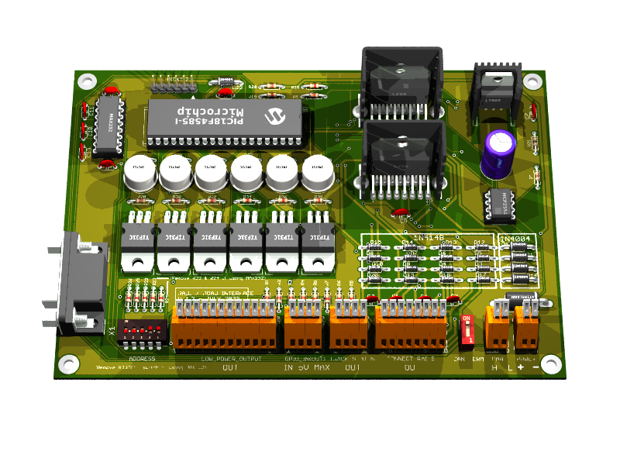

Written by: Philippe Cavenel
17 July 2023
Last update July, 31 2025
Documentation Version 1.9

Table of contents
Table of contents 1
Illustrations 4
1 Preamble 5
1.1 History 5
1.2 Abbreviations 5
1.3 Typographic convention 5
2 Disclaimer 6
3 Introduction 7
3.1 Document purpose 7
Why this document? 7
Document content 7
Warning 7
3.2 Technical References 8
Eagle 6.6.0 8
POV-Ray 3.7 8
MPLAB 8.92 9
PICKIT 2 9
4 Electronic design 11
4.1 Global architecture 11
4.2 Data transfer between boards 12
4.3 Data transfer between master board and PC 13
4.4 Schematic 14
4.5 Pin assignment 19
4.6 Place and route 20
Top view 20
Bottom view 20
Components view 21
3D view 22
4.7 BOM 23
L7805 or DollaTek 5V 1A 23
4.8 Generate the manufacturing files 24
First step: ERC on Eagle 24
Step two: DRC and silkscreen on Eagle 24
Step three: CAM processor on Eagle 24
Fourth stage: Final rendering 24
How to add a 3d model 25
Fifth stage: BOM 26
Sixth step: send files for manufacturing 26
5 Firmware design 27
5.1 Set PIC18F frequency to 32MHz 27
5.2 CAN bus control library 27
Introduction 27
Module Features 27
List of Component Modules 27
Functions 28
CAN Initialization 28
CAN Reception 28
5.3 PWM management in analog mode, DCC management in NMRA digital mode and TM1637 device management 31
5.4 Flash storage of programming information 37
5.5 Automation management 41
5.6 Software design 42
5.7 Protocol on serial link 42
5.8 BNF Grammar 42
5.9 Protocol on CAN bus 43
5.10 Output display and knob controls 45
Command 46
Programming DCC mode on a board 46
Programming ANA mode on a board 47
Programming AUTOMATIC mode on a board 48
Programming MANUAL mode on a board 49
Initialize a GPIO as output on a board 50
Initialize a GPIO as input on a board 51
Program an automatic action on a GPIO driven by a timer 52
Program an automatic action on a LPO driven by a timer 53
Program an automatic action on a track driven by a timer 54
Program on a timer driven by a timer 55
Turn On or Off an automation driven by a timer 56
Program an automatic action on a GPIO driven by a change of level on a GPIO 57
Program an automatic action on a LPO driven by a change of level on a GPIO 58
Program an automatic action on a track driven by a level change on a GPIO 59
Program an automatic action on a loco (DCC) driven by a level change on a GPIO 60
Program on a timer driven by a level change on a GPIO 61
Turn on or off an automation by a level change on a GPIO 62
Program an automatic action on a GPIO driven by a change of vehicle presence on a track 63
Program an automatic action on a LPO driven by a change of vehicle presence on a track 64
Program an automatic action on a track driven by a change of vehicle presence on a track 65
Program an automatic action on a loco (DCC) by a change of vehicle presence on a track 66
Program on a timer driven by a change of vehicle presence on a track 67
Turn on or off an automation by a change of vehicle presence on a track 68
Delete an automation on a board 69
Force the value on a GPIO on a board 70
Create a timer on a board 71
Force the value on a LPO on a board 72
Turn on an automation on a board 73
Turn off an automation on a board 74
Force speed and direction on a track 75
Send a DCC command to a board 76
Request the status of all the GPIOs on a board 77
Request the status of all the LPOs on a board 78
Request track status on a board 79
Request board status 80
Request the list of actions programmed on a board 81
Request a dump of memory on a board 82
Request a calibration of knobs 83
5.11 Global command 84
Stop all 84
Run all 84
Run a specific board 84
Reset all automation of a specific board 84
Inconsistent programming 85
Barraux's railway network (31/07/2025) 86
General System Structure 86
⚙️ Operating Modes 86
🧠 Automation per Board 87
📌 TCO (Optical Control Panel) Commands 88
📌 Programing the boards 88
Source Code and Project Access 89
Board Code (31/07/2025) 91

Illustrations
Figure 1 PICkit 2 Programmer Connector pinout 10
Figure 2 PWM Mode 11
Figure 3 DCC NMRA mode 11
Figure 4 Master/slave board operating diagram 12
Figure 5 CAN bus wiring diagram 13
Figure 6 Transceiver MCP2551 wiring diagram 13
Figure 7 (Proposed by Kyle Thomson Revised 8/18/2009) 14
Figure 8 5V power supply with standard 7805 14
Figure 9 CAN and RS232 interface 15
Figure 10 Master or Slave board 15
Figure 11Power boost 16
Figure 12 Vehicle Presence Detection 16
Figure 13 Top, Pads, Vias 20
Figure 14 Bottom, Pads, Vias 20
Figure 15 Pads, Vias, tPlace, tValues 21
Figure 16 Top View (800 x 600) 22
Figure 17 Bottom View (800 x 600) 22
Figure 18 Led Display on TCO 45
Figure 19 Railway network (31/07/2025) 86
Figure 20 Rail Manager UI, sribe interface 89
Figure 21 Rail Manager UI, node interface 90
Figure 22 Rail Manager UI, node highlighted 90

Preamble

History

History | Exchange | Date
Version 1.0 | Creation | 18/May/2021
Version 1.1 | New PCB design | 18/May/2023
Version 1.2 | Replace H-bridge transistors with L298s | 22/July/2023
Version 1.3 | Add more information on last development with PIC18F4680 | 30/07/2025

Abbreviations

DCC: Digital Command Control (defined by a NMRA standard)
NMRA: National Model Railroad Association
AMS: Auto Motor Sport (Faller)
HO: Half-O (model railway scale corresponding to 1:87)
DIY: Do It Yourself
PC: Personal Computer
USB: Universal Serial Bus
FTDI: Future Technology Devices International
CAN (bus): Controller Area Network
TTL: Transistor-Transistor logic
GPI : Global Purpose Input-Output
LED: Light-Emitting Diode
PWM: Pulse Width Modulation
EMC: ElectroMagnetic Compatibility
STL: STereo-Lithography
STEP: STandard for the Exchange of Product model data
DRC: Design Rule Check
ERC: Electrical Rule Check

Typographic convention

The file names are in Courier New format, for example RailDriverCamJob.cam file

The online order examples or file contents are in bold Courier New on a grey background, for example

stl2pov.exe myModel.stl > myModel.inc.

Warning is in bold red inside a frame

Binary names are in bolt like for example stl2pov.exe

Disclaimer



The information contained in this document has been obtained from sources believed to be reliable. However, it may contain technical inaccuracies or typographical errors.

The author reserves the right to correct such errors as soon as they are brought to his attention. We strongly recommend that you check the accuracy and relevance of the information provided in this document.

The information contained in this document is subject to change at any time, and may have been updated. In particular, it may have been updated between the time it was downloaded and the time the user takes cognizance of it.

Use of the information contained in this document is at the user's sole risk, and the user assumes full responsibility for any consequences arising therefrom, without any liability or recourse against the author.

In no event shall the author be liable for any damages whatsoever resulting from the interpretation or use of the information contained herein.

Introduction

Document purpose

Why this document?
Faller AMS car networks do not have a DCC-type control mode (NMRA standard). This makes it difficult to have several vehicles on the same network. Using diodes, it is possible to operate a maximum of 2 vehicles per track, which is not very many. By creating track sections and vehicle detections per track section, you can have many more vehicles on the track. On the other hand, the realism of these networks is not respected with operating speeds that are too high, and by using PWM-type pulsed current mechanism, a much more realistic effect can be achieved.

As soon as this type of board is developed, it seems interesting to have a universal programmable interface that can also be used to drive a railway network, and thus support DCC mode (NMRA).

Document content
This document describes the development of a DIY Faller AMS network board for HO rail and road models and the various associated software (Firmware for PIC18F4585 and PIC18F4680 and PC software) developed since 2021.

The PIC18F4680 allows for storing more program data in memory; the only difference in firmware programming is the use of the correct 18f4680_g.lkr file during compilation. The use of this microcontroller occurred during the course of the project development, so it is possible that other models may still be referenced in this document. However, the code available on GitHub has been properly developed for the 4680 version of the PIC18F.

The board is designed to communicate with a PC via an RS232 serial link (or via a USB connection using an FTDI cable connected to the RS232 connector, available at Amazon: DSD TECH SH-RS232G USB to DB9 Female serial cable Integrated FTDI FT232RL chip) and with each other via a CAN bus.

Each board can drive up to 4 sections in analog or digital DCC mode (NMRA standard) with electric vehicle presence detection, and 6 low-power controls for lighting or small mechanisms (such as turnout controls). Finally, 8 TTL inputs/outputs (GPIOs) 4 are dedicated to vehicle presence detection, and 4 enable the addition of detectors, control LEDs, or the linking of boards to generate automatic control mechanisms (blocking).

Boards cannot individually mix DCC and analog modes, but it is possible to run one board in DCC mode and another in analog mode.

Each board has a 5-bit address (so 31 can be used, i.e. 128 slots for the whole network). The PC interface board called the "master" is set to address 31 by default. Each other boards should have at least the bit 0 or 1 or 2 set to 0.

Warning
The current 2023 version at the time of writing is V1.2, and this document describes this version.
This board was developed for personal usage and on an old but readily available and quickly mastered environment that can simply be replaced by a tool like KiCad EDA or Altium on more recent computers.

All technical indications (such as layer numbers in the Eagle tool) therefore refer to these tools (see Technical References below). To simplify use of this documentation, a zip file containing all developments is available for download.
Finally, the development of a professional version would require the use of SMD components, a minimum EMC and countries compliance study, integration into a great casing, cost analysis, user manual, and targeting of customers for a possible market launch. This is not the purpose of this documentation. This development should be considered as a simple prototype for personal usage.

Technical References
In order to reduce development costs and simplify board assembly, the entire board is mounted using radial components, and the design was conceived on an available professional version 6.6.0 of Eagle, MPLAB 8.92 and POV-Ray 3.7 running Mac OS High Sierra on a MacBook Pro in early 2011, 2.7 GHz Intel Core I7 with 16 GB DDR3 1333 MHz memory. This computer runs Mac OS and Windows on Parallel desktop V16.5.1. Development environment needs tools on both operating system, Mac OS and Windows. Pending the development of a bootloader for the master and slave boards, the firmware is updated using a PICkit™ 2 programmer/debugger (PG164120).

Eagle 6.6.0
EAGLE contains a schematic editor, for designing circuit diagrams. Schematics are stored in files with . SCH extension, parts are defined in device libraries with . LBR extension. Parts can be placed on many sheets and connected together through ports.

The PCB layout editor stores board files with the extension . BRD. It allows back-annotation to the schematic and auto-routing to automatically connect traces based on the connections defined in the schematic.

EAGLE saves Gerber and PostScript layout files as well as Excellon and Sieb & Meyer drill files. These are standard file formats accepted by PCB fabrication companies, but given EAGLE's typical user base of small design firms and hobbyists, many PCB fabricators and assembly shops also accept EAGLE board files (with extension . BRD) directly to export optimized production files and pick-and-place data themselves.

EAGLE provides a multi-window graphical user interface and menu system for editing, project management and to customize the interface and design parameters. The system can be controlled via mouse, keyboard hotkeys or by entering specific commands at an embedded command line. Keyboard hotkeys can be user defined. Multiple repeating commands can be combined into script files (with file extension . SCR). It is also possible to explore design files utilizing an EAGLE-specific object-oriented programming language (with extension . ULP).
(source Wikipedia)

POV-Ray 3.7
POV-Ray (Persistence of Vision Raytracer), or POV, is a free raytracing software available on a wide variety of platforms (Windows, Mac OS, GNU/Linux, etc.). It was originally based on DKBTrace sources, and to a lesser extent on Polyray.

POV-Ray does not have an integrated graphical interface (3D modeler) like most current synthesis software, but uses scene description scripts, in which all objects, lights, etc. must be described.

Modelers dedicated solely to POV-Ray exist (KPovModeler, Moray, Yet another POV-Ray modeller...), while many others export to the POV-Ray file format. Its file format is ASCII, and the default file extension is ".pov".

This provides basic shapes (spheres, boxes, toroids, etc.) on which Boolean operations can be performed using CSG. It also makes it possible to create volumes or surfaces based on mathematical functions, such as isosurfaces.

Example: function {x*x - F/y*y + z*z} draws a kind of gravity well, with F representing its force.

It is also possible to import objects from other software (such as 3D Studio Max, Poser, etc.), which will be rendered in POV-Ray as an assembly of triangles, as many software programs are compatible, but it is very difficult to export POV-Ray objects to other formats.

POV-Ray can also be used to create animations.
(source Wikipedia)

MPLAB 8.92
MPLAB is a proprietary freeware integrated development environment for the development of embedded applications on PIC microcontrollers, and is developed by Microchip Technology.

MPLAB X is the latest edition of MPLAB, and is developed on the NetBeans platform. MPLAB and MPLAB X support project management, code editing, debugging and programming of Microchip 8-bit PIC and AVR (including ATMEGA) microcontrollers, 16-bit PIC24 microcontrollers, as well as 32-bit SAM (ARM) and PIC32 (MIPS) microcontrollers.

MPLAB is designed to work with MPLAB-certified devices such as the MPLAB ICD 3 and MPLAB REAL ICE, for programming and debugging PIC microcontrollers using a personal computer. PICKit programmers are also supported by MPLAB.

MPLAB X supports automatic code generation with the MPLAB Code Configurator and the MPLAB Harmony Configurator plugins.
(source Wikipedia)

PICKIT 2
The PICkit™ 2 programmer/debugger (PG164120) is a low-cost development tool with a comprehensive interface for programming and debugging microchips or microcontrollers.

Its comprehensive Windows® programming interface supports basic families (PIC10F, PIC12F5xx, PIC16F5xx), mid-range families (PIC12F6xx, PIC16F), controller families PIC18F, PIC24, dsPIC30, dsPIC33, and PIC32, 8-bit, 16-bit and 32-bit, and a large number of EEPROM-type serial microchips.

With the powerful Integrated Development Environment (IDE), PICkit™ 2 lets you debug on-circuit directly, on most PIC® microcontrollers. On-circuit debugging runs, pauses, and executes the program step by step, while the microcontroller is integrated into the application. When paused on a breakpoint, file registers can be examined and modified.
(source https://pickit2.software.informer.com )
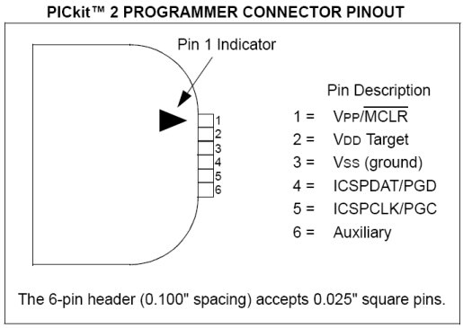
Figure 1 PICkit 2 Programmer Connector pinout

Electronic design

Global architecture
The complete system consists of a PC running, a rail or road network control application. This may be a fully developed application, or an existing one with a programmable interface driver. The interface between this PC and the control boards is via a 115200 Baud serial bus connected to a board with an RS232 serial interface. Only one of these boards, known as the "Master" board, has this interface.

The master board communicates with the other boards, known as slaves, via a 500K Baud CAN bus. The master board contains an RS232 transmitter (MAX232). By default, this board has address 31 (the address selector on this board must be removed, as well as resistors R23 and R24, giving it the value 31 by hardware setting). Address 31 is therefore forbidden on other boards, as it indicates to the PIC18F the presence of an RS232 transmitter.

If the user inadvertently sets address 31 on a board that does not contain an RS232 transmitter module, the PIC18F will begin by testing the presence on the TX line (RC6/TX/CK, pin 25) of either level 0 (switch bit 4 to 0) or level 1 (switch bit 4 to 1). If either of these levels is detected, address 31 has been selected by mistake, and the PIC18F goes into standby mode until the address is changed.

If two cards have the same address, the overall behavior of the system may be inconsistent, without compromising network security.

Each board is supplied with a power supply between 12 and 24V DC. The optimum supply voltage depends on the type of equipment operating on the network. The maximum theoretical voltage supported is 32V, but such a voltage could destroy the equipment connected to the board. In practice, we advise you not to exceed a supply voltage of 20V, especially if you use DCC environment.

Each board can drive 4 PWM or DCC blocks and 6 low-power modules. The boards also feature 8 TTL-level inputs/outputs (not to be used for direct control of a power module).

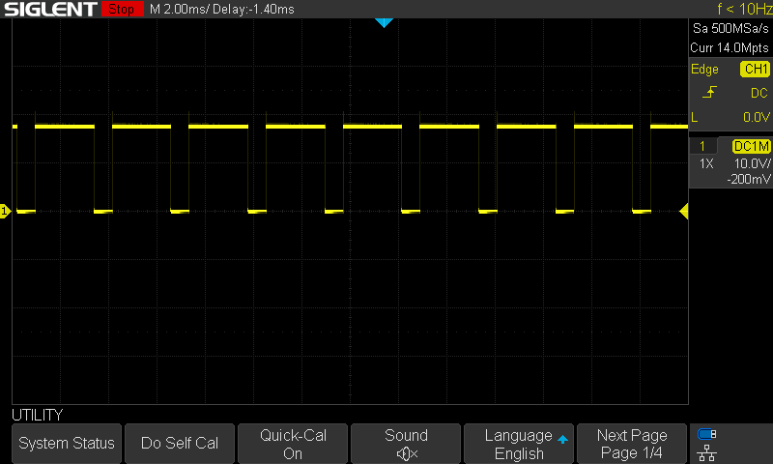
Figure 2 PWM Mode

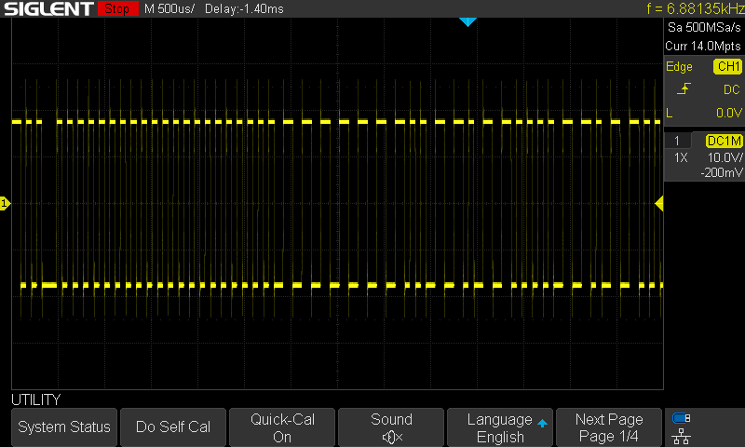
Figure 3 DCC NMRA mode

The system is controlled using a command language sent to the master board via the RS232 serial link. This language has two modes: a programming mode and a control mode.

- In programming mode, it is possible to specify the direction of each board's GPIOS, and to trigger automatic actions on events, e.g. "on detection of a vehicle on block 3 of board 8, feed block 6 of board 5 in the forward direction at speed 10" (speeds are between 0 and 15).

- In control mode, commands can be given, e.g. "feed block 3 of board 2 in the reverse direction at speed 2".

Each event (detection or loss of presence of a vehicle or change of status on a GPIO or TIMER triggered) generates an event which is sent to the other boards on CAN bus.

The commands and language are described in the following chapters.
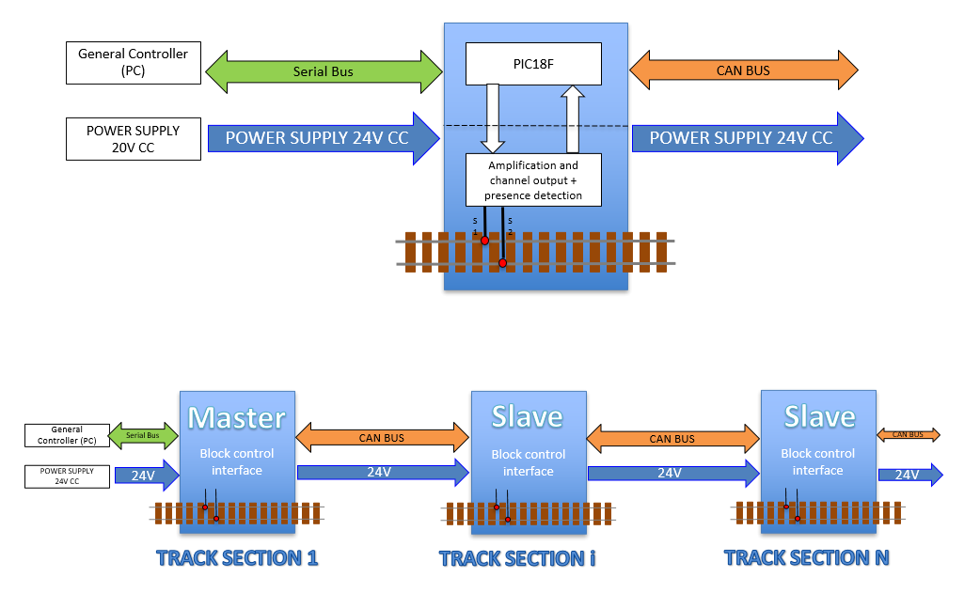
Figure 4 Master/slave board operating diagram

Data transfer between boards
Data transfer between boards is via a 500 KBaud CAN bus. The boards are connected to the CAN bus.

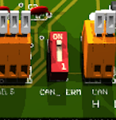 | The first and last boards in this network have a switch for connecting a terminating resistor.

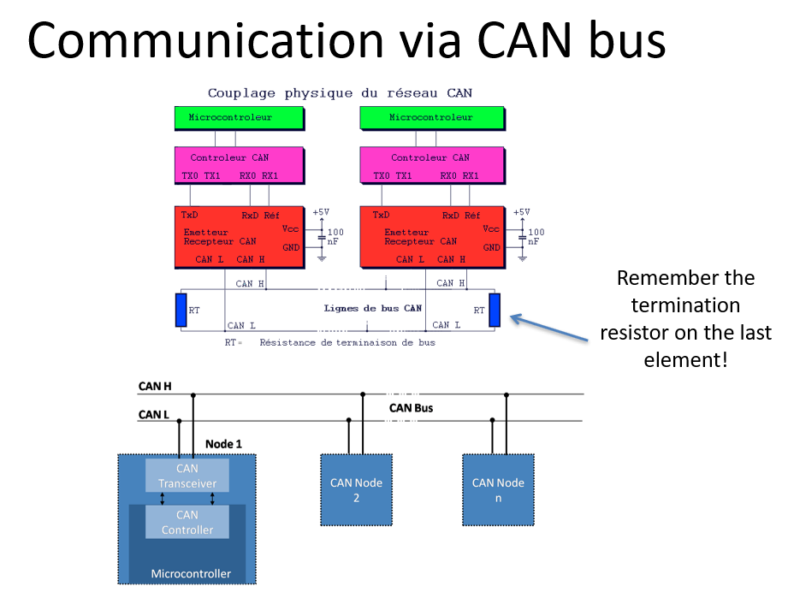
Figure 5 CAN bus wiring diagram

A transceiver MCP2551 is used to link the PIC18F to the CAN bus.

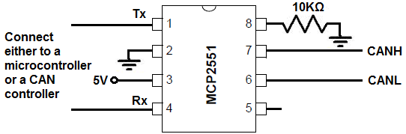
Figure 6 Transceiver MCP2551 wiring diagram

Data transfer between master board and PC
Data transfer between the master board and the PC is via an RS232 serial bus at 115200 baud. The link to the PC and the PIC18F is done via a MAX232 transmitter, which can be connected to an FTDI RS232/USB cable if the user so wishes.

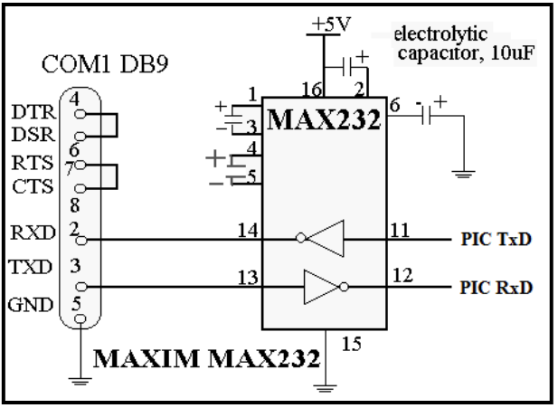
Figure 7 (Proposed by Kyle Thomson Revised 8/18/2009)

Schematic
The schematic consists of two parts:

- The first contains the 5V power supply (Note the STTH5L06RL inversion protection diode on this power supply). The L7805 could be replaced by a DollaTek 5V 1A regulated board, more robust. (https://www.amazon.fr/DollaTek-r%C3%A9gulateur-bornes-lentr%C3%A9e-LM7805/dp/B081JMJZG6)

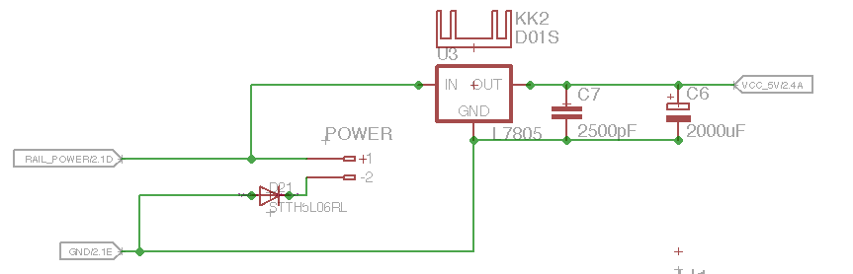
Figure 8 5V power supply with standard 7805

- The RS232 and CAN bus transmitters and transceivers, the programming connector for the PIC18F and the board address selector.

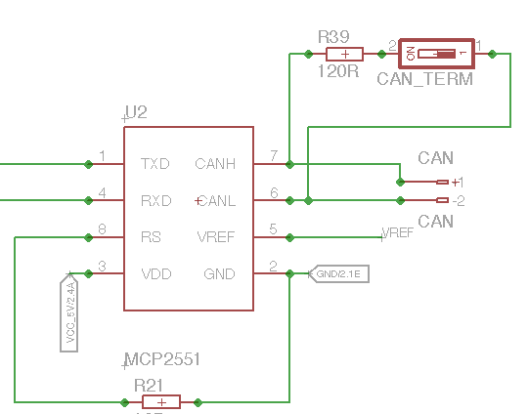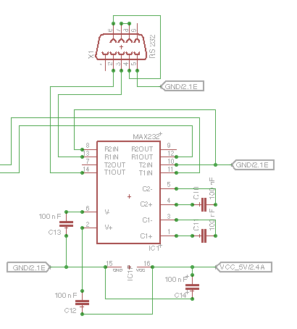
Figure 9 CAN and RS232 interface

- This assembly enables the master and slave boards to be wired on the same design. For the master board, solder the RS232 DB9 connector, the MAX232 transmitter and remove resistors R23 and R24 as well as the address selector. For the slave board, do not solder the RS232 DB9 connector, nor the MAX232 transmitter but keep C14.

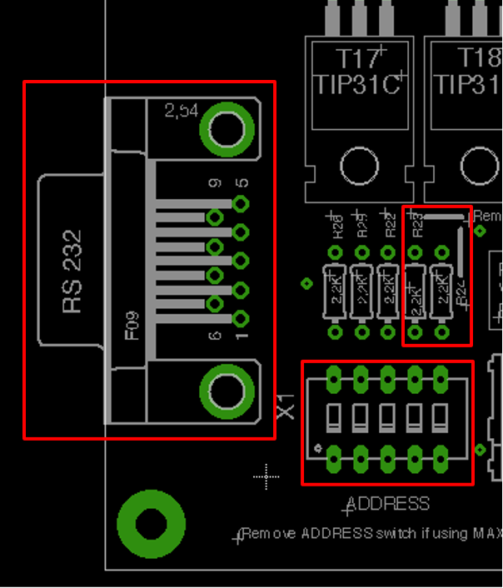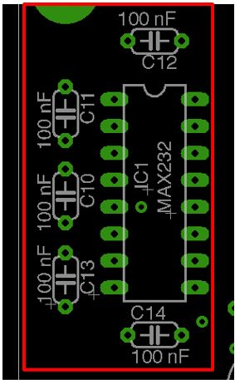
Figure 10 Master or Slave board

- The second contains the L298 power drivers and the 6 TIP31C transistors in Darlington circuit controlled by the PIC18F, as well as the power outputs to the rail or road network.

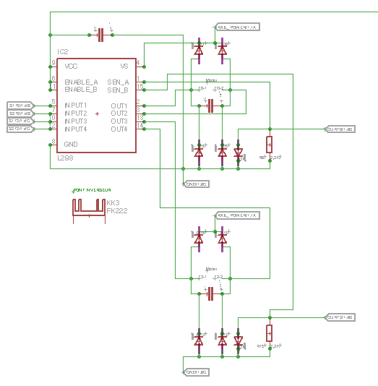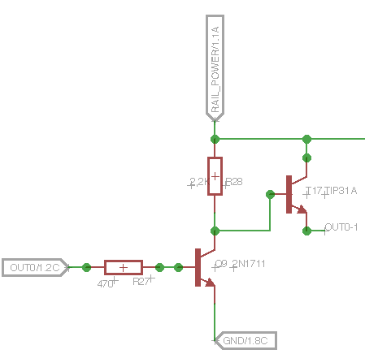
Figure 11Power boost

- Note that it is essential to place decoupling capacitors as close as possible to the components on the 5V supply, otherwise there is a risk of catastrophic loss of control due to PIC18F shutdown. These decoupling capacitors are 100nF on the 5V supply and 2500pF on the power outputs of the tracks to be supplied.

- Vehicle presence is detected by measuring the voltage across a diode at the output of the L298. When no load is present, a voltage close to 0V is measured at the terminal of a 2K2 resistor connected to ground, whereas when a load is present, the connection to ground is made via the 1N4004 diode, whose 0.7V bias voltage is then detected by the PIC18F.

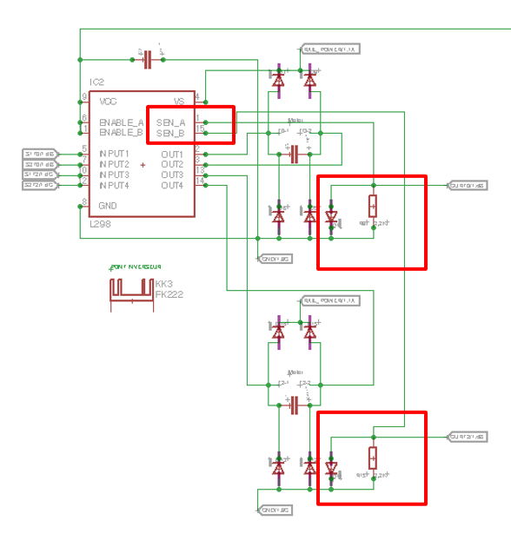
Figure 12 Vehicle Presence Detection

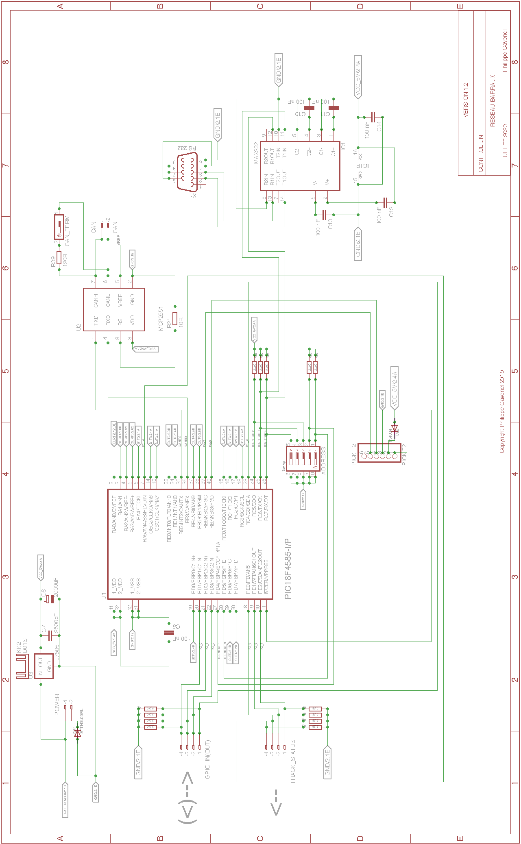
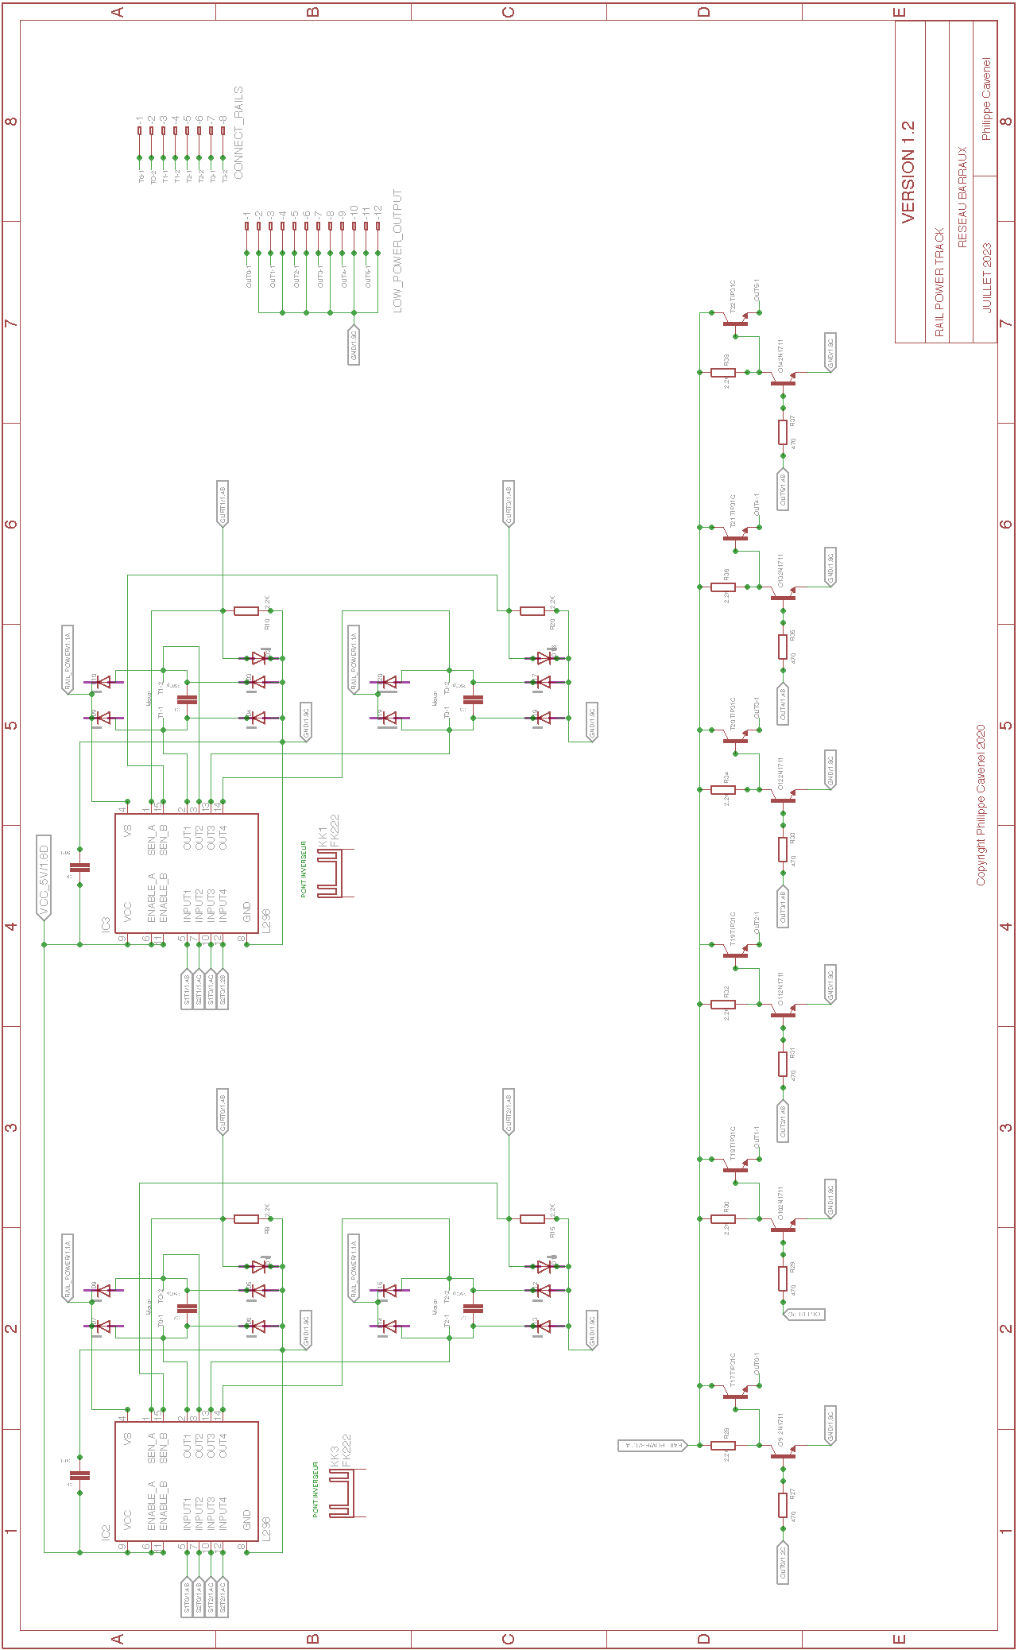

Pin assignment
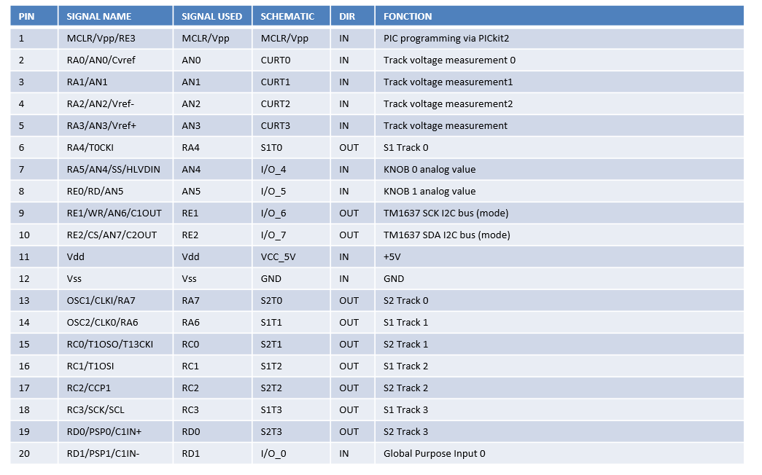
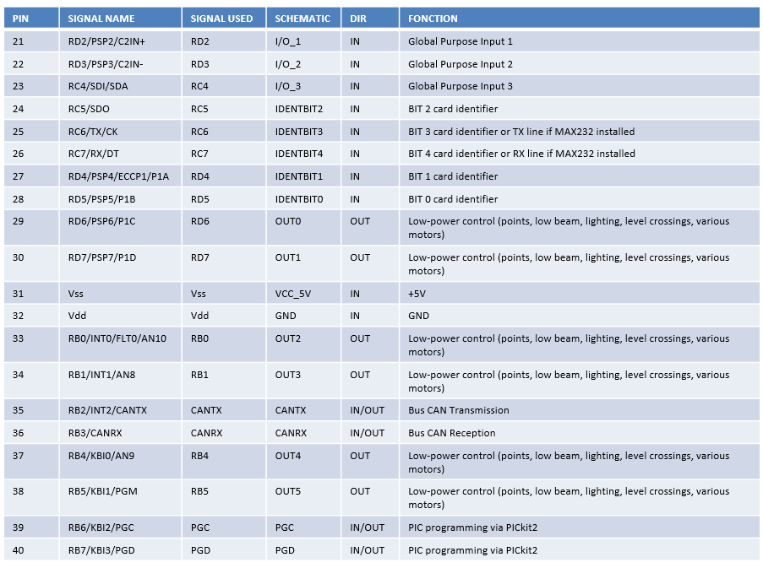

Place and route
Components are placed as close as possible to each other to limit the distance between related components, especially for decoupling capabilities. Routing is performed automatically.

Top view

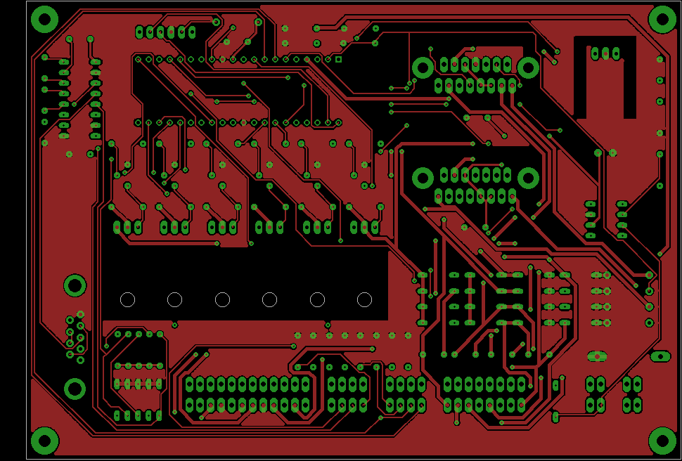
Figure 13 Top, Pads, Vias

Bottom view

Figure 14 Bottom, Pads, Vias

Components view
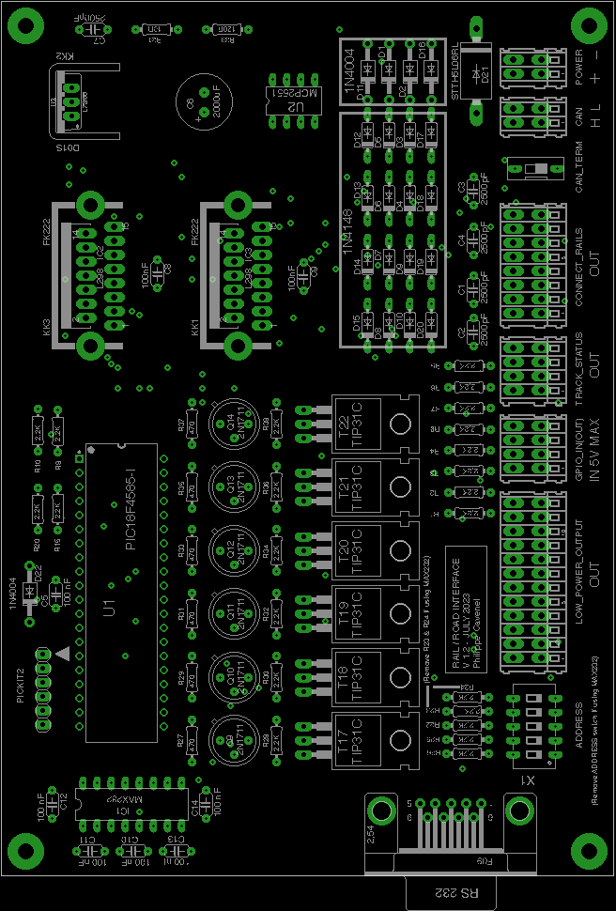
Figure 15 Pads, Vias, tPlace, tValues

3D view

Figure 16 Top View (800 x 600)

Figure 17 Bottom View (800 x 600)

BOM
Qty | VALUE | DESCRIPTION | Farnell
1 | Standard D-Sub connectors AMPL PLUG HD20, R/A 9P, B/L,4-40 INS | X1 | 2857982
8 | 100nF | C5, C8, C9, C10, C11, C12, C13, C14 | 2309064
1 | MAX 232N | IC1 | 3121260
1 | 2000uF | C6 | 2766923
1 | 10R | R21 | 2329993
1 | 120R | R39 | 2329862
16 | 1N4148 | D3, D4, D5, D6, D7, D8, D9, D10, D12, D13, D14, D15, D17, D18, D19, D20 | 9843680
5 | 1N4004 | D22, D1, D11, D2, D16 | 1843708
1 | STTH5L06RL | D21 | 2353682
23 | 2.2K | R1, R2, R3, R4, R5, R6, R7, R8, R9, R10, R15, R20, R22, R23, R24, R25, R26, R28, R30, R32, R34, R36, R38 | 9341536
5 | 2500pF | C1, C2, C3, C4, C7 | 2860175
6 | 2N1711 | Q9, Q10, Q11, Q12, Q13, Q14 | 1611558
6 | 470 | R27, R29, R31, R33, R35, R37 | 3496822
1 | DIP / SIP Switch, 5 Circuit(s), Slide, Through Hole, SPST, 24 VDC, 100 mA | ADDRESS | 3397711
1 | Terminal block x2 | CAN | 1777096
1 | Terminal block x2 | POWER | 1777096
1 | DIP / SIP switch, 1 circuit | CAN TERMINATOR | 1960919
1 | Terminal block x12 | LOW_POWER_OUTPUT | 1777102
1 | Terminal block x8 | CONNECT_RAILS | 1777101
2 | Terminal block x4 | TRACK_STATUS, GPIO_IN(OUT) | 1777098
1 | L7805 or DollaTek 5V 1A | U3 | 1467758
1 | MCP2551P | U2 | 1439745
1 | PIC18F4585-I (or PIC18F4680) | U1 | 1439547
1 | PICKIT2 | PICKIT2 | 1187827
6 | TIP31C | T17, T18, T19, T20, T21, T22 | 9804145
2 | L298N | IC2, IC3 | 403295
2 | FK222 | KK1, KK3 | 4621281
1 | 274-1AB | KK2 | 1611445

Generate the manufacturing files

First step: ERC on Eagle
- Generate schematic and validate circuit with ERC
- Pay particular attention to net class, especially for the power section (larger surface area required)

Step two: DRC and silkscreen on Eagle
- Component placement and automatic routing.
- To fill the top and bottom polygons, draw a polygon around the map, selecting the right layer (Top or Bottom) in the top left-hand corner after routing (otherwise automatic routing won't work), then restart routing.
- Validate with a DRC, selecting only the Top, Bottom, Via and Pad layers.
- Finalize silkscreen (layer 21) by placing all indications correctly, then generate drill legend on layer 144 by launching the ULP icon in the layout screen of Eagle on drillegend-stack.ulp

Step three: CAM processor on Eagle
- Generate the files for CAM Processor production by clicking on the CAM_JOB/RailDriverCamJob.cam file.
- In the top-left File menu, select the .brd file for the corresponding design.
- The directories and file names must be correct in the various tabs (check and correct if necessary).
- All that's left to do is run PROCESS JOB to produce the files.

Fourth stage: Final rendering
- To modify the selection of unknown boxes, modify the 3D_RENDERING/eagle3d/ulp/3dusrpac.dat file.
- Update the configuration files directory in 3dconf.dat
- Generate a 3D rendering of the design by launching the ULP icon in the layout screen of Eagle on 3D_RENDERING/eagle3d/ulp/3d50.ulp
- Specify the .brd file, which will generate a .pov file that can be processed by POV-Ray to obtain the 3D rendering.
- Select "User-defined model" in the General tab
- Add layer 25 in Miscellaneous Case Design
- Modify Writing on plate to display layers 21 and 25 only.
- Add layers 25 and 27 in Case Reference
- Click on Create POVRay file and Exit.
- Copy the generated EAGLE_FILES/RailDriver/RailDriver.pov file into 3D_RENDERING/eagle3d/povray
- Repeat the same operation, moving the camera to shoot from below (using Y) and/or from the other sides (using X and Z).
- Click on the 3D_RENDERING/eagle3d/povray/RailDriver.pov file to start building the 3D view with POV-Ray (automatic launch on Windows). Use 800 x 600 AA 0.3 for a reasonable image creation time, or 1600 x 1200 A 0.3 for a better resolution, but the image creation time will take several tens of minutes (On old PC).
- In Eagle, make a screen copy of the various layers built during the construction of the manufacturing files. Place all views in a PNGVIEW directory

How to add a 3d model
- Retrieve the model in STL format from the net (snapeda for example on https://www.snapeda.com/ ). If the model is in STEP format, it must first be converted to STL, you can do that for example at on https://polyd.com/fr/convertir-step-en-stl-en-ligne
- Use the stl2pov.exe utility (launch a Windows shell)

stl2pov.exe myModel.stl > myModel.inc.

- Copy it to 3D_RENDERING/eagle3d/povray. For example:

stl2pov.exe "TO220HeatSink\TO220_Heatsink.stp">"TO220HeatSink\TO220HeatSink.inc"

- Modify the myModel.inc file so that it is understood by POV-Ray, taking as an example fk_222_sa.inc

- Add the following include to the 3D_RENDERING/eagle3d/povray/e3d_user.inc file:

#include "myModel.inc".

- Add the following information to the 3D_RENDERING/eagle3d/ulp/3dusrpac.dat file:

MYMODEL:0:1:0:0:0:0:0:0:0:0:0:0:0:0:0:0:0:0:0:0:0:0:0:0:0:0:0:0:0:0:0:0:0:0:0:0:0:0:0:0:0:0:0:0:0:0:MYMODEL_GRND 0:0:0:0:0:0:0:0:0:0:0:0:0:0:0:0:0:0:0:0:0:0:0:0:0:0:0:0:0:0:0:0:0:0:0:0:0:0:0:0:0:0:0:0:0:0:0:0:0:0:0:0:0:0:0:0:0:0:0:0:0:0:0:0:

[00] Eagle component package name  [01] Output name  [02] Output value  [03] Define color bands  [04] SMD offset (parts will be moved pcb_cuhight up/down)  [05] LED options (LED options dialog box will be displayed)  [06] Ready for sockets (see explanation)  [07] Quartz height request  [08] A part of a macro (e.g. SMD jumpers)  [09] SMD resistor, generates a combination of numbers  [10] Macro socket  [11] Socket height in 1/10mm  [12] Comments on socket  [13] Internal for administration (not currently used) | [14] Y-axis rotation correction  [15] Offset correction x  [16] Offset correction y  [17] Offset z correction  [18] Use Prefix from Part?  [19] Shunt on pin header (a dialog box will be displayed)  [20] Logo selection dialog box is displayed  [21] Reserved  [29] Minimum encircling box  [30] Maximum bounding box  [31] POV-Ray macro (Name of pov macro and left parenthesis)  [32] Package comments (German)  [33] Package comments

Fifth stage: BOM
- Update the BOM to purchase components on Farnell or Mouser or other dealers on the net.

Sixth step: send files for manufacturing
- Compress CAM_JOB and PNGVIEW directories to start manufacturing on a PCB manufacturing site such as AllPcb: https://www.allpcb.com/ or other manufacturer on the net.

Firmware design

Set PIC18F frequency to 32MHz

OSCCON = 0x70; no pre-divider => 8MHz // comment to set 8MHz
OSCTUNE = 0x40; activate PLL *4 => 32MHz // comment to set 8MHz

CAN bus control library

Introduction
This document describes programming interface to ECAN (Enhanced Controller Area Network) module. At the time of writing this document, only PIC18F family of microcontroller contained ECAN module. This module provides access to ECAN module in polling fashion. This module is completely written in 'C' language. It provides many customization options that may result in significant code reduction. To utilize this module, one must understand all options offered by ECAN module. This module is also available in Microchip Application Note AN878.
(source ECANPoll.ReadMe file)

Module Features
- Out-of-box support for Microchip C18 and HI-TECH PICC-18TM C compilers
- Offers simple abstract interface to ECAN module for most applications
- Additional functions/macros are available for advanced applications
- Supports all three functional modes
- Provides access to all ECAN features in Polling mode
- Easily modifiable to Interrupt-driven mode
- Operates in two main modes:
- Run-time Library Mode and Fixed Library Mode
- Various compile-time options to customization routines to a specific application
- Also available as Microchip Application Note AN878

(source ECANPoll.ReadMe file)

List of Component Modules
ECAN.ex.txt | This is main test file developed to demonstrate use of the library functions.
ECANPoll.c | This is ECAN code implementation file. One needs to include this file in their project.
ECANPoll.h | This file contains prototypes of functions and macros. One needs to include this file in every source file where ECAN functions will be called.
ECANPoll.def | This file contains all compile-time options for ECAN module. If you are using Maestro, this file will be created as per your option selections. This file is automatically included by ECANPoll.h file.

Functions
Refer to the ECANPoll.ReadMe file

CAN Initialization

In order to improve performance, data reception is interrupted.

ECAN
TRISBbits.TRISB3 = 1; CANRX input setting
gl_InputBufferPointer=0;
gl_getDataCANPointer=0;
gl_canMode=CAN_UNKNOWN;

ECANInitialize(); init ECAN
PIE3bits.RXB0IE=1; enable interrupt for CAN
PIE3bits.RXB1IE=1; enable interrupt for CAN

CAN Reception
Can reception is shared with RS232 reception:

/****************************************************************************/
/* high_isr */
/****************************************************************************/
#pragma interrupt high_isr
void high_isr(void){

BYTE dataLen; Number of bytes transmitted in the message
ECAN_RX_MSG_FLAGS flags; Flags
unsigned long id; Id of sender

if(PIR3bits.RXB0IF ||PIR3bits.RXB1IF) {
while(ECANReceiveMessage(&id, &gl_inputBuffer[gl_InputBufferPointer], &dataLen, &flags)) {
gl_InputBufferPointer+=dataLen;
if(gl_InputBufferPointer>=MAXTRAMESIZE)gl_InputBufferPointer-=MAXTRAMESIZE;
}
gl_synchroSend=(gl_boardNumber+1)*SYNCHROSENDDELAY;
}

if (gl_master==FALSE)return;

Check if interrupt originates from USART reception
if (PIR1bits.RCIF)
{
Read received data
gl_receivedUSARTData[gl_receivedUSARTPointer++] = RCREG;
if (gl_receivedUSARTPointer>=USARTBUFFERSIZE)gl_receivedUSARTPointer=0;
}
}
#pragma code
Can transmission is performed either by the user_putc() function when an ASCII message is to be sent to the master, or by a specific CAN routine to send compressed data.

/*****************************************************************************/
/* CANsendDelay*/
/*****************************************************************************/
void CANsendDelay() {
unsigned short Delay;
for(delay=0; delay<WAITDELAYTRAMECAN; delay++);
}

/*****************************************************************************/
/* _user_putc*/
/*****************************************************************************/
int _user_putc (char c) {

unsigned long id; Id of sender
unsigned char dataOut[8]; // DATA to CAN
unsigned char dataCounter;
unsigned char dataOutCounter;
unsigned char frameComplete;

BYTE dataLen; Number of bytes transmitted in the gl_message
ECAN_RX_MSG_FLAGS flags; Flags

On master board send to UART via standart putc()
if (gl_master==TRUE){
if (gl_inputCounter==0)sendUSART(c);
}
else {
if (gl_outputBufferCounter<MAXMESSAGESIZE)gl_outputBuffer[gl_outputBufferCounter++]=c;

Send on CAN bus

if (gl_outputBufferCounter==MAXMESSAGESIZE || c==ENDOFPRINTFTRAME) {
dataLen=8;
flags=ECAN_TX_STD_FRAME;
id=gl_boardNumber;

Header Frame
for(dataOutCounter=0; dataOutCounter<8; dataOutCounter++) dataOut[dataOutCounter]=TRAMEPRINTHEADER;

Synchro send
while(gl_synchroSend >0);

while(! ECANSendMessage(id,dataOut,dataLen,flags));
CANsendDelay();

weft
frameComplete=FALSE;
dataCounter=0;
while(dataCounter<MAXMESSAGESIZE) {
for(dataOutCounter=0; dataOutCounter<8; dataOutCounter++) {
if (dataCounter<gl_outputBufferCounter) {
dataOut[dataOutCounter]=gl_outputBuffer[dataCounter++];
if (dataOut[dataOutCounter]==ENDOFPRINTFTRAME) frameComplete=TRUE;
}
else {
dataOut[dataOutCounter]=ENDOFPRINTFTRAME;
if (dataCounter<MAXMESSAGESIZE)dataCounter++;
frameComplete=TRUE;
}
}
while(! ECANSendMessage(id,dataOut,dataLen,flags));
CANsendDelay();

if (FrameComplete==TRUE) break;
}
gl_outputBufferCounter=0;

Frame Footer
for(dataOutCounter=0; dataOutCounter<8; dataOutCounter++) dataOut[dataOutCounter]=TRAMEPRINTFOOTER;
while(! ECANSendMessage(id,dataOut,dataLen,flags));
CANsendDelay();
}
}
return(c);
}

/*****************************************************************************/
/* sendRequestToCAN() */
/*****************************************************************************/
void sendRequestToCAN(unsigned char* request) {

unsigned long id; Id of sender
unsigned char dataOut[8]; // DATA to CAN
unsigned char dataCounter;
unsigned char dataOutCounter;
BYTE dataLen; Number of bytes transmitted in the gl_message
ECAN_RX_MSG_FLAGS flags; Flags
unsigned char frameSize;

Convert request to dataOut using gl_dataStructure
frameSize=compressData(request);

dataLen=8;
flags=ECAN_TX_STD_FRAME;
dataCounter=0;
id=gl_boardNumber;

Header Frame
for(dataOutCounter=0; dataOutCounter<8; dataOutCounter++) {
dataOut[dataOutCounter]=TRAMEREQUESTHEADER;
}

Synchro send
while(gl_synchroSend >0);
CANsendDelay(); Delay to avoid sending to fast after receiving a trame

while(! ECANSendMessage(id,dataOut,dataLen,flags));
CANsendDelay();

weft
while(dataCounter<frameSize) {
for(dataOutCounter=0; dataOutCounter<8; dataOutCounter++) {
if (dataCounter<frameSize) {
dataOut[dataOutCounter]=request[dataCounter++];
if(dataCounter>=MAXTRAMESIZE) return; Something wrong happened
}
else {
dataOut[dataOutCounter]=0;
}
}
while(! ECANSendMessage(id,dataOut,dataLen,flags));
CANsendDelay();
}

Frame Footer
for(dataOutCounter=0; dataOutCounter<8; dataOutCounter++) {
dataOut[dataOutCounter]=TRAMEREQUESTFOOTER;
}
while(! ECANSendMessage(id,dataOut,dataLen,flags));
uncompressData(request); get back to initial data for other action in manageRequest()
}
/*****************************************************************************/
/* getInputRequestFromCAN() */
/*****************************************************************************/
unsigned char getInputRequestFromCAN(unsigned char* request) {

unsigned char requestHeaderTrameDetected=0;
unsigned char printHeaderTrameDetected=0;
unsigned char requestFooterTrameDetected=0;
unsigned char printFooterTrameDetected=0;
Car requestTrameEnd;
Car printTrameEnd;

unsigned char dataInCounter;
unsigned char dataStructureCounter;

sprintf(gl_message,"");
while (gl_getDataCANPointer!=gl_InputBufferPointer) {

if (gl_inputBuffer[gl_getDataCANPointer]==TRAMEREQUESTHEADER) requestHeaderTrameDetected++; else requestHeaderTrameDetected=0;
if (gl_inputBuffer[gl_getDataCANPointer]==TRAMEREQUESTFOOTER) requestFooterTrameDetected++; else requestFooterTrameDetected=0;

if (gl_inputBuffer[gl_getDataCANPointer]==TRAMEPRINTHEADER) printHeaderTrameDetected++; else printHeaderTrameDetected=0;
if (gl_inputBuffer[gl_getDataCANPointer]==TRAMEPRINTFOOTER) printFooterTrameDetected++; else printFooterTrameDetected=0;

// REQUEST HEADER
if (requestHeaderTrameDetected==8) {
gl_canMode=CAN_REQUEST;
requestHeaderTrameDetected=0;
gl_requestTrameStart=gl_getDataCANPointer+1;
if (gl_requestTrameStart>=MAXTRAMESIZE)gl_requestTrameStart=0;
}

// PRINT HEADER
else if (printHeaderTrameDetected==8) {
gl_canMode=CAN_PRINT;
printHeaderTrameDetected=0;
gl_printTrameStart=gl_getDataCANPointer+1;
if (gl_printTrameStart>=MAXTRAMESIZE)gl_printTrameStart=0;
}

// REQUEST FOOTER
else if (requestFooterTrameDetected==8 & gl_canMode==CAN_REQUEST) {
requestTrameEnd=gl_getDataCANPointer-7;
if (requestTrameEnd<0)requestTrameEnd+=MAXTRAMESIZE;
dataInCounter=gl_requestTrameStart;
dataStructureCounter=0;
while(dataInCounter!=requestTrameEnd) {
request[dataStructureCounter++]=gl_inputBuffer[dataInCounter++];
if (dataInCounter>=MAXTRAMESIZE)dataInCounter=0;
}
gl_canMode=CAN_UNKNOWN; If more data arrives.... we delete this frame
gl_getDataCANPointer++;
if (gl_getDataCANPointer>=MAXTRAMESIZE)gl_getDataCANPointer=0;
uncompressData(request);
return(TRUE); Mean request available to proceed
}

// PRINT FOOTER
else if (printFooterTrameDetected==8 & gl_canMode==CAN_PRINT) {
printTrameEnd=gl_getDataCANPointer-7;
if (printTrameEnd<0)printTrameEnd+=MAXTRAMESIZE;
dataInCounter=gl_printTrameStart;

while(dataInCounter!=printTrameEnd) {
if (gl_master==TRUE)printf("%c",gl_inputBuffer[dataInCounter]);
dataInCounter++;
if (dataInCounter>=MAXTRAMESIZE)dataInCounter=0;
}
if (gl_master==TRUE) prompt(gl_message);
gl_canMode=CAN_UNKNOWN; If more data arrives.... we continue to get data
gl_getDataCANPointer++;
if (gl_getDataCANPointer>=MAXTRAMESIZE)gl_getDataCANPointer=0;
return(FALSE); Mean no more data to print
}

read new data
gl_getDataCANPointer++;
if (gl_getDataCANPointer>=MAXTRAMESIZE)gl_getDataCANPointer=0;
}
return(FALSE); Nothing to do
}

PWM management in analog mode, DCC management in NMRA digital mode and TM1637 device management
PWM or DCC signal management is performed under interrupt, including TM1637 7 segment display management

//////////////////////////////////////////////////////////////////////////////
// INTERRUPT AND SIGNAL MANAGEMENT
//////////////////////////////////////////////////////////////////////////////

//////////////////////////////////////////////////////////////////////////////
function set7segmentPort
//////////////////////////////////////////////////////////////////////////////
void set7segmentPort(unsigned char CLK, unsigned char DIO) {

unsigned char myPortE; used to better synchronised output updates
unsigned char delay;

myPortE= (CLK<<1) + (DIO<<2);
LATE=myPortE;
}

/////////////////////////////////////////////////////////////////////////////
function twoWire_init()
/////////////////////////////////////////////////////////////////////////////
void twoWire_init() {
set7segmentPort(0,0);
}
/////////////////////////////////////////////////////////////////////////////
function twoWire_start()
/////////////////////////////////////////////////////////////////////////////
void twoWire_start(){

set7segmentPort(1,1);
set7segmentPort(1,0);
}
/////////////////////////////////////////////////////////////////////////////
function twoWire_stop()
/////////////////////////////////////////////////////////////////////////////
void twoWire_stop(){
set7segmentPort(0,0);
set7segmentPort(1,0);
set7segmentPort(1,1);
}
/////////////////////////////////////////////////////////////////////////////
function twoWire_ack()
/////////////////////////////////////////////////////////////////////////////
void twoWire_ack(){

set7segmentPort(0,0);
set7segmentPort(1,0);
}
/////////////////////////////////////////////////////////////////////////////
function twoWire_write(char data)
/////////////////////////////////////////////////////////////////////////////
char twoWire_write(char data){

unsigned char tx;
unsigned char DIO;
for(tx = 0; tx < 8 ; tx++) {
DIO = ((data >> tx) & 0x01)? 1 : 0 ; LSB first (Real 12c sends MSB first)
set7segmentPort(0,DIO);
set7segmentPort(1,DIO);
set7segmentPort(0,DIO);
}
}
/////////////////////////////////////////////////////////////////////////////
function
/////////////////////////////////////////////////////////////////////////////
void TM1637_init(void){
twoWire_init();
}
/////////////////////////////////////////////////////////////////////////////
function TM1637_write(unsigned char number1, unsigned char number2)
/////////////////////////////////////////////////////////////////////////////
void TM1637_write(short number1,short number2){

char str1Num[4];
char str2Num[4];
char strNum[8];
char size;

sprintf(str1Num,"%3d",number1);
sprintf(str2Num,"%3d",number2); 3 characters
sprintf(strNum,"%s%s",str2Num,str1Num);

for(size=5; size>=0; size--) {
if (strNum[size]==' ')twoWire_write(digits[11]);
else if (strNum[size]=='-')twoWire_write(digits[10]);
else {
unsigned char i = strNum[size] - '0'; Get index 0 - 9
twoWire_write(digits[i]);
}
twoWire_ack();
}
}

/////////////////////////////////////////////////////////////////////////////
main function for display TM1637_display(unsigned char number1, unsigned char number2)
/////////////////////////////////////////////////////////////////////////////
void TM1637_display(short number1,short number2){

twoWire_start();
twoWire_write(0x40);
twoWire_ack();
twoWire_stop();

twoWire_start();
twoWire_write(0xC0);
twoWire_ack();
TM1637_write(number1,number2);

twoWire_stop();

}
/////////////////////////////////////////////////////////////////////////////
Valid brightness values: 0 - 8.
0 = display off.
main function for display TM1637_setBrightness(char level)
/////////////////////////////////////////////////////////////////////////////
void TM1637_setBrightness(char level){

gl_mutex=1;
twoWire_start();
twoWire_write(0x87 + level);
twoWire_ack();
twoWire_stop();
gl_mutex=0;
}

//////////////////////////////////////////////////////////////////////////////
function SetPort
//////////////////////////////////////////////////////////////////////////////
void setPort(){

unsigned char OUTCounter;
unsigned char myPortA; used to better synchronised output updates
unsigned char myPortB; used to better synchronised output updates
unsigned char myPortC; used to better synchronised output updates
unsigned char myPortD; used to better synchronised output updates

if (gl_stopAll==TRUE) {
gl_S1T0char=0; gl_S2T0char=0;
gl_S1T1char=0; gl_S2T1char=0;
gl_S1T2char=0; gl_S2T2char=0;
gl_S1T3char=0; gl_S2T3char=0;
for(OUTCounter=0; OUTCounter<6; OUTCounter++) gl_OUTchar[OUTCounter]=1;
}

myPortA=(gl_S1T0char<<4) + (gl_S1T1char<<6) + (gl_S2T0char<<7);
myPortB=(gl_OUTchar[2]) + (gl_OUTchar[3]<<1) + (gl_OUTchar[4]<<4) + (gl_OUTchar[5]<<5);
myPortC=(gl_S2T1char) + (gl_S1T2char<<1) + (gl_S2T2char<<2) + (gl_S1T3char<<3) +(TRISCbits.RC4==0 ? gl_GPIOchar[3] <<4: 0);
myPortD=(gl_S2T3char) + (TRISDbits.RD1==0 ? gl_GPIOchar[0] <<1:0) + (TRISDbits.RD2==0 ? gl_GPIOchar[1] <<2:0) +(TRISDbits.RD3==0 ? gl_GPIOchar[2] <<3:0) + (gl_OUTchar[0]<<6) + (gl_OUTchar[1]<<7);

LATA=myPortA;
LATB=myPortB;
LATC=myPortC;
LATD=myPortD;

}

/*****************************************************************************/
/* interrupt_at_high_vector */
/*****************************************************************************/
#pragma code high_vector=0x08
void interrupt_at_high_vector(void){
_asm goto high_isr _endasm
}
#pragma code
/****************************************************************************/
/* high_isr */
/****************************************************************************/
#pragma interrupt high_isr
void high_isr(void){

BYTE dataLen; Number of bytes transmitted in the message
ECAN_RX_MSG_FLAGS flags; Flags
unsigned long id; Id of sender

if(PIR3bits.RXB0IF ||PIR3bits.RXB1IF) {
while(ECANReceiveMessage(&id, &gl_inputBuffer[gl_InputBufferPointer], &dataLen, &flags)) {
gl_InputBufferPointer+=dataLen;
if(gl_InputBufferPointer>=MAXTRAMESIZE)gl_InputBufferPointer-=MAXTRAMESIZE;
}
gl_synchroSend=(gl_boardNumber+1)*SYNCHROSENDDELAY;
}

if (gl_master==FALSE)return;

Check if interrupt originates from USART reception
if (PIR1bits.RCIF)
{
Read received data
gl_receivedUSARTData[gl_receivedUSARTPointer++] = RCREG;
if (gl_receivedUSARTPointer>=USARTBUFFERSIZE)gl_receivedUSARTPointer=0;
}
}
#pragma code
/*****************************************************************************/
/* low_interrupt */
/*****************************************************************************/
#pragma code low_vector=0x18
void low_interrupt (){
_asm goto low_isr _endasm
}
#pragma code
/*****************************************************************************/
/* low_isr */
/*****************************************************************************/
#pragma interruptlow low_isr
void low_isr(void){
unsigned char bitStateCounter;
unsigned char Delay;
unsigned char selectBitDelay;
unsigned char bitNumber;
unsigned char bitValue;
shorts ADC;

Synchro send
if(gl_synchroSend>0)gl_synchroSend--;

if (!gl_mutex) {

// KNOB VALUE
ADCON0=INKNOB0;
ADCON0bits.GO = 1; ADCON0. GODONE = 1
while(ADCON0bits.GO == 1); wait till GODONE bit is zero
ADC = ADRESH; Read converted result
ADC = (ADC<<8) + ADRESL;
gl_adcKnobValue0=((9*gl_adcKnobValue0)+ADC)/10;
gl_knobValue0=(9*gl_knobValue0+(gl_adcKnobValue0/20)-25)/10;

if (gl_knobValue0<-15)gl_knobValue0=-15;
if (gl_knobValue0>15)gl_knobValue0=15;

ADCON0=INKNOB1;
ADCON0bits.GO = 1; ADCON0. GODONE = 1
while(ADCON0bits.GO == 1); wait till GODONE bit is zero
ADC = ADRESH; Read converted result
ADC = (ADC<<8) + ADRESL;
gl_adcKnobValue1=((9*gl_adcKnobValue1)+ADC)/10;
gl_knobValue1=(9*gl_knobValue1+(gl_adcKnobValue1/9))/10;

if (gl_knobValue1<0)gl_knobValue1=0;
if (gl_knobValue1>MAXINERTIAVALUE)gl_knobValue1=MAXINERTIAVALUE;

// GPIO IN Detection
if(TRISDbits.RD1==1 && PORTDbits.RD1!=gl_GPIOchar[0]){
gl_GPIOstabilized[0]++;
if (gl_GPIOstabilized[0]>GPIOTHRESHOLD) {
gl_GPIOchar[0]=PORTDbits.RD1;
if (gl_GPIOchar[0]==1)gl_GPIOcounter[0]++;
gl_GPIONotification[0]=TRUE;
gl_GPIOstabilized[0]=0;
}
}
else gl_GPIOstabilized[0]=0;

if(TRISDbits.RD2==1 &&PORTDbits.RD2!=gl_GPIOchar[1]){
gl_GPIOstabilized[1]++;
if (gl_GPIOstabilized[1]>GPIOTHRESHOLD) {
gl_GPIOchar[1]=PORTDbits.RD2;
if (gl_GPIOchar[1]==1)gl_GPIOcounter[1]++;
gl_GPIONotification[1]=TRUE;
gl_GPIOstabilized[1]=0;
}
}
else gl_GPIOstabilized[1]=0;

if(TRISDbits.RD3==1 & PORTDbits.RD3!=gl_GPIOchar[2]){
gl_GPIOstabilized[2]++;
if (gl_GPIOstabilized[2]>GPIOTHRESHOLD) {
gl_GPIOchar[2]=PORTDbits.RD3;
if (gl_GPIOchar[2]==1)gl_GPIOcounter[2]++;
gl_GPIONotification[2]=TRUE;
gl_GPIOstabilized[2]=0;
}
}
else gl_GPIOstabilized[2]=0;

if(TRISCbits.RC4==1 & PORTCbits.RC4!=gl_GPIOchar[3]){
gl_GPIOstabilized[3]++;
if (gl_GPIOstabilized[3]>GPIOTHRESHOLD) {
gl_GPIOchar[3]=PORTCbits.RC4;
if (gl_GPIOchar[3]==1)gl_GPIOcounter[3]++;
gl_GPIONotification[3]=TRUE;
gl_GPIOstabilized[3]=0;
}
}
else gl_GPIOstabilized[3]=0;

if (gl_stopAll==FALSE) {

TIMER
gl_timer--;
if (gl_timer==0) {
gl_timer=INITTIMERVALUE;
if (gl_TIMERValue[gl_timerNumber]>0){
gl_TIMERValue[gl_timerNumber]--;
if (gl_TIMERValue[gl_timerNumber]==0)gl_TIMERNotification[gl_timerNumber]=TRUE;
}
gl_timerNumber++;
if(gl_timerNumber>MAXTIMER)gl_timerNumber=0;
}

gl_trackNumber=gl_trackNumber+1;
if (gl_trackNumber>3)gl_trackNumber=0;

ANALOG //////////////// MODE
if(gl_boardMode==ANAValue) {
gl_speedCounter++;
if (gl_speedCounter>MAX_INERTIA_COUNTER) {
gl_speedCounter=1;
}

if (gl_curSpeed[gl_trackNumber]!=gl_setPoint[gl_trackNumber]) {
if (gl_curSpeed[gl_trackNumber]>gl_setPoint[gl_trackNumber]){
gl_curSpeed[gl_trackNumber]-=(MAXINERTIAVALUE-gl_setStep[gl_trackNumber]+1)/5;
if(gl_curSpeed[gl_trackNumber]<gl_setPoint[gl_trackNumber])gl_curSpeed[gl_trackNumber]=gl_setPoint[gl_trackNumber];
}
else {
gl_curSpeed[gl_trackNumber]+=(MAXINERTIAVALUE-gl_setStep[gl_trackNumber]+1)/5;
if(gl_curSpeed[gl_trackNumber]>gl_setPoint[gl_trackNumber])gl_curSpeed[gl_trackNumber]=gl_setPoint[gl_trackNumber];
}

if (gl_curSpeed[gl_trackNumber]>0) {
gl_speed[gl_trackNumber]=gl_curSpeed[gl_trackNumber]/(MAXINTERNALSPEED);
gl_direction[gl_trackNumber]=TRACK_BACKWARD;
}
else if (gl_curSpeed[gl_trackNumber]<0) {
gl_speed[gl_trackNumber]=-gl_curSpeed[gl_trackNumber]/(MAXINTERNALSPEED);
gl_direction[gl_trackNumber]=TRACK_FORWARD;
}
else {
gl_direction[gl_trackNumber]==TRACK_STOP;
gl_speed[gl_trackNumber]=0;
}
}

if (gl_speed[gl_trackNumber]>=gl_speedCounter) {
if (gl_direction[gl_trackNumber]==TRACK_FORWARD) {
switch (gl_trackNumber) {
box 0:gl_S1T0char=1; gl_S2T0char=0; station wagon;
box 1:gl_S1T1char=1; gl_S2T1char=0; station wagon;
box 2:gl_S1T2char=1; gl_S2T2char=0; station wagon;
box 3:gl_S1T3char=1; gl_S2T3char=0; station wagon;
}
}
if (gl_direction[gl_trackNumber]==TRACK_BACKWARD) {
switch (gl_trackNumber) {
box 0:gl_S1T0char=0; gl_S2T0char=1; station wagon;
box 1:gl_S1T1char=0; gl_S2T1char=1; station wagon;
box 2:gl_S1T2char=0; gl_S2T2char=1; station wagon;
box 3:gl_S1T3char=0; gl_S2T3char=1; station wagon;
}
}
if (gl_direction[gl_trackNumber]==TRACK_STOP) {
switch (gl_trackNumber) {
box 0:gl_S1T0char=0; gl_S2T0char=0; station wagon;
box 1:gl_S1T1char=0; gl_S2T1char=0; station wagon;
box 2:gl_S1T2char=0; gl_S2T2char=0; station wagon;
box 3:gl_S1T3char=0; gl_S2T3char=0; station wagon;
}
}
}
else {
switch (gl_trackNumber) {
box 0:gl_S1T0char=0; gl_S2T0char=0; station wagon;
box 1:gl_S1T1char=0; gl_S2T1char=0; station wagon;
box 2:gl_S1T2char=0; gl_S2T2char=0; station wagon;
box 3:gl_S1T3char=0; gl_S2T3char=0; station wagon;
}
}

setPort();
}

DIGITAL MODE////////////////

if(gl_boardMode==DCCValue && gl_dcc_ready==0) {

for (bitStateCounter=0; bitStateCounter<FRAME_SIZE; bitStateCounter++) {

if (gl_dcc[bitStateCounter]==0) selectBitDelay=DCC_0;
else selectBitDelay=DCC_1;

gl_S1T0char=0; gl_S1T1char=0;
gl_S1T2char=0; gl_S1T3char=0;
gl_S2T0char=1; gl_S2T1char=1;
gl_S2T2char=1; gl_S2T3char=1;
setPort();
for (delay=0; delay<selectBitDelay; delay++);

gl_S2T0char=0; gl_S2T1char=0;
gl_S2T2char=0; gl_S2T3char=0;
gl_S1T0char=1; gl_S1T1char=1;
gl_S1T2char=1; gl_S1T3char=1;
setPort();
for (delay=0; delay<selectBitDelay; delay++);
}

gl_S1T0char=0; gl_S2T0char=1;
gl_S1T1char=0; gl_S2T1char=1;
gl_S1T2char=0; gl_S2T2char=1;
gl_S1T3char=0; gl_S2T3char=1;
setPort();
for (delay=0; delay<selectBitDelay; delay++);
for (bitStateCounter=0; bitStateCounter<FRAME_SIZE; bitStateCounter++)gl_dcc[bitStateCounter]=1;
}
gl_dcc_ready--;
if (gl_dcc_ready<0) gl_dcc_ready=INITWAITDCCCOUNTER;
setPort();

// TRACK DETECTION

switch(gl_trackNumber) {
box 0: ADCON0=CURT0; station wagon;
box 1: ADCON0=CURT1; station wagon;
box 2: ADCON0=CURT2; station wagon;
box 3: ADCON0=CURT3; station wagon;
}
// NEED TO GET LOW VOLTAGE VALUE WHEN TRACK IS OFF FOR CALIBRATION AT POWER ON
if (gl_calibration==TRUE) {
ADCON0bits.GO = 1; ADCON0. GODONE = 1
while(ADCON0bits.GO == 1); wait till GODONE bit is zero
ADC = 0;
ADC = ADRESH; Read converted result
ADC = (ADC<<8) + ADRESL;
gl_average[gl_trackNumber]=(SAMPLEFORCALIBRATION*gl_average[gl_trackNumber]+ADC)/(SAMPLEFORCALIBRATION+1);
if (gl_noVehicule[gl_trackNumber]>gl_average[gl_trackNumber])gl_noVehicule[gl_trackNumber]=gl_average[gl_trackNumber];
}

if((gl_speed[gl_trackNumber]==gl_speedCounter && gl_boardMode==ANAValue) || (gl_dcc_ready==INITWAITDCCCOUNTER && gl_boardMode==DCCValue)) { // ONLY WHEN POWER ON
ADCON0bits.GO = 1; ADCON0. GODONE = 1
while(ADCON0bits.GO == 1); wait till GODONE bit is zero
ADC = 0;
ADC = ADRESH; Read converted result
ADC = (ADC<<8) + ADRESL;

if (gl_average[gl_trackNumber]<ADC) gl_average[gl_trackNumber]=ADC; // TRAP THE EVENT
else gl_average[gl_trackNumber]=(SAMPLEFORAVERAGE*gl_average[gl_trackNumber]+ADC)/(SAMPLEFORAVERAGE+1);

if ((10*gl_average[gl_trackNumber]>(10+HYSTERERISHIGH)*gl_noVehicule[gl_trackNumber]) & (gl_OUTSTATchar[gl_trackNumber]==0) && (gl_trackNotification[gl_trackNumber]==FALSE)) {
gl_OUTSTATchar[gl_trackNumber]=1;
gl_trackNotification[gl_trackNumber]=TRUE;
}
else if ((10*gl_average[gl_trackNumber]<(10+HYSTERERISLOW)*gl_noVehicule[gl_trackNumber]) & (gl_OUTSTATchar[gl_trackNumber]==1) && (gl_trackNotification[gl_trackNumber]==FALSE)) {
gl_OUTSTATchar[gl_trackNumber]=0;
gl_trackNotification[gl_trackNumber]=TRUE;
}
}
}
else setPort();
}

// INTERRUPT RESET
if(INTCONbits.TMR0IF==1){
INTCONbits.TMR0IF = 0;
T0CONbits.PSA = 0; Timer0 prescaler is assigned
T0CONbits.T0PS0 = 0; Prescale value
T0CONbits.T0PS1 = 0; Prescale value
T0CONbits.T0PS2 = 0; Prescale value
}
}
#pragma code

The DCC frame in standard NMRA format is generated by the setDcc() function and sent by low_isr(void) shown above . Please note that the timings have been adjusted by the following define values:

// DELAY FOR DCC SIGNAL
#define DCC_0 48
#define DCC_1 18

Any modification to the code, such as the use of int instead of char for example, may modify the timing and cause the DCC signal to become invalid. In this case, it is necessary to check the correct timing values of the DCC signal with an oscilloscope (58us for a 1 and 100us for a 0).

/////////////////////////////////////////////////////////////////////////////
setDcc
/////////////////////////////////////////////////////////////////////////////
void setDcc(unsigned char address, unsigned char command) {

unsigned char i;
unsigned char bitNumber;
unsigned char control;

control=address ^ command; Control
bitNumber=0;

PREAMBLE
for(i=0; i<PREAMBLE_SIZE; i++) {
gl_dcc[bitNumber++]=1;
}
// 0
gl_dcc[bitNumber++]=0;

ADDRESS
for(i=0; i<8; i++) {
gl_dcc[bitNumber++]=address >> (7-i) & 1;
}
// 0
gl_dcc[bitNumber++]=0;

COMMAND
for(i=0; i<8; i++) {
gl_dcc[bitNumber++]=command >> (7-i) & 1;
}
// 0
gl_dcc[bitNumber++]=0;

CONTROL
for(i=0; i<8; i++) {
gl_dcc[bitNumber++]=control >> (7-i) & 1;
}
// 1
gl_dcc[bitNumber++]=1;
gl_dcc[bitNumber++]=1; Only one is enough, but in case of....
}

Flash storage of programming information
EEPROM data storage is managed by a set of flash read/write functions. In order to get more space, automations are compressed inside EEPROM.

//////////////////////////////////////////////////////////////////////////////
// EEPROM READ / WRITE FUNCTION
//////////////////////////////////////////////////////////////////////////////
/**********************************************************
This function reads a byte at given addresse in EEPROM.
IN: address
OUT: data
Return Value: ERROR, SUCCESS
**********************************************************/
unsigned char ReadEEPROM(unsigned int adr, unsigned char *data){

if(adr > 0x3FF){
return(ERROR);
}
else{
EEADR = adr&0xFF;
HRSDS = (adr>>8) & 0x3;
EECON1bits.EEPGD = 0; Point to data memory
EECON1bits.CFGS = 0; // Access EEPROM
EECON1bits.RD = 1; Read data
*data = EEDATA; Load data
return(SUCCESS);
}
} // end of ReadEEPROM()

/****************************************************************************
*
* Function ResetEEPROM
*
****************************************************************************/
void ResetEEPROM(){

unsigned char value;
unsigned short adr;
unsigned char checkMagicNumberCounter;

Init EEPROM after flashing the board
adr=(unsigned short)MAGICNUMBER_ADDRESS;
for (checkMagicNumberCounter=0; checkMagicNumberCounter<MAGICNUMBERSIZE; checkMagicNumberCounter++) {
WriteEEPROM(adr++,checkMagicNumberCounter);
}
ANA Fashion Set
adr=(unsigned short)MODE_ADDRESS;
value=ANAValue;
WriteEEPROM(adr,value);

No automation
adr=(unsigned short)NEXTTAUTOMATION_ADDRESS;
value=0;
WriteEEPROM(adr,value);

gl_mutex=1; gl_mode = ANAValue; gl_nexAvailableAutomation=0; gl_mutex=0;

// GPIO IN
for(adr=(unsigned short)GPIO0DIR_ADDRESS; adr<=(unsigned short)GPIO0DIR_ADDRESS+3; adr++)WriteEEPROM(adr,1);

Init
initSignal();

Calibration
calibration();
}

/****************************************************************************
*
* Function ReadEEPROMConfig
*
****************************************************************************/
void ReadEEPROMConfig(void) {

unsigned char value;
unsigned short adr;
unsigned char automationCounter;
unsigned char automationDataCounter;
unsigned char checkMagicNumberCounter;

// Read MAGIC NUMBER
adr=(unsigned char)MAGICNUMBER_ADDRESS;
for (checkMagicNumberCounter=0; checkMagicNumberCounter<MAGICNUMBERSIZE; checkMagicNumberCounter++) {
ReadEEPROM(adr++,&value);
if (value!=checkMagicNumberCounter) {

ResetEEPROM();
return;
}
}

// Read in EEPROM MODE
adr=(unsigned short)MODE_ADDRESS;
ReadEEPROM(adr,&value);
gl_mutex=1; gl_mode=value; gl_mutex=0;

Read in GPIO dir
adr=(unsigned short)GPIO0DIR_ADDRESS;
ReadEEPROM(adr++,&value);
TRISDbits.RD1=value;
ReadEEPROM(adr++,&value);
TRISDbits.RD2=value;
ReadEEPROM(adr++,&value);
TRISDbits.RD3=value;
ReadEEPROM(adr,&value);
TRISCbits.RC4=value;

Read in EEPROM last automation
uncompressAutomation();
}

/**********************************************************
This function informs on if write to EEPROM is completed.
IN: None
OUT: None
Return Value: IN_PROGRESS, SUCCESS
**********************************************************/
unsigned char WriteCompletedEEPROM(void) {

if(PIR2bits.EEIF){
PIR2bits.EEIF=0; Clear write complete flag
EECON1bits.WREN = 0; Disable write
return(SUCCESS); Write to EEPROM completed
}
else {
return(ERROR); Write to EEPROM not completed
}
}

/**********************************************************
This function informs on if it is possible to write in EEPROM.
IN: None
OUT: None
Return Value: ERROR, SUCCESS
**********************************************************/
unsigned char WriteRdyEEPROM(void){

if(! EECON1bits.WR) {
return(SUCCESS); // New Write Enabled
}
else {
return(ERROR); new Write Disabled
}
}

/**********************************************************
This function writes a byte at given addresse in EEPROM.
IN: addresse, data
Return Value: ERROR, SUCCESS
**********************************************************/
unsigned char WriteEEPROM(unsigned short adr, unsigned char data){
if(adr > 0x3FF){
return(ERROR);
}
else{

Wait eeprom ready to be written
while (WriteRdyEEPROM()==(unsigned char) ERROR);

EEADR = adr&0xFF; // Address of the data in EEPROM
HRSDS = (adr>>8) & 0x3; // Address of the data in EEPROM
EEDATA = data; // Data to write in EEPROM
EECON1bits.EEPGD = 0; Point to data memory
EECON1bits.CFGS = 0; // Access EEPROM
EECON1bits.WREN = 1; Enable write
INTCONbits.GIE = 0; // Disable Interrupt
EECON2 = 0x55;
EECON2 = 0x0AA;
EECON1bits.WR = 1; Begin write

Wait data written
while (WriteCompletedEEPROM()==(unsigned char) IN_PROGRESS);
while (WriteRdyEEPROM()==(unsigned char) ERROR);

INTCONbits.GIE = 1; // Enable Interrupt

return(SUCCESS);
}
} // end of WriteEEPROM()

/////////////////////////////////////////////////////////////////////////////
memAvailable
/////////////////////////////////////////////////////////////////////////////
void memAvailable() {

sprintf(gl_message,"Memory available %d %",uncompressAutomation());
prompt(gl_message);
if (gl_nexAvailableAutomation>0) {
if (gl_nexAvailableAutomation==1)sprintf(gl_message,"%d automation",gl_nexAvailableAutomation);
else sprintf(gl_message,"%d automations",gl_nexAvailableAutomation);
prompt(gl_message);
}
sprintf(gl_message,"");
prompt(gl_message);
}

/////////////////////////////////////////////////////////////////////////////
uncompressAutomation
/////////////////////////////////////////////////////////////////////////////
unsigned char uncompressAutomation() {

unsigned short quantityValue;
unsigned char automationCounter;
unsigned char automationDataCounter;
unsigned char value;
unsigned short adr;
long percentage;

Get next automation address
adr=(unsigned short)NEXTTAUTOMATION_ADDRESS;
ReadEEPROM(adr,&value);
gl_nexAvailableAutomation=value;
if (gl_nexAvailableAutomation==0) return((double)100); nothing to do

// Read and uncompress automation from EEPROM
adr=(unsigned short)AUTOMATION_ADDRESS;
ReadEEPROM(adr++,&value);
quantityValue=value;
ReadEEPROM(adr++,&value);

for(automationCounter=0; automationCounter<gl_nexAvailableAutomation; automationCounter++) {
for(automationDataCounter=0; automationDataCounter<AUTOMATIONSIZE; automationDataCounter++) {
gl_automation[automationCounter][automationDataCounter]=value;
if (quantityValue>0)quantityValue--;
if (quantityValue==0) {
ReadEEPROM(adr++,&value);
quantityValue=value;
ReadEEPROM(adr++,&value);
}
if (quantityValue==0 || adr>=1024) {
percentage=100*(1024-(long)adr)/(1024-(long)AUTOMATION_ADDRESS);
return((unsigned char)percentage);
}
}
}
percentage=100*(1024-(long)adr)/(1024-(long)AUTOMATION_ADDRESS);
return((unsigned char)percentage);
}

/////////////////////////////////////////////////////////////////////////////
compressAutomation
/////////////////////////////////////////////////////////////////////////////
unsigned char compressAutomation() {

unsigned char automationCounter;
unsigned char automationDataCounter;
unsigned short dataCounter;
unsigned short dataEeprom;
unsigned short quantityValue;
unsigned char curValue;
unsigned short adr;
unsigned char value;
unsigned char checkValue;

// Codage is simply a list of (X,Y) where X is the number of Y.
dataCounter=0;
curValue=gl_automation[0][0];
quantityValue=0;

Check size
for(automationCounter=0; automationCounter<gl_nexAvailableAutomation; automationCounter++) {
for(automationDataCounter=0; automationDataCounter<AUTOMATIONSIZE; automationDataCounter++) {
if (gl_automation[automationCounter][automationDataCounter]==curValue) {
quantityValue++;
if (quantityValue>=256) {
gl_parserErrorCode=AUTOMATIONSIZELIMIT;
return(FALSE);
}
}
else {
if (dataCounter<=(unsigned short)(1021-AUTOMATION_ADDRESS)) {
dataCounter+=2;
}
else {
gl_parserErrorCode=AUTOMATIONSIZELIMIT;
return(FALSE);
}
quantityValue=1;
curValue=gl_automation[automationCounter][automationDataCounter];
}
}
}

Write to eeprom
curValue=gl_automation[0][0];
quantityValue=0;
adr=(unsigned short)AUTOMATION_ADDRESS;

for(automationCounter=0; automationCounter<gl_nexAvailableAutomation; automationCounter++) {
for(automationDataCounter=0; automationDataCounter<AUTOMATIONSIZE; automationDataCounter++) {
if (gl_automation[automationCounter][automationDataCounter]==curValue) {
quantityValue++;
}
else {
value=quantityValue;
ReadEEPROM(adr,&checkValue);
if (checkValue!=value)WriteEEPROM(adr++,value); else adr++;
value=curValue;
ReadEEPROM(adr,&checkValue);
if (checkValue!=value)WriteEEPROM(adr++,value); else adr++;
quantityValue=1;
curValue=gl_automation[automationCounter][automationDataCounter];
}
}
}
Write end of automation list (no more data)
if (adr<=1021) {

value=quantityValue;
ReadEEPROM(adr,&checkValue);
if (checkValue!=value)WriteEEPROM(adr++,value); else adr++;
value=curValue;
ReadEEPROM(adr,&checkValue);
if (checkValue!=value)WriteEEPROM(adr++,value); else adr++;

value=0;
ReadEEPROM(adr,&checkValue);
if (checkValue!=value)WriteEEPROM(adr++,value); else adr++;
}

update in EEPROM next automation value
adr=(unsigned short)NEXTTAUTOMATION_ADDRESS;
value=gl_nexAvailableAutomation;
ReadEEPROM(adr,&checkValue);
if (checkValue!=value)WriteEEPROM(adr++,value);
return(TRUE);
}

Automation management
The system is automated using a language that allows commands to be given or actions to be programmed on receipt of events. Syntax is parsed using a parser() function, and semantics and automation management are handled by a function for managing the system's various requests (from the RS232 link or the CAN bus).

A main loop in the main() function analyzes data from the RS232 link, CAN bus, internal timers, GPIOs or vehicle presence detection on the tracks.

Software design

Protocol on serial link
The protocol describes all the data exchanged between a PC and a master board. All data exchanged on the serial bus are in ASCII format, so the value 25 is transmitted with the letter "2" followed by the letter "5". This allows the board to be controlled directly from a terminal. Each transmission could be followed by one or more return messages.

- If message sent to the master needs a specific response
  - a status of a board (DCC or ANA)
  - a list of automation (value and name)
  - a status of a track
  - a status of GPIO
  - a status of a board
- Error: the board number with an error message

BNF Grammar
Sending a command on the serial bus uses the following BNF grammar:

Command ::= <Mode> <Board Number> <Control> |
<Global Command>
Fashion ::= PROG | COM
Board Number ::= <between 0 and 31>
Control ::= <Program> | <Command>
Global Command ::= STOP | RUNALL | RUN <Board Number> |RESET <Board Number>

For Programing Mode (P)

Program ::= <Board Mode> |
<GPIO Setting> |
<Automation> |
<Del Automation>
Board Mode ::= DCC | ANA
GPIO Setting ::= GPIO <GPIO Number> <GPIO Dir>
GPIO number ::= 0 | 1 | 2 | 3
GPIO Dir ::= IN | OUT
Automation ::= AUT <Identifier> <Manual Status> <Event> ACT <Action>
Manual Status ::= AUTOFF | AUTON
Identify ::= <List of 2 characters max between 2 spaces>
Event ::= BOARD < Board Number> TIMER <Timer Number>
BOARD < Board Number> GPIO < Board Number> <GPIO Level>|
BOARD < Board Number> TRACK < Track Number> STA <vehicle status>
Board Number ::= <between 0 and 31>
Timer number ::= <A value between 0 and 15>
GPIO Level ::= <0 or 1 for output, a value between 0 and 255 and input, counter mode>
Vehicle Status ::= ONTRACK | OFFTRACK
Action ::= TIMER <Timer Number> <Timer Delay>
GPIO <GPIO Number> <GPIO Level> |
LPO <LPO Number> <LPO Level> |
TRACK <Track Number> SPEED <Track Speed> <Track Dir> INERTIA <Inertia>|
DCC <DCC NMRA>|
MANUAL | AUTOMATIC |
AUTOFF < identify> | AUTON < identify>
Timer delay ::= <A value between 0 and 255>
LPO Number ::= 0 | 1 | 2 | 3 | 4 | 5
LPO Level ::= 0 | 1
Track Number ::= 0 | 1 | 2 | 3 | 4
Track Speed ::= <A value between 0 and 99> | KNOB0 | KNOB1
Track Dir ::= FORW | BACK
Inertia ::= <A value between 0 and 99> | KNOB0 | KNOB1
Del Automation ::= DEL <Automation Number>
For Command Mode (C)

Command ::= < > Action | <GPIO Status> | <LPO Status> | <Track Status> |
<Board Status> |<Automation List> | <Dump Memory> | <Knob Calib>
Action ::= TIMER<Timer Number> <Timer delay>
GPIO <GPIO Number> <GPIO Level> |
LPO <LPO Number> <LPO Level> |
TRACK <Track Number> SPEED <Track Speed> <Track Dir> INERTIA <Inertia>|
DCC <DCC NMRA> |
MANUAL | AUTOMATIC
AUTOFF < identify> | AUTON < identify>
Timer number ::= <A value between 0 and 15>
Timer delay ::= <A value between 0 and 255>
GPIO Number ::= 0 | 1 | 2 | 3
GPIO Level ::= <0 or 1 for output, a value between 0 and 255 and input, counter mode>
LPO Number ::= 0 | 1 | 2 | 3 | 4 | 5
LPO Level ::= 0 | 1
Track Number ::= 0 | 1 | 2 | 3 | 4
Track Speed ::= <A value between 0 and 99> | KNOB0 | KNOB1
Inertia ::= <A value between 0 and 99> | KNOB0 | KNOB1
AFC NMRA ::= <See NMRA standard specification>
GPIO Status ::= GSTAT
LPO Status ::= LSTAT
Track Status ::= TSTAT
Board Status ::= BSTAT
Automation List::= AUTLIST
Dump Memory ::= DUMP
Knob Calib ::= CALIB

Any other syntax in command or programing mode should produce an error.

Response from the master

Response ::= <Acknowledge> |
Board <Board Number> : GPIO <GPIO Number> VAL <GPIO Level> <GPIO Dir> |
Board <Board Number> : LPO <LPO Number> VAL <LPO Level> |
Board <Board Number> : KNOB0 VAL <knob 0 value> |
Board <Board Number> : KNOB1 VAL <knob 1 value> |
Board <Board Number> : TRACK <Track Number> SPEED <Track Speed> <Track Dir><vehicle status>
Board <Board Number> : DCC |
Board <Board Number> : ANA |
Board <Board Number>: AUT <Number> <Identifier> ON | AUT <Number> <Identifier> OFF |
Board <Board Number> : <Memory content>
Memory content ::= (<Automation number>,<Data index>,<Data>)<Memory Content>| <empty>
Vehicle Status ::= ONTRACK | OFFTRACK
Acknowledge ::= Board <Board Number> : <Error Message>

Protocol on CAN bus
Each data exchange on the CAN bus is made up of a frame containing the sender identifier (address value defined with the switch) and a set of data grouped on 8 bytes (Data Field); the other frame information is of no importance here. These fields are described below:

SOF (START OF FRAME): 1 BIT.
Frame start field always equal to 0.

IDENTIFIER: 11-BIT.
Identifies the message sender.

RTR (REMOTE TRANSMISSION REQUEST): 1 BIT.
Usually 0 except in the case of a request frame.

COMMAND: 6-BIT.
Contains the DLC (Data Length Code), the length of data transmitted in of bytes. For example, if 4 bytes of data: DLC = 001000.

DATA : FROM 0 TO 8 BYTES.

CRC (CYCLIC REDUNDANCY CHECK): 16-BIT.
A calculation algorithm is used to check for transmission errors.

ACK (ACKNOWLEDGE): 2 BITS.
Acknowledges whether the frame has been read by a node.

EOF (END OF FRAME): 7 BITS.
Indicates the end of message transmission, 7 bits to 1: 1111111.

The data exchanged on the CAN bus is either text between two 8-byte frames (header 0xCC and footer 0xDD) or compressed data between two 8-byte frames (header 0xEE and footer 0xFF).

Output display and knob controls

We can connect 2 knobs and an output display of 6 7-segments LEDS compliant with TM1637 protocol on track status GPIO

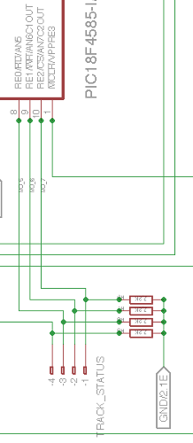

- GPIO 4 is used for KNOB0 where a value between 0 and 5V must be read.
- GPIO 3 is used for KNOB1 where a value between 0 and 5V must be read.
- GPIO 2 is used for CLK (or SCK) line.
- GPIO 1 is used for DIO (or SDA) line.

On the SPEED and INERTIA command or program, the numerical value can be replaced by KNOB0 or KNOB1, in which case the value read when the command is executed on GPIO 4 or 3 is used.

KNOB0 has a value between -15 and 15, where -15 is 0V and 15 is 5V
KNOB1 has a value between 0 and 100, where 0 is 0V and 100 is 5V

Negative value used on SPEED reverses the running direction. The lowest inertia value corresponds to the shortest time needed to change speed.

Warning: A FORW command with a negative value will result in a BACK side and a BACK command with a negative value will result in a FORW command

The corresponding values are sent to the 7-segments LEDS display

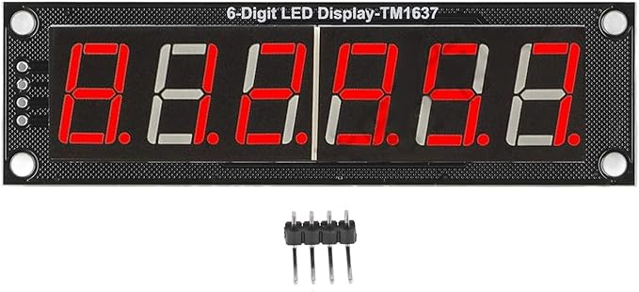
Figure 18 Led Display on TCO

The left side shows the value of KNOB0 and the right side of KNOB1
In MANUAL mode, speed and inertia have an immediate action on all the tracks
.
To calibrate the knobs, turn the min to max values of the two knobs and run the CALIB command. Calibration is saved in EEPROM. Need to be done once after firmware update.

Command

Programming DCC mode on a board

Description | This command allows you to configure a board to operate at the NMRA DCC standard. This action remains memorized when the power is off
Syntax | PROG <Board Number> DCC
Response | No response
Example | To configure board number 5 in DCC mode:  PROG 5 DCC

Programming ANA mode on a board

Description | This command allows you to configure a board to operate in analogic mode using PWM on track for speed setting. This action remains memorized when the power is off
Syntax | PROG <Board Number> ANA
Response | No response
Example | To configure board number 5 in ANA mode:  PROG 5 ANA

Programming AUTOMATIC mode on a board

Description | This command reactivates all AUTOFF-type commands and disables track control from the speed and inertia knobs.
Syntax | PROG <Board Number> AUT <Identifier> <Manual Status> <Event> ACT AUTOMATIC
Response | No response
Example | To configure board number 2 in AUTOMATIC mode based on GPIO 3 status  PROG 2 AUT MC AUTON BOARD 2 GPIO 3 0 ACT AUTOMATIC

Programming MANUAL mode on a board

Description | This command deactivates all AUTOFF-type commands and enables track control from the speed and inertia knobs. MANUAL0 also allows controlling only channel 0; otherwise, all four channels will be controlled by the knobs in this mode.
Syntax | PROG <Board Number> AUT <Identifier> <Manual Status> <Event> ACT MANUAL
Response | No response
Example | To configure board number 2 in MANUAL mode based on GPIO 3 status  PROG 2 AUT MC AUTON BOARD 2 GPIO 3 0 ACT MANUAL

Initialize a GPIO as output on a board

Description | This command allows you to configure a GPIO in output mode. This action remains memorized when the power is off (By default, the 4 GPIO are in input mode). Default value in output mode is 1.
Syntax | PROG <Board Number> GPIO <GPIO Number> OUT
Response | No response
Example | To configure GPIO 3 on board 5 in output mode  PROG 5 GPIO 3 OUT

Initialize a GPIO as input on a board

Description | This command allows you to configure a GPIO in input mode (default mode). This action remains memorized when the power is off  In input mode, the GPIO counts level changes from 0 to 255. To reset this counter to 0, simply initialize the GPIO to 0 as if it were an output GPIO, and the counter will be reset to zero.
Syntax | PROG <Board Number> GPIO <GPIO Number> IN
Response | No response
Example | To configure GPIO 3 on board 5 in input mode  PROG 5 GPIO 3 IN

Program an automatic action on a GPIO driven by a timer

Description | This command allows you to program an automatic change on GPIO output level when a timer is triggered. This action remains memorized when the power is off
Syntax | PROG <Board Number> AUT <Identifier> <Manual Status> BOARD <Board Number> TIMER <Timer Number> ACT GPIO <GPIO Number> <GPIO Level>
Response | No response
Example | To automatically switch the level of GPIO 3 of board 5 to level 1 when the TIMER 2 of board 2 is triggered  PROG 5 AUT Test AUTOFF BOARD 2 TIMER 2 ACT GPIO 3 1
Detail | PROG 5 => programming board number 5  AUT Test AUTOFF BOARD 2 TIMER 2 => when TIMER 2 of board 2 is triggered. This action is not active in manual mode  ACT GPIO 3 1 => GPIO 3 of board 5 is set to 1

Program an automatic action on a LPO driven by a timer

Description | This command allows you to program an automatic change on LPO output level when a timer is triggered. This action remains memorized when the power is off
Syntax | PROG <Board Number> AUT <Identifier> <Manual Status> BOARD <Board Number> TIMER <Timer Number> ACT LPO <LPO Number > <LPO Level>
Response | No response
Example | To automatically switch the level of GPIO 3 of board 5 to level 1 when the TIMER 2 of board 2 is triggered  PROG 5 AUT Test AUTON BOARD 2 TIMER 2 ACT LPO 3 1
Detail | PROG 5 => programming board number 5  AUT Test AUTON BOARD 2 TIMER 2 => when TIMER 2 of board 2 is triggered. This action is active in manual mode  ACT LPO 3 1 => LPO 3 of board 5 is set to 1

Program an automatic action on a track driven by a timer

Description | This command allows you to program an automatic change of track speed and direction when a timer is triggered. This action remains memorized when the power is off
Syntax | PROG <Board Number> AUT <Identifier> <Manual Status> BOARD <Board Number> TIMER <TIMER Number> ACT TRACK <Track Number> SPEED <Track Speed> <Track Dir> INERTIA <Inertia>
Response | No response
Example | To slowly change speed and direction of track 2 of board 5 to speed 10 and travel forward when the TIMER 2 of board 2 is triggered  PROG 5 AUT Test1 AUTOFF BOARD 2 TIMER 2 ACT TRACK 2 SPEED 10 FORW INERTIA 15
Detail | PROG 5 => programming board number 5  AUT Test1 AUTOFF BOARD 2 TIMER 2 => when TIMER 2 of board 2 is triggered. This action is not active in manual mode  ACT TRACK 2 SPEED 10 FORW INERTIA 15 => set track 2 for board 5 at speed 10 forward, 15 steps inertia to change speed
How | Speed and/or Inertia value(s) could be replaced by KNOB0 or KNOB1, in this case the value of the knob is read when the action is performed

Program on a timer driven by a timer

Description | This command allows you to program a timer when a timer (the same or another) is triggered. This action remains memorized when the power is off
Syntax | PROG <Board Number> AUT <Identifier> <Manual Status> BOARD <Board Number> TIMER <TIMER Number> ACT TIMER <TIMER Number> <TIMER delay>
Response | No response
Example | To set TIMER 3 on board 5 with a delay of 100 when the TIMER 2 of board 2 is triggered  PROG 5 AUT Test AUTOFF BOARD 2 TIMER 2 ACT TIMER 3 100
Detail | PROG 5 => programming board number 5  AUT Test AUTOFF BOARD 2 TIMER 2 => when TIMER 2 of board 2 is triggered. This action is not active in manual mode  ACT TIMER 3 100 => TIMER 3 is set up at value 100

Turn On or Off an automation driven by a timer

Description | This command allows you to turn on or off an automation when a timer (the same or another) is triggered. This action remains memorized when the power is off
Syntax | PROG <Board Number> AUT <Identifier> <Manual Status> BOARD <Board Number> TIMER <TIMER Number> ACT AUTOFF <Identifier>  PROG <Board Number> AUT <Identifier> BOARD <Board Number> TIMER <TIMER Number> ACT AUTON <Identifier>
Response | No response
Example | To turn on automation Test1 on board 5 when the TIMER 2 of board 2 is triggered  PROG 5 AUT Test AUTOFF BOARD 2 TIMER 2 ACT AUTON Test1
Detail | PROG 5 => programming board number 5  AUT Test AUTOFF BOARD 2 TIMER 2 => when TIMER 2 of board 2 is triggered. This action is not active in manual mode  ACT AUTON Test1 => turn on Test1

Program an automatic action on a GPIO driven by a change of level on a GPIO

Description | This command allows you to program an automatic change on GPIO output level when the level of a GPIO input has changed on a board. This action remains memorized when the power is off
Syntax | PROG <Board Number> AUT <Identifier> <Manual Status> BOARD <Board Number> GPIO <GPIO Number> <GPIO Level> ACT GPIO <GPIO Number> <GPIO Level>
Response | No response
Example | To automatically switch the level of GPIO 3 of board 5 to level 1 when the GPIO 2 of board 2 changes to level 0  PROG 5 AUT Test AUTOFF BOARD 2 GPIO 2 0 ACT GPIO 3 VAL 1
Detail | PROG 5 => programming board number 5  AUT Test AUTOFF BOARD 2 GPIO 2 0 => when GPIO 2 of board 2 is set to 0. This action is not active in manual mode  ACT GPIO 3 1 => GPIO 3 of board 5 is set to 1

Program an automatic action on a LPO driven by a change of level on a GPIO

Description | This command allows you to program an automatic change on LPO output level when the level of a GPIO input has changed on a board. This action remains memorized when the power is off.
Syntax | PROG <Board Number> AUT <Identifier> <Manual Status> BOARD <Board Number> GPIO <GPIO Number> <GPIO Level> ACT LPO <LPO Number> VAL <LPO Level>
Response | No response
Example | To automatically switch the level of LPO 3 of board 5 to level 1 when the GPIO 1 of board 2 changes to level 0  PROG 5 AUT Test AUTOFF BOARD 2 GPIO 1 0 ACT LPO 3 VAL 1
Detail | PROG 5 => programming board number 5  AUT Test AUTOFF BOARD 2 GPIO 1 VAL 0 => when GPIO 1 of board 2 is set to 0. This action is not active in manual mode  ACT LPO 3 1 => LPO 3 of board 5 is set to 1

Program an automatic action on a track driven by a level change on a GPIO

Description | This command allows you to program an automatic change of track speed and direction when the level of a GPIO input has changed on a board. This action remains memorized when the power is off
Syntax | PROG <Board Number> AUT <Identifier> <Manual Status> BOARD <Board Number> GPIO <GPIO Number> <GPIO Level> ACT TRACK <Track Number> SPEED <Track Speed> <Track Dir> INERTIA <Inertia>
Response | No response
Example | To quickly change speed and direction of track 2 of board 5 to speed 10 and travel forward when the GPIO 1 of board 2 changes to level 0 and reverse when the GPIO 1 of board 2 changes to level 1  PROG 5 AUT Test1 AUTOFF BOARD 2 GPIO 1 0 ACT TRACK 2 SPEED 10 FORW INERTIA 0  PROG 5 AUT Test2 AUTOFF BOARD 2 GPIO 1 1 ACT TRACK 2 SPEED 10 BACK INERTIA 0
Detail | PROG 5 => programming board number 5  AUT Test1 AUTOFF BOARD 2 GPIO 1 0 => Automation Test1 when GPIO 1 of board 2 is set to 0. Not active in manual mode  AUT Test2 AUTOFF BOARD 2 GPIO 1 1 => Automation Test2 when GPIO 1 of board 2 is set to 1. Not active in manual mode  ACT TRACK 2 SPEED 10 FORW INERTIA 0 => set track 2 for board 5 at speed 10 forward, immediate change  ACT TRACK 2 SPEED 10 BACK INERTIA 0 => set track 2 for board 5 at speed 10 backward, immediate change

Program an automatic action on a loco (DCC) driven by a level change on a GPIO

Description | This command allows you to program an automatic change of loco setting when the level of a GPIO input has changed on a board. This action remains memorized when the power is off
Syntax | PROG <Board Number> AUT <Identifier> <Manual Status> BOARD <Board Number> GPIO <GPIO Number> <GPIO Level> ACT DCC <DCC Standard Command>
Response | No response
Example | To speed up loco 3 at speed "0xF" forward on board 8 when the GPIO 1 of board 2 changes to level 0  PROG 8 AUT Test AUTOFF BOARD 2 GPIO 1 0 ACT DCC 0x03 0x6F
Detail | PROG 8 => programming board number 8  AUT Test AUTOFF BOARD 2 GPIO 1 0 => Automation Test when GPIO 1 of board 2 is set to 0. Not active in manual mode.  ACT DCC 0x03 0x6F => to speed up loco "0x3" at speed "0xF" forward

Program on a timer driven by a level change on a GPIO

Description | This command allows you to program a timer when the level of a GPIO input has changed on a board. This action remains memorized when the power is off
Syntax | PROG <Board Number> AUT <Identifier> <Manual Status> BOARD <Board Number> GPIO <GPIO Number> <GPIO Level> ACT TIMER <TIMER Number> <TIMER delay>
Response | No response
Example | To set TIMER 3 on board 5 with a delay of 100 when the GPIO 1 of board 2 changes to level 0  PROG 5 AUT Test1 AUTOFF BOARD 2 GPIO 1 0 ACT TIMER 3 VAL 100
Detail | PROG 5 => programming board number 5  AUT Test1 AUTOFF BOARD 2 GPIO 1 0 => Automation Test1 when GPIO 1 of board 2 is set to 0. Not active in manual mode.  ACT TIMER 3 100 => TIMER 3 is set up at value 100

Turn on or off an automation by a level change on a GPIO

Description | This command allows you to turn on or off an automation when the level of a GPIO input has changed on a board. This action remains memorized when the power is off
Syntax | PROG <Board Number> AUT <Identifier> <Manual Status> BOARD <Board Number> GPIO <GPIO Number> <GPIO Level> ACT AUTOFF <Identifier>  PROG <Board Number> AUT <Identifier> <Manual Status> BOARD <Board Number> GPIO <GPIO Number> <GPIO Level> ACT AUTON <Identifier>
Response | No response
Example | To turn off Test2 when the GPIO 1 of board 2 changes to level 0  PROG 5 AUT Test1 AUTOFF BOARD 2 GPIO 1 0 ACT AUTOFF Test2
Detail | PROG 5 => programming board number 5  AUT Test1 AUTOFF BOARD 2 GPIO 1 0 => Automation Test1 when GPIO 1 of board 2 is set to 0. Not active in manual mode  ACT AUTOFF Test2 => turn off Test2

Program an automatic action on a GPIO driven by a change of vehicle presence on a track

Description | This command allows you to program an automatic change on GPIO output when the presence of a vehicle has changed on a track. This action remains memorized when the power is off
Syntax | PROG <Board Number> AUT <Identifier> <Manual Status> BOARD <Board Number> TRACK <Track Number> STA <Vehicle Status> ACT GPIO <GPIO Number> <GPIO Level>
Response | No response
Example | To switch the level of GPIO 3 of board 5 to 1 when a vehicle is on track 1 of board 2 and to 0 when a vehicle is no more on track 1 of board 2  PROG 5 AUT Test1 AUTOFF BOARD 2 TRACK 1 STA ONTRACK ACT GPIO 3 1  PROG 5 AUT Test2 AUTOFF BOARD 2 TRACK 1 STA OFFTRACK ACT GPIO 3 0
Detail | PROG 5 => programming board number 5  AUT Test1 AUTOFF BOARD 2 TRACK 1 STA ONTRACK => Automation Test1 when a vehicle is on track 1 of board 2. Not active in manual mode  AUT Test2 AUTOFF BOARD 2 TRACK 1 STA OFFTRACK => Automation Test2 when a vehicle is no more on track 1 of board 2. Not active in manual mode  ACT GPIO 3 1 => GPIO 3 of board 5 is set to 1

Program an automatic action on a LPO driven by a change of vehicle presence on a track

Description | This command allows you to program an automatic change on LPO output when the presence of a vehicle has changed on a track. This action remains memorized when the power is off
Syntax | PROG <Board Number> AUT <Identifier> <Manual Status> BOARD <Board Number> TRACK <Track Number> STA <Vehicle Status> ACT LPO <LPO Number> <LPO Level>
Response | No response
Example | To switch the level of LPO 3 of board 5 to 1 when a vehicle is on track 1 of board 2 and to 0 when a vehicle is no more on track 1 of board 2  PROG 5 Test1 AUTOFF AUT BOARD 2 TRACK 1 STA ONTRACK ACT LPO 3 1  PROG 5 Test2 AUTOFF AUT BOARD 2 TRACK 1 STA OFFTRACK ACT LPO 3 0
Detail | PROG 5 => programming board number 5  AUT Test1 AUTOFF BOARD 2 TRACK 1 STA ONTRACK => Automation Test1 when a vehicle is on track 1 of board 2. Not active in manual mode  AUT Test2 AUTOFF BOARD 2 TRACK 1 STA OFFTRACK => Automation Test2 when a vehicle is no more on track 1 of board 2. Not active in manual mode  ACT LPO 3 1 => LPO 3 of board 5 is set to 1  ACT LPO 3 0 => LPO 3 of board 5 is set to 0

Program an automatic action on a track driven by a change of vehicle presence on a track

Description | This command allows you to program an automatic change of track, speed and direction when the presence of a vehicle has changed on a track. This action remains memorized when the power is off
Syntax | PROG <Board Number> AUT <Identifier> <Manual Status> BOARD <Board Number> TRACK <Track Number> STA <Vehicle Status> ACT TRACK <Track Number> SPEED <Track Speed> <Track Direction> INERTIA <Inertia>
Response | No response
Example | To change the speed and direction of track 3 to 10 and forward when a vehicle is on track 1 of board 2  PROG 5 AUT Test AUTOFF BOARD 2 TRACK 1 STA ONTRACK ACT TRACK 3 SPEED 10 DIR FORW INERTIA 5
Detail | PROG 5 => programming board number 5  AUT Test AUTOFF BOARD 2 TRACK 1 STA ONTRACK => Automation Test when a vehicle is on track 1 of board 2. Not active in manual mode  ACT TRACK 3 SPEED 10 FORW INERTIA 5=> set speed of track 3 to 10 forward, 5 steps inertia to change speed
How | Speed and/or Inertia value(s) could be replaced by KNOB0 or KNOB1, in this case the value of the knob is read when the action is performed

Program an automatic action on a loco (DCC) by a change of vehicle presence on a track

Description | This command allows you to program an automatic change of loco setting when the presence of a vehicle has changed on a track. This action remains memorized when the power is off
Syntax | PROG <Board Number> AUT <Identifier> <Manual Status> BOARD <Board Number> TRACK <Track Number> STA <Vehicle Status> ACT DCC <DCC Standard Command>
Response | No response
Example | To speed up loco 3 at speed "0xF" forward on board 8 when a vehicle is on track 1 of board 2  PROG 8 AUT Test AUTOFF BOARD 2 TRACK 1 STA ONTRACK ACT DCC 0x03 0x6F
Detail | PROG 8 => programming board number 8  AUT Test AUTOFF BOARD 2 TRACK 1 STA ONTRACK => Automation Test when a vehicle is on track 1 of board 2. Not active in manual mode  ACT DCC 0x03 0x6F => to speed up loco "0x3" at speed "0xF" forward

Program on a timer driven by a change of vehicle presence on a track

Description | This command allows you to program a timer when the presence of a vehicle has changed on a track. This action remains memorized when the power is off
Syntax | PROG <Board Number> AUT <Identifier> <Manual Status> BOARD <Board Number> TRACK <Track Number> STA <Vehicle Status> ACT TIMER <TIMER Number> <TIMER delay>
Response | No response
Example | To set TIMER 3 on board 5 with a delay of 100 when a vehicle is on track 1 of board 2  PROG 8 AUT Test AUTOFF BOARD 2 TRACK 1 STA ONTRACK ACT TIMER 3 100
Detail | PROG 8 => programming board number 8  AUT Test AUTOFF BOARD 2 TRACK 1 STA ONTRACK => Automation Test when a vehicle is on track 1 of board 2. Not active in manual mode  ACT TIMER 3 100 => TIMER 3 is set up at value 100

Turn on or off an automation by a change of vehicle presence on a track

Description | This command allows you to turn on or off an automation when the presence of a vehicle has changed on a track. This action remains memorized when the power is off
Syntax | PROG <Board Number> AUT <Identifier> <Manual Status> BOARD <Board Number> TRACK <Track Number> STA <Vehicle Status> ACT AUTOFF <Identifier>  PROG <Board Number> AUT <Identifier> <Manual Status> BOARD <Board Number> TRACK <Track Number> STA <Vehicle Status> ACT AUTON <Identifier>
Response | No response
Example | To turn off Test1 when a vehicle is on track 1 of board 2  PROG 8 AUT Test AUTOFF BOARD 2 TRACK 1 STA ONTRACK ACT AUTOFF Test1
Detail | PROG 8 => programming board number 8  AUT Test AUTOFF BOARD 2 TRACK 1 STA ONTRACK => Automation Test when a vehicle is on track 1 of board 2. Not active in manual mode  ACT AUTOFF Test1 => Turn off Test1

Delete an automation on a board

Description | This command allows you to remove an automation on a board. This action remains memorized when the power is off
Syntax | PROG <Board Number> DEL <Number>
Response | No response
Example | To remove automation 3 on board 5 (List of automation could be retrieve using the Automation list command COM <Board Number> AUTLIST)  PROG 5 LED 3
Warning | Deleting an automation changes the number of the other automations, so you need to perform once again an AUTLIST command to know the new numbers

Force the value on a GPIO on a board

Description | This command allows you to set the level of a GPIO. This action remains valid until the board is stopped or an automatic action is triggered. When GPIO is in input mode, this command reset the counter when set to 0
Syntax | COM <Board Number> GPIO <GPIO Number> <GPIO Level>
Response if GPIO in output mode | No response
Example | To set GPIO 3 at level 1 on board 4  COM 4 GPIO 3 1

Create a timer on a board

Description | This command allows you to set a timer. This action remains valid until the board is stopped or the timer is triggered
Syntax | COM <Board Number> TIMER <Timer Number> <Timer delay>
Response if GPIO in output mode | No response
Example | To set TIMER 3 with a delay of 10 on board 4  COM 4 TIMER 3 10

Force the value on a LPO on a board

Description |  | This command allows you to set the level of a LPO. This action remains valid until the board is stopped or an automatic action is triggered
Syntax |  | COM <Board Number> LPO <LPO Number> <LPO Level>
Response |  | No response
Example |  | To set LPO 3 at level 1 on board 4  COM 4 LPO 3 1

Turn on an automation on a board

Description |  | This command allows you to turn on an automation. This action remains valid until the board is stopped or an automatic action is triggered
Syntax |  | COM <Board Number> AUTON <Identifier>
Response |  | No response
Example |  | To turn on automation Test On board 4  COM 4 AUTON Test

Turn off an automation on a board

Description |  | This command allows you to turn off an automation. This action remains valid until the board is stopped or an automatic action is triggered
Syntax |  | COM <Board Number> AUTOFF <Identifier>
Response |  | No response
Example |  | To turn off automation Test On board 4  COM 4 AUTOFF Test

Force speed and direction on a track

Description | This command allows you to set the speed and direction on a track. This action remains valid until the board is stopped or an automatic action is triggered
Syntax | COM <Board Number> TRACK <Track Number> SPEED <Track Speed> <Dir> INERTIA <Inertia>
Response | No response
Response if board in DCC mode | Board <Board Number> Bad mode
Example | To set speed at 4 and direction forward on track 2 board 8  COM 8 TRACK 2 SPEED 4 FORW INERTIA 2
How | Speed and/or Inertia value(s) could be replaced by KNOB0 or KNOB1, in this case the value of the knob is read when the action is performed

Send a DCC command to a board

Description | This command allows you to send a DCC NMRA command to a board (all tracks). This action remains valid until the board is stopped or an automatic action is triggered
Syntax | COM <Board Number> DCC <DCC Stand Command>
Response | No response
Response if board in ANA mode | Board <Board Number> Bad mode
Example | To send a command to speed up loco 3 at speed "0xF" forward on board 8  COM 8 DCC 0x03 0x6F  To send a command to speed up loco 3 at speed "0xF" backward on board 8  COM 8 DCC 0x03 0x4F

Request the status of all the GPIOs on a board

Description | This command allows you to get the direction and the level of all the GPIOs on a board
Syntax | COM <Board Number> GSTAT
Response | Board <Board Number> GPIO 0 <GPIO Dir> VAL <GPIO Level> COUNT <GPIO Counter>  Board <Board Number> GPIO 1 <GPIO Dir> VAL <GPIO Level> COUNT <GPIO Counter>  Board <Board Number> GPIO 2 <GPIO Dir> VAL <GPIO Level> COUNT <GPIO Counter>  Board <Board Number> GPIO 3 <GPIO Dir> VAL <GPIO Level> COUNT <GPIO Counter>  Board <Board Number> KNOB0 VAL <knob value>  Board <Board Number> KNOB1 VAL <knob value>
Example | To get the status of all the GPIO of board 5  COM 5 GSTAT

Request the status of all the LPOs on a board

Description | This command allows you to get the direction and the level of all the LPOs on a board
Syntax | COM <Board Number> LSTAT
Response | Board <Board Number> LPO 0 VAL <LPO Level>  Board <Board Number> LPO 1 VAL <LPO Level>  Board <Board Number> LPO 2 VAL <LPO Level>  Board <Board Number> LPO 3 VAL <LPO Level>  Board <Board Number> LPO 4 VAL <LPO Level>  Board <Board Number> LPO 5 VAL <LPO Level>
Example | To get the status of all the LPO of board 5  COM 5 LSTAT

Request track status on a board

Description | This command allows you to get the direction and the speed and direction of all the tracks on a board if the board is in ANA mode
Syntax | COM <Board Number> TSTAT
Response | Board <Board Number> TRACK 0 SPEED <Track Speed> <Track Dir> <vehicle status>  Board <Board Number> TRACK 1 SPEED <Track Speed> <Track Dir> <vehicle status>  Board <Board Number> TRACK 2 SPEED <Track Speed> <Track Dir> <vehicle status>  Board <Board Number> TRACK 3 SPEED <Track Speed> <Track Dir> <vehicle status>
Example | To get the status of all the tracks of board 5  COM 5 TSTAT

Request board status

Description | This command allows you to get the status of a board to know if the running mode is DCC or ANA
Syntax | COM <Board Number> BSTAT
Response if DCC mode | Board <Board Number> DCC
Response if ANA mode | Board <Board Number> ANA
Example | To get the status of the board 5  COM 5 BSTAT

Request the list of actions programmed on a board

Description | This command allows you to get all the Automations stored in a board
Syntax | COM <Board Number> AUTLIST
Response if no data | No response
Response for each automation | Board <Board Number> <Number> <Identifier> ON  Board <Board Number> <Number> <Identifier> OFF
Example | To get the list of actions programmed on board 5  COM 5 AUTLIST

Request a dump of memory on a board

Description | This command allows you to get the content of Automations stored in a board in binary mode (reserved for PC application)
Syntax | COM <Board Number> DUMP
Response if no data | No response
Response for each automation | Board <Board Number> <Number> (<Number>,<Index>,<Data>)...
Example | To get the dump of board 5  COM 5 DUMP

Request a calibration of knobs

Description | This command is used to save the min and max values of knobs 0 and 1. To do this, turn both knobs to the min value and then to the max value and execute this command.
Syntax | CALIB <Board Number>
Response | No response
Example | To calibrate knobs of board 5  CALIB 5

Global command

Stop all

Description | This command will stop the activity on all the boards of the network
Syntax | STOP
Response | No response
Example | To stop all  STOP

Run all

Description | This command will start the activity on all the boards of the network
Syntax | RUNALL
Response | No response
Example | To run all  RUNALL

Run a specific board

Description | This command will start the activity on a specific board
Syntax | RUN <Board Number>
Response | No response
Example | To run board 5  RUN 5

Reset all automation of a specific board

Description | This command will delete all the automation on a specific board. Warning this action is performed immediately without any notification!
Syntax | RESET <Board Number>
Response | No response
Example | To reset board 5  RESET 5

Inconsistent programming

If an impossible automatic action is triggered, such as setting the speed and direction on the track of a board in DCC mode, or configuring a locomotive on a map in ANA mode, the action is simply ignored and a message is sent to the serial console:

- Unknown token
- Number missing
- Incomplete request
- Bad number
- Mode is missing
- Bad GPIO number
- Bad TIMER number
- Bad TIMER value
- Bad LPO number
- Bad Automation status
- Bad Automation name
- Automation name missing
- Bad GPIO direction
- Bad GPIO level
- Bad Low Power Output level
- Bad track speed
- Bad track direction
- Bad track number
- Bad fashion
- Wrong board number
- No more automation available
- Space missing
- Identifier is too long
- Automation already defined
- Wrong automation number
- Bad inertia value
- Bad user mode

Barraux's railway network (31/07/2025)

General System Structure
- The system uses several boards (from board 0 to board 3, plus a special board "MASTER 31").
- Each board controls:
  - Up to 4 tracks (tracks A0 to D3 for board 31, E0 to H3 for board 0, etc.)
  - 6 low-power outputs (LPO): for LEDs, lights, switch controls, etc.
  - 4 GPIO inputs: for buttons, optical sensors, contacts, etc.
  - 4 "Track Status" inputs: for 7-segment displays, speed and inertia potentiometers.
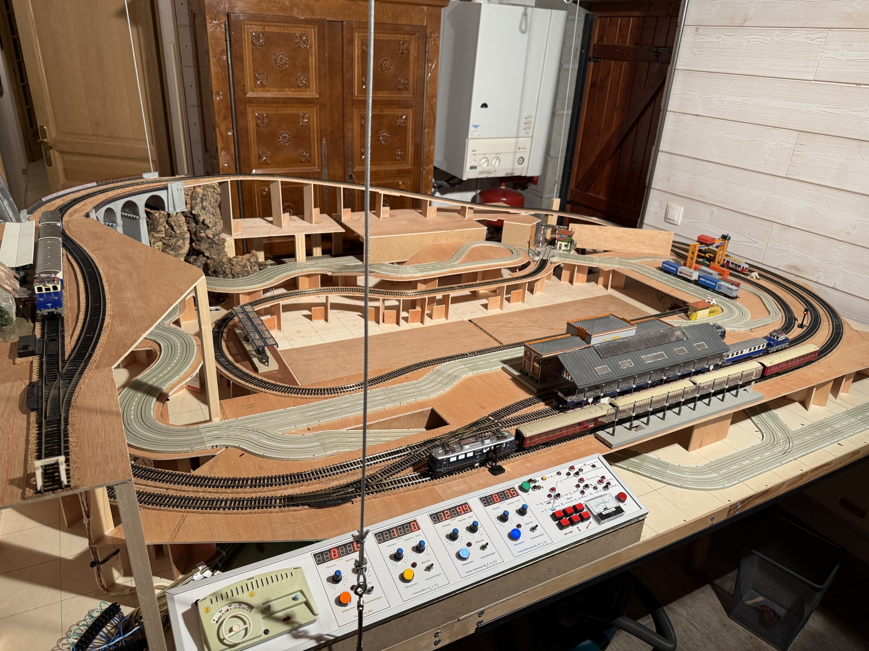
Figure 19 Railway network (31/07/2025)

⚙️ Operating Modes

▶️ Automatic Mode
Commands like:
Plaintext
CopyEdit
PROG <board> AUT <ID> AUTON/AUTOFF BOARD <n°> ... ACT ...
- Activates complex sequences with timing (TIMER), train detection (STA ONTRACK), rail actions (TRACK ... SPEED ...), LEDs (LPO ...), and I/O.
- Examples:
  - Launching a train based on a timer.
  - Controlling traffic lights (green/red) as trains pass.
  - Specific sequences for uncoupling wagons, level crossings, reversing locomotives, etc.

⏸️ Manual Mode
Commands like:
Plaintext
CopyEdit
PROG <board> AUT M<ID> AUTON BOARD <n°> ... ACT ...
- GPIO resets.
- Stops tracks (speed 0, inertia 0).
- Turns indicator LEDs on/off (e.g., start button LED, manual mode indicator).

🧠 Automation per Board

🟩 MASTER 31 Board
- Controls tracks A0 to D3.
- Coordinates all other boards.
- Includes an optical control panel (TCO).
- Automations: loop sequences with station wait times, signal light control, train restart, synchronized timers (TIMER 1, TIMER 2, etc.).

🟦 Board 0
- Controls tracks E0 to H3.
- Includes logic for uncoupling and coordination with board 1 (rack train).
- Advanced management of two trains coexisting on internal tracks.

🟨 Board 1
- Controls tracks I0 to L3.
- Detailed sequence for fully automatic locomotive reversal.
- Uses six timers (TIMER 1 to TIMER 6).
- Tightly coupled with boards 0 and 2.

🟧 Board 2
- Controls one tramway track (M0) and two temporary Faller AMS tracks.
- Extensive commands for level crossing lights, optical sensors, and regular back-and-forth sequences.
- Manages TCO LEDs to display tramway position.

🟥 Board 3
- Dedicated board for manual/automatic switch control.
- Examples: toggling between main and passing track, dual-press manual commands.

📌 TCO (Optical Control Panel) Commands
- Enable manual or automatic control of events like:
  - Triggering red lights.
  - Switches when a train arrives or departs.
  - Activating or stopping uncoupling actions.
- Prefixes:
  - M<i>: manual mode.
  - A<i>: automatic.
  - T<i>: TCO command.
  - D<i>: deactivatable (can be temporarily removed from execution logic).

📌 Programing the boards
A Qt application is available to send the programming code to the different boards via board 31. This application recognizes the boards' programming language, can check the syntax before sending the instructions, and includes a graphical visualization of the interconnections between the commands.

The Qt code is available in RailManagerUI, a customized version of the open-source project Scribe, described as:
A simple, user-friendly text editor.
GitHub Stars: https://github.com/AleksandrHovhannisyan/Scribe-Text-Editor/stargazers
Latest Release: https://github.com/AleksandrHovhannisyan/Scribe-Text-Editor/releases
This application also incorporates the QtNodes library, which has been modified to meet the specific needs of the project.
As of July 31, 2025, the application is still under development but already functional. It is configured for compilation on both macOS and Windows platforms.

Source Code and Project Access
The code, along with the entire development of this railway network, is available on the public GitHub repository:
https://github.com/PhilippeCavenel/RAIL-DRIVER

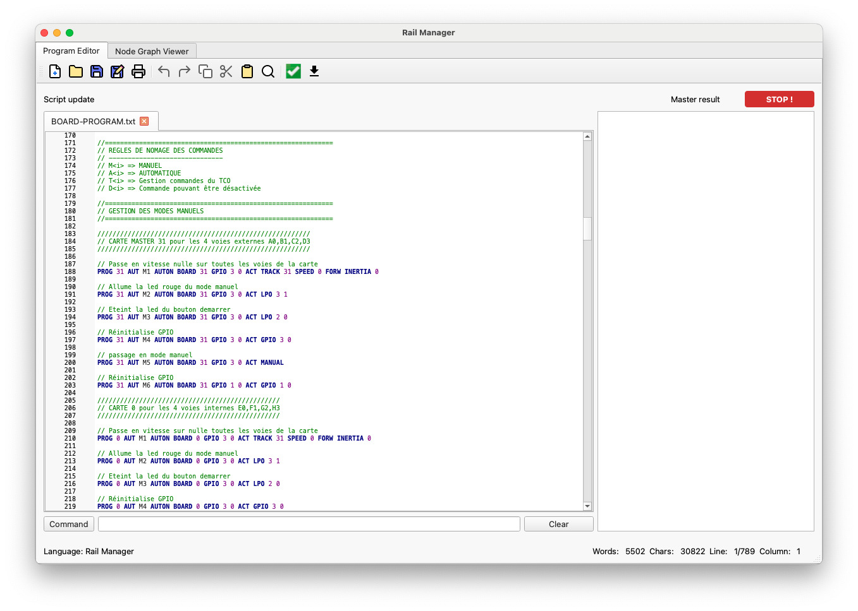
Figure 20 Rail Manager UI, sribe interface

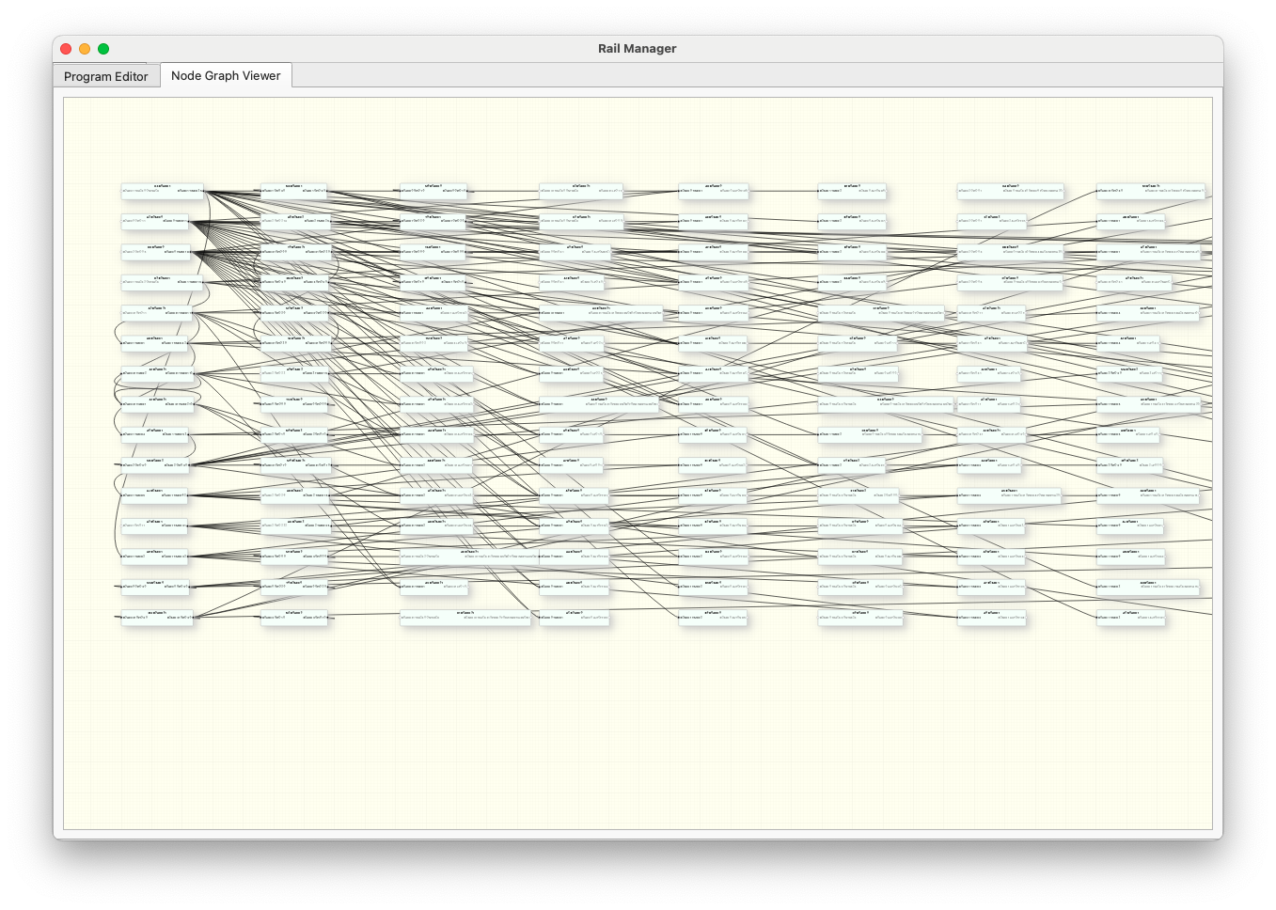
Figure 21 Rail Manager UI, node interface

By clicking on a node, you can easily view the interconnections.
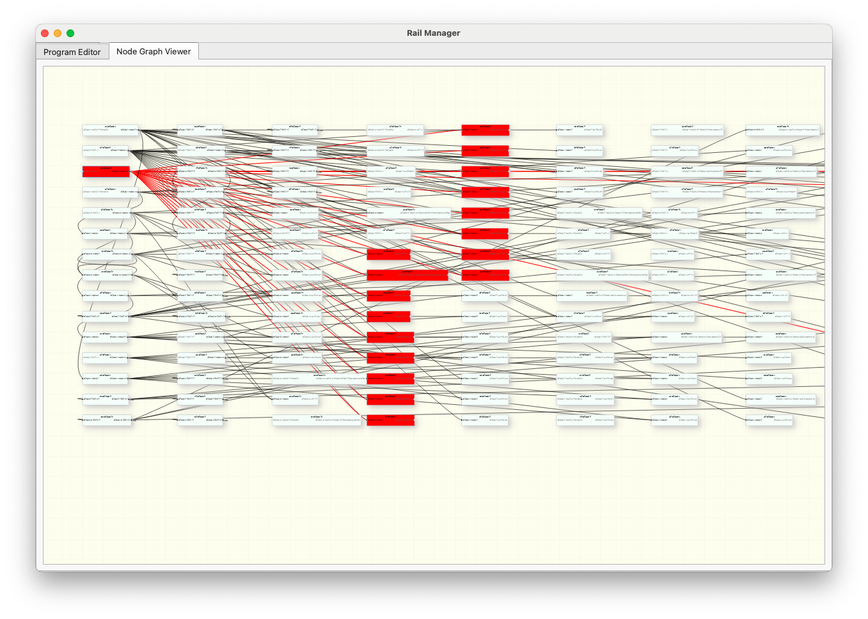
Figure 22 Rail Manager UI, node highlighted

Board Code (31/07/2025)

//================================================
//Runway number management
//Between 0 and 3, unique track number
//Between 17 and 31:
//17 = 0
//18 = 1
//19 = 1 0
//20 = 2
//21 = 2 0
//22 = 2 1
//23 = 2 1 0
//24 = 3
//25 = 3 0
//26 = 3 1
//27 = 3 1 0
//28 = 3 2
//29 = 3 2 0
//30 = 3 2 1
//31 = 3 2 1 0
//================================================

//================================================
//MASTER CARD AUTOMATION MANAGEMENT 31
//================================================

//Connect Rail 0 Lane A0
//Connect Rail 1 Lane B1
//Connect Rail 2 Way C2
//Connect Rail 3 D3 Way

//LPO 0 Green Light B1
//LPO 1 Red Light B1
//LPO 2 Led Blue Button
//LPO 3 Led manual mode
//LPO 4 stall wagon low circuit
//LPO 5 not connected

//GPIO input 0 Red CROSS Switch Button
//GPIO input 1 Blue start button
//GPIO input 2 CROSS turnout button black
//GPIO input 3 Contact manual mode

//Track Status 0 7-segment DIO display
//Track Status 1 7-segment CLK display
//Track Status 2 Inertia Potentiometer
//Track Status 3 Speed Potentiometer

//================================================
//MANAGEMENT OF CARD AUTOMATIONS 0
//================================================

//Connect Rail 0 Lane E0
//Connect Rail 1 Lane F1
//Connect Rail 2 Way G2
//Connect Rail 3 Way H3

//LPO 0 Green light E0
//LPO 1 Red Light E0
//LPO 2 Led White Button
//LPO 3 Led manual mode
//LPO 4 stall station rack top
//LPO 5 CROSS channel on F channel (0) / CROSS channel not connected

//GPIO input 0 Turnout button D3 / H3 and C2/ G2 red
//GPIO input 1 White start button
//GPIO input 2 D3 / H3 and C2/ G2 turnout button black
//GPIO input 3 Contact manual mode

//Track Status 0 7-segment DIO display
//Track Status 1 7-segment CLK display
//Track Status 2 Inertia Potentiometer
//Track Status 3 Speed Potentiometer

//================================================
//MANAGEMENT OF CARD AUTOMATIONS 1
//================================================

//Connect Rail 0 Lane I0
//Connect Rail 1 Lane J1
//Connect Rail 2 Way K2
//Connect Rail 3 Way L3
//LPO 0 Switch E0 / (E0) H1 and E0 / G2
//LPO 1 not connected (connected to a relay)
//LPO 2 Yellow Button Led
//LPO 3 Led manual mode
//LPO 4 Turnout I0 / J1 , K2
//LPO 5 not connected (connected to a relay)

//GPIO input 0 turnout E0 / (E0) H1 and E0 / G2
//GPIO input 1 Yellow Button
//GPIO input 2 turnout E0 / (E0) H1 and E0 / G2
//GPIO input 3 Contact manual mode

//Track Status 0 7-segment DIO display
//Track Status 1 7-segment CLK display
//Track Status 2 Inertia Potentiometer
//Track Status 3 Speed Potentiometer

//================================================
//MANAGEMENT OF CARD AUTOMATIONS 2
//================================================

//Connect Rail 0 Lane M0
//Connect Rail 1 Lane Car 1
//Connect Rail 2 Lane Car 2
//Connect Rail 3 Non-connected channel

//LPO 0 Level crossing barrier opening
//LPO 1 Barrier closure at level crossings
//LPO 2 Led Orange Button
//LPO 3 Led manual mode
//LPO 4 Led tram in front of crane
//LPO 5 Led tram in front of terminal station

//GPIO input 0 Optical detector
//GPIO input 1 Orange button
//GPIO input 2 Detection of tram passage in front of magnetic sensor
//GPIO input 3 Contact manual mode

//Track Status 0 7-segment DIO display
//Track Status 1 7-segment CLK display
//Track Status 2 Inertia Potentiometer
//Track Status 3 Speed Potentiometer

//================================================
//MANAGEMENT OF CARD AUTOMATIONS 3
//================================================

//Connect Rail 0 Unconnected Track
//Connect Rail 1 Unconnected Channel
//Connect Rail 2 Unconnected Track
//Connect Rail 3 Non-connected channel

//LPO 0 CROSS switch black
//LPO 1 red CROSS switch
//LPO 2 B1 / CROSS switch (black manual double support cmd)
//LPO 3 Switch B1 / CROSS (Red Cmd Manual Double Press)
//LPO 4 not connected (connected to a relay)
//LPO 5 D3/H3 and C2/G2 Turnout

//GPIO input 0 I0 / J1 switch , K2
//GPIO input 1 turnout I0 / J1 , K2
//GPIO input 2 Control stall wagon station rack high
//GPIO input 3 Low Circuit Wagon Stall Control

//Track Status 0 not logged in
//Track Status 1 not logged in
//Track Status 2 not logged in
//Track Status 3 not logged in

//============================================================
//GENERAL OPERATING PRINCIPLES FOR ALL CARDS
//============================================================

//Switching to manual mode
//- Passes all the channels on the map in zero speed
//- Lights up the red manual mode LED
//- Turned off the start button led
//- Resets all timers
//- Switching to manual mode

//Switching to automatic mode
//- Turns off the red led of the manual mode button
//- Switching to automatic mode
//- Pressing the start button
//- Lights up the start button led
//- Starts the programmed automatic sequence

//============================================================
//ORDER NAMING RULES
//// ------------------------------
//M<i> => MANUAL
//A<i> => AUTOMATIC
//T<i> => TCO Order Management
//D<i> => Command that can be disabled

//============================================================
//MANUAL MODE MANAGEMENT
//============================================================

////////////////////////////////////////////////////////
//MASTER BOARD 31 for the 4 external channels A0,B1,C2,D3
////////////////////////////////////////////////////////

//Zero-speed shifts on all lanes on the map
PROG 31 AUT M1 AUTON BOARD 31 GPIO 3 0 ACT TRACK 31 SPEED 0 FORW INERTIA 0

//Turns on the red manual mode LED
PROG 31 AUT M2 AUTON BOARD 31 GPIO 3 0 ACT LPO 3 1

//Turn off the start button led
PROG 31 AUT M3 AUTON BOARD 31 GPIO 3 0 ACT LPO 2 0

//Resets GPIO
PROG 31 AUT M4 AUTON BOARD 31 GPIO 3 0 ACT GPIO 3 0

//Switching to manual mode
PROG 31 AUT M5 AUTON BOARD 31 GPIO 3 0 ACT MANUAL

//Resets GPIO
PROG 31 AUT M6 AUTON BOARD 31 GPIO 1 0 ACT GPIO 1 0

////////////////////////////////////////////////
//MAP 0 for the 4 internal channels E0,F1,G2,H3
////////////////////////////////////////////////

//Speed to zero all the lanes on the map
PROG 0 AUT M1 AUTON BOARD 0 GPIO 3 0 ACT TRACK 31 SPEED 0 FORW INERTIA 0

//Turns on the red manual mode LED
PROG 0 AUT M2 AUTON BOARD 0 GPIO 3 0 ACT LPO 3 1

//Turn off the start button led
PROG 0 AUT M3 AUTON BOARD 0 GPIO 3 0 ACT LPO 2 0

//Resets GPIO
PROG 0 AUT M4 AUTON BOARD 0 GPIO 3 0 ACT GPIO 3 0

//Switching to manual mode
PROG 0 AUT M5 AUTON BOARD 0 GPIO 3 0 ACT MANUAL

//Resets GPIO
PROG 0 AUT M6 AUTON BOARD 0 GPIO 1 0 ACT GPIO 1 0

/////////////////////////////////////////////////////////
//MAP 1 for the 4 lanes of the rack I0,J1,K2,L3
/////////////////////////////////////////////////////////

//Speed to zero all the lanes on the map
PROG 1 AUT M1 AUTON BOARD 1 GPIO 3 0 ACT TRACK 31 SPEED 0 FORW INERTIA 0

//Turns on the red manual mode LED
PROG 1 AUT M2 AUTON BOARD 1 GPIO 3 0 ACT LPO 3 1

//Turn off the start button led
PROG 1 AUT M3 AUTON BOARD 1 GPIO 3 0 ACT LPO 2 0

//Resets GPIO
PROG 1 AUT M4 AUTON BOARD 1 GPIO 3 0 ACT GPIO 3 0

//Switching to manual mode
PROG 1 AUT M5 AUTON BOARD 1 GPIO 3 0 ACT MANUAL

//Resets GPIO
PROG 1 AUT M6 AUTON BOARD 1 GPIO 1 0 ACT GPIO 1 0

///////////////////////////////////////////////////////////////////////
//MAP 2 for the tram track and the 2 temporary lanes Faller AMS
///////////////////////////////////////////////////////////////////////

//Speed to zero all the lanes on the map
PROG 2 AUT M1 AUTON BOARD 2 GPIO 3 0 ACT TRACK 31 SPEED 0 FORW INERTIA 0

//Turns on the red manual mode LED
PROG 2 AUT M2 AUTON BOARD 2 GPIO 3 0 ACT LPO 3 1

//Turn off the start button led
PROG 2 AUT M3 AUTON BOARD 2 GPIO 3 0 ACT LPO 2 0

//Resets GPIO
PROG 2 AUT M4 AUTON BOARD 2 GPIO 3 0 ACT GPIO 3 0

//Manual Mode(0)
PROG 2 AUT M5 AUTON BOARD 2 GPIO 3 0 ACT MANUAL0

//Resets GPIO
PROG 2 AUT M6 AUTON BOARD 2 GPIO 1 0 ACT GPIO 1 0

//Off display of the TCO LEDs (position of the Tramway on the track)
PROG 2 AUT M7 AUTON BOARD 2 GPIO 3 0 ACT LPO 4 0
PROG 2 AUT M8 AUTON BOARD 2 GPIO 3 0 ACT LPO 5 0

//Close the barriers
PROG 2 AUT M9 AUTON BOARD 2 GPIO 3 0 ACT LPO 0 0
PROG 2 AUT MA AUTON BOARD 2 GPIO 3 0 ACT LPO 1 1

//============================================================
//AUTOMATIC MODE MANAGEMENT
//============================================================

/////////////////////////////////////////////////////////

//MASTER BOARD 31 for the 4 external channels A0,B1,C2,D3
//TIMER 1 => Waiting time at the station
//TIMER 2 => Running time on the tracks
//TIMER 3 => Deactivation uncoupling
////////////////////////////////////////////////////////

//Switching to automatic mode will reset all timers
PROG 31 AUT A0 AUTON BOARD 31 GPIO 3 1 ACT AUTOMATIC

//Turns off the red led of the manual mode button
PROG 31 AUT A1 AUTON BOARD 31 GPIO 3 1 ACT LPO 3 0

//Lights up the start button LED
PROG 31 AUT A2 AUTON BOARD 31 GPIO 1 1 ACT LPO 2 1

//Initiates the programmed automatic sequence

//// DESCRIPTION DE LA SEQUENCE
//// --------------------------
//On the start button, the train will perform turns for 10 timer time units (about 1mn20),
//then stop at the station for the same period before starting again

//TIMER Weapon 1 to initiate the boot cycle on channels A0, B1, C2 and D3
PROG 31 AUT A3 AUTOFF BOARD 31 GPIO 1 1 ACT TIMER 1 1

//Starts track train A0, B1, C2 and D3 on TIMER 1 activation according to TCO set values
PROG 31 AUT A4 AUTOFF BOARD 31 TIMER 1 ACT TRACK 31 SPEED KNOB0 FORW INERTIA KNOB1

//Transition from light to green
PROG 31 AUT A5 AUTOFF BOARD 31 TIMER 1 ACT LPO 1 0
PROG 31 AUT A6 AUTOFF BOARD 31 TIMER 1 ACT LPO 0 1

//TIMER 2 weapon to spin the train for 10 units
PROG 31 AUT A7 AUTOFF BOARD 31 TIMER 1 ACT TIMER 2 10

//Disables the stop at the station on track A0 train detection
PROG 31 AUT A8 AUTOFF BOARD 31 TIMER 1 ACT AUTOFF D1

//Disables Red light on A0 track train detection
PROG 31 AUT A9 AUTOFF BOARD 31 TIMER 1 ACT AUTOFF D2
PROG 31 AUT AA AUTOFF BOARD 31 TIMER 1 ACT AUTOFF D3

//Reactivates the stop at the station when the TIMER 2 is triggered
PROG 31 AUT AB AUTOFF BOARD 31 TIMER 2 ACT AUTON D1

//Reactivates the change from the light to red on track A0 train detection
PROG 31 AUT AC AUTOFF BOARD 31 TIMER 2 ACT AUTON D2
PROG 31 AUT AD AUTOFF BOARD 31 TIMER 2 ACT AUTON D3

//If the train is detected on track C2 because it received the stop command too late, it must be restarted for a turn
PROG 31 AUT AE AUTOFF BOARD 31 TRACK 2 STA ONTRACK ACT TRACK 31 SPEED KNOB0 FORW INERTIA KNOB1

//Resets TIMER 1 for a waiting time at the station of 10 units
PROG 31 AUT AF AUTOFF BOARD 31 TIMER 2 ACT TIMER 1 10

//Control can be disabled
//// --------------------------------

//Stop at the station on track A0, tracks A0, B1, C2 and D3 are gradually stopped
PROG 31 AUT D1 AUTOFF BOARD 31 TRACK 0 STA ONTRACK ACT TRACK 31 SPEED 0 FORW INERTIA KNOB1

//Changing the light to red on train detection track A0
PROG 31 AUT D2 AUTOFF BOARD 31 TRACK 0 STA ONTRACK ACT LPO 1 1
PROG 31 AUT D3 AUTOFF BOARD 31 TRACK 0 STA ONTRACK ACT LPO 0 0

/////////////////////////////////////////////////////////////////////
//MAP 0 for the 4 internal channels E0,F1,G2,H3
//TIMER 1 => normal mode of the channel
//TIMER 2 => Return of the locomotive to retrieve the detached cars
//TIMER 3 => deactivation of uncoupling actions
/////////////////////////////////////////////////////////////////////

//Switching to automatic mode will reset all timers
PROG 0 AUT A0 AUTON BOARD 0 GPIO 3 1 ACT AUTOMATIC

//Turns off the red led of the manual mode button
PROG 0 AUT A1 AUTON BOARD 0 GPIO 3 1 ACT LPO 3 0

//Normal board mode by press start button or automatic cogwheel train action
PROG 0 AUT A2 AUTOFF BOARD 0 GPIO 1 1 ACT TIMER 1 1

//Lights up the start button LED
PROG 0 AUT A3 AUTOFF BOARD 0 GPIO 1 1 ACT LPO 2 1

//Lights up the start button LED
PROG 0 AUT A4 AUTOFF BOARD 0 TIMER 1 ACT LPO 2 1

//Initiates the programmed automatic sequence

//// DESCRIPTION DE LA SEQUENCE
//// --------------------------
//By pressing the start button, the train will make turns until the cogwheel train leaves the upper station, in order to allow the latter to turn the locomotive over on the internal tracks. The train will restart when the cogwheel train returns to the central station.

//Start the train track E0, F1, G2 and H3
PROG 0 AUT A5 AUTOFF BOARD 0 TIMER 1 ACT TRACK 31 SPEED KNOB0 FORW INERTIA KNOB1

//Transition from light to green
PROG 0 AUT A6 AUTOFF BOARD 0 TIMER 1 ACT LPO 1 0
PROG 0 AUT A7 AUTOFF BOARD 0 TIMER 1 ACT LPO 0 1

//Disables stop at the station on train detection track F1
PROG 0 AUT A8 AUTOFF BOARD 0 TIMER 1 ACT AUTOFF D1

//Disables Red light change on F1 track train detection
PROG 0 AUT A9 AUTOFF BOARD 0 TIMER 1 ACT AUTOFF D2
PROG 0 AUT AA AUTOFF BOARD 0 TIMER 1 ACT AUTOFF D3

//Disables train restart on track H3 detection
PROG 0 AUT AB AUTOFF BOARD 0 TIMER 1 ACT AUTOFF D4

//Disabling controls for the cogwheel train
PROG 0 AUT AC AUTOFF BOARD 0 TIMER 1 ACT AUTOFF D5
PROG 0 AUT AD AUTOFF BOARD 0 TIMER 1 ACT AUTOFF D6
PROG 0 AUT AE AUTOFF BOARD 0 TIMER 1 ACT AUTOFF D7
PROG 0 AUT AF AUTOFF BOARD 0 TIMER 1 ACT AUTOFF D8
PROG 0 AUT AG AUTOFF BOARD 0 TIMER 1 ACT AUTOFF D9
PROG 0 AUT AH AUTOFF BOARD 0 TIMER 1 ACT AUTOFF DA
PROG 0 AUT AI AUTOFF BOARD 0 TIMER 1 ACT AUTOFF DB
PROG 0 AUT AJ AUTOFF BOARD 0 TIMER 1 ACT AUTOFF DC
PROG 0 AUT AK AUTOFF BOARD 0 TIMER 1 ACT AUTOFF DD

/////////////////////////////////////////////////////////////////////////////////////////////////////////
//These different commands are controlled from the 1 Rack card through TIMER 6 (when the cogwheel train leaves from the top station)
//Activates the stop at the station on F1 track train detection
PROG 0 AUT B0 AUTOFF BOARD 1 TIMER 6 ACT AUTON D1

//Activates the red light on F1 track train detection
PROG 0 AUT B1 AUTOFF BOARD 1 TIMER 6 ACT AUTON D2
PROG 0 AUT B2 AUTOFF BOARD 1 TIMER 6 ACT AUTON D3

//Activates the restart of the train on track detection H3
PROG 0 AUT B3 AUTOFF BOARD 1 TIMER 6 ACT AUTON D4

//Disables train restart on track H3 detection, because the cogwheel train is passing by
PROG 0 AUT B4 AUTOFF BOARD 1 TIMER 2 ACT AUTOFF D4

//Disables the train stop at the main station upon detection of the train on track F1, because the cogwheel train is passing by
PROG 0 AUT B5 AUTOFF BOARD 1 TIMER 2 ACT AUTOFF D1

//Activation of the controls for the cogwheel train as soon as timer 2 of the card 1 is activated
PROG 0 AUT B6 AUTOFF BOARD 1 TIMER 2 ACT AUTON D5
PROG 0 AUT B7 AUTOFF BOARD 1 TIMER 2 ACT AUTON D6
PROG 0 AUT B8 AUTOFF BOARD 1 TIMER 2 ACT AUTON D7
PROG 0 AUT B9 AUTOFF BOARD 1 TIMER 2 ACT AUTON D8
PROG 0 AUT BA AUTOFF BOARD 1 TIMER 2 ACT AUTON D9

/////////////////////////////////////////////////////////////////////////////////////////////////////////

//Control can be disabled
//// --------------------------------

//=> Automatic management of stall hidden circuit and E0 / (E0) H1 and E0 / G2 switches, see automatic TCO controls

/////////////////////////////////////////////////////////////////////////////////////////////////////////
//Normal management of the card for train stop at main station
//Stopping at the station, tracks E0, F1, G2 and H3 are gradually stopped on detection of train track F1
PROG 0 AUT D1 AUTOFF BOARD 0 TRACK 1 STA ONTRACK ACT TRACK 31 SPEED 0 FORW INERTIA KNOB1

//Turning the light to red on train detection track F1
PROG 0 AUT D2 AUTOFF BOARD 0 TRACK 1 STA ONTRACK ACT LPO 1 1
PROG 0 AUT D3 AUTOFF BOARD 0 TRACK 1 STA ONTRACK ACT LPO 0 0

//If the train is detected on track H3 because it received the stop command too late, it must be restarted for a turn
PROG 0 AUT D4 AUTOFF BOARD 0 TRACK 3 STA ONTRACK ACT TRACK 31 SPEED KNOB0 FORW INERTIA KNOB1
/////////////////////////////////////////////////////////////////////////////////////////////////////////

/////////////////////////////////////////////////////////////////////////////////////////////////////////
//Managing the Cogwheel Railway Card

//Rack and pinion gear start to stall hidden part
PROG 0 AUT D5 AUTOFF BOARD 1 TIMER 2 ACT TRACK 30 SPEED 5 BACK INERTIA 15

//Activation of the optical sensor reset function when the locomotive arrives on the H3 runway
PROG 2 AUT E0 AUTON BOARD 1 TIMER 2 ACT AUTON E1

//When the rack and pinion gear arrives on runway 3, the stall is activated (see TCO), the optical detector is reset, and the functions related to the optical sensors are activated
PROG 2 AUT E1 AUTON BOARD 0 TRACK 3 STA ONTRACK ACT GPIO 0 0

PROG 0 AUT D6 AUTOFF BOARD 0 TRACK 3 STA ONTRACK ACT AUTON DA
PROG 0 AUT D7 AUTOFF BOARD 0 TRACK 3 STA ONTRACK ACT AUTON DB
PROG 0 AUT D8 AUTOFF BOARD 0 TRACK 3 STA ONTRACK ACT AUTON DC
PROG 0 AUT D9 AUTOFF BOARD 0 TRACK 3 STA ONTRACK ACT AUTON DD

//When the locomotive passes over the optical sensor after the uncoupling system, the direction of the locomotive and switches is reversed and the uncoupling is stopped (see TCO)
PROG 0 AUT DA AUTOFF BOARD 2 GPIO 0 1 ACT TRACK 30 SPEED 6 FORW INERTIA 20

//The optical sensor's reset function is deactivated
PROG 2 AUT E2 AUTON BOARD 2 GPIO 0 1 ACT AUTOFF E1

//The second pass in front of the optical sensor stops the uncoupling (see TCO)

//When the locomotive passes over the other optical sensor, the switches are replaced correctly (see TCO) and the direction of the locomotive is reversed
PROG 0 AUT DB AUTOFF BOARD 2 GPIO 0 3 ACT TRACK 30 SPEED 4 BACK INERTIA 20

//As soon as the first wagon passes in front of the optical sensor, after uncoupling, we return to the central station

PROG 0 AUT DC AUTOFF BOARD 2 GPIO 0 5 ACT TRACK 30 SPEED 8 FORW INERTIA 0

//Back to the map's normal mode
PROG 0 AUT DD AUTOFF BOARD 2 GPIO 0 5 ACT TIMER 1 8

/////////////////////////////////////////////////////////
//MAP 1 for the 4 lanes of the rack I0,J1,K2,L3
//TIMER 1 => Waiting at the upper station before locomotive stall
//TIMER 2 => start of the rack and pinion mill to the centre tracks for rollover
//TIMER 3 => normal mode of the track
//TIMER 4 => locomotive backtracking start
//TIMER 5 => forward return start for locomotive hook-up
//TIMER 6 => Return to Central Station
/////////////////////////////////////////////////////////

//Switching to automatic mode will reset all timers
PROG 1 AUT A0 AUTON BOARD 1 GPIO 3 1 ACT AUTOMATIC

//Turns off the red led of the manual mode button
PROG 1 AUT A1 AUTON BOARD 1 GPIO 3 1 ACT LPO 3 0

//Lights up the start button LED
PROG 1 AUT A2 AUTOFF BOARD 1 GPIO 1 1 ACT LPO 2 1

//Initiates the programmed automatic sequence

//// DESCRIPTION DE LA SEQUENCE
//// -------------------------
//On the press of the start button, the cogwheel train leaves the main station to go to the upper station. After a waiting time of 5 units, the locomotive unhooks and positions itself at the back of the train to return to the central station. On arrival at the central station, after a waiting time of 5 units, the cogwheel train goes on the internal track for a stall of the locomotive and positioning at the front of the train on the hidden track before returning to the central station and then going directly back to the upper station

//TIMER 3 weapon for automatic normal mode triggering
PROG 1 AUT A3 AUTOFF BOARD 1 GPIO 1 1 ACT TIMER 3 1

//Correctly positions the top switches
PROG 1 AUT A4 AUTOFF BOARD 1 TIMER 3 ACT LPO 4 0

//Start the train (which must be somewhere on track I0 or L3 (station) )
PROG 1 AUT A5 AUTOFF BOARD 1 TIMER 3 ACT TRACK 31 SPEED 8 FORW INERTIA 20

//Active detection arrival at the top station and activation timer
PROG 1 AUT A6 AUTOFF BOARD 1 TIMER 3 ACT AUTON D2
PROG 1 AUT A8 AUTOFF BOARD 1 TIMER 3 ACT AUTON D3

//Deactivate train stop at Central Station
PROG 1 AUT A7 AUTOFF BOARD 1 TIMER 3 ACT AUTOFF D1

//Deactivates TIMER 2 cocking for low stall
PROG 1 AUT A9 AUTOFF BOARD 1 TIMER 3 ACT AUTOFF D4

//Disables Arrival Detection at the top station and activation timer
PROG 1 AUT AA AUTOFF BOARD 1 TIMER 1 ACT AUTOFF D2
PROG 1 AUT AB AUTOFF BOARD 1 TIMER 1 ACT AUTOFF D3

//Wagon stall start
PROG 1 AUT AC AUTOFF BOARD 1 TIMER 1 ACT TRACK 31 SPEED 4 FORW INERTIA 40

//TIMER 4 Locomotive Rear Weapon
PROG 1 AUT AD AUTOFF BOARD 1 TIMER 1 ACT TIMER 4 2

//locomotive reverse on TIMER 4 trigger
PROG 1 AUT AE AUTOFF BOARD 1 TIMER 4 ACT TRACK 31 SPEED 5 BACK INERTIA 10

//switch change on TIMER 4 trigger
PROG 1 AUT AF AUTOFF BOARD 1 TIMER 4 ACT LPO 4 1

//TIMER 5 weapon for locomotive forward return
PROG 1 AUT AG AUTOFF BOARD 1 TIMER 4 ACT TIMER 5 2

//Locomotive forward return at TIMER 5
PROG 1 AUT AH AUTOFF BOARD 1 TIMER 5 ACT TRACK 31 SPEED 4 FORW INERTIA 20

//switch change on TIMER 5 trip
PROG 1 AUT AI AUTOFF BOARD 1 TIMER 5 ACT LPO 4 0

//TIMER 6 weapon for locomotive final return
PROG 1 AUT AJ AUTOFF BOARD 1 TIMER 5 ACT TIMER 6 2

//Return of the train to the central station (platform I0, J1, K2 and L3)
PROG 1 AUT AK AUTOFF BOARD 1 TIMER 6 ACT TRACK 31 SPEED 5 BACK INERTIA 15

//Active train stop at Central Station
PROG 1 AUT AL AUTOFF BOARD 1 TIMER 6 ACT AUTON D1

//Active TIMER 2 cocking for low stall
PROG 1 AUT AM AUTOFF BOARD 1 TIMER 6 ACT AUTON D4

////////////////////////////////////////////////////////////////////////
//Start the train that passes on MAP 0
PROG 1 AUT AN AUTOFF BOARD 1 TIMER 2 ACT TRACK 31 SPEED 7 BACK INERTIA 15

//Disables Train Stop When Arriving at Central Station

PROG 1 AUT AO AUTOFF BOARD 1 TIMER 2 ACT AUTOFF D1

//TIMER 3 weapon for restoring the track to normal mode
PROG 1 AUT AP AUTOFF BOARD 1 TIMER 2 ACT TIMER 3 2

////////////////////////////////////////////////////////////////////////

//Control can be disabled
//// --------------------------------

//Train stop when arriving at Central Station (track I0, J1, K2 and L3)
PROG 1 AUT D1 AUTOFF BOARD 1 TRACK 0 STA ONTRACK ACT TRACK 31 SPEED 0 BACK INERTIA 100

//Detection of the train on track K, stop of tracks I0, J1, K2 and L3
PROG 1 AUT D2 AUTOFF BOARD 1 TRACK 2 STA ONTRACK ACT TRACK 31 SPEED 0 FORW INERTIA 20

//TIMER 1 weapon for waiting at the upper station for 5 units
PROG 1 AUT D3 AUTOFF BOARD 1 TRACK 2 STA ONTRACK ACT TIMER 1 5

//TIMER 2 weapon for stall sequence to the hidden part
PROG 1 AUT D4 AUTOFF BOARD 1 TRACK 0 STA ONTRACK ACT TIMER 2 5

///////////////////////////////////////////////////////////////////////
//MAP 2 for the tramway platform 0 and the 2 temporary Faller AMS tracks
//TIMER 1 => Waiting time in front of the main and intermediate stations on the outward journey
//TIMER 2 => Waiting time at the station in front of the crane
//TIMER 3 => Waiting time at the intermediate station on the return trip
///////////////////////////////////////////////////////////////////////

//Switching to automatic mode will reset all timers
PROG 2 AUT A0 AUTON BOARD 2 GPIO 3 1 ACT AUTOMATIC

//Turns off the red led of the manual mode button
PROG 2 AUT A1 AUTON BOARD 2 GPIO 3 1 ACT LPO 3 0

//Lights up the start button LED
PROG 2 AUT A2 AUTOFF BOARD 2 GPIO 1 1 ACT LPO 2 1

//Initiates the programmed automatic sequence

//// DESCRIPTION DE LA SEQUENCE
//// --------------------------
//By pressing the start button, and provided that the Tramway has been positioned in front of the central station, it will position itself in front of the tram station to the right of the central station, then follow a regular round trip cycle with a stop on the way to and from the intermediate station. Each stop is programmed on a timer of 5 units

//Start the tram to bring it back to the right, the tram should be in front of the train station
PROG 2 AUT A3 AUTOFF BOARD 2 GPIO 1 1 ACT TRACK 0 SPEED 5 BACK INERTIA 27

//Resets GPIO 2 for tram position counting
PROG 2 AUT A4 AUTOFF BOARD 2 GPIO 1 1 ACT GPIO 2 0

//Starts car lanes (temporary)
PROG 2 AUT A5 AUTOFF BOARD 2 GPIO 1 1 ACT TRACK 1 SPEED 5 FORW INERTIA 1
PROG 2 AUT A6 AUTOFF BOARD 2 GPIO 1 1 ACT TRACK 2 SPEED 6 FORW INERTIA 1

//Lights led TCO right M0
PROG 2 AUT A7 AUTOFF BOARD 2 GPIO 2 2 ACT LPO 5 1

//Stop the tram
PROG 2 AUT A8 AUTOFF BOARD 2 GPIO 2 2 ACT TRACK 0 SPEED 0 BACK INERTIA 27

//Weapon timer 1 waiting at the station
PROG 2 AUT A9 AUTOFF BOARD 2 GPIO 2 2 ACT TIMER 1 5

//Restarts the tram on timer 1 trigger
PROG 2 AUT AA AUTOFF BOARD 2 TIMER 1 ACT TRACK 0 SPEED 5 FORW INERTIA 27

//Off LED TCO right M0
PROG 2 AUT AB AUTOFF BOARD 2 GPIO 2 4 ACT LPO 5 0

//Intermediate station
PROG 2 AUT AC AUTOFF BOARD 2 GPIO 2 6 ACT TRACK 0 SPEED 0 FORW INERTIA 27

//Weapon timer 1 waiting at the intermediate station
PROG 2 AUT AD AUTOFF BOARD 2 GPIO 2 6 ACT TIMER 1 5

//Closes the barriers
PROG 2 AUT AE AUTOFF BOARD 2 GPIO 2 8 ACT LPO 0 0
PROG 2 AUT AF AUTOFF BOARD 2 GPIO 2 8 ACT LPO 1 1

PROG 2 AUT AG AUTOFF BOARD 2 TIMER 2 ACT LPO 0 0
PROG 2 AUT AH AUTOFF BOARD 2 TIMER 2 ACT LPO 1 1

//Open the barriers
PROG 2 AUT AI AUTOFF BOARD 2 GPIO 2 12 ACT LPO 0 1
PROG 2 AUT AJ AUTOFF BOARD 2 GPIO 2 12 ACT LPO 1 0

PROG 2 AUT AK AUTOFF BOARD 2 GPIO 2 20 ACT LPO 0 1
PROG 2 AUT AL AUTOFF BOARD 2 GPIO 2 20 ACT LPO 1 0

PROG 2 AUT AM AUTOFF BOARD 2 GPIO 2 2 ACT LPO 0 1
PROG 2 AUT AN AUTOFF BOARD 2 GPIO 2 2 ACT LPO 1 0

//Stop the tram
PROG 2 AUT AO AUTOFF BOARD 2 GPIO 2 14 ACT TRACK 0 SPEED 0 FORW INERTIA 27

//Left TCO LED light M0
PROG 2 AUT AP AUTOFF BOARD 2 GPIO 2 14 ACT LPO 4 1

//Weapon timer 2 waiting at the station
PROG 2 AUT AQ AUTOFF BOARD 2 GPIO 2 14 ACT TIMER 2 5

//Restarts the tram on timer 2 trigger
PROG 2 AUT AR AUTOFF BOARD 2 TIMER 2 ACT TRACK 0 SPEED 5 BACK INERTIA 27

//Off left TCO led M0
PROG 2 AUT AS AUTOFF BOARD 2 GPIO 2 16 ACT LPO 4 0

//Intermediate station return
PROG 2 AUT AT AUTOFF BOARD 2 GPIO 2 22 ACT TRACK 0 SPEED 0 FORW INERTIA 27

//Waiting timer 3 weapon at the intermediate station
PROG 2 AUT AU AUTOFF BOARD 2 GPIO 2 22 ACT TIMER 3 5

//Restarts the tram on timer 3 trigger
PROG 2 AUT AV AUTOFF BOARD 2 TIMER 3 ACT TRACK 0 SPEED 5 BACK INERTIA 27

//Resets GPIO 2 for new round-trip cycle
PROG 2 AUT AW AUTOFF BOARD 2 GPIO 2 24 ACT GPIO 2 0

///////////////////////////////////////////////////////////////////////
//MAP 3 SWITCHES
///////////////////////////////////////////////////////////////////////

PROG 3 AUT M1 AUTON BOARD 3 GPIO 0 0 ACT GPIO 0 0
PROG 3 AUT M2 AUTON BOARD 3 GPIO 1 0 ACT GPIO 1 0
PROG 3 AUT M3 AUTON BOARD 3 GPIO 2 0 ACT GPIO 2 0
PROG 3 AUT M4 AUTON BOARD 3 GPIO 3 0 ACT GPIO 3 0

//============================================================
//AUTOMATIC TCO ORDER MANAGEMENT
//============================================================

//Autopilot, stall, hidden circuit
PROG 31 AUT T1 AUTOFF BOARD 0 TIMER 1 ACT AUTOFF T2
PROG 31 AUT T2 AUTOFF BOARD 0 TRACK 3 STA ONTRACK ACT LPO 4 1
PROG 31 AUT T3 AUTOFF BOARD 1 TIMER 2 ACT AUTON T2
PROG 31 AUT T4 AUTOFF BOARD 2 GPIO 0 1 ACT AUTOFF T2
PROG 31 AUT T5 AUTOFF BOARD 2 GPIO 0 1 ACT LPO 4 0

//Automatic switch control E0 / (E0) H1 and E0 / G2
PROG 1 AUT T1 AUTOFF BOARD 0 TIMER 1 ACT AUTOFF T2
PROG 1 AUT T2 AUTOFF BOARD 2 GPIO 0 1 ACT LPO 0 1
PROG 1 AUT T3 AUTOFF BOARD 1 TIMER 2 ACT AUTON T2
PROG 1 AUT T4 AUTOFF BOARD 2 GPIO 0 4 ACT AUTOFF T2
PROG 1 AUT T5 AUTOFF BOARD 2 GPIO 0 3 ACT LPO 0 0

//Automatic control stall station rack and pinion high
PROG 0 AUT T1 AUTOFF BOARD 1 TIMER 1 ACT LPO 4 1
PROG 0 AUT T2 AUTOFF BOARD 1 TIMER 4 ACT LPO 4 0

PROG 3 AUT T1 AUTOFF BOARD 1 TIMER 2 ACT LPO 1 0
PROG 3 AUT T2 AUTOFF BOARD 1 TIMER 2 ACT LPO 0 1

//Automatic control B1 / CROSS
PROG 3 AUT T3 AUTOFF BOARD 31 GPIO 1 1 ACT LPO 2 1
PROG 3 AUT T4 AUTOFF BOARD 31 GPIO 1 1 ACT LPO 3 0
PROG 3 AUT T5 AUTOFF BOARD 31 GPIO 1 1 ACT LPO 2 1
PROG 3 AUT T6 AUTOFF BOARD 31 GPIO 1 1 ACT LPO 3 0

//Automatic control D3/H3 and C2/G2
PROG 3 AUT T7 AUTOFF BOARD 31 GPIO 1 1 ACT LPO 5 0
PROG 3 AUT T8 AUTOFF BOARD 0 GPIO 1 1 ACT LPO 5 0

//CROSS automatic control
PROG 3 AUT T9 AUTOFF BOARD 0 TIMER 1 ACT LPO 1 1
PROG 3 AUT TA AUTOFF BOARD 0 TIMER 1 ACT LPO 0 0

PROG 3 AUT TB AUTOFF BOARD 1 TIMER 2 ACT LPO 1 0
PROG 3 AUT TC AUTOFF BOARD 1 TIMER 2 ACT LPO 0 1

//============================================================
//MANUAL TCO ORDER MANAGEMENT
//============================================================

//Manual control stall hidden circuit
PROG 31 AUT T7 AUTON BOARD 3 GPIO 3 1 ACT LPO 4 1
PROG 31 AUT T8 AUTON BOARD 3 GPIO 3 0 ACT LPO 4 0

//GPIO reset
PROG 31 AUT T9 AUTON BOARD 31 GPIO 0 0 ACT GPIO 2 0
PROG 31 AUT TA AUTON BOARD 31 GPIO 2 0 ACT GPIO 0 0

//Manual control stall station rack and pinion high
PROG 0 AUT T3 AUTON BOARD 3 GPIO 2 1 ACT LPO 4 1
PROG 0 AUT T4 AUTON BOARD 3 GPIO 2 0 ACT LPO 4 0

//Manual control D3/H3 and C2/G2
PROG 0 AUT T5 AUTON BOARD 0 GPIO 0 0 ACT GPIO 0 0
PROG 0 AUT T6 AUTON BOARD 0 GPIO 2 0 ACT GPIO 2 0

//Manual control of E0 / (E0) H1 and E0 / G2 switches
PROG 1 AUT T7 AUTON BOARD 1 GPIO 2 1 ACT LPO 0 1
PROG 1 AUT T8 AUTON BOARD 1 GPIO 0 1 ACT LPO 0 0
PROG 1 AUT T9 AUTON BOARD 1 GPIO 2 0 ACT GPIO 2 0
PROG 1 AUT TA AUTON BOARD 1 GPIO 0 0 ACT GPIO 0 0

//Manual control of I0 / J1 , K2
PROG 1 AUT TB AUTON BOARD 3 GPIO 0 1 ACT LPO 4 1
PROG 1 AUT TC AUTON BOARD 3 GPIO 1 1 ACT LPO 4 0

//CROSS manual control
PROG 3 AUT TD AUTON BOARD 31 GPIO 0 1 ACT LPO 1 1
PROG 3 AUT TE AUTON BOARD 31 GPIO 2 1 ACT LPO 0 1
PROG 3 AUT TF AUTON BOARD 31 GPIO 2 1 ACT LPO 1 0
PROG 3 AUT TG AUTON BOARD 31 GPIO 0 1 ACT LPO 0 0

//Manual control D3/H3 and C2/G2
PROG 3 AUT TH AUTON BOARD 0 GPIO 0 1 ACT LPO 5 1
PROG 3 AUT TI AUTON BOARD 0 GPIO 2 1 ACT LPO 5 0

//Manual control B1 / CROSS
PROG 3 AUT TJ AUTON BOARD 31 GPIO 0 2 ACT LPO 2 1
PROG 3 AUT TK AUTON BOARD 31 GPIO 2 2 ACT LPO 3 1
PROG 3 AUT TL AUTON BOARD 31 GPIO 2 2 ACT LPO 2 0
PROG 3 AUT TM AUTON BOARD 31 GPIO 0 2 ACT LPO 3 0

