Invoice process:
Selling an item through an invoice settlement follows those steps:
- Select the item to sell
- Select Invoice payment
- Fill out the customer’s personal details
- Scan the destination address for that customer (either his existing address if he has one or the one from the paper wallet)
- Validate. On pop-up notifies that the invoice has been prepared
- Go to the manager application
- Go to the invoice menu, download and and hand-over the invoice to the customer
- When the payment is receieved, go to the invoice tab
- Click on transfer to initiate the transfer
- Insert any payment reference you may like and verify or change the destination address
- Check once again the destination address
- Validate

Select the payment per invoice
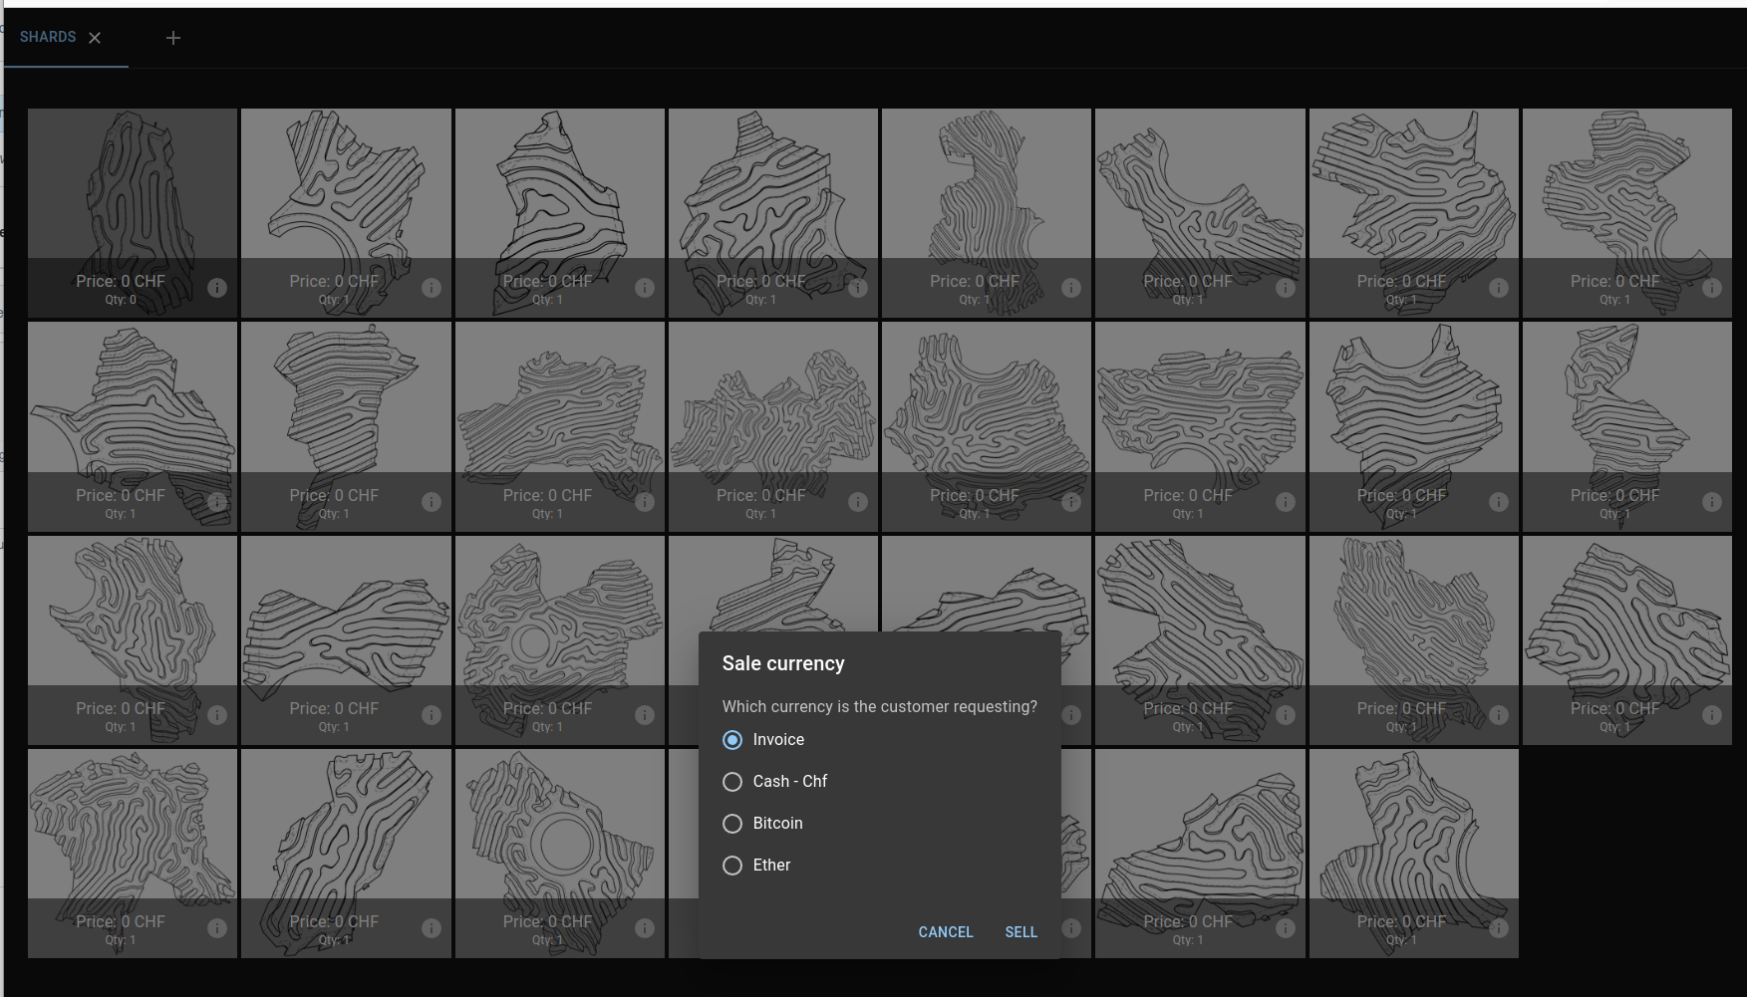

Enter the personal details
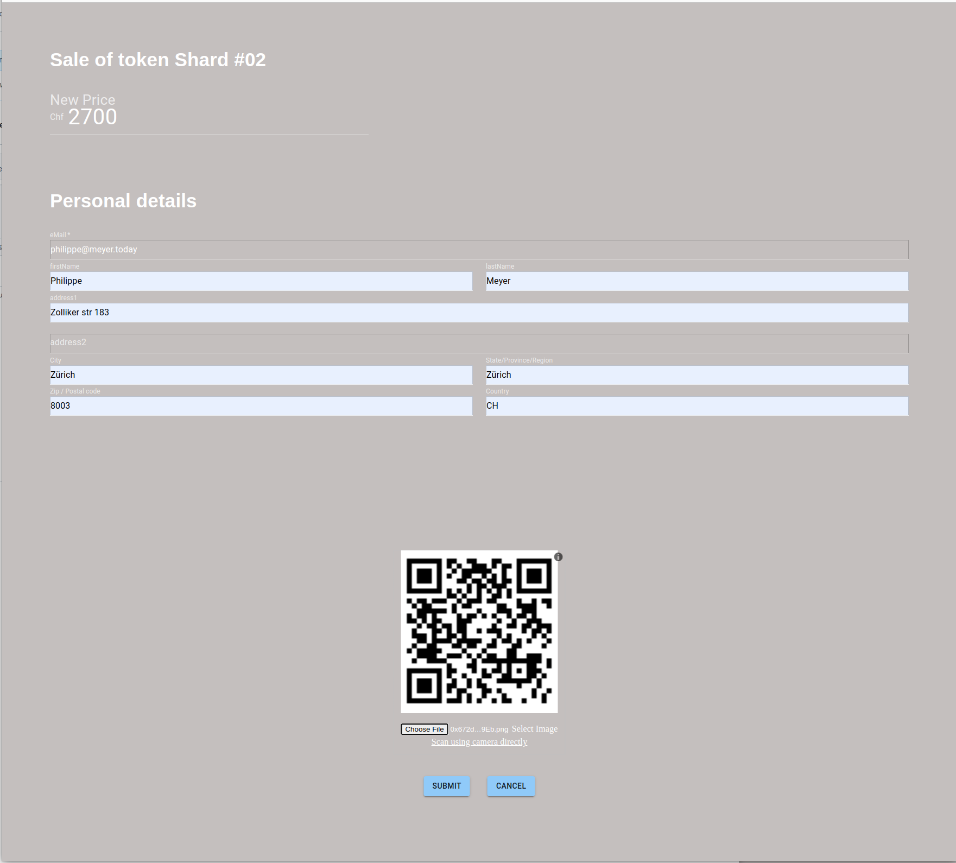

Hand-over the invoice to the customer
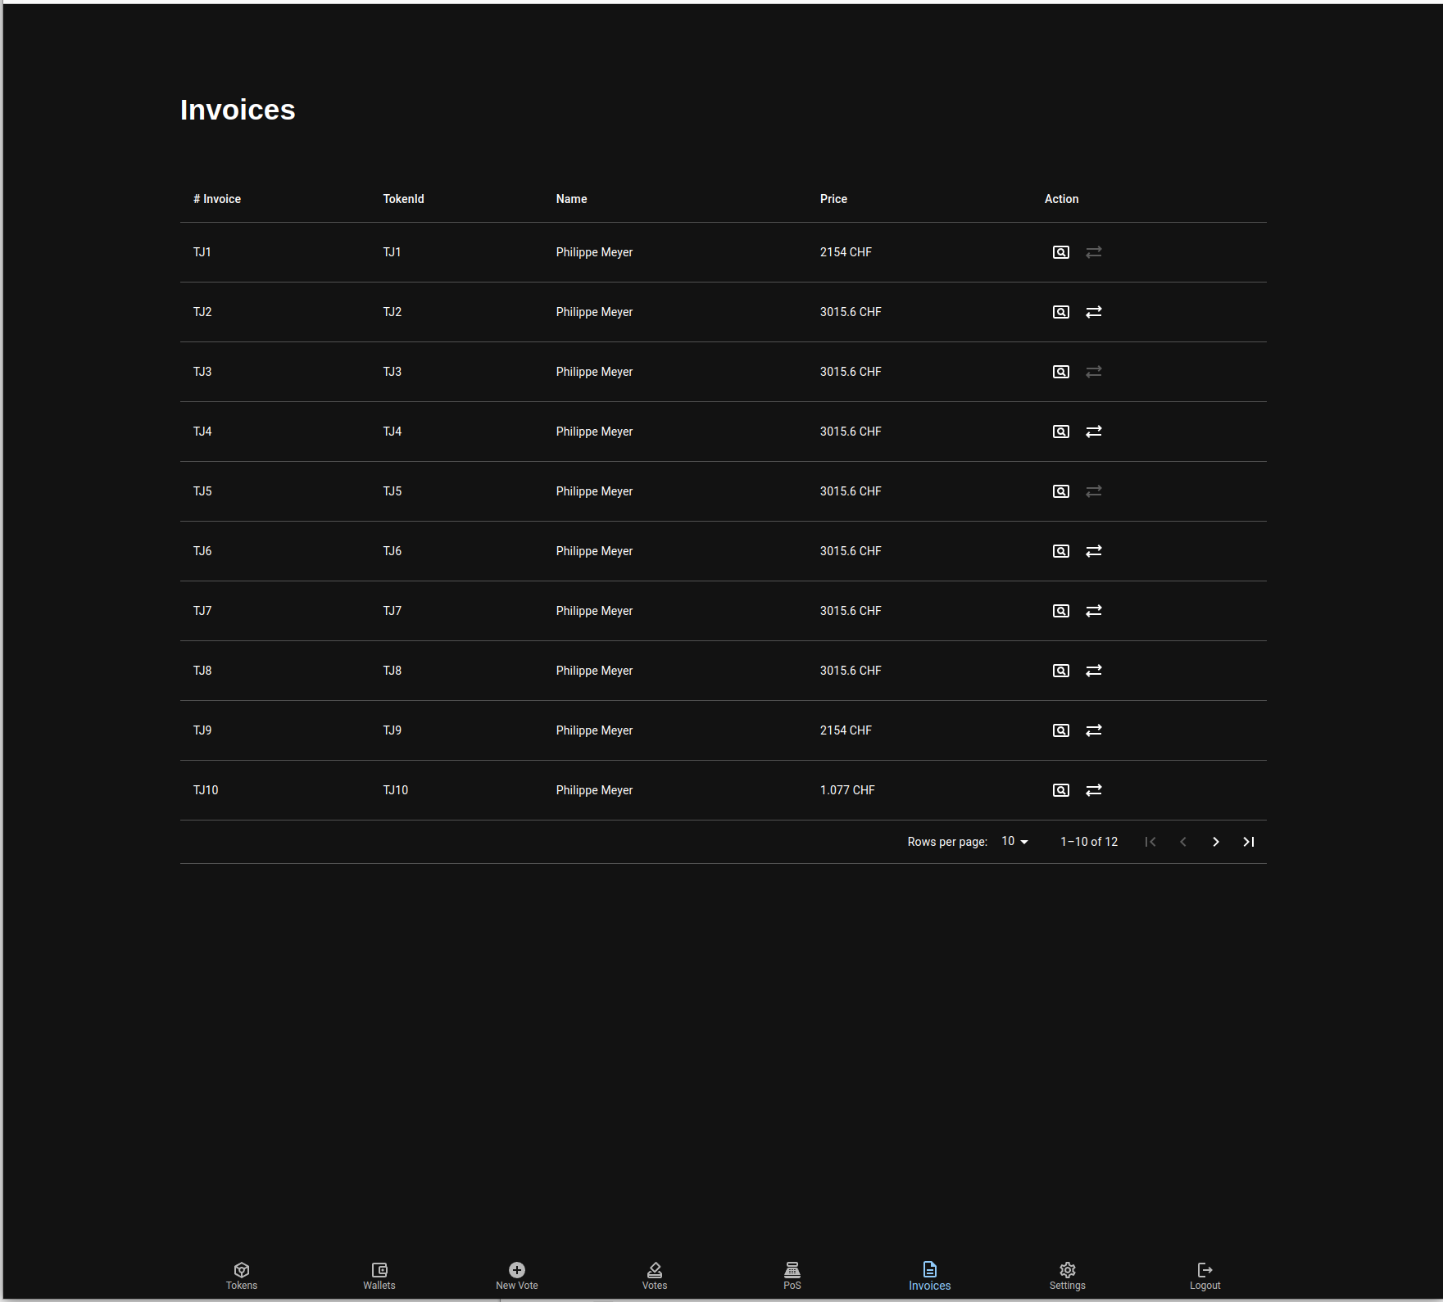

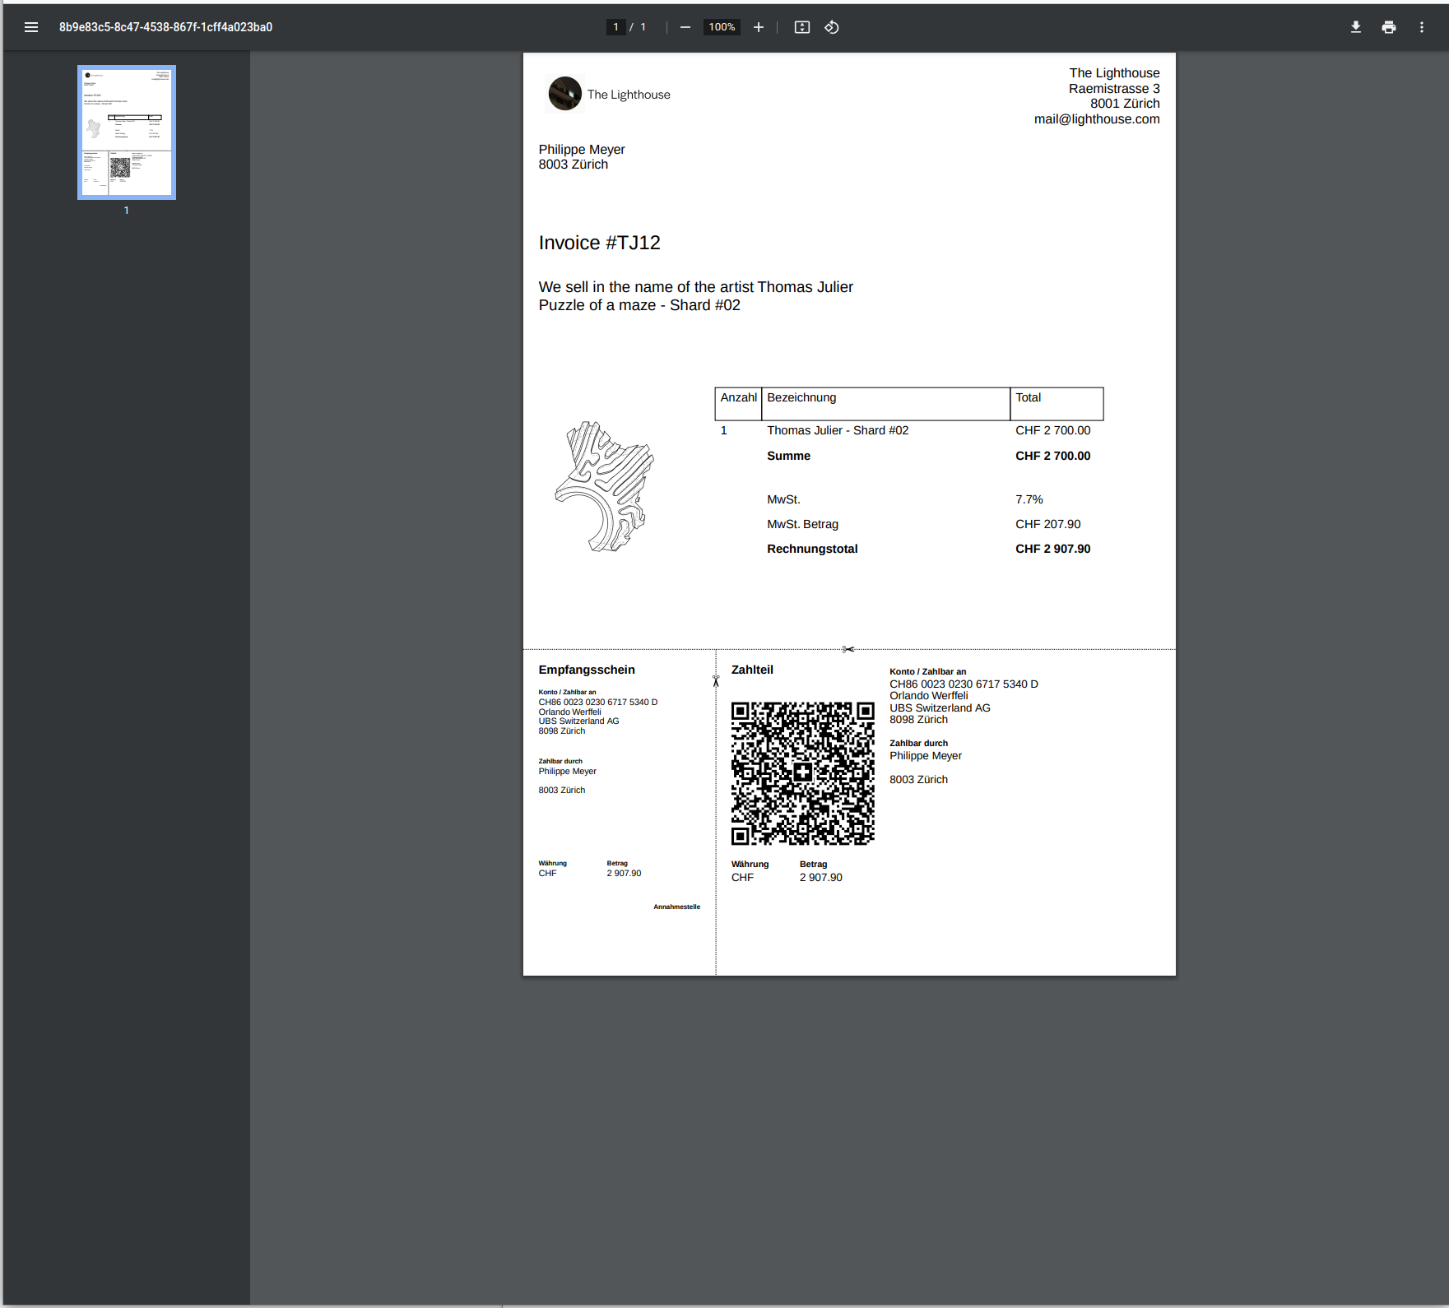

Perform the transfer once the payment has been received
The transfer button is disabled as the transfer has already been performed
Click here to perform a transfer when the paymant has been received

Enter or verify the destination address
