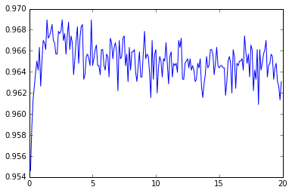

Accuracy as a function of C Value

Accuracy

C Value

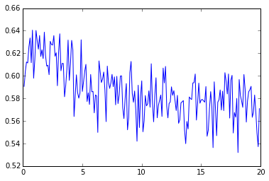

F Score as a function of C Value

F score

C Value

ROC AUC Score as a function of C Value

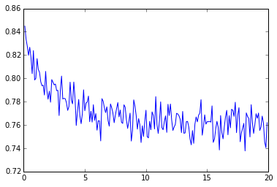

C Value

ROC AUC Score