ABSTRACT

With the aid of appropriate technology, there is never an end to gadgets that can be made 'smarter'. This paper introduces the design and creation of a futuristic interactive multimedia Smart Mirror with artificial intelligence. For the atmosphere at home as well as for industrial use in different industries. The project, which would collect computer data from the real world and the data would be transmitted from the machine and controlled by the Raspberry Pi.
The design and implementation of a 'Smart Mirror using Raspberry Pi' is mentioned in this paper. The computer acts as a digital display that simultaneously displays the required contents. by giving commands to the mirror, the user may communicate very easily with the mirror, so it can also be called an interactive display.
The Smart Mirror was introduced as a personalized digital system fitted with peripherals such as Raspberry PI, speakers, LED Monitor, microphone, covered with a sheet of reflective one-way mirror provides one of the most basic common amenities such as weather of the city, one of the sheets covered with a reflective one-way mirror offers one of the latest headlines or the latest updates of news local time or depending upon the user’s requirement as well as corresponding to the location.
With the aid of appropriate technology, there is never an end to gadgets that can be made 'smarter'. Many smart display devices exist, but while viewing information, mirrors provide an interactive environment. This paper presents the design and creation of a smart mirror with extra features using raspberry pi that include face recognition for protection and smart unlocking processes. The contents are seen on an LED display that is enclosed in a wooden frame and covered with a single-way reflective mirror sheet.

LIST OF FIGURES

S.NO | FIGURE NO. | FIGURE DESCRPTION | PAGE NO.
1 | 1.1 | Block diagram of the proposed project
2 | 3.1 | Raspberry Pi
3 | 3.2 | Two-way mirror
4 | 3.3 | Monitor
5 | 3.4 | Micro SD card
6 | 3.5 | Mouse & Keyboard
7 | 3.6 | The Frame

LIST OF ABBREVIATION, SYMBOLS AND NOMENCLATURE

S.NO | ABBREVIATION /SYMBOLS | DESCRIPTION
1 | IOT | Internet of things
2 | SPI | Serial peripheral interface
3 | GPS | Global Positioning System
4 | SSID | Service set identifier
5 | SD CARD | Secure Digital card
6 | DIY | Do it yourself
7 | USB | Universal Serial Bus

TABLE OF CONTENTS

Abstract | 1
List of figures | 2
List of symbols and abbreviations | 3
CHAPTER 01
Introduction | 5
CHAPTER 02
Literature survey | 8
CHAPTER 03
3.1 Components required
3.2 Hardware descriptions
CHAPTER 04

CHAPTER 01

INTRODUCTION

Advancement rate of technology is rapidly increasing so as to make life simpler and tasks easier. Society is moving a step ahead towards automation with every new invention or discovery.

Based on these advanced computing techniques for communication many modern-day devices are being designed and developed. Computerized, wireless connection embedded devices are being developed and used in everyday activities and are changing and improving health quality standards. These devices provide ease of access according to the user's requirement.

Many believe that technology advancement will lead to a smart and brighter future, whereas others believe and still debate replacement of human intelligence by computers and artificial intelligence-based technologies.

If we look around us and compare today's technology to that of olden days, we can notice that almost everything has undergone major changes. From wall clocks to wrist watches to smart watches. From waiting in line to make a trunk call to having a telephone connection at every residence to cordless telephones to modern day Mobile phones. From letters to Emails to messaging apps. From referring several books for information to Wikipedia. From maps and compass to GPS. We can also notice that the Internet has played a key role in all these developments. Almost all technologies to connect and interchange data these days are internet based and the concept is called Internet of Things. IOT has made smart watches, smart phones, smart bulbs, smart and automated vehicles etc. an essential part of our daily life.

Our everyday routine may include activities like getting news updates, weather updates, traffic updates etc. We use different forms of technology in almost all of these activities.
As a part of our daily routine, most of us spend a decent amount of time in front of a mirror to groom ourselves or maybe to just have a glance at ourselves, this way we are interacting with the mirror, psychologically.
In the above tasks we use separate smart devices everywhere except while grooming ourselves.

To reduce the number of devices and make use of time efficiently, as a part of home automation we can implement the idea of an AI based interacting Mirror.

This artificial Intelligence based interactive mirror would be able to provide news updates, weather updates, traffic updates, have personalized music or email or social media access by recognizing the person's face or voice, compliment the user etc.

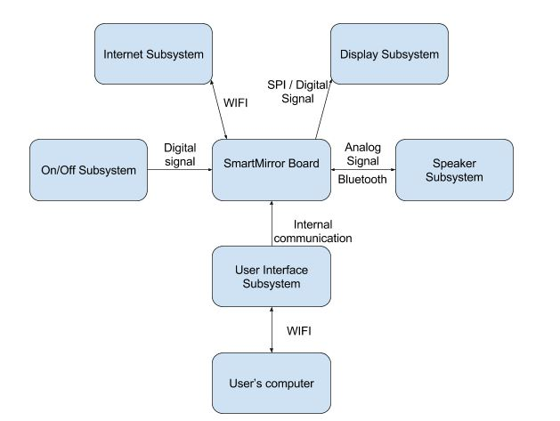
Fig. 1.1 block diagram of the proposed project

The overall system has been divided into five subsystems: On/Off Subsystem, Internet Subsystem, Subsystem for User Interface, Subsystem for Speakers, and Subsystem show. The connectivity of the whole system is shown in the figure.

To evaluate the SSID, the User Interface Subsystem takes user input, password, zip code, and a news source to view and write headlines from into memory that is nonvolatile. This data is read from memory and out of memory and passed to the Subsystem of the Internet. Link of the Internet Subsystem to the Internet Wi-fi and analyzes the time, temperature, and news headlines from the sources chosen in the Interface User. The knowledge parsed by the Internet Subsystem is stored in arrays that are stored the Display Subsystem can be printed onto the screens. The Subsystem On/Off runs a motion sensor is disconnected and decides whether the device is in sleep mode or active to pull and show data on the screens. There will be a Speaker Subsystem available for whenever the overall device is switched on, it is connected via Bluetooth.

The Internet of Things is a term described as a network (Internet) of linked physical objects of Things. It's always seen as the internet's next move. It has recently acquired a lot of popularity implies that most everyday objects will be connected to each other in the future. In coming future, we can be looking for smart ways, and will be able to communicate better. One of these would ultimately become the Smart Mirror related items in our households and whether we think of being able to interact with them the possibilities become infinite with other things.
A wall-mounted mirror that shows the weather, time, news and other areas of interest is known as a smart mirror. More and more devices have been connected to the Internet in recent years. The Internet has played an important role in linking more and more individuals worldwide. Our project aims to explore other areas where it is feasible to use this technology. It is supposed to use this technology in a mirror, since people spend a large amount of time in front of a mirror in general.
We see clocks mounted on the wall, we see displays at airports as well, and we are aiming to carry this technology to our homes. Another benefit of this system is that face recognition is offered.
This helps with security advantages for the customer. Smart mirror can also be helpful to quickly view your Google feeds or to reach Gmail accounts. The smart mirror will assist in the production of smart homes and eventually find a place in industry.

In modern culture, presentation and punctuality are two of the most valued values. However, while staying informed about current affairs and yet keeping a timely schedule, it can be difficult to efficiently plan for the day. In the morning, preparing for the day in front of a mirror, which is always a slow operation, is crucial. Furthermore, variables such as the current weather conditions may affect how a person is preparing for the day. It can be a challenge to find an effective way to check all the variables that can impact how an individual prepares for the day while also not adversely influencing the tasks carried out in front of a mirror.
The aim of our project was to develop a product that would provide fast and easy access to time, news, and weather while enabling an individual to go through their morning routine at the same time. Our project can increase performance while offering a practical and enjoyable user experience.
The idea is to have a mirror that is interactive and can respond to your commands. In order to combine everyday routine activities such as reading newspapers, receiving stock alerts, weather updates etc, Smart Mirror aims to improve the simple reflective mirror with embedded intelligence and to provide the user with all that knowledge as he/she gets ready.
Performance and efficiency are two characteristics that, as keywords are used to advertise their goods, are gradually establishing their dominance. A real selling point has been the fact that their product can multi-task or improve efficiency better than the competition. This is because successful time-management is a significant factor in rising day-to-day efficiency. The best time-management techniques include the opportunity to find time when there was no time before. Incorporating technology into the everyday lives of people has made it easier to manage time.
Using items such as tablets, PCs, and smartphones has provided people access to the resources they need to be effective. Although successful technological products have been used to improve productivity, however, it has also done its fair share to stifle it. On everyone's regular to-do list, the use of technology has become another job. Technology, not the other way around, should adhere to our schedule.
That is where the concept of the smart mirror originated. The smart mirror idea sought to easily incorporate technology into the lives of people by placing it where the routine of all, the bathroom, inevitably collides. The smart mirror's purpose is to maximize the efficiency of a consumer by saving them time.
According to a survey, we waste around half an hour on many activities after getting up, and these 30 minutes are also the time for us to focus in the mirror.
In order to require full use of this time, at the same time in the mirror, it can
This project indicates that a type of intelligence mirror can be used in the home to fully access the relative data of the day. The mirror will address the issues that many people face. Every day without distraction to get details. The user will want to know before going to bed if it will rain the next day so that they can plan accordingly. Mirror is a simple thing that is accessible at the home of everyone, take advantage of this technology to make it smart and use it more. We get all the alerts now-a-days on our smart phone that we go through on time, but it becomes a great haste to complete all morning activities during morning rush hours.
Smart mirrors can come in all sizes, from small mirrors for the table to complete mirrors for the bathroom. Smart mirrors are often referred to as magic mirrors, but both refer to the same thing.
Basically, the mirror acts like a regular mirror, but the scene shifts when someone stands in front of it. The mirror offers a user friendly, functional and interactive UI to access their social media, messengers etc. With the mirror, switching home appliances becomes simple. Digital dressing, a smart way to test your fashion sense, makes things in malls very convenient. The elegance of the home can only increase with such an intellectual mirror.
The raspberry pi is python programmed and connects to a display with incorporated speaker to have both an on-screen interface and voice assistance

CHAPTER 02

LITERATURE SURVEY
There are large numbers of technologies relevant to the work on this project that take users to automation and AI. Josep Cumeras I Khan built a magic mirror in June 2016. The key characteristics of this project is that the Mirror displays simple weather and time data, adds alarms, reminders or notes in a similar way to post-it notes on a refrigerator. The first question that occurs when introducing a smart mirror is, "What is the need for a smart mirror?" Technology has been an important part of daily life in recent years. In many electronic products, technology has been integrated into and has made it a basic necessity.
A Mirror was de-wrought by Suryansh Chandel, Ashay Mandwarya, s. Ushasukhanya. It can act as both a mirror and an interactive display that displays multimedia content simultaneously, such as time, date, weather and news. It can also be controlled by voice commands. We are developing a similar unit. The mirror will show news and weather updates in real time and date. The input for face recognition will be taken from the webcam.
The aim of creating a 'Smart Mirror' is to put technology into a traditional household mirror and make it smart. This introduced a new concept of a smart mirror: "a smart mirror is a mirror with extra features and functions, with the aim of introducing human interaction capabilities." There was always a need for a computer to be built to help organize a day's activities by performing other household activities. A mirror is one such location where we visit regularly and can therefore get basic information such as time, daily news and events, etc.
The smart mirror definition revolves around the growth of the Internet of Things (IoT). IoT is a physical computer network of electronic or software functions linked together for data exchange. IoT's primary goal is to establish a virtual route for all the devices connected to it to be connected. This offers a means of contact between people and things and between the objects themselves.
Another area that has IoT applications is home automated smart mirror. Although IoT implementations are complex, this study paper helps to make life simpler by using IoT. The mirror will show date and time, news reports, weather conditions, to-do lists, reminders, conditions of traffic, etc.
A mirror can be upgraded to act as a browser with the support of IoT. We can access the news or even watch videos on YouTube. A raspberry pi, which does not need large space, is the computer needed for computing.
Smart mirrors have tremendous potential to boost the user experience of data access and interaction. Not only do they allow users to quickly see relevant data, they can also be incorporated into a larger system, such as a home automation system.
The Smart Mirror system was developed by M. Yusri et al. It helps users to access data and monitor the lights as well. in your house. Related data such as time can be tracked, day, weather, alert, traffic, position map, and date. The machine uses Sonus technology as a means of interaction between individuals and structures.
Users need to have, therefore, instructions orally to the device to obtain the system’s a reply. Sonus is a text library speech that can be easily spoken to a VUI (Voice User Interface) is quickly added to any hardware or project with software. With this Smart Mirror device, it is possible for users to manage their everyday lives at ease and solve several problems issues with handling some house chores.
O. Gomez-Carmona, with D. It reflects the style and implementation of a smart mirror device for multiple users built to support fitness and healthy lifestyles throughout the via persuasion tactics, work atmosphere. The interactive mirror identifies numerous users by its interactive mirrors private corporate ID card, allowing them to have access to their custom user-interface
The Knowledgeable Mirror provides indoor environmental conditions for the workplace (thermal, moisture and light), personal physical activity knowledge obtained and general purpose from wearable devices data (e.g., weather and daily news). Furthermore, motivational guidelines relating to physical activity are submitted via request by speech-based application techniques for appreciation.
The Magic Memory Mirror, also known as Memomi, is another high-tech mirror on the list of currently available mirrors. This mirror is used in stores that sell clothes as a substitute for dressing rooms. Customers may use the smartphone application to communicate with the mirror. The mirror provides them with a 360-degree view of their outfits and the ability to change their looks by adjusting the color or adding accessories to the outfit.
There are also smaller-scale projects that require piecing components together to achieve the functionality of a smart mirror, in addition to the items listed above. These are often carried out as DIY programs and are used for individual purposes.

CHAPTER 03
REQUIRMENTS

3.1 COMPONENT DETAILS
Components required to design the required smart mirror with the given specifications are as follows:

S.NO | COMPONENTS | QUANTITY
1. | Raspberry Pi | 1
2. | Two-way mirror | 1
3. | Monitor | 1
4. | Micro SD card | 1
5. | Mouse & Keyboard | 1
6. | The Frame: | 1

Table 3.1. Components required for the hardware

3.2 HARDWARE DESCRIPTION

3.2.1. Raspberry Pi:
A Raspberry Pi is a small-sized computer originally developed for educational purposes. But eventually it was widely used in other areas because of its small size, low price, great processing power compared to its size, multiple interfaces and its simple design. Raspberry Pi is a series of small single-board computers produced in the United Kingdom in collaboration with Broadcom by the Raspberry Pi Foundation.

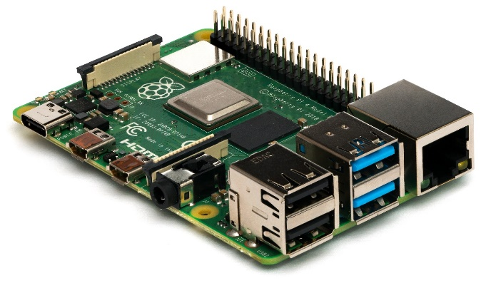
Fig. 3.1. Raspberry pi model
The Raspberry Pi hardware has developed through many iterations that include variations in the central processing unit type, memory capacity quantity, support for networking, and support for peripheral devices. While often pre-configured to act as a headless computer, any generic USB computer keyboard and mouse can also optionally control the Raspberry Pi. Depending on the installed device drivers in the underlying operating system, it can also be used with USB storage, USB to MIDI converters, and virtually any other device/component with USB capabilities.
The Pi is like a motherboard that has all the necessary components that make up a great CPU. It is the size of a credit card and can still act as a full-fledged device. Pi is designed using the Python language.

3.2.2 Two-way mirror:
A two-way mirror is a special mirror in which the glass is clear on one side and reflective on the other. It will appear as a normal mirror to the people who are looking at it through the reflective side, while people on the clear side can see through it just like a transparent glass.
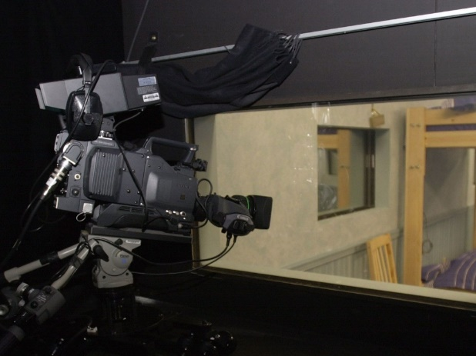
Fig.3.2. two-way mirror

3.2.3 Monitor
A monitor is connected to display the contents of the smart mirror. This can be connected to the Raspberry pi using HDMI cable. The role of the monitor is to facilitate the user's contact with the computer. User input is provided by the mouse and keyboard. The display provides a way for the user to connect with the device.
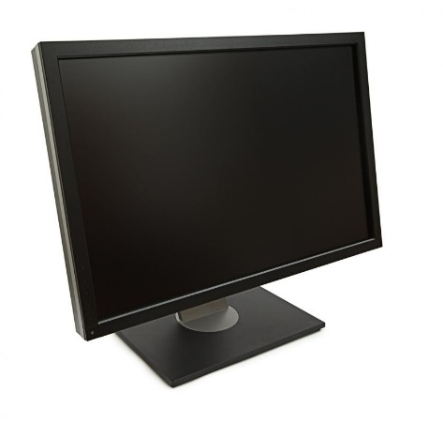
Fig. 3.3. monitor display

3.2.4 Micro SD card
The operating system "Raspbian" has to be installed on the micro-SD card. It should be inserted in the SD card slot on the Raspberry pi module. Officially abbreviated as SD, Stable Digital is a proprietary non-volatile memory card format developed for use in portable devices by the SD Association.
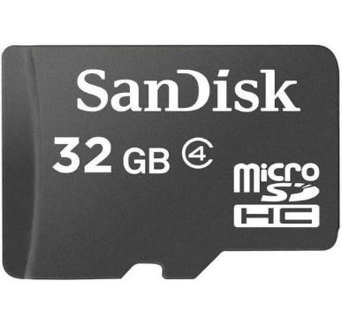
Fig.3.4. SD Card

3.2.5 Mouse & Keyboard:
A keyboard and mouse are important computer peripherals that allow your computer programs to search and navigate.

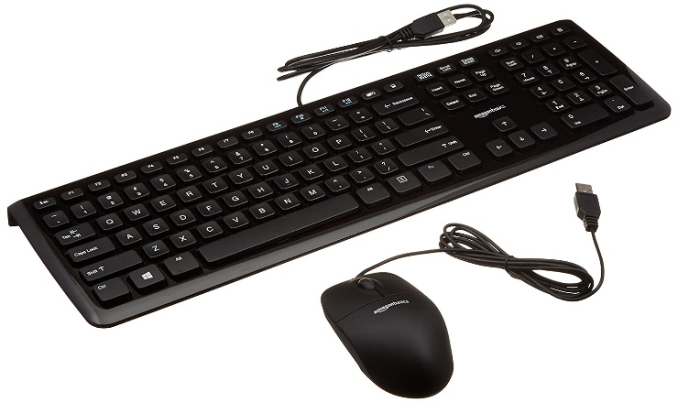
Fig.3.5 mouse and keyboard

3.2.6. The Frame:
Depending on the size of the monitor, one is required to cut the mirror to size around a half an inch larger (width and length wise) than the monitor.
Once the frame has been set and is stable, sandwich the mirror between the frame and the monitor. Screw in the 3D brackets, making sure they are firmly placed.
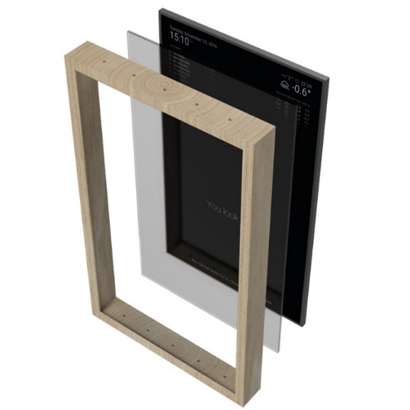
Fig. 3.6 Wooden frame

CHAPTER 04

PROPOSED METHODOLOGY
4.1. PREPOSITION
The idea behind our smart mirror is to display information such as time, date, weather, and list of tasks to be done on a mirror display. This is the basic information we need not only in the morning, but throughout the day as well. Making the most of the time we have available during the day is important when it comes to being successful and efficient, and this project is a perfect example of how technology can make our lives easier and ease our everyday routines.
The construction of the system is carried out in two parts. The first part deals with the configuration of the box that is used as a display, control board, and mirror container. Both the monitor and Raspberry Pi need to be put inside the box and protected when moving the box around to prevent any potential harm to any of the components.
The mirror will cover the front of the box until these two components are fixed. Any detail on the mirror that is to be shown will actually be reflected on the monitor. The mirror's features are such that the front side is opaque and functions like a mirror, while the back side is translucent, such that everything that is reflected on the display can be shown on the surface of the mirror. The mirror must therefore be positioned directly on the monitor to ensure that all the information is visible.
In addition to this, the control board and display power cables will have openings in the box. In addition, since Raspberry Pi has many USB ports that may be needed for system manual configuration for keyboard or mouse, the box has a side opening.
To prevent any future the box would have compartments for the display and control board movements that could cause damage to these components to ensure they remain in place. The box will be covered with this cover until all components are put inside, thereby holding everything inside the box in one place.
The second aspect of the design is designing the application. Since the aim is to provide a mirror that displays some details, the design must ensure that the current mirror surface, which covers the display, is used in the most effective way. It is important to arrange the information to be presented in such a way that the monitor display area is used efficiently and that it does not stand in the way of one's reflection. Therefore, thorough preparation of the layout is a must. The best way to do this is to put these pieces of information in the display corners, leaving the middle portion of the display surface bare, so that the reflection of people in the mirror is clearly visible.
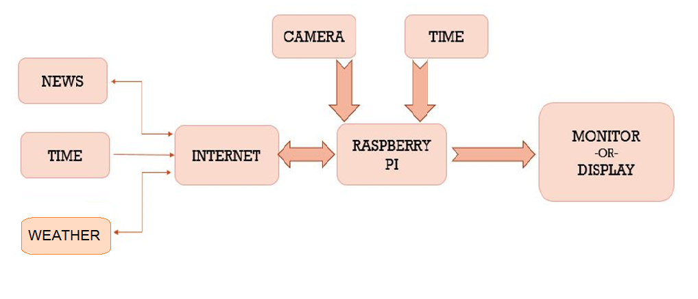
The Block diagram is divided into 3 sections, The internet, The Modular section and the Display.
In the first section we are considering only the components that provide the major setup for the model, the News, Time and Weather modules are default modules along with few modules which have been provided as 3rd party module to the model, here its easier for the model to accumulate applications to the mirror making the interface easier.
The Modular section contains the exterior connections to the keyboard mouse and camera as well. The raspberry pi used is configured to power at 230V and 50 Hz. The OS used is Raspbian with a 32 gb memory. It acts as the platform for smart mirror configurations. The processing is listed below.
The display is a simple section that protrudes the activity of the Raspbian and also lets the user to copy and edit the modules in the file.
4.2. FUNCTIONAL OVERVIEW
It works as a normal reflective mirror so that the user can use it as a regular mirror. The two-way mirror acts both as a reflective surface as well as transparent to display the updates.
Everyone using this mirror will get real time updates.
User will be able to give commands to the mirror using the microphone in the raspberry pi 3 for appliances control.
The proposed mirror is designed to perform
a) Mimic a natural mirror interface
b) A flat monitor is used for the mirror display. A one-way mirror is used to provide real time display of what is located in front of the Smart Mirror using Raspberry Pi thereby mimicking the
function of a regular mirror.
c) Personalized Information services: Users will be able to obtain minute updates of latest news and public headlines, weather reports as well as get reports of our interests.
d) Customized management of profiles: Users can create their own profiles and store them in the system. According to this profile, customized services are provided to the user.
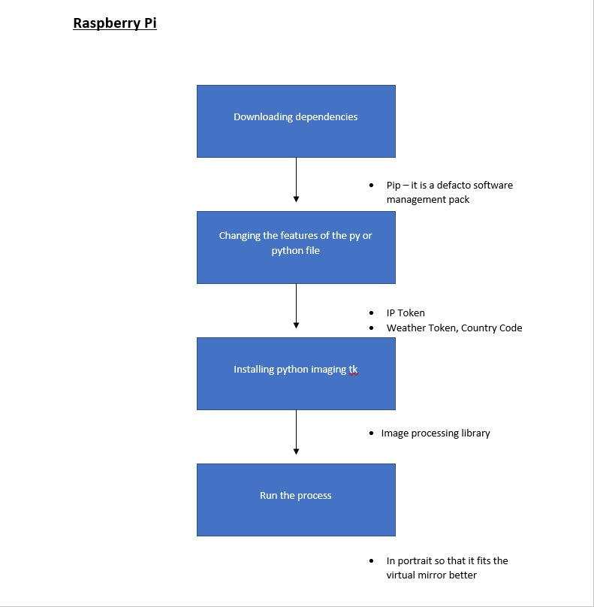

INCULCATION OF AI
Furthermore, in the course of the project the team is looking forward to inculcate AI components for facial recognition and speech to text vice-versa so that it allows the user to interact with the mirror. Conversion is not only it a smart but a self-thinking, self-taught mirror which satisfies a basic set oof requirement for the user.

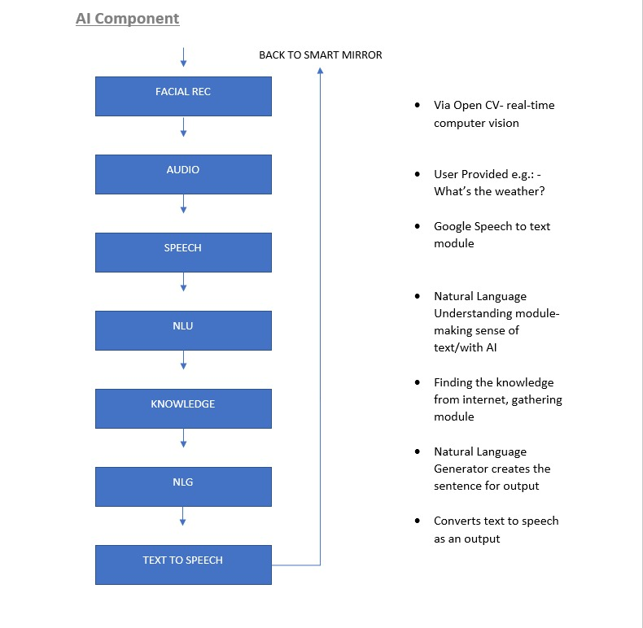

4.3. PROGRAM USED
Electron or the Magic Mirror software accessible to everyone via the internet. Electron provides an easy and pleasant looking platform. It is run over simple command using the terminal on the Raspbian. Refer the following set up for the complete understanding of the procedure.

Installation and running of the software is done successively using the following steps.

Step 1:
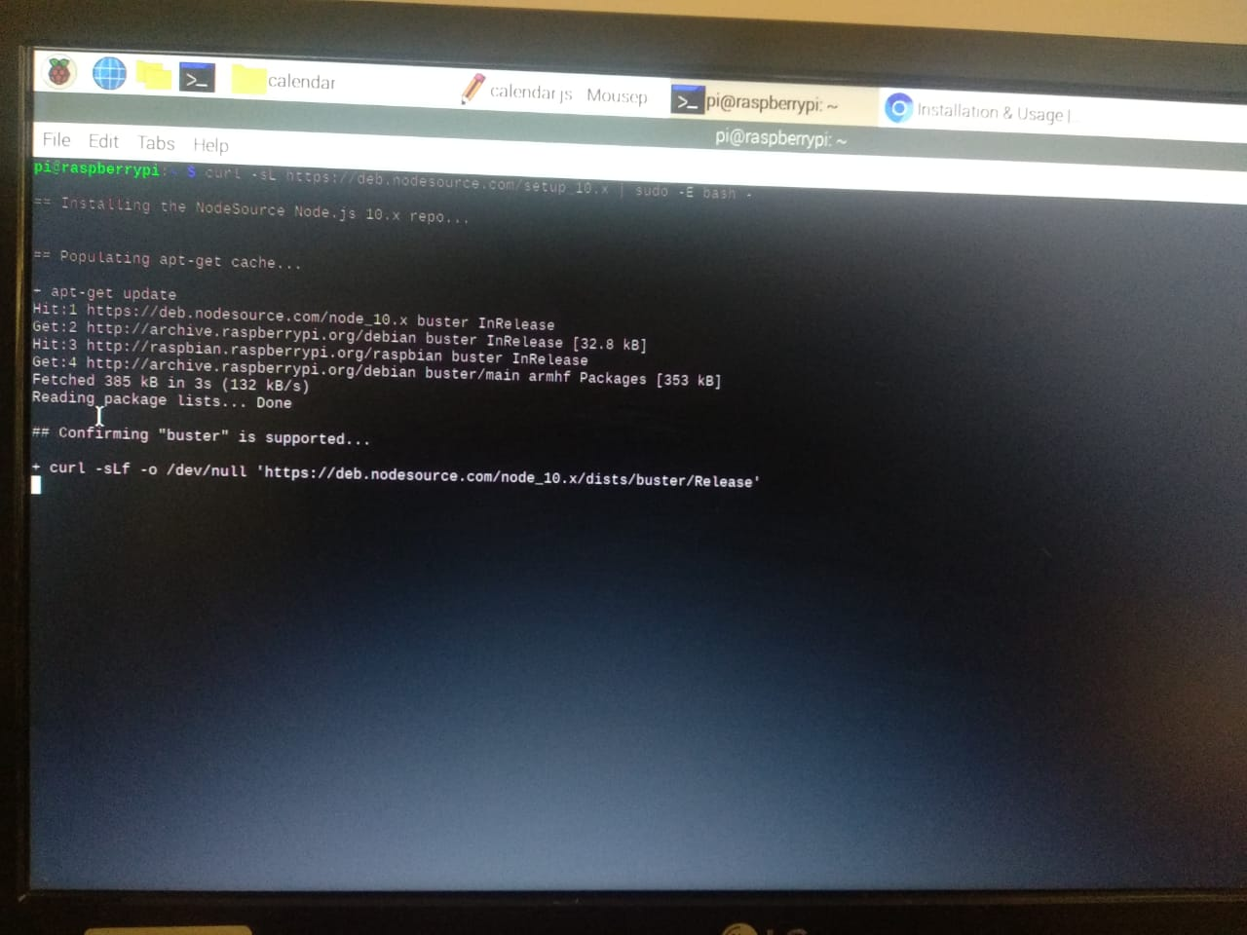
Download and install the latest version of Node.js. Node js is a java runtime open-source platform that includes the dependencies for the modules in the software.
Step 2:
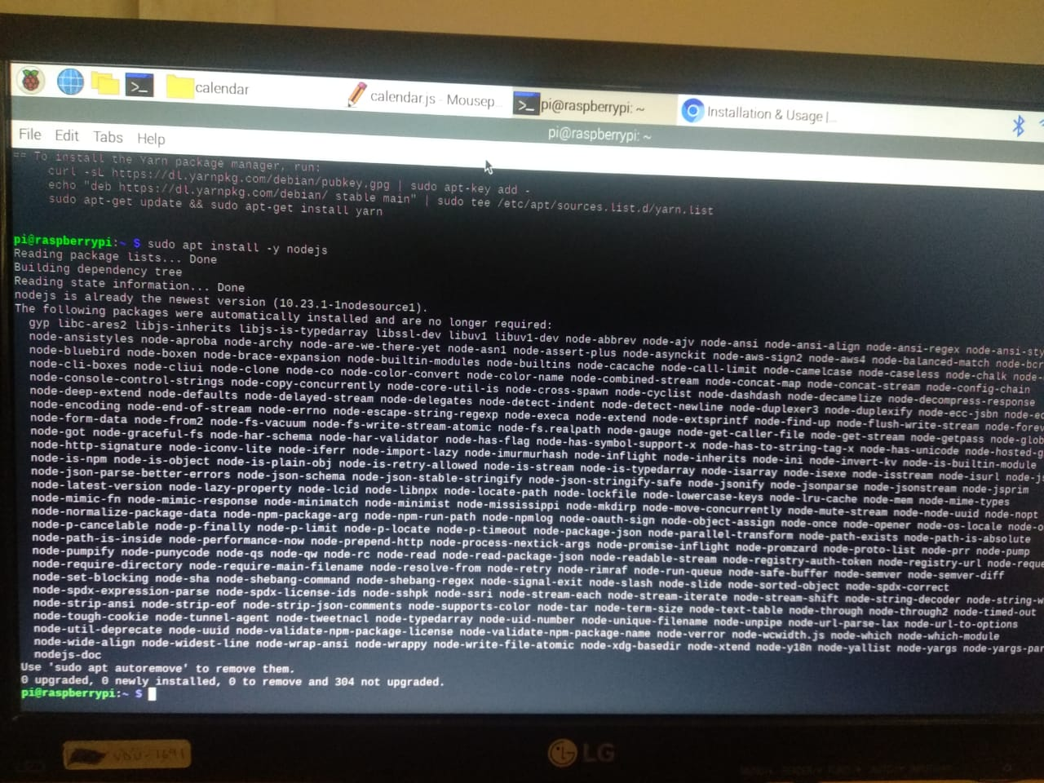
Completion of the set up is done through running the install node js command.
Step 3:
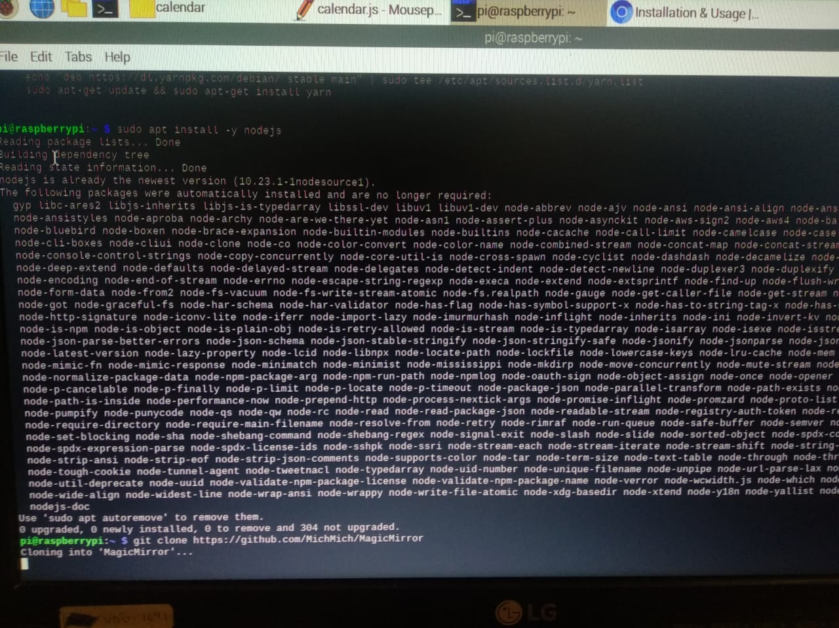
Using the GitHub repository for magic mirror or electron in the terminal. The repository comes along with default modules like news, weather, time, calendar etc. The process takes a certain amount of time till which the terminal shouldn’t be disturbed.

Step 4.
After the cloning is completed, the change directory command is called to reach the magic mirror directory. Here if we further navigate the default modules and their setups can be seen easily.
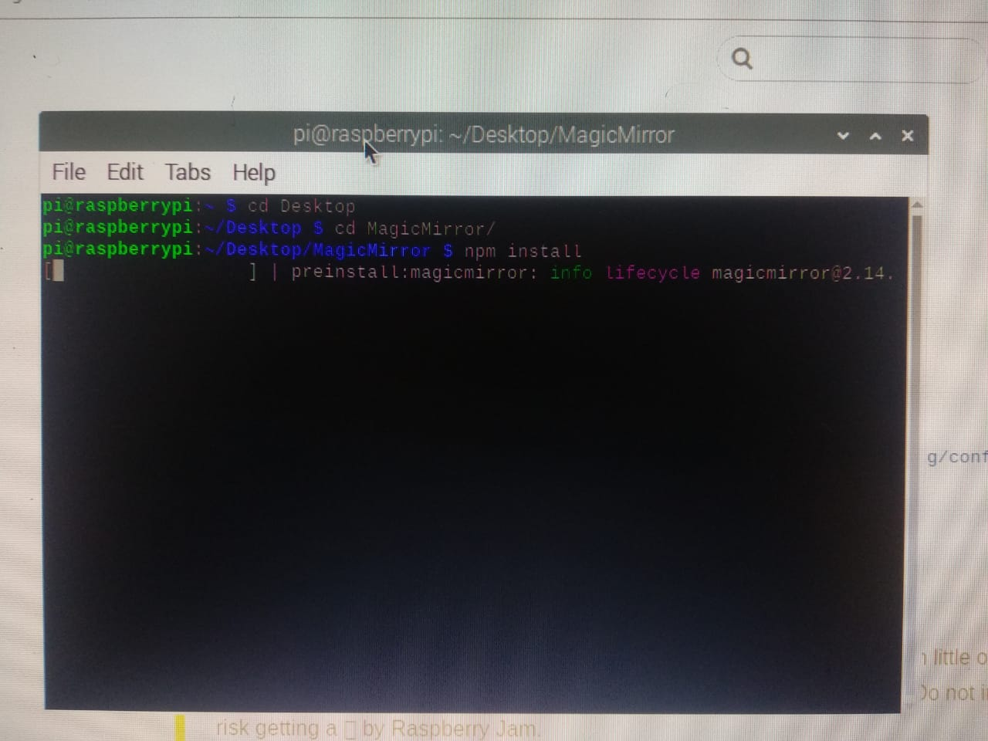
Step 5
Using the MagicMirror directory call npm install command. It further downloads dependencies used by electron to run the program. ‘npm’ is a package manager for java and javascript files

After the installation the script looks like what is mentioned below. It might generate a few warnings, but if there are no errors we are good to go.
. 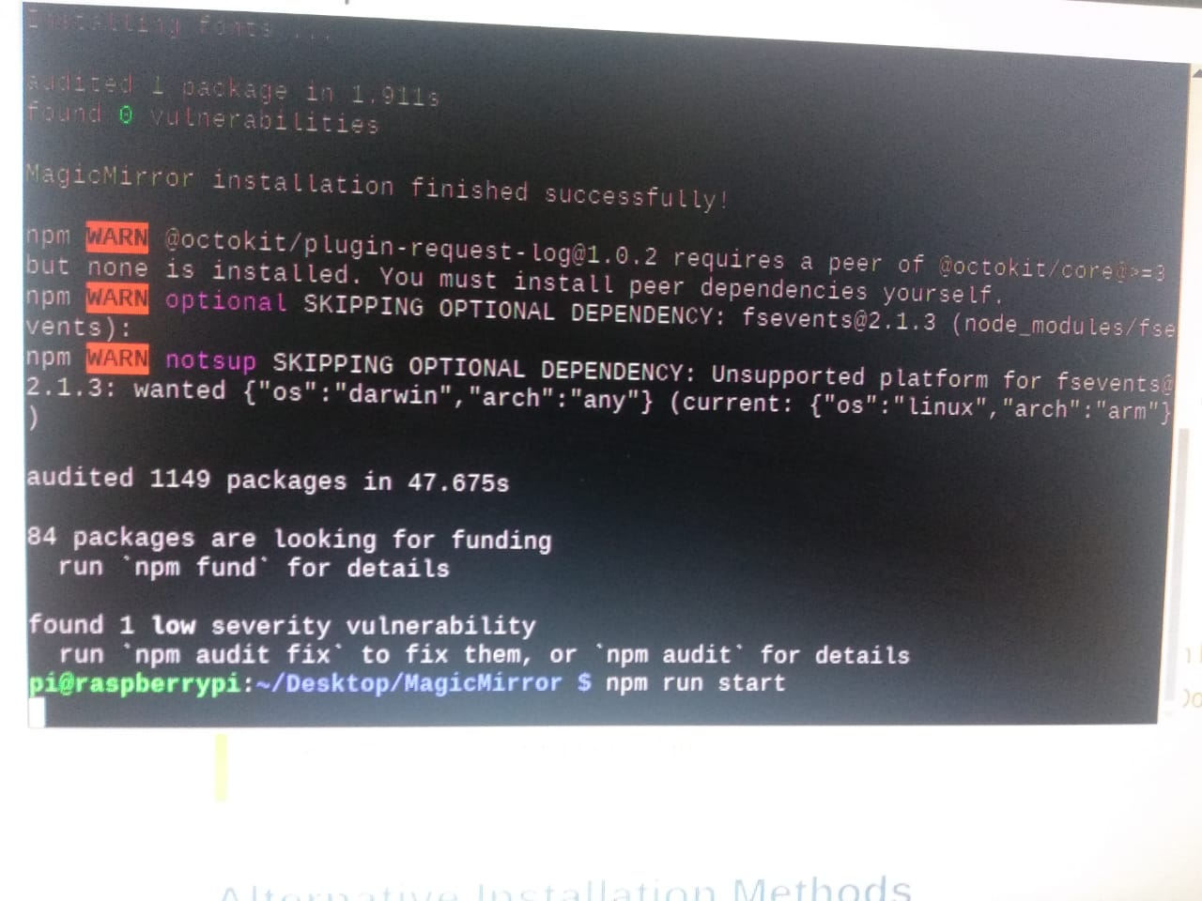
Step 6
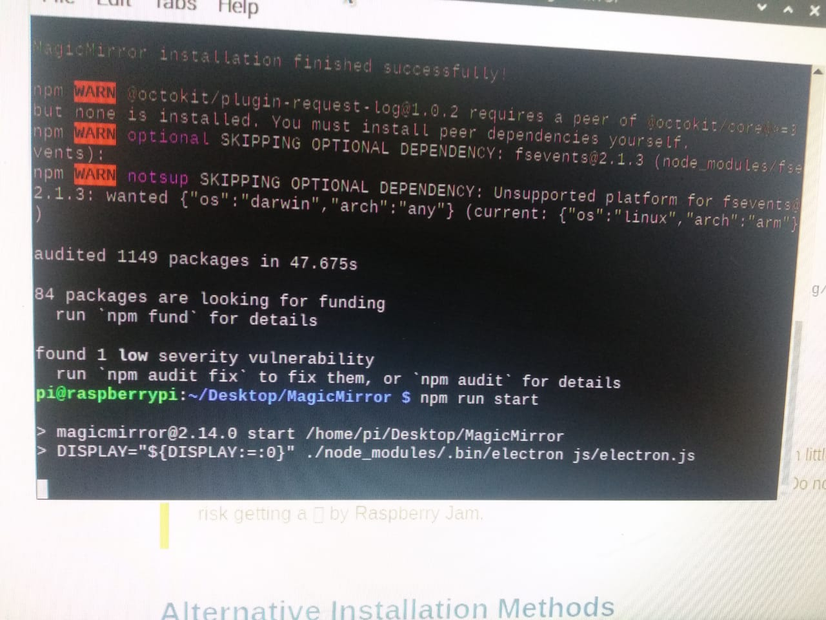
After the installation is complete the run command is called and the electron software that we cloned launches. Here the electron boots up with the final message and module outputs.
Step 7
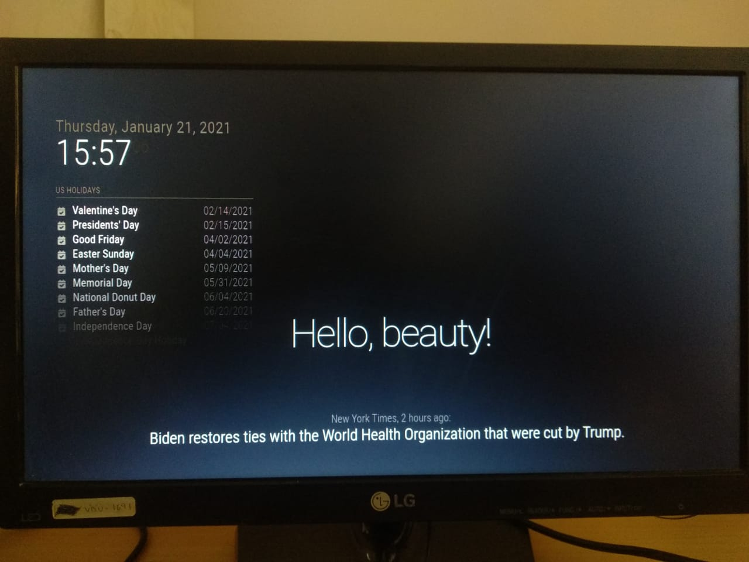
A sample output for the software with bare completion of each default module.

CHAPTER 05
CODES AND OBSERVATIONS
The following where the modular codes and observations used.
Alert Module
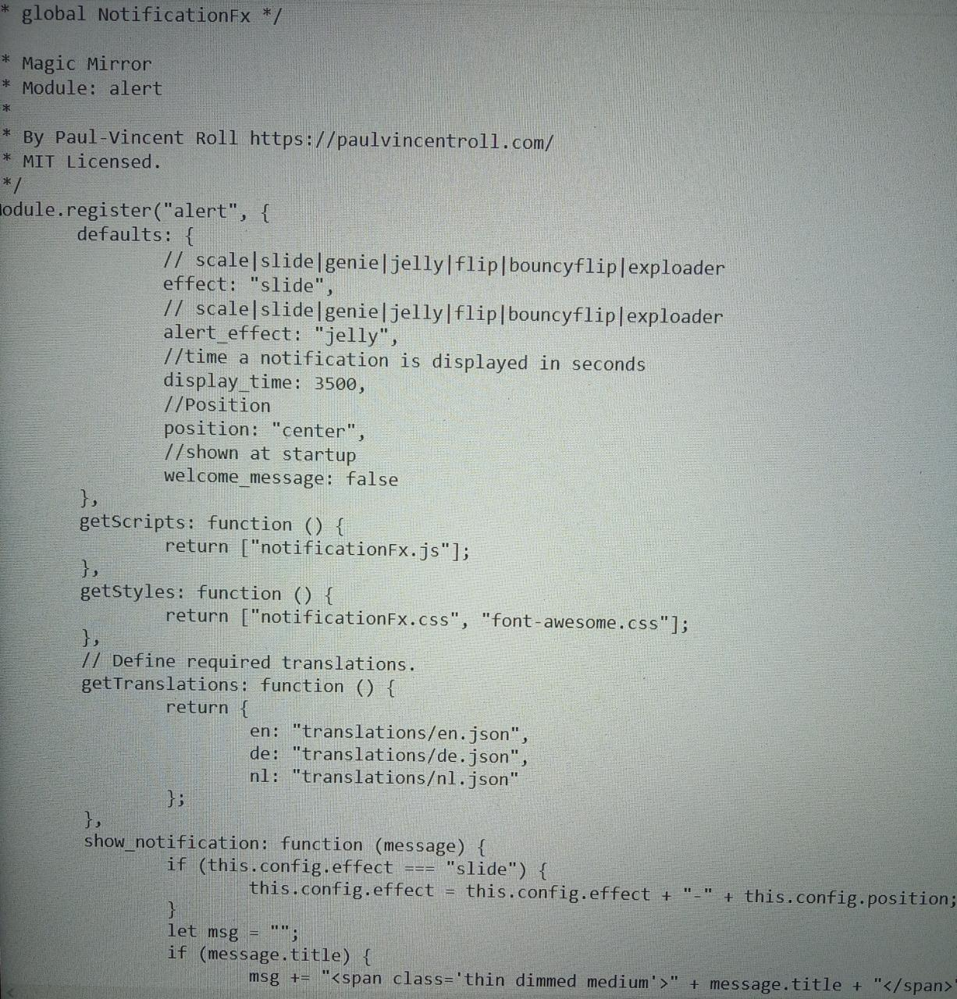

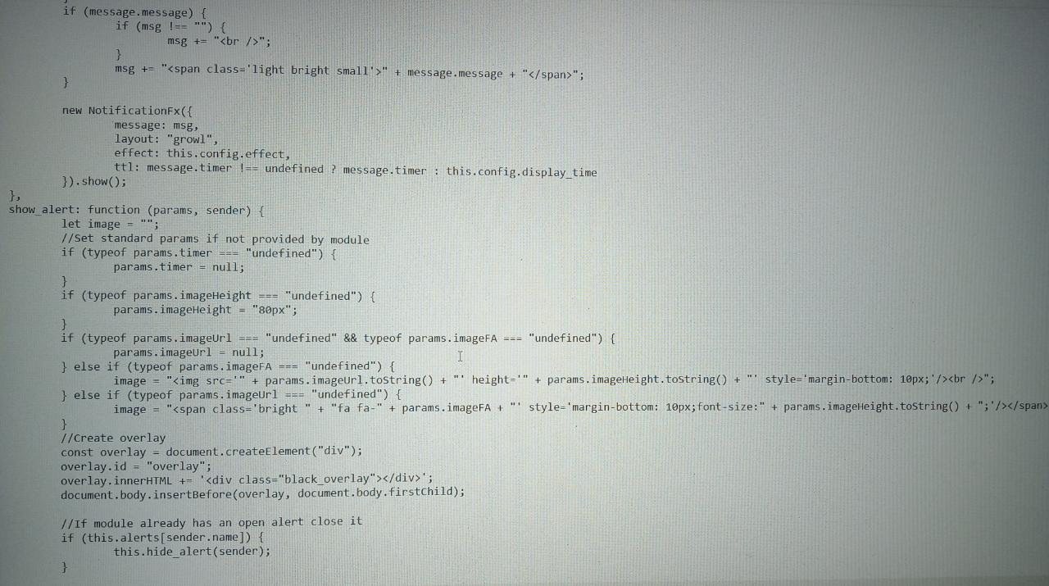

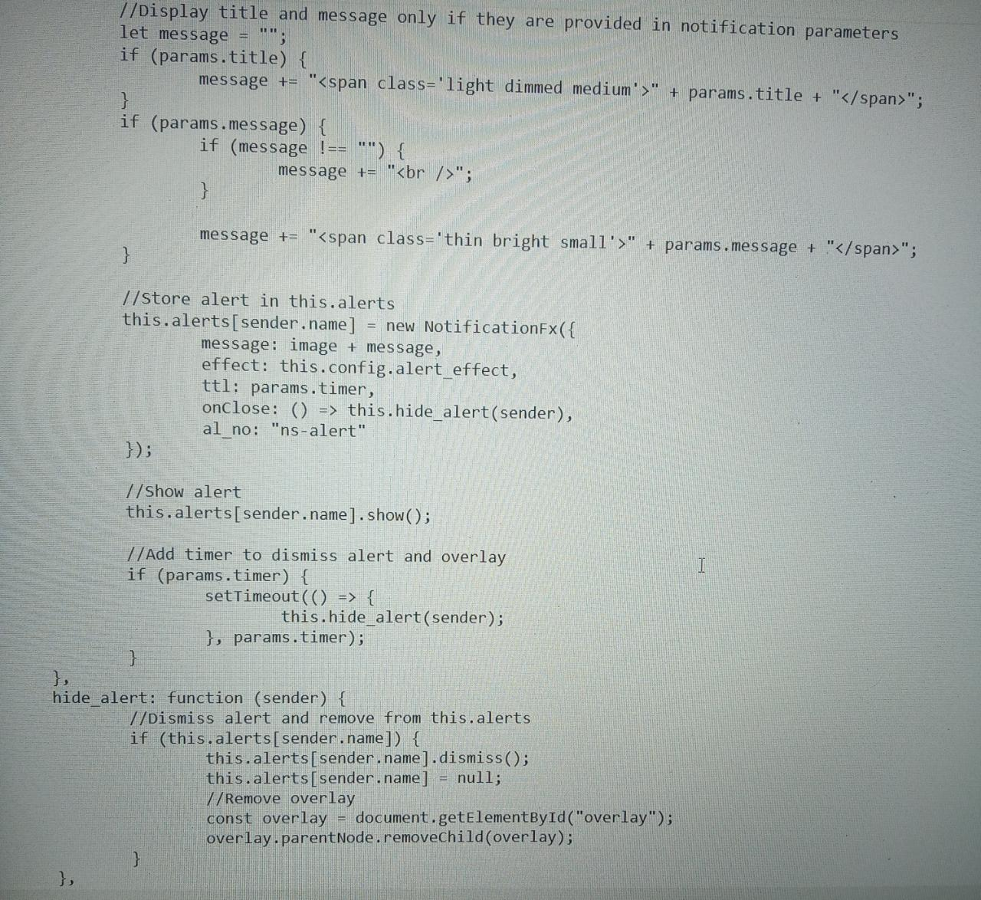
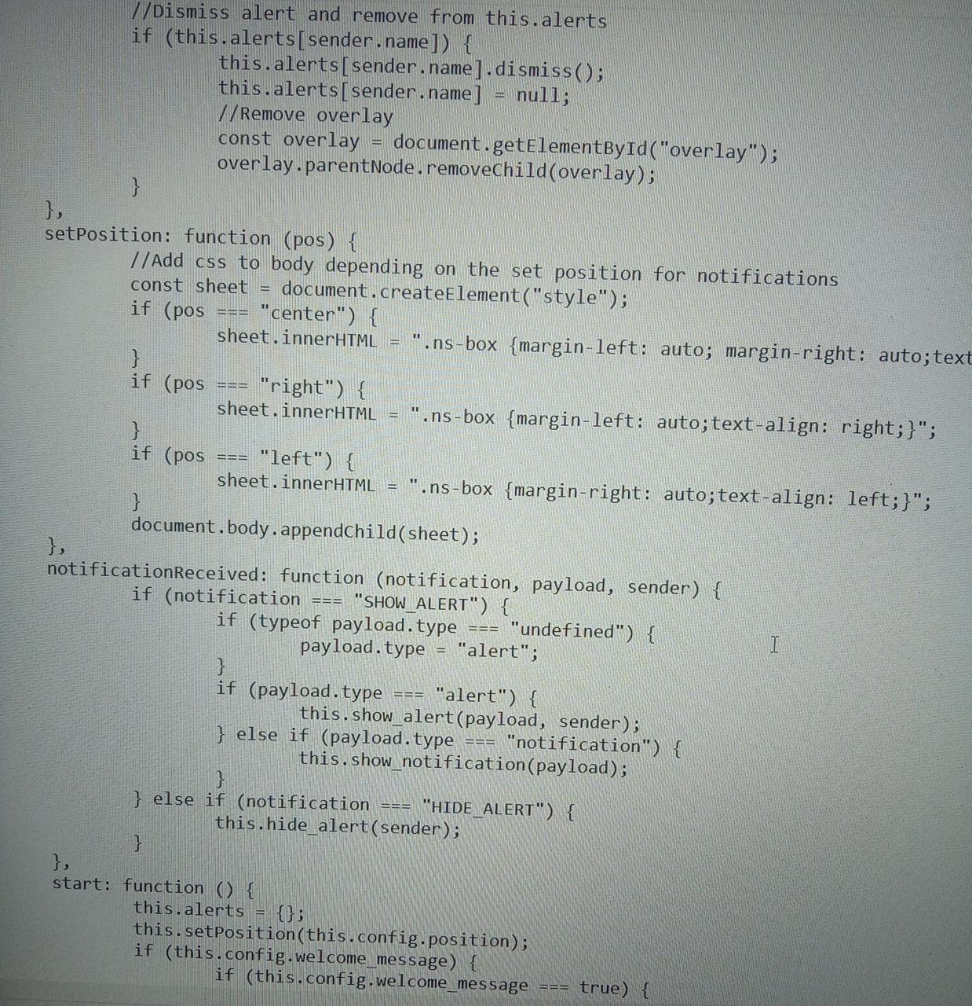
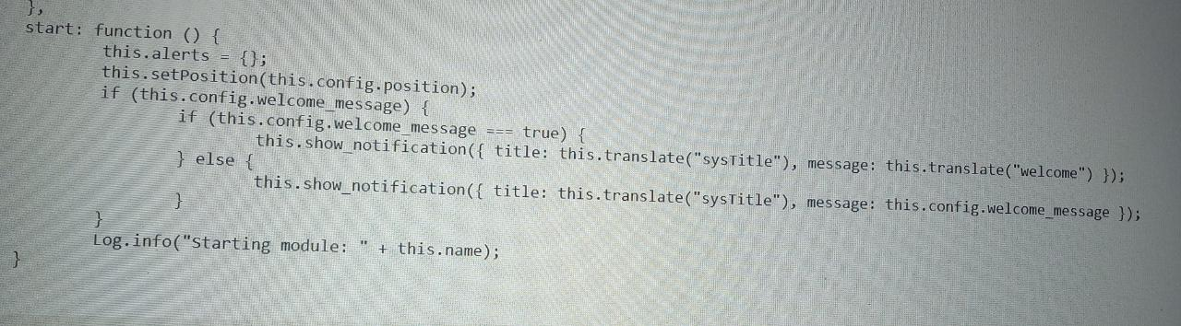
Calendar Module
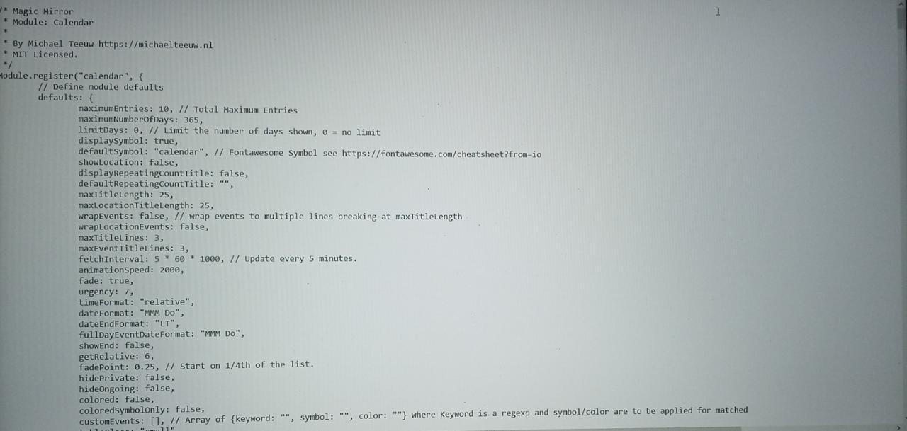

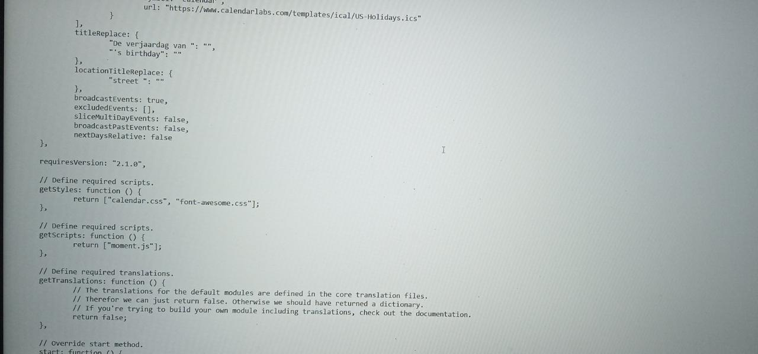

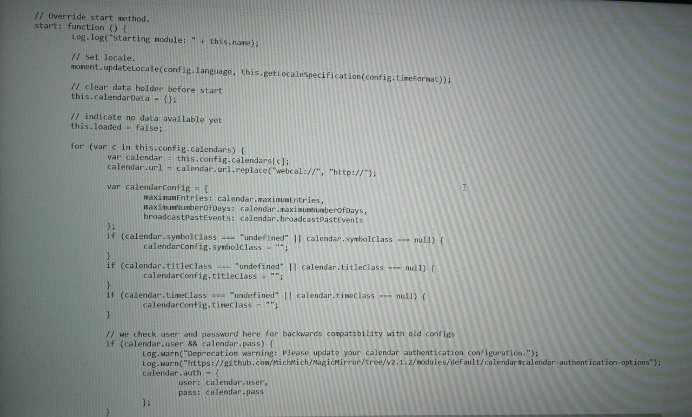

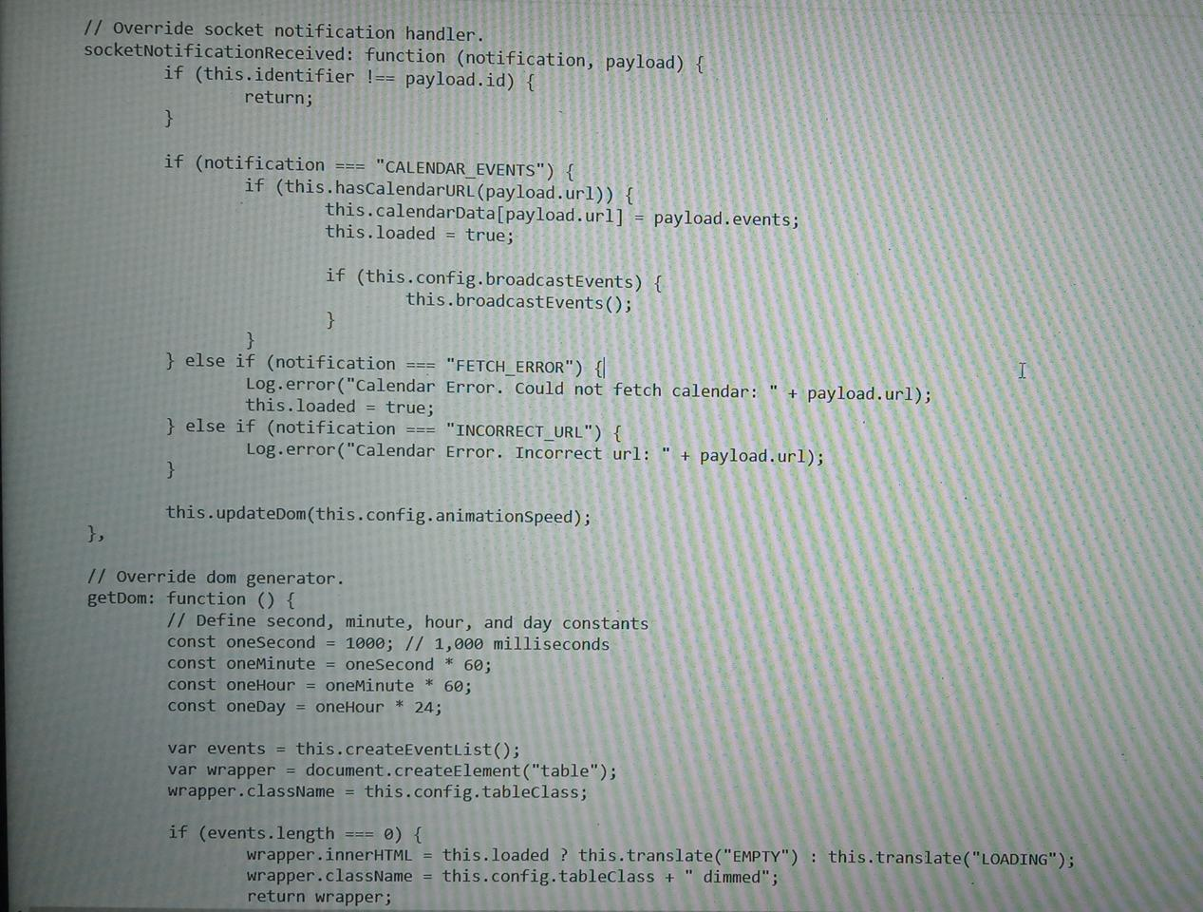

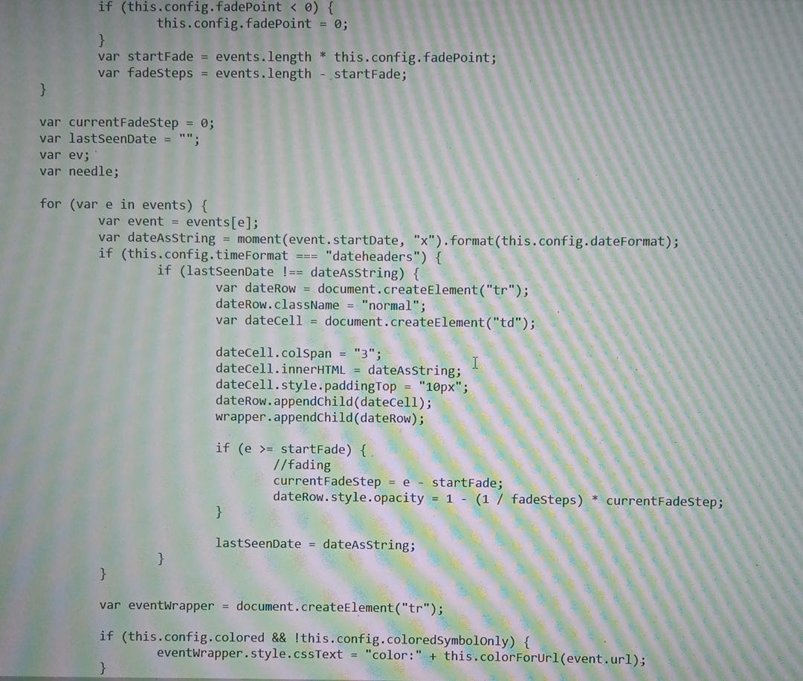

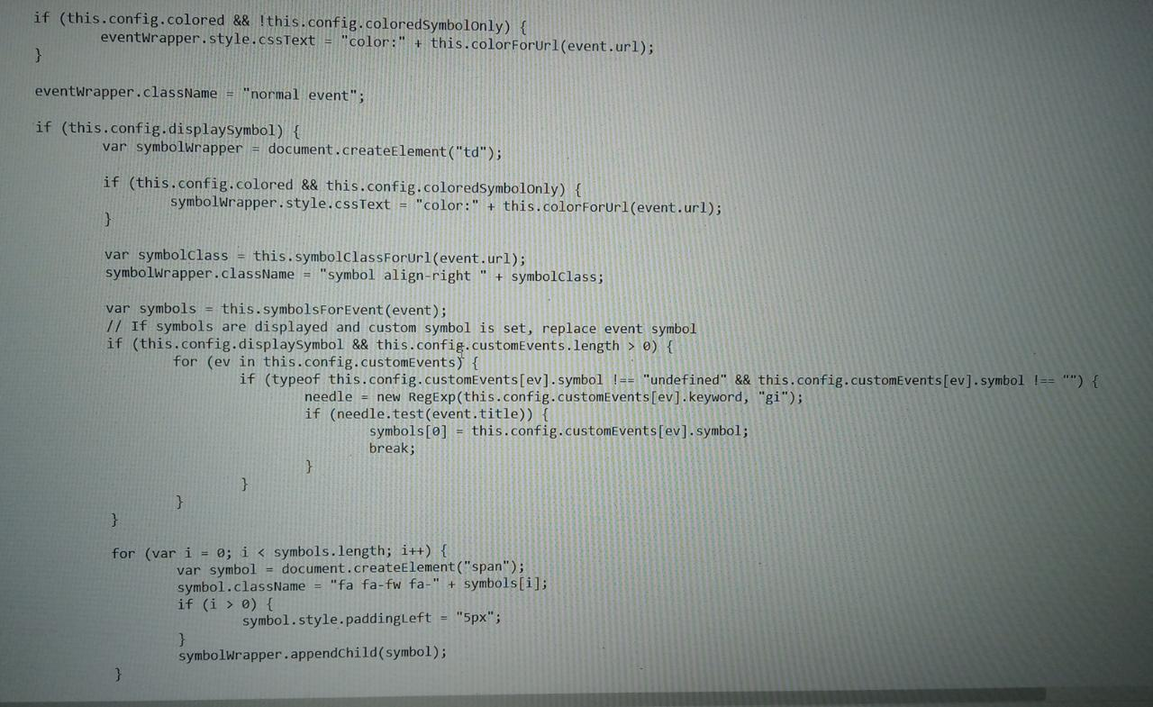

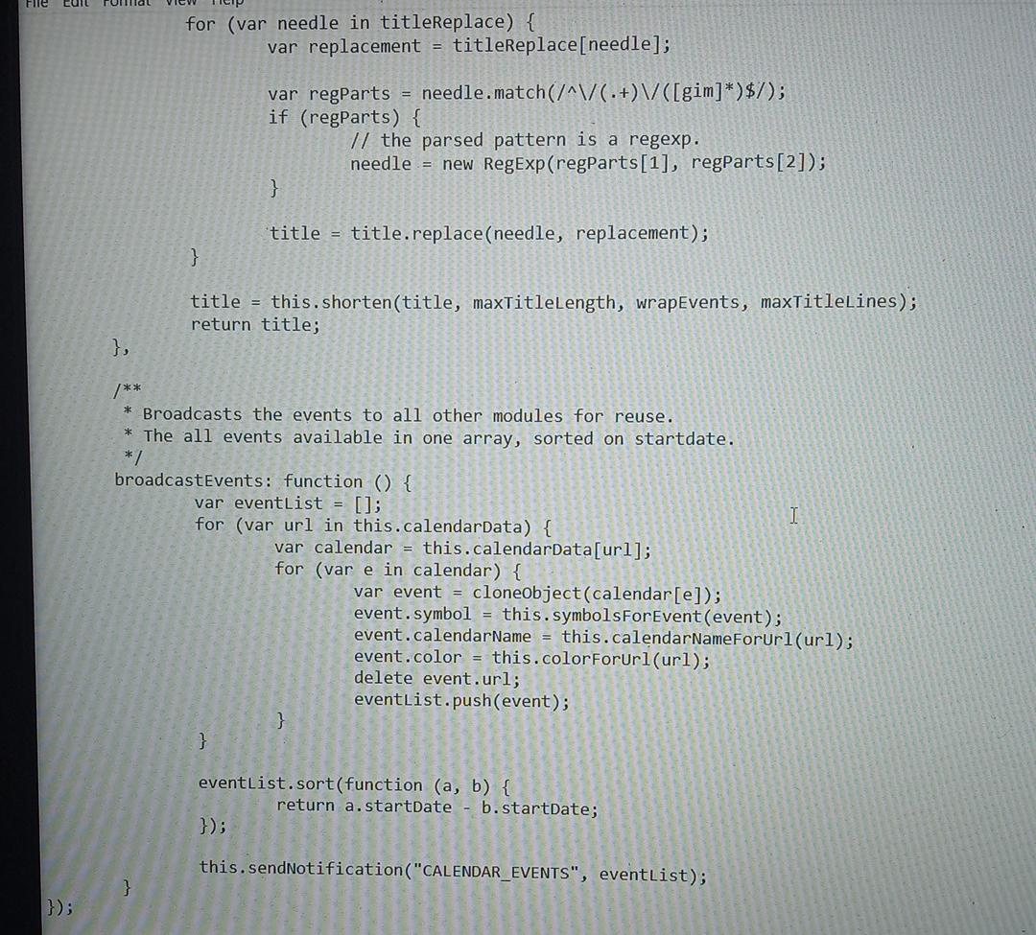
These are the simple coding for 2 out of the numerous default modules available. Even though the complexity increases by each modular increase, the level of understanding is made simpler for the apparatus.
Furthermore the addition of 3rd party modules require even further understanding and swift motion.

CHAPTER 06
RESULT AND DISCUSSIONS

6.1. EXPECTED OUTPUT

There is a black output screen for the output of the Smart Mirror that shows temperature, news and time. The screen's upper right corner reveals the time that is present in the Raspberry Pi. This makes use of the calendar along with time to display the day and date. The corner of the screen shows meteorological conditions. On 'forecast.io', the weather API used in this project is open. The Weather Condition Update varies every hour and is shown on the screen if the temperature changes, otherwise the temperature remains unchanged.
With the support of the numerous png images that are stored in a Raspberry Pi archive, the weather icon on the screen is displayed. A module named 'Tkinter' makes use of the weather output. Tkinter provides an output window and we can adjust the size of the window according to the output.
It acts as a standard reflective mirror, so it can be used as a regular mirror by the user. The two-way mirror serves both as a reflective surface and to view the notifications transparently.
All who uses this mirror can get updates in real time. Using the microphone in the raspberry pi 3 for appliance power, users will be able to send commands to the mirror. We built a smart futuristic mirror that It provides natural interaction between users and the ambient facilities at home. The display with the mirror is provided by a flat monitor LED display that displays all the necessary details practical for the consumer. The mirror also includes a mirror for to allow the view, the picture-in-picture sub-display.

6.2 CONCLUSION

We strive to build a smart mirror between users and the Internet that provides an ambient atmosphere. It will assist users in their everyday operations. In different industrial and home applications, the smart mirror can also be introduced. Therefore, IoT is an essential technology that makes household appliances smart. The facial recognition technology used in the intelligent mirror proves to be an effective security tool.
Home appliances and mobile phones can be connected to smart mirrors. The mirrors are able to recognize the face and provide access to tailored services. To understand feelings, the mirror can also be introduced. Smart mirrors can be advanced into touch screen modes with the aid of emerging technologies. With better technical developments, mirrors can be used in many other fields to better enhance the mirrors to be deployed in beauty parlors, cloth shops, hotels, etc.
Overall, the prototype offers a simple solution. extensible structure that can be used for the provision of to the user, still more features. In Our Future we can research how the surrounding context functions. It is possible to use the user and the environment in to have optimal customer experiences in the sense of climate at home. More can be made of the scheme more convenient for consumers by incorporating more features like incorporating light settings, processing of voice, etc.

6.3 REFERENCES

https://www.researchgate.net/publication/322812753_DIY_Smart_Mirror
https://www.irjet.net/archives/V7/i2/IRJET-V7I2551.pdf
http://repositori.uvic.cat/bitstream/handle/10854/4702/trealu_a2016_cumeras_josep_buiding_smart.pdf?sequence=1&isAllowed=y
http://seniordesign.ee.nd.edu/2017/Design%20Teams/smartmir/SmartMirrorFinalReport.pdf
https://www.researchgate.net/publication/310845534_SmartReflect_A_Modular_Smart_Mirror_Application_Platform
http://seniordesign.ee.nd.edu/2017/Design%20Teams/smartmir/SmartMirrorFinalReport.pdf
https://www.seminarsonly.com/computer%20science/smart-mirror-seminar-report-ppt.php
https://www.irjet.net/archives/V7/i2/IRJET-V7I2551.pdf
http://edge.rit.edu/edge/C16103/public/Smart%20Mirror%3Apublic/FinalProjectReport.pdf

