|  |  |  |  |  |  |
| --- | --- | --- | --- | --- | --- |
| **Document History** | | | | | |
| **Version** | **Date** | **Author** | **Section** | **Changes** |
| 1.0 | 10-07-2015 | Deepthi Shivakumar | All | Release 2 features |
| 1.1 | 30-09-2015 | Sameer Sulaiman | Integration section | Bazaar voice feature changes. |
| 1.2 | 1-10-2015 | Deepthi Shivakumar | Integration section | Bazaar voice feature changes. Added API details. |
| 1.3 | 12/12/2015 | Sameer Sulaiman | Integration section | Modified changes for 15.2 PI release. |
| 1.4 | 13/05/2016 | Sameer Sulaiman | Integration section | Modified changes for 16.2 PI release |
| 1.5 | 22/07/2016 | Sameer Sulaiman | Integration section | Modified changes for 16.3 PI release |
| 1.6 | 8/09/2016 | Sameer Sulaiman | Integration section | Modified changes for 16.4 PI release |

Digital Care IOS Integration

|  |  |
| --- | --- |
| **Author** | Deepthi Shivakumar, Sameer Sulaiman |
| **Approved by** | [Aravind.Gundumane@philips.com](mailto:Aravind.Gundumane@philips.com) |
| **Email Id** | Deepthi.Shivakumar @philips.com, Sameer.Sulaiman@philips.com |

1. INTRODUCTION 3

2. INTEGRATION 3

2.1 Cocoa pod Integration 3

2.2 Library Integration 3

2.3 Prerequisites 4

3. INITIALIZATION 5

3.1 Digital care Configuration 6

3.1.1.1 Main menu configuration 8

3.1.1.2 Product menu configuration 9

3.1.1.3 Social provider configuration 10

4. Vertical features customization 11

5. Navigation bar customization 13

6. Tagging 13

7. LOCALIZATION SUPPORT 13

8. FAQ 13

9. Notes 14

# INTRODUCTION

This document provides an overview of integration procedure for consumer care library in iOS mobile applications.

Digital care library provides set of standardized consumer care support features which can be used in all Philips apps.

# INTEGRATION

## Cocoa pod Integration

The easiest and preferred way to use these components is using Cocoapods (version 0.36.0 or newer). In your podfile, you have to add a source line for the Philips internal pod spec repository. So a minimal Podfile would look like this:

Source: <https://atlas.natlab.research.philips.com/stash/scm/ehpmat/cocoapod-specs.git>

pod PhilipsConsumerCare, '~> 6.0.0'

Please refer sample app to add dependent libraries.

Integrating application can get the framework files from the below path,

Source> ConsumerCareBinaries

## Library Integration

1. Git source path : **https://**[**atlas.natlab.research.philips.com/bitbucket/scm/cc/consumer_care_ios.git**](http://atlas.natlab.research.philips.com/bitbucket/scm/cc/consumer_care_ios.git) Branch: PI16.4
2. Check out the code from above path where in you can find sample app which depends on consumer care library’s.
3. Consumer care needs other libraries to build which are as below
4. liblocaleMatch.a pod ‘PhilipsLocalMatch’ , ‘~> 0.3’
5. PhilipsUIKit >= 4.0.0 pod ‘PhilipsUIKit’ , ‘~> 4.0.0’
6. PhilipsIconFont >= 1.1 pod ‘PhilipsIconFont’ , ‘~> 1.1’
7. AFNetworking (<https://github.com/AFNetworking/AFNetworking)> pod ‘AFNetworking’ , ‘~> 3.0’
8. MBProgressHUD (MBProgressHUD.h, .m - <https://github.com/jdg/MBProgressHUD)> pod ‘MBProgressHUD’ , ‘~> 0.9.2’
9. PRXLib ( http://pww.clscmgit.pic.philips.com:9000/scm/git/hor-prxclient-ios)

Please take the PI16.1 release branch for PRXLib and also available in pod ‘PhilipsPRXClient’, ‘~> 1.2.0’

1. AdobeMobileLibrary.a
2. PhilipsProductSelection

**https://**[atlas.natlab.research.philips.com/bitbucket/scm/cc/productselection_ios.git](http://atlas.natlab.research.philips.com/bitbucket/scm/cc/productselection_ios.git)

Please take the PI16.4 release branch for ProductSelectionLib and also available in pod ‘PhilipsProductSelection’, ‘~> 2.0.2’

1. AppInfra: pod ‘AppInfra, ‘~> 1.2.0’

Vertical app has to add AppInfra configuration via **AppConfig.json** , **LoggingConfig.plist, appIdentityConfig.plist** from **AppInfra** Component. Please refer their integration document attached .

Please find the Source code path for AppInfra,

<https://atlas.natlab.research.philips.com/bitbucket/projects/MAIL/repos/app-infra_ios/browse/Source>

1. UAPPFramework pod 'UAPPFramework', '~> 1.0.0'

Vertical app has to add UAPPFramework for invoking all CoCo’s same follows for consumer care. .

Please find the Source code path for UAPPFramework,

<https://atlas.natlab.research.philips.com/bitbucket/scm/maf/app-framework_ios.git>

Please make sure all these are added to application’s build phase.

1. Please copy DigitalCareConfiguration.plist from library’s DigitalCareBundle.bundle to application’s folder and override the attributes.
2. Override the values in config file and define the features as per requirement.

## Prerequisites

1. Application need to know **CTN** number for each product used in app     Ex: HD8967/01 2.Along with sector and catalog. Example: **Sector**: B2C and **catalog**: CARE ( Mandatory for Consumer care ) Most of the apps will have above sector and catalog.

Above information is used for backend services and mostly uses PRX system.  Hence please provide valid and complete CTN number as input otherwise consumer care features are not functional as expected.

# INITIALIZATION

1. App can invoke the library using below API’s

From PI16.4 all common components follow the one roof standards, so all the app has to use the uappframework standard API’s for invoking common components.

The invocation for ConsumerCare looks below eg:-,

**-(void) invokeConsumerCare**

**{**

**// setting hardcoded product list**

**PSHardcodedProductList *hardcodedList =**

**[[PSHardcodedProductList alloc] init];**

**hardcodedList.catalog= CARE;**

**hardcodedList.sector= B2C;**

**[hardcodedList setHardcodedProductListArray:[NSArray arrayWithObject:[NSString stringWithFormat:@"%@",self.ctnField.text]]];**

**launchInput.productModelSelectionType = hardcodedList;**

**// Invoking CC with uApp API's**

**DCDependencies *dcDependencies = [[DCDependencies alloc] init];**

**dcDependencies.appInfra = [AIAppInfraSingleton sharedInstance].sharedAppInfra;**

**self.dcInterface = [[DCInterface alloc]init];**

**self.dcInterface = [[DCInterface alloc]initWithDependencies:dcDependencies andSettings:nil];**

**DCLaunchInput *launchInput = [[DCLaunchInput alloc] init];**

**launchInput.dCMenuDelegates = self;**

**UIViewController *childViewController = [self.dcInterface launch:launchInput withErrorHandler:^(NSError *error) {**

**NSLog(@"error happened");**

**}];**

**[self.navigationController pushViewController:childViewController animated:YES];**

**}**

1. For supporting Multiple product selection we have introduced PhilipsProductSelection component. Vertical has to set the CTN’s in **PSHardcodedProductList** object as mentioned below.This is applicable for single as well as multiple products and depends on the array size consumer care will launch the multiproductselection library in consumercare .

Apart from this Vertical must set the SECTOR and CATALOG values as mentioned in the below enum’s.

Catalog Types Available :-

CATALOG_DEFAULT,

CONSUMER,

NONCONSUMER,

CARE,

PROFESSIONAL,

LP_OEM_ATG,

LP_PROF_ATG,

HC,

HHSSHOP,

MOBILE,

EXTENDEDCONSENT

Sector Types Available:-

DEFAULT,

B2C,

B2B_LI,

B2B_HC

Ex:-

PSHardcodedProductList *hardcodedList = [[PSHardcodedProductList alloc] initWithArray:[NSArray arrayWithObjects:@"HX9371/04",@"HF3330/01",@"HP6581/03",@"HP8656/03",@"S9031/26",@"SCF693/17",@"SCF145/06",@"FC6168/62",@"GC9550/02",@"PR3743/00", nil]];

hardcodedList.catalog=CARE;

hardcodedList.sector=B2C;

* **DCDependencies** :-

All dependency to CC will passed via DCdependency , for CC AppInfra instance will be passed as dependency injection from integrating app,

**DCDependencies *dcDependencies = [[DCDependencies alloc] init];**

**dcDependencies.appInfra = [AIAppInfraSingleton sharedInstance].sharedAppInfra;**

* **DCLaunchInput** :-

Configurations required while launching CC has to be done here. CC requires the Menu delegate’s required to handle the menu buttons action handling to CC or Vertical app. The menu includes Support, Product, Social Button Menu’s.

**DCLaunchInput *launchInput = [[DCLaunchInput alloc] init];**

**launchInput.dCMenuDelegates = self;**

* **DCInterface** :-

Interface object provides the method for returning CC ViewController with parameter launchinput as below,

**UIViewController *childViewController = [self.dcInterface launch:launchInput withErrorHandler:^(NSError *error) {**

**NSLog(@"error happened");**

**}];**

**[self.navigationController pushViewController:childViewController animated:YES];**

### b. PhilipsUIKit:-

The Multiproduct Selection component uses the PhilipsUIKit for the UI components.So the applications that are already using PhilipsUIKit need not do anything.Applications that are not using the PhilipsUIKit have to assign the theme, else it will use the default blue theme for MultiproductSelection.

Configuring the theme:



[PhilipsUIKit Documentation](http://sesvm-webserver.htce.nl.philips.com/PhilipsUIKit/ios/latest/Documentation/)

## Digital care Configuration

The application has to copy DigitalCareConfiguration.plist from library resource bundle and create one in app resource bundle by overriding the parameters present in it. The file contains the following,

1. UI resources like themes, styles, background colors and strings
2. Facebook page id or page name and twitter page name for respective Philips product page.

Note: If applications having both facebook page name and page id it will take the page name. If pagename is empty it will check for page id and will be setted.

1. App store id for the app can be added in the FeedbackMenu for app feedback.
2. An array is defined for defining main menu title, main menu icons, product menu title and social provider list. Each menu contains default features supported by Digital Care library. App can include only the required features by adding/deleting/modifying the array items.
3. Each title string in above arrays is expected to be a resource key and not the value.
4. ProductionEnvironment is added where in apps can mention whether it is production or test environment. This is applicable for all backend systems which we use.

#### Main menu configuration

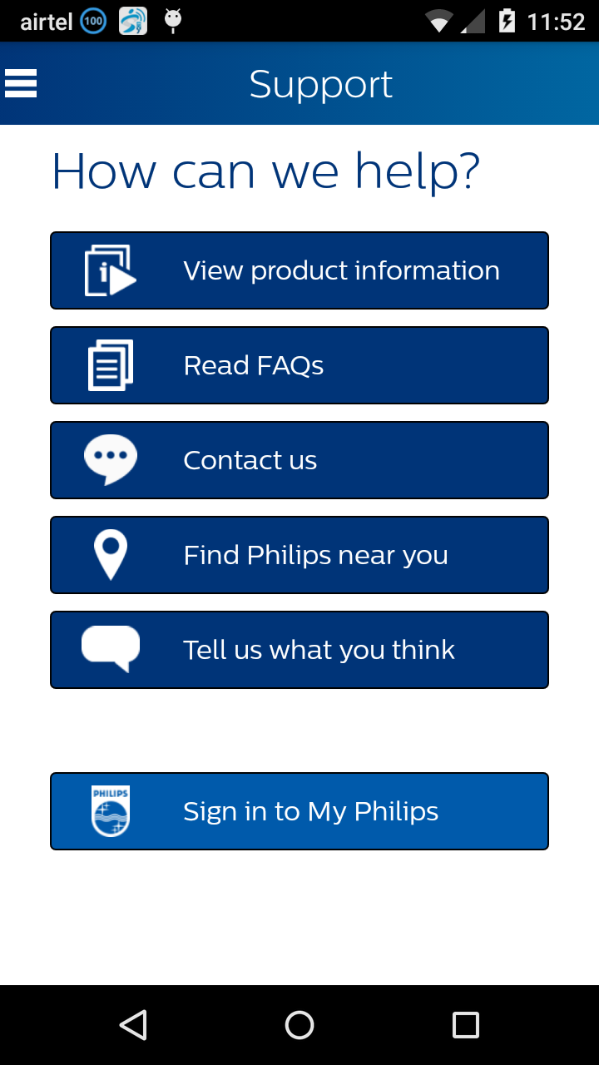

**RegisterButtonBackgroundColor**

**IconName under Main Menu**

**Localisedkey under Main Menu**

**ButtonTextColor**

**ScreenBackgroundColor**

**ButtonBackgroundColor**

**HeaderTextColor**

#### Product menu configuration

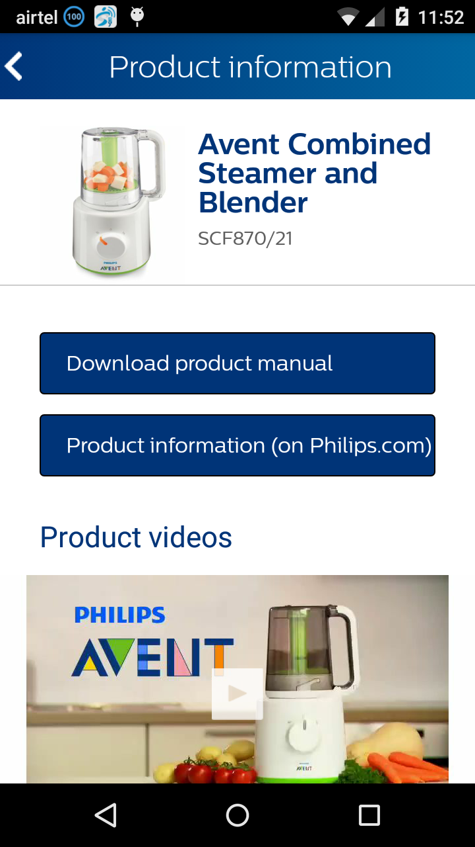

ProductMenu-> LocalizedKey

#### Social provider configuration

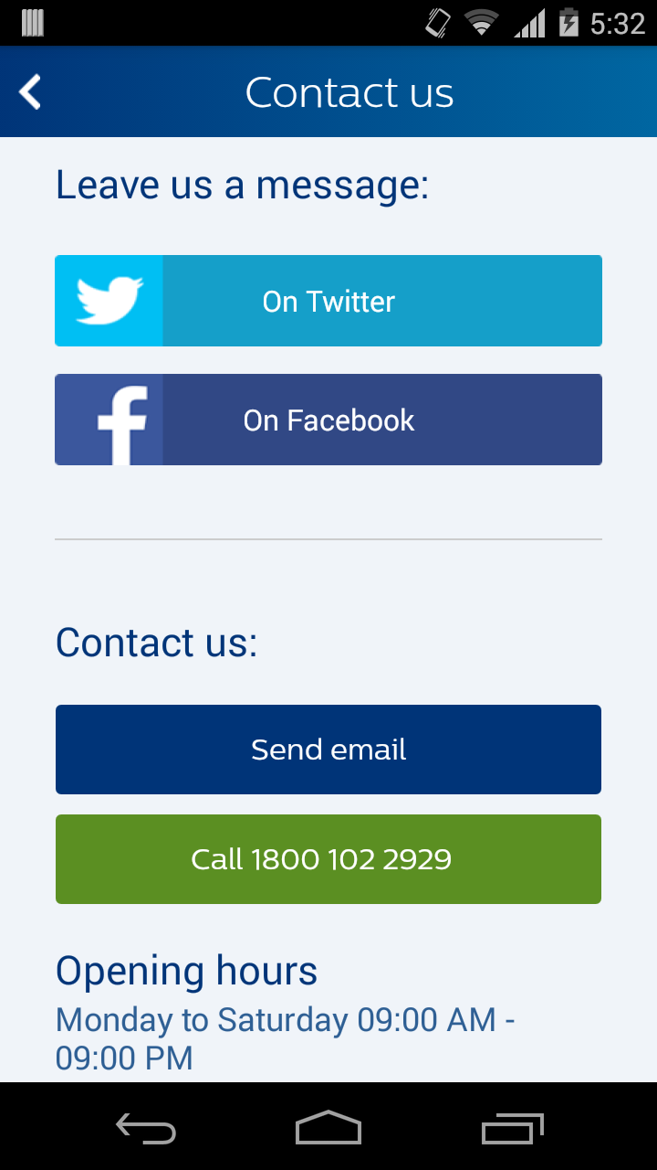

**SubHeaderTextColor**

**IconName under SocialListProviders**

**LocalisedKey under**

**SocialListProviders**

# Vertical features customization

* 1. App can add its own button by passing valid string for button title and icon resource name in configuration file.
  2. Also application has to implement protocols like MainMenuDelegate,

ProductMenuDelegate, and SocialProviderDelegate which will be combined to MenuDelegates .

1. MainMenuDelegate – Invoked on click of each button on support home page. This helps in configuring features on main/home page.
2. ProductMenuDelegate – Invoked on click of each button on product info page. This helps in configuring features on product info page.
3. SocialProviderDelegate – Invoked on click of each social provider buttons in Contact us page. This helps in configuring list of social list providers. CC by default supports Facebook and Twitter.
   1. App is required to implement all these to take control on app side for the

menu items which is added by verticals. For digital care menu item, library is supposed to take action and app should not ideally override this.

* 1. If app returns “true” then it means that app will take action on click of that

button and library will not perform anything in that case otherwise library will take action if app returns “false”.

Example : Air Fryer customization

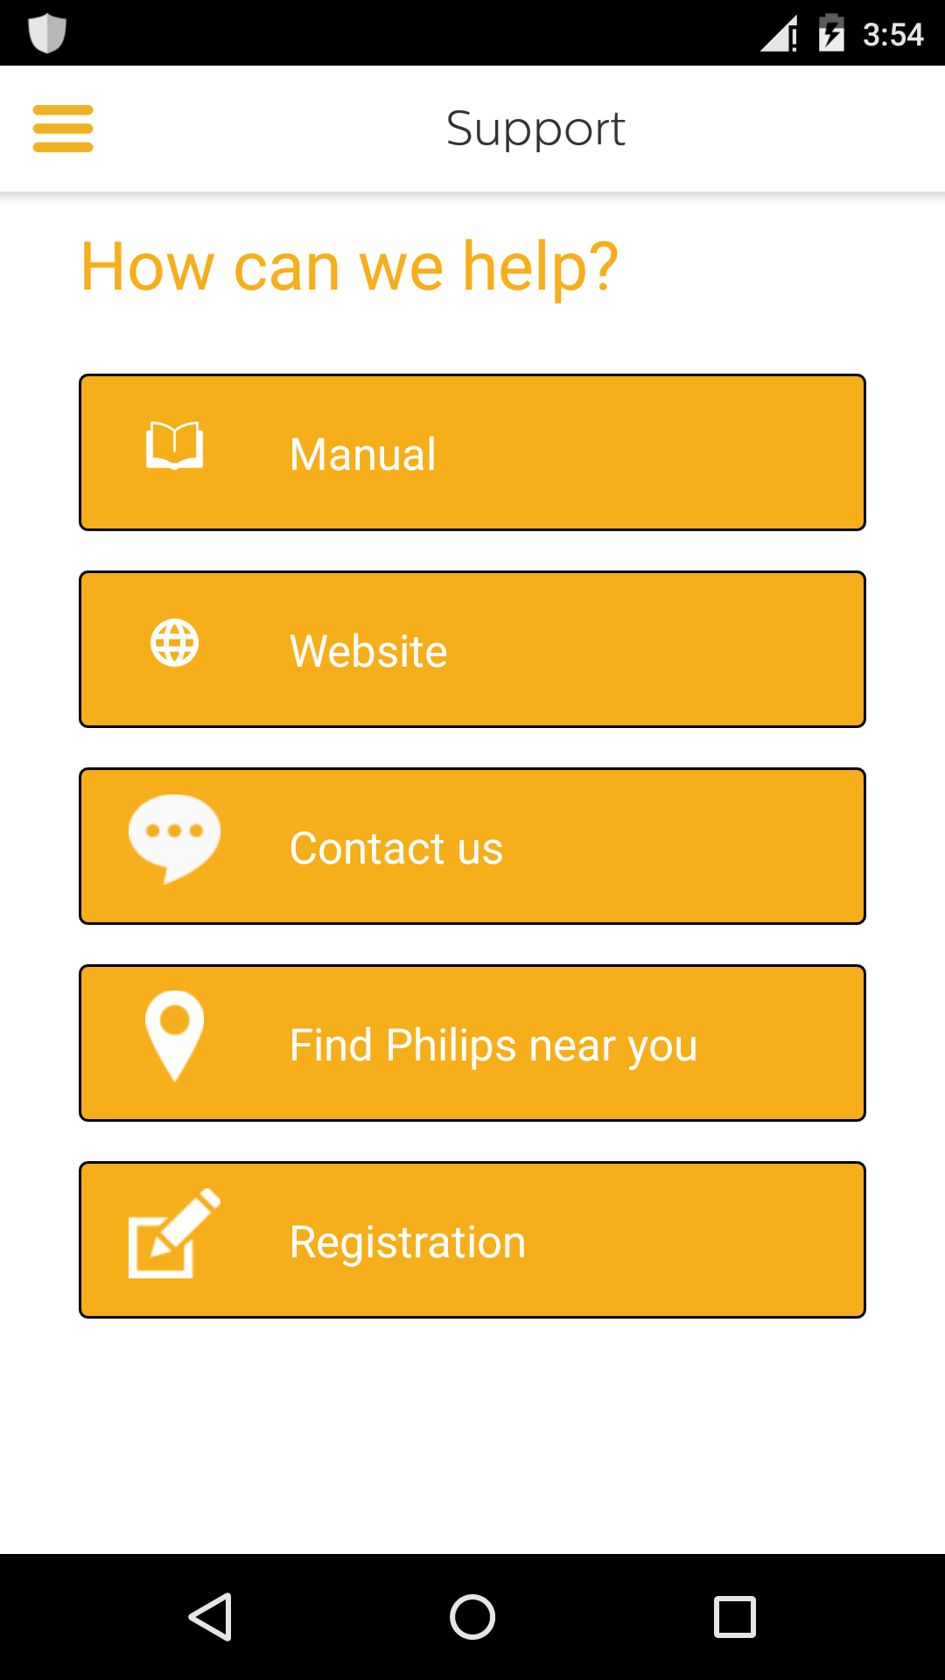

# Navigation bar customization

PI16.4 release onwards ConsumerCare is returning the viewcontroller to integrating app’s. So the vertical app will be using their own NavigationControllers.

# Tagging

Tagging was completely handled by AppInfra tagging component , Please refer the AppInfra integration document attached. Inititialisation can be referred in consumercare sample as well.

# Localization support

|  |  |  |  |  |  |
| --- | --- | --- | --- | --- | --- |
| English | German | French (FR) | Simplified Chinese | Traditional Chinese | Portuguese (EU) |
| Russian | Arabic | Japanese | Dutch | Malay | Montenegrin |
| French-CA | Romanian | Spanish Mexican | Ukrainian | Portuguese (BR) | Serbian |
| Gaelic | Greek | Hebrew | Hindi | Finnish | Swedish |
| Italian | Polish | Spanish | Korean | Czech | English UK |
| Norwegian | Albanian | Bosnian | Bulgarian | Croatian | Estonian |
| Hungarian | Indonesian | Kazakh | Latvian | Lithuanian | Macedonian |
| Slovak | Slovenian | Spanish (AR) | Thai | Vietnamese | Danish |
| Farsi | Turkish |  |  |  |  |

# FAQ

**a.**   **How about customising fonts and sizes?**

We use Central Sans Font as per Philips design guidelines. Both fonts and sizes cannot be configured as of now.

**b.**   **Can we add our own buttons inside consumer care?**

Yes. However we have restricted this to main menu screen, product menu and list of social service providers list.

**c.**  **Does Consumer care support App Tagging?**

Yes. Please make sure you call enableTagging and provide apps ID. Please check sample app for more details. Unless App calls enableTagging () API tagging will not be enabled inside consumer care.

**d.**  **Where do I find my product information?**

Each business has to provide complete ctn number including slash

Ex: HD9240/90

With this please check below link which helps in finding out product tree information like catalog, sector and ctn. please add relevant ctn and locale number as below PRX Product Summary request

<http://www.philips.com/prx/product/B2C/en_GB/CONSUMER/products/HR2106/91.summary>

Please replace locale to check whether product data is available in corresponding countries.

**e.**   **Does Consumer care support multiple products?**

Yes, it supports multiple products from 16.1 release which has version 4.0.0 onwards.

.

Currently app can send hardcoded list of products as input after which consumer care will take care of selection of product.

# Notes

1. Registration is developed as separate library project. App is expected to invoke registration library on click of registration button inside consumer care support page.
2. Integrating application has to add the list of custom font‘s which is used in the sample application for DigitalCareLibrary ,which is mentioned in the LibraryIntegrationSample app info.plist.
3. Please refer sample application for more details.
4. Consumer Care 6.0.0 version will give support from iOS 8 and greater.
5. Remove the App tagging API’s which was their in <5.0.0 versions of consumercare, as it is taken cared by AppInfra API’s.
6. It is very important that ,from iOS 10 onward’s integrating app has to add privacy messages in info.plist. Consumer care uses Camera and Photolibrary for posting images to twitter. So vertical can add the key and messages like below,

1, *Privacy - Photo Library Usage Description        -           App used to access your photo library to post it in Twitter Page*

*2, Privacy - Camera Usage Description                  -           App used to take photos of yours to post it in Twitter Page*

Note:- Above strings can be added by vertical as per the use case and sample we mentioned. If not added it can lead to app rejection from Apple from iOS 10 onwards.

