AboutScreen: Two versions for aboutscreen are avialable.  
Please use below theme and layout.

1. With Philps logo ->   
 Theme: android:theme="@style/AboutScreenTheme"/  
 layout: R.layout.uikit_about_screen

2. Makers mark ->   
 Theme: android:theme="@style/AboutScreenTheme.MM"  
 layout: R.layout.uikit_about_screen_mm

ID String Ressource

1. **aboutscreen_back**
2. **aboutscreen_title aboutscreen_title**
3. **about_title uikit_about_screen_apptitle**
4. **about_version uikit_about_screen_version**
5. **about_copyright uikit_about_screen_copyright**
6. **about_terms uikit_about_screen_terms**
7. **about_policy uikit_about_screen_privacy**
8. **about_content uikit_about_screen_content**

1. **about_screen_logo**

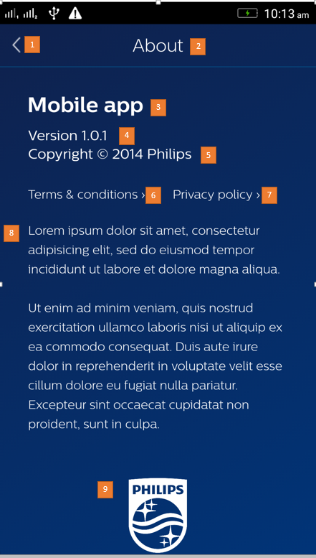

String resources can be overridden to populate the xml automatically, or using findViewID(resID) the content can be changed.

**Close Button: aboutscreen_close**